**Validation of Powerflow application of GridPACK against commercial solvers like Powerworld and PSS/E**

Mallikarjuna Vallem, Ruisheng Diao, An Wang, Yousu Chen

This document provides validation results for the GridPACK™ powerflow application compared against commercial solvers like Powerworld and PSS/E. In this document, results from GridPACK™ are compared against two test systems, the IEEE 300 bus system and European 2736 bus system provided by MATPOWER.

GridPACK™ uses a Newton Raphson algorithm on a parallel processing platform to solve the power flow equations. GridPACK™ has a relatively fixed procedure for solving the power flow equations, whereas commercial solvers provide more options.

**Choice of settings:**

The Powerworld settings for power flow: 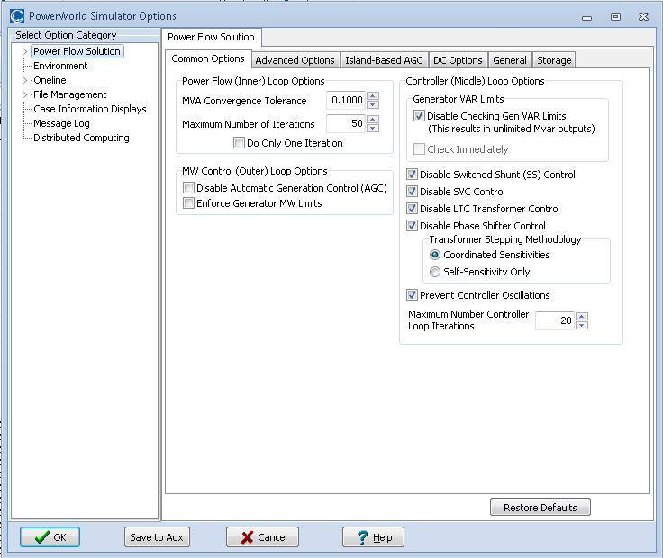

The PSS/E settings for power flow:

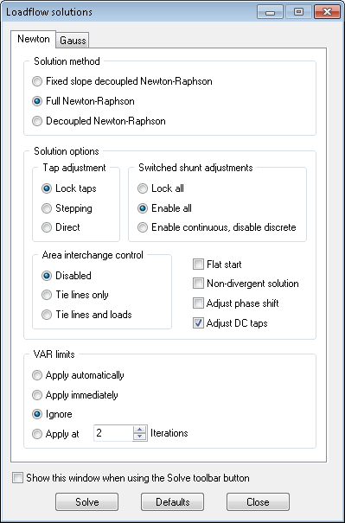

Both Powerworld and PSS/E softwares have a default tolerance of 0.1 MVA. It is often difficult to converge these commercial solvers’ power flows if the tolerance is reduced by an order of magnitude magnitude or so (for example 1e-6 MVA)

Based on the analysis of the results, which will be explained in the next section, it seems that GridPACK™ has these particular settings:

Generator VAR limits – No limit

Transformer tap control – No control

Switched shunt control – No control

Further analysis of the settings and GridPACK™ solution strategy will be explained in the next section:

**Validation results and analysis:**

IEEE 300 bus system:

The first two graphs show the largest bus mismatches compared between GridPACK™, Powerworld, and PSS/E. For the same parameters, the results for the GridPACK™ powerflow calculations are in good agreement with Powerworld and PSS/E. The mismatch in bus voltage, angle and branch flows between GridPACK and commercial solvers is within the mismatch that is observed between commercial solvers. Figures 1-3 show the 20 maximum mismatches between different solvers.

Figure 1: Comparison of calculated voltage magnitudes from GridPACK, Powerworld and PSS/E for 300 bus test case.

|  |  |  |  |  |  |  |
| --- | --- | --- | --- | --- | --- | --- |
|  | **Powerworld** | | **PSSE** | | **Powerworld - PSSE** | |
| **Bus** | **Voltage (pu)** | **Angle (deg)** | **Voltage (pu)** | **Angle (deg)** | **ΔV** | **ΔAng** |
| 224 | 1.00025 | -21.35 | 1.00205 | -21.35 | 0.0018 | 0 |
| 175 | 0.97308 | -7.18 | 0.974439 | -7.18 | 0.001359 | 0 |
| 226 | 1.01801 | -21.41 | 1.019227 | -21.4 | 0.001217 | 0.01 |
| 163 | 1.04106 | 2.93 | 1.040196 | 2.94 | 0.000864 | 0.01 |
| 225 | 0.94528 | -11.14 | 0.945939 | -11.16 | 0.000659 | 0.02 |
|  | **Gridpack™** | | **PSSE** | | **Gridpack™ - PSSE** | |
| **Bus** | **Voltage (pu)** | **Angle (deg)** | **Voltage (pu)** | **Angle (deg)** | **ΔV** | **ΔAng** |
| 224 | 1.000254 | -21.349743 | 1.00205 | -21.35 | 0.001796 | 0.000257 |
| 175 | 0.973081 | -7.180312 | 0.974439 | -7.18 | 0.001358 | 0.000312 |
| 226 | 1.018005 | -21.405482 | 1.019227 | -21.4 | 0.001222 | 0.005482 |
| 163 | 1.041011 | 2.929255 | 1.040196 | 2.94 | 0.000815 | 0.010745 |
| 225 | 0.945276 | -11.141547 | 0.945939 | -11.16 | 0.000663 | 0.018453 |
|  | **Gridpack™** | | **Powerworld** | | **Gridpack™ - Powerworld** | |
| **Bus** | **Voltage (pu)** | **Angle (deg)** | **Voltage (pu)** | **Angle (Deg)** | **ΔV** | **ΔAng** |
| 204 | 0.96671 | -29.548667 | 0.96665 | -29.55 | 6E-05 | 0.001333 |
| 163 | 1.041011 | 2.929255 | 1.04106 | 2.93 | 4.9E-05 | 0.000745 |
| 164 | 0.983914 | 9.684465 | 0.98396 | 9.68 | 4.6E-05 | 0.004465 |
| 205 | 0.985554 | -28.515769 | 0.98551 | -28.52 | 4.4E-05 | 0.004231 |
| 193 | 0.998236 | -27.470335 | 0.9982 | -27.47 | 3.6E-05 | 0.000335 |

Figure 2: Comparison of calculated voltage angles from GridPACK, Powerworld and PSS/E for 300 bus test case.

|  |  |  |  |  |  |  |
| --- | --- | --- | --- | --- | --- | --- |
|  | **Powerworld** | | **PSSE** | | **Powerworld PSSE** | |
| **Bus** | **Voltage (pu)** | **Angle (deg)** | **Voltage (pu)** | **Angle (deg)** | **ΔV** | **ΔAng** |
| 166 | 0.99726 | 30.24 | 0.99717 | 30.27 | 9E-05 | 0.03 |
| 7166 | 1.0145 | 35.07 | 1.0145 | 35.1 | 0 | 0.03 |
| 191 | 1.0435 | 12.45 | 1.0435 | 12.42 | 0 | 0.03 |
| 165 | 1.00023 | 26.33 | 1.00006 | 26.35 | 0.00017 | 0.02 |
| 155 | 1.01775 | 6.77 | 1.017701 | 6.79 | 4.9E-05 | 0.02 |
|  | **Gridpack™** | | **PSSE** | | **Gridpack™ - PSSE** | |
| **Bus** | **Voltage (pu)** | **Angle (deg)** | **Voltage (pu)** | **Angle (deg)** | **ΔV** | **ΔAng** |
| 191 | 1.0435 | 12.451664 | 1.0435 | 12.42 | 0 | 0.031664 |
| 7166 | 1.0145 | 35.072373 | 1.0145 | 35.1 | 0 | 0.027627 |
| 166 | 0.997254 | 30.243735 | 0.99717 | 30.27 | 8.4E-05 | 0.026265 |
| 225 | 0.945276 | -11.141547 | 0.945939 | -11.16 | 0.000663 | 0.018453 |
| 165 | 1.000211 | 26.331975 | 1.00006 | 26.35 | 0.000151 | 0.018025 |
|  | **Gridpack™** | | **Powerworld** | | **Gridpack™ - Powerworld** | |
| **Bus** | **Voltage (pu)** | **Angle (deg)** | **Voltage (pu)** | **Angle (deg)** | **ΔV** | **ΔAng** |
| 78 | 0.990023 | -24.034599 | 0.99002 | -24.04 | 3E-06 | 0.005401 |
| 9025 | 0.964756 | -20.434718 | 0.96476 | -20.44 | 4E-06 | 0.005282 |
| 8 | 1.0153 | 2.415278 | 1.0153 | 2.41 | 0 | 0.005278 |
| 139 | 1.011709 | -3.544731 | 1.01171 | -3.55 | 1E-06 | 0.005269 |
| 17 | 1.064906 | -13.084747 | 1.06491 | -13.09 | 4E-06 | 0.005253 |

Figure 3: Comparison of calculated reactive power between GridPACK, Powerworld and PSS/E for 300 bus test case.

|  |  |  |  |  |  |  |  |  |
| --- | --- | --- | --- | --- | --- | --- | --- | --- |
|  |  |  | **Powerworld** | | **PSSE** | | **Powerworld - PSSE** | |
| **Bus 1** | **Bus 2** | **CKT** | **MW** | **Mvar** | **P** | **Q** | **ΔP** | **ΔQ** |
| 222 | 237 | 1 | -78 | -26.6152 | -78 | -44.0679 | 0 | 17.45267 |
| 190 | 231 | BL | 528.9429 | -363.699 | 528.986 | -349.793 | 0.04312 | 13.90623 |
| 231 | 237 | BL | -452.149 | -527.838 | -452.052 | -515.289 | 0.09718 | 12.54888 |
| 227 | 231 | 1 | -235 | -106.043 | -235 | -114.722 | 1.53E-05 | 8.679546 |
| 221 | 223 | BL | 325.4972 | 140.7018 | 325.5046 | 149.0766 | 0.00738 | 8.374769 |
|  |  |  | **GridPACK™** | | **PSSE** | | **GridPACK™ - PSSE** | |
| **Bus 1** | **Bus 2** | **CKT** | **P** | **Q** | **P** | **Q** | **ΔP** | **ΔQ** |
| 222 | 237 | 1 | -78 | -26.6147 | -78 | -44.0679 | 0 | 17.45322 |
| 190 | 231 | BL | 528.9429 | -363.69 | 528.986 | -349.793 | 0.04316 | 13.89749 |
| 231 | 237 | BL | -452.149 | -527.828 | -452.052 | -515.289 | 0.09719 | 12.53894 |
| 227 | 231 | 1 | -235 | -106.042 | -235 | -114.722 | 1.53E-05 | 8.679884 |
| 221 | 223 | BL | 325.4972 | 140.7021 | 325.5046 | 149.0766 | 0.00743 | 8.374499 |
|  |  |  | **Gridpack™** | | **Powerworld** | | **Gridpack™ - Powerworld** | |
| **Bus 1** | **Bus 2** | **CKT** | **P** | **Q** | **MW** | **Mvar** | **ΔP** | **ΔQ** |
| 155 | 156 | 1 | 102.8437 | 21.9238 | 102.8433 | 22.0108 | 0.00036 | 0.086997 |
| 7166 | 166 | 1 | 553 | 136.924 | 553 | 136.8603 | 0 | 0.063729 |
| 165 | 166 | BL | -552.385 | 51.92083 | -552.384 | 51.9833 | 0.00031 | 0.062472 |
| 162 | 165 | BL | -546.877 | -37.9969 | -546.877 | -37.9458 | 8.5E-05 | 0.051064 |
| 162 | 164 | BL | 461.8771 | 13.99686 | 461.877 | 13.9458 | 8.5E-05 | 0.051064 |

European 2736 bus system (MATPOWER library):

Figures 4-6 show the largest bus mismatches in bus voltage and phase angle and branch flow compared among Powerworld, PSSE, and GridPACK™. The maximum mismatch in bus voltage between GridPACK and commercial solvers is about 0.0032 and about 0.035 degrees in the bus angles. Such a mismatch is acceptable based on similar differences between commercial solvers with other cases.

Figure 4: Comparison of calculated voltage magnitudes from GridPACK, Powerworld and PSS/E for European 2736 bus test case.

|  |  |  |  |  |  |  |
| --- | --- | --- | --- | --- | --- | --- |
|  | **Powerworld** | | **PSSE** | | **Powerworld - PSSE** | |
| **Bus** | **Voltage (pu)** | **Angle (deg)** | **Voltage (pu)** | **Angle (deg)** | **ΔV** | **ΔAng** |
| 2209 | 1.09076 | 20.628 | 1.0914 | 20.6263 | 0.00064 | 0.0017 |
| 2206 | 1.09038 | 20.5864 | 1.091 | 20.5846 | 0.00062 | 0.0018 |
| 2210 | 1.0906 | 20.6 | 1.0912 | 20.5982 | 0.0006 | 0.0018 |
| 2208 | 1.0891 | 20.4003 | 1.0897 | 20.3988 | 0.0006 | 0.0015 |
| 2201 | 1.08713 | 20.3729 | 1.0877 | 20.3719 | 0.00057 | 0.001 |
|  | **GridPACK™** | | **PSSE** | | **GridPACK™ - PSSE** | |
| **Bus** | **Voltage (pu)** | **Angle (deg)** | **Voltage (pu)** | **Angle (deg)** | **ΔV** | **ΔAng** |
| 2516 | 1.055277 | 10.969782 | 1.0585 | 10.9352 | 0.003223 | 0.034582 |
| 2568 | 1.05599 | 11.030275 | 1.0592 | 10.9953 | 0.00321 | 0.034975 |
| 2449 | 1.04973 | 10.336278 | 1.0526 | 10.3167 | 0.00287 | 0.019578 |
| 2202 | 1.04443 | 11.25968 | 1.0467 | 11.2423 | 0.00227 | 0.01738 |
| 2228 | 1.04849 | 11.673873 | 1.0507 | 11.6571 | 0.00221 | 0.016773 |
|  | **GridPACK™** | | **Powerworld** | | **GridPACK™ - Powerworld** | |
| **Bus** | **Voltage (pu)** | **Angle (deg)** | **Voltage (pu)** | **Angle (deg)** | **ΔV** | **ΔAng** |
| 2516 | 1.055277 | 10.969782 | 1.05852 | 10.9315 | 0.003243 | 0.038282 |
| 2568 | 1.05599 | 11.030275 | 1.05923 | 10.9917 | 0.00324 | 0.038575 |
| 2449 | 1.04973 | 10.336278 | 1.05257 | 10.3129 | 0.00284 | 0.023378 |
| 2056 | 1.04402 | 11.316453 | 1.04616 | 11.2957 | 0.00214 | 0.020753 |
| 2228 | 1.04849 | 11.673873 | 1.05063 | 11.6541 | 0.00214 | 0.019773 |

Figure 5: Comparison of calculated voltage angles from GridPACK, Powerworld and PSS/E for European 2736 bus test case.

|  |  |  |  |  |  |  |
| --- | --- | --- | --- | --- | --- | --- |
|  | **Powerworld** | | **PSSE** | | **Powerworld - PSSE** | |
| **Bus** | **Voltage (pu)** | **Angle (deg)** | **Voltage (pu)** | **Angle (deg)** | **ΔV** | **ΔAng** |
| 220 | 1.08853 | 20.3348 | 1.0885 | 20.349 | 3E-05 | 0.0142 |
| 214 | 1.09209 | 16.9099 | 1.0921 | 16.9178 | 1E-05 | 0.0079 |
| 493 | 1.09185 | 16.8637 | 1.0919 | 16.8715 | 5E-05 | 0.0078 |
| 217 | 1.09161 | 16.7837 | 1.0916 | 16.7908 | 1E-05 | 0.0071 |
| 341 | 1.08719 | 16.63 | 1.0873 | 16.6369 | 0.00011 | 0.0069 |
|  | **GridPACK™** | | **PSSE** | | **GridPACK™ - PSSE** | |
| **Bus** | **Voltage (pu)** | **Angle (deg)** | **Voltage (pu)** | **Angle (deg)** | **ΔV** | **ΔAng** |
| 2568 | 1.05599 | 11.030275 | 1.0592 | 10.9953 | 0.00321 | 0.034975 |
| 2516 | 1.055277 | 10.969782 | 1.0585 | 10.9352 | 0.003223 | 0.034582 |
| 2438 | 1.0503 | 10.95865 | 1.0523 | 10.9356 | 0.002 | 0.02305 |
| 1984 | 1.049959 | 10.987469 | 1.0519 | 10.9672 | 0.001941 | 0.020269 |
| 2449 | 1.04973 | 10.336278 | 1.0526 | 10.3167 | 0.00287 | 0.019578 |
|  | **GridPACK™** | | **Powerworld** | | **GridPACK™ - Powerworld** | |
| **Bus** | **Voltage (pu)** | **Angle (deg)** | **Voltage (pu)** | **Angle (deg)** | **ΔV** | **ΔAng** |
| 2568 | 1.05599 | 11.030275 | 1.05923 | 10.9917 | 0.00324 | 0.038575 |
| 2516 | 1.055277 | 10.969782 | 1.05852 | 10.9315 | 0.003243 | 0.038282 |
| 2438 | 1.0503 | 10.95865 | 1.05218 | 10.9325 | 0.00188 | 0.02615 |
| 2449 | 1.04973 | 10.336278 | 1.05257 | 10.3129 | 0.00284 | 0.023378 |
| 1984 | 1.049959 | 10.987469 | 1.0518 | 10.9641 | 0.001841 | 0.023369 |

The maximum mismatch in the branch reactive power flow for GridPACK – PSS/E is 12.67 Mvar which is the same as that between Powerworld – PSS/E. These larger mismatches is among branches that have lower impedance. The mismatches are comparable between different solvers and can be accepted as has been seen between commercial solvers.

The next graph shows the largest branch data mismatch between solvers for case 2736:

Figure 6: Comparison of calculated reactive power between GridPACK, Powerworld and PSS/E for European 2736 bus test case.

|  |  |  |  |  |  |  |  |  |
| --- | --- | --- | --- | --- | --- | --- | --- | --- |
|  |  |  | **Powerworld** | | **PSSE** | | **Powerworld - PSSE** | |
| **Bus 1** | **Bus 2** | **CKT** | **MW** | **Mvar** | **P** | **Q** | **ΔP** | **ΔQ** |
| 29 | 28 | BL | 177.5750 | -16.9023 | 177.4978 | -29.5735 | 0.0772 | 12.6712 |
| 150 | 149 | BL | 35.5833 | -11.7545 | 35.5575 | -23.0323 | 0.0258 | 11.2778 |
| 57 | 56 | BL | -110.3671 | -41.1480 | -110.3752 | -33.6897 | 0.0081 | 7.4583 |
| 205 | 204 | BL | 20.2708 | 3.8959 | 20.2716 | -3.3785 | 0.0008 | 7.2744 |
| 127 | 126 | BL | 13.0317 | -5.3736 | 13.0487 | -3.2760 | 0.0170 | 2.0976 |
|  |  |  | **GridPACK™** | | **PSSE** | | **GridPACK™ - PSSE** | |
| **Bus 1** | **Bus 2** | **CKT** | **P** | **Q** | **P** | **Q** | **ΔP** | **ΔQ** |
| 29 | 28 | BL | 177.5549 | -16.9004 | 177.4978 | -29.5735 | 0.0571 | 12.6731 |
| 57 | 56 | BL | -110.3676 | -39.0264 | -110.3752 | -33.6897 | 0.0076 | 5.3367 |
| 150 | 149 | BL | 35.5949 | -19.6594 | 35.5575 | -23.0323 | 0.0374 | 3.3729 |
| 2471 | 2470 | BL | -2.7882 | -3.6311 | -2.7212 | -6.5719 | 0.0670 | 2.9409 |
| 18 | 17 | BL | 2.1158 | 34.0131 | 2.1258 | 31.2614 | 0.0100 | 2.7517 |
|  |  |  | **GridPACK™** | | **Powerworld** | | **GridPACK™ - Powerworld** | |
| **Bus 1** | **Bus 2** | **CKT** | **P** | **Q** | **MW** | **Mvar** | **ΔP** | **ΔQ** |
| 150 | 149 | BL | 35.5949 | -19.6594 | 35.5833 | -11.7545 | 0.0116 | 7.9049 |
| 205 | 204 | BL | 20.2820 | -1.9315 | 20.2708 | 3.8959 | 0.0111 | 5.8274 |
| 2471 | 2470 | BL | -2.7882 | -3.6311 | -2.7243 | -6.5730 | 0.0639 | 2.9419 |
| 18 | 17 | BL | 2.1158 | 34.0131 | 2.1270 | 31.2984 | 0.0112 | 2.7147 |
| 2568 | 2592 | BL | -26.8160 | -2.2879 | -26.8607 | -0.0954 | 0.0447 | 2.1925 |

**Conclusions:**

The results shown verify that when similar choice of power flow options are chosen, GridPACK™ results are very close to the results produced from the commercial grade solvers Powerworld and PSS/E.