**Application Validation of Dynamic State Estimation using EnKF (Ensemble Kalman Filter)**

**Xinya Li**

This document provides validation results for the GridPACKTM application of dynamic state estimation using EnKF compared against a MATLAB version of EnKF solver. In this document, results from GridPACKTM were compared against four test systems:

1. 14 Buses 5 Machines
2. 145 Buses 50 Machines
3. 1081 Buses 148 Machines
4. WECC: 15575 Buses 2484 Machines

The setting parameters of these four cases are concluded in Table 1. The size of a testing system is categorized b number of buses, number of generator and number of ensembles, from small and medium cases (1 & 2) to large cases (3 & 4).

Table 1. Setting parameters of the four test cases.

|  |  |  |  |  |
| --- | --- | --- | --- | --- |
| **System** | **14bus 5machine** | **145bus 50machine** | **1081bus 148machine** | **WECC** |
| **Bus #** | **14** | **145** | **1081** | **15575** |
| **Generator #** | **5** | **50** | **148** | **2484** |
| **Ensemble Size** | **21** | **123** | **296** | **2484** |
| **Number of Measurements** | **28** | **290** | **2162** | **31150** |
| **Total Simulation Time (second)** | 10 | 25 | 10 | 2 |
| **Fault Begin Time (second)** | 1 | 1 | 0.5 | 1 |
| **Fault End Time (second)** | 1.1 | 1.15 | 0.6 | 1.05 |
| **Time Step (second)** | 0.01 | 0.001 | 0.01 | 0.01 |
| **Process Noise** | 1.0E-02 | 1.0E-02 | 2.0E-05 | 6.0E-06 |
| **Measurement Noise** | 1.0E-04 | 1.0E-04 | 1.0E-02 | 1.0E-02 |
| **Tolerance** | 1.0E-06 | 1.0E-06 | 1.0E-06 | 1.0E-10 |

**Validation:**

The Ensemble Kalman Filter (EnKF), a Monte-Carlo implementation of the Bayesian update problem, is a methodology for assimilating new measurements and continuously updating the state of a nonlinear system. This update is carried out in the presence of noisy data introduced by the level of process (ensemble) error (process noise) and the level of measurement error (measurement noise). The EnKF procedure is initialized by powerflow outcomes and the fault information (start time, end time, the fault branch) is known.

The validation of accuracy and robustness was performed by comparing with the estimated results (generator angles and speeds) from the MATLAB version of the EnKF solver. And also the result from GridPACKTM were compared with the true results, which are actual generator angle and speed values. Since GridPACKTM runs on parallel high performance computing platforms, multiple processors were used to testify the applications.

By using the same parameters listed in Table 1, the GridPACKTM simulations are in good agreement with MATLAB and True results. The mean absolute errors (MAEs) of generator angles and speeds observed are small (Table 2). The largest mismatches (maximum MAEs) were observed on generator #2 for 14bus5machine case, generator #14 for 145bus50machine case and generator #65 for 1081bus148machine case. Figure 1-3 show the curve matching of angle and speed results at the generators with the largest mismatches.

Table 2. Maximum MAEs between GridPACKTM and True/ MATLAB across three test cases.

|  |  |  |  |  |
| --- | --- | --- | --- | --- |
| **GridPACKTM** **VS.** | **Mean Absolute Error (MAE)** | **14bus 5machine** | **145bus 50machine** | **1081bus 148machine** |
| **True** | **Maximum MAE of Angle** | 6.90E-05 | 4.30E-05 | 4.72E-04 |
| **Maximum MAE of Speed** | 1.00E-05 | 1.00E-05 | 1.00E-05 |
| **MATLAB** | **Maximum MAE of Angle** | 6.90E-05 | 5.00E-05 | 4.72E-04 |
| **Maximum MAE of Speed** | 1.00E-05 | 1.00E-05 | 1.00E-05 |

To investigate the effectiveness of EnKF in real application, the following condition is considered:

* the fault information is unknown

EnKF still can update the states effectively according to measurements matching the curve progression (Figure 4).

Figure 1. Comparisons of GridPack with True results (Top) and MATLAB results (Bottom) on generator #2 for the case of 14bus5machine.

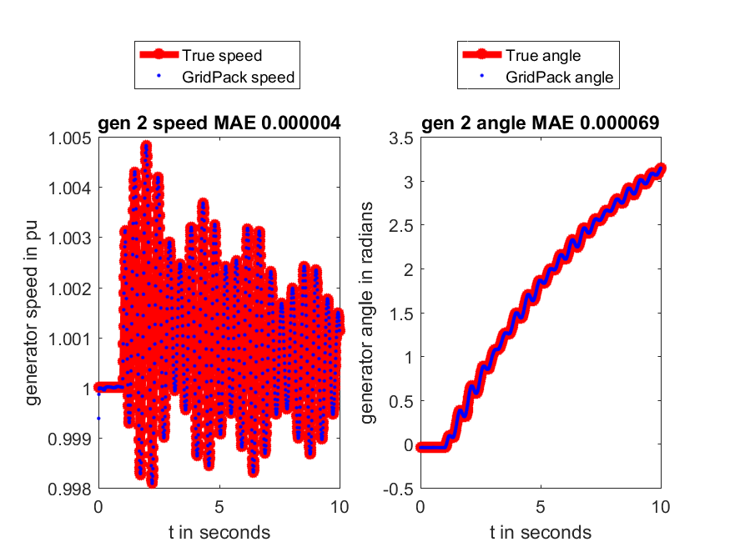

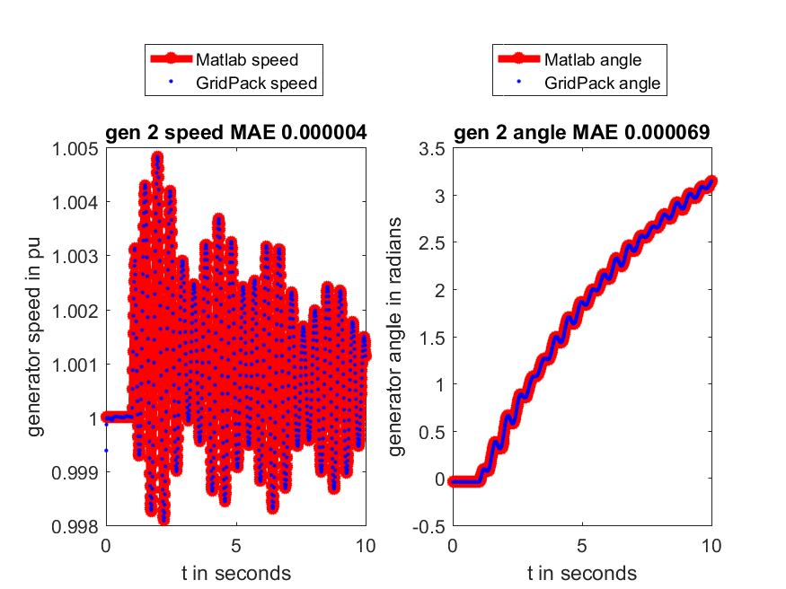

Figure 2. Comparisons of GridPack with True results (Top) and MATLAB results (Bottom) on generator #14 for the case of 145bus50machine.

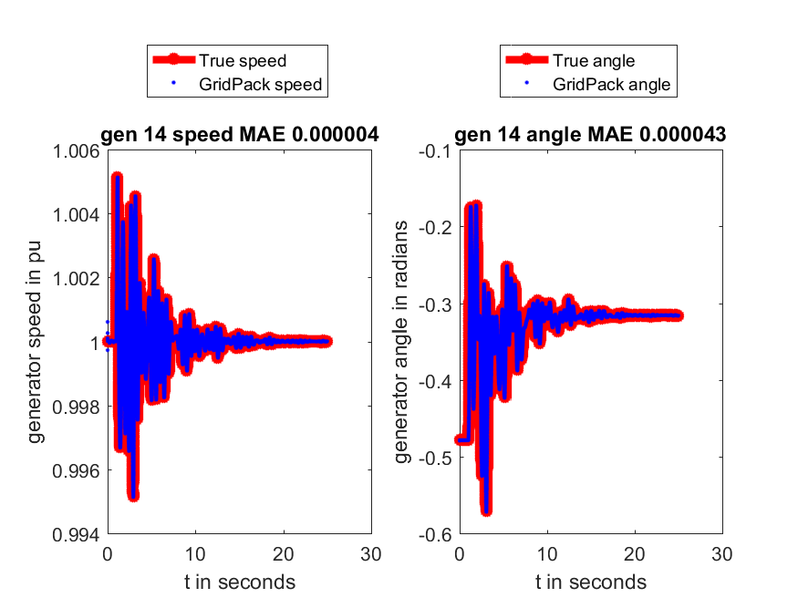

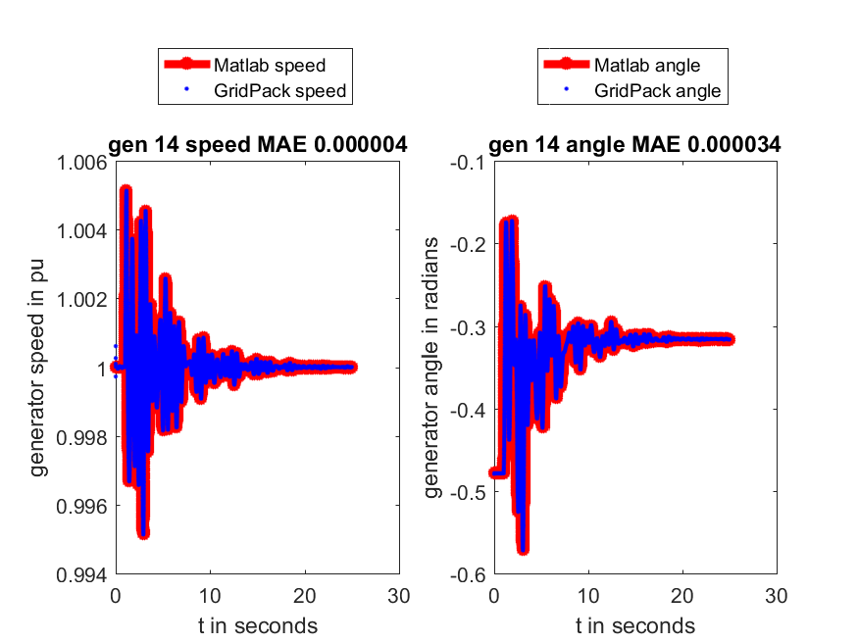

Figure 3. Comparisons of GridPack with True results (Top) and MATLAB results (Bottom) on generator #65 for the case of 1081bus148machine.

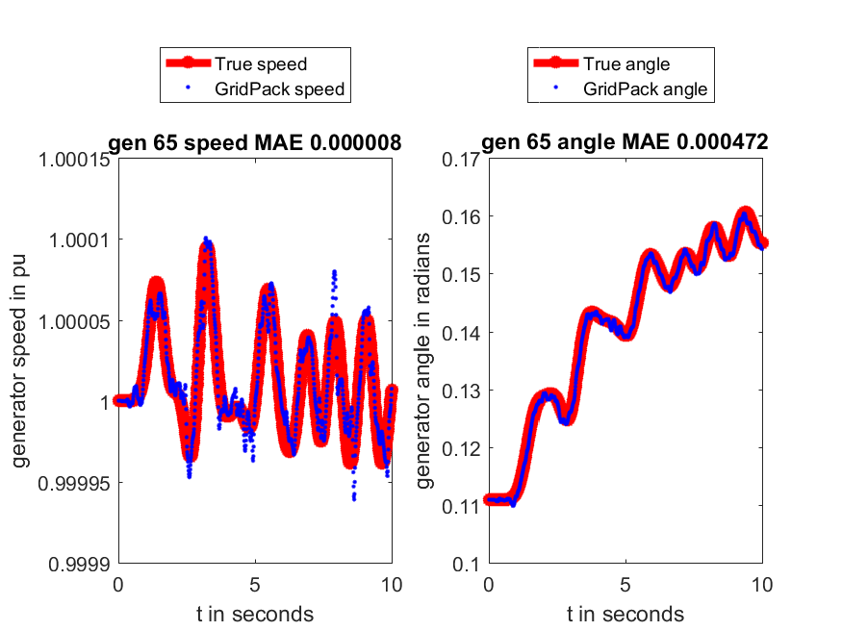

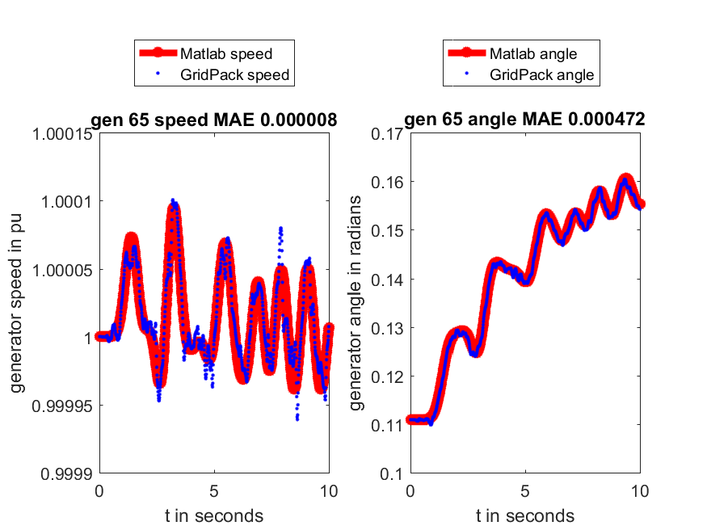

Figure 4. Comparisons of GridPack with True results on generator #12 for the case of 1081bus148machine when fault is unknown.

