**Structured Population Models—Exercise 1**

**Natural history and life cycle of teasel (*Dipsacus sylvestris*)**

Below is the life cycle diagram for a population of the perennial, monocarpic plant teasel. The life cycle consists of six stages: (i) first-year dormant seeds, (ii) second-year dormant seeds, (iii) small rosettes, (iv) medium rosettes, (v) large rosettes, and (vi) flowering plants. Plants can grow to larger sizes or shrink to smaller size. Plants only reproduce when they are flowering through seeds—there is no vegetative or clonal reproduction. Plants flower only once and die shortly after dispersing their seeds.

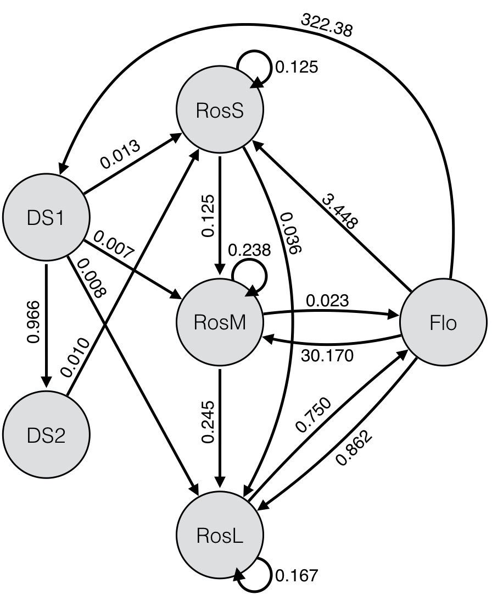

1. Convert the life cycle diagram into a stage-structured matrix population model, and calculate the stage-specific survival rates.

**U – Survival & growth**

|  |  |  |  |  |  |  |  |  |
| --- | --- | --- | --- | --- | --- | --- | --- | --- |
|  | **Time t** | | | | | | | |
| **Time t+1** |  | DS1 | DS2 | RosS | RosM | RosL | Flo |
| DS1 | 0 | 0 | 0 | 0 | 0 | 0 |
| DS2 | 0.966 | 0 | 0 | 0 | 0 | 0 |
| RosS | 0.013 | 0.010 | 0.125 | 0 | 0 | 0 |
| RosM | 0.007 | 0 | 0.125 | 0.238 | 0 | 0 |
| RosL | 0.008 | 0 | 0.036 | 0.245 | 0.167 | 0 |
| Flo | 0 | 0 | 0 | 0.023 | 0.750 | 0 |
|  |  |  |  |  |  |  |  |
| Survival | | 0.994 | 0.010 | 0.286 | 0.506 | 0.917 | 0 |

**Key natural history detail: “Plants flower only once and die shortly after dispersing their seeds.” Thus all ‘Flo’ plants must die.**

**F – Fertility**

|  |  |  |  |  |  |  |  |  |
| --- | --- | --- | --- | --- | --- | --- | --- | --- |
|  | **Time t** | | | | | | | |
| **Time t+1** |  | DS1 | DS2 | RosS | RosM | RosL | Flo |
| DS1 | 0 | 0 | 0 | 0 | 0 | 322.380 |
| DS2 | 0 | 0 | 0 | 0 | 0 | 0 |
| RosS | 0 | 0 | 0 | 0 | 0 | 3.448 |
| RosM | 0 | 0 | 0 | 0 | 0 | 30.170 |
| RosL | 0 | 0 | 0 | 0 | 0 | 0.862 |
| Flo | 0 | 0 | 0 | 0 | 0 | 0 |

**“Plants only reproduce when they are flowering through seeds—there is no vegetative or clonal reproduction.” Don’t be confused by Flo->RosL being less than 1. It’s just rare for a plant to go from seed to large rosette in just 1 year.**

**C – Clonality**

|  |  |  |  |  |  |  |  |  |
| --- | --- | --- | --- | --- | --- | --- | --- | --- |
|  | **Time t** | | | | | | | |
| **Time t+1** |  | DS1 | DS2 | RosS | RosM | RosL | Flo |
| DS1 | 0 | 0 | 0 | 0 | 0 | 0 |
| DS2 | 0 | 0 | 0 | 0 | 0 | 0 |
| RosS | 0 | 0 | 0 | 0 | 0 | 0 |
| RosM | 0 | 0 | 0 | 0 | 0 | 0 |
| RosL | 0 | 0 | 0 | 0 | 0 | 0 |
| Flo | 0 | 0 | 0 | 0 | 0 | 0 |

**“Plants only reproduce when they are flowering through seeds—there is no vegetative or clonal reproduction.”**

**A – Projection matrix**

|  |  |  |  |  |  |  |  |  |
| --- | --- | --- | --- | --- | --- | --- | --- | --- |
|  | **Time t** | | | | | | | |
| **Time t+1** |  | DS1 | DS2 | RosS | RosM | RosL | Flo |
| DS1 | 0 | 0 | 0 | 0 | 0 | 322.380 |
| DS2 | 0.966 | 0 | 0 | 0 | 0 | 0 |
| RosS | 0.013 | 0.010 | 0.125 | 0 | 0 | 3.448 |
| RosM | 0.007 | 0 | 0.125 | 0.238 | 0 | 30.170 |
| RosL | 0.008 | 0 | 0.036 | 0.245 | 0.167 | 0.862 |
| Flo | 0 | 0 | 0 | 0.023 | 0.750 | 0 |

Suppose a new population is started (time=0) with 50 first-year dormant seeds and 50 second-year dormant seeds (NDS1=NDS2=50).

1. **What is the total population size (N) at time=15?**

library(popbio)

teasel <- matrix(c(0, 0, 0, 0, 0, 322.38,

0.966, 0, 0, 0, 0, 0,

0.013, 0.010, 0.125, 0, 0, 3.448,

0.007, 0, 0.125, 0.238, 0, 30.170,

0.008, 0, 0.036, 0.245, 0.167, 0.862,

0, 0, 0, 0.023, 0.750, 0), nrow = 6, byrow = TRUE)

pop0 <- matrix(c(50,

50,

0,

0,

0,

0),

nrow = 6, byrow = TRUE)

pop15 <- pop.projection(A = teasel, n = pop0)$stage.vectors[, "15"]

sum(pop15)

**Nt=15 = 1,824,897 (a lot of plants, but see section d. below)**

1. **What is the equilibrium population growth rate (λ)?**

lambda(teasel)

**λ = 2.333**

1. **What is the equilibrium population size structure (w)?**

|  |  |
| --- | --- |
| **Stage** | **Proportion** |
| DS1 | 0.6377 |
| DS2 | 0.2640 |
| RosS | 0.0122 |
| RosM | 0.0693 |
| RosL | 0.0122 |
| Flo | 0.0046 |

stable.stage(teasel)

**Notice that the population is already quite close to the equilibrium stage structure at t=15 (section b).**

pop15/sum(pop15) # this gives the stage structure at t=15 as a proportion

**That means that >90% of the “plants” that are included in Nt=15 are seeds in the soil that are hidden from view. Only about 8,000 plants would be flowering, which is a lot, but is a reasonable number for a large agricultural field. Our model doesn’t account for spread through seed dispersal, nor do the vital rates change in response to competition.**