Ref:

[1] <https://docs.scipy.org/doc/scipy/reference/tutorial/fftpack.html>

[2] <https://blog.csdn.net/ouening/article/details/71079535>

[3] <https://stackoverflow.com/questions/3694918/how-to-extract-frequency-associated-with-fft-values-in-python>

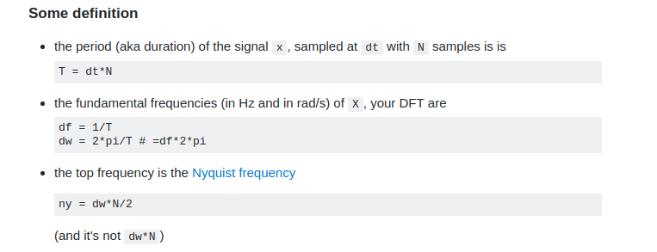

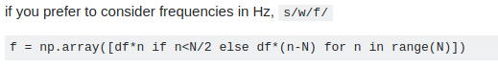

Mainly reference 1 and 3, the second ref does not give how to calculate the frequency!