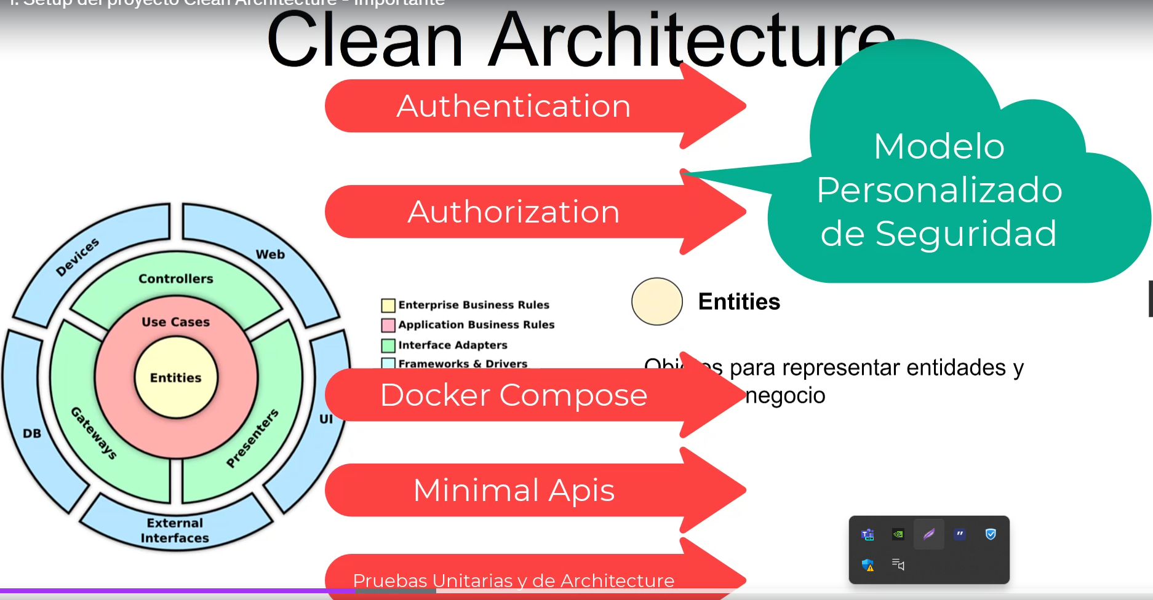

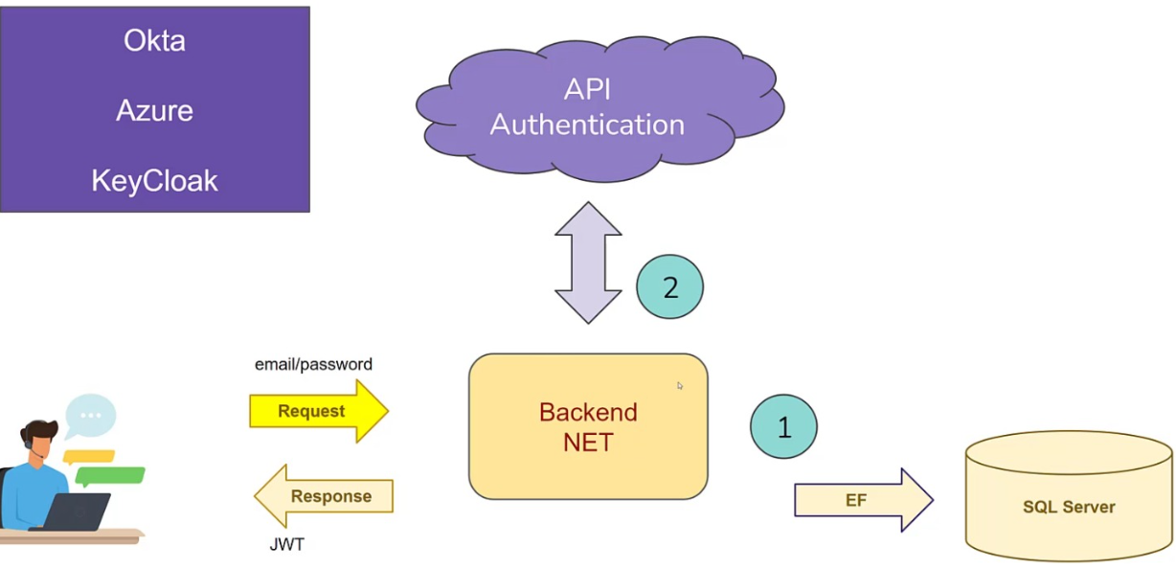

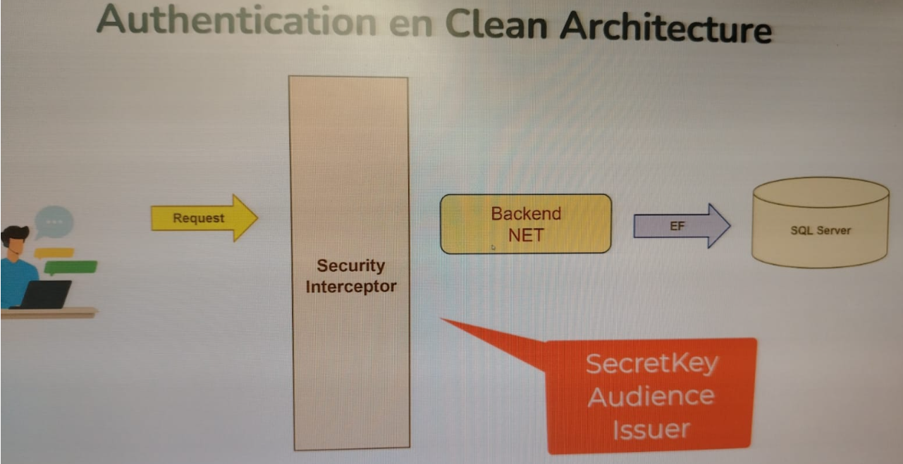

Enumerar ventajas de docker.

Como funciona docker?

* Docker engine.
* Docker desktop.
* Docker hub.
* Docker compose
* Kubernetes.

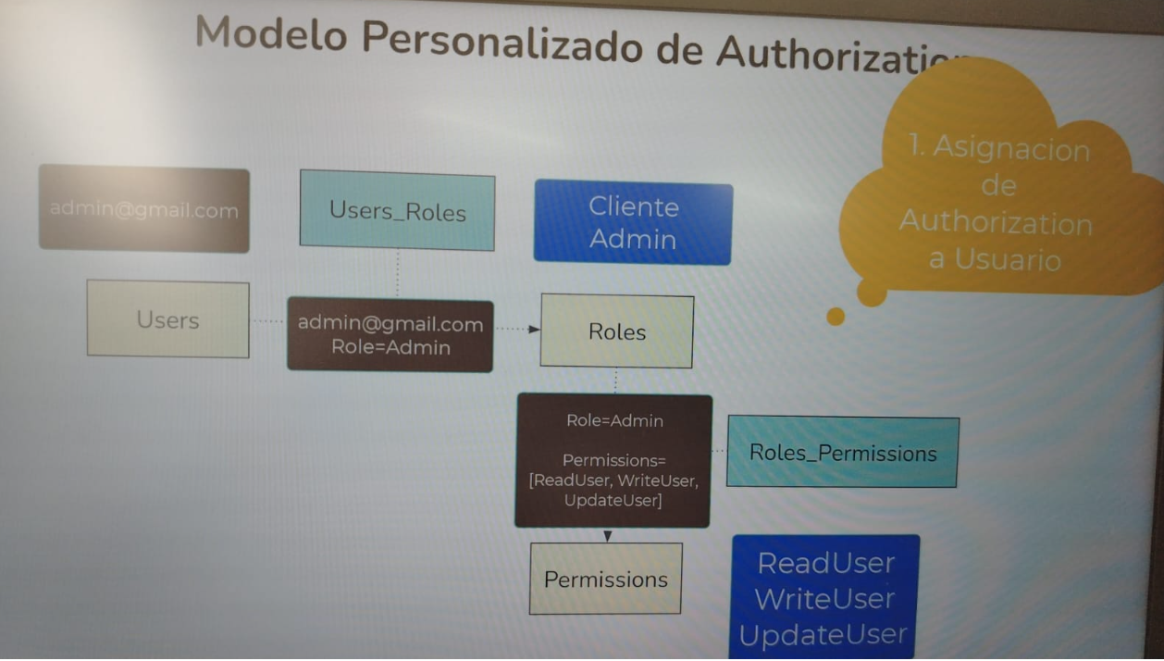

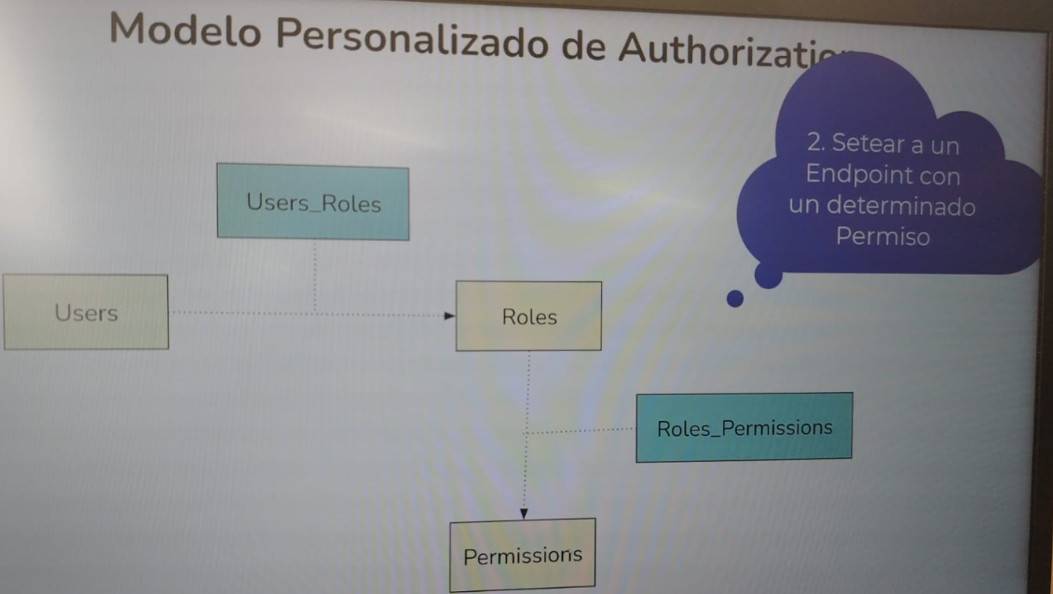

dotnet ef --verbose migrations add InitialCreate -p src/CleanArchitecture/CleanArchitecture.Infrastructure -s src/CleanArchitecture/CleanArchitecture.Api