Contenido

IMPLEMENTAR CARGA EMPLEADO 2

CARGAR BASE DE DATOS NORTHWND_METADATA 4

CONFIGURARA TABLA DE METADATOS 4

IMPLEMENTAR CARGA PRODUCTO 9

INSERTAR EN TABLA ETL EXECUTION DE BASE DE DATOS METADATA 10

OBTENER ID NORTHWND METADATA 10

CARGAR CATEGORIA 15

CARGAR CUSTOMER 18

CARGAR ORDER 21

CARGAR ORDER DETAIL 24

CARGA LOAD MASTER 25

# IMPLEMENTAR CARGA EMPLEADO

Se crea la tabla empleados en la Base De Datos **LOAD_NORTHWND**



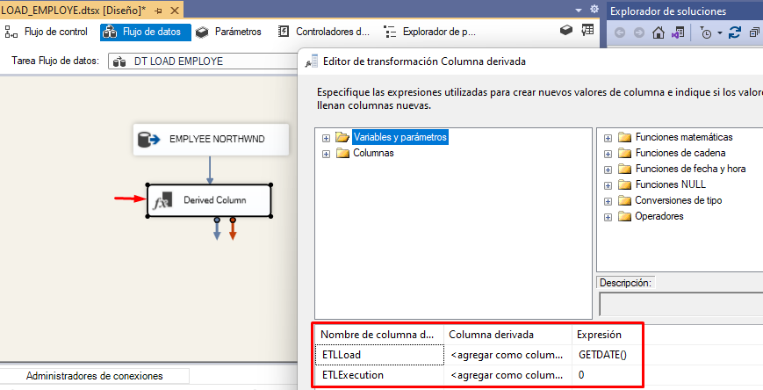

DESTINO LOAD NORTHWND

Se carga el empleado de NORTHWND a la tabla employee de la base de datos de LOAD_NORTHWND.

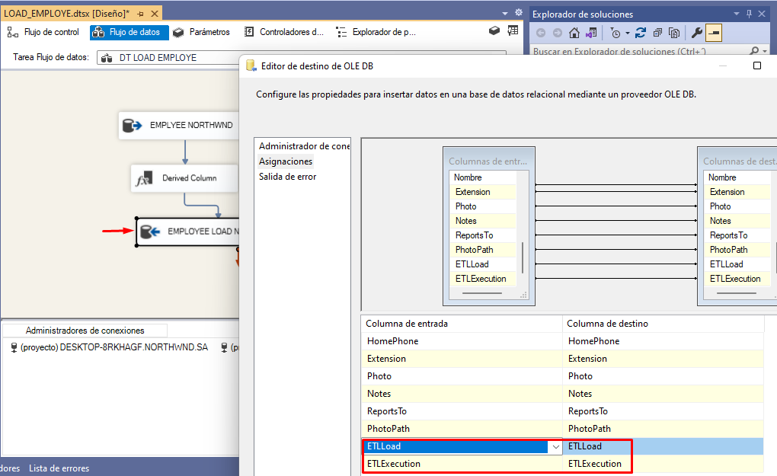

USE LOAD_NORTHWND

GO

SELECT * FROM Employees

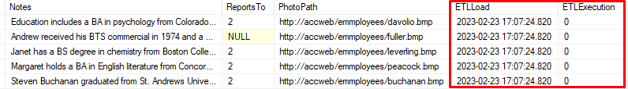

## CARGAR BASE DE DATOS NORTHWND_METADATA

USE NORTHWND_METADATA

GO

CREATE TABLE ETLExecution(

ID [int] NOT NULL,

NombreUsuario [nvarchar](100) NULL,

NombreMaquina [nvarchar](100) NULL,

NombrePaquete [nvarchar](100) NULL,

ETLload [DateTime] NULL,

ETLCountRows [int] NULL,

ETLCountNewRegister [int] NULL,

ETLCountModifiedRegister [int] NULL )

## CONFIGURARA TABLA DE METADATOS

INSERT INTO ETLExecution(NombreUsuario, NombreMaquina, NombrePaquete,ETLload)

VALUES(?,?,?,GETDATE())

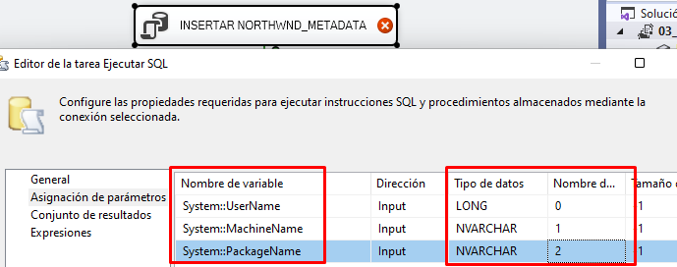

**OBTENER ID**

SELECT TOP 1 ID

FROM [NORTHWND_METADATA].[dbo].[ETLExecution]

WHERE NombrePaquete = ?

ORDER BY ID DESC

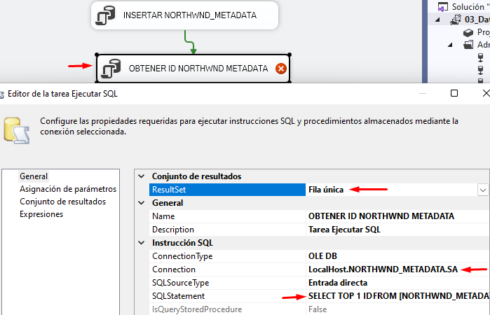

**ASIGNAR PARAMETROS**

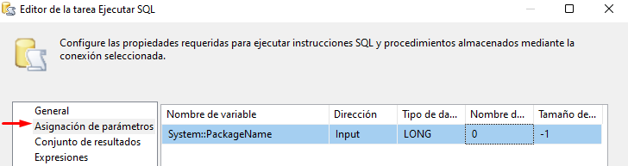

**CONJUNTO DE SALIDA**

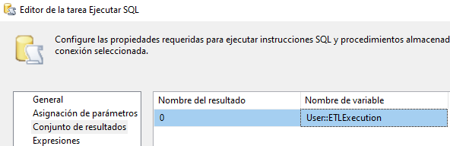

**CONTROLADOR DE EVENTOS**

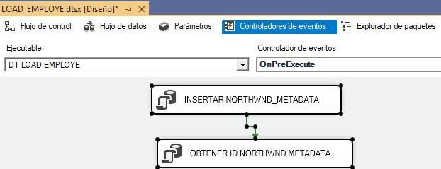

ASIGNAR VARIABLE **@[User::ETLExecution]** A EMPLEADOS

Se toma el valor del query.

SELECT TOP 1 *

FROM [NORTHWND_METADATA].[dbo].[ETLExecution]

ORDER BY 1 DESC



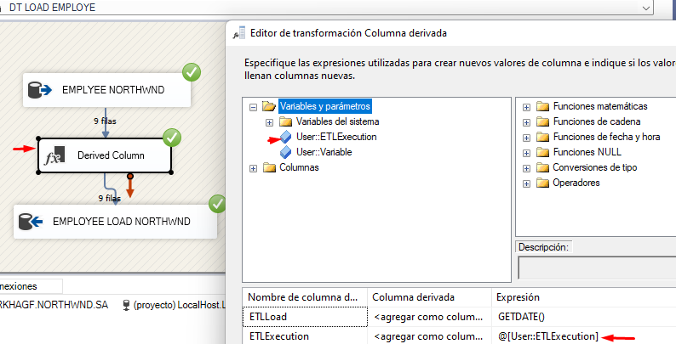

Una vez configurado el valor se realiza la consulta.

SELECT * FROM [dbo].[Employees]

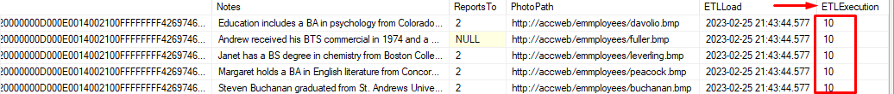

**CONFIGURAR CONTEO DE FILAS**

**CREAR VARIABLE ETLCOUNTROWS**

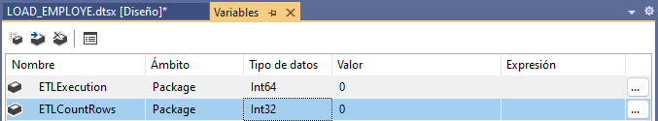

**CONTEO FILAS**

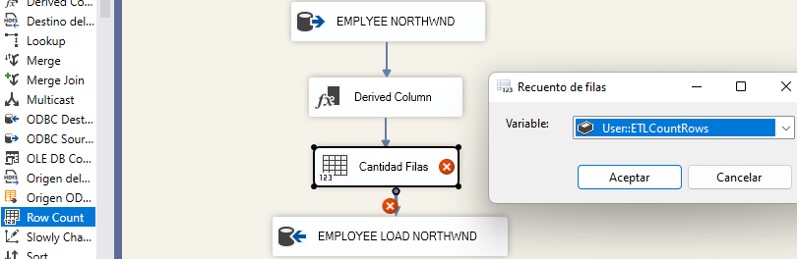

**ACTUALZIAR VARIABLE CONTEO DE FILAS**

UPDATE ETLExecution

SET ETLCountRows=?

WHERE ID=?

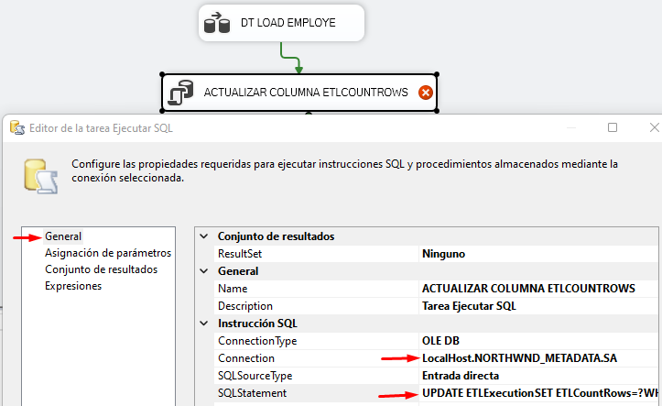

En la consulta anterior se configura 2 parámetros para la actualización del query.

A continuación, se asignan los parámetros.

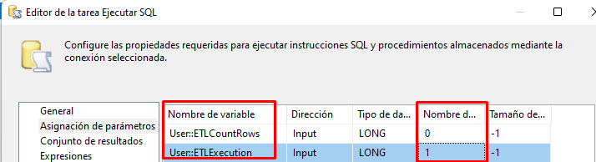

**PASAR TAREA DE ACTUALIZAR CONTEO FILAS A EVENTO POST EXECUTE**

SELECT TOP 1 *

FROM [NORTHWND_METADATA].[dbo].[ETLExecution]

ORDER BY 1 DESC



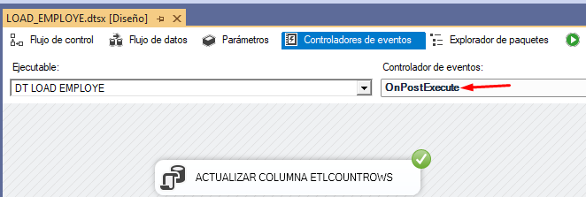

# IMPLEMENTAR CARGA PRODUCTO

**CREAR TABLA BASE DE DATOS LOAD_NORTHWND**

CREATE TABLE [dbo].[Products](

[ProductID] [int] NOT NULL,

[ProductName] [nvarchar](40) NOT NULL,

[SupplierID] [int] NULL,

[CategoryID] [int] NULL,

[QuantityPerUnit] [nvarchar](20) NULL,

[UnitPrice] [money] NULL,

[UnitsInStock] [smallint] NULL,

[UnitsOnOrder] [smallint] NULL,

[ReorderLevel] [smallint] NULL,

[Discontinued] [bit] NOT NULL,

ETLLoad DATETIME,

ETLExecution int )

**COLUMNAS DERIVADAS INICIO**

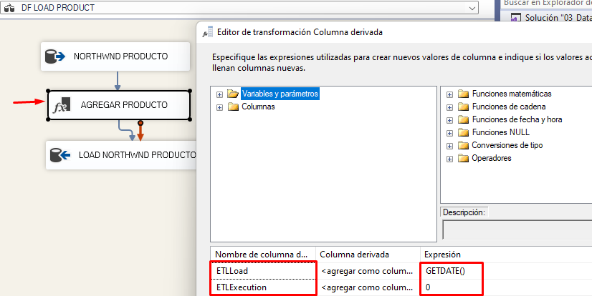

**DESTINO LOAD NORTHWND**

Se carga el empleado de NORTHWND a la tabla employee de la base de datos de LOAD_NORTHWND.

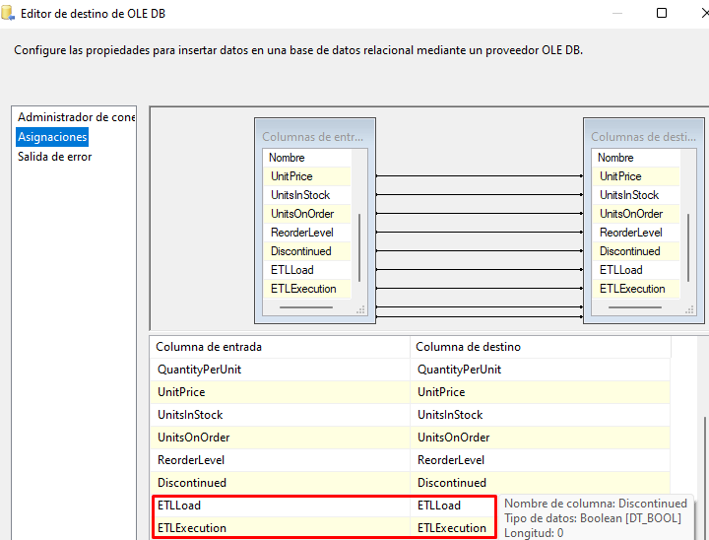

## INSERTAR EN TABLA ETL EXECUTION DE BASE DE DATOS METADATA

INSERT INTO [dbo].[ETLExecution](NombreUsuario,NombreMaquina,NombrePaquete,ETLload )VALUES(?,?,?,GETDATE())

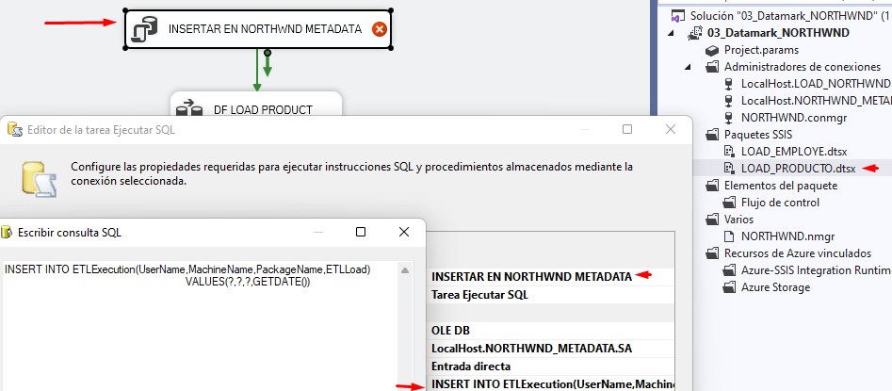

**ASIGNAR PARAMETROS**

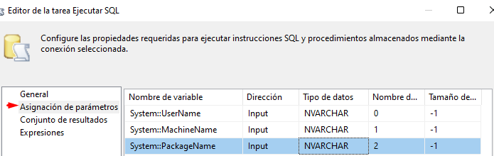

## OBTENER ID NORTHWND METADATA

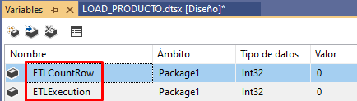

SELECT TOP(1) ID FROM ETLExecution

WHERE NombrePaquete=?

ORDER BY ID DESC

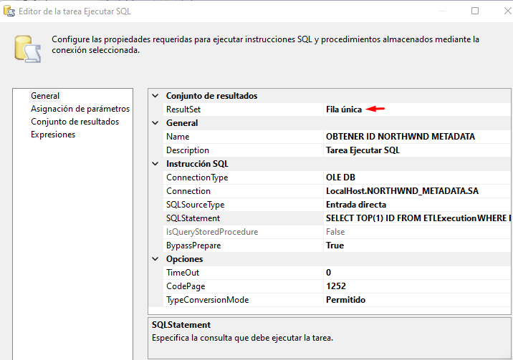

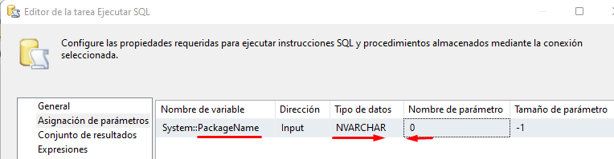

Resultados

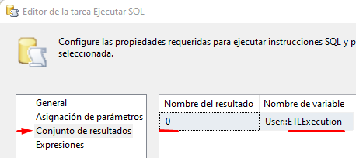

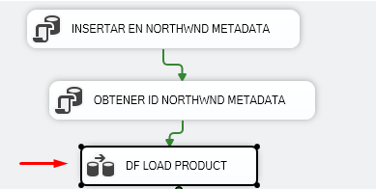

**ASIGNAR VARIABLE ETLEXECUTION**

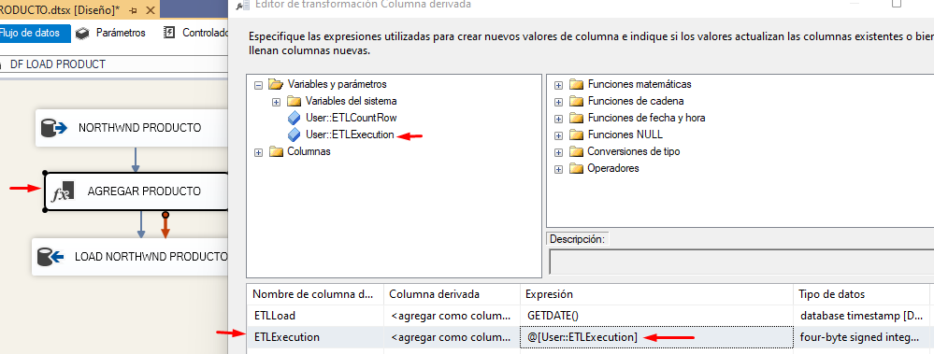

**CONTAR CANTIDAD FILAS**

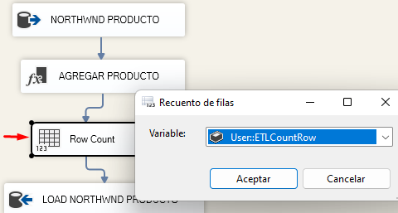

**PRE - EXECUTE**

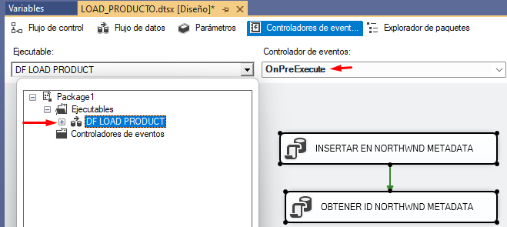

**POST – EXECUTE**

UPDATE ETLExecution

SET ETLCountRows=?

WHERE ID=?

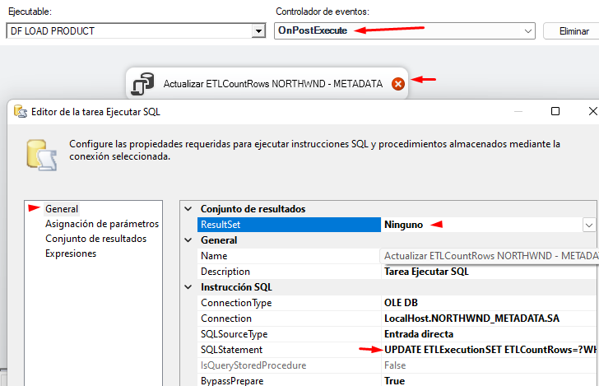

**ASIGNACION DE PARAMETROS**

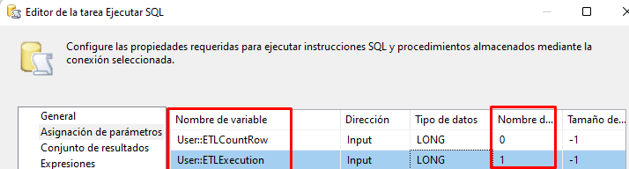

**EJECUCION**

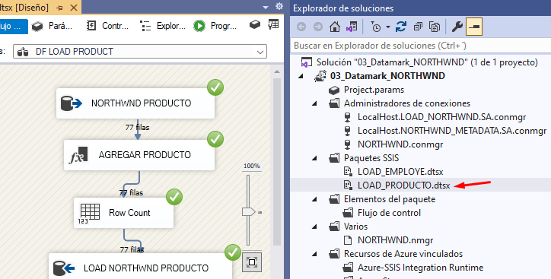

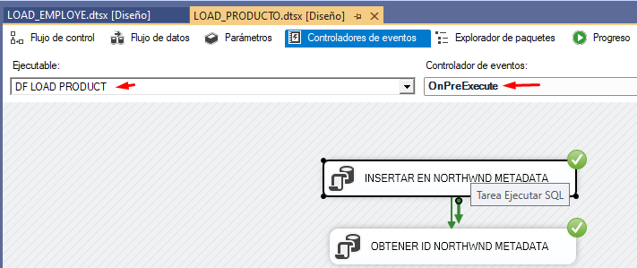

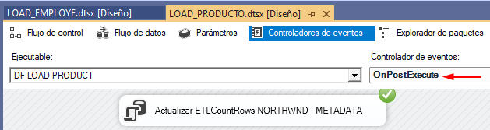

SELECT * FROM Products

ORDER BY ETLExecution DESC

SELECT * FROM [NORTHWND_METADATA].DBO.ETLExecution

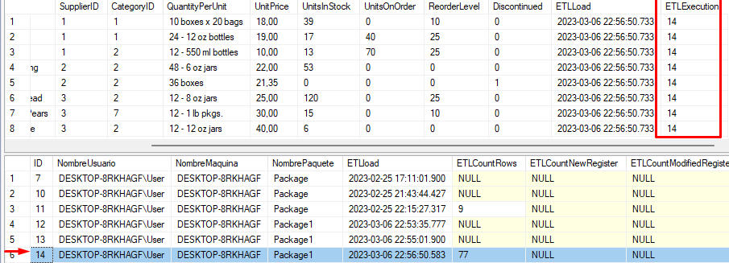

# CARGAR CATEGORIA

USE LOAD_NORTHWND GO

CREATE TABLE [dbo].[Categories](

[CategoryID] [int] NOT NULL,

[CategoryName] [nvarchar](15) NOT NULL,

[Description] [ntext] NULL,

[Picture] [image] NULL,

ETLLoad DATETIME,

ETLExecution int )

Copiar **Load_Producto** para load Categoría

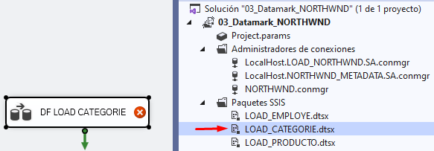

**CARGAR ORIGEN**

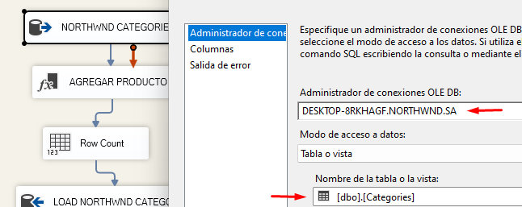

**VARIABLES**

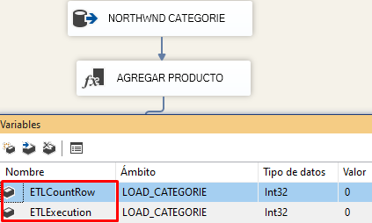

**MAPEAR DESTINO**

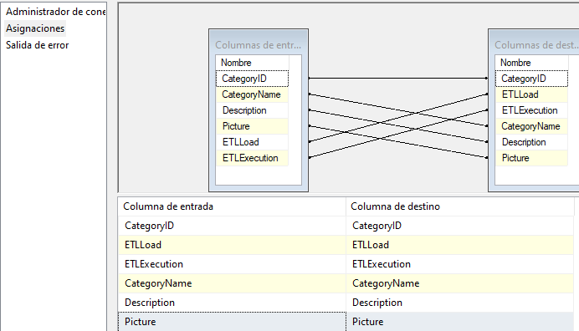

Se verifica los Eventos de Pre-Execute y Post-Execute.

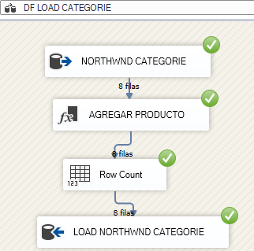

USE [LOAD_NORTHWND] GO

SELECT *

FROM [dbo].[Categories]

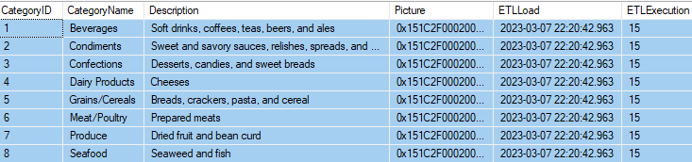

SELECT * FROM [NORTHWND_METADATA].DBO.ETLExecution

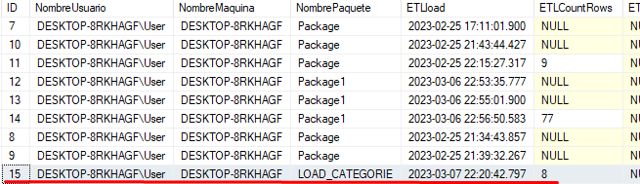

# CARGAR CUSTOMER

USE LOAD_NORTHWND GO

CREATE TABLE [dbo].[Customers](

[CustomerID] [nchar](5) NOT NULL,

[CompanyName] [nvarchar](40) NOT NULL,

[ContactName] [nvarchar](30) NULL,

[ContactTitle] [nvarchar](30) NULL,

[Address] [nvarchar](60) NULL,

[City] [nvarchar](15) NULL,

[Region] [nvarchar](15) NULL,

[PostalCode] [nvarchar](10) NULL,

[Country] [nvarchar](15) NULL,

[Phone] [nvarchar](24) NULL,

[Fax] [nvarchar](24) NULL,

ETLLoad DATETIME,

ETLExecution INT )

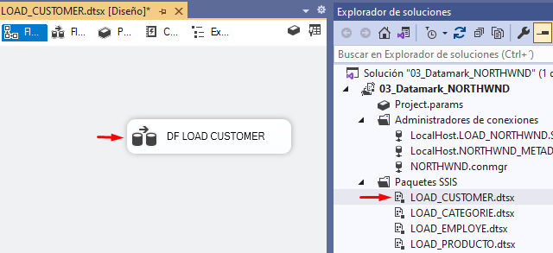

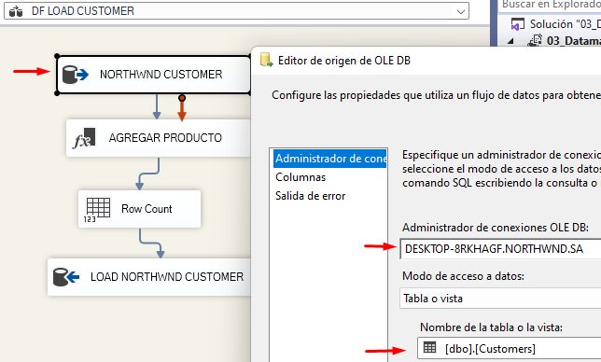

Seguir los pasos de crear variables y contar filas similares a **Cargar Productos**.

**MAPEAR VALORES**

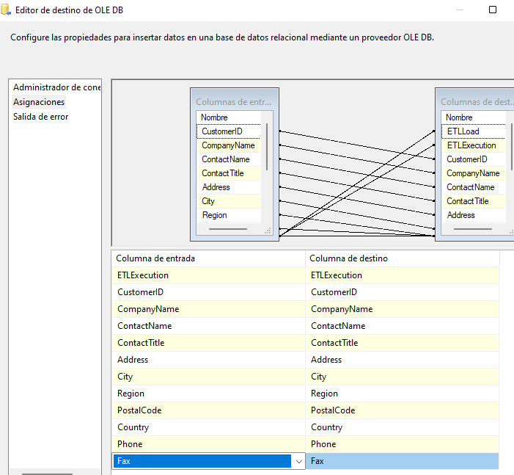

EJECUCION

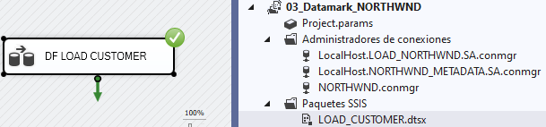

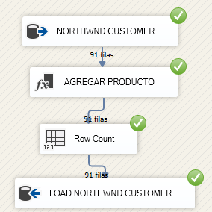

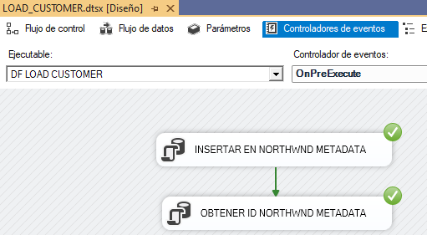

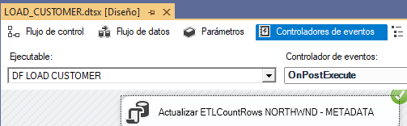

SELECT * FROM Customers

SELECT * FROM [NORTHWND_METADATA].[dbo].[ETLExecution]

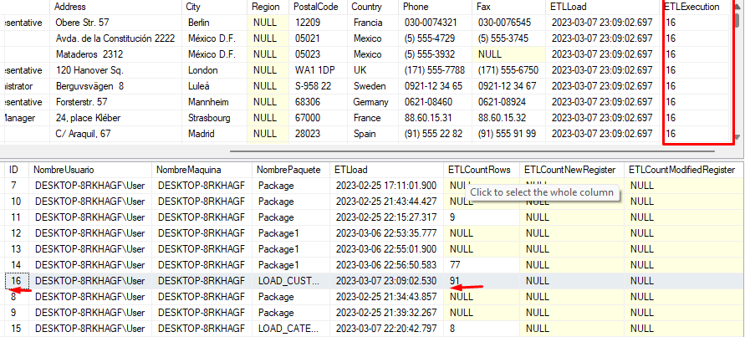

# CARGAR ORDER

USE LOAD_NORTHWND

CREATE TABLE [dbo].[Orders](

[OrderID] [int] NOT NULL,

[CustomerID] [nchar](5) NULL,

[EmployeeID] [int] NULL,

[OrderDate] [datetime] NULL,

[RequiredDate] [datetime] NULL,

[ShippedDate] [datetime] NULL,

[ShipVia] [int] NULL,

[Freight] [money] NULL,

[ShipName] [nvarchar](40) NULL,

[ShipAddress] [nvarchar](60) NULL,

[ShipCity] [nvarchar](15) NULL,

[ShipRegion] [nvarchar](15) NULL,

[ShipPostalCode] [nvarchar](10) NULL,

[ShipCountry] [nvarchar](15) NULL,

ETLLoad DATETIME,

ETLExecution INT )

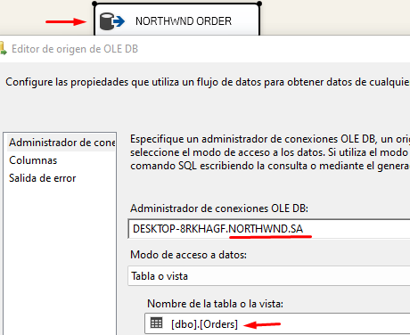

Seguir los pasos de crear variables y contar filas similares a **Cargar Productos**.

**MAPEAR VALORES**

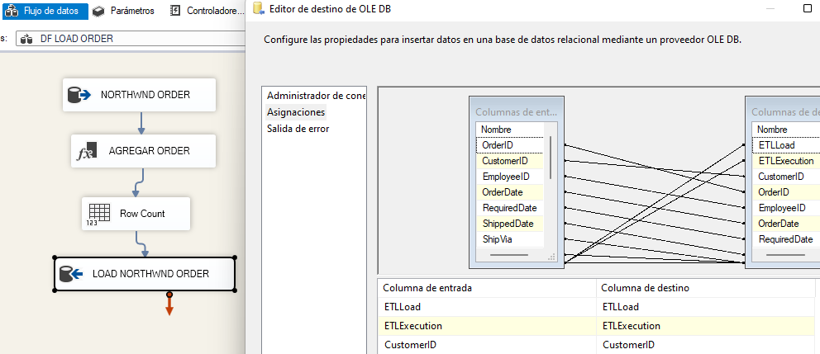

EJECUCION

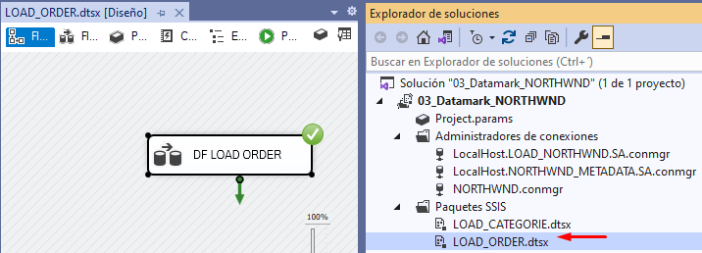

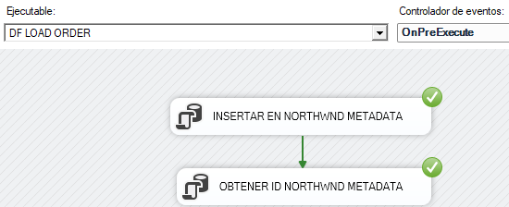

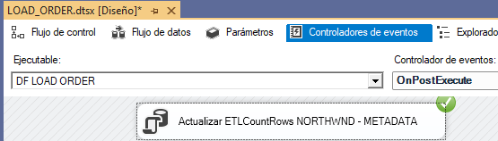

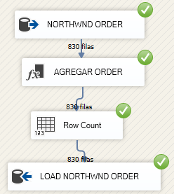

USE LOAD_NORTHWND

GO

SELECT * FROM Orders

SELECT * FROM [NORTHWND_METADATA].[dbo].[ETLExecution]

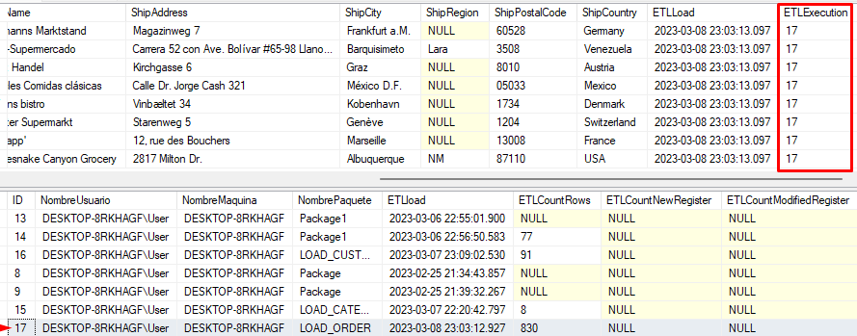

# CARGAR ORDER DETAIL

USE LOAD_NORTHWND GO

CREATE TABLE [dbo].[Order Details](

[OrderID] [int] NOT NULL,

[ProductID] [int] NOT NULL,

[UnitPrice] [money] NOT NULL,

[Quantity] [smallint] NOT NULL,

[Discount] [real] NOT NULL,

ETLLoad DATETIME,

ETLExecution INT )

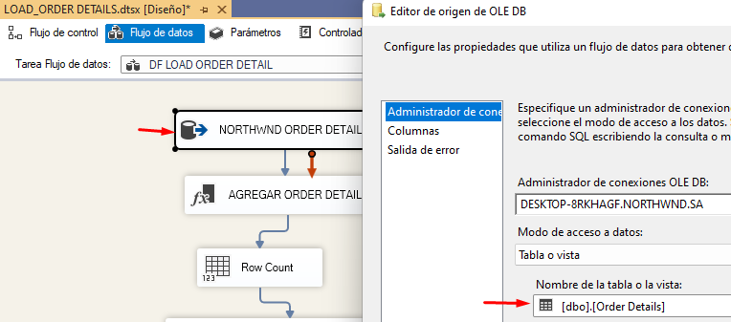

Seguir los pasos de crear variables y contar filas similares a **Cargar Productos**.

**MAPEAR VALORES**

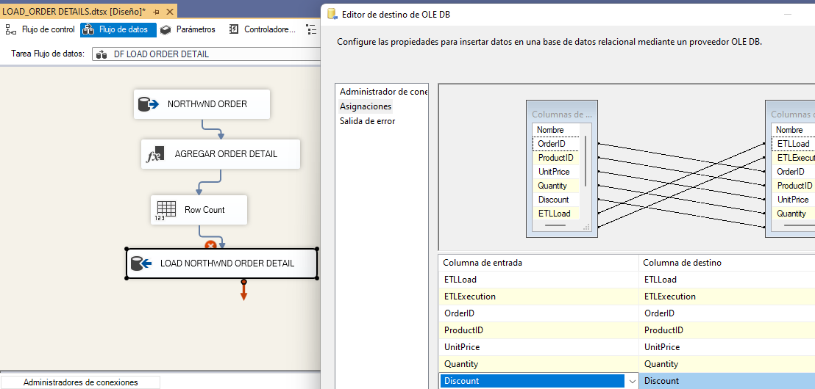

EJECUCION

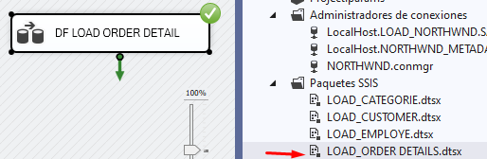

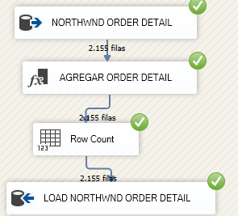

USE LOAD_NORTHWND

GO

SELECT * FROM [Order Details]

SELECT * FROM [NORTHWND_METADATA].[dbo].[ETLExecution]

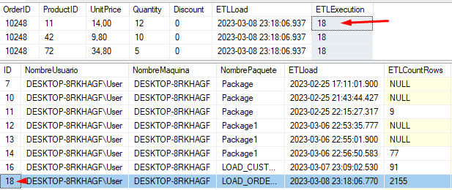

# CARGA LOAD MASTER

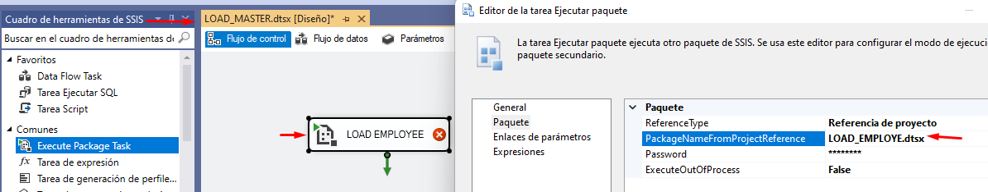

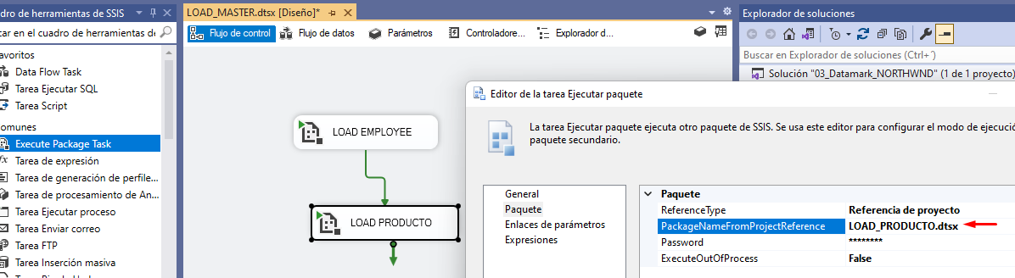

**CARGAR TODOS LOS PAQUETES VISTOS**

