Contenido

IMPLEMENTAR CARGA STAGE EMPLEADO 2

INSERTANDO REGISTRO EN EL METADATA 5

OBTENIENDO EL ULTIMO ID DEL METADATA 6

CONTROLADOR DE EVENTOS PRE-EXECUTE 7

OBTENER ULTIMO ETL EXECUTION 9

AGREGAR FILTRO EN EMPLEADO 10

IMPLEMENTAR CARGA STAGE PRODUCTO 11

ORIGEN 12

DESTINO STAGE NORTHWND PRODUCTO 13

INSERTAR REGISTROS EN NORTHWND METADATA 13

ASIGNAR PARAMETROS 14

OBTENER ID (NORTHWND_METADATA) 14

PRE-EXECUTE 15

POST-EXECUTE ACTUALIZAR ETL ROWCOUNT NORTHWND_METADATA 15

OBTENER ULTIMO ETL EXECUTION (BD LOAD_NORTHWND) 16

IMPLEMENTAR CARGA STAGE CATEGORIA 17

ORIGEN 17

IMPLEMENTAR CARGA STAGE CLIENTE 18

IMPLEMENTAR CARGA STAGE VENTAS 19

ORIGEN 19

Variables Nuevas 20

OBTENER ULTIMO ETL 20

DESTINO 21

IMPLEMENTAR CARGA STAGE TIEMPO 21

ORIGEN 21

OBTENER ULTIMO ETL 22

DESTINO 22

IMPLEMENTAR CARGA STAGE MASTER 23

# IMPLEMENTAR CARGA STAGE EMPLEADO

Crear Base de Datos **STAGE_NORTHWND**.

USE STAGE_NORTHWND

GO

CREATE TABLE [dbo].[Stage_Empleado](

[Empleado_Codigo] [int] NOT NULL,

[Empleado_Apellido] [varchar](40) NOT NULL,

[Empleado_Nombre] [varchar](20) NULL,

[Empleado_NombreCompleto] [varchar](70) NOT NULL,

[Empleado_Direccion] [varchar](120) NULL,

[Empleado_Ciudad] [varchar](15) NULL,

[Empleado_Region] [varchar](15) NULL,

[Empleado_Pais] [varchar](15) NULL,

[Empleado_Postal] [varchar](10) NULL,

[ETLLoad] [datetime] NULL,

[ETLExecution] [int] NULL )

**AGREGAR NUEVO PROYECTO**

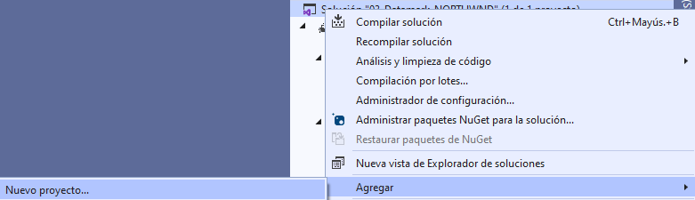



**ORIGEN DE DATOS**

SELECT [EmployeeID]

,CAST([LastName] AS VARCHAR(40)) AS LastName

,CAST([FirstName] AS VARCHAR(20)) AS FirstName

,(CAST([LastName] AS VARCHAR(40)) +', '+CAST([FirstName] AS VARCHAR(20))) AS Name

,CAST([Address] AS VARCHAR(120)) AS Address

,CAST([City] AS VARCHAR(15)) AS City

,CAST([Region] AS VARCHAR(15)) AS Region

,CAST([Country] AS VARCHAR(15)) AS Country

,CAST([PostalCode] AS VARCHAR(10)) AS PostalCode

FROM **[Load_Northwnd]**.[dbo].[Employees]

**AGREGAR COLUMNAS**

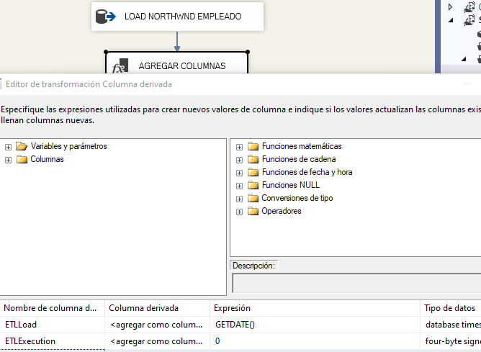

**CREAR VARIABLES**

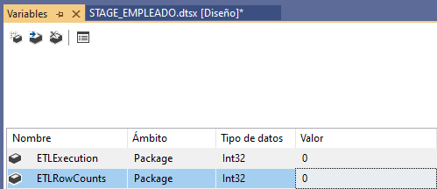

**ASIGNAR VARIABLES A AGREGAR PARAMETROS Y CONTAR FILAS**

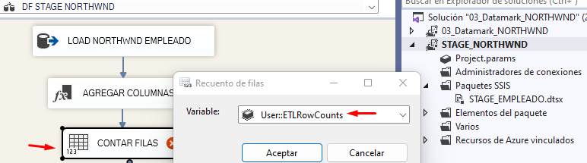

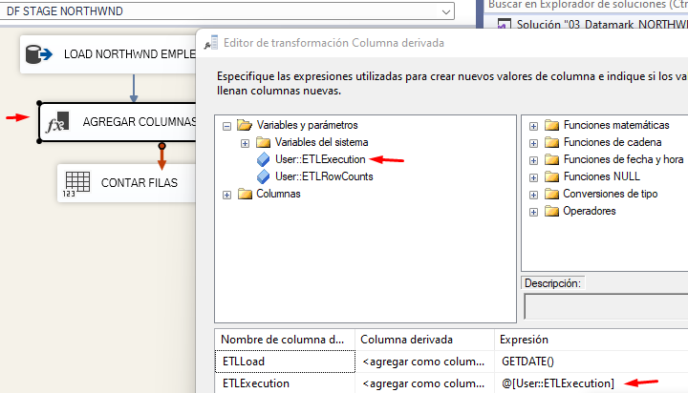

**NUEVA CONEXON A BASE DE DATOS STAGE NORTHWND**

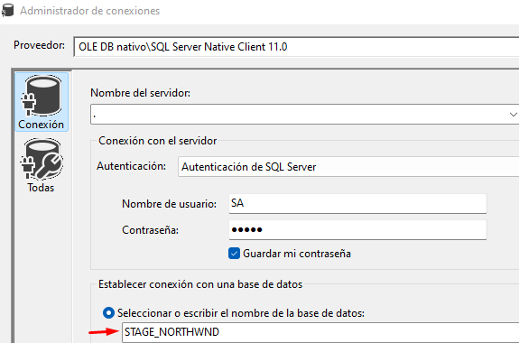

**MAPEAR CON STAGE EMPLEADO**

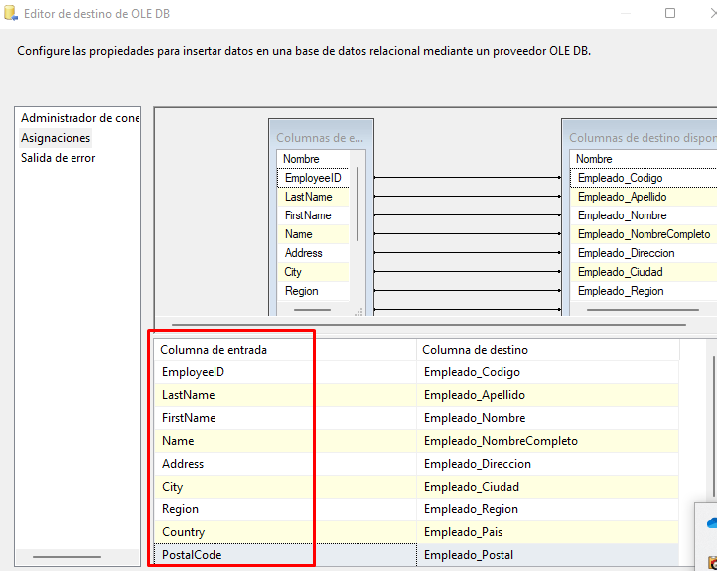

## INSERTANDO REGISTRO EN EL METADATA

INSERT INTO ETLExecution(NombreUsuario, NombreMaquina, NombrePaquete, ETLload)

VALUES (?,?,?,GETDATE())

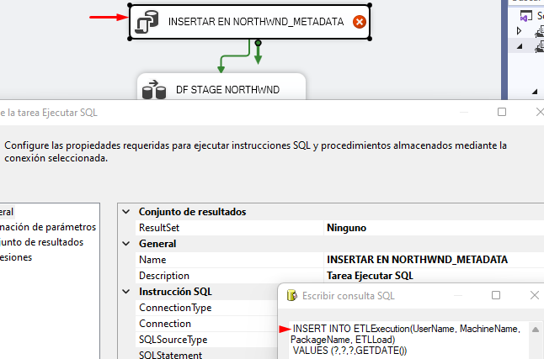

**ASIGNAR PARAMETROS**

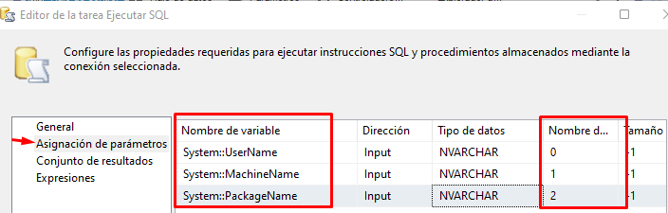

## OBTENIENDO EL ULTIMO ID DEL METADATA

SELECT TOP(1) ID FROM ETLExecution

WHERE NombrePaquete=?

Order By ID Desc

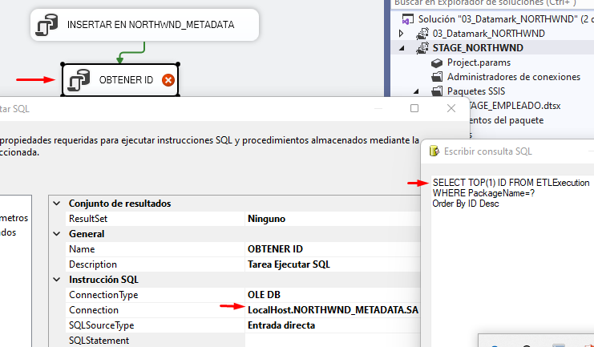

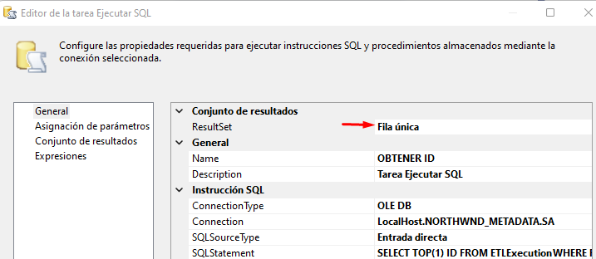

**ASIGNAR PARAMETROS**

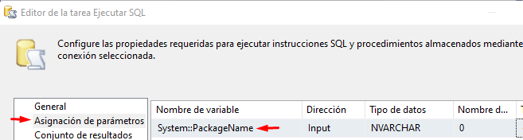

**CONJUNTO DE RESULTADOS**

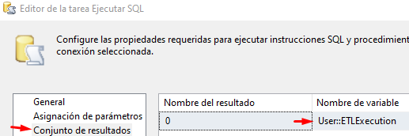

## CONTROLADOR DE EVENTOS PRE-EXECUTE

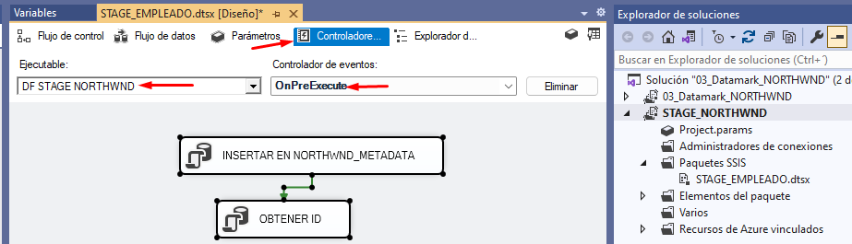

**ACTUALIZAR ETL ROWCOUNT NORTHWND_METADATA**

UPDATE ETLExecution

SET ETLCountRows=?

WHERE ID=?

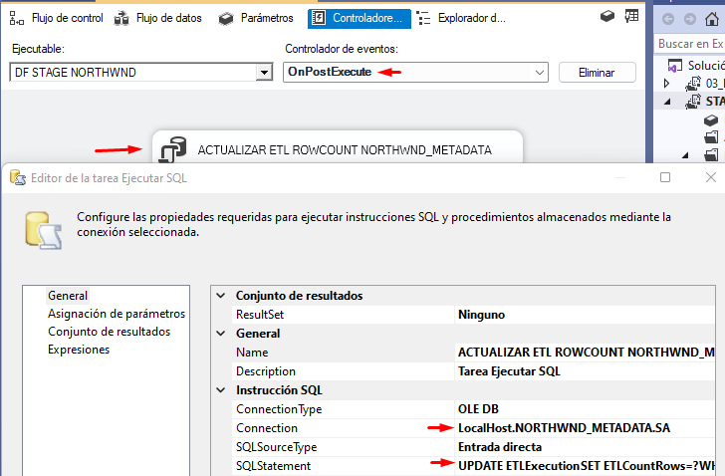

**ASIGNAR PARAMETROS**

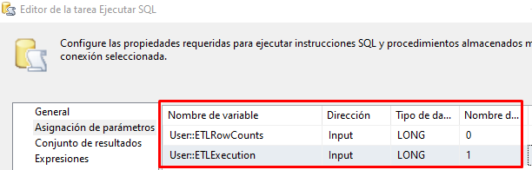

**LIMPIAR TABLA**

TRUNCATE TABLE [dbo].[Stage_Empleado]

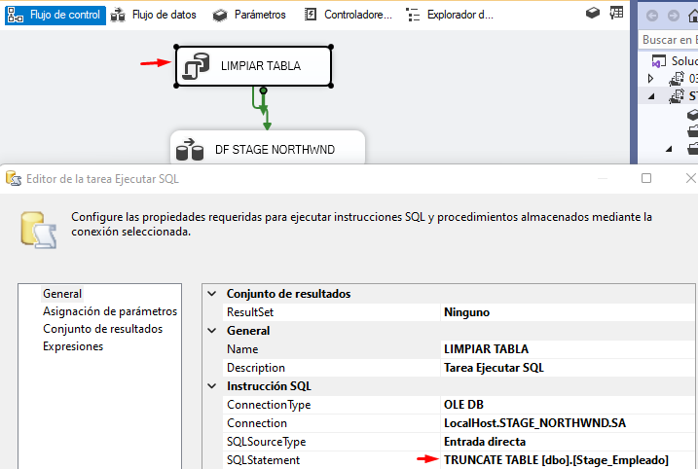

**CREAR VARIABLE**

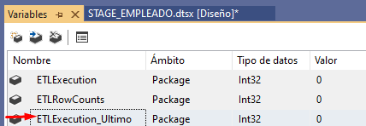

## OBTENER ULTIMO ETL EXECUTION

SELECT MAX(ETLExecution) FROM [LOAD_NORTHWND].[dbo].[Employees]

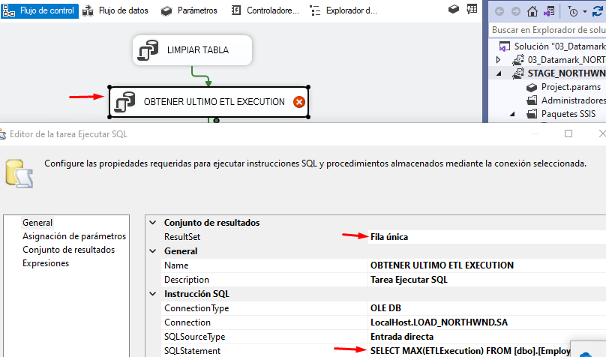

**ESTABLECER CONJUNTO DE RESULTADOS**

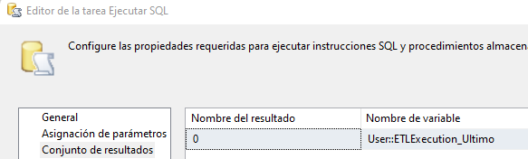

## AGREGAR FILTRO EN EMPLEADO

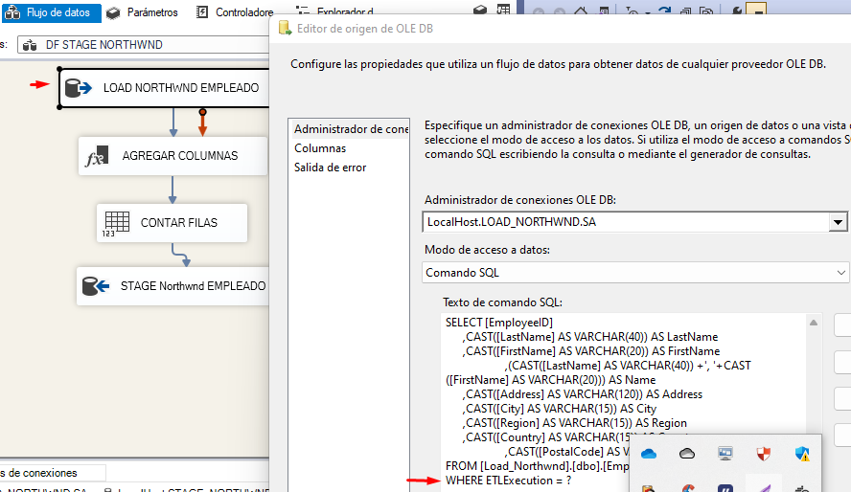

**AGREGAR PARAMETRO**

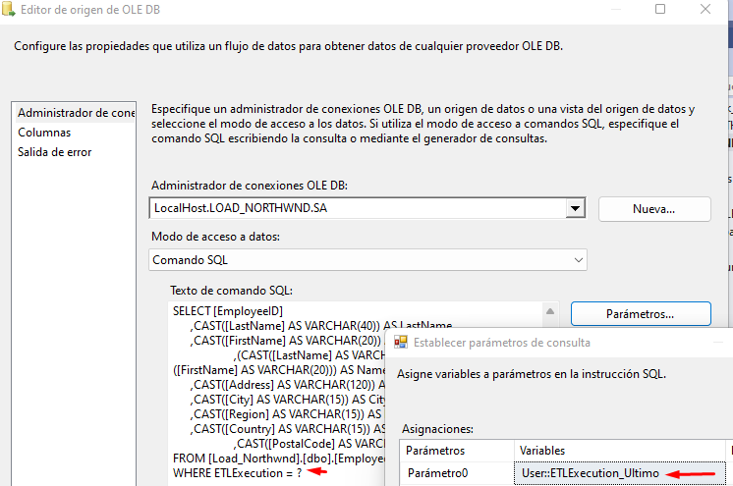

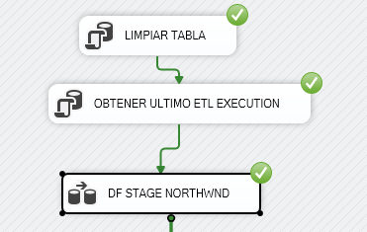

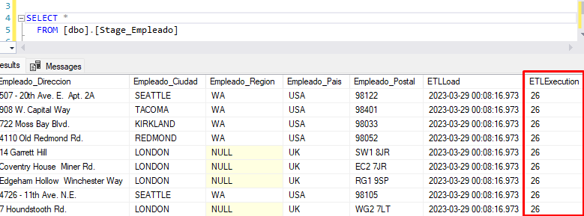

# IMPLEMENTAR CARGA STAGE PRODUCTO

USE STAGE_NORTHWND

GO

IF EXISTS(SELECT NAME FROM SYS.tables WHERE NAME='Stage_Producto')

BEGIN

DROP TABLE Stage_Producto

END

GO

CREATE TABLE [dbo].[Stage_Producto](

[Producto_Codigo] [int] NOT NULL,

[Producto_Nombre] [varchar](50) NOT NULL,

[Producto_PUnitario] [decimal](15, 2) NULL,

[CategoriaProducto_Codigo] [int] NOT NULL,

[ProveedorNombre] [varchar](40) NULL,

[ETLLoad] [datetime] NULL,

[ETLExecution] [int] NULL

)

GO

## ORIGEN

SELECT [ProductID]

,CAST([ProductName] AS VARCHAR(50)) AS ProductName

,CAST([UnitPrice] AS DECIMAL(15,2)) AS UnitPrice

,[CategoryID]

,'NORTHWND' Proveedor

FROM [Load_Northwnd].[dbo].[Products]

AGREGAR COLUMNAS

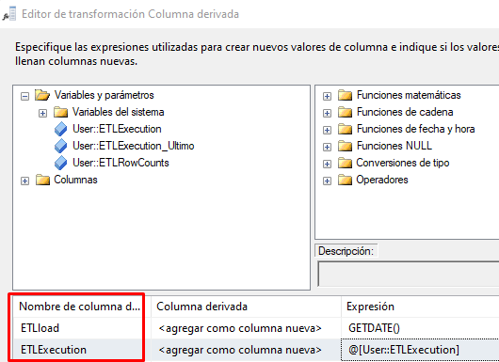

**CONTAR CANTIDAD FILAS**

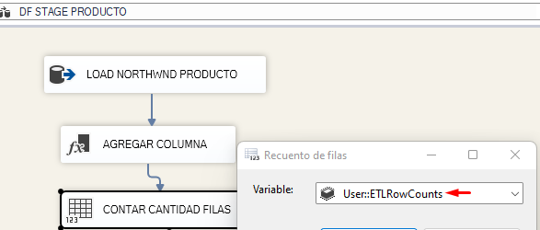

## DESTINO STAGE NORTHWND PRODUCTO

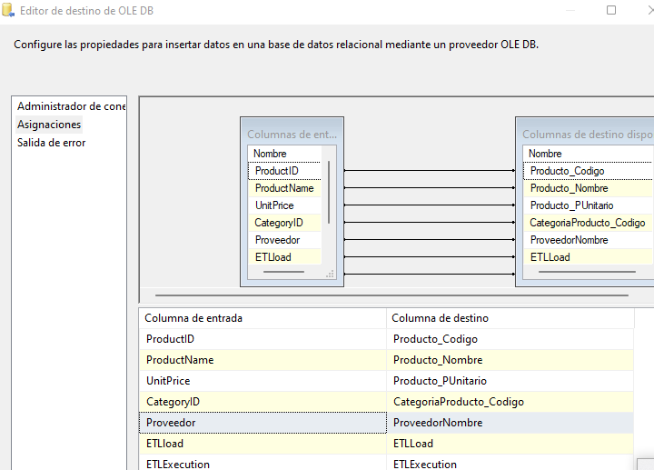

## INSERTAR REGISTROS EN NORTHWND METADATA

INSERT INTO ETLExecution(NombreUsuario, NombreMaquina, NombrePaquete, ETLload)

VALUES (?,?,?,GETDATE())

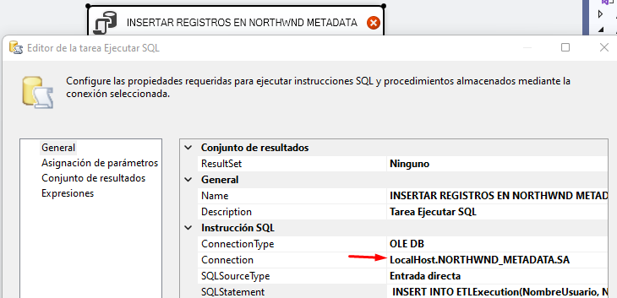

## ASIGNAR PARAMETROS

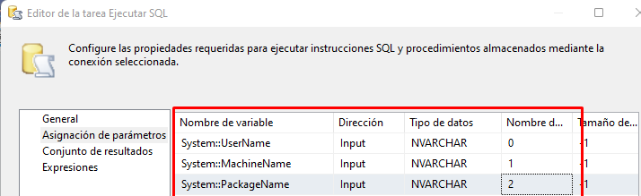

## OBTENER ID (NORTHWND_METADATA)

SELECT TOP(1) ID FROM ETLExecution

WHERE NombrePaquete=?

ORDER BY ID Desc

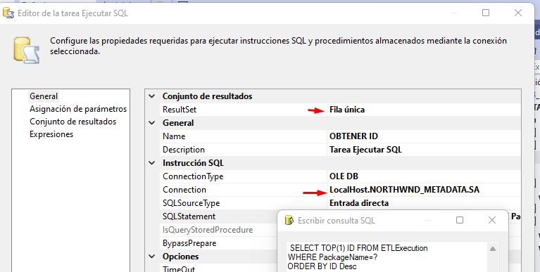

ASIGNAR PARAMETRO

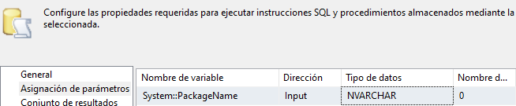

**CONJUNTO DE RESULTADOS**

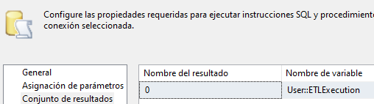

## PRE-EXECUTE

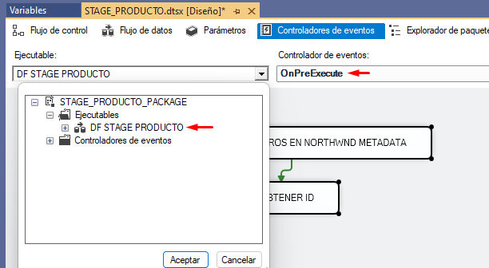

## POST-EXECUTE ACTUALIZAR ETL ROWCOUNT NORTHWND_METADATA

UPDATE ETLExecution

SET ETLCountRows = ?

WHERE ID = ?

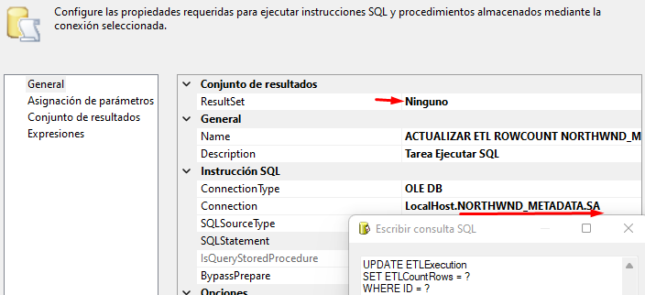

**ASIGNAR PARAMETROS**

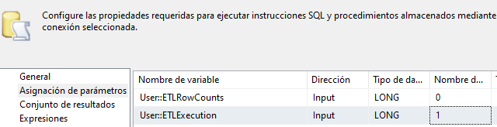

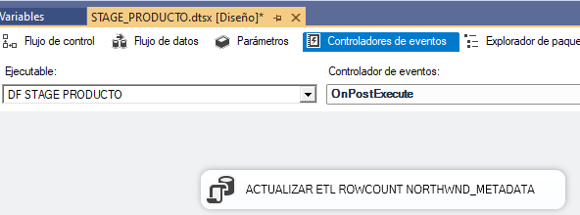

**LIMPIAR STAGE PRODUCTO**

TRUNCATE TABLE [dbo].[Stage_Producto]

## OBTENER ULTIMO ETL EXECUTION (BD LOAD_NORTHWND)

SELECT MAX(ETLExecution) FROM [LOAD_NORTHWND].[dbo].[Products]

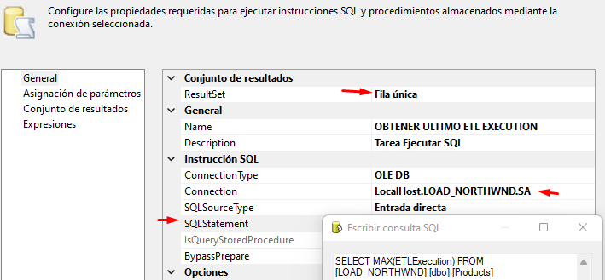

**ASIGNAR RESULTADO**

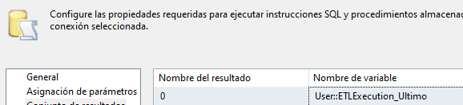

**ASIGNAR PARAMETRO EN QUERY ORIGEN**

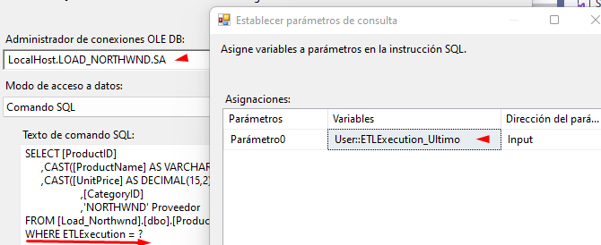

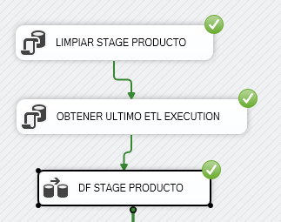

SELECT * FROM Stage_Producto

SELECT * FROM [LOAD_NORTHWND].[dbo].[Products]

SELECT * FROM [NORTHWND_METADATA].[dbo].[ETLExecution] ORDER BY 1 DESC

# IMPLEMENTAR CARGA STAGE CATEGORIA

## ORIGEN

USE STAGE_NORTHWND

GO

CREATE TABLE [dbo].[Stage_Categoria](

[Categoria_Codigo] [int] NOT NULL,

[Categoria_Nombre] [varchar](15) NOT NULL,

[ETLLoad] [datetime] NULL,

[ETLExecution] [int] NULL

) ON [PRIMARY]

**CONSULTAR BASE DE DATOS LOAD_NORTHWND**

SELECT [CategoryID]

,CAST([CategoryName] AS VARCHAR(15)) AS CategoryName

FROM [Load_Northwnd].[dbo].[Categories]

SELECT *

FROM [dbo].[Stage_Categoria]

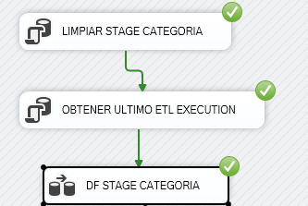

# IMPLEMENTAR CARGA STAGE CLIENTE

ORIGEN

USE STAGE_NORTHWND

GO

CREATE TABLE [dbo].[Stage_Cliente](

[Cliente_Codigo] [char](5) NOT NULL,

[Cliente_Nombre] [varchar](40) NOT NULL,

[Cliente_Compania] [varchar](40) NULL,

[Cliente_Direccion] [varchar](60) NULL,

[Cliente_Ciudad] [varchar](15) NULL,

[Cliente_Region] [varchar](15) NULL,

[Cliente_Pais] [varchar](15) NULL,

[Cliente_Postal] [varchar](10) NULL,

[ETLLoad] [datetime] NULL,

[ETLExecution] [int] NULL )

SELECT CAST([CustomerID] AS CHAR(5)) AS CustomerID

,CAST([CompanyName] AS VARCHAR(40)) AS CompanyName

,CAST([ContactName] AS VARCHAR(40)) AS ContactName

,CAST([Address] AS VARCHAR(60)) AS Address

,CAST([City] AS VARCHAR(15)) AS City

,CAST([Region] AS VARCHAR(15)) AS Region

,CAST([PostalCode] AS VARCHAR(10)) AS PostalCode

,CAST([Country] AS VARCHAR(15)) AS Country,ETLExecution

FROM [Load_Northwnd].[dbo].[Customers]

WHERE ETLExecution = 16

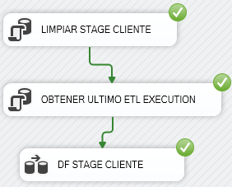

# IMPLEMENTAR CARGA STAGE VENTAS

## ORIGEN

USE STAGE_NORTHWND

GO

CREATE TABLE [dbo].[Stage_Ventas](

[Cliente_Codigo] [char](5) NOT NULL,

[Empleado_Codigo] [int] NOT NULL,

[Producto_Codigo] [int] NOT NULL,

[Ventas_OrderDate] [datetime] NOT NULL,

[Ventas_NOrden] [int] NOT NULL,

[Ventas_Monto] [decimal](15, 2) NOT NULL,

[Ventas_Unidades] [int] NOT NULL,

[Ventas_PUnitario] [decimal](15, 2) NOT NULL,

[Ventas_Descuento] [decimal](15, 2) NOT NULL,

[ETLLoad] [datetime] NULL,

[ETLExecution] [int] NULL )

SELECT O.OrderID,

CAST(O.CustomerID AS CHAR(5)) AS CustomerID,

O.EmployeeID,

OD.ProductID,

O.OrderDate,

CAST(((OD.UnitPrice * OD.Quantity) - OD.Discount) AS decimal(15,2)) AS Total,

OD.Quantity,

OD.UnitPrice,

OD.Discount

FROM [LOAD_NORTHWND].[dbo].[Orders] O INNER JOIN [LOAD_NORTHWND].[dbo].[OrderDetails] OD

ON O.OrderID = OD.OrderID

WHERE O.ETLExecution = ? AND OD.ETLExecution = ?

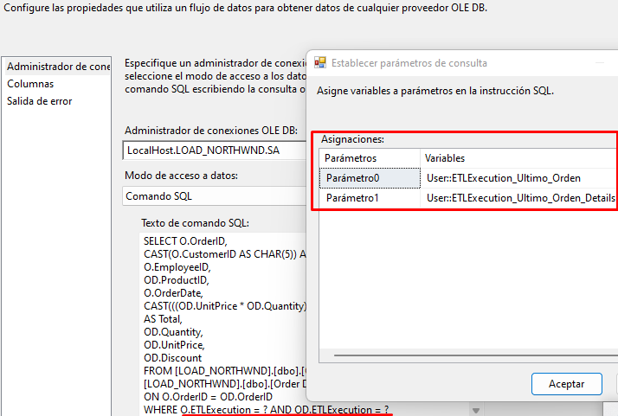

## Variables Nuevas

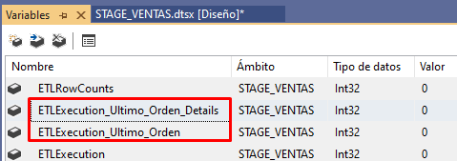

## OBTENER ULTIMO ETL

DECLARE @ETLExecutionOrder int

DECLARE @ETLExecutionOrderDetail int

SET @ETLExecutionOrder =(SELECT MAX(ETLExecution) FROM [LOAD_NORTHWND].[dbo].[Orders])

SET @ETLExecutionOrderDetail = (SELECT MAX(ETLExecution) FROM [LOAD_NORTHWND].[dbo].[Order Details])

SELECT @ETLExecutionOrder, @ETLExecutionOrderDetail

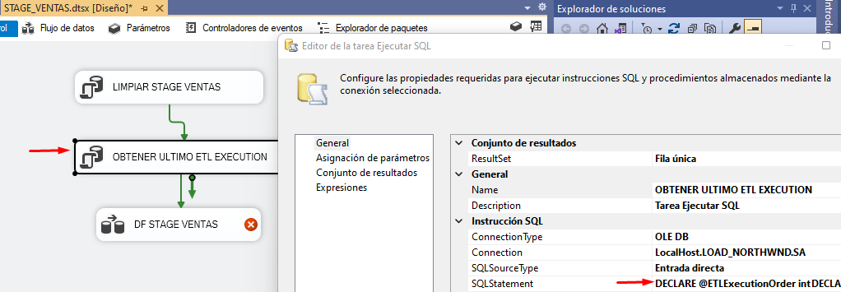

**CONJUNTO DE RESULTADOS**

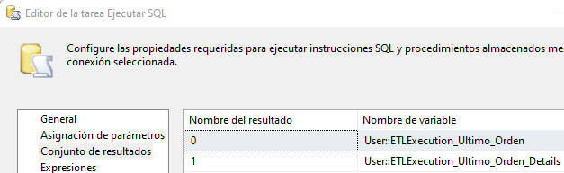

## DESTINO

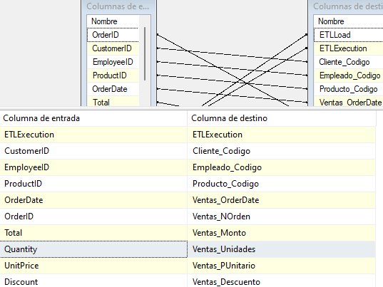

SELECT *

FROM [dbo].[Stage_Ventas]

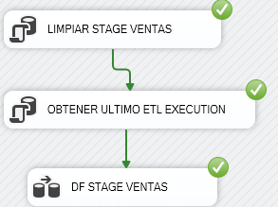

# IMPLEMENTAR CARGA STAGE TIEMPO

## ORIGEN

USE STAGE_NORTHWND

GO

CREATE TABLE [dbo].[Stage_Tiempo](

[Tiempo_Skey] [int] IDENTITY(1,1) NOT NULL,

[Tiempo_FechaActual] [datetime] NOT NULL,

[Tiempo_Anio] [int] NOT NULL,

[Tiempo_Trimestre] [int] NOT NULL,

[Tiempo_Mes] [int] NOT NULL,

[Tiempo_Semana] [int] NOT NULL,

[Tiempo_DiaDeAnio] [int] NOT NULL,

[Tiempo_DiaDeMes] [int] NOT NULL,

[Tiempo_DiaDeSemana] [int] NOT NULL,

[Tiempo_EsFinSemana] [int] NULL,

[Tiempo_EsFeriado] [int] NULL,

[Tiempo_Comentarios] [varchar](20) NULL,

[Tiempo_SemanaCalendario] [int] NOT NULL,

[Tiempo_SemanasDelAñoLaborales] [int] NOT NULL,

[Tiempo_AñoBisiesto] [tinyint] NOT NULL,

ETLLoad DATETIME,

ETLExecution INT )

SELECT Distinct(OrderDate),

YEAR(OrderDate) AS Anio,

DATEPART(QUARTER,OrderDate) as Trimestre,

DATEPART(MONTH,OrderDate) as Mes,

DATEPART(WEEK,OrderDate) as Semana,

DATEPART(DAYOFYEAR,OrderDate) as DiaDeAnio,

DATEPART(DAY,OrderDate) as DiaDeMes,

DATEPART(WEEKDAY,OrderDate-1) as DiaDeSemana,

IIF((DATEPART(WEEKDAY,OrderDate-1)=6 OR DATEPART(WEEKDAY,OrderDate-1)=7),1,0) AS EsFinSemana,

IIF((DATEPART(MONTH,OrderDate) = 6 AND DATEPART(DAY,OrderDate) = 29) OR

(DATEPART(MONTH,OrderDate) = 7 AND DATEPART(DAY,OrderDate) = 28) OR

(DATEPART(MONTH,OrderDate) = 7 AND DATEPART(DAY,OrderDate) = 29) OR

(DATEPART(MONTH,OrderDate) = 8 AND DATEPART(DAY,OrderDate) = 30) OR

(DATEPART(MONTH,OrderDate) = 10 AND DATEPART(DAY,OrderDate) = 8) OR

(DATEPART(MONTH,OrderDate) = 11 AND DATEPART(DAY,OrderDate) = 1) OR

(DATEPART(MONTH,OrderDate) = 12 AND DATEPART(DAY,OrderDate) = 8) OR

(DATEPART(MONTH,OrderDate) = 12 AND DATEPART(DAY,OrderDate) = 25)

,1,0) AS EsFeriado,

'1 -> (V) / 0 -> (F)' AS Comentarios,

DATEPART(WEEK,OrderDate) as SemanaCalendario,

DATEPART(WEEK,OrderDate) as SemanasDelAñoLaborales,

IIF(DATEPART(DAYOFYEAR,OrderDate) = 366, 1, 0) AS AñoBisiesto

FROM [LOAD_NORTHWND].[dbo].Orders

WHERE ETLExecution = ?

## OBTENER ULTIMO ETL

SELECT MAX(ETLExecution) FROM [LOAD_NORTHWND].[dbo].[Orders]

## DESTINO

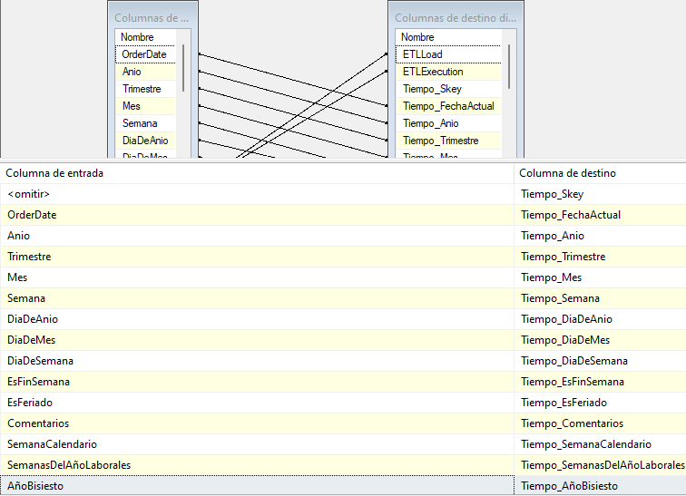

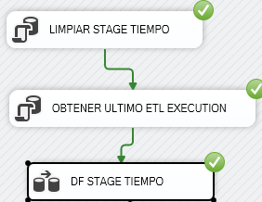

# IMPLEMENTAR CARGA STAGE MASTER

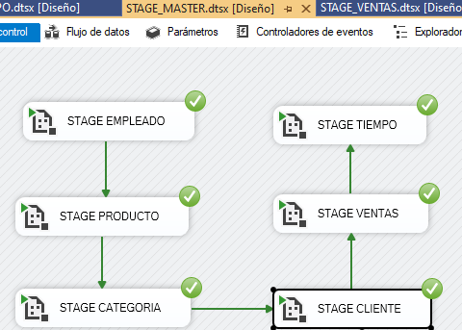

SELECT * FROM [NORTHWND_METADATA].[dbo].[ETLExecution] WHERE ID > 52

