HDMI 5 INCH TOUCH

User Manual

**Description**

5 inch Resistive Touch Screen LCD, HDMI interface, supports various systems

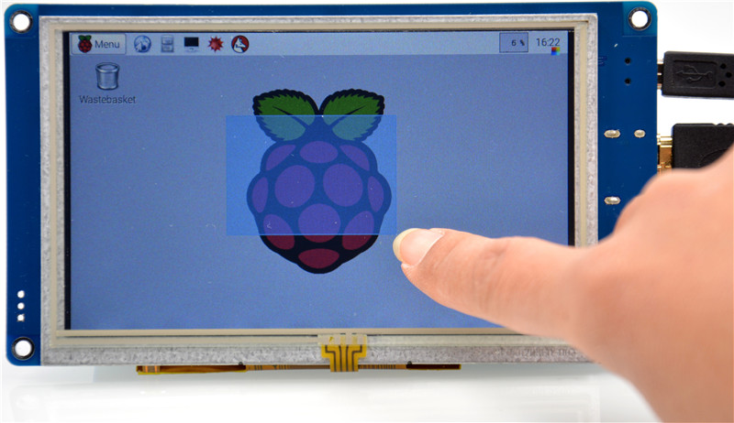

# Features

* 800×480 high resolution, touch control
* Supports Raspberry Pi,BeagleBone with free-driver
* Supports Windows / Mac / Ubuntu PC
* Supports Lubuntu, Android Media Box / MiniPC
* HDMI interface for displaying, USB interface for touch control
* ULP Back light

|  |  |
| --- | --- |
| **1.** | **On-Board resource** |

**Figure 1: Interfaces**

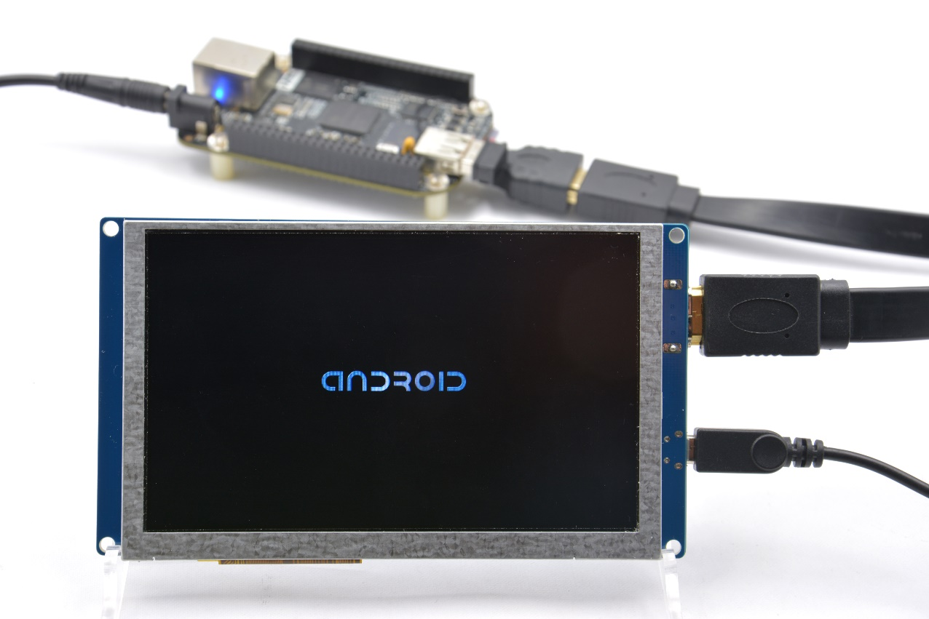

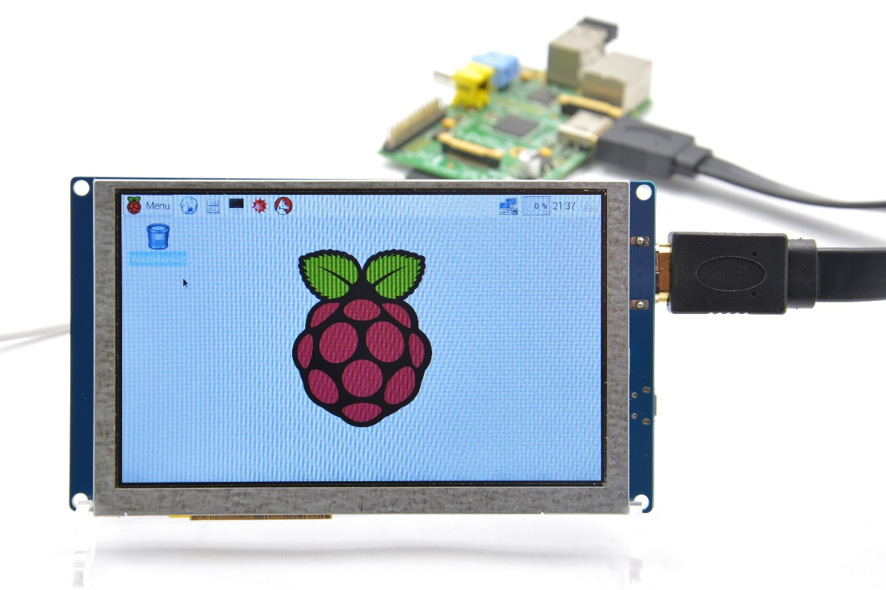

1. HDMI: it is used for connecting the main board to the LCD screen.
2. USB Touch Interface: USB touch/power interface.

|  |  |
| --- | --- |
| **2.** | **Working with Raspberry Pi** |
|  |  |
| 2.1. | Edit /boot/config.txt to change resolution |

# uncomment if you get no picture on HDMI for a default "safe" mode

#hdmi_safe=1

# uncomment this if your display has a black border of unused pixels visible

# and your display can output without overscan

#disable_overscan=1

# uncomment the following to adjust overscan. Use positive numbers if console

# goes off screen, and negative if there is too much border

#overscan_left=16

#overscan_right=16

#overscan_top=16

#overscan_bottom=16

# uncomment to force a console size. By default it will be display's size minus

# overscan.

#framebuffer_width=1280

#framebuffer_height=720

# uncomment if hdmi display is not detected and composite is being output

hdmi_force_hotplug=1

# uncomment to force a specific HDMI mode (here we are forcing 800x480!)

hdmi_group=2

hdmi_mode=1

hdmi_mode=87

hdmi_cvt 800 480 60 6 0 0 0

# uncomment to force a HDMI mode rather than DVI. This can make audio work in

# DMT (computer monitor) modes

#hdmi_drive=2

# uncomment to increase signal to HDMI, if you have interference, blanking, or

# no display

#config_hdmi_boost=4

# uncomment for composite PAL

#sdtv_mode=2

#uncomment to overclock the arm. 700 MHz is the default.

#arm_freq=800

# for more options see http://elinux.org/RPi_config.txt

|  |  |
| --- | --- |
| 2.2. | Hardware connection |

1. Connect the LCD to the HDMI on the Raspberry Pi board with a HDMI cable;
2. Connect the USB Touch interface on the LCD to the USB interface on the Raspberry Pi board with a USB type-A male to micro-B cable.

|  |  |
| --- | --- |
| 2.3. | Have fun. |

|  |  |
| --- | --- |
| **3.** | **How to use with PC** |

|  |  |
| --- | --- |
| 3.1. | Plug & Play |