______________________________________________________________________


______________________________________________________________________

TCP2101
ALGORITHM DESIGN AND ANALYSIS
Trimester 2, 2014/15
TC01/TT03

Question 4
Assignment Report

Comparative Analysis between Merge-Sort and Bucket-Sort

Lecturer
Sir Neoh Kee Lin

Tutor
Sir William Ban

Prepared by
Lim Wan Ping
1121119034

Report

Merge-sort is a sorting algorithm based on the divide-and-conquer paradigm. On an input sequence S with n elements, Merge-sort consists of three steps, that is to partition S into two sequences, recursively sort both sequences and lastly merge the sequences into a unique sorted sequence. It has the time complexity of O(n log n) in all cases.

Bucket-sort is a sorting algorithm that works by partitioning the sequence into a number of buckets. Each bucket is then sorted individually, and then merged back into the sorted sequence. Bucket-sort works as follows: Create empty buckets, move each element from the sequence into bucket, sort each non-empty bucket and finally gather all the elements back to original sequence. It has the time complexity of O(n+N) in average and best case, and O(n^2) in worst case.

From the experiment, the runtimes of the algorithms sorting numbers with three different orders and various sizes are summarised in the following tables.

Random order:

Array size | 10k | 50k | 100k | 500k | 1m | 10m | 50m | 100m
Merge-sort * | 0.00173841 | 0.010073 | 0.021511 | 0.16 | 0.284152 | 2.7667 | 17.9223 | 36.2469
Bucket-sort * | 0.0045789 | 0.0157608 | 0.0318427 | 0.188025 | 0.373549 | 3.92832 | 27.0239 | 54.1881

Ascending order:

Array size | 10k | 50k | 100k | 500k | 1m | 10m | 50m | 100m
Merge-sort * | 0.00128424 | 0.00616292 | 0.0135387 | 0.0724715 | 0.165479 | 1.88408 | 9.95482 | 22.6909
Bucket-sort * | 0.00191632 | 0.00967268 | 0.0154268 | 0.0692453 | 0.143457 | 1.53617 | 8.82104 | 18.0335

Descending order:

Array size | 10k | 50k | 100k | 500k | 1m | 10m | 50m | 100m
Merge-sort * | 0.00160156 | 0.00870105 | 0.0133988 | 0.0732285 | 0.149854 | 1.73185 | 9.97476 | 19.8174
Bucket-sort * | 0.00942635 | 0.0449315 | 0.0862091 | 0.498044 | 1.02997 | 12.3379 | 70.1367 | 154.986

* Runtime in seconds

The above data can be summed into three graphs as shown below.

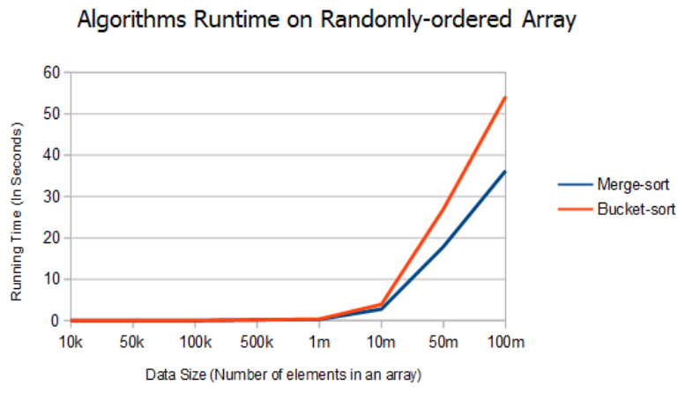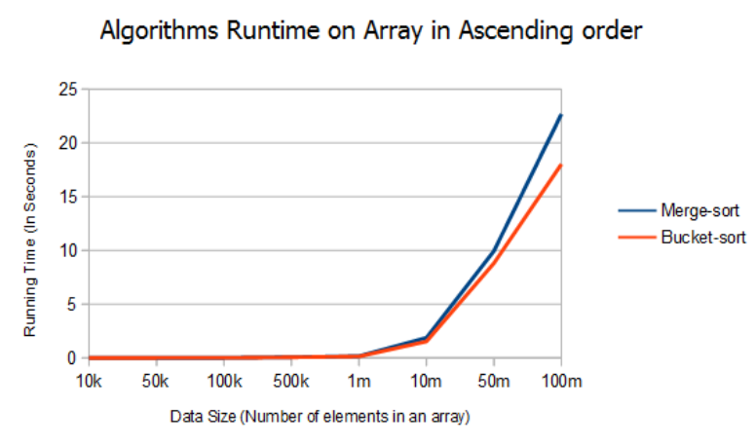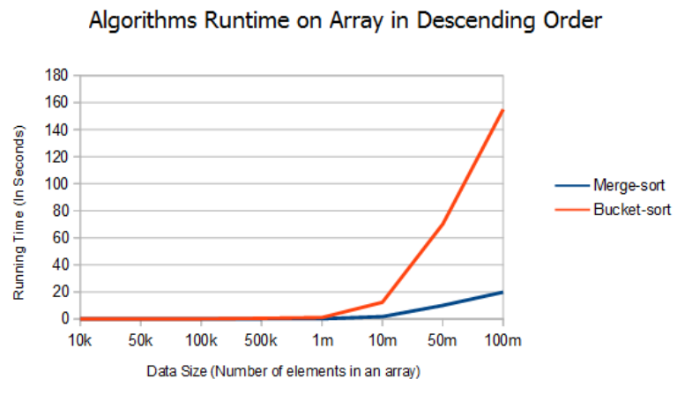

From the results, it can be seen that merge-sort is better than bucket sort in the cases where the numbers are in random order or descending order, while its performance on array in the ascending order is slightly slower than bucket-sort.

