William Mackay
MTH 337, Professor Adam Cunningham

Weekly Report 08
Introduction
This report explores the generation and applications of random numbers in science and mathematics. Random numbers are very useful in simulating systems with stochastic elements, function integration, and estimation, among other things. Unfortunately, because computers are deterministic systems, “random” numbers generated by a computer are only pseudo-random. This can lead to biases and errors. In order to better understand this phenomenon and its implications, two variants of a linear congruential generator were written in Python and their uniformity and pairwise correlation were compared against those of numpy's built-in rand function.
One of the important uses of random numbers is characterizing functions that are unknown but whose value at any x can be found. By evaluating the function at a large number of random points in an interval, the mean of the function on that interval can be found. In order to demonstrate this, a function “mysteryf” was evaluated at many x values generated using Python's rand function and then averaged.
Similarly, random numbers can be used to estimate the area of a curve. In polar coordinates, the area enclosed by a curve can be estimated by generating a large number of random points in a square enclosing the curve. The ratio of points inside the curve to the total number of points should give a good approximation of the curve's area relative to the area of the square circumscribed around it.
Random numbers can also be used to numerically simulate Bernoulli random variables, or random variables with two possible outcomes. In the Python script for this report, this principle is used to estimate the probability of getting exactly 29 out of 100 baseball hits when the probability of getting a hit is 29%.
The behavior of the sums of sets of random numbers is also examined in this report. In the python script for this report the sums of 2-8 random numbers are plotted on a histogram to examine their behavior as the number of sets in the sum increases. This is also done for several non-uniform sets of random numbers from a probability density function.
The last exercise covered in this report is a simulation of the stock market using random elements in a normal distribution. The simulation is run many times to determine the most likely outcome of investing money for 1 year in a volatile market and a less volatile market.
Approach
Part 1:
For this section of the Python script, two functions were written, RNG and randu. These functions are linear congruential generators. A linear congruential generator generates random numbers using a seed number k and applying the equation k = a·k mod m, then dividing the new k by m to get x_{k}, a pseudo-random number. a and m are typically very large numbers. In the case of RNG, a and m were 427419669081 and 999999999989, respectively. In the case of randu, a and m were 2¹⁶+3 and 2³¹, respectively.
Part 2:
The function mysteryf was averaged using the function mysteryf_mean. This function generated a sample of random numbers of size n (chosen by the user) using Python's rand function. The array had to be multiplied by 5 so that the numbers were in the interval [0,5] as opposed to [0,1]. A new array was then generated by evaluating the function at each random number. The array was then averaged to approximate the mean of the function on the interval [0,5] using numpy's mean function. The output of mysteryf was also plotted for a sample of random points in order to observe the shape of the function.
Part 3:
The function r=2+cos(7θ) was integrated in polar coordinates by generating a two large samples of random numbers in the range [-3,3] (x and y coordinates) and converting the pairs into polar coordinates (r and θ) to create a bounding square. The number of points inside the curve was determined by checking the r component against that of the function at the same value of θ from the random set of polar coordinates. The ratio of the number of points inside the function to the total points was multiplied by the total area of the bounding square to get the approximate area of the function.
Part 4:
In order to estimate the probability of scoring exactly 29 out of 100 hits in baseball when the probability of getting a hit is 29%, a function batting_trials was written. This function took as inputs the number of swings (100), number of hits (29), number of trials, and the probability of a hit (29%). It then generated an n by m array of random numbers where n was the number of trials and m was the number of swings in each trial. The number of hits in each trial were then summed and each trial in which the desired number of swings were hits was counted. The number of trials in which there were exactly 29 hits was then counted and divided by the total number of trials to get the probability.
Part 5:

Part 6:
For this part of the script, a function stock_sim was written that took as inputs the initial value of the stock, the time that was to be simulated, the growth rate (μ), the volatility (σ), and the number of trials. For the purposes of this simulation, the growth rate was set to 0. The volatility represented the effect of random variations on the price of stock and was initially set to 0.05. The price of stock at a given time step was calculated using the equation s_{i+1}=(1+μ+σε)s_{i}, where epsilon was a random number between 0 and 1 generated using numpy's normal function. This function generates normally distributed random number as opposed to a uniformly distributed random number. 5 trials of the simulation were plotted so that the behavior of the simulation could be observed. The final prices after a large number of trials were also averaged to obtain the expected value and plotted on a histogram. The probability of losing money was calculated by dividing the number of trials in which the final price was less than 1 by the total number of trials. These operations were also performed for a simulation with a more conservative value of σ (0.001).
Results
Part 1:
The following histograms and pairwise correlation plots were obtained from the RNG, randu, and rand functions.
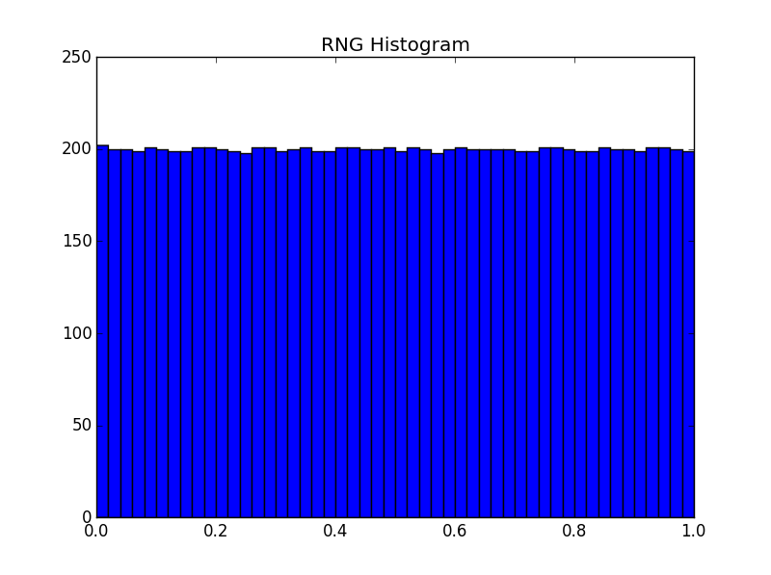Figure 1

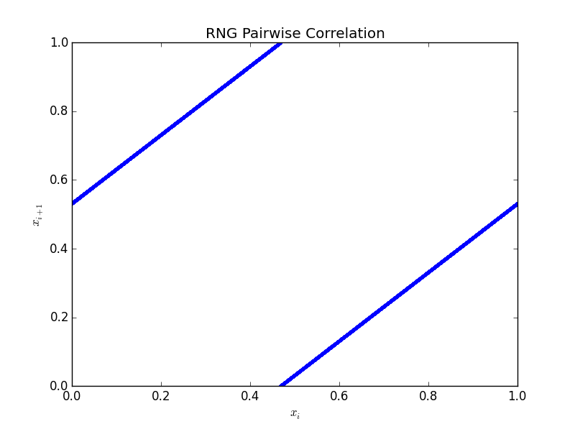Figure 2

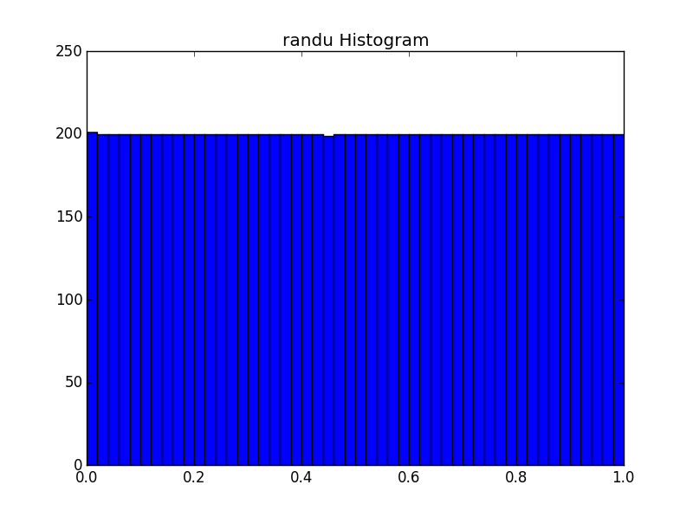Figure 3

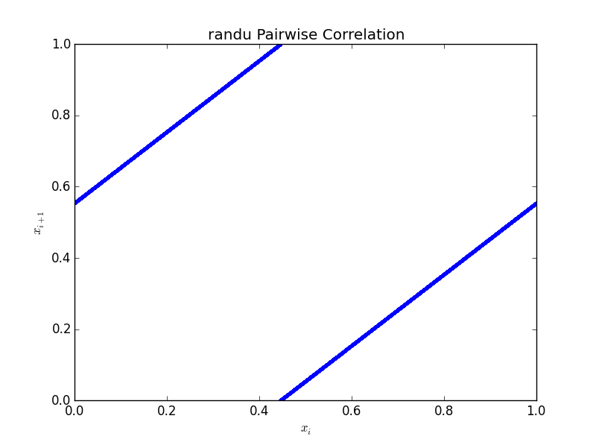Figure 4

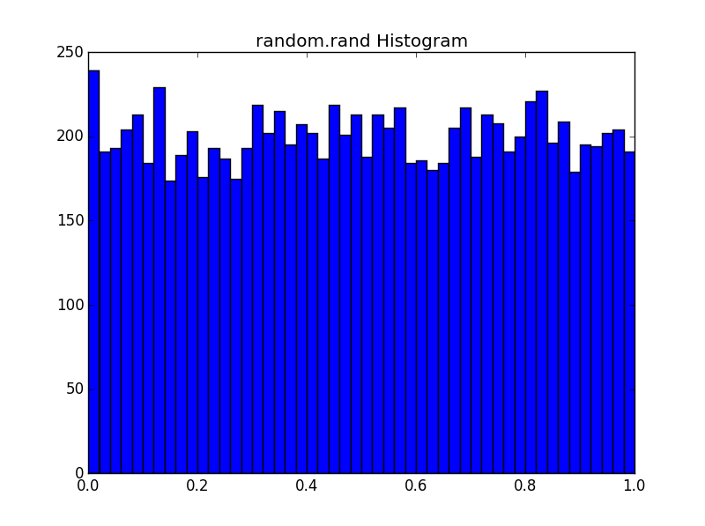Figure 5

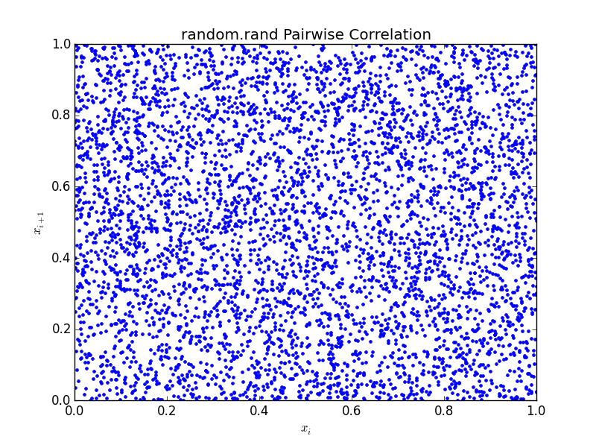Figure 6

Part 2:
The mean of the function mysteryf was approximately 68.0423813255 on the interval [0,5]. This varied by a few tenths over multiple runs. The plot of mysteryf for random inputs is shown in figure 7.
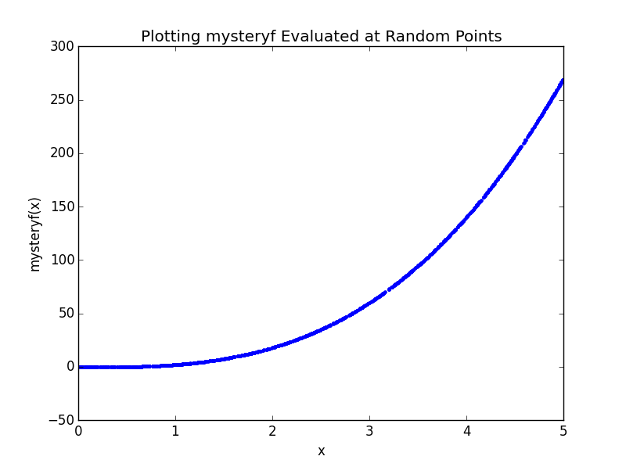Figure 7

Part 3:
The approximate area of the curve was 14.1012. This value varied by a few tenths on successive runs of the simulation. Figure 8 shows the curve and random points in the bounding square.
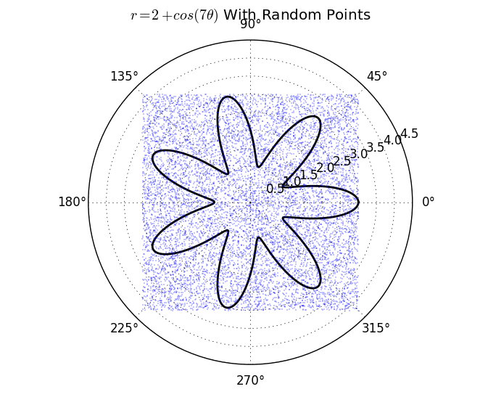

Part 4:
The probability of scoring exactly 29 hits in 100 swings is approximately 0.092. This value varied by a few thousandths on successive runs.
Part 5:
Part 6:
The probability of losing money when the σ was 0.05 was 0.6749. The expected value was 0.9979. When σ was 0.01, the probability of losing money and the expected value were 0.537 and 0.9999, respectively. Figure 12 is a plot of five different runs of stock_sim. Figures 13 and 14 are histograms of the final stock prices for both σ values.

