William Mackay
MTH 337, Professor Adam Cunningham

Weekly Report 01
Introduction
Pythagorean triples are sets of three integers a, b, and c, where a²+b²=c². These triples are unique because c² must be a perfect square in order for c to be an integer. Pythagorean triples, especially small ones such as {3,4,5}, can provide useful shortcuts when working on more complicated problems involving trigonometry. There is also a subset of Pythagorean triples, primitive Pythagorean triples, where the greatest common divisor of a, b, and c is one. Interestingly, multiples of primitive Pythagorean triples are also Pythagorean triples ({3,4,5} and {6,8,10}, for example). In order to better understand the mathematical nature and structure of Pythagorean triples, an algorithm was written in Python to generate all primitive Pythagorean triples for a and b between 1 and 5000.
Approach
A primitive Pythagorean triple must meet two conditions. First, the three integers must be relatively prime. Second, the sum of the squares of a and b must be a perfect square (c must be an integer). In order to test which pairs of numbers in the range 1 to 5000 met these criteria, two for-loops, one nested inside the other, were used to iterate through all possible combinations of a and b. The outer loop iterated through values of a while the inner iterated through values of b. In order to save time and avoid finding redundant triples, the second for-loop began at the previous value of a. Each combination was then tested using two functions written for this assignment. These functions were my_gcd, which found the greatest common divisor of two integers, and is_square, which determined whether or not an integer was a perfect square. If my_gcd(a,b) returned 1, then a and b were relatively prime and the script moved on to the next step, determining whether or not a²+b² was a perfect square. If is_square(a²+b²) returned 'True', then a, b, and c formed a primitive Pythagorean triple. These Pythagorean triples were then stored in an array and plotted.
my_gcd(a,b) determined the greatest common divisor of two integers by using the Euclidean algorithm. The function, when fed two integers, would subtract the smaller integer from the larger over and over until they were both equal. This algorithm is based on the premise that the greatest common divisor of {a, b}, where a>b, is the same as the greatest common divisor of {(a-b), b}. Once a and b have reached the same value, that value is the greatest common divisor. If that value is one, then a and b are relatively prime. is_square(n) was much simpler, and only tested whether the square root of the integer n was also an integer.
After all of the primitive Pythagorean triples were found, three plots were made in order to observe whatever patterns may be present. For each primitive triple ({a,b,c}), a vs. b, a vs. c, and b vs. c were plotted on three separate figures.
Results
The plots generated by the python script are shown below. It is important to not that, because of the way in which the script iterated through values of a and b, there should be no redundant triples. If there were, the plots would be mirrored about the a=b axis for figure 1, the a=c axis for figure 2, and the b=c axis for figure 3. In total, 890 unique primitive Pythagorean triples were found.
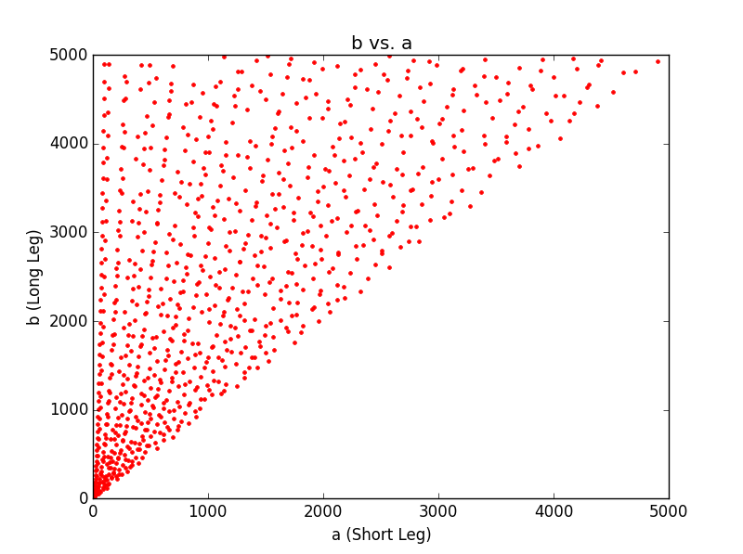Figure 1

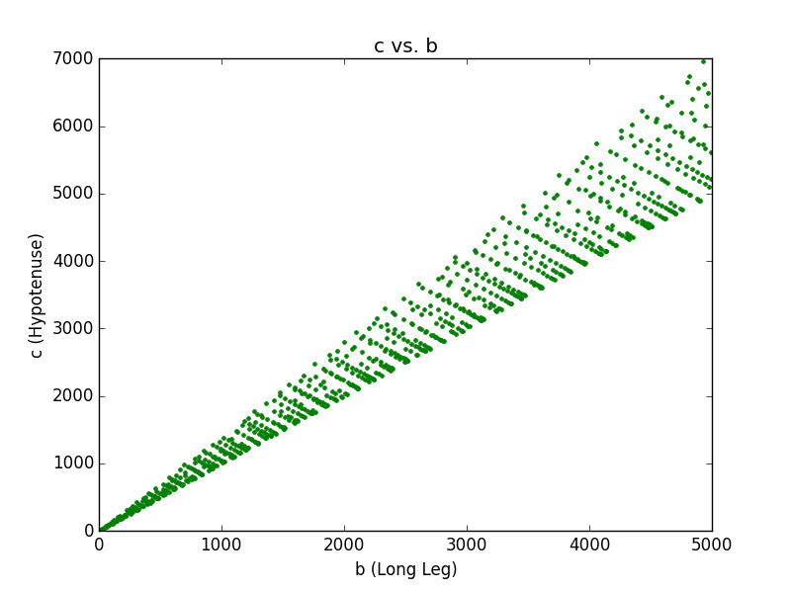Figure 2

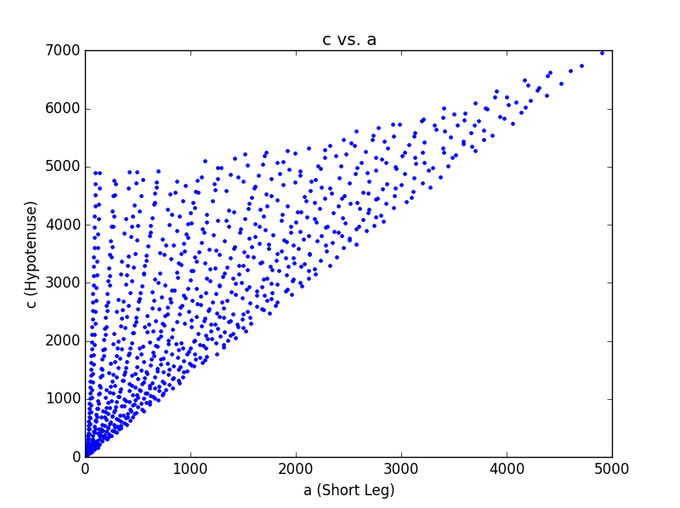Figure 3

Conclusion
There are several interesting trends present in the results generated by the Python code. When the legs of the primitive triples are plotted against each other (b vs. a), the points exhibit a parabolic pattern. More analysis would be needed to find the equations of the parabolas on which the points lie, but such an analysis would be beyond the scope of this report. When the c is plotted against b (hypotenuse vs. long leg), the points seem to fall on parallel lines. Upon closer examination, the lines are not all parallel but have similar slopes close to -1. The lines also almost always begin with triples where the hypotenuse is either 1 or 2 greater than the longest leg. When c is plotted against a, both trends appear to be present. Many of the points lie on both parabolas and lines of similar slope.
In the code that was written for this assignment, the inner for-loop iterated from the last value of the outer loop to save time and to make sure that only unique triples were found. If both loops had gone from 1 to 5000, the script would have taken significantly longer to run. Despite this, the code still took over a minute to run. This is because the algorithm took a “brute force” approach to finding triples. If both loops had iterated through the full range, this algorithm would have had to check 25000000 pairs, which is incredibly inefficient. Other, more efficient algorithms exist, such as using a ternary tree to generate primitive Pythagorean triples. There were also some smaller issues in the code that may have contributed to poor speed, such as dynamically adding values to storage arrays. The arrays containing the three values for each triple increased in size every time a new triple was discovered. It would have been more efficient to initialize arrays of some size and then change values as necessary, but this would have required knowing beforehand how many triples there were.

Python Code

#William Mackay, MTH 337, Fall 2015
#Finding Pythagorean triples for legs a and b between 1 and 5000

from pylab import *
ion

#Defining function to test whether or not a number 'n' is a perfect square
def is_square(n):
m=n**.5
if m%1==0:
return True
else:
return False

# MTH 337, Fall 2015
# Created by Adam Cunningham, 9th September 2015
def test_is_square(n):
'''Test the is_square function on all integers from 1 to n**2'''
# Keep track of the number of incorrect results
false_positives = 0
false_negatives = 0
for i in xrange(1, n):
# Check all integers in the interval [i**2, (i+1)**2 - 1]
start = i**2
# Check that the start of the interval is a perfect square
if not is_square(start):
false_negatives += 1
print "Fails for perfect square", start
# Check that the rest of the interval contains no perfect squares
for j in xrange(start+1, (i+1)**2):
if is_square(j):
false_positives += 1
print "Fails for non-perfect square", j
end = n**2
# Check that n**2 is a perfect square
if not is_square(end):
false_negatives += 1
print "Fails for perfect square", end
print '"is_square" returned', false_positives, "false positives,", false_negatives, "false negatives"
test_is_square(1000)

#Defining function to find the greatest common divisor of two integers
def my_gcd(a,b):
while a!=b:
if b>a:
(a,b)=(b,a)
a=a-b
return a

#Defining arrays for legs a and b
(a,b)=(range(1,5000),range(1,5000))
#Defining arrays to store legs and hypotenuses of pythagorean triples
(x,y,z)=([],[],[])

count=0
print "Progress: [",
#Finding the primitive pythagorean triples
for i in range(0,4999): #Outer loop from 1 to 5000
for j in range(i,4999): #Start inner loop from i to avoid redundant pairs
g=my_gcd(a[i],b[j])
if g==1: #If GCD is 1, then check that a**2+b**2 is a perfect square
n=(a[i]**2+b[j]**2)
m=n**.5
if is_square(n)==True: #If a**2+b**2 is a perfect square, then a,b,c is a primitive pythagorean triple
#Adding legs and hypotenuse of pythagorean triple to arrays x, y, and z
x.append(a[i])
y.append(b[j])
z.append(m)
count+=1
if i%50==0:
print ".", #a[i],b[j],m
print "]" " Done."

#Plotting figures
figure(0)
plot(x,y,'r.')
title('b vs. a')
xlabel('a (Short Leg)')
ylabel('b (Long Leg)')
draw()
figure(1)
plot(x,z,'b.')
title('c vs. a')
xlabel('a (Short Leg)')
ylabel('c (Hypotenuse)')
draw()
figure(2)
plot(y,z,'g.')
title('c vs. b')
xlabel('b (Long Leg)')
ylabel('c (Hypotenuse)')
draw()

#Printing number of primitive triples found
print count,"primitive Pythagorean triples were found."

show()
show()
show()

