**# Project introduction**

springboot+h2+swagger2+jpa+junit

**#Project build**

cd ~/transaction

mvn clean package (or install)

**#Api List**

--UI model

<http://127.0.0.1:8080/swagger-ui.html>

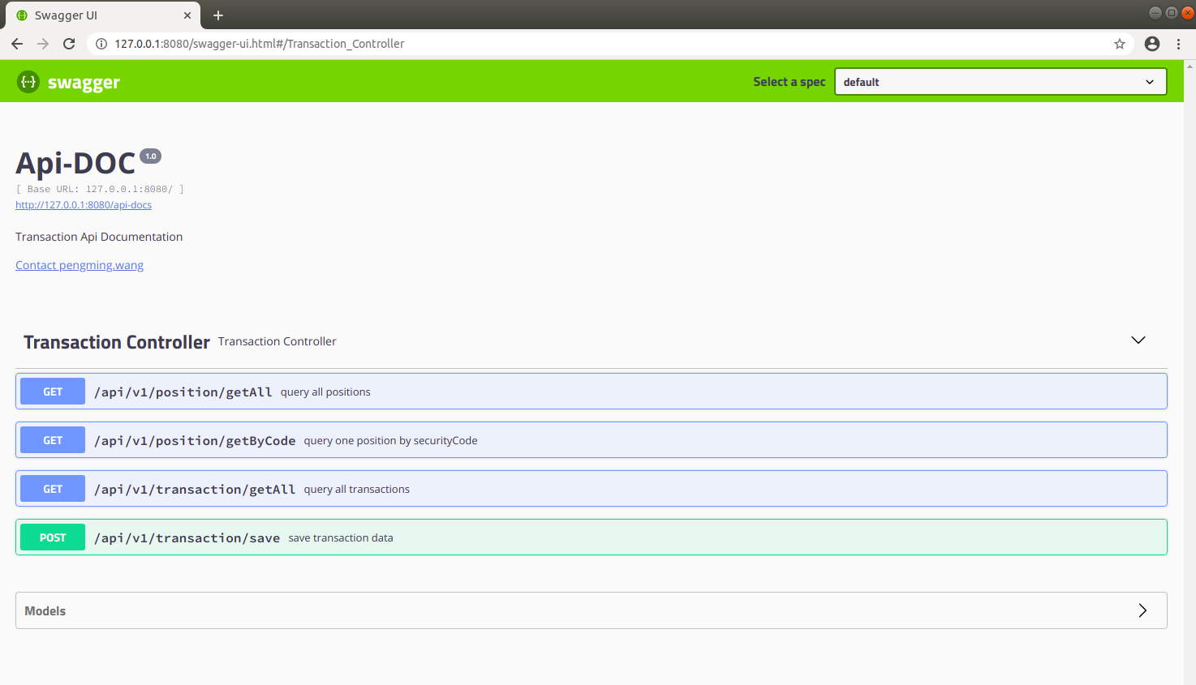

--Json model

<http://127.0.0.1:8080/api-docs>

**#Test - UT**

mvn clean package

or

Run TransactionControllerTest.java as JUnit Test in IDE.

**#Test - curl command( can get from swagger ui)**

*--Post example:add one transaction*

curl -w "\n" -H "Content-Type:application/json" -X POST -d '{"tradeId": 1,"version": 1,"securityCode": "REL","quantity": 50,"operationType": "INSERT","tradeType": "Buy"}' localhost:8080/api/v1/transaction/save

*--GET example:get all transactions*

curl -w "\n" -H "Content-Type:application/json" -X GET 127.0.0.1:8080/api/v1/transaction/getAll

**#Test - swagger-ui**

1. Add transaction with ‘/api/v1/transaction/save’

Choice api /api/v1/transaction/save

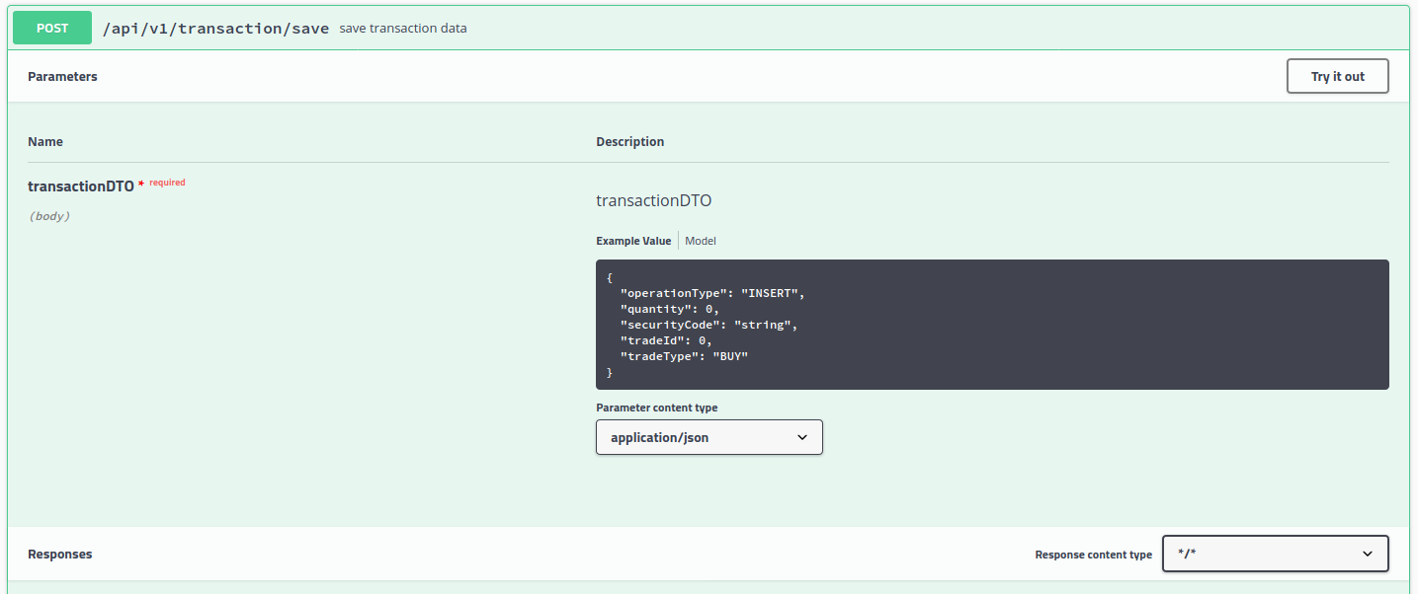

Point ‘Try it out’ and edit transactionDTO

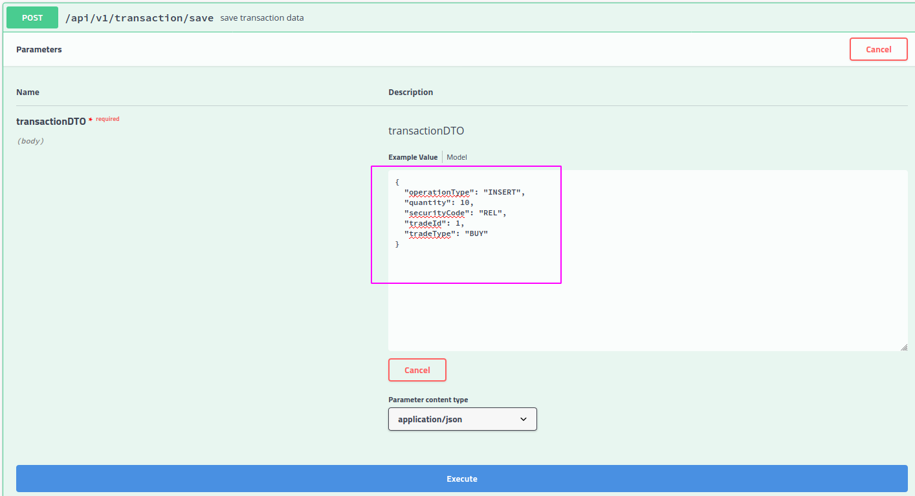

Point ‘Execute’ to send request

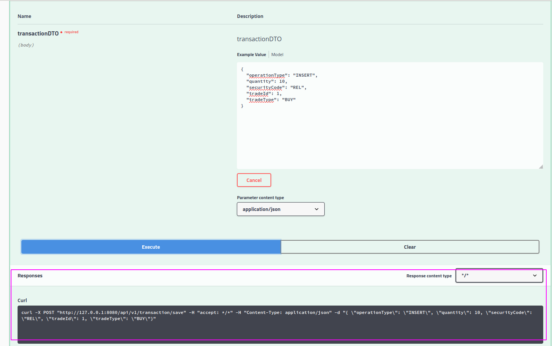

1. Query transaction with /api/v1/transaction/getAll

Choice /api/v1/transaction/getAll -> Try it out -> Excute

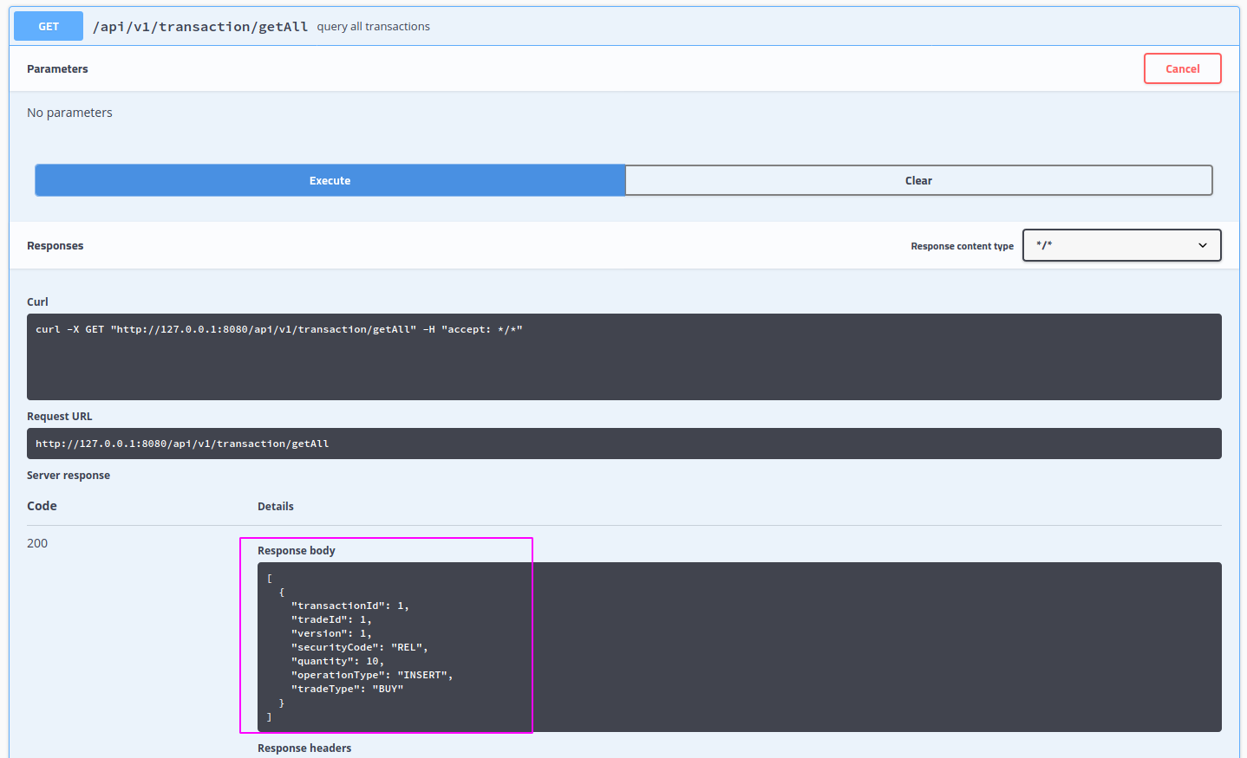

1. Add the same transaction with ‘/api/v1/transaction/save’( just execute again) will throw custom exception(error code is 1002)

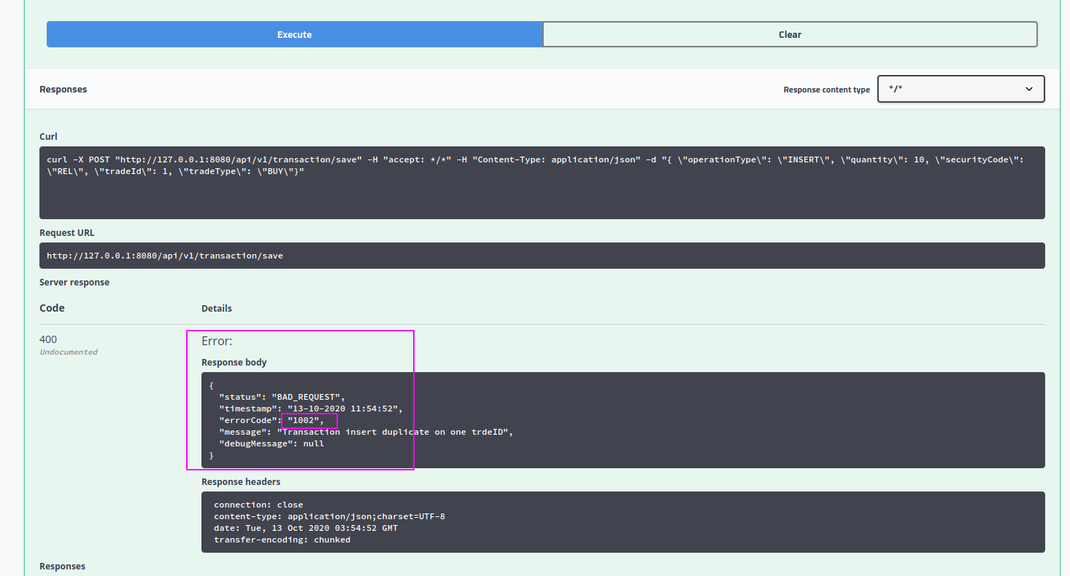

1. Query ‘Output’ of position with ‘/api/v1/position/getAll’

Choice /api/v1/position/getAll -> Try it out -> Excute

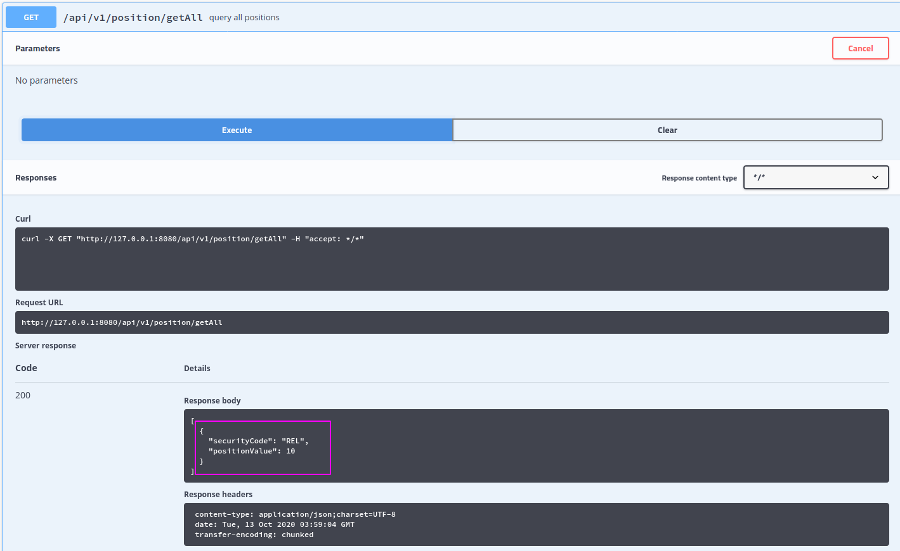

1. Add transactions of programmingTest then query the position:

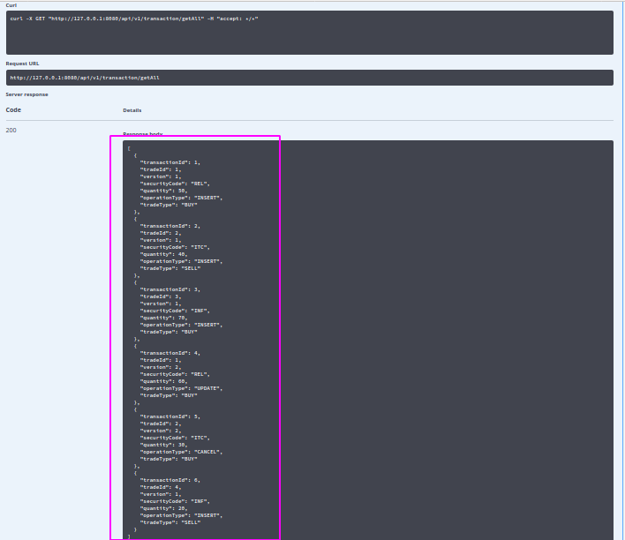

Output:

