Crossmark  RECEIVED  dd Month Year  REVISED  dd Month Year  ACCEPTED  dd Month Year  PUBLISHED  dd Month Year | ARTICLE TYPE  Tracking Forest Height Growth Over Time with ICESat-2 ATL08  Will Poncy¹, Valerie Thomas¹, Randolph Wynne^{1*}, P. Corey Greene¹, Phil Radtke¹, and Todd Schroeder²  ¹ Department of Forest Resources and Environmental Conservation, Virginia Tech, Blacksburg, VA USA  ² USDA Forest Service, Southern Research Station, Knoxville, TN USA  *Author to whom any correspondence should be addressed.  E-mail: wynne@vt.edu  Keywords: remote sensing, forests, LiDAR, ICESat-2  Abstract  Quantifying forest height growth over broad spatial scales is vital to conservation efforts that cross jurisdictional boundaries. In this research, we assessed whether forest height growth in eastern North Carolina can be estimated as well using ICESat-2 ATL08 data as it is from continuous forest inventory and analysis (FIA) plots. We first assured that the ICESat-2 data in the study area are suitable by (1) checking to see whether canopy heights from ATL08 align with canopy heights measured with airborne laser scanning data in the study area and (2) ensuring that canopy heights across different ICESat-2 segments are practically equivalent. We then assessed the change in mean canopy heights from 2020 to 2024 using 17,358 ICESat-2 segments and 252 FIA plots, and determined whether the ICESat-2-derived mean height growth was within the confidence interval of the FIA-derived mean height growth. ATL08 canopy heights compare well to near-coincident airborne laser scanning data, with an RMSE of 2.7 m. ICESat-2 canopy heights were equivalent within 1 m across segment locations from 2020 to 2024. FIA-assessed growth was 1.95 m with a confidence interval of 1.82 to 2.10 m. ICESat-2 ATL08-assessed growth was 1.87 m, which is within the confidence interval of the FIA-assessed growth. However, even with the large number of ICESat-2 segments, the confidence interval is very large, 0.51 to 3.42 m, since the segments are not paired plots. In this and possibly similar study areas, ICESat-2 could be used to estimate forest growth without being constrained to continuous forest inventory remeasurement periods. Use of mid-latitude repeat track pointing on ICESat-2 would enable paired plots. Most importantly, countries or regions lacking nationwide forest management programs might be able to assess forest height growth using spaceborne lidar data.  1. Introduction  Forest height is a fundamental descriptor of forest structure, and a key variable in calculations of forest biomass and carbon stock (Lang et al., 2023; Zhou et al., 2023). Changes in forest height over time can indicate the presence of, and recovery from, disturbance events (Dubayah et al., 2010; Gautam et al., 2025; Pellissier-Tanon et al., 2024). Tracking changes in forest height over time is crucial for effective forest management and robust forest ecosystem modelling (Battison et al., 2024; Dempewolf et al., 2017; Mitchell et al., 2023).  Common protocols for tracking forest height growth have their respective shortcomings. Continuous field inventory programs are rare and labor intensive, while airborne laser scanning is financially prohibitive to repeat collection (Battison et al., 2024; Hancock et al., 2021; Li et al., 2024). Often, researchers want to track forest height growth during a timeframe that does not coincide with remeasurement dates from these data sources, or in regions without representative reference data.  Spaceborne LiDAR missions have gathered forest structural measurements at regional and global scales by sampling earth’s surface during continued orbit throughout time (Dubayah et al., 2020; Liu et al., 2019; Markus et al., 2017). However, the lack of spatial coincidence, geolocation error, and previously reported high error margins might preclude detection of forest height growth in spaceborne LiDAR data (Fernandez-Diaz et al., 2022; Shannon et al., 2024; Yu et al., 2024). The question remains whether spaceborne LiDAR can reliably detect forest height growth over time when and where other data sources are not available—especially valuable for countries or regions without strong, continuous forest inventory programs (Li et al., 2022; Malambo and Popescu, 2021).  In this research, we used multiple years of ICESat-2 data to track forest height growth in a coastal region of North Carolina. We validated canopy height measurements obtained by ICESat-2 against airborne laser scanning, and used equivalence testing to assess homogeneity of forest conditions across ICESat-2 tracks. We then compared ICESat-2-derived canopy height growth against that from coincident field inventory data. This research serves as a proof-of-concept for using spaceborne LiDAR data to track forest height growth over time.  2. Materials & Methods  2.1. Study Area  Hurricane Florence made landfall in coastal North Carolina on September 14th, 2018 (Callaghan, 2020). It brought record-breaking levels of rain, causing an estimated $16-44 billion in damages to public and private infrastructure (Griffin et al., 2020; Paul et al., 2019). In response, the USGS 3D Elevation Program (3DEP) collected high-resolution elevation data to quantify the extent of hurricane damage and support infrastructure recovery efforts (Hinck and Stachyra, 2019). The study area of this research is defined as the collective boundary of the 3DEP Hurricane Florence airborne laser scanning projects (Figure 1), comprising ~5.1 million hectares in the Eastern region of North Carolina.  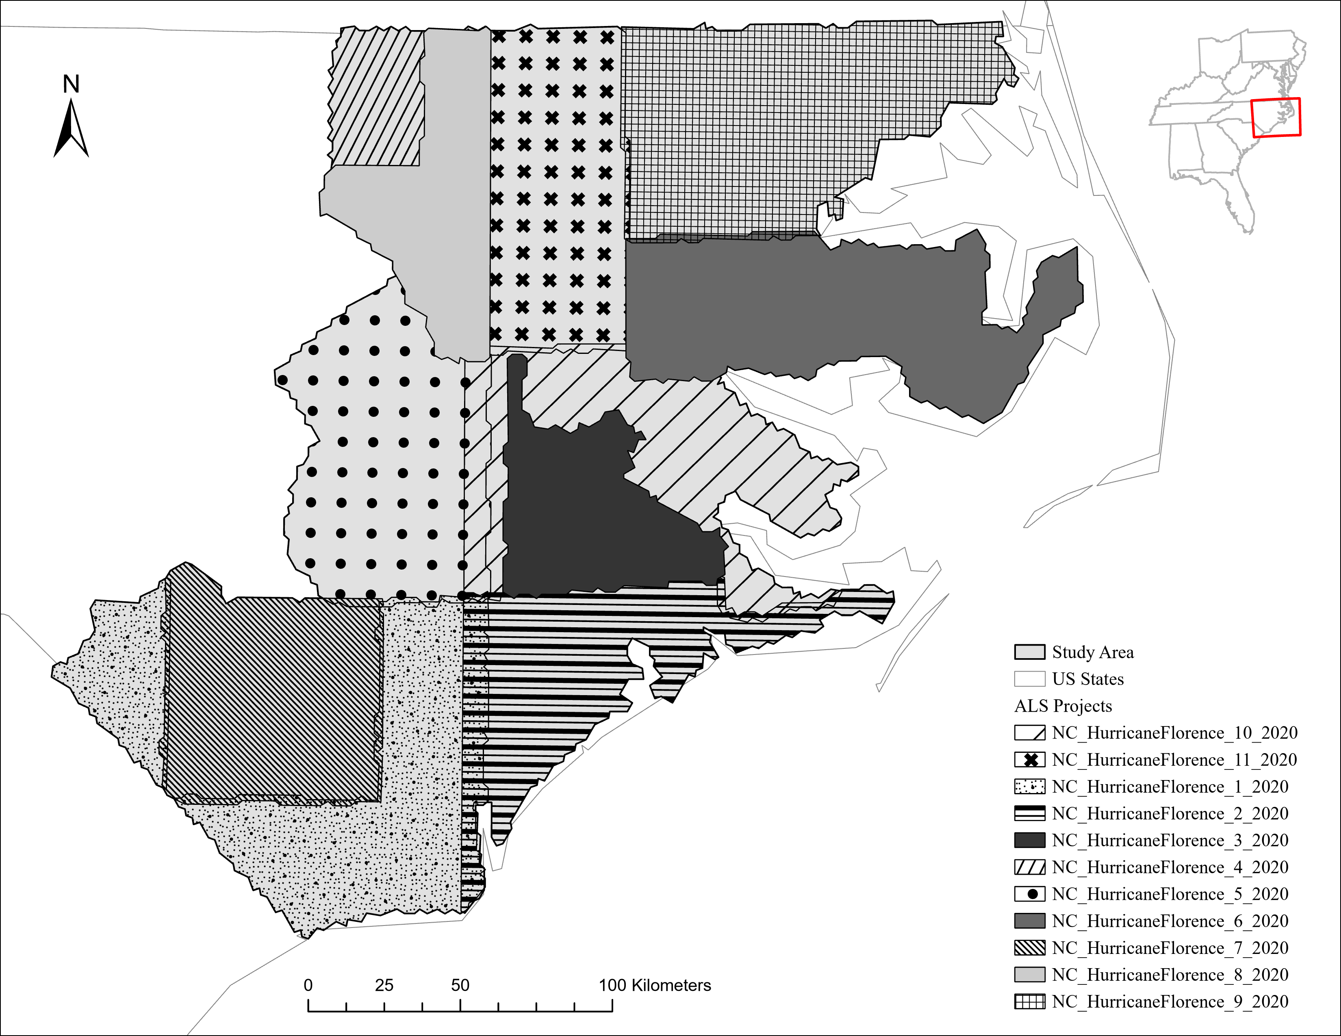  Figure 1. Study area in North Carolina. Polygons indicate boundaries of USGS 3D Elevation Program ALS projects collected in response to Hurricane Florence. Projects were flown in late 2019 and early 2020.  The study area was selected for several reasons. Although repeat coverage from ICESat-2 is unlikely at the stand or plantation scale, the chosen study area is large enough to contain ample ICESat-2 data even after quality filters. Additionally, the collection of data to validate ATL08 canopy height estimations across ecological gradients can be financially cumbersome. However, the study area contains wall-to-wall coverage of high-resolution ALS data. Though topography has noticeable effects on ATL08 canopy height estimation, the study area contains low terrain variability, with an elevation standard deviation of 27.3 meters and an average slope of 0.89 degrees (LANDFIRE, Earth Resources Observation and Science Center (EROS), U.S. Geological Survey, 2022a, 2022b; Liu et al., 2021; Malambo and Popescu, 2021). As of 2023, the National Land Cover Database characterizes the study area as predominantly Woody Wetlands (29%), Cultivated Crops (26%), and Evergreen Forest (42%; U.S. Geological Survey, 2024). Moreover, the study area falls within the historical natural range of Pinus taeda (loblolly pine). As such, the regular tree spacing, consistent tree heights, and fast tree growth observed in the region’s forest plantations should facilitate canopy height growth quantification with ATL08 data (Baker and Langdon, 1990).  2.2. Data Products  This research utilizes ICESat-2 ATL08 data to track canopy height growth over time. Land cover data from the Annual National Land Cover Database was used to isolate forested regions within the study area. The disturbance history of these forested regions was derived from the U.S. Forest Service’s Landscape Change Monitoring System. ALS data from the USGS 3DEP was used to validate ATL08 canopy height estimations, and assess spatial biases in the locations of ICESat-2 coverage. Finally, data from the U.S. Forest Service’s Nationwide Forest Inventory provided local, repeat plot surveys for determining expected canopy height growth patterns within our study area. Furter details on each of these datasets are provided below.  2.2.1. Airborne Laser Scanning  Hurricane Florence airborne laser scanning (ALS) data is contained in 11 projects of the USGS 3DEP flown between December 7th, 2019, and February 28th, 2020. All projects utilized the Reigl VQ 1560i or 1560ii instruments to collect data, meeting the Quality Level 1 requirements of the 3DEP LiDAR Base Specification. This guarantees an aggregate nominal pulse density of >8 points per square meter, and an absolute vertical accuracy (RMSE) of <10 centimeters in non-vegetated areas (U.S. Geological Survey, 2025). With this strong vertical accuracy and high point density, we considered this ALS data to be adequate for validating ATL08 canopy height estimations. USGS 3DEP LiDAR Point Clouds were accessed on August 11, 2025 from https://registry.opendata.aws/usgs-lidar. A custom Python script was created in Python 3.13.5 to stream the 3DEP data from the Entwine Point Tiles format during data processing (Rossum and Drake, 2010).  2.2.2. ICESat-2 ATL08  Photon measurements from the ICESat-2 satellite are aggregated into multiple data products. The L3A Land and Vegetation Height (ATL08) estimates land and surface vegetation heights relative to the WGS84 ellipsoid, labelling individual photons as noise, ground, canopy, or top of canopy (Malambo and Popescu, 2024; Neuenschwander et al., 2020; Neuenschwander and Pitts, 2019). Parameters for canopy height, used in this study, are provided in the ATL08 product in 100-meter segments along the satellite track (Neuenschwander et al., 2023).  The ATL08 product reports several canopy height parameters for segments, including the mean, median, minimum, and maximum of relative and absolute heights for canopy photons. ATL08’s primary canopy height metric, h_canopy, uses a segment’s 98th percentile relative canopy height to represent the top of canopy height, as true maximum canopy height may include background noise (Neuenschwander and Pitts, 2019). For this study, all available ATL08 Version 6 granules collected within the study area extent between October 14th, 2018 and December 31st, 2024 were downloaded from NASA’s Earthdata Search (https://search.earthdata.nasa.gov/search) using the Cygwin command-line interface . This provided 740 granules for further analysis.  2.2.3. National Land Cover Database  To advance research on land surface characteristics within human-environmental systems, the USGS produced the Annual National Land Cover Database (NLCD) Collection 1 Science Products. Within the collection, the Land Cover data product categorizes the earth’s land surface into 16 broad natural and artificial cover types for each mapping year using a modified Anderson Level II classification system (Anderson et al., 1976). While ATL08 segments include native land cover information in the segment_landcover attribute, it is derived from the Copernicus Land cover data product at a 100-meter resolution (Buchhorn et al., 2020; Neuenschwander et al., 2023). The NLCD Land Cover dataset was chosen for this research due to its higher spatial resolution, and alignment with historical forest disturbance data from the U.S. Forest Service. NLCD data used in this research was accessed from the Multi-Resolution Land Characteristics Consortium data archive (https://www.mrlc.gov/data). The Annual National Land Cover Database Conterminous United States Collection 1.0 Land Cover (version 0) was downloaded for 2023, provided in a single-band TIFF raster at a 30-meter spatial resolution (U.S. Geological Survey, 2024) . Although using land cover data from 2023 yields a 1-year discrepancy with the ATL08 data (2018-2024), 2023 was chosen for consistency with the most recent year available of forest disturbance history data.  2.2.4. Landscape Change Monitoring System  The Landscape Change Monitoring System (LCMS) is a suite of remotely sensed data products developed by the U.S. Forest Service to monitor landscape dynamics across the United States. The vegetation cover Change product is comprised of subproducts that categorize change processes into Fast Loss, Slow Loss, and Gain (Housman et al., 2024). Fast loss events indicate an abrupt disturbance to vegetation cover (fire, harvesting, etc.), slow loss events indicate gradual structural or spectral decline, and gain indicates vegetation growth or recovery. A summary product is created for each of these processes, with pixel values identifying the most recent occurrence of the given change from 1985 to 2023. For this research, the Fast Loss Change summary product for the Conterminous United States (version 2023-9) was downloaded from the LCMS Data Explorer (https://apps.fs.usda.gov/lcms-viewer/; USDA Forest Service, 2024).  2.2.5. Forest Inventory & Analysis Program  The Forest Inventory & Analysis Program is an effort by the U.S. Forest Service Research and Development Branch to monitor the distribution and health of forest resources in all 50 states, U.S. territories, and Freely Associated States (Renwick, 2023). A core tenet of the FIA is the Nationwide Forest Inventory (NFI), a network of forest plots that receive repeat tree height measurements every 5-10 years. Though precise NFI plot locations are obscured for privacy concerns, the county of each plot record is specified with Census Bureau FIPS codes, providing a level of spatial accuracy sufficient for this research (Burrill et al., 2024).  2.3. Data Processing  2.3.1. ICESat-2 ATL08  Addressing potential sources of error in ATL08 data is necessary to optimize its application for given analyses (Feng et al., 2023; Li et al., 2022, 2020; Rai et al., 2024; Wang et al., 2024; Xi et al., 2022). Raw ATL08 granules were first processed in a custom Python script to extract metrics related to the vegetation conditions, terrain characteristics, and satellite operation for each 100-meter segment.  The centroids of ATL08 segments were run through a custom Python script to apply data quality filters and intersect with land cover characteristics. Centroids were geolocated with the GeoPandas library from the latitude and longitude attributes, identifying the center coordinates of signal photons for each segment (Jordahl et al., 2020; Neuenschwander et al., 2023). The centroids were clipped to retain only those collected within the study area, and centroids with invalid (3.403e+38) canopy height values were removed. To minimize biases introduced by low-lying vegetation or high noise, canopy heights were filtered to values between 2 meters and a global maximum (Cao et al., 2016; Li et al., 2020; Rai et al., 2024). Following the approach of Malambo & Popescu (2024), the global maximum for canopy heights was calculated as k * P, where k is a constant factor of 1.2, and P is the 98th percentile of all ATL08 canopy heights in the dataset. For our study area, the calculated global maximum was 39.42 meters. Further filters subset only ATL08 data collected by strong beams, at nighttime, within the months of May to September to minimize the effect of solar noise and vegetation phenology on canopy height estimation (Neuenschwander et al., 2020).  Segment centroids were intersected with 2023 NLCD land cover data. Forested segments were identified by selecting only segments with NLCD values of 41 (Deciduous Forest), 42 (Evergreen Forest), 43 (Mixed Forest), or 90 (Woody Wetlands). The segment centroids were also intersected with the annual LCMS Fast Loss Change product to provide insight into the disturbance history of these forests. For segment centroids intersecting with a disturbance event reported by the Fast Loss product, the years since the last disturbance were calculated as the difference between the year of ICESat-2 collection and the most recent disturbance year. For this research, ATL08 segments with disturbances occurring after the year of ICESat-2 collection were removed, as ATL08 canopy heights may no longer reflect the forest conditions present. Additionally, ATL08 data with 3 years or less since the last disturbance event were removed to provide a buffer of forest regrowth and recovery from disturbance.  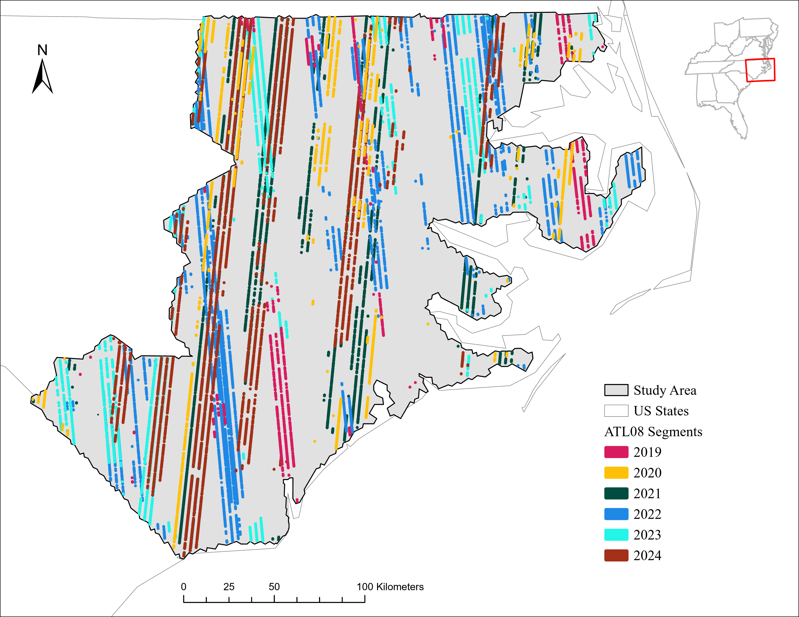  Figure 2: ATL08 segments collected in study area after data quality filters, colored by year of collection.  2.3.2. Extracting ALS Data Within ATL08 Segments  For this research, it was necessary to extract 2020 ALS data within each individual ATL08 segment. To generate the rectangular shape of the ATL08 segments, a polygon of 100 x 11 meters was created around the centroid coordinates of each segment, and rotated to align with the ICESat-2 track inclination (Neuenschwander et al., 2020; Rai et al., 2024). The polygons were reprojected to the Web Mercator projection system (EPSG:3857), which the 3DEP ALS data uses in its native storage format (Hobu, Inc., 2025). These polygons served as cropping geometries for ALS data.  ALS data was processed in a custom pipeline using the Point Data Abstraction Library (Figure 3; PDAL Contributors, 2025). For each ATL08 segment, ALS data was streamed from any 3DEP project intersecting the polygon’s extent. The filters.smrf function was used to interpolate the ground surface and minimize Type I errors (Pingel et al., 2013). Heights above the interpolated ground surface were calculated using a nearest neighbor approach with the filters.hag_nn function (Ribas-Costa et al., 2024). The normalized point cloud was cropped to the geometry of the respective polygon to match the polygon’s along-track inclination (Figure 4).  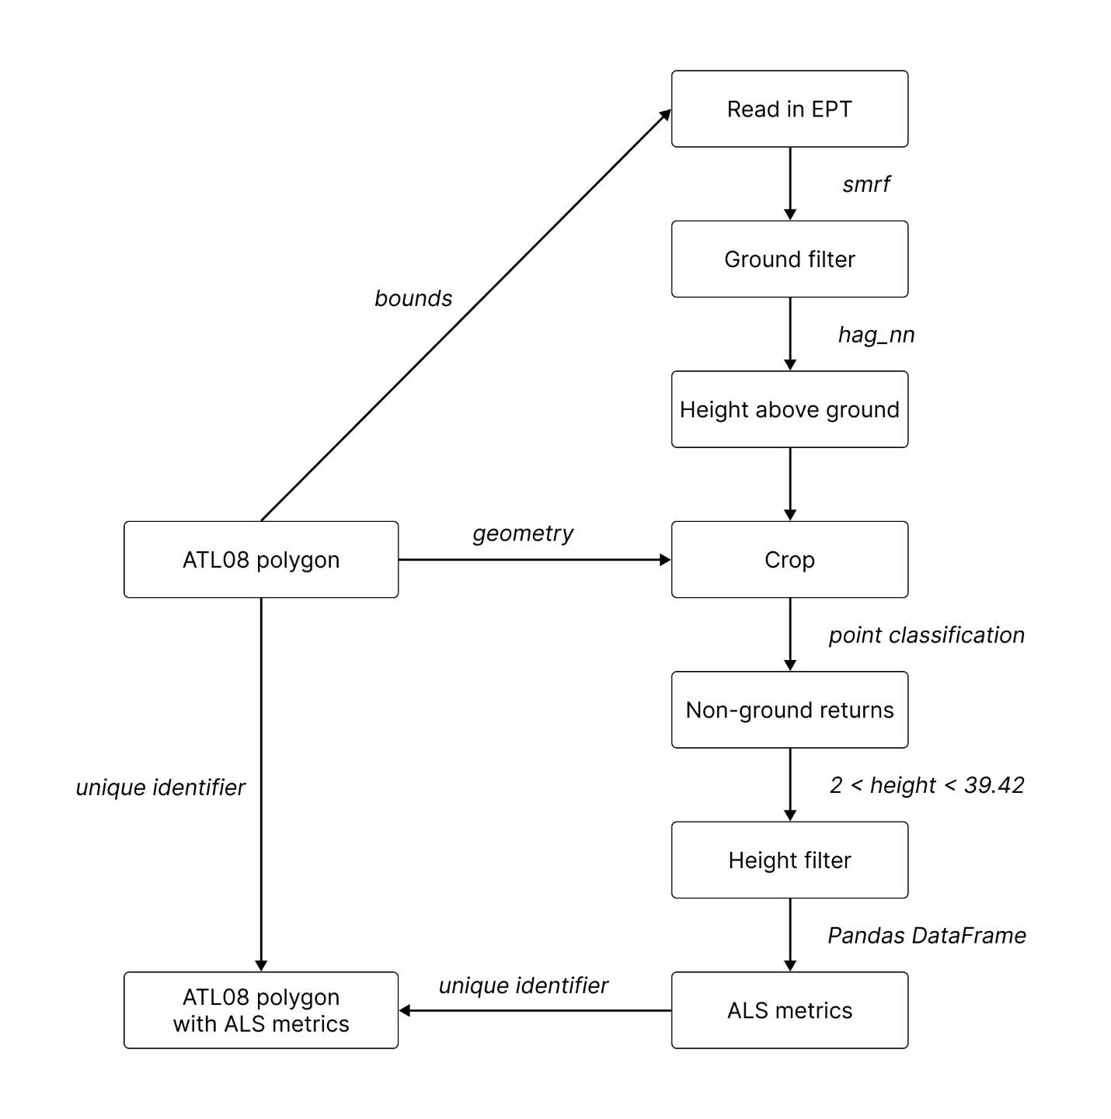  Figure 3. Python workflow for extracting ALS data within ATL08 polygons.  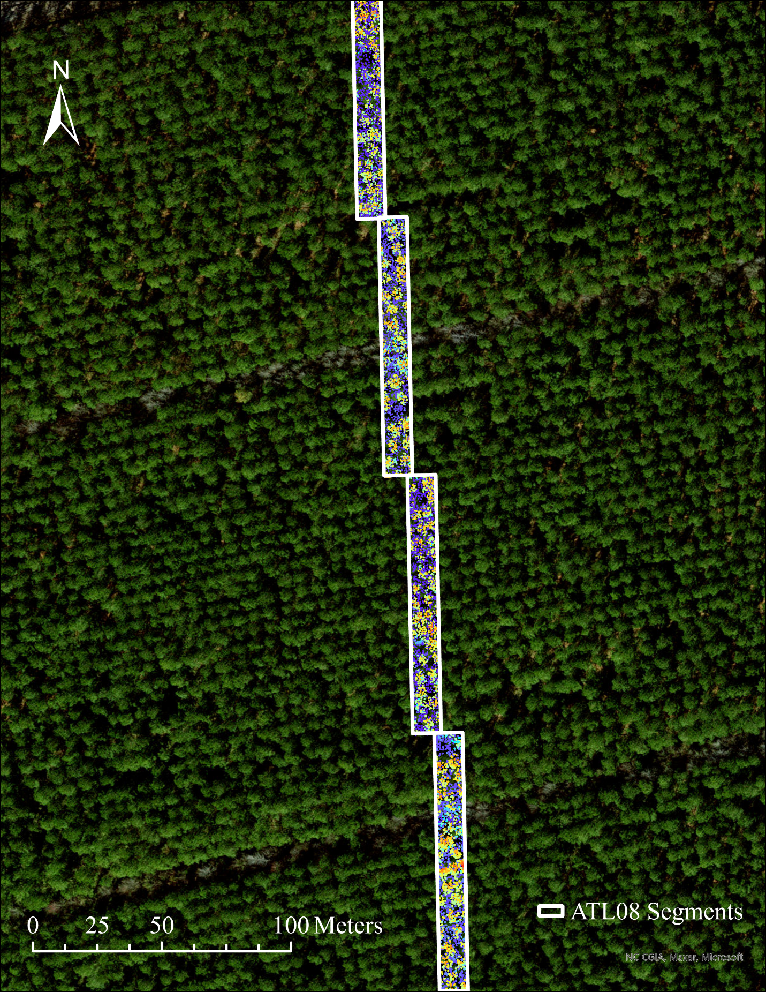  Figure 4. ALS data extracted within ATL08 segments. Segments were collected over a forest plantation region as shown from the World Imagery basemap in ArcGIS Pro 3.4.3 (Esri, Inc., 2024).  For each normalized point cloud, we selected only non-ground returns, with heights above ground between 2 meters and the global maximum of 39.42 meters—matching the filters applied to ATL08 data. These ALS returns were deemed as vegetation returns, from which the following metrics were calculated for the return heights: mean, median, minimum, maximum, and the 90th, 95th, 98th, and 99th percentiles. These ALS metrics were joined to the corresponding ATL08 segment using a unique identifier. Importantly, the 3DEP projects were flown with overlap to guarantee wall-to-wall coverage of the Hurricane Florence impact area. As a result, some ATL08 segments intersected with multiple ALS projects, and were duplicated during the join. In these instances, only the segment associated with the ALS project providing the highest number of vegetation returns was retained. Moreover, the 3DEP project boundaries are generalized, and cropping ATL08 segments to the generalized 3DEP Hurricane Florence projects (the study area) yielded some ATL08 segments with no ALS returns within their bounds. These were also removed from analyses, resulting in a final working set of 53,938 ATL08 segments. In summary, the working set contains 6 years (2019 - 2024) of ICESat-2 ATL08 segments, for which vegetation height metrics were also calculated from 2020 airborne laser scanning within each segment’s geometry.  2.3.3. Retrieving Study Area FIA Data  A copy of the North Carolina Forest Inventory & Analysis database (FIADB) was created in PostgreSQL using a custom repository that provides scripts for manipulating FIA data in a local environment (Radtke, 2025). North Carolina NFI remeasurement plots were accessed using a custom R script. The script selected only remeasurement plots in the NFI evaluation group 372023, corresponding to plots in North Carolina (state code 37) remeasured during 2023. These plots were further subset to select only those from the 40 counties within the study area using county code attributes (Figure 5).  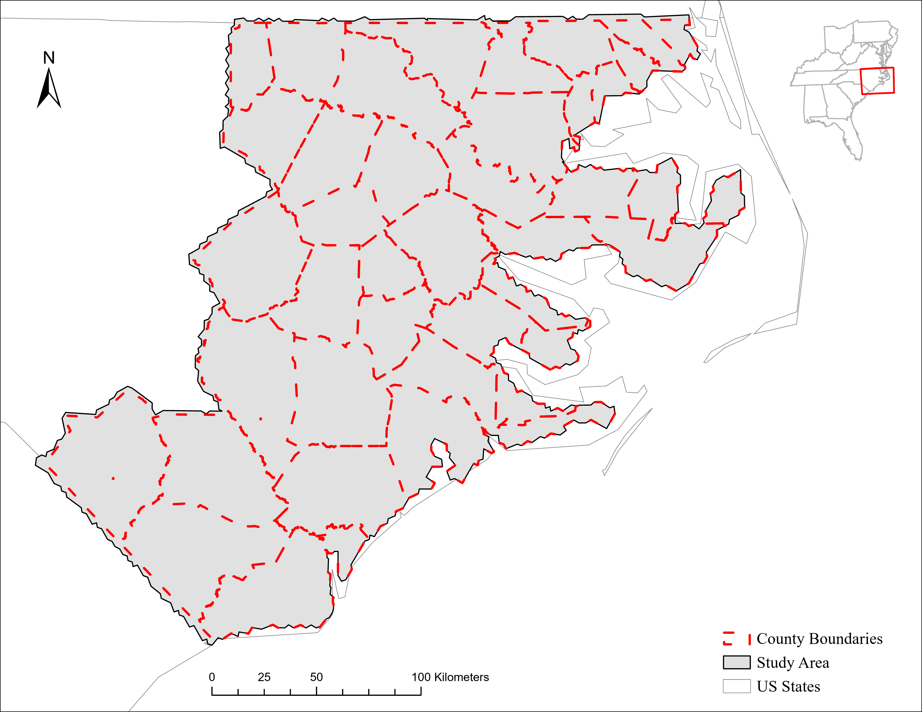  Figure 5. Counties of North Carolina within study area. County boundaries are used to subset NFI remeasurement plots using County FIPS codes.  Unique plot sequence numbers were extracted from NFI plots within the study area. For these sequence numbers, the Plot, Condition, and Tree tables were extracted from the North Carolina FIADB. These tables were joined into an R dataframe to provide a set of current measurements.  The current record of a remeasurement plot was matched to the record of the previous inventory using the previous plot sequence number. For these previous sequence numbers, the same Plot, Condition, and Tree data records were gathered from the respective tables in the FIADB. These records were joined into an R dataframe to provide a set of historical measurements.  Current and historical measurements were joined by matching state, survey unit, county, plot, subplot, and species-specific individual tree records. This provided a single R dataframe of individual tree growth data from NFI remeasurement plots to establish reference tree height growth.  2.4. Data Analysis  We provide further information about some of the statistical approaches used in this research in Appendix 1. Unless otherwise stated, all statistical tests used a significance (alpha) value level of 0.05. Analyses were conducted in R version 4.3.2 and Python 3.13.5 (R Core Team, 2023; Rossum and Drake, 2010)  2.4.1. Validating ATL08 Canopy Heights with ALS  Prior to identifying canopy height growth with ATL08 data, it is necessary to establish a strong relationship between ATL08 canopy heights and those from reference data at a single point in time. Doing so allows us to take the canopy heights reported in ATL08 data at face value. To do this, we use a linear regression to compare ATL08 canopy height estimations against ALS-derived canopy heights extracted within the bounds of each ATL08 segment (see section 2.3.2).  Since the ALS data was collected in the winter months of late 2019 to early 2020, ATL08 segments were restricted to only those collected during the year of 2020 for this portion of the analysis. The resulting 5,042 segments serve as a validation set to assess the accuracy of the ATL08 product in canopy height estimation. For the validation set, the correlation between ATL08 and ALS canopy height metrics was assessed with a Theil-Sen regression model from the RobustLinearReg package in R (Hurtado, 2020). We compared the 98th percentile ATL08 canopy height variable (h_canopy) to the 98th percentile of ALS vegetation returns. From this regression, we report the R² and RMSE.  2.4.2. Addressing Sampling Bias of ICESat-2 Data Collection  Using ICESat-2 or GEDI to track forest change over time is challenged by the transect sampling patterns of spaceborne LiDAR (Mulverhill et al., 2022). ICESat-2 intentionally employs off-nadir pointing at mid-latitudes to fill gaps between reference ground tracks and obtain dense coverage of terrestrial vegetation—prohibitive to repeat measurement of individual forest stands (Markus et al., 2017; Neuenschwander et al., 2023; Neumann et al., 2019). As such, each year of ATL08 segment data is a spatially distinct ‘sample’ of the study area (Figure 6).  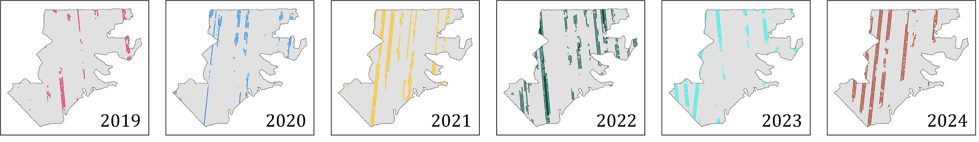  Figure 6. Spatial distribution each year’s ATL08 segments collected in each year across the study area. Separate plot used for each year of segments. Each year of ATL08 segments do not align, but shift to provide greater spatial coverage.  Since spatial differences in forest height between these samples may be misinterpreted as change over time, we address two possible sources of bias. To obtain confidence in individual samples, we verify that each sample represents the population distribution of forests throughout the entire study area. To use the samples together to identify change over time, we also verify that the footprints of each sample are equivalent with each other. By adequately addressing the bias that may exist within ICESat-2 data collection, we can move across space and throughout time to track canopy height growth with the confidence that results emerge despite the samples being distinct, and not because the samples are distinct.  2.4.2.1 Sample Representation  To generate the population of forests within our study area, we used a custom Python script to randomly select 50,000 pixels across all forest cover types present in the NLCD land cover data (Figure 7).  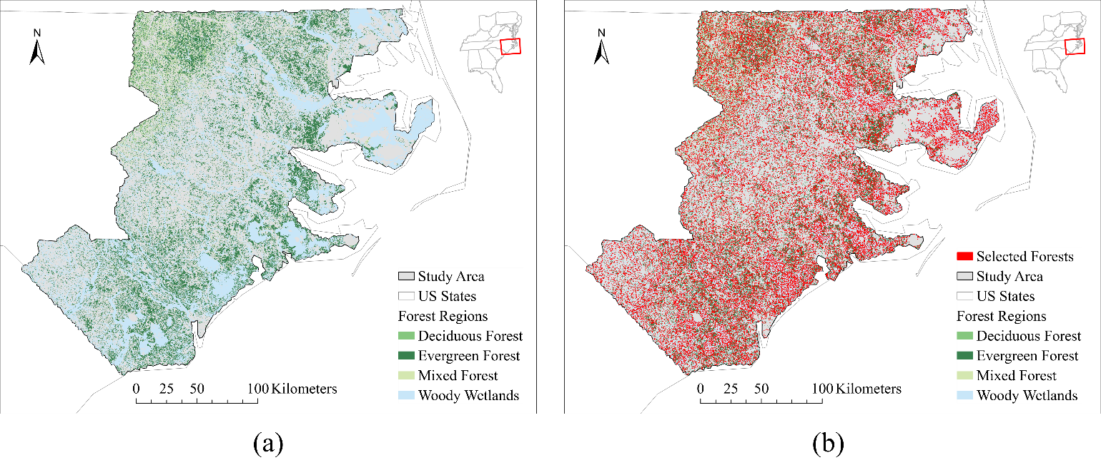  Figure 7. Population of forests throughout the study area: a) all forested pixels, colored by NCLD forest cover type, and b) a random selection of 50,000 forest pixels, each with an ATL08 segment created at their center, resulting in the red speckled effect.  For each selected pixel, we create a 100 x 11-meter polygon at its center to simulate an ATL08 segment and extract the ALS canopy height within the segment. Altogether, the ALS canopy heights extracted within these 50,000 cells comprise the population of forests across the study area.  To establish individual samples as representative, we compare the ALS canopy heights within the footprints of each sample against the population using a kernel density estimate (KDE) plot. Separate KDE functions were created for each sample. If each sample’s distribution of ALS canopy heights agrees with the distribution of the overall population, we can proceed with confidence that ICESat-2 data collection yields representative samples of our study area.  2.4.2.2. Sample Equivalence  To establish the samples as equivalent, we compare the distribution of ALS canopy heights in the sample footprints against each other, using a bootstrapped two one-sided tests technique from the TOSTER package in R (Caldwell, 2025, 2022; Lakens, 2017).  For these two one-sided tests, the equivalence margin corresponds to the difference (in meters) of canopy height between the footprints of samples. These tests were performed at equivalence margin values of 2, 1.5, 1, 0.5, 0.25, and 0.1 meters, spanning a range of interpretations for ‘equivalence’ in canopy height. The equivalence tests employ a Bonferroni-corrected significance level of α = 0.05 / 15 or 0.0033.  Ultimately, these tests aim not to demonstrate perfect equivalence among samples, but to identify samples with noticeable divergence from the rest, which were then removed from temporal analyses under the assumption of spatial differences that would confound detecting change over time.  2.4.3. NFI-Derived Tree Height Growth  Data from NFI remeasurement plots indicate the expected tree height growth within the study area. From this data, we use actual tree height measurements rather than total tree height measurements, reflecting the canopy surface that is sampled by LiDAR scanners (Burrill et al., 2024). We used measurements only from live trees by removing dead trees with the tree status code. After matching current and previous measurements of individual trees, records where the current tree height is less than the previous tree height—possibly the result of errors in the NFI protocol or damage from disturbance events—were removed. Moreover, we subset to only tree records with a remeasurement period matching the timeframe of our ATL08 segments, as plot remeasurement periods range in length (U.S. Department of Agriculture Forest Service, 2025).  Importantly, NFI measurements are collected at the level of individual trees. To align with the spatial scale of ATL08 segments, we aggregate individual tree height measurements up to the plot-level mean using the plot sequence number. We do this separately for current and previous measurements, providing two samples of filtered, plot-level heights. To estimate total growth over time, we use a difference-of-means approach, subtracting the mean of all previous plot-level heights from the mean of all current plot-level heights:  $$G_{total}={\overline{X}}_{current}-{\overline{X}}_{previous}$$  The paired plot growth standard error was calculated as the standard deviation of total growth divided by the square root of n, where n is the number of NFI plots after filters:  $$SE=\frac{s_{G_{total}}}{\sqrt{n}}$$  The 95% confidence interval of growth over time was determined using a bootstrapping technique with 10,000 iterations. For each bootstrap iteration, 252 plots were randomly sampled with replacement, and the mean growth over this sample was calculated. The bootstrapping was performed with the numpy.random.default_rng function in NumPy 2.3.1 (seed = 20,260,521; Harris and Gibbs, 2021). Using 10,000 iterations stabilized the variability inherent in bootstrapping techniques.  There is precedence in the literature for assuming simple random sampling with FIA data (Bechtold et al., 2005; McConville et al., 2020). The FIA program’s design provides sufficient geographic scope and temporal stratification to assume that any sample of the landscape (in our case, the groups of current & previous plot measurements) adequately reflects the natural variation in forest conditions across the study area. Ultimately, the metrics obtained from NFI remeasurement plots serve not as ‘targets’ to hit when tracking growth with ATL08 segments, but context for forest growth patterns in the study area determined with a long-standing, foundational data source (Goeking et al., 2024).  2.4.4. Assessing Canopy Height Growth with ATL08  While the treatment of ATL08 data as a random sample may pose challenges, we address this with equivalence testing in Section 2.4.2, whereby the de facto equivalence for our samples functionally (though not formally) establishes their representativeness of the population in each temporal instance. Moreover, ICESat-2’s use of off-track pointing over land areas at mid-latitudes for global carbon inventory provides roughly homogenous sampling probabilities for vegetated areas throughout its mission lifetime (Markus et al., 2017). As such, we treat each year of ATL08 data as a spatially disjoint, independent sample, and therefore use only non-overlapping segments collected at the start and end of the timeframe to determine growth. For direct comparison to NFI data, canopy height growth in ATL08 data was calculated with a difference-of-means approach, subtracting the mean canopy height of all segments collected at the start of the timeframe from the mean canopy height of all segments collected at the end of the timeframe:  $$G_{total}={\overline{X}}_{end}-{\overline{X}}_{start}$$  ATL08 segments within a single reference ground track are likely subject to spatial autocorrelation due to similar forest cover, topography, and atmospheric conditions (Lu et al., 2025). With this in mind, we group ATL08 segments with a unique identifier that combines the cycle, reference ground track, and beam of a segment’s collection. The standard error and 95% confidence interval of ATL08-derived growth were calculated using a whole-track bootstrap approach, resampling entire tracks with replacement. Like NFI data, the bootstrapping was conducted with 10,000 samples, using the numpy.random.default_rng function in NumPy 2.3.1 (seed = 20,260,521). This bootstrapping technique serves to accommodate unequal sample sizes between tracks of ATL08 data.  3. Results  3.1. Accuracy of ATL08 Canopy Height Estimation  ATL08 segment canopy height estimations show strong correlation with reference ALS data at a single point in time (Figure 8). With an R² of 0.88 and an RMSE of 2.65 meters, ATL08 segments are adequately estimating canopy heights within the study area. The greater dispersion of points below the regression (red) line is indicative of an overall underestimation of canopy height by ATL08 in comparison to ALS data.  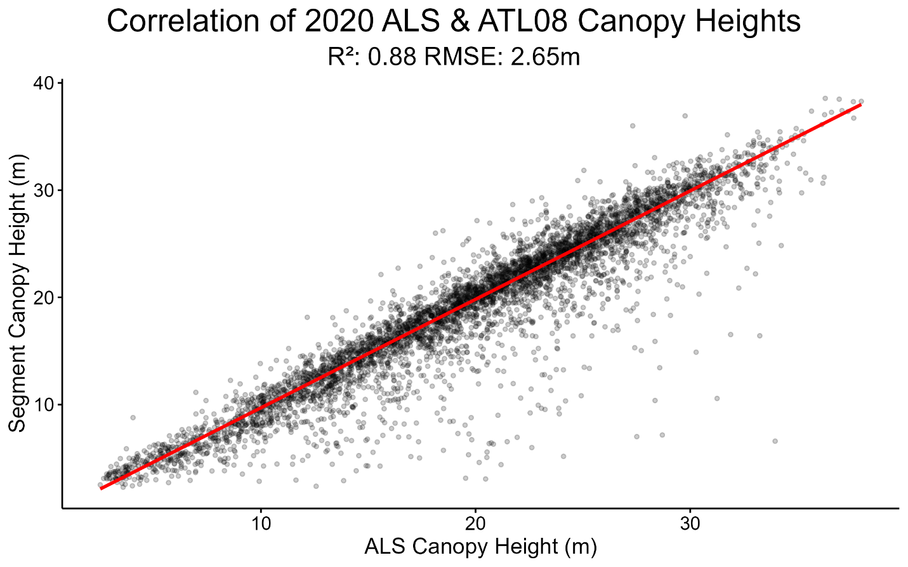  Figure 8. Correlation of canopy heights estimated by ALS (X) and ATL08 (Y). Each point in the scatterplot corresponds to an individual ATL08 segment (n = 5,042). Canopy heights are reported in meters above ground. Red line indicates trend line from a Theil-Sen regression.  3.2. Study Area Homogeneity  3.2.1. Sample Representation  When comparing ALS canopy heights in the footprints of each sample against the population of ALS canopy heights across the study area, the samples appear representative of the broader forest population (Figure 9). The kernel density estimate of each sample’s canopy heights is in reasonable agreement with the overall population distribution. This suggests that ICESat-2 samples sufficiently capture the range of canopy heights across the study area, despite the spatial shift between samples.  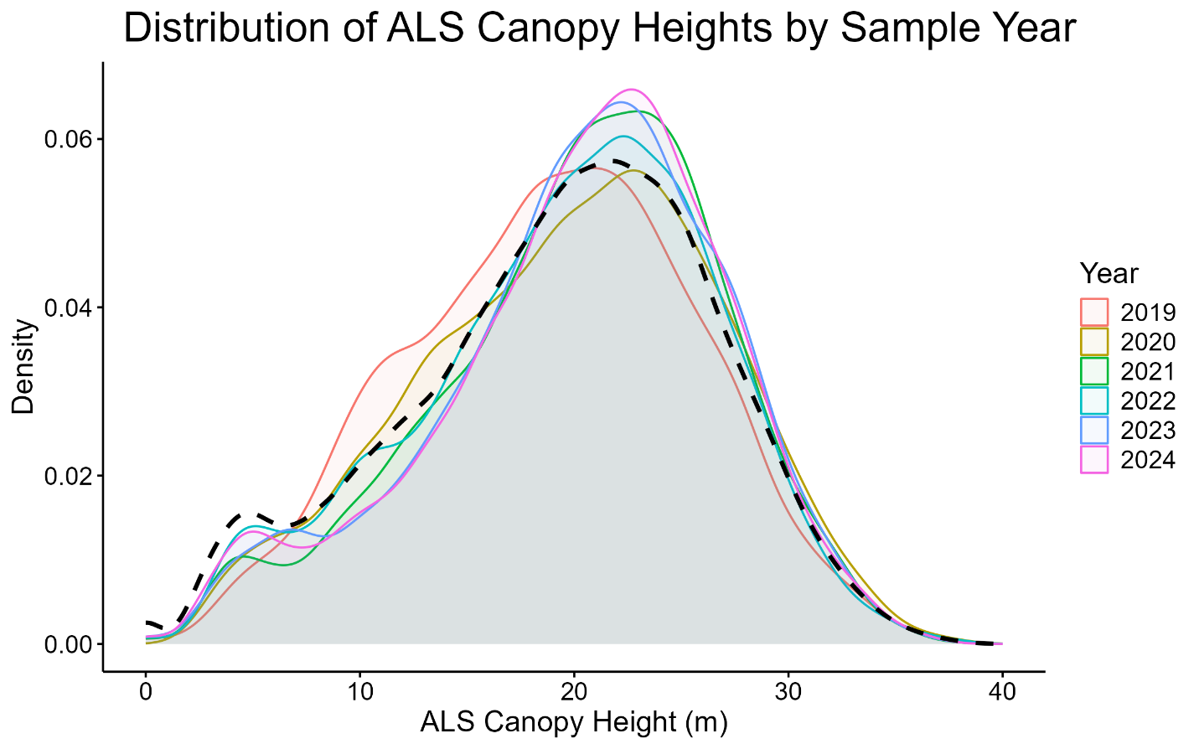  Figure 9. Representation of annual ATL08 samples. Plot shows kernel density estimates of ALS canopy heights within each annual ATL08 sample (colored distributions), overlaid on a kernel density estimate of the ALS canopy heights across the entire study area (dashed black line). Unique colors chosen for each sample’s kernel density estimate  3.2.2. Sample Location Equivalence  Bootstrapped TOST show that sample footprints are practically equivalent within a margin of two meters in canopy height (Figure 10). Below this margin, not all samples demonstrate equivalence with each other.  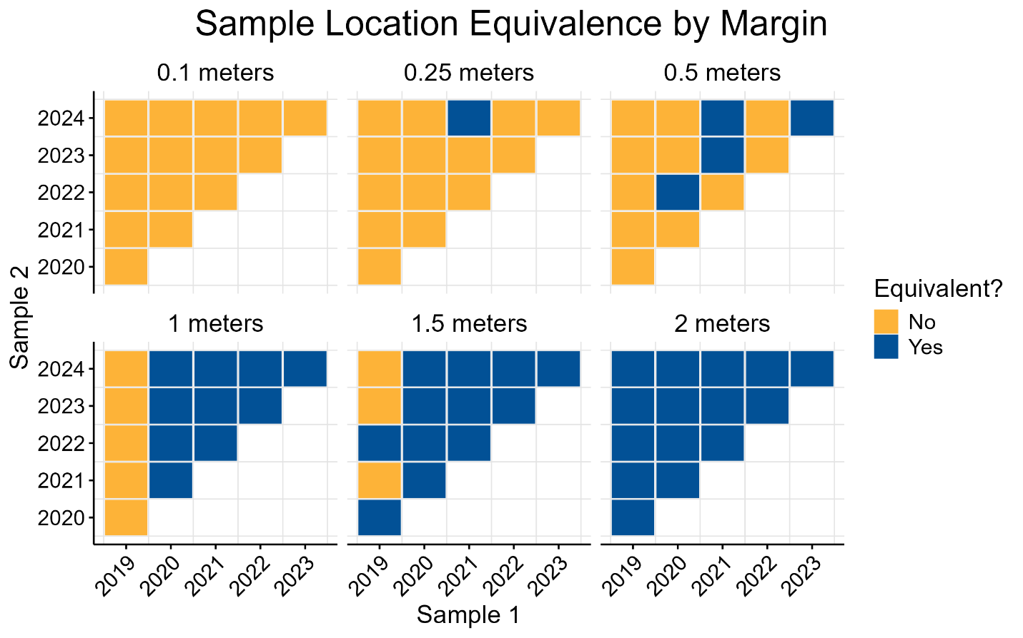  Figure 10. Grid of sample location equivalence across margin values, where each subplot represents a unique equivalence margin in meters. Within each subplot, cells indicate the result of an equivalence test comparing ALS canopy heights between the footprints of Sample 1 (X) and Sample 2 (Y). Blue cells indicate practical equivalence within the specified margin. Yellow cells indicate non-equivalence, where at least one null hypothesis from the two one-sided tests was not rejected.  At a stricter equivalence margin of 0.1 meters, none of the samples demonstrate equivalence in canopy height. Based on the results in Figure 10, the 2019 sample demonstrates the lowest equivalence with other samples. This suggests that although the 2019 sample may be representative of the overall population, it contains spatial differences in canopy height with the other samples which could bias trends over time. We therefore remove the 2019 ATL08 sample from further analyses, and all remaining samples now demonstrate equivalence within a margin of 1 meter in canopy height. This minimizes the sampling bias present in the footprints of our ATL08 segments, but limits tracking canopy height growth to within a four-year (2020-2024) timeframe. As mentioned in section 2.4.3, we likewise filter NFI plots to only those with remeasurement period of ~4 years to match the ATL08 data timeframe.  3.3. Reference Growth  Figure 11 shows the distributions of current and previous plot-level tree heights from NFI remeasurement plots. Previous measurements yielded a mean of 14.92 meters, and current measurements yielded a mean of 16.88 meters. Based on these values, we expect a net growth of 1.95 meters in tree height over four years within the study area, with a growth standard error of 0.075 meters. The 95% confidence interval ranges from 1.82 meters to 2.10 meters.  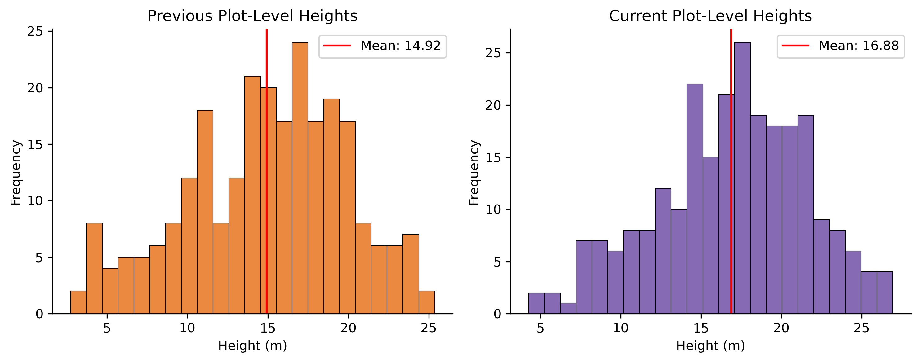  Figure 11. Distributions of previous (left) and current (right) NFI plot-level tree height values (n = 252).  3.4. ATL08-Derived Growth  There were 5,042 ATL08 segments (across 35 tracks) collected in 2020, and 12,316 ATL08 segments (across 30 tracks) collected in 2024. Figure 12 displays the distributions of canopy heights at the start (2020) and end (2024) of our ATL08 segment timeframe. ATL08 segments collected in 2020 had a mean canopy height of 19.1 meters, and 2024 segments had a mean canopy height of 20.97 meters. Based on these values, we expect a net growth of 1.87 meters over a four-year period, with a standard error of 0.75 meters. The 95% confidence interval ranges from 0.51 to 3.42 meters.  S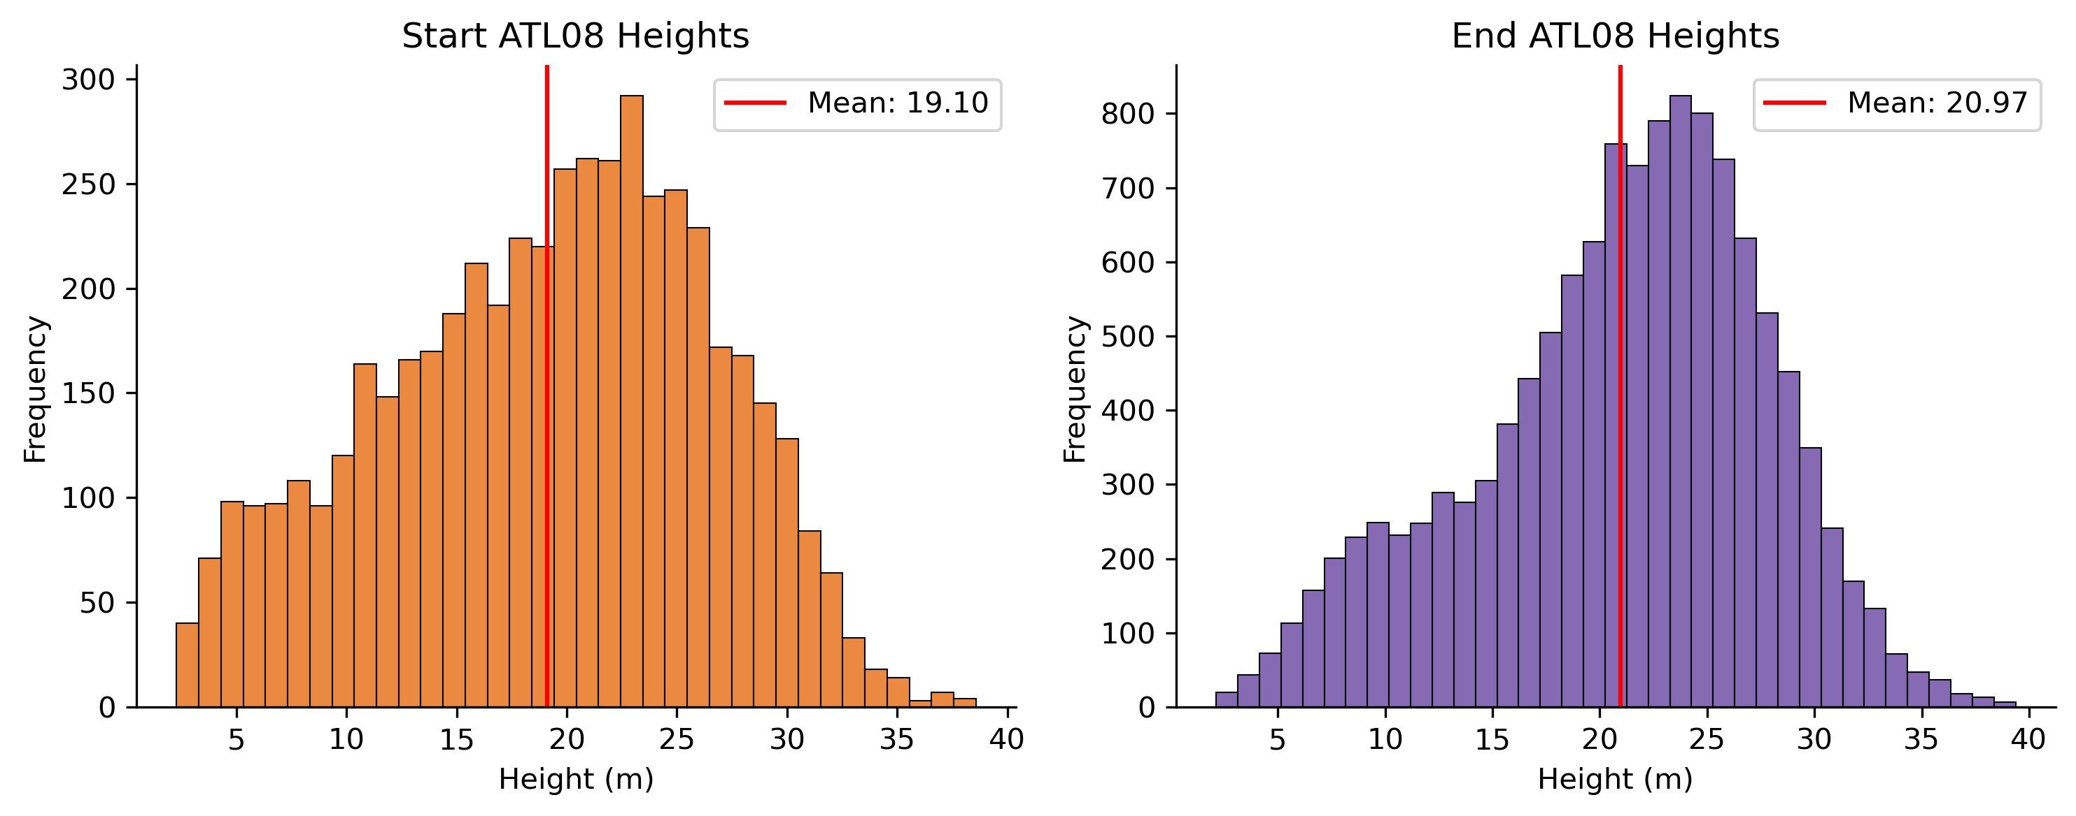  Figure 12. Distributions of 2020 (left; n = 5,042) and 2024 (right; n = 12,316) ATL08 segment canopy height values  4. Discussion  The ability of spaceborne LiDAR to reliably detect canopy height growth over time is vital for broad-scale forest monitoring, overcoming the temporal limitations of repeat ALS data acquisition and the spatial limitations of field inventories. Using coincident high-resolution ALS data, we found ATL08 segments to be effectively estimating canopy heights within our study area (R² = 0.88 , RMSE = 2.65), with a minor underestimation of ATL08 canopy heights against reference ALS noted in the literature (Neuenschwander et al., 2020; Rai et al., 2024; Yu et al., 2024). The strong ATL08 canopy height estimations were likely due to the presence of forest plantations within the study area, and were conducive for identifying trends throughout time.  By assessing the sampling bias present in ATL08 data, we determined that ATL08 segment locations provide representative samples of the broader landscape. Equivalence testing reveals a practical equivalence of 2 meters in canopy height across ICESat-2 tracks, showing a considerable level of agreement across a study area of over 5 million hectares. After removing an annual sample with noticeable divergence, all samples demonstrate equivalence to each other within an even tighter margin of 1 meter. The equivalence in canopy height between samples was deemed sufficient for our purposes, especially considering the RMSE of 2.65 meters between ATL08 & ALS canopy heights (Figure 8), as it is unlikely that ATL08 measurements would be heavily influenced by spatial biases in canopy height within this margin of error.  NFI remeasurement plots established a reference tree height growth of 1.95 meters over four years in the study area. This level of growth may reflect maturing forests across the study area, as forest height growth and productivity slows as stands mature (Bennett, 1963; Tang et al., 2014). For loblolly pines vastly present throughout the southeastern United States (and therefore the study area), crown closure may occur within 10-20 years of age (Baker and Langdon, 1990; Bradley and Kush, 2019), leading to a reduced growth rate. While time since disturbance is not a direct proxy for stand age, ATL08 segments were primarily collected in forests with 10-20 years (n = 9,478) since disturbance.  Dead trees were removed during NFI data processing to focus solely on living-tree growth. Although ATL08 segments do not report tree status in canopy height estimations, dead trees were filtered during NFI processing for the best data subset to demonstrate forest height growth—just as the heavy filtering of ATL08 data aimed to achieve.  In revisiting the research question, the results show that ATL08 segments can detect canopy height growth over a four-year period, with a reasonable alignment to the long-established ways of so doing, that of the NFI (Table 1). The very minimal growth standard error and narrow confidence interval from the NFI data speaks to the value of paired revisit plots as a reference data source. The larger growth standard error and wider confidence interval of the ATL08 data is expected. Most importantly, the ATL08-derived growth is within the confidence interval calculated with NFI data for the same area, and does not differ at the 95% level.  Table 1. Direct comparison of NFI and ATL08 net growth results.  The study area undeniably influenced the results, specifically chosen for its gentle topographic relief. In regions of higher terrain variability or canopy complexity, ATL08 canopy height estimations may have yielded greater error (Fernandez-Diaz et al., 2022; Liu et al., 2021). Our study area is located within the loblolly pine range, a region noted for its exceptional forest productivity (Ribas-Costa et al., 2024). This region provides canopy height growth greater than that expected in other U.S. forests, where growth patterns over four years may not reach a level detectable in ATL08 data. We must note that researchers should strongly consider the dominant topography, forest conditions, and productivity level of their study area if attempting to identify canopy height growth in ATL08 data.  Researchers must also consider the spatial scale of their study area, selecting a region large enough to ensure an ample set of ATL08 segments after quality filters, but small enough to maintain consistency in forest conditions. The Environmental Protection Agency has outlined Ecoregions of the U.S. with similar geology, vegetation, climate, wildlife. Figure 13 shows the proportion of ATL08 segments from each annual sample in the Level II Ecoregions found within our study area.  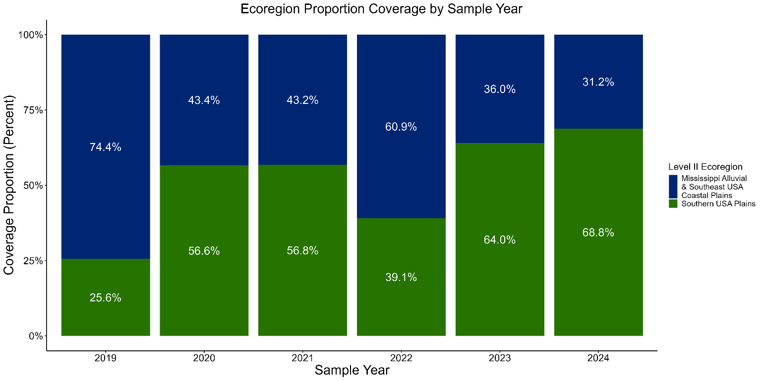  Figure 13. Proportion of ATL08 segments in EPA Level II Ecoregions by year. Percent values in stacked bars are relative to each annual sample’s total number of ATL08 segments.  As shown in Figure 13, the 2019 sample demonstrates the lowest similarity in its distribution across Level II Ecoregions with the other samples, just as section 3.2.2 showed that the 2019 sample had the lowest canopy height equivalence with other samples,. When considering spatial scales best suited for forest monitoring with ATL08 data, this presents EPA Ecoregions as a possible recommendation.  Testing equivalence between treatments requires careful consideration of a margin of practical equivalence (Lakens, 2022). In this research, this margin was the difference in canopy height between the footprints of annual samples we would tolerate when tracking growth over time. In absence of a widely accepted standard for canopy height equivalence, researchers may derive their own definition to balance the timeframe for determining growth, the amount and spatial coverage of ATL08 data available, and the accuracy of ATL08 canopy height estimates within their study area. Since the sampling sparsity of ICESat-2 tracks will always pose a challenge to analyses of multitemporal ATL08 data, and canopy height is emergent from multiple ecological factors, we found it appropriate to test equivalence across a range of equivalence margin values (Gautam et al., 2025; Malambo and Popescu, 2024).  4. Conclusion  Land management decisions at a local scale affect biodiversity and climatic processes, and contribute collectively to global climate change (Griffith et al., 2003). Understanding regional differences in environmental resource use and degradation is therefore critical to ensure effective land management that is locale-specific (Omernik and Griffith, 2014). In consideration of the spatial biases in canopy height discussed in Section 4, future research could stratify ATL08-derived trends by EPA Ecoregions for ecological continuity.  The results of this research show that ATL08 segments hold the potential to identify forest height growth throughout time. However, this ability will be reliant upon several factors, not only those influencing ATL08 canopy height estimations at a single point in time but also their compounded effects throughout time. This study applied several quality filters to ATL08 data that were non-trivial in their reduction of the sample size, controlling for beam strength, time of collection, and seasonality to identify the best subset of ATL08 data for tracking growth. While strong beam, nighttime data collected in leaf-on conditions have historically provided the highest accuracy in static canopy height estimation, future studies could maintain all ATL08 segments within a study area to test the emergence of temporal trends across factors of ATL08 data and environmental conditions. This would extend the work of Neuenschwander et al. (2020), Malambo & Popescu (2021), A. Liu et al. (2021), Rai et al. (2024), and others across multiple timesteps.  When assessing the sampling bias present in annual ATL08 samples, spatial biases in canopy height may have arisen from post-Hurricane Florence recovery of the forests in our study area, as the occurrence of Hurricane Florence (September 2018) aligns closely with the beginning of ICESat-2 data collection (October 2018). Further work is required to investigate the spatial stratification of the segments using a Hurricane Florence flood extent product (NC OneMap, 2020), which could determine if Hurricane Florence inundation is impacting the canopy height values estimated by the 2020 ALS.  Ultimately, this research aims to understand structural changes of vegetation throughout time using modern active remote sensing missions. In understanding these dynamics at the regional scale, this research can aid governing agencies and local stakeholders with spatially explicit management strategies. Such strategies can protect vegetation and natural resources against site-specific threats, supporting conservation efforts and land use planning in the face of a changing climate.  Acknowledgements  This research was funded by USDA Forest Service JVA: “Using next generation tree canopy cover and forest disturbance data products to develop large area maps of post-harvest recovery rates for southeastern managed forests” (Number: 20-jv-11330145-037).  We thank Dr. Christine Blinn and Aakriti Sakpota from Virginia Tech’s Department of Forest Resources & Environmental Conservation for their invaluable work in making data from the Nationwide Forest Inventory more accessible. We also thank Dr. Daniel Putnam for his guidance in streaming and filtering Entwine Point Tile data.  Appendices  1. Statistical Approaches Used  General descriptions for the statistical approaches used in this research are provided. For further information, readers should refer to the sources cited therein.  - Linear Regression Model  Linear regression is a statistical method that represents the relationship between a dependent and explanatory variable by fitting a linear equation to the observations (Esri Inc., 2025). Linear regression employs an equation of the form:  $$Y=a+bX$$  Where Y is the dependent variable, X is the explanatory variable, b is the slope of the line, and $a$ is the intercept (Y when x = 0). Linear regression is often performed using a least squares approach, where the fitted line attempts to minimize the sum of the squared residuals (Linear Regression, 1997). However, least squares approaches can be highly sensitive to outliers, a non-trivial issue in the context of canopy height estimation using LiDAR which may generate errant returns (Yu and Yao, 2017). The least squares estimation of a regression slope is ultimately a weighted average of pairwise slopes, and an extreme slope value between a data point and an outlier may strongly influence the slope estimate (Goldstein-Greenwood, 2023). As such, this research employed a method of robust regression—the Theil-Sen regression (Sen, 1968; Theil, 1992). The Theil-Sen regression calculates the slope between a predictor and response variable as the median of slopes between each pair of points in the dataset, providing a correlation estimate that is more resistant to outliers.  - Equivalence Test  An insignificant p-value of a null-hypothesis test merely indicates the absence of evidence of a difference between treatments, which is not the same as stating equivalence between treatments (Altman and Bland, 1995). Failure in rejecting the null hypothesis does not automatically make it true, but merely shows insufficient evidence to support the alternate hypothesis (Wachs, 2015). More plainly, absence of evidence is not evidence of absence .  An equivalence test is a subtype of interval hypothesis testing which tests the null hypothesis that the difference between group means is larger than a margin of tolerable difference (Shtaynberger and Bar, 2023). Equivalence tests are used to show that group means are equivalent within a margin that is practically important, as it is never truly possible to show that an effect size (Δ) is zero (Lakens, 2017). As such, when reporting the results of an equivalence test it is common practice to report the equivalence margin the data is tested against.  This research employed a two one-sided tests procedure for equivalence testing. In this procedure, the smallest effect size of interest is specified with an upper (Δ_{U}) and lower (Δ_{L}) bound of equivalence. Two one-sided tests utilize two composite null hypotheses (Lakens, 2017). These hypotheses follow the formulas:  $$\begin{matrix}{H0}_{1}: Δ<-Δ_{L} \\ and \\ {H0}_{2}: Δ>Δ_{U}\end{matrix}$$  With this setup, we reject the presence of meaningful effects only if both tests yield values below 0.05, and consider the groups practically equivalent within the margin provided (JMP Statistical Discovery LLC, 2024).  - Bonferroni Correction  In a single hypothesis test with a significance level of 0.05 the probability of a Type I error, or false positive, is 5%. However, when running multiple tests (a family), the Type I error rate increases considerably. In this research, we run 15 pairwise equivalence tests at each equivalence bound, increasing the family-wise error rate to 54% (Frost, 2023). By dividing the significance level by the total number of hypothesis tests performed, the Bonferroni correction controls the likelihood of a false positives (Amplitude, Inc., 2025). This correction yielded a new significance level for our multiple hypothesis tests to be evaluated against.  References  Altman, D.G., Bland, J.M., 1995. Statistics Notes: Absence of Evidence Is Not Evidence of Absence. BMJ 311, 485–485. https://doi.org/10.1136/bmj.311.7003.485  Amplitude, Inc., 2025. Bonferroni Correction Explained: Managing Multiple Testing in Statistics.  Anderson, J.R., Hardy, E.E., Roach, J.T., Witmer, R.E., 1976. A Land Use and Land Cover Classification System for Use with Remote Sensor Data, Professional Paper. US Geological Survey. https://doi.org/10.3133/pp964  Baker, J.B., Langdon, G.O., 1990. Pinus Taeda L. Loblolly Pine, in: Silvics of North America. U.S. Deptartment of Agriculture, Forest Service, Washington, D.C., pp. 497–512.  Battison, R., Prober, S.M., Zdunic, K., Jackson, T.D., Fischer, F.J., Jucker, T., 2024. Tracking tree demography and forest dynamics at scale using remote sensing. New Phytol. 244, 2251–2266. https://doi.org/10.1111/nph.20199  Bechtold, W.A., Patterson, P.L., Station, U.States.F.Service.S.R., 2005. The enhanced forest inventory and analysis program–national sampling design and estimation procedures, General technical report SRS. USDA Forest Service, Southern Research Station.  Bennett, F., 1963. Gorwth and Yield of Slash Pine Plantations (No. SE-1). U.S. Department of Agriculture, Forest Service Southern Forest Experiment Station, Asheville, N.  Bradley, S., Kush, J., 2019. Thinning Loblolly Pine Stands To Benefit Wildlife & Timber Production.  Buchhorn, M., Smets, B., Bertels, L., Roo, B.D., Lesiv, M., Tsendbazar, N.-E., Herold, M., Fritz, S., 2020. Copernicus Global Land Service: Land Cover 100m: Collection 3: Epoch 2019: Globe. https://doi.org/10.5281/ZENODO.3939050  Burrill, E.A., DiTommaso, A.M., Turner, J.A., Pugh, S.A., Christensen, G., Kralicek, K.M., Perry, C.J., Lepine, L.C., Walker, D.M., Conkling, B.L., 2024. The Forest Inventory and Analysis Database, FIADB User Guides. U.S. Department of Agriculture, Forest Service.  Caldwell, A.R., 2025. Robust TOST Procedures (Vigenette).  Caldwell, A.R., 2022. Exploring Equivalence Testing with the Updated TOSTER R Package. https://doi.org/10.31234/osf.io/ty8de  Callaghan, J., 2020. Extreme Rainfall and Flooding from Hurricane Florence. Trop. Cyclone Res. Rev. 9, 172–177. https://doi.org/10.1016/j.tcrr.2020.07.002  Cao, L., Coops, N.C., Innes, J.L., Sheppard, S.R.J., Fu, L., Ruan, H., She, G., 2016. Estimation of Forest Biomass Dynamics in Subtropical Forests Using Multi-Temporal Airborne LiDAR Data. Remote Sens. Environ. 178, 158–171. https://doi.org/10.1016/j.rse.2016.03.012  Dempewolf, J., Nagol, J., Hein, S., Thiel, C., Zimmermann, R., 2017. Measurement of Within-Season Tree Height Growth in a Mixed Forest Stand Using UAV Imagery. Forests 8, 231. https://doi.org/10.3390/f8070231  Dubayah, R., Blair, J.B., Goetz, S., Fatoyinbo, L., Hansen, M., Healey, S., Hofton, M., Hurtt, G., Kellner, J., Luthcke, S., Armston, J., Tang, H., Duncanson, L., Hancock, S., Jantz, P., Marselis, S., Patterson, P.L., Qi, W., Silva, C., 2020. The Global Ecosystem Dynamics Investigation: High-resolution laser ranging of the Earth’s forests and topography. Sci. Remote Sens. 1, 100002. https://doi.org/10.1016/j.srs.2020.100002  Dubayah, R.O., Sheldon, S.L., Clark, D.B., Hofton, M.A., Blair, J.B., Hurtt, G.C., Chazdon, R.L., 2010. Estimation of tropical forest height and biomass dynamics using lidar remote sensing at La Selva, Costa Rica. J. Geophys. Res. Biogeosciences 115, 2009JG000933. https://doi.org/10.1029/2009JG000933  Esri Inc., 2025. How Linear Regression Algorithm Works.  Feng, T., Duncanson, L., Montesano, P., Hancock, S., Minor, D., Guenther, E., Neuenschwander, A., 2023. A Systematic Evaluation of Multi-Resolution ICESat-2 ATL08 Terrain and Canopy Heights in Boreal Forests. Remote Sens. Environ. 291, 113570. https://doi.org/10.1016/j.rse.2023.113570  Fernandez-Diaz, J.C., Velikova, M., Glennie, C.L., 2022. Validation of ICESat-2 ATL08 Terrain and Canopy Height Retrievals in Tropical Mesoamerican Forests. IEEE J. Sel. Top. Appl. Earth Obs. Remote Sens. 15, 2956–2970. https://doi.org/10.1109/JSTARS.2022.3163208  Frost, J., 2023. What is the Bonferroni Correction and How to Use It.  Gautam, A., Narine, L.L., Anderson, C.J., Cristan, R., 2025. Synergistic use of ICESat-2 lidar data and Sentinel-2 imagery for assessing hurricane-driven forest changes. Environ. Monit. Assess. 197, 1310. https://doi.org/10.1007/s10661-025-14749-1  Goeking, S.A., Woodall, C.W., Bush, R., Heath, L.S., 2024. Collaboration can preserve the integrity of gold standard carbon data from forest inventories. Proc. Natl. Acad. Sci. 121, e2409263121. https://doi.org/10.1073/pnas.2409263121  Goldstein-Greenwood, J., 2023. Theil-Sen Regression: Programming and Understanding an Outlier-Resistant Alternative to Least Squares. UVA Libr. StatLab.  Griffin, M., Malsick, M., Mizzell, H., Moore, L., 2020. Historic Rainfall and Record-Breaking Flooding from Hurricane Florence in the Pee Dee Watershed. J. S. C. Water Resour. 28–35. https://doi.org/10.34068/JSCWR.06.03  Griffith, J.A., Stehman, S.V., Loveland, T.R., 2003. Landscape Trends in Mid-Atlantic and Southeastern United States Ecoregions. Environ. Manage. 32, 572–588. https://doi.org/10.1007/s00267-003-0078-2  Hancock, S., McGrath, C., Lowe, C., Davenport, I., Woodhouse, I., 2021. Requirements for a Global Lidar System: Spaceborne Lidar with Wall-to-Wall Coverage. R. Soc. Open Sci. 8, 211166. https://doi.org/10.1098/rsos.211166  Harris, N., Gibbs, D., 2021. Forests Absorb Twice As Much Carbon As They Emit Each Year.  Hinck, J.E., Stachyra, J., 2019. 2019 Disaster Relief Act: USGS Recovery Activities (USGS Numbered Series No. 2019–3066), Fact Sheet. Columbia Environmental Research Center, U.S. Geological Survey, Reston, VA.  Hobu, Inc., 2025. USGS 3DEP LiDAR Point Clouds.  Housman, I.W., Heyer, J.P., Hardwick, E.A., Leatherman, L., Beck, H., Lecker, J., Megown, K., Ross, J., 2024. Forest Service Landscape Change Monitoring System Methods (GTAC-10252- RPT4 No. Version 2023.9). U.S. Department of Agriculture, Forest Service, Geospatial Technology and Applications Center, Salt Lake City, UT.  Hurtado, S., 2020. RobustLinearReg: Robust Linear Regressions. https://doi.org/10.32614/CRAN.package.RobustLinearReg  JMP Statistical Discovery LLC, 2024. Equivalence Test Reports.  Jordahl, K., Bossche, J.V.D., Fleischmann, M., Wasserman, J., McBride, J., Gerard, J., Tratner, J., Perry, M., Badaracco, A.G., Farmer, C., Hjelle, G.A., Snow, A.D., Cochran, M., Gillies, S., Culbertson, L., Bartos, M., Eubank, N., Maxalbert, Bilogur, A., Rey, S., Ren, C., Arribas-Bel, D., Wasser, L., Wolf, L.J., Journois, M., Wilson, J., Greenhall, A., Holdgraf, C., Filipe, Leblanc, F., 2020. geopandas/geopandas: v0.8.1. https://doi.org/10.5281/ZENODO.3946761  Lakens, D., 2022. Improving Your Statistical Inferences.  Lakens, D., 2017. Equivalence Tests: A Practical Primer for T Tests, Correlations, and Meta-Analyses. Soc. Psychol. Personal. Sci. 8, 355–362. https://doi.org/10.1177/1948550617697177  LANDFIRE, Earth Resources Observation and Science Center (EROS), U.S. Geological Survey, 2022a. LANDFIRE 2020 Aspect (Asp) CONUS.  LANDFIRE, Earth Resources Observation and Science Center (EROS), U.S. Geological Survey, 2022b. LANDFIRE 2020 Elevation (Elev) CONUS.  Lang, N., Jetz, W., Schindler, K., Wegner, J.D., 2023. A high-resolution canopy height model of the Earth. Nat. Ecol. Evol. 7, 1778–1789. https://doi.org/10.1038/s41559-023-02206-6  Li, B., Zhao, T., Su, X., Fan, G., Zhang, W., Deng, Z., Yu, Y., 2022. Correction of Terrain Effects on Forest Canopy Height Estimation Using ICESat-2 and High Spatial Resolution Images. Remote Sens. 14, 4453. https://doi.org/10.3390/rs14184453  Li, H., Hiroshima, T., Li, X., Hayashi, M., Kato, T., 2024. High-resolution mapping of forest structure and carbon stock using multi-source remote sensing data in Japan. Remote Sens. Environ. 312, 114322. https://doi.org/10.1016/j.rse.2024.114322  Li, W., Niu, Z., Shang, R., Qin, Y., Wang, L., Chen, H., 2020. High-Resolution Mapping of Forest Canopy Height Using Machine Learning by Coupling ICESat-2 LiDAR with Sentinel-1, Sentinel-2 and Landsat-8 Data. Int. J. Appl. Earth Obs. Geoinformation 92, 102163. https://doi.org/10.1016/j.jag.2020.102163  Linear Regression (No. 101), 1997. , Course List for 1997-98. Department of Statistics, Yale University.  Liu, A., Cheng, X., Chen, Z., 2021. Performance Evaluation of GEDI and ICESat-2 Laser Altimeter Data for Terrain and Canopy Height Retrievals. Remote Sens. Environ. 264, 112571. https://doi.org/10.1016/j.rse.2021.112571  Liu, M., Popescu, S., Malambo, L., 2019. Feasibility of Burned Area Mapping Based on ICESAT2 Photon Counting Data. Remote Sens. 12, 24. https://doi.org/10.3390/rs12010024  Lu, M.-K., Popescu, S., Malambo, L., 2025. Improving ICESat-2 photon classification and tree height estimation using Moran’s I and machine learning. Sci. Remote Sens. 12, 100251. https://doi.org/10.1016/j.srs.2025.100251  Malambo, L., Popescu, S., 2024. Mapping Vegetation Canopy Height Across the Contiguous United States Using ICESat-2 and Ancillary Datasets. Remote Sens. Environ. 309, 114226. https://doi.org/10.1016/j.rse.2024.114226  Malambo, L., Popescu, S.C., 2021. Assessing the Agreement of ICESat-2 Terrain and Canopy Height with Airborne Lidar Over US Ecozones. Remote Sens. Environ. 266, 112711. https://doi.org/10.1016/j.rse.2021.112711  Markus, T., Neumann, T., Martino, A., Abdalati, W., Brunt, K., Csatho, B., Farrell, S., Fricker, H., Gardner, A., Harding, D., Jasinski, M., Kwok, R., Magruder, L., Lubin, D., Luthcke, S., Morison, J., Nelson, R., Neuenschwander, A., Palm, S., Popescu, S., Shum, C., Schutz, B.E., Smith, B., Yang, Y., Zwally, J., 2017. The Ice, Cloud, and Land Elevation Satellite-2 (ICESat-2): Science Requirements, Concept, and Implementation. Remote Sens. Environ. 190, 260–273. https://doi.org/10.1016/j.rse.2016.12.029  McConville, K.S., Moisen, G.G., Frescino, T.S., McConville, K.S., Moisen, G.G., Frescino, T.S., 2020. A Tutorial on Model-Assisted Estimation with Application to Forest Inventory. Forests 11. https://doi.org/10.3390/f11020244  Mitchell, J.C., Kashian, D.M., Chen, X., Cousins, S., Flaspohler, D., Gruner, D.S., Johnson, J.S., Surasinghe, T.D., Zambrano, J., Buma, B., 2023. Forest Ecosystem Properties Emerge from Interactions of Structure and Disturbance. Front. Ecol. Environ. 21, 14–23. https://doi.org/10.1002/fee.2589  Mulverhill, C., Coops, N.C., Hermosilla, T., White, J.C., Wulder, M.A., 2022. Evaluating ICESat-2 for Monitoring, Modeling, and Update of Large Area Forest Canopy Height Products. Remote Sens. Environ. 271, 112919. https://doi.org/10.1016/j.rse.2022.112919  NC OneMap, 2020. Hurricane Florence Flood Extent Across the Piedmont and Coastal Plain of North Carolina.  Neuenschwander, A., Guenther, E., White, J.C., Duncanson, L., Montesano, P., 2020. Validation of ICESat-2 Terrain and Canopy Heights in Boreal Forests. Remote Sens. Environ. 251, 112110. https://doi.org/10.1016/j.rse.2020.112110  Neuenschwander, A., Pitts, K., 2019. The ATL08 land and vegetation product for the ICESat-2 Mission. Remote Sens. Environ. 221, 247–259. https://doi.org/10.1016/j.rse.2018.11.005  Neuenschwander, A., Pitts, K., Jelley, B.J., Robbins, J., Markel, J., Popescu, S., Nelson, R., Harding, D., Pederson, Klotz, B., Sheridan, R., 2023. Ice, Cloud, and Land Elevation Satellite (ICESat-2) Project Algorithm Theoretical Basis Document (ATBD) for Land - Vegetation Along-Track Products (ATL08), version 6. https://doi.org/10.5067/8ANPSL1NN7YS  Neumann, T.A., Martino, A.J., Markus, T., Bae, S., Bock, M.R., Brenner, A.C., Brunt, K.M., Cavanaugh, J., Fernandes, S.T., Hancock, D.W., Harbeck, K., Lee, J., Kurtz, N.T., Luers, P.J., Luthcke, S.B., Magruder, L., Pennington, T.A., Ramos-Izquierdo, L., Rebold, T., Skoog, J., Thomas, T.C., 2019. The Ice, Cloud, and Land Elevation Satellite – 2 Mission: A Global Geolocated Photon Product Derived from the Advanced Topographic Laser Altimeter System. Remote Sens. Environ. 233, 111325. https://doi.org/10.1016/j.rse.2019.111325  Omernik, J.M., Griffith, G.E., 2014. Ecoregions of the Conterminous United States: Evolution of a Hierarchical Spatial Framework. Environ. Manage. 54, 1249–1266. https://doi.org/10.1007/s00267-014-0364-1  Paul, S., Ghebreyesus, D., Sharif, H.O., 2019. Brief Communication: Analysis of the Fatalities and Socio-Economic Impacts Caused by Hurricane Florence. Geosciences 9, 58. https://doi.org/10.3390/geosciences9020058  PDAL Contributors, 2025. PDAL Point Data Abstraction Library.  Pellissier-Tanon, A., Ciais, P., Schwartz, M., Fayad, I., Xu, Y., Ritter, F., De Truchis, A., Leban, J.-M., 2024. Combining satellite images with national forest inventory measurements for monitoring post-disturbance forest height growth. Front. Remote Sens. 5, 1432577. https://doi.org/10.3389/frsen.2024.1432577  Pingel, T.J., Clarke, K.C., McBride, W.A., 2013. An Improved Simple Morphological Filter for the Terrain Classification of Airborne LiDAR Data. ISPRS J. Photogramm. Remote Sens. 77, 21–30. https://doi.org/10.1016/j.isprsjprs.2012.12.002  R Core Team, 2023. R: A Language and Environment for Statistical Computing.  Radtke, P., 2025. FIADB_Direct.  Rai, N., Ma, Q., Poudel, K.P., Himes, A., Meng, Q., 2024. Evaluating the Uncertainties in Forest Canopy Height Measurements Using ICESat-2 Data. J. Remote Sens. 4, 0160. https://doi.org/10.34133/remotesensing.0160  Renwick, K., 2023. 2022 Forest Inventory and Analysis Business Report (Business Report). U.S. Department of Agriculture, Forest Service, Research and Development, Forest Inventory and Analysis Program, Washington, D.C.  Ribas-Costa, V.A., Gastón, A., Cook, R.L., 2024. Modeling Dominant Height with USGS 3DEP LiDAR to Determine Site Index in Even-Aged Loblolly Pine (Pinus Taeda L.) Plantations in the Southeastern Us. For. Int. J. For. Res. cpae034. https://doi.org/10.1093/forestry/cpae034  Rossum, G. van, Drake, F.L., 2010. The Python Language Reference, Release 3.0.1 [Repr.]. ed, Python documentation manual / Guido van Rossum; Fred L. Drake [ed.]. Python Software Foundation, Hampton, NH.  Sen, P.K., 1968. Estimates of the Regression Coefficient Based on Kendall’s Tau. J. Am. Stat. Assoc. 63, 1379–1389. https://doi.org/10.1080/01621459.1968.10480934  Shannon, E.S., Finley, A.O., Hayes, D.J., Noralez, S.N., Weiskittel, A.R., Cook, B.D., Babcock, C., 2024. Quantifying and correcting geolocation error in spaceborne LiDAR forest canopy observations using high spatial accuracy data: A Bayesian model approach. Environmetrics 35, e2840. https://doi.org/10.1002/env.2840  Shtaynberger, J., Bar, H., 2023. Equivalence Testing. Cornell Statistical Consulting Unit.  Tang, J., Luyssaert, S., Richardson, A.D., Kutsch, W., Janssens, I.A., 2014. Steeper Declines in Forest Photosynthesis Than Respiration Explain Age-Driven Decreases in Forest Growth. Proc. Natl. Acad. Sci. 111, 8856–8860. https://doi.org/10.1073/pnas.1320761111  Theil, H., 1992. A Rank-Invariant Method of Linear and Polynomial Regression Analysis, in: Raj, B., Koerts, J. (Eds.), Henri Theil’s Contributions to Economics and Econometrics. Springer Netherlands, Dordrecht, pp. 345–381.  U.S. Department of Agriculture Forest Service, 2025. Nationwide Forest Inventory (NFI) [WWW Document]. For. Inventory Anal. URL https://research.fs.usda.gov/programs/nfi#data-collection-and-inventory-methods  U.S. Geological Survey, 2025. 3DEP LiDAR Base Specification.  U.S. Geological Survey, 2024. Annual NLCD Collection 1 Science Products (ver. 1.2, June 2026): U.S. Geological Survey data release. https://doi.org/https://doi.org/10.5066/P94UXNTS  USDA Forest Service, 2024. USFS Landscape Change Monitoring System Conterminous United States version 2023-9.  Wachs, S., 2015. What Is Equivalence Testing & When Should We Use It?  Wang, X., Liang, X., Gong, W., Häkli, P., Wang, Y., 2024. Accuracy Fluctuations of ICESat-2 Height Measurements in Time Series. Int. J. Appl. Earth Obs. Geoinformation 135, 104234. https://doi.org/10.1016/j.jag.2024.104234  Xi, Z., Xu, H., Xing, Y., Gong, W., Chen, G., Yang, S., 2022. Forest Canopy Height Mapping by Synergizing ICESat-2, Sentinel-1, Sentinel-2 and Topographic Information Based on Machine Learning Methods. Remote Sens. 14, 364. https://doi.org/10.3390/rs14020364  Yu, C., Yao, W., 2017. Robust linear regression: A review and comparison. Commun. Stat. - Simul. Comput. 46, 6261–6282. https://doi.org/10.1080/03610918.2016.1202271  Yu, Q., Ryan, M.G., Ji, W., Prihodko, L., Anchang, J.Y., Kahiu, N., Nazir, A., Dai, J., Hanan, N.P., 2024. Assessing Canopy Height Measurements from ICESat-2 and GEDI Orbiting Lidar Across Six Different Biomes with G-LiHT LiDAR. Environ. Res. Ecol. 3, 025001. https://doi.org/10.1088/2752-664X/ad39f2  Zhou, X., Hao, Y., Di, L., Wang, X., Chen, C., Chen, Y., Nagy, G., Jancso, T., 2023. Improving GEDI Forest Canopy Height Products by Considering the Stand Age Factor Derived from Time-Series Remote Sensing Images: A Case Study in Fujian, China. Remote Sens. 15, 467. https://doi.org/10.3390/rs15020467
  Data Source | N_{T1} | N_{T2} | Difference in Means (Growth) | Standard Error | 95% CI
  NFI | 252 | 252 | 1.95 | 0.075 | [1.82, 2.1]
  ATL08 | 5,042 | 12,316 | 1.87 | 0.75 | [0.51, 3.42]

