**正文**

To further clearly quantify the hydrophobicity, a theoretical model was constructed (Figure S4). With the hydrogen bonding and the repulsion interaction between water molecule and other groups taken into considerations, different water molecule adsorption sites on perovskite surface were investigated (See details in supporting information), and the primary steric stabilization coefficient (PSSC) and secondary steric stabilization coefficient (SSSC) were introduced here to quantify the hydrophobicity. The PSSC is defined as the decreasing possibility of water adsorption due to the existence of methyl group, and SSSC is defined as the decreasing possibility of water adsorption due to the existence of iodine ions. The effect of PSSC is much stronger than SSSC due to the stronger chemical bond of carbon and nitrogen than hydrogen bond of iodine ion and water molecule. The results were list in Table S4, the values of PSSC and SSSC for DMA were 0.250 and 0.592, respectively, which were larger than that for MA (0.216 for and 0.522). The increased PSSC and SSSC denote the good moisture resistance.

**SI**

**The primary and secondary steric stabilization coefficient calculation**. To clearly quantify the hydrophobicity, a theoretical model with the hydrogen bonding and the repulsion interaction between water molecule and other groups taken into considerations was set as following. Firstly, the adsorption area for hydrogen atoms attached to the amino group was constructed using the distance of hydrogen bonding between amino group and water molecule as radius, and the superficial area of the constructed area represents the total possible adsorption area if the water molecule was adsorbed by the amino group. We use SNH2/NH3 to describe the superficial area. Secondly, the repulsion area for methyl group was added using the distance between methyl group and water molecule as radius. The existence of methyl group results in a decrease of SNH2/NH3, and we define this kind of effect as the primary steric stabilization due to the strong chemical bond of carbon and nitrogen. denotes the decreasing superficial area due to the existence of methyl group. Finally, the repulsion area for iodine ions were constructed based on the distance of hydrogen bonding between iodine ions and water molecule, and this also results in a decrease of . Since the interaction between iodine ion and amino group is much weaker than the carbon and nitrogen chemical bond in MA and DMA molecular, we define this effect as the secondary steric stabilization, and is the further decreasing superficial area due to the existence of iodine ions. Then primary and secondary steric stabilization coefficient were used here to quantify the steric effect of methyl group and iodine ion. All the surface areas were calculated using SolidWorks 2014 x64 edition.

The primary steric stabilization coefficient is defined as:

and the secondary steric stabilization coefficient is defined as:

**Defect formation energy calculation**

To gain insight into the origins of improved efficiency of DMA0.11, we calculated the defect formation energy of MA1 and DMA0.11. previous calculations have shown that interstitial defect Pbi and antisite defects PbI, IPb are deep-level defects, which are responsible for nonradiative recombination centers in perovskite layers. Therefore, the defect formation energy of Pbi, PbI and IPb are calculated here (Figure Sxxx ), and the result is listed in Table Sxxx. According to the result, there is a significant improvement in the formation energy of PbI, from 2.1 eV in MA1 to 2.5 eV in DMA0.11. The improved formation energy contributes to the reduction of nonradiative recombination centers.

**Defect formation energy calculation-SI**

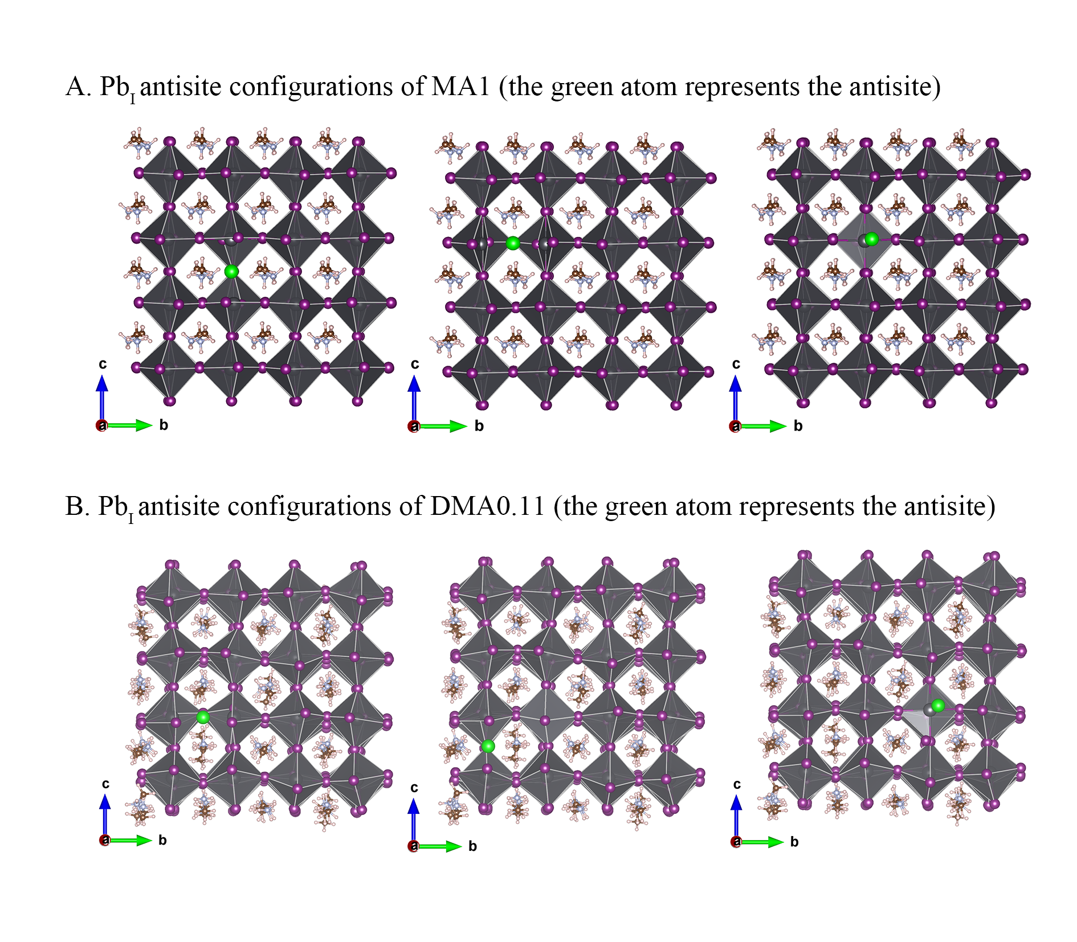

Figure S1. Structure configurations used in DFT calculations of PbI antisite formation energy. A) MA1 and b) DMA0.11 PbI antisite defect configurations. 3 different I sites were selected to be substituted by Pb atom to find the lowest defect formation energy. The defect formation energies of charged-neutral defects were obtained as:

where and is the total energy of the supercell with an without a defect respectively. is the number of atom removed from the supercell and is the is the component element in its pure phase.

Table S1. Calculated point defects formation energies at neutral charge state.

|  |  |  |
| --- | --- | --- |
| Defects | Defect formation energy of MA1 / eV | Defect formation energy of DMA0.11 / eV |
| IPb |  |  |
| PbI |  |  |
| Pbi |  |  |