

课 程 实 验 报 告

课程名称：面向对象程序设计
实验名称：继承对象的整型队列编程

院 系 ：计算机科学与技术
专业班级 ： CS1704
学 号 ： U201714626
姓 名 ： 汪清
指导教师 ： 辜希武

2019 年 12 月 14 日

- 需求分析
- 题目要求
整型队列是一种先进后出的存储结构，对其进行的操作通常包括判断队列是否为空、向队列顶添加一个整型元素、出队列等。整型队列类型及其操作函数采用面向对象的C++语言定义，请将完成上述操作的所有函数采用C++编程。然后写一个main函数对队列的所有操作函数进行测试，要求main按照《关于C++实验自动验收系统说明》给定的方式工作。注意，请用实验三的SATCK继承形成新的类QUEUE。分析说明除构造函数以外的函数，加virtual说明与不加virtual说明有无区别。并说明为什么不将s2也作为基类。
class QUEUE：public STACK{
STACK s;
public:
QUEUE(int m); //每个栈最多m个元素，要求实现的队列最多能入2m个元素
QUEUE(const QUEUE&q); //用队列q拷贝初始化队列
QUEUE(QUEUE&&q); //移动构造
virtual operator int ( ) const; //返回队列的实际元素个数
virtual int full ( ) const; //返回队列是否已满，满返回1，否则0
virtual int operator[ ](int x)const; //取下标为x的元素，第1个元素下标为0
virtual QUEUE& operator<<(int e); //将e入队列,并返回队列
virtual QUEUE& operator>>(int &e); //出队列到e,并返回队列
virtual QUEUE& operator=(const QUEUE&q); //赋q给队列,并返回被赋值队列
virtual QUEUE& operator=(QUEUE&&q) ; //移动赋值
virtual void print( ) const; //打印队列
virtual ~QUEUE( ); //销毁队列
};
注意：虽然实现的队列 最多能入2m个元素，但是由于模拟中入出操作序列的限制，即操作不能违背先进先出的原则，可能还没入2m个元素队列就“满”了，所以要注意full( )函数的实现：不能简单判断队列是否装了2m个元素。
在完成上述程序及测试无误后，请使用队列解决如下舞伴问题，此时main用非命令行的方式工作。假定在一次舞会上，男士排成一队，女士排成另一队。每次舞曲响起时，从男队和女队的队头各出一人，配成舞伴跳完此曲，跳完后各自进入自己队列的尾部。若男女两队的初始人数分别为M和F（M和F均为素数，且M!=F），男队中排在位置m（m<=M）的男士，非常想和女队位置f（f<=F）的女士跳舞，问他在第几支曲舞曲才能和该女士跳舞?请编程解决上述问题。
- 需求分析
在整型队列的实现中，对于部分方法有功能上的需求，具体需求如下：
- 对于所有分配空间的操作，在内存不足时应该抛出异常。
- 对于需要访问数组下标的操作，如operator [], operator <<，operator >>等，在下表访问越界（小于0或大于等于数组长度时应该抛出异常，包括：访问数组访问越界，队列满时尝试入队列，队列空时尝试出队列。
- 程序不能有内存泄漏，所有申请的内存最终都需要释放。
- 程序性能在要求下应该尽可能高。
- 对于舞伴问题而言，需要对输入进行合法性判断。
- 系统设计
- 概要设计
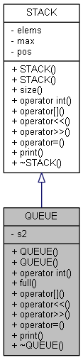 | INCLUDEPICTURE "C:\\msys64\\home\\HuSixu\\Project\\CppExperiment\\report\\temp\\doc\\html\\d5\\dbd\\class_q_u_e_u_e_a14dbdf5c5b6be50595926fa149854d5c_cgraph.png" \* MERGEFORMATINET INCLUDEPICTURE "C:\\msys64\\home\\HuSixu\\Project\\CppExperiment\\report\\temp\\doc\\html\\d5\\dbd\\class_q_u_e_u_e_a14dbdf5c5b6be50595926fa149854d5c_cgraph.png" \* MERGEFORMATINET INCLUDEPICTURE "C:\\msys64\\home\\HuSixu\\Project\\CppExperiment\\report\\temp\\doc\\html\\d5\\dbd\\class_q_u_e_u_e_a14dbdf5c5b6be50595926fa149854d5c_cgraph.png" \* MERGEFORMATINET INCLUDEPICTURE "C:\\msys64\\home\\HuSixu\\Project\\CppExperiment\\report\\temp\\doc\\html\\d5\\dbd\\class_q_u_e_u_e_a14dbdf5c5b6be50595926fa149854d5c_cgraph.png" \* MERGEFORMATINET INCLUDEPICTURE "C:\\msys64\\home\\HuSixu\\Project\\CppExperiment\\report\\temp\\doc\\html\\d5\\dbd\\class_q_u_e_u_e_a14dbdf5c5b6be50595926fa149854d5c_cgraph.png" \* MERGEFORMATINET INCLUDEPICTURE "C:\\msys64\\home\\HuSixu\\Project\\CppExperiment\\report\\temp\\doc\\html\\d5\\dbd\\class_q_u_e_u_e_a14dbdf5c5b6be50595926fa149854d5c_cgraph.png" \* MERGEFORMATINET INCLUDEPICTURE "C:\\msys64\\home\\HuSixu\\Project\\CppExperiment\\report\\temp\\doc\\html\\d5\\dbd\\class_q_u_e_u_e_a14dbdf5c5b6be50595926fa149854d5c_cgraph.png" \* MERGEFORMATINET INCLUDEPICTURE "C:\\msys64\\home\\HuSixu\\Project\\CppExperiment\\report\\temp\\doc\\html\\d5\\dbd\\class_q_u_e_u_e_a14dbdf5c5b6be50595926fa149854d5c_cgraph.png" \* MERGEFORMATINET INCLUDEPICTURE "C:\\msys64\\home\\HuSixu\\Project\\CppExperiment\\report\\temp\\doc\\html\\d5\\dbd\\class_q_u_e_u_e_a14dbdf5c5b6be50595926fa149854d5c_cgraph.png" \* MERGEFORMATINET INCLUDEPICTURE "C:\\msys64\\home\\HuSixu\\Project\\CppExperiment\\report\\temp\\doc\\html\\d5\\dbd\\class_q_u_e_u_e_a14dbdf5c5b6be50595926fa149854d5c_cgraph.png" \* MERGEFORMATINET INCLUDEPICTURE "C:\\msys64\\home\\HuSixu\\Project\\CppExperiment\\report\\temp\\doc\\html\\d5\\dbd\\class_q_u_e_u_e_a14dbdf5c5b6be50595926fa149854d5c_cgraph.png" \* MERGEFORMATINET INCLUDEPICTURE "C:\\msys64\\home\\HuSixu\\Project\\CppExperiment\\report\\temp\\doc\\html\\d5\\dbd\\class_q_u_e_u_e_a14dbdf5c5b6be50595926fa149854d5c_cgraph.png" \* MERGEFORMATINET INCLUDEPICTURE "C:\\msys64\\home\\HuSixu\\Project\\CppExperiment\\report\\temp\\doc\\html\\d5\\dbd\\class_q_u_e_u_e_a14dbdf5c5b6be50595926fa149854d5c_cgraph.png" \* MERGEFORMATINET INCLUDEPICTURE "C:\\msys64\\home\\HuSixu\\Project\\CppExperiment\\report\\temp\\doc\\html\\d5\\dbd\\class_q_u_e_u_e_a14dbdf5c5b6be50595926fa149854d5c_cgraph.png" \* MERGEFORMATINET INCLUDEPICTURE "C:\\msys64\\home\\HuSixu\\Project\\CppExperiment\\report\\temp\\doc\\html\\d5\\dbd\\class_q_u_e_u_e_a14dbdf5c5b6be50595926fa149854d5c_cgraph.png" \* MERGEFORMATINET INCLUDEPICTURE "C:\\msys64\\home\\HuSixu\\Project\\CppExperiment\\report\\temp\\doc\\html\\d5\\dbd\\class_q_u_e_u_e_a14dbdf5c5b6be50595926fa149854d5c_cgraph.png" \* MERGEFORMATINET INCLUDEPICTURE "C:\\msys64\\home\\HuSixu\\Project\\CppExperiment\\report\\temp\\doc\\html\\d5\\dbd\\class_q_u_e_u_e_a14dbdf5c5b6be50595926fa149854d5c_cgraph.png" \* MERGEFORMATINET INCLUDEPICTURE "C:\\msys64\\home\\HuSixu\\Project\\CppExperiment\\report\\temp\\doc\\html\\d5\\dbd\\class_q_u_e_u_e_a14dbdf5c5b6be50595926fa149854d5c_cgraph.png" \* MERGEFORMATINET 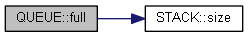
 | INCLUDEPICTURE "C:\\msys64\\home\\HuSixu\\Project\\CppExperiment\\report\\temp\\doc\\html\\d5\\dbd\\class_q_u_e_u_e_a4ebfea56851a2b04aa1c719b2feefa41_cgraph.png" \* MERGEFORMATINET INCLUDEPICTURE "C:\\msys64\\home\\HuSixu\\Project\\CppExperiment\\report\\temp\\doc\\html\\d5\\dbd\\class_q_u_e_u_e_a4ebfea56851a2b04aa1c719b2feefa41_cgraph.png" \* MERGEFORMATINET INCLUDEPICTURE "C:\\msys64\\home\\HuSixu\\Project\\CppExperiment\\report\\temp\\doc\\html\\d5\\dbd\\class_q_u_e_u_e_a4ebfea56851a2b04aa1c719b2feefa41_cgraph.png" \* MERGEFORMATINET INCLUDEPICTURE "C:\\msys64\\home\\HuSixu\\Project\\CppExperiment\\report\\temp\\doc\\html\\d5\\dbd\\class_q_u_e_u_e_a4ebfea56851a2b04aa1c719b2feefa41_cgraph.png" \* MERGEFORMATINET INCLUDEPICTURE "C:\\msys64\\home\\HuSixu\\Project\\CppExperiment\\report\\temp\\doc\\html\\d5\\dbd\\class_q_u_e_u_e_a4ebfea56851a2b04aa1c719b2feefa41_cgraph.png" \* MERGEFORMATINET INCLUDEPICTURE "C:\\msys64\\home\\HuSixu\\Project\\CppExperiment\\report\\temp\\doc\\html\\d5\\dbd\\class_q_u_e_u_e_a4ebfea56851a2b04aa1c719b2feefa41_cgraph.png" \* MERGEFORMATINET INCLUDEPICTURE "C:\\msys64\\home\\HuSixu\\Project\\CppExperiment\\report\\temp\\doc\\html\\d5\\dbd\\class_q_u_e_u_e_a4ebfea56851a2b04aa1c719b2feefa41_cgraph.png" \* MERGEFORMATINET INCLUDEPICTURE "C:\\msys64\\home\\HuSixu\\Project\\CppExperiment\\report\\temp\\doc\\html\\d5\\dbd\\class_q_u_e_u_e_a4ebfea56851a2b04aa1c719b2feefa41_cgraph.png" \* MERGEFORMATINET INCLUDEPICTURE "C:\\msys64\\home\\HuSixu\\Project\\CppExperiment\\report\\temp\\doc\\html\\d5\\dbd\\class_q_u_e_u_e_a4ebfea56851a2b04aa1c719b2feefa41_cgraph.png" \* MERGEFORMATINET INCLUDEPICTURE "C:\\msys64\\home\\HuSixu\\Project\\CppExperiment\\report\\temp\\doc\\html\\d5\\dbd\\class_q_u_e_u_e_a4ebfea56851a2b04aa1c719b2feefa41_cgraph.png" \* MERGEFORMATINET INCLUDEPICTURE "C:\\msys64\\home\\HuSixu\\Project\\CppExperiment\\report\\temp\\doc\\html\\d5\\dbd\\class_q_u_e_u_e_a4ebfea56851a2b04aa1c719b2feefa41_cgraph.png" \* MERGEFORMATINET INCLUDEPICTURE "C:\\msys64\\home\\HuSixu\\Project\\CppExperiment\\report\\temp\\doc\\html\\d5\\dbd\\class_q_u_e_u_e_a4ebfea56851a2b04aa1c719b2feefa41_cgraph.png" \* MERGEFORMATINET INCLUDEPICTURE "C:\\msys64\\home\\HuSixu\\Project\\CppExperiment\\report\\temp\\doc\\html\\d5\\dbd\\class_q_u_e_u_e_a4ebfea56851a2b04aa1c719b2feefa41_cgraph.png" \* MERGEFORMATINET INCLUDEPICTURE "C:\\msys64\\home\\HuSixu\\Project\\CppExperiment\\report\\temp\\doc\\html\\d5\\dbd\\class_q_u_e_u_e_a4ebfea56851a2b04aa1c719b2feefa41_cgraph.png" \* MERGEFORMATINET INCLUDEPICTURE "C:\\msys64\\home\\HuSixu\\Project\\CppExperiment\\report\\temp\\doc\\html\\d5\\dbd\\class_q_u_e_u_e_a4ebfea56851a2b04aa1c719b2feefa41_cgraph.png" \* MERGEFORMATINET INCLUDEPICTURE "C:\\msys64\\home\\HuSixu\\Project\\CppExperiment\\report\\temp\\doc\\html\\d5\\dbd\\class_q_u_e_u_e_a4ebfea56851a2b04aa1c719b2feefa41_cgraph.png" \* MERGEFORMATINET INCLUDEPICTURE "C:\\msys64\\home\\HuSixu\\Project\\CppExperiment\\report\\temp\\doc\\html\\d5\\dbd\\class_q_u_e_u_e_a4ebfea56851a2b04aa1c719b2feefa41_cgraph.png" \* MERGEFORMATINET INCLUDEPICTURE "C:\\msys64\\home\\HuSixu\\Project\\CppExperiment\\report\\temp\\doc\\html\\d5\\dbd\\class_q_u_e_u_e_a4ebfea56851a2b04aa1c719b2feefa41_cgraph.png" \* MERGEFORMATINET 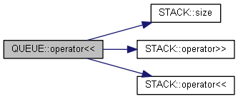
 | INCLUDEPICTURE "C:\\msys64\\home\\HuSixu\\Project\\CppExperiment\\report\\temp\\doc\\html\\d5\\dbd\\class_q_u_e_u_e_aae5e9420750df08a2358b01cf0bd8f17_cgraph.png" \* MERGEFORMATINET INCLUDEPICTURE "C:\\msys64\\home\\HuSixu\\Project\\CppExperiment\\report\\temp\\doc\\html\\d5\\dbd\\class_q_u_e_u_e_aae5e9420750df08a2358b01cf0bd8f17_cgraph.png" \* MERGEFORMATINET INCLUDEPICTURE "C:\\msys64\\home\\HuSixu\\Project\\CppExperiment\\report\\temp\\doc\\html\\d5\\dbd\\class_q_u_e_u_e_aae5e9420750df08a2358b01cf0bd8f17_cgraph.png" \* MERGEFORMATINET INCLUDEPICTURE "C:\\msys64\\home\\HuSixu\\Project\\CppExperiment\\report\\temp\\doc\\html\\d5\\dbd\\class_q_u_e_u_e_aae5e9420750df08a2358b01cf0bd8f17_cgraph.png" \* MERGEFORMATINET INCLUDEPICTURE "C:\\msys64\\home\\HuSixu\\Project\\CppExperiment\\report\\temp\\doc\\html\\d5\\dbd\\class_q_u_e_u_e_aae5e9420750df08a2358b01cf0bd8f17_cgraph.png" \* MERGEFORMATINET INCLUDEPICTURE "C:\\msys64\\home\\HuSixu\\Project\\CppExperiment\\report\\temp\\doc\\html\\d5\\dbd\\class_q_u_e_u_e_aae5e9420750df08a2358b01cf0bd8f17_cgraph.png" \* MERGEFORMATINET INCLUDEPICTURE "C:\\msys64\\home\\HuSixu\\Project\\CppExperiment\\report\\temp\\doc\\html\\d5\\dbd\\class_q_u_e_u_e_aae5e9420750df08a2358b01cf0bd8f17_cgraph.png" \* MERGEFORMATINET INCLUDEPICTURE "C:\\msys64\\home\\HuSixu\\Project\\CppExperiment\\report\\temp\\doc\\html\\d5\\dbd\\class_q_u_e_u_e_aae5e9420750df08a2358b01cf0bd8f17_cgraph.png" \* MERGEFORMATINET INCLUDEPICTURE "C:\\msys64\\home\\HuSixu\\Project\\CppExperiment\\report\\temp\\doc\\html\\d5\\dbd\\class_q_u_e_u_e_aae5e9420750df08a2358b01cf0bd8f17_cgraph.png" \* MERGEFORMATINET INCLUDEPICTURE "C:\\msys64\\home\\HuSixu\\Project\\CppExperiment\\report\\temp\\doc\\html\\d5\\dbd\\class_q_u_e_u_e_aae5e9420750df08a2358b01cf0bd8f17_cgraph.png" \* MERGEFORMATINET INCLUDEPICTURE "C:\\msys64\\home\\HuSixu\\Project\\CppExperiment\\report\\temp\\doc\\html\\d5\\dbd\\class_q_u_e_u_e_aae5e9420750df08a2358b01cf0bd8f17_cgraph.png" \* MERGEFORMATINET INCLUDEPICTURE "C:\\msys64\\home\\HuSixu\\Project\\CppExperiment\\report\\temp\\doc\\html\\d5\\dbd\\class_q_u_e_u_e_aae5e9420750df08a2358b01cf0bd8f17_cgraph.png" \* MERGEFORMATINET INCLUDEPICTURE "C:\\msys64\\home\\HuSixu\\Project\\CppExperiment\\report\\temp\\doc\\html\\d5\\dbd\\class_q_u_e_u_e_aae5e9420750df08a2358b01cf0bd8f17_cgraph.png" \* MERGEFORMATINET INCLUDEPICTURE "C:\\msys64\\home\\HuSixu\\Project\\CppExperiment\\report\\temp\\doc\\html\\d5\\dbd\\class_q_u_e_u_e_aae5e9420750df08a2358b01cf0bd8f17_cgraph.png" \* MERGEFORMATINET INCLUDEPICTURE "C:\\msys64\\home\\HuSixu\\Project\\CppExperiment\\report\\temp\\doc\\html\\d5\\dbd\\class_q_u_e_u_e_aae5e9420750df08a2358b01cf0bd8f17_cgraph.png" \* MERGEFORMATINET INCLUDEPICTURE "C:\\msys64\\home\\HuSixu\\Project\\CppExperiment\\report\\temp\\doc\\html\\d5\\dbd\\class_q_u_e_u_e_aae5e9420750df08a2358b01cf0bd8f17_cgraph.png" \* MERGEFORMATINET INCLUDEPICTURE "C:\\msys64\\home\\HuSixu\\Project\\CppExperiment\\report\\temp\\doc\\html\\d5\\dbd\\class_q_u_e_u_e_aae5e9420750df08a2358b01cf0bd8f17_cgraph.png" \* MERGEFORMATINET INCLUDEPICTURE "C:\\msys64\\home\\HuSixu\\Project\\CppExperiment\\report\\temp\\doc\\html\\d5\\dbd\\class_q_u_e_u_e_aae5e9420750df08a2358b01cf0bd8f17_cgraph.png" \* MERGEFORMATINET 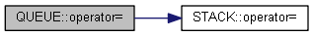
 | INCLUDEPICTURE "C:\\msys64\\home\\HuSixu\\Project\\CppExperiment\\report\\temp\\doc\\html\\d5\\dbd\\class_q_u_e_u_e_a578a6367b781d8aa471828fd2bb45fa4_cgraph.png" \* MERGEFORMATINET INCLUDEPICTURE "C:\\msys64\\home\\HuSixu\\Project\\CppExperiment\\report\\temp\\doc\\html\\d5\\dbd\\class_q_u_e_u_e_a578a6367b781d8aa471828fd2bb45fa4_cgraph.png" \* MERGEFORMATINET INCLUDEPICTURE "C:\\msys64\\home\\HuSixu\\Project\\CppExperiment\\report\\temp\\doc\\html\\d5\\dbd\\class_q_u_e_u_e_a578a6367b781d8aa471828fd2bb45fa4_cgraph.png" \* MERGEFORMATINET INCLUDEPICTURE "C:\\msys64\\home\\HuSixu\\Project\\CppExperiment\\report\\temp\\doc\\html\\d5\\dbd\\class_q_u_e_u_e_a578a6367b781d8aa471828fd2bb45fa4_cgraph.png" \* MERGEFORMATINET INCLUDEPICTURE "C:\\msys64\\home\\HuSixu\\Project\\CppExperiment\\report\\temp\\doc\\html\\d5\\dbd\\class_q_u_e_u_e_a578a6367b781d8aa471828fd2bb45fa4_cgraph.png" \* MERGEFORMATINET INCLUDEPICTURE "C:\\msys64\\home\\HuSixu\\Project\\CppExperiment\\report\\temp\\doc\\html\\d5\\dbd\\class_q_u_e_u_e_a578a6367b781d8aa471828fd2bb45fa4_cgraph.png" \* MERGEFORMATINET INCLUDEPICTURE "C:\\msys64\\home\\HuSixu\\Project\\CppExperiment\\report\\temp\\doc\\html\\d5\\dbd\\class_q_u_e_u_e_a578a6367b781d8aa471828fd2bb45fa4_cgraph.png" \* MERGEFORMATINET INCLUDEPICTURE "C:\\msys64\\home\\HuSixu\\Project\\CppExperiment\\report\\temp\\doc\\html\\d5\\dbd\\class_q_u_e_u_e_a578a6367b781d8aa471828fd2bb45fa4_cgraph.png" \* MERGEFORMATINET INCLUDEPICTURE "C:\\msys64\\home\\HuSixu\\Project\\CppExperiment\\report\\temp\\doc\\html\\d5\\dbd\\class_q_u_e_u_e_a578a6367b781d8aa471828fd2bb45fa4_cgraph.png" \* MERGEFORMATINET INCLUDEPICTURE "C:\\msys64\\home\\HuSixu\\Project\\CppExperiment\\report\\temp\\doc\\html\\d5\\dbd\\class_q_u_e_u_e_a578a6367b781d8aa471828fd2bb45fa4_cgraph.png" \* MERGEFORMATINET INCLUDEPICTURE "C:\\msys64\\home\\HuSixu\\Project\\CppExperiment\\report\\temp\\doc\\html\\d5\\dbd\\class_q_u_e_u_e_a578a6367b781d8aa471828fd2bb45fa4_cgraph.png" \* MERGEFORMATINET INCLUDEPICTURE "C:\\msys64\\home\\HuSixu\\Project\\CppExperiment\\report\\temp\\doc\\html\\d5\\dbd\\class_q_u_e_u_e_a578a6367b781d8aa471828fd2bb45fa4_cgraph.png" \* MERGEFORMATINET INCLUDEPICTURE "C:\\msys64\\home\\HuSixu\\Project\\CppExperiment\\report\\temp\\doc\\html\\d5\\dbd\\class_q_u_e_u_e_a578a6367b781d8aa471828fd2bb45fa4_cgraph.png" \* MERGEFORMATINET INCLUDEPICTURE "C:\\msys64\\home\\HuSixu\\Project\\CppExperiment\\report\\temp\\doc\\html\\d5\\dbd\\class_q_u_e_u_e_a578a6367b781d8aa471828fd2bb45fa4_cgraph.png" \* MERGEFORMATINET INCLUDEPICTURE "C:\\msys64\\home\\HuSixu\\Project\\CppExperiment\\report\\temp\\doc\\html\\d5\\dbd\\class_q_u_e_u_e_a578a6367b781d8aa471828fd2bb45fa4_cgraph.png" \* MERGEFORMATINET INCLUDEPICTURE "C:\\msys64\\home\\HuSixu\\Project\\CppExperiment\\report\\temp\\doc\\html\\d5\\dbd\\class_q_u_e_u_e_a578a6367b781d8aa471828fd2bb45fa4_cgraph.png" \* MERGEFORMATINET INCLUDEPICTURE "C:\\msys64\\home\\HuSixu\\Project\\CppExperiment\\report\\temp\\doc\\html\\d5\\dbd\\class_q_u_e_u_e_a578a6367b781d8aa471828fd2bb45fa4_cgraph.png" \* MERGEFORMATINET INCLUDEPICTURE "C:\\msys64\\home\\HuSixu\\Project\\CppExperiment\\report\\temp\\doc\\html\\d5\\dbd\\class_q_u_e_u_e_a578a6367b781d8aa471828fd2bb45fa4_cgraph.png" \* MERGEFORMATINET 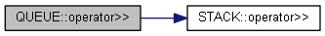
 | INCLUDEPICTURE "C:\\msys64\\home\\HuSixu\\Project\\CppExperiment\\report\\temp\\doc\\html\\d5\\dbd\\class_q_u_e_u_e_a2447a839b2b020724dbec2ba7a73aae0_cgraph.png" \* MERGEFORMATINET INCLUDEPICTURE "C:\\msys64\\home\\HuSixu\\Project\\CppExperiment\\report\\temp\\doc\\html\\d5\\dbd\\class_q_u_e_u_e_a2447a839b2b020724dbec2ba7a73aae0_cgraph.png" \* MERGEFORMATINET INCLUDEPICTURE "C:\\msys64\\home\\HuSixu\\Project\\CppExperiment\\report\\temp\\doc\\html\\d5\\dbd\\class_q_u_e_u_e_a2447a839b2b020724dbec2ba7a73aae0_cgraph.png" \* MERGEFORMATINET INCLUDEPICTURE "C:\\msys64\\home\\HuSixu\\Project\\CppExperiment\\report\\temp\\doc\\html\\d5\\dbd\\class_q_u_e_u_e_a2447a839b2b020724dbec2ba7a73aae0_cgraph.png" \* MERGEFORMATINET INCLUDEPICTURE "C:\\msys64\\home\\HuSixu\\Project\\CppExperiment\\report\\temp\\doc\\html\\d5\\dbd\\class_q_u_e_u_e_a2447a839b2b020724dbec2ba7a73aae0_cgraph.png" \* MERGEFORMATINET INCLUDEPICTURE "C:\\msys64\\home\\HuSixu\\Project\\CppExperiment\\report\\temp\\doc\\html\\d5\\dbd\\class_q_u_e_u_e_a2447a839b2b020724dbec2ba7a73aae0_cgraph.png" \* MERGEFORMATINET INCLUDEPICTURE "C:\\msys64\\home\\HuSixu\\Project\\CppExperiment\\report\\temp\\doc\\html\\d5\\dbd\\class_q_u_e_u_e_a2447a839b2b020724dbec2ba7a73aae0_cgraph.png" \* MERGEFORMATINET INCLUDEPICTURE "C:\\msys64\\home\\HuSixu\\Project\\CppExperiment\\report\\temp\\doc\\html\\d5\\dbd\\class_q_u_e_u_e_a2447a839b2b020724dbec2ba7a73aae0_cgraph.png" \* MERGEFORMATINET INCLUDEPICTURE "C:\\msys64\\home\\HuSixu\\Project\\CppExperiment\\report\\temp\\doc\\html\\d5\\dbd\\class_q_u_e_u_e_a2447a839b2b020724dbec2ba7a73aae0_cgraph.png" \* MERGEFORMATINET INCLUDEPICTURE "C:\\msys64\\home\\HuSixu\\Project\\CppExperiment\\report\\temp\\doc\\html\\d5\\dbd\\class_q_u_e_u_e_a2447a839b2b020724dbec2ba7a73aae0_cgraph.png" \* MERGEFORMATINET INCLUDEPICTURE "C:\\msys64\\home\\HuSixu\\Project\\CppExperiment\\report\\temp\\doc\\html\\d5\\dbd\\class_q_u_e_u_e_a2447a839b2b020724dbec2ba7a73aae0_cgraph.png" \* MERGEFORMATINET INCLUDEPICTURE "C:\\msys64\\home\\HuSixu\\Project\\CppExperiment\\report\\temp\\doc\\html\\d5\\dbd\\class_q_u_e_u_e_a2447a839b2b020724dbec2ba7a73aae0_cgraph.png" \* MERGEFORMATINET INCLUDEPICTURE "C:\\msys64\\home\\HuSixu\\Project\\CppExperiment\\report\\temp\\doc\\html\\d5\\dbd\\class_q_u_e_u_e_a2447a839b2b020724dbec2ba7a73aae0_cgraph.png" \* MERGEFORMATINET INCLUDEPICTURE "C:\\msys64\\home\\HuSixu\\Project\\CppExperiment\\report\\temp\\doc\\html\\d5\\dbd\\class_q_u_e_u_e_a2447a839b2b020724dbec2ba7a73aae0_cgraph.png" \* MERGEFORMATINET INCLUDEPICTURE "C:\\msys64\\home\\HuSixu\\Project\\CppExperiment\\report\\temp\\doc\\html\\d5\\dbd\\class_q_u_e_u_e_a2447a839b2b020724dbec2ba7a73aae0_cgraph.png" \* MERGEFORMATINET INCLUDEPICTURE "C:\\msys64\\home\\HuSixu\\Project\\CppExperiment\\report\\temp\\doc\\html\\d5\\dbd\\class_q_u_e_u_e_a2447a839b2b020724dbec2ba7a73aae0_cgraph.png" \* MERGEFORMATINET INCLUDEPICTURE "C:\\msys64\\home\\HuSixu\\Project\\CppExperiment\\report\\temp\\doc\\html\\d5\\dbd\\class_q_u_e_u_e_a2447a839b2b020724dbec2ba7a73aae0_cgraph.png" \* MERGEFORMATINET INCLUDEPICTURE "C:\\msys64\\home\\HuSixu\\Project\\CppExperiment\\report\\temp\\doc\\html\\d5\\dbd\\class_q_u_e_u_e_a2447a839b2b020724dbec2ba7a73aae0_cgraph.png" \* MERGEFORMATINET 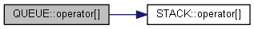
 | INCLUDEPICTURE "C:\\msys64\\home\\HuSixu\\Project\\CppExperiment\\report\\temp\\doc\\html\\d5\\dbd\\class_q_u_e_u_e_a8be99c66ddd6e99d836f2aa62b6cccd4_cgraph.png" \* MERGEFORMATINET INCLUDEPICTURE "C:\\msys64\\home\\HuSixu\\Project\\CppExperiment\\report\\temp\\doc\\html\\d5\\dbd\\class_q_u_e_u_e_a8be99c66ddd6e99d836f2aa62b6cccd4_cgraph.png" \* MERGEFORMATINET INCLUDEPICTURE "C:\\msys64\\home\\HuSixu\\Project\\CppExperiment\\report\\temp\\doc\\html\\d5\\dbd\\class_q_u_e_u_e_a8be99c66ddd6e99d836f2aa62b6cccd4_cgraph.png" \* MERGEFORMATINET INCLUDEPICTURE "C:\\msys64\\home\\HuSixu\\Project\\CppExperiment\\report\\temp\\doc\\html\\d5\\dbd\\class_q_u_e_u_e_a8be99c66ddd6e99d836f2aa62b6cccd4_cgraph.png" \* MERGEFORMATINET INCLUDEPICTURE "C:\\msys64\\home\\HuSixu\\Project\\CppExperiment\\report\\temp\\doc\\html\\d5\\dbd\\class_q_u_e_u_e_a8be99c66ddd6e99d836f2aa62b6cccd4_cgraph.png" \* MERGEFORMATINET INCLUDEPICTURE "C:\\msys64\\home\\HuSixu\\Project\\CppExperiment\\report\\temp\\doc\\html\\d5\\dbd\\class_q_u_e_u_e_a8be99c66ddd6e99d836f2aa62b6cccd4_cgraph.png" \* MERGEFORMATINET INCLUDEPICTURE "C:\\msys64\\home\\HuSixu\\Project\\CppExperiment\\report\\temp\\doc\\html\\d5\\dbd\\class_q_u_e_u_e_a8be99c66ddd6e99d836f2aa62b6cccd4_cgraph.png" \* MERGEFORMATINET INCLUDEPICTURE "C:\\msys64\\home\\HuSixu\\Project\\CppExperiment\\report\\temp\\doc\\html\\d5\\dbd\\class_q_u_e_u_e_a8be99c66ddd6e99d836f2aa62b6cccd4_cgraph.png" \* MERGEFORMATINET INCLUDEPICTURE "C:\\msys64\\home\\HuSixu\\Project\\CppExperiment\\report\\temp\\doc\\html\\d5\\dbd\\class_q_u_e_u_e_a8be99c66ddd6e99d836f2aa62b6cccd4_cgraph.png" \* MERGEFORMATINET INCLUDEPICTURE "C:\\msys64\\home\\HuSixu\\Project\\CppExperiment\\report\\temp\\doc\\html\\d5\\dbd\\class_q_u_e_u_e_a8be99c66ddd6e99d836f2aa62b6cccd4_cgraph.png" \* MERGEFORMATINET INCLUDEPICTURE "C:\\msys64\\home\\HuSixu\\Project\\CppExperiment\\report\\temp\\doc\\html\\d5\\dbd\\class_q_u_e_u_e_a8be99c66ddd6e99d836f2aa62b6cccd4_cgraph.png" \* MERGEFORMATINET INCLUDEPICTURE "C:\\msys64\\home\\HuSixu\\Project\\CppExperiment\\report\\temp\\doc\\html\\d5\\dbd\\class_q_u_e_u_e_a8be99c66ddd6e99d836f2aa62b6cccd4_cgraph.png" \* MERGEFORMATINET INCLUDEPICTURE "C:\\msys64\\home\\HuSixu\\Project\\CppExperiment\\report\\temp\\doc\\html\\d5\\dbd\\class_q_u_e_u_e_a8be99c66ddd6e99d836f2aa62b6cccd4_cgraph.png" \* MERGEFORMATINET INCLUDEPICTURE "C:\\msys64\\home\\HuSixu\\Project\\CppExperiment\\report\\temp\\doc\\html\\d5\\dbd\\class_q_u_e_u_e_a8be99c66ddd6e99d836f2aa62b6cccd4_cgraph.png" \* MERGEFORMATINET INCLUDEPICTURE "C:\\msys64\\home\\HuSixu\\Project\\CppExperiment\\report\\temp\\doc\\html\\d5\\dbd\\class_q_u_e_u_e_a8be99c66ddd6e99d836f2aa62b6cccd4_cgraph.png" \* MERGEFORMATINET INCLUDEPICTURE "C:\\msys64\\home\\HuSixu\\Project\\CppExperiment\\report\\temp\\doc\\html\\d5\\dbd\\class_q_u_e_u_e_a8be99c66ddd6e99d836f2aa62b6cccd4_cgraph.png" \* MERGEFORMATINET INCLUDEPICTURE "C:\\msys64\\home\\HuSixu\\Project\\CppExperiment\\report\\temp\\doc\\html\\d5\\dbd\\class_q_u_e_u_e_a8be99c66ddd6e99d836f2aa62b6cccd4_cgraph.png" \* MERGEFORMATINET INCLUDEPICTURE "C:\\msys64\\home\\HuSixu\\Project\\CppExperiment\\report\\temp\\doc\\html\\d5\\dbd\\class_q_u_e_u_e_a8be99c66ddd6e99d836f2aa62b6cccd4_cgraph.png" \* MERGEFORMATINET 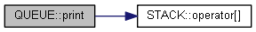
图 1 模块——调用关系图
由于要使用栈来实现队列，按照给定的接口形式，队列的结构应该为：使用QUEUE类继承STACK类，并让这个QUEUE类持有另一个STACK实例，然后通过STACK的入栈和出栈方法，通过将元素在两个栈之间交换来实现入队列和出队列的过程。
具体模块关系如下：首先定义栈类，在其中定义构造函数，复制构造函数，析构函数，size()， operator int， operator []， operator <<， operator >>， operator =， print方法。栈类作为基类，在其上公有派生出队列类并让这个队列类持有另外一个栈类，这样这一队列类中就包含了继承而来的和作为成员的两个栈类， 然后通过栈的方法来实现队列类的方法。栈类的所有方法均为虚方法，队列的方法重载了栈的方法，因此在操作继承而来的栈时，需要显式地调用父类的方法以避免歧义。总体的模块图以及调用关系图如图 1所示
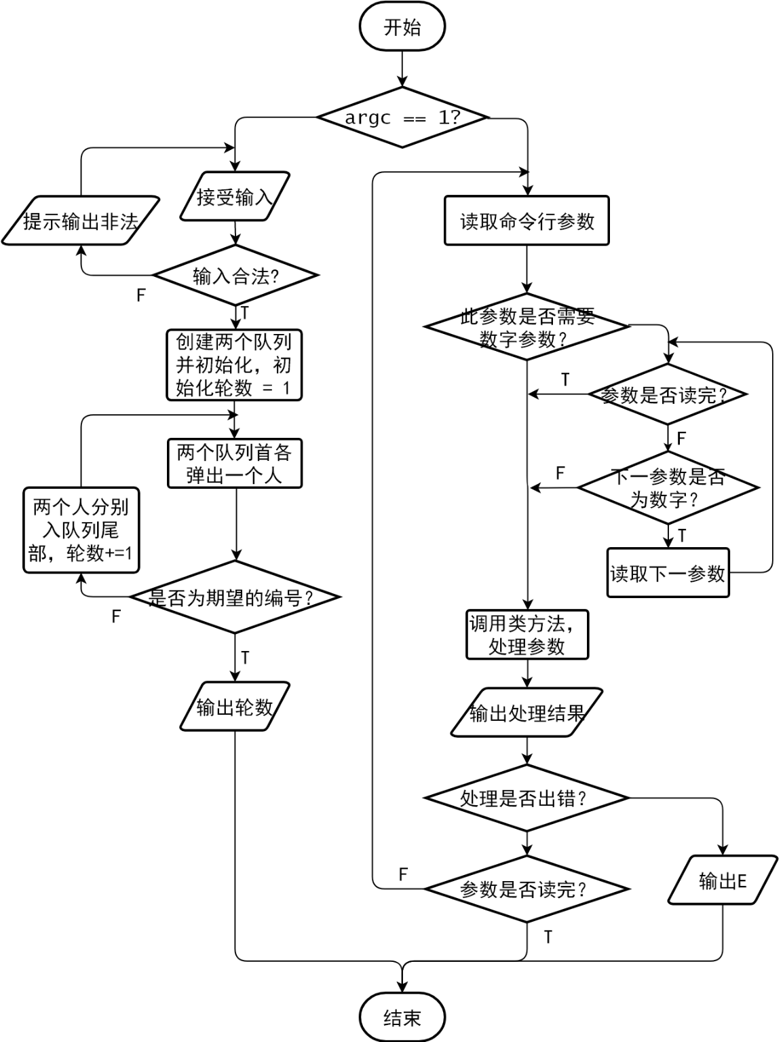
图 2 总体流程图
对于主函数而言，其总体流程如下：首先读取argc判断参数的个数，若没有参数（argc == 1）则执行舞伴问题，否则执行对于队列类的测试。总体的流程图框架如图 2所示。
对于舞伴问题而言，首先要接受4个输入，然后判断输入是否合法，包括判断男士和女士人数是否为质数，m和f是否越界等，若输入不合法，需要提示用户重新输入。若输入检查无误，则初始化两个队列代表男士和女士，大小分别为输入的两个人数，并将两个队列按1, 2, 3, … 的顺序初始化，并初始化计数器为1。在每一轮分别从两队列首弹出两个元素，若两个元素的值分别为m和f，则代表男士m和女士f成功跳上舞，输出计数器的值并结束程序，否则将弹出的值压入队列尾部，计数器加一并进行下一轮模拟。
当argc不为1时进行自动测试，开始逐个读入参数。对于要读入的字母参数分为两类，一类如 -I 等后面需要接一个或多个数字的参数，另一类如-N等后面不需要接数字，依次为依据决定是否继续读入参数。当一组参数读入完成后，调用需要用于测试的类方法来测试参数，如果在测试中出现错误，则输出E并停止测试，否则按照测试的需求输出测试结果并继续测试，直到全部参数读完或出现错误。
- 详细设计
以下展示了STACK和QUQUE类各个类方法的程序说明，入口参数说明，出口参数（返回值）说明，并对每个方法方法给出了详细的解释和流程图。

STACK部分
栈使用整型数组elems实现，在构造时指定其大小并分配空间，并在析构时销毁。使用两个辅助成员pos和max用于指定当前栈中的元素个数和栈的容量。在构造时pos初始化为0并随着入栈和出栈而变化，在入栈时pos自增，在出栈时pos自减，max为const值，初始化为一固定大小后不再变化，栈的结构如图 3所示。
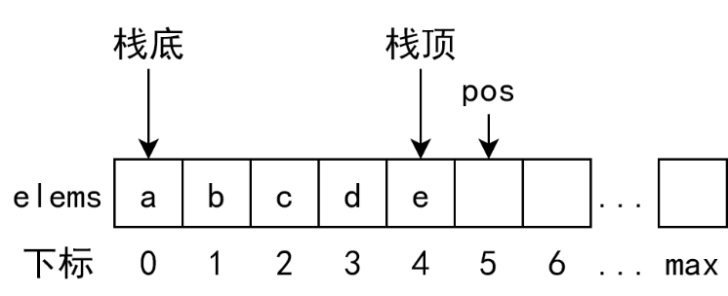
图 3 栈的结构

- STACK::STACK(int m)
参数： m:栈的大小
返回： 构造函数无返回值
说明： 构造函数，构造一个栈并将其大小初始化为m。
流程： 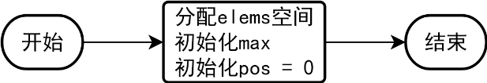

- STACK::STACK(const STACK &s)
参数： s:要复制的栈
返回： 构造函数无返回值
说明： 复制构造函数，构造一个大小与s相同的栈并将s中的元素拷贝到新栈中。
流程： 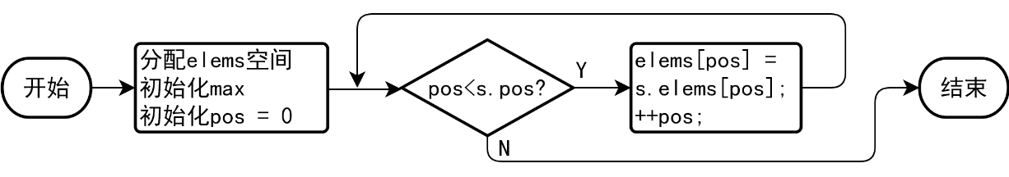

- STACK::~STACK()
参数： 析构函数无参数
返回： 析构函数无返回值
说明： 析构函数，销毁当前栈并释放构造时所申请的栈空间。
流程： 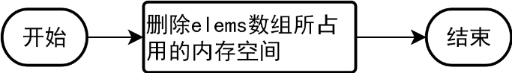

- STACK::operator int() const
参数： 无
返回： 栈中元素的个数
说明： 重载int()运算符，获取当前的栈中所存放的元素个数。
流程： 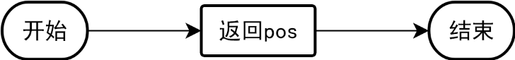

- STACK &STACK::operator<<(int e)
参数： e:将要压入栈中的元素
返回： 栈本身
说明： 重载<<运算符，将元素e压入栈顶，并返回栈本身。
异常： 当栈空间已满时，抛出std::logic_error异常。
流程： 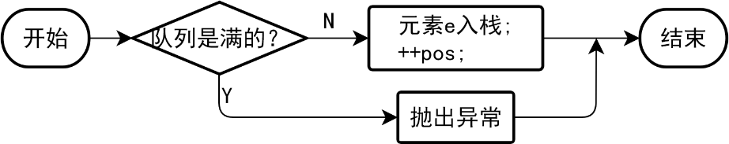

- STACK &STACK::operator>>(int &e)
参数： e:弹出的元素
返回： 栈本身
说明： 重载>>运算符，弹出栈顶的元素，将其赋值给e，并返回栈本身。
异常： 当栈为空时，抛出std::logic_error异常。
流程： 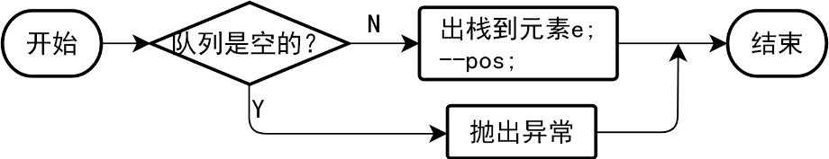

- STACK &STACK::operator=(const STACK &s)
参数： s:被复制的栈
返回： 栈本身
说明： 重载=运算符，将本栈的大小更改为与栈s的大小相同，然后将栈s的内容赋值给本栈，并返回本栈。由于栈的大小是由const int max指定的，在更改max的值时需要首先使用const_cast获得一个指向max的非const指针再赋值。此过程需要删除原来的数组空间并重新分配空间。
流程： 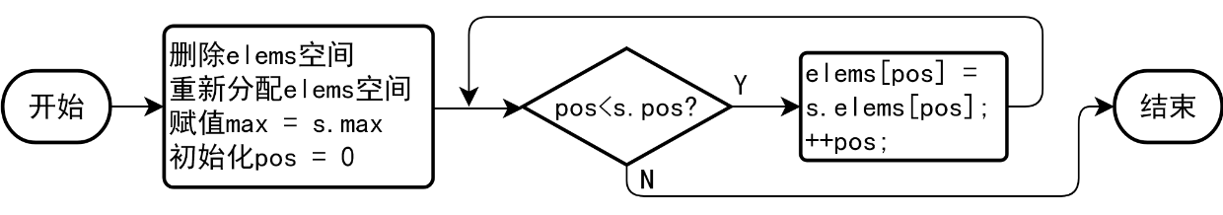

- int STACK::operator[](int x) const
参数： x:所取值的下标
返回： 栈中下标为x的值
说明： 重载[]运算符，取栈中下标为x的元素并返回其值。
异常： 当x越界时（即x<0或x≥pos）则抛出std::logic_error异常。
流程： 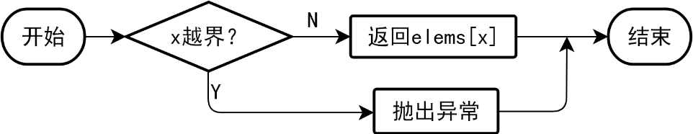

- int STACK::size() const
参数： 无
返回： 栈的容量
说明： 直接返回max，即栈可以容纳的元素个数。
流程： 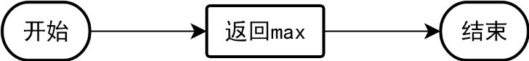

- void STACK::print() const
参数： 无
返回： 无
说明： 遍历成员数组，并打印其中存放的元素，每两个元素间有两个空格。
流程： 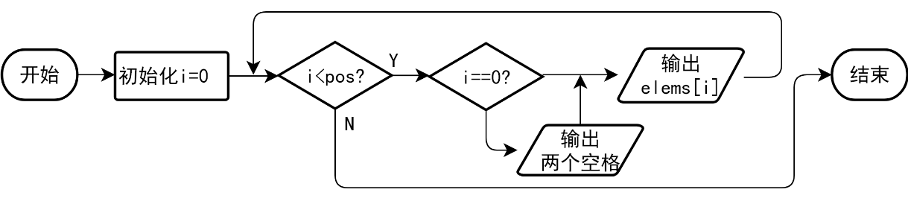

QUEUE部分
QUEUE使用两个STACK来实现。QUEUE类继承STACK类，并在QUEUE类中有一个STACK成员，即在实例化后QUEUE示例内含有一个继承而来的STACK和一个持有的STACK s2，以下分别称为STACKin和STACKout。STACK0用于入队列，STACKout用于出队列。即在尝试将元素加入队列尾时队列总是尝试将其压入STACKin，而在尝试出队列时总是尝试从STACKout弹出元素。队列的结构如图 4所示。
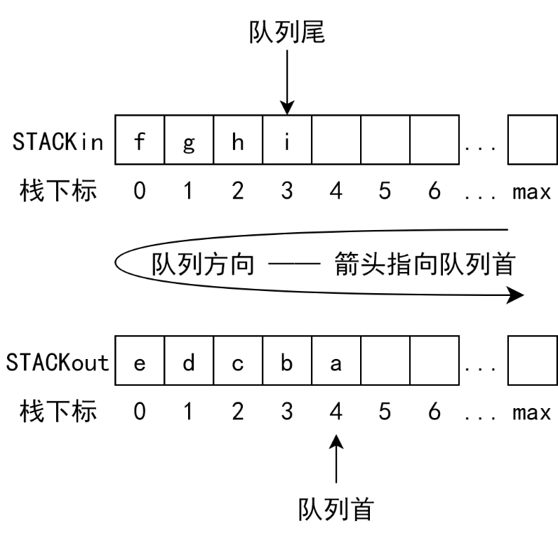
图 4 队列结构

- QUEUE::QUEUE(int m)
参数： m:队列中栈的大小（队列大小为2m）
返回： 构造函数无返回值
说明： 构造函数，构造一个队列并初始化其继承而来的栈和其持有的栈大小均为m，这样此队列最多能存放2m个元素，初始化栈时在初始化列表中直接调用栈的构造函数。
流程： 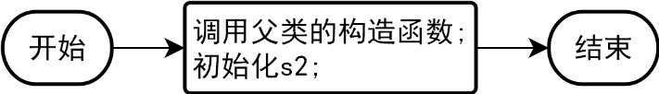

- QUEUE::QUEUE(const QUEUE &s)
参数： s:要复制的队列
返回： 构造函数无返回值
说明： 复制构造函数，构造一个大小和内容与s均相同的队列。直接在初始化列表中调用栈的复制构造函数分别构造本队列继承而来的栈和持有的栈。
流程： 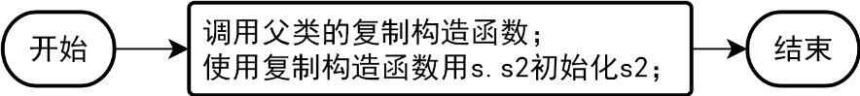

- QUEUE::~QUQUE()
参数： 析构函数无参数
返回： 析构函数无返回值
说明： 析构函数，销毁当前队列并释放构造时所申请的空间。对于持有的栈和继承而来的栈而言，在销毁本队列时会自动为成员变量以及基类调用其析构函数，因此不用手动销毁，直接返回即可。
流程： 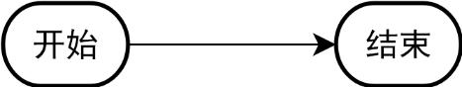

- int QUEUE::full() const
参数： 无
返回： 若当前队列已满则返回1，否则返回0
说明： 由于队列使用两个栈实现，用于判断队列已满的依据并不是直接判断两个栈是否分别为满，而是队列是否还能压入元素。由于STACKin用于入队列，而STACKout用于出队列，那么当继承的为满且STACKout为空的时候不能再向队列尾部添加元素。因为此时不能将继承的栈的元素转移到STACKout中。除此以外的情况均可以再向队列尾部添加元素。
流程： 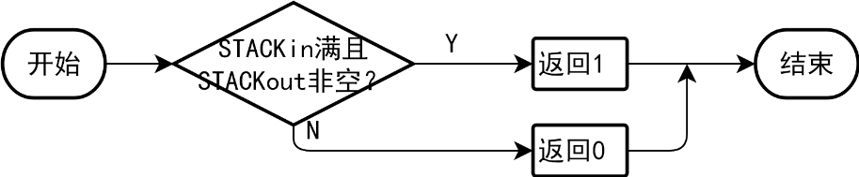

- QUEUE::operator int() const
参数： 无
返回： 队列中元素的个数
说明： 重载int()运算符，返回队列中元素的个数，即两个栈中的元素个数之和。
流程：

- QUEUE &QUEUE::operator<<(int e)
参数： e:插入队列尾部的元素
返回： 队列本身
说明： 重载<<运算符，将e插入队列的尾部，并返回队列本身。在尝试入队列时，STACKin和STAK1只可能处于如下3种状态：
1)STACKin未满
2)STACKin满且STACKout空
3)STACKin满且STACKout非空
第一种情况下可以直接将元素压入STACKin。第二种情况下可先将STACKin中的元素依次全部转移到STACKout中，然后将元素压入STACKin。第三种情况下队列将被判断为满的，不能入栈。
异常： 当队列满时将抛出logic_error异常。
流程： 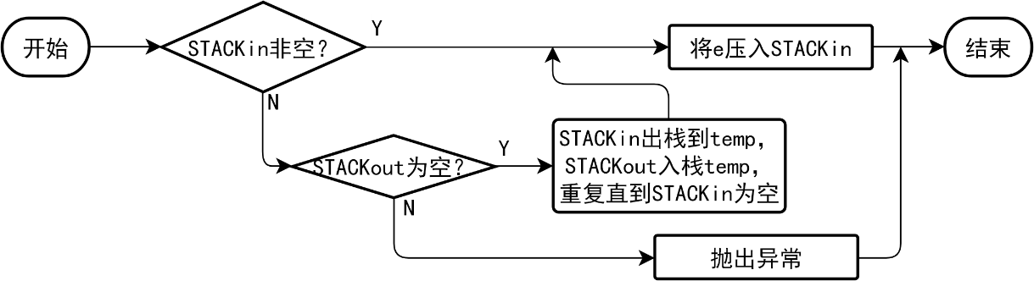

- QUEUE &QUEUE::operator>>(int &e)
参数： e:弹出队列的元素
返回： 队列本身
说明： 重载>>运算符，从队列首弹出一个元素并赋值给e，然后返回队列本身。在尝试出队列时，STACKin和STACKout只可能处于如下3种状态：
1)STACKout非空
2)STACKout空且STACKin非空
3)STACKout空且STACKin空
第一种情况下可以直接从STACKout中弹出元素。第二种情况下可先将STACKin中的元素依次全部转移到STACKout中，然后从STACKout中弹出元素。第三种情况下队列将被判断为空，不能弹出。
异常： 当队列为空时将抛出logic_error异常。
流程： 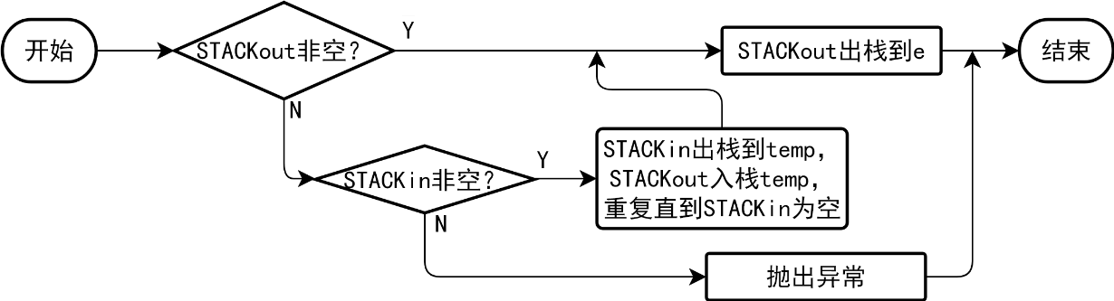

- QUEUE &QUEUE::operator=(const QUEUE &s)
参数： s:被复制的队列
返回： 队列本身
说明： 重载=运算符，将本队列的大小更改为与队列s的大小相同，然后将队列s的内容赋值给本队列，并返回本队列。直接调用STACK::operator=()将STACKin和STACKout分别复制一份即可。
流程： 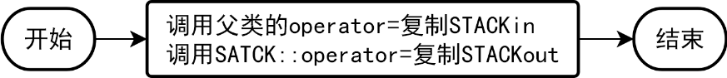

- int QUEUE::operator[](int x) const
参数： x:要取出的元素的下标
返回： 队列中下标为x的元素的值
说明： 重载[]运算符，取出从队列首开始计数的下标为x的元素值并将其返回。由于队列是由两个栈实现的，因此不能够直接从栈的数组中取元素，而要进行计算。尝试取元素时，有3种可能：
1)x小于STACKout中元素的个数
2)x大于或等于STACKout中元素的个数
3)x越界(x<0或x≥队列中的元素个数)
由于队列首是从STACKout开始计算的，因此在第一种情况下，要取出的元素在STACKout中，直接从STACKout中取出第x-int(STACKout)个元素即可。第二种情况下要取出的元素在STACKin中，需要取出STACKin中的第int(STACKout)-x-1个元素。第三种情况直接抛出异常。
异常：当x越界(x<0或x≥队列中的元素个数)时抛出std::logic_error异常。
流程： 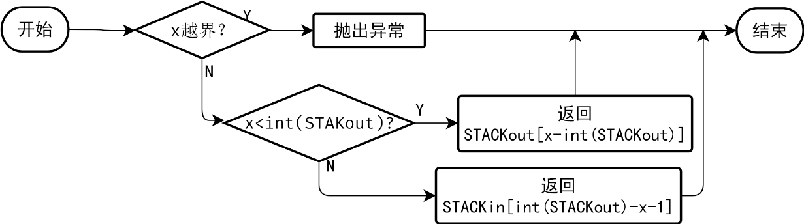

- void QUEUE::print() const
参数： 无
返回： 无
说明： 从队列首遍历到队列尾，并打印每一个存放的元素，每两个元素间有两个空格。由于队列首位于STACKout的栈顶，而队列尾位于STACKin的栈底，因此从s2开始反向遍历，完成后正向遍历s1中的元素。
流程：

Utils部分
Utils命名空间提供了两个工具函数：convertToInt和isPrime，供main函数使用。

- bool Utils::convertToInt(const std::string &s, const &out)
参数： s:输入字符串
out:转换结果
返回： 转换是否成功，成功则返回true，否则返回false
说明： 此函数用于命令行处理，尝试将字符串s的内容转换为整型并存储于out中。调用标准库的stoi进行实现并尝试捕获invalid_argument和out_of_range异常。若捕获到异常则说明转换出现错误，返回false，否则返回true。
流程： 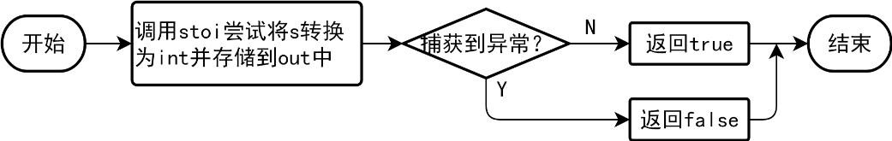

- bool Utils::isPrime(const int a)
参数： a:用于判断的数
返回： a是否为质数，是则返回true，否则返回false
说明： 此函数用于舞伴问题判断输入是否为质数，通过计算a对从2到每一个数的模来判断a是否为质数。
流程： 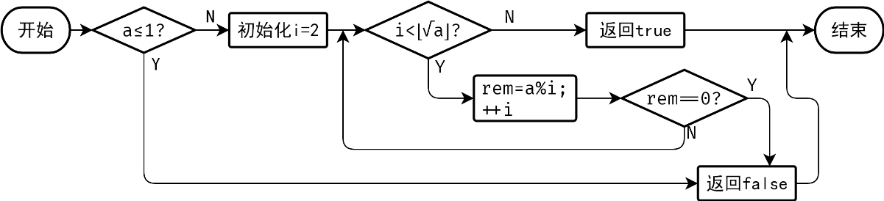
- 软件开发
开发编译软件：vs2017
测试软件：checksystem_v3.0
- 软件测试
自动测试部分
这一部分测试当argc!=1时的程序功能。包括了对于每一个类方法的正确性测试。通过修改命令行参数并比较程序运行结果和标准程序运行结果来判断程序是否运行正确。为了节省篇幅，直接将如图 5所示的测试结果的输出部分复制到输出部分，而不再单独给出截图。

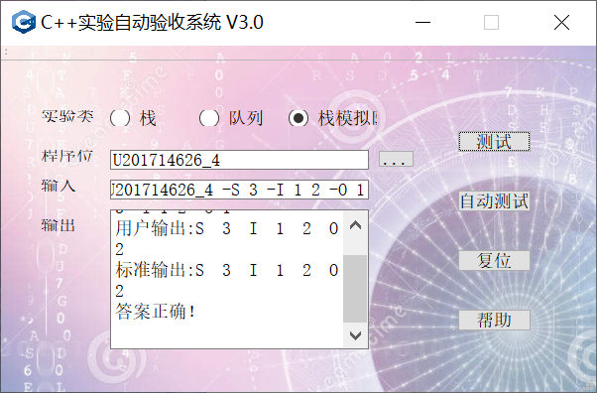
图 5 输出界面样例
- 设定队列大小测试
输入：-S 1
用户输出：S 1
标准输出：S 1

输入：-S 100
用户输出：S 100
标准输出：S 100

输入：-S 0
用户输出：S 0
标准输出：S E

可以看出，在输入大于0的情况下程序正确地创建了指定大小的栈，并正确地进行了输出。而当S后面为0的时候程序输出S 0，标准程序输出S E。由于题目要求中没有规定队列大小为0时程序的行为，也没有规定不允许出现大小为0的队列，因此认为是未定义行为，这种边界情况不予考虑。

- 入队列测试
输入：-S 3 -I 1 2 3
用户输出：S 3 I 1 2 3
标准输出：S 3 I 1 2 3

输入：-S 3 -I 1 2 3 4 5 6 7
用户输出：S 3 I E
标准输出：S 3 I E

可以看出，对于正确的插入和错误的插入程序都能够正确的处理，插入完成则输出队列中的元素，否则输出E。

- 出队列测试
输入：-S 3 -O 1
用户输出：S 3 O E
标准输出：S 3 O E

输入：-S 3 -I 1 2 -O 2
用户输出：S 3 I 1 2 O
标准输出：S 3 I 1 2 O

输入：-S 3 -I 1 2 -O 3
用户输出：S 3 I 1 2 O E
标准输出：S 3 I 1 2 O E

对于出队列而言，若队列是空的，那么程序能够正确输出E，否则程序将-O后所接数字个数的元素出栈，输出结果表明程序能够正常运行。

- 深拷贝构造测试
输入：-S 1 -C
用户输出：S 1 C
标准输出：S 1 C

输入：-S 3 -I 1 2 -C
用户输出：S 3 I 1 2 C 1 2
标准输出：S 3 I 1 2 C 1 2

从输出可以看出，无论队列中是否有元素深拷贝构造都能够正确地复制构造整个队列。

- 深拷贝赋值测试
输入：-S 3 -I 1 2 3 -A 6
用户输出：S 3 I 1 2 3 A 1 2 3
标准输出：S 3 I 1 2 3 A 1 2 3

输入：4 -I 1 2 3 -A 2
用户输出：S 4 I 1 2 3 A 1 2 3
标准输出：S 4 I 1 2 3 A 1 2 3

从输出可以看出，无论-A所指定的参数是大于原队列大小还是小于原队列大小，程序表现都与标准程序一致。

- 随机取值测试
输入：-S 4 -I 1 2 3 4 -G 1
用户输出：S 4 I 1 2 3 4 G 2
标准输出：S 4 I 1 2 3 4 G 2

输入：-S 4 -I 1 2 3 4 -G 7
用户输出：S 4 I 1 2 3 4 G E
标准输出：S 4 I 1 2 3 4 G E

对于范围在数组存储元素个数范围内的取值而言，程序能够正确地取出下标为-G参数后的数字所指定的下标的元素。在越界情况下能够正确输出E。

- 大小显示测试
输入：-S 4 -I 1 2 -N
用户输出:S 4 I 1 2 N 2
标准输出:S 4 I 1 2 N 2

输入：-S 6 -N
用户输出：S 6 N 0
标准输出：S 6 N 0

从输出可以看出，当程序参数带有-N时，程序会正确的打印队列现存元素的大小。

- 综合测试
输入：-S 3 -I 1 2 3 -O 2 -G 2 -A 10 -C -N
用户输出:S 3 I 1 2 3 O 3 G E
标准输出:S 3 I 1 2 3 O 3 G E

输入：-S 3 -I 1 2 3 -O 1 -G 1 -A 1 -C -N
用户输出:S 3 I 1 2 3 O 2 3 G 3 A 2 3 C 2 3 N 2
标准输出:S 3 I 1 2 3 O 2 3 G 3 A 2 3 C 2 3 N 2

输入：-S 14 -I 1 2 3 4 5 -O 1 -G 1 -A 3 -C -C
用户输出:S 14 I 1 2 3 4 5 O 2 3 4 5 G 3 A 2 3 4 5 C 2 3 4 5 C 2 3 4 5
标准输出:S 14 I 1 2 3 4 5 O 2 3 4 5 G 3 A 2 3 4 5 C 2 3 4 5 C 2 3 4 5

对于连续的输入，程序能够正确的处理并没有返回错误，至此自动测试部分完成，程序的功能全部实现且没有错误出现。

舞伴问题部分
这一部分测试当argc==1时程序的功能，即对于舞伴问题解决程序的测试。直接运行，然后输入进行测试。测试包含了程序的正确性测试和健壮性测试：在输入非法时，应该提示用户重新输入数据并继续执行程序。输入正确时，程序的输出结果应该与理论值相比较以保证其正确性。理论值为 。

- M=2 F=3 m=1 f=1
理论值：1
运算结果：1
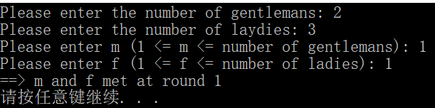

- M=2 F=3 m=2 f=3
理论值：6
运算结果：6
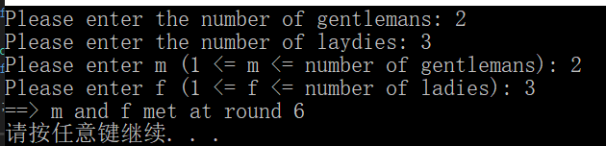

- M=1009 N=1013 m=512 f=513
理论值：255789
运算结果：255789
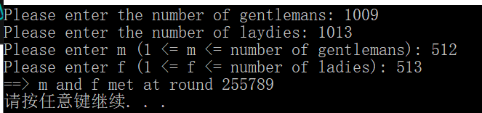

- 错误输入测试
尝试输入非质数的人数，越界的m和f，以及非数（字母），并观察程序的行为。从下图可以看出，对于不合法的输出，程序提示出错以及错误的原因，并要求重新输入，这与期望的结果一致。
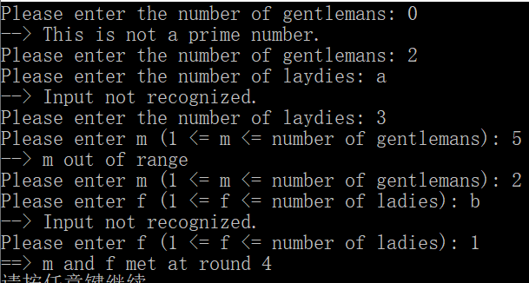

至此所有测试完成。程序功能的正确性和程序的健壮性都得到了验证，程序的行为与与预想的一致。

- 特点与不足
- 技术特点
面向对象式编程
有一定的差错机制
- 不足和改进的建议
功能单一
可移植能力不强
- 过程和体会
- 遇到的主要问题和解决方法
最开始因为对概念理解的偏差导致类成员声明出现问题，移动构造没有真正实现，且没有正确析构导致内存泄漏，在老师的提醒下理解了这些概念后才得以改正
- 课程设计的体会
通过这次课程设计，我更巩固并加深了对于C++部分知识的理解，包括继承和多态，const成员的修改，重载运算符，标准异常库等等，并成功的进行了实践。此外，还对于以前并不熟悉的命令行解析进行了深入的探究与实践。四次渐进性的实验也让我更深入的了解到了C++与C之间、面向对象与面向过程之间的联系与区别，为今后的学习与实践生活打下了基础。
- 源码和说明
- 文件清单及其功能说明
U201714626_4.h 头文件
U201714626_4.c++源程序
U201714626_4.exe可执行文件
- 用户使用说明书
下载exe文件后直接运行即可。
- 源代码
U201714626
#pragma once
class STACK {
int *const elems; //申请内存用于存放栈的元素
const int max; //栈能存放的最大元素个数
int pos; //栈实际已有元素个数，栈空时pos=0;
public:
STACK(int m); //初始化栈：最多存m个元素
STACK(const STACK&s); //用栈s拷贝初始化栈
STACK(STACK&&s); //移动构造
virtual int size() const; //返回栈的最大元素个数max
virtual operator int() const; //返回栈的实际元素个数pos
virtual int operator[ ] (int x) const; //取下标x处的栈元素，第1个元素x=0
virtual STACK& operator<<(int e); //将e入栈,并返回栈
virtual STACK& operator>>(int &e); //出栈到e,并返回栈
virtual STACK& operator=(const STACK&s); //赋s给栈,并返回被赋值栈
virtual STACK &operator=(STACK&&s); //移动赋值
virtual void print() const; //打印栈
virtual ~STACK(); //销毁栈
};
class QUEUE: public STACK {
STACK s;
public:
QUEUE(int m); //每个栈最多m个元素，要求实现的队列最多能入2m个元素
QUEUE(const QUEUE&q); //用队列q拷贝初始化队列
QUEUE(QUEUE&&q); //移动构造
virtual operator int() const; //返回队列的实际元素个数
virtual int full() const; //返回队列是否已满，满返回1，否则0
virtual int operator[ ](int x)const; //取下标为x的元素，第1个元素下标为0
virtual QUEUE& operator<<(int e); //将e入队列,并返回队列
virtual QUEUE& operator>>(int &e); //出队列到e,并返回队列
virtual QUEUE& operator=(const QUEUE&q); //赋q给队列,并返回被赋值队列
virtual QUEUE& operator=(QUEUE&&q); //移动赋值
virtual void print() const; //打印队列
virtual ~QUEUE(); //销毁队列
};
int k = 1;

namespace Utils {
bool convertToInt(const std::string &s, int &out);
bool isPrime(const int a);
}
U201714626_4.c++
#include<cstdio>
#include<iostream>
#include<fstream>
#include<string>
#include<cctype>
#include "U201714626_4.h"
using namespace std;
ofstream out;

/*
* 栈函数定义
*/
STACK::STACK(int m) : max(m), elems(new int[m]) {
pos = 0;
}
STACK::STACK(const STACK&s) : max(s.max), elems(new int[s.max]), pos(s.pos) {
for (int i = 0; i < s.pos; i++) {
STACK::elems[i] = s.elems[i];
}
}
STACK::STACK(STACK&&s) : max(STACK::max), elems(s.elems), pos(s.pos) {
*((int **)&(s.elems)) = nullptr;
*((int *)&(s.max)) = 0;
s.pos = 0;
}
STACK::operator int() const {
return pos;
}
int STACK::operator[] (int x) const {
return elems[x];
}
STACK& STACK::operator<<(int e) {
if (pos >= max) {
this->~STACK();

}
else {
*(elems + pos) = e;
pos++;
}
return (*this);
}
STACK& STACK::operator>>(int &e) {
if (pos == 0) {
cout << "栈为空";
}
else {
e = *(elems + pos - 1);
pos -= 1;
}
return (*this);
}
STACK& STACK::operator=(const STACK&s) {
pos = s.pos;
*((int *)&(s.max)) = s.max;
int *arr = new int[s.max];
for (int i = 0; i < this->size(); i++) {
arr[i] = s.elems[i];
}
this->~STACK();
*(int **)(&elems) = arr;
return (*this);
}
STACK &STACK::operator=(STACK&&s) {
*((int **)&(elems)) = s.elems;
pos = s.pos;
*((int *)&(max)) = s.max;
*((int **)&(s.elems)) = 0;
*((int *)&(s.max)) = 0;
s.pos = 0;
return (*this);
}
int STACK::size() const {
return max;
}
void STACK::print() const {
if (k == 1) {
for (int i = 0; i < pos; ++i) {
out << elems[i] << " ";
}
out << flush;
}
else {
for (int i = pos - 1; i >= 0; --i) {
out << elems[i] << " ";
}
out << flush;
}
}
STACK::~STACK() {
if (elems != 0) {
delete[]elems;
*(int **)(&elems) = 0;
}
}

/*
* 队列函数定义
*/
QUEUE::QUEUE(int m) :STACK(m), s(m) {};
QUEUE::QUEUE(const QUEUE&q) : s(q.s), STACK(q) {};
QUEUE::QUEUE(QUEUE&&s) :s(s.s), STACK(s) {};
QUEUE::operator int() const {
return STACK::operator int() + this->s.operator int();
}
int QUEUE::full() const {
return (STACK::operator int() == STACK::size() && this->s.operator int() != 0) ? 1 : 0;
}
int QUEUE::operator[ ] (int x) const {
if (x >= s.operator int()) {
return STACK::operator[](s.operator int() - (x - STACK::operator int()) - 1);
}
return STACK::operator[](x);
}
QUEUE& QUEUE::operator<<(int e) {
if (STACK::operator int() == STACK::size() && s.operator int() == 0) {
int ele;
while (STACK::operator int() > 0) {
STACK::operator>>(ele);
s.operator<<(ele);
}
}
STACK::operator<<(e);
return (*this);
}
QUEUE& QUEUE::operator>>(int &e) {
if (s.operator int() == 0) {
int ele;
while (STACK::operator int() > 0) {
STACK::operator>>(ele);
s.operator<<(ele);
}
}
s.operator>>(e);
return (*this);
}
QUEUE& QUEUE::operator=(const QUEUE&q) {
STACK::operator=(q);
s.operator=(q.s);
return (*this);
}
QUEUE& QUEUE::operator=(QUEUE&&q) {
STACK::operator=(q);
s.operator=(q.s);
q.~QUEUE();
return (*this);
}
void QUEUE::print() const {
k = -1;
s.print();
k = 1;
STACK::print();
}
QUEUE::~QUEUE() {
STACK::~STACK();
s.~STACK();
}

bool Utils::convertToInt(const std::string &s, int &out) {
using namespace std;

try {
out = stoi(s);
}
catch (invalid_argument i) {
return false;
}
catch (out_of_range o) {
return false;
}
return true;
}

bool Utils::isPrime(const int a) {
if (a <= 1)
return false;

int i;
for (i = 2; i * i <= a; i++)
if (a % i == 0)
return false;
return true;
}

int main(int argc, char *argv[]) {
using namespace std;
using namespace Utils;

// if argc is 1, run dancer problem, else run tests
if (argc == 1) {
int menNum, womenNum, m, f;
//> get men number
while (true) {
cout << "Please enter the number of gentlemans: " << flush;
cin >> menNum;
if (cin.eof() || cin.bad()) {
continue;
}
else if (cin.fail()) {
cout << "--> Input not recognized." << endl;
cin.clear();
cin.ignore(numeric_limits<streamsize>::max(), '\n');
}
else if (!isPrime(menNum)) {
cout << "--> This is not a prime number." << endl;
}
else
break;
}
//> get women number
while (true) {
cout << "Please enter the number of laydies: " << flush;
cin >> womenNum;
if (cin.eof() || cin.bad()) {
continue;
}
else if (cin.fail()) {
cout << "--> Input not recognized." << endl;
cin.clear();
cin.ignore(numeric_limits<streamsize>::max(), '\n');
}
else if (!isPrime(womenNum)) {
cout << "--> This is not a prime number." << endl;
}
else if (womenNum == menNum) {
cout << "--> The number of laydies must be unequal with the number of gentlemans." << endl;
}
else
break;
}
//> get m
while (true) {
cout << "Please enter m (1 <= m <= number of gentlemans): " << flush;
cin >> m;
if (cin.eof() || cin.bad()) {
continue;
}
else if (cin.fail()) {
cout << "--> Input not recognized." << endl;
cin.clear();
cin.ignore(numeric_limits<streamsize>::max(), '\n');
}
else if (m <= 0 || m > menNum) {
cout << "--> m out of range" << endl;
}
else
break;
}
//> get f
while (true) {
cout << "Please enter f (1 <= f <= number of ladies): " << flush;
cin >> f;
if (cin.eof() || cin.bad()) {
continue;
}
else if (cin.fail()) {
cout << "--> Input not recognized." << endl;
cin.clear();
cin.ignore(numeric_limits<streamsize>::max(), '\n');
}
else if (f <= 0 || f > womenNum) {
cout << "--> f out of range" << endl;
}
else
break;
}

// create QUEUE
QUEUE queueMen(2 * menNum + 1), queueWomen(2 * womenNum + 1);
for (int i = 0; i < menNum; ++i)
queueMen << i + 1;
for (int i = 0; i < womenNum; ++i)
queueWomen << i + 1;

int currentMan, currentWoman, counter = 1;
while (1) {
queueMen >> currentMan;
queueWomen >> currentWoman;
if (currentMan == m && currentWoman == f) {
cout << "==> m and f met at round " << counter << endl;
break;
}
queueMen << currentMan;
queueWomen << currentWoman;
++counter;
}
return 0;
}
else {
// arguments
string arg;
int number;

// queue for test
QUEUE *queue = nullptr;

// file to write
ofstream outFile;
outFile.open("U201514898_6.TXT");

auto coutBackup = cout.rdbuf();
cout.rdbuf(outFile.rdbuf());

#define CHECK_IF_LAST_ARG if (i == argc - 1){ \
cerr << "paramter not found after: " << arg << endl; \
return 1; \
}

try {
for (int i = 1; i < argc; ++i) {
arg = string(argv[i]);
if (arg == "-S" || arg == "-s") {
CHECK_IF_LAST_ARG;

arg = string(argv[++i]);
if (!convertToInt(arg, number)) {
cerr << "Error: cannot convert " << arg << " to int" << endl;
return 1;
}

queue = new QUEUE(number);
cout << "S " << number;
}
else if (arg == "-I" || arg == "-i") {
cout << "I";

for (++i; i < argc; ++i) {
arg = string(argv[i]);
// until there's noting to covert
if (!convertToInt(arg, number)) {
break;
}
(*queue) << number;
}
if (i != argc)
--i;

if (int(*queue)) {
cout << " ";
queue->print();
}
}
else if (arg == "-O" || arg == "-o") {
CHECK_IF_LAST_ARG

cout << "O";
arg = string(argv[++i]);
if (!convertToInt(arg, number)) {
cerr << "Error: cannot convert " << arg << " to int" << endl;
return 1;
}

int garbage;
for (int j = 0; j < number; ++j) {
(*queue) >> garbage;
}

if (int(*queue)) {
cout << " ";
queue->print();
}

}
else if (arg == "-C" || arg == "-c") {
QUEUE *newQueue = new QUEUE(*queue);
queue = newQueue;

cout << "C";
if (int(*queue)) {
cout << " ";
queue->print();
}
}
else if (arg == "-A" || arg == "-a") {
CHECK_IF_LAST_ARG

arg = string(argv[++i]);
if (!convertToInt(arg, number)) {
cerr << "Error: cannot convert " << arg << " to int" << endl;
return 1;
}

QUEUE *newQueue = new QUEUE(number);
*newQueue = *queue;
queue = newQueue;

cout << "A";
if (int(*queue)) {
cout << " ";
queue->print();
}

}
else if (arg == "-N" || arg == "-n") {
cout << "N " << int(*queue);

}
else if (arg == "-G" || arg == "-g") {
CHECK_IF_LAST_ARG

arg = string(argv[++i]);
if (!convertToInt(arg, number)) {
cerr << "Error: cannot convert " << arg << " to int" << endl;
return 1;
}

cout << "G " << (*queue)[number];

}
else {
cerr << "Wrong parameter: " << arg << endl;
return 1;
}

if (i != argc - 1)
cout << " ";
}
}
catch (logic_error error) {
cout << " E" << endl;
return 1;
}
cout.rdbuf(coutBackup);
outFile.close();
return 0;
}
}

