Sequential Sentence Classification in Medical Abstracts
Using LSTM and BioBERT
Jialu Liang, Benjamin Tondre, Qing Wang
BME 6938 — Spring 2026 — Project 3 — Group 2
GitHub: https://github.com/wq2581/bme6938-2026-spring-project3-group2

Abstract
Automated classification of sentences in medical abstracts into rhetorical roles (Background, Objective, Methods, Results, Conclusions) can facilitate systematic reviews, literature screening, and evidence-based medicine. In this work, we address this task using the PubMed RCT 20k dataset, which contains approximately 180,000 training sentences drawn from randomized controlled trial abstracts. We implement and compare two neural approaches: (1) a bidirectional LSTM baseline trained from scratch with learned word embeddings, and (2) a fine-tuned BioBERT transformer model pre-trained on biomedical corpora. On the held-out test set, the LSTM baseline achieves 82.6% accuracy and 76.1% macro F1, while BioBERT achieves 86.9% accuracy and 80.5% macro F1, representing a 4.3 percentage-point improvement in accuracy. Both models perform well on majority classes (Methods, Results) but struggle with minority classes (Objective, Background), suggesting that class imbalance and inherent linguistic ambiguity remain challenges. We discuss clinical implications, limitations, and directions for future work.

1. Introduction
The exponential growth of biomedical literature poses a significant challenge for clinicians and researchers who must efficiently identify relevant evidence from published studies. PubMed alone indexes over 35 million citations, with thousands of new articles added daily [1]. Randomized controlled trials (RCTs) are the gold standard for evaluating clinical interventions, and their abstracts follow a structured format organized into rhetorical sections: Background, Objective, Methods, Results, and Conclusions [2]. However, many abstracts are published in unstructured free-text form, making it difficult to quickly extract specific information such as study findings or methodology.
Automatic sequential sentence classification (SSC) in medical abstracts addresses this problem by assigning each sentence to its rhetorical role [3]. This capability has direct clinical applications: it can accelerate systematic review workflows by enabling automated PICO (Population, Intervention, Comparison, Outcome) extraction [4], support clinical decision support systems by surfacing relevant evidence by section type, and assist medical students in understanding the standard organization of scientific writing [5].
In this project, we tackle the sentence classification task using the PubMed RCT 20k dataset [3] and compare two neural architectures. First, we implement a bidirectional LSTM baseline that learns word representations from scratch, serving as a straightforward sequence model. Second, we fine-tune BioBERT [6], a transformer model pre-trained on PubMed abstracts and PMC full-text articles, which captures domain-specific biomedical knowledge. Our goal is to evaluate how transfer learning from biomedical corpora compares to training a simpler recurrent model from scratch on this clinically relevant task.

2. Related Works
Sequential sentence classification in medical abstracts has been studied extensively. Dernoncourt and Lee [3] introduced the PubMed RCT dataset and established baselines using convolutional neural networks (CNNs) and recurrent neural networks (RNNs), achieving around 90% accuracy with models that leveraged both token and character embeddings along with sentence position features. Their work demonstrated that deep learning methods significantly outperform traditional feature-engineered approaches such as SVMs and CRFs for this task.
The introduction of transformer-based language models fundamentally changed NLP. Devlin et al. [7] proposed BERT, a bidirectional transformer pre-trained on masked language modeling and next-sentence prediction, which achieved state-of-the-art results across diverse NLP benchmarks. Recognizing the domain gap between general and biomedical text, Lee et al. [6] developed BioBERT by continuing BERT's pre-training on PubMed abstracts (4.5B words) and PMC full-text articles (13.5B words). BioBERT demonstrated significant improvements over BERT on biomedical NER, relation extraction, and question answering tasks.
Subsequent domain-specific models have further advanced biomedical NLP. Gu et al. [8] introduced PubMedBERT, pre-trained from scratch exclusively on PubMed text, arguing that domain-specific pre-training from scratch outperforms mixed-domain continual pre-training. Alsentzer et al. [9] developed BioClinicalBERT by further pre-training BioBERT on clinical notes from MIMIC-III, targeting clinical NLP applications.
For the specific task of abstract sentence classification, Jin and Szolovits [10] explored hierarchical models that capture both sentence-level and document-level context, showing that inter-sentence dependencies improve classification accuracy. Cohan et al. [11] proposed pretrained models for scientific documents (SciBERT) trained on semantic scholar papers. Beltagy et al. [12] introduced Longformer for handling long documents efficiently.
Hochreiter and Schmidhuber [13] proposed Long Short-Term Memory (LSTM) networks to address the vanishing gradient problem in standard RNNs, enabling effective modeling of long-range dependencies in sequential data. Bidirectional LSTMs [14] extend this by processing sequences in both forward and backward directions, capturing contextual information from both sides of each token. Vaswani et al. [15] introduced the Transformer architecture based on self-attention, which has since become the foundation for modern NLP models.
Our work builds on these foundations by directly comparing an LSTM baseline against a fine-tuned BioBERT model on the PubMed RCT 20k dataset, providing a clear illustration of the performance gap between traditional recurrent models and pre-trained transformers in biomedical text classification.

3. Methods and Data

3.1 Dataset
We use the PubMed RCT 20k dataset [3], available on Hugging Face (armanc/pubmed-rct20k). The dataset contains sentences extracted from approximately 20,000 RCT abstracts from PubMed, each labeled with one of five rhetorical roles: Background, Objective, Methods, Results, and Conclusions. The dataset provides pre-defined train/validation/test splits: approximately 176,642 training sentences, 29,672 validation sentences, and 29,578 test sentences.
The class distribution is imbalanced. Methods (33.4%) and Results (32.8%) dominate, followed by Conclusions (15.4%), Background (10.4%), and Objective (7.9%). This imbalance reflects the natural structure of RCT abstracts, where methodology and findings typically constitute the longest sections.

3.2 Text Preprocessing
For the LSTM model, we apply text preprocessing including lowercasing, replacing digits with a NUM token, removing punctuation, and collapsing whitespace. We build a vocabulary from the training set with a minimum frequency threshold of 2, yielding approximately 36,000 unique tokens. Unknown words are mapped to a special UNK token, and sequences are padded or truncated to a maximum length of 128 tokens.
For BioBERT, we use the model's native WordPiece tokenizer (dmis-lab/biobert-base-cased-v1.2) with padding to max_length=128 and truncation enabled. No additional text normalization is applied, as the pre-trained tokenizer handles subword segmentation of biomedical terminology.

3.3 Model Architectures
LSTM Baseline. We implement a bidirectional LSTM classifier with the following architecture: an embedding layer (128 dimensions), followed by a 2-layer bidirectional LSTM (256 hidden units per direction), dropout (p=0.3), and a linear classification head mapping the concatenated final forward and backward hidden states (512 dimensions) to 5 output classes. The model has approximately 5.4 million trainable parameters.
BioBERT Transformer. We fine-tune BioBERT (dmis-lab/biobert-base-cased-v1.2) [6], which consists of 12 transformer layers, 768 hidden dimensions, and 12 attention heads (approximately 110 million parameters). A linear classification head is added on top of the [CLS] token representation. The pre-trained weights capture biomedical language patterns from PubMed and PMC corpora.

3.4 Training Details
LSTM training. We train for 10 epochs using Adam optimizer with learning rate 1e-3, batch size 128, and gradient clipping at max_norm=1.0. A ReduceLROnPlateau scheduler with patience 2 and factor 0.5 is used. The best model is selected based on validation macro F1 score.
BioBERT training. We fine-tune for 5 epochs using AdamW optimizer with learning rate 2e-5, weight decay 0.01, warmup ratio 0.1, and batch size 32. Mixed-precision (FP16) training is enabled on GPU. Early stopping with patience 2 based on validation F1 is applied. The best checkpoint is selected based on validation macro F1.
Both models are trained on the same data splits to ensure a fair comparison. All experiments are conducted on a single NVIDIA L4 GPU (16 GB).

4. Results and Evaluation

4.1 Overall Performance
Table 1 summarizes the test set performance of both models. BioBERT outperforms the LSTM baseline across all metrics, with a 4.3 percentage-point improvement in accuracy and a 4.4 percentage-point improvement in macro F1.
Table 1: Overall test set performance comparison.
Model | Accuracy | Macro Precision | Macro Recall | Macro F1
BiLSTM | 0.826 | 0.777 | 0.754 | 0.761
BioBERT | 0.869 | 0.821 | 0.803 | 0.805

4.2 Per-Class Performance
Table 2 shows per-class F1 scores. Both models perform best on Methods and Results, which are the most frequent classes. The largest performance gap between the two models appears in the minority classes: BioBERT improves F1 on Background by 4.0 points, on Objective by 1.8 points, and on Conclusions by 2.2 points compared to the LSTM baseline.
Table 2: Per-class F1 scores on the test set.
Model | Background | Objective | Methods | Results | Conclusions
BiLSTM | 0.638 | 0.630 | 0.906 | 0.883 | 0.748
BioBERT | 0.678 | 0.648 | 0.926 | 0.900 | 0.770

4.3 Confusion Matrices
Figures 1 and 2 show confusion matrices for both models. The most common confusion pattern is between Background and Objective, which is expected since both categories describe the study context and motivation. Another notable confusion is between Results and Conclusions, as concluding sentences often restate key findings.
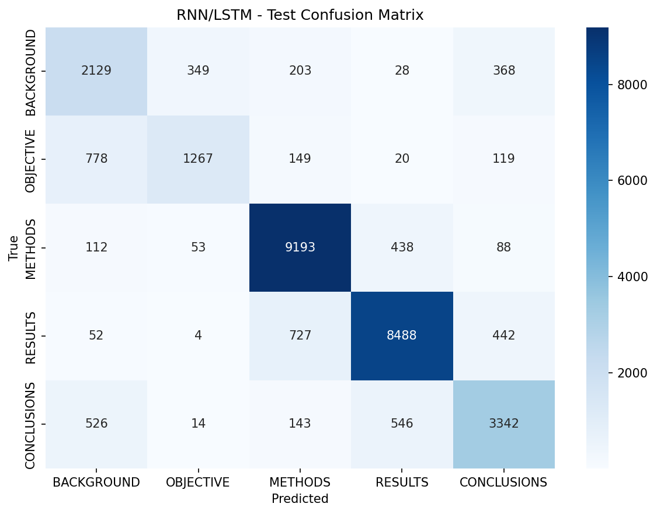
Figure 1: Confusion matrix for the BiLSTM model on the test set.
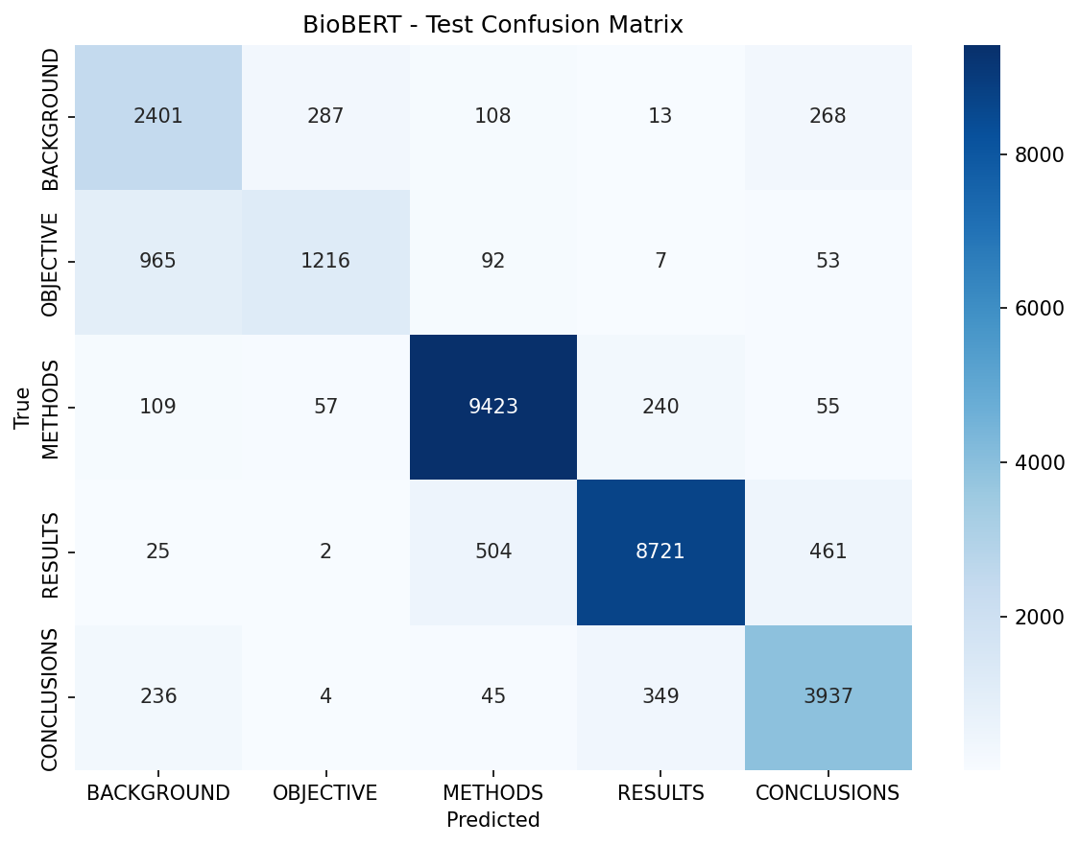
Figure 2: Confusion matrix for the BioBERT model on the test set.

4.4 Training Dynamics
Figures 3 and 4 show training curves. The LSTM model exhibits clear overfitting: training loss continues to decrease while validation loss increases after epoch 2, and validation accuracy plateaus around 83%. The BioBERT model also shows some overfitting, with validation loss increasing after epoch 1 while training loss decreases steadily. Early stopping selects the best checkpoint before overfitting degrades generalization.
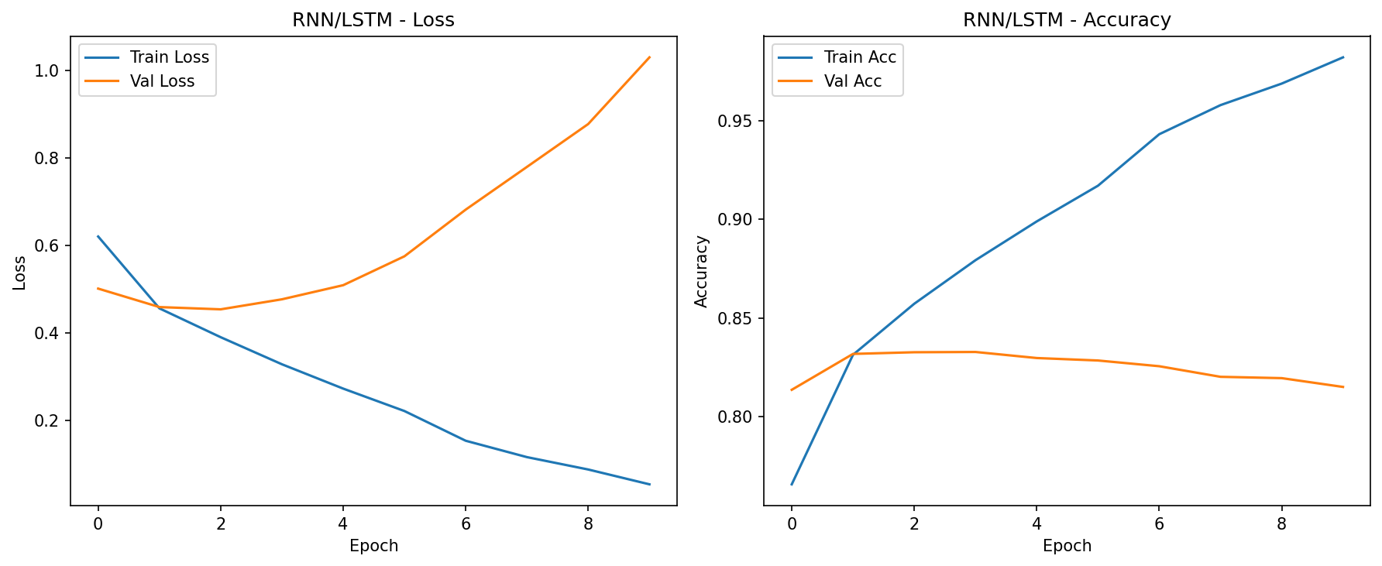
Figure 3: Training and validation loss/accuracy curves for the BiLSTM model.
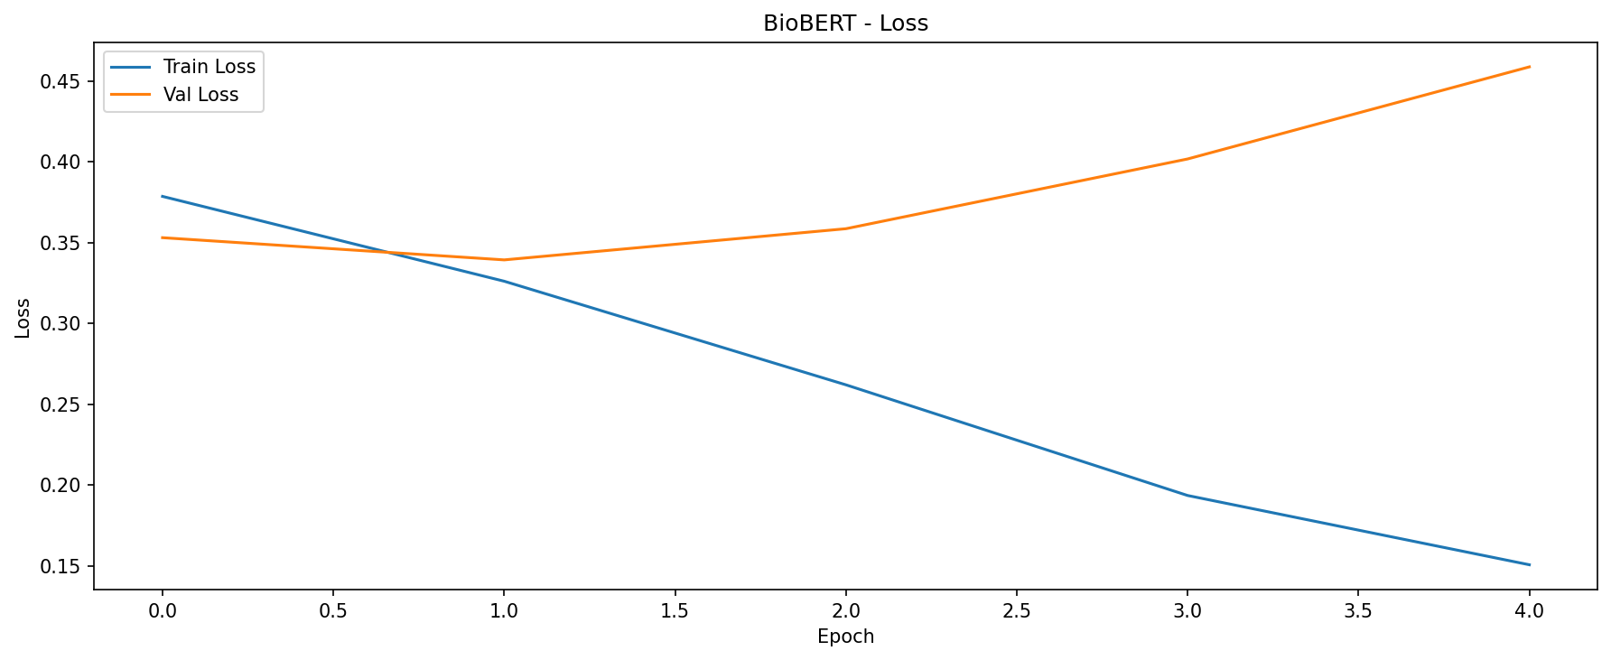
Figure 4: Training and validation loss curves for the BioBERT model.

5. Discussion and Limitations

5.1 Interpretation of Results
The BioBERT model consistently outperforms the LSTM baseline across all classes, confirming the value of transfer learning from biomedical corpora for this task. The pre-trained representations capture domain-specific terminology and contextual patterns that the LSTM must learn entirely from the training data. Notably, the performance gap is most pronounced for underrepresented classes (Background, Objective), where the limited training examples make it harder for the LSTM to learn robust representations.
The confusion between Background and Objective is clinically understandable: both describe the rationale and goals of a study, and the boundary between establishing context and stating an aim can be linguistically subtle. Similarly, Conclusions sentences that restate quantitative findings are easily confused with Results, reflecting genuine ambiguity in rhetorical structure.

5.2 Clinical Relevance
Automated sentence classification in medical abstracts has practical applications in clinical workflows. A model that reliably identifies Results and Conclusions sentences could help clinicians rapidly extract actionable evidence from the literature during time-constrained clinical decision-making. Integration with systematic review tools could reduce the manual effort required in evidence synthesis, which currently represents a significant bottleneck in evidence-based medicine [4].
Both models achieve over 88% F1 on Methods and Results, the two most clinically relevant categories for understanding what was done and what was found. However, the lower performance on Background and Objective (F1 around 0.63-0.68) suggests that current models are less reliable for identifying contextual and motivational content, which may limit their utility in fully automated abstract structuring systems.

5.3 Limitations
Dataset limitations. The PubMed RCT 20k dataset only covers RCT abstracts, which tend to follow a relatively standardized structure. Generalization to other study designs (observational studies, case reports, meta-analyses) or to full-text articles remains untested. The class imbalance in the dataset, with Methods and Results comprising over 66% of all sentences, may bias models toward majority classes.
Model limitations. Our models classify sentences independently without considering their position in the abstract or relationships with neighboring sentences. Prior work has shown that sequential context (e.g., a Background sentence is more likely to precede an Objective sentence) provides valuable signal [3, 10]. Incorporating such hierarchical or sequential modeling could improve performance, particularly for distinguishing between related categories.
Overfitting. Both models show signs of overfitting, particularly the LSTM model whose validation loss increases substantially after early epochs. More aggressive regularization, data augmentation, or reduced model capacity could mitigate this issue.

5.4 Ethical Considerations
Deploying NLP models in clinical settings requires careful consideration of potential biases. The training data is drawn exclusively from English-language PubMed abstracts, which may underrepresent research from non-English-speaking regions and certain medical specialties. Misclassification of sentence roles could lead to incorrect evidence extraction, which in a clinical decision support context could potentially influence patient care. Any deployment should include human oversight and validation against domain-expert annotations.

5.5 Future Work
Several directions could improve upon this work: (1) incorporating sentence position and inter-sentence context through hierarchical models or CRF layers; (2) experimenting with other domain-specific models such as PubMedBERT [8] or SciBERT [11]; (3) addressing class imbalance through oversampling, class-weighted loss, or focal loss; (4) evaluating on additional datasets to test cross-domain generalization; and (5) integrating attention visualization for model interpretability in clinical applications.

Author Contributions
Jialu Liang: Data preprocessing pipeline, RNN/LSTM baseline model implementation, EDA notebook, training curve analysis.
Qing Wang: BioBERT transformer fine-tuning, evaluation framework, demo notebook, error analysis and visualization.
Benjamin Tondre: Literature review, report writing, results documentation.

References
[1] National Library of Medicine. PubMed overview. https://pubmed.ncbi.nlm.nih.gov, 2024.
[2] ICMJE. Recommendations for the Conduct, Reporting, Editing, and Publication of Scholarly Work in Medical Journals. ICMJE, 2023.
[3] F. Dernoncourt and J. Y. Lee. PubMed 200k RCT: a dataset for sequential sentence classification in medical abstracts. In Proc. IJCNLP, 2017.
[4] A. M. Cohen et al. Reducing workload in systematic review preparation using automated citation classification. JAMIA, 13(2):206-219, 2006.
[5] B. Nye et al. A corpus with multi-level annotations of patients, interventions and outcomes to support language processing for medical literature. In Proc. ACL, 2018.
[6] J. Lee et al. BioBERT: a pre-trained biomedical language representation model for biomedical text mining. Bioinformatics, 36(4):1234-1240, 2020.
[7] J. Devlin et al. BERT: Pre-training of deep bidirectional transformers for language understanding. In Proc. NAACL-HLT, 2019.
[8] Y. Gu et al. Domain-specific language model pretraining for biomedical natural language processing. ACM Trans. Comput. Healthcare, 3(1):1-23, 2022.
[9] E. Alsentzer et al. Publicly available clinical BERT embeddings. In Proc. ClinicalNLP Workshop, NAACL, 2019.
[10] D. Jin and P. Szolovits. Hierarchical neural networks for sequential sentence classification in medical scientific abstracts. In Proc. EMNLP, 2018.
[11] A. Cohan et al. Pretrained language models for sequential sentence classification. In Proc. EMNLP, 2019.
[12] I. Beltagy et al. Longformer: The long-document transformer. arXiv:2004.05150, 2020.
[13] S. Hochreiter and J. Schmidhuber. Long short-term memory. Neural Computation, 9(8):1735-1780, 1997.
[14] M. Schuster and K. K. Paliwal. Bidirectional recurrent neural networks. IEEE Trans. Signal Processing, 45(11):2673-2681, 1997.
[15] A. Vaswani et al. Attention is all you need. In Proc. NeurIPS, 2017.
[16] T. Wolf et al. Transformers: State-of-the-art natural language processing. In Proc. EMNLP: System Demonstrations, 2020.
[17] A. Paszke et al. PyTorch: An imperative style, high-performance deep learning library. In Proc. NeurIPS, 2019.

