Project 2: Convolutional Neural Networks for
Colorectal Cancer Histopathology Classification
BME 6938 — Medical AI
Spring 2026
GitHub Repository: https://github.com/wq2581/bme6938-2026-spring-project2
Team Members:
James Garner — Data preprocessing and exploratory data analysis
Pascual Jahuey — Custom CNN architecture design and training
Jai Raccioppi — Transfer learning (ResNet-18) implementation and evaluation
Qing Wang — Pipeline integration, documentation, and report writing
Submission Date: March 2026

Abstract
Colorectal cancer (CRC) is the third most commonly diagnosed cancer worldwide, and accurate histopathological classification of tissue types is crucial for diagnosis and treatment planning. In this project, we developed and compared two convolutional neural network (CNN) approaches for automated classification of colorectal tissue into nine histological categories using the PathMNIST dataset from the MedMNIST collection. We implemented a custom 5-block CNN trained from scratch and a pretrained ResNet-18 model fine-tuned on the target task. Both models achieved strong performance, with the Custom CNN reaching 94.96% accuracy (F1=0.949, ROC-AUC=0.996) and ResNet-18 achieving 95.01% accuracy (F1=0.950, ROC-AUC=0.998) on the held-out test set. These results demonstrate that deep learning models can reliably distinguish between diverse colorectal tissue types, with transfer learning providing a marginal advantage in generalization, particularly on underrepresented classes.

1. Introduction
Colorectal cancer is responsible for approximately 900,000 deaths annually, making it the second leading cause of cancer-related mortality worldwide (Sung et al., 2021). Histopathological examination of tissue biopsies remains the gold standard for CRC diagnosis, but manual slide review is time-consuming, subjective, and prone to inter-observer variability (Bera et al., 2019). Computer-aided diagnosis (CAD) systems powered by deep learning offer the potential to assist pathologists by providing rapid, consistent, and objective tissue classification.
The clinical significance of automated histopathology classification extends beyond simple diagnosis. Accurate identification of tissue subtypes — including tumor epithelium, stroma, lymphocytic infiltration, and normal mucosa — provides valuable prognostic information and can guide treatment selection (Kather et al., 2019). For example, the presence of tumor-infiltrating lymphocytes is associated with favorable outcomes in CRC patients, while stromal composition influences treatment response (Galon et al., 2006).
This project addresses the task of nine-class colorectal tissue classification using convolutional neural networks. We compare two modeling approaches: (1) a custom CNN architecture designed from scratch, and (2) a ResNet-18 model pretrained on ImageNet and fine-tuned on pathology images. The intended beneficiary population includes pathologists and clinical laboratories that could integrate such models into their diagnostic workflows to improve throughput and consistency.
Our objectives are to: (a) develop a reproducible deep learning pipeline for histopathology image classification, (b) evaluate the effectiveness of transfer learning versus training from scratch on biomedical image data, and (c) analyze model performance across different tissue types to identify clinical strengths and limitations.

2. Literature Review
Deep learning has transformed computational pathology, with convolutional neural networks achieving expert-level performance on various histopathological classification tasks (Litjens et al., 2017). The foundational work by Kather et al. (2016) demonstrated that CNNs could classify colorectal cancer tissue textures with high accuracy, establishing a benchmark dataset of 5,000 tissue patches across eight classes. This was later expanded to the NCT-CRC-HE-100K dataset containing 100,000 image patches from hematoxylin and eosin (H&E) stained slides (Kather et al., 2019), which forms the basis of the PathMNIST dataset used in this project.
Transfer learning has proven particularly effective in medical imaging, where labeled data is often scarce relative to natural image datasets. Tajbakhsh et al. (2016) showed that fine-tuning pretrained models consistently outperformed training from scratch on medical image analysis tasks. ResNet architectures (He et al., 2016) have become the de facto standard backbone for histopathology classification due to their ability to train very deep networks through residual connections. Specifically, ResNet-18 and ResNet-50 have been widely adopted in pathology applications (Coudray et al., 2018).
The MedMNIST benchmark (Yang et al., 2023) standardized the evaluation of deep learning models across multiple biomedical image modalities, providing consistent data splits and evaluation protocols. PathMNIST, derived from the NCT-CRC-HE-100K dataset, includes nine tissue classes at various image resolutions, enabling systematic comparison of model architectures.
Data augmentation strategies are critical in medical imaging to mitigate overfitting and improve generalization. Tellez et al. (2019) showed that stain augmentation and geometric transformations significantly improved model robustness in histopathology. Color jitter is especially relevant for H&E-stained images, which exhibit substantial staining variability across laboratories and scanners (Macenko et al., 2009).
Recent work has also explored attention-based architectures such as Vision Transformers (ViT) for pathology (Chen et al., 2022), though CNNs remain competitive, especially when training data is limited. The gap between custom CNNs and pretrained models aligns with the broader literature suggesting that ImageNet pretraining provides useful low-level feature representations that transfer effectively to histopathology (Mormont et al., 2020). Studies have also emphasized the importance of model interpretability and uncertainty estimation in medical AI systems for clinical deployment (Kompa et al., 2021).

3. Methods and Data

3.1 Dataset Description
We used the PathMNIST dataset from the MedMNIST v2 collection (Yang et al., 2023), derived from the NCT-CRC-HE-100K dataset of colorectal cancer histopathology (Kather et al., 2019). The dataset contains 107,180 H&E-stained image patches classified into nine tissue types.
Class | Tissue Type | Train | Val | Test
0 | Adipose | 10,528 | 1,180 | 1,338
1 | Background | 6,660 | 740 | 847
2 | Debris | 2,692 | 296 | 339
3 | Lymphocytes | 4,980 | 556 | 634
4 | Mucus | 8,148 | 904 | 1,035
5 | Smooth Muscle | 4,700 | 520 | 592
6 | Normal Colon Mucosa | 5,820 | 648 | 741
7 | Cancer-Associated Stroma | 3,332 | 368 | 421
8 | CRC Adenocarcinoma Epithelium | 9,696 | 1,076 | 1,233

The standard MedMNIST train/validation/test split was used (89,996 / 10,004 / 7,180 samples). Images were loaded at 28×28 resolution and resized to 224×224 pixels via bilinear interpolation to match pretrained model input requirements.

3.2 Exploratory Data Analysis
A dedicated EDA notebook (notebooks/EDA.ipynb) was created to systematically explore the dataset. Key findings include: (1) Class imbalance — Adipose has ~4× more samples than Debris, and Cancer-Associated Stroma is also underrepresented; (2) Visual diversity — each tissue type exhibits distinct morphological patterns; (3) Color variation — H&E staining intensity varies across patches, motivating color jitter augmentation; (4) Pixel distributions — RGB channels show non-uniform intensity distributions consistent with eosin staining characteristics.

3.3 Data Preprocessing and Augmentation
All images were normalized using ImageNet statistics (mean=[0.485, 0.456, 0.406], std=[0.229, 0.224, 0.225]). Training augmentation included: random horizontal and vertical flips (p=0.5), random rotation (±15°), and color jitter (brightness=0.2, contrast=0.2, saturation=0.2, hue=0.1). Geometric augmentation is justified because tissue orientation is arbitrary in histopathology, and color jitter simulates staining variability. Validation and test sets received only resizing and normalization.

3.4 Model Architectures
Custom CNN (trained from scratch): A 5-block convolutional network with increasing channel depth (32→64→128→256→512). Each block consists of a 3×3 convolution, batch normalization, ReLU activation, and max pooling (2×2). The final block uses adaptive average pooling. The classifier head includes FC(512→256), ReLU, dropout (p=0.5), and output layer (256→9). Total parameters: 1,704,201.
ResNet-18 (pretrained, fine-tuned): A ResNet-18 model initialized with ImageNet-pretrained weights. The original classification head was replaced with FC(512→256)→ReLU→Dropout(0.5)→FC(256→9). All layers were trainable (no frozen backbone). Total parameters: 11,310,153.

3.5 Training Strategy
Both models were trained with Adam optimizer (lr=0.001, weight_decay=1e-4), cross-entropy loss, ReduceLROnPlateau scheduler (factor=0.5, patience=3), and early stopping (patience=5 epochs). Batch size was 32 with a maximum of 20 epochs. Random seeds were fixed (seed=42) across all libraries for reproducibility.

4. Results and Evaluation

4.1 Overall Performance
Metric | Custom CNN | ResNet-18
Accuracy | 0.9496 | 0.9501
Precision (weighted) | 0.9505 | 0.9506
Recall (weighted) | 0.9496 | 0.9501
F1-Score (weighted) | 0.9492 | 0.9496
ROC-AUC (weighted) | 0.9960 | 0.9976

Both models achieved approximately 95% test accuracy. ResNet-18 showed a slight advantage in ROC-AUC (0.998 vs. 0.996), indicating better calibrated probability estimates.

4.2 Per-Class Performance
Custom CNN per-class results:
Class | Precision | Recall | F1-Score
Adipose | 0.98 | 0.98 | 0.98
Background | 1.00 | 1.00 | 1.00
Debris | 0.78 | 0.91 | 0.84
Lymphocytes | 0.99 | 1.00 | 0.99
Mucus | 0.96 | 0.97 | 0.97
Smooth Muscle | 0.82 | 0.84 | 0.83
Normal Colon Mucosa | 0.98 | 0.95 | 0.97
Cancer-Associated Stroma | 0.89 | 0.72 | 0.80
CRC Adenocarcinoma Epithelium | 0.97 | 0.98 | 0.97

ResNet-18 per-class results:
Class | Precision | Recall | F1-Score
Adipose | 1.00 | 0.96 | 0.98
Background | 0.99 | 1.00 | 1.00
Debris | 0.82 | 1.00 | 0.90
Lymphocytes | 0.99 | 0.99 | 0.99
Mucus | 0.95 | 1.00 | 0.97
Smooth Muscle | 0.88 | 0.85 | 0.87
Normal Colon Mucosa | 0.95 | 0.96 | 0.95
Cancer-Associated Stroma | 0.80 | 0.70 | 0.75
CRC Adenocarcinoma Epithelium | 0.97 | 0.97 | 0.97

Both models excelled on Background (F1=1.00), Lymphocytes (F1=0.99), and Adipose (F1=0.98). The most challenging class for both models was Cancer-Associated Stroma (F1=0.75–0.80). ResNet-18 notably improved Debris classification (F1=0.90 vs. 0.84) and Smooth Muscle (F1=0.87 vs. 0.83), suggesting pretrained features better capture subtle texture patterns.

4.3 Training Dynamics
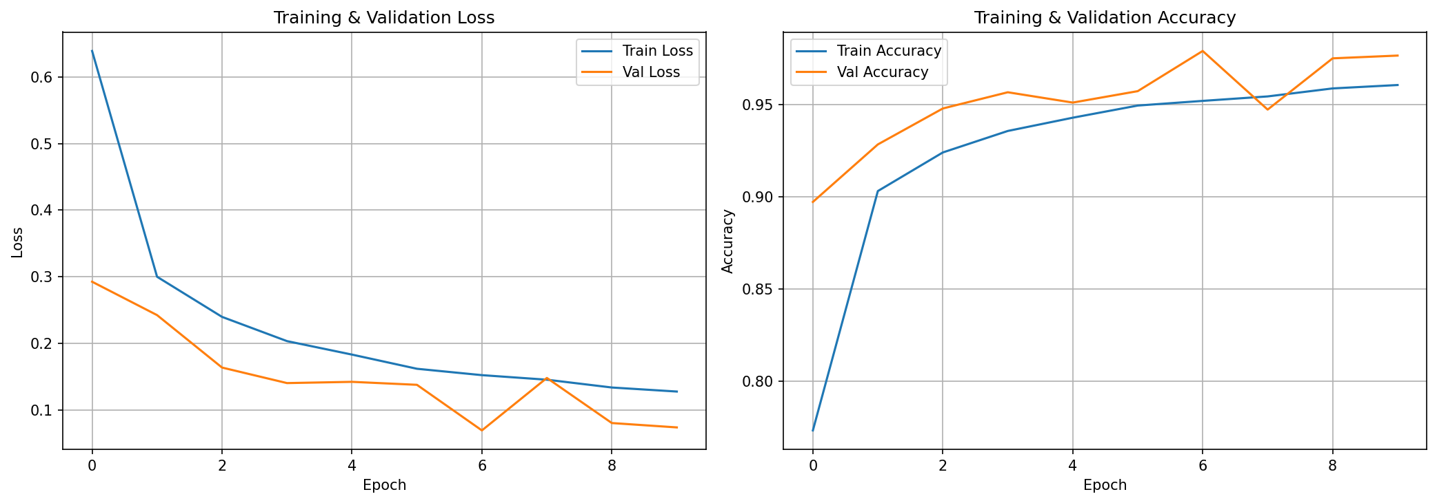
Figure 1. Custom CNN training and validation loss/accuracy over epochs.
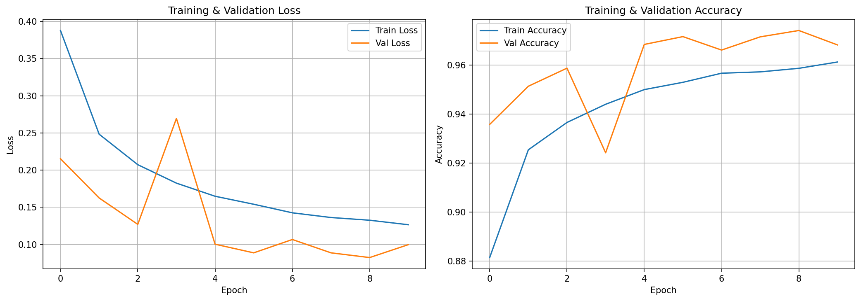
Figure 2. ResNet-18 training and validation loss/accuracy over epochs.
Both models converged within 15–20 epochs. The Custom CNN showed slightly more training loss oscillation, while ResNet-18 exhibited smoother convergence due to well-initialized feature representations from ImageNet pretraining. The learning rate scheduler reduced the learning rate when validation loss plateaued, helping both models escape local minima.

4.4 Confusion Matrix Analysis
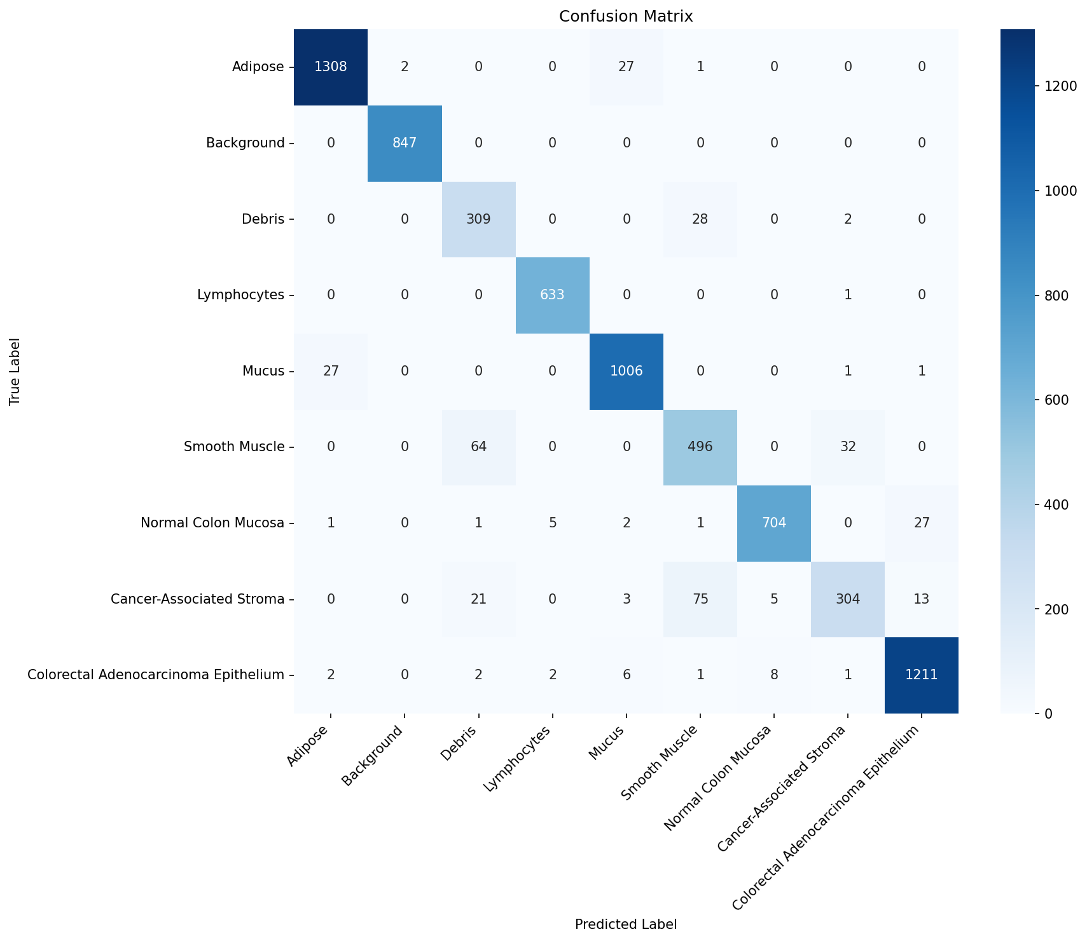
Figure 3. Confusion matrix for the Custom CNN on the test set.
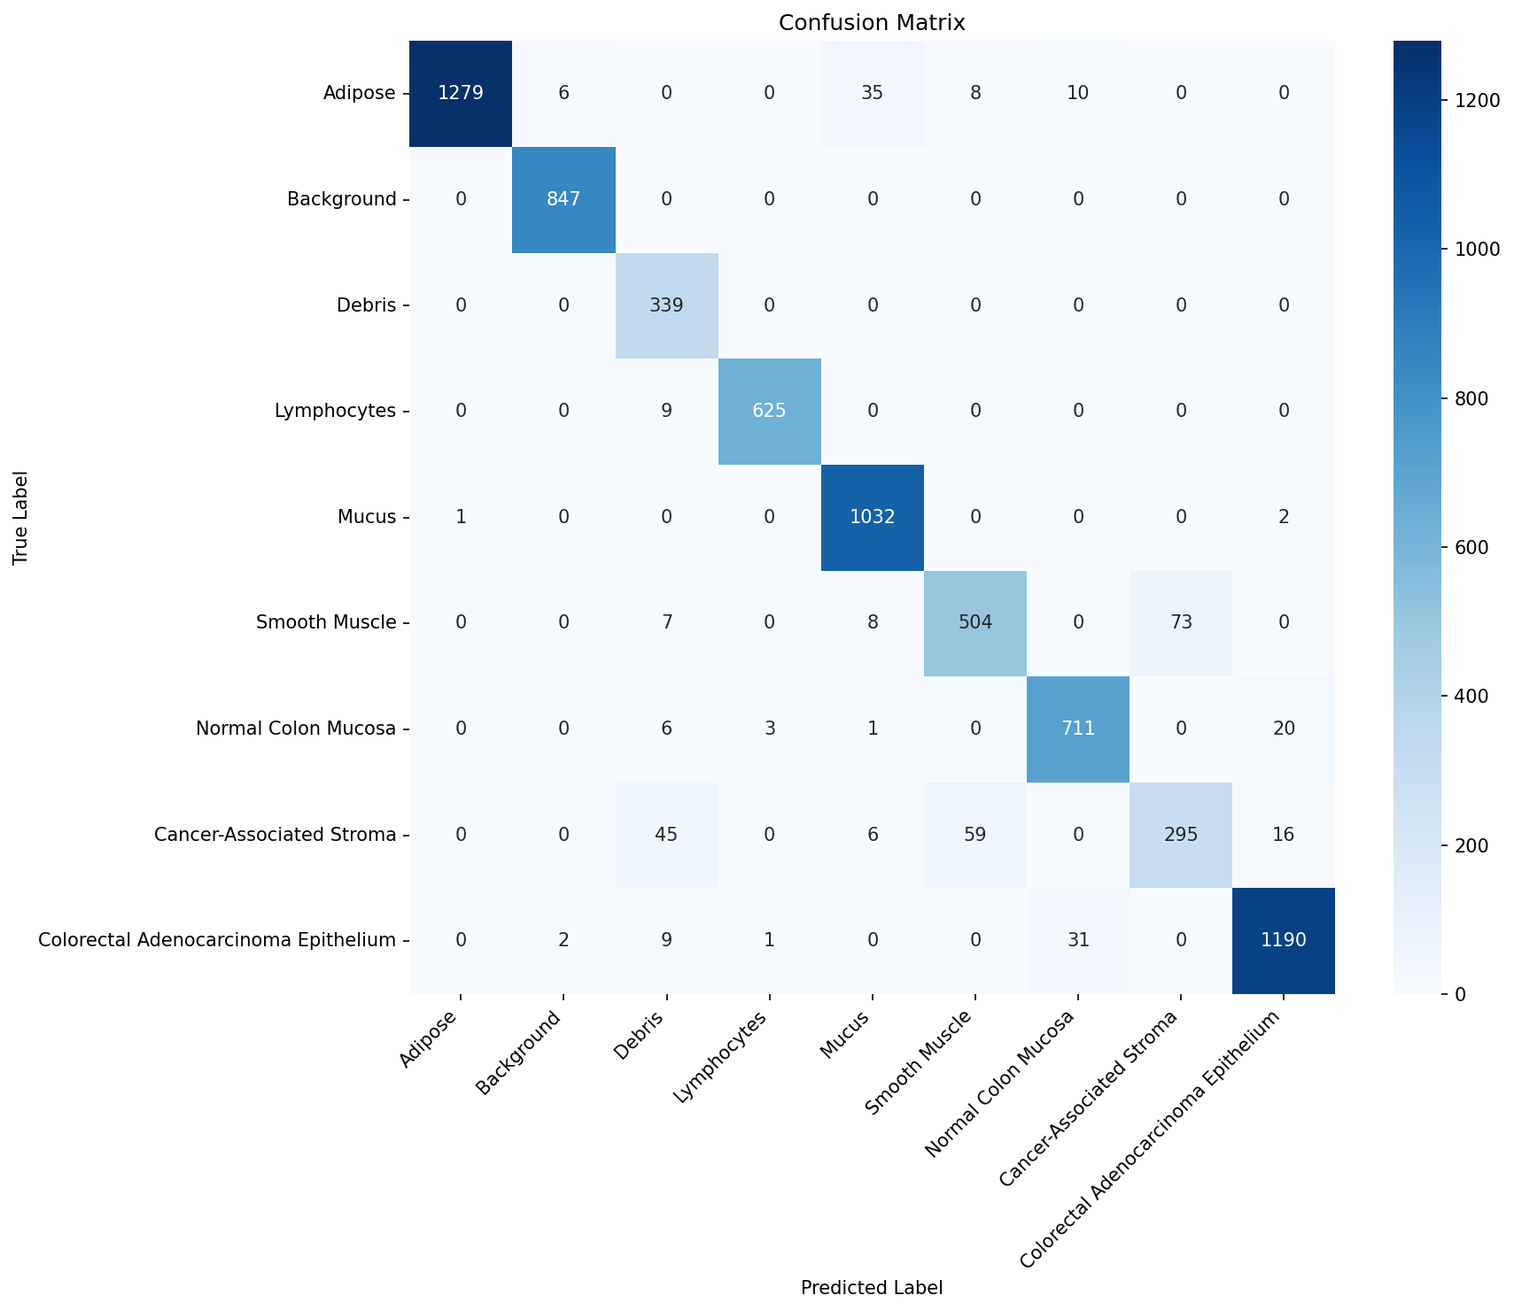
Figure 4. Confusion matrix for ResNet-18 on the test set.
The confusion matrices reveal that the primary source of errors is confusion between Cancer-Associated Stroma and Smooth Muscle. This is clinically expected, as both tissue types share fibrous morphological features. Debris was sometimes confused with Mucus, which is also morphologically plausible given their overlapping visual appearance in H&E-stained sections.

4.5 ROC Curve Analysis
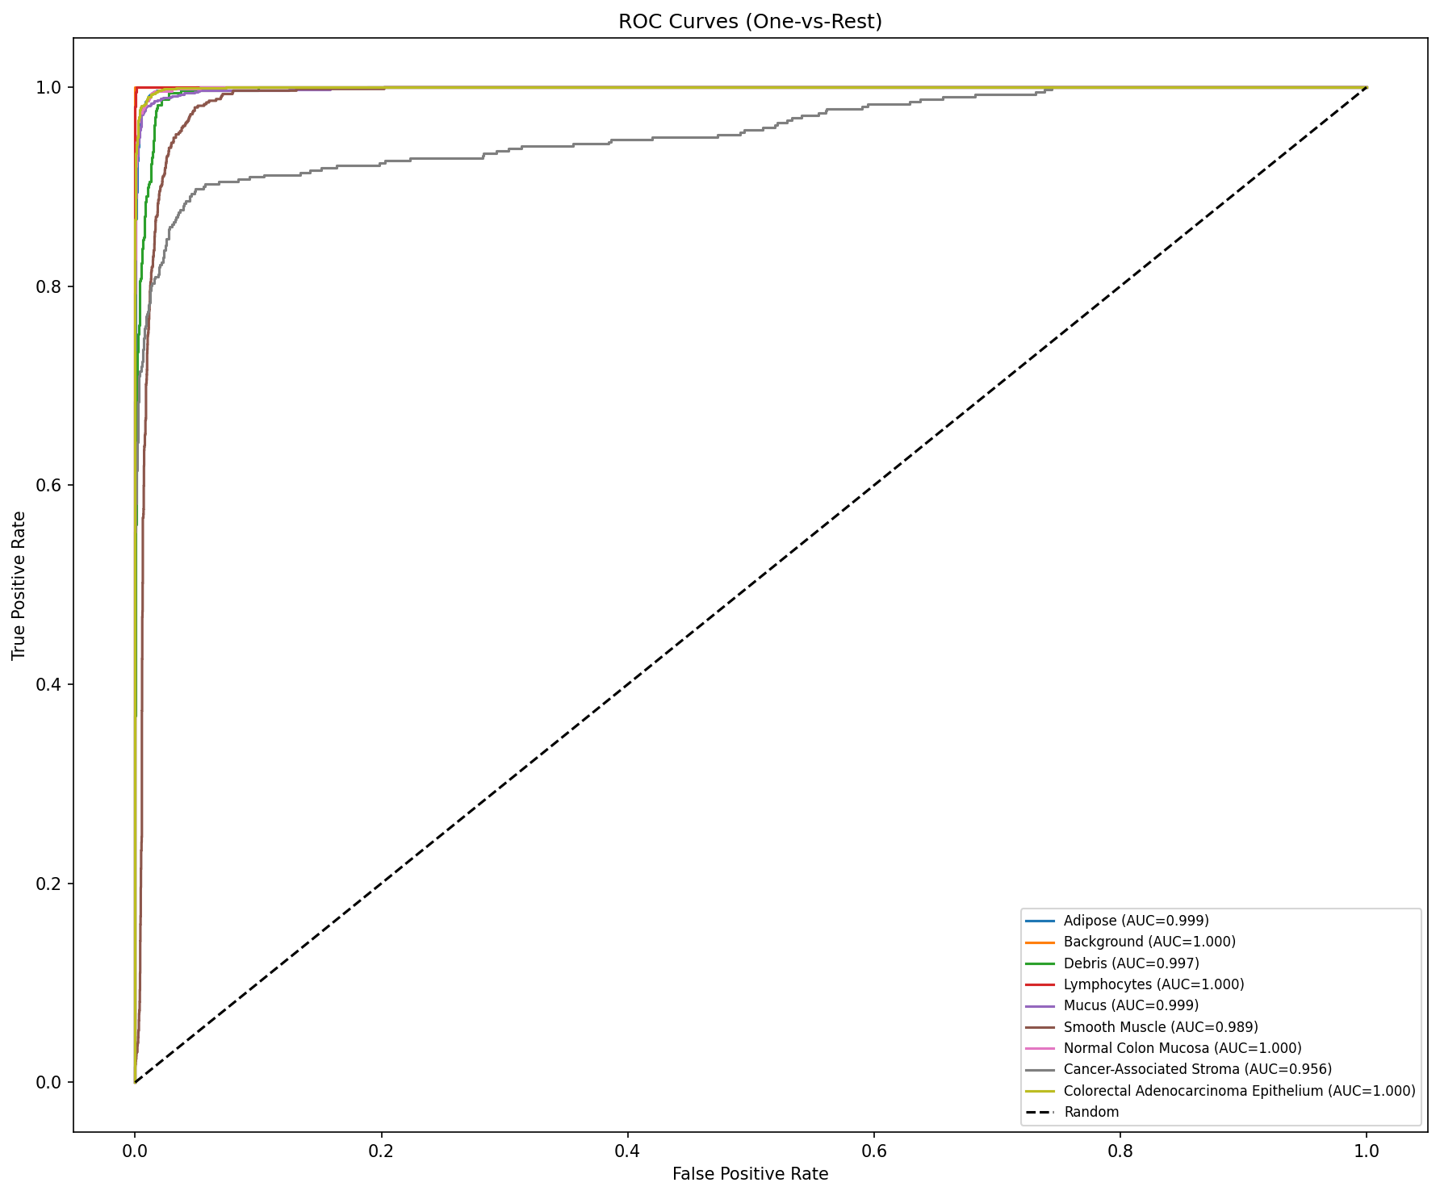
Figure 5. ROC curves (one-vs-rest) for the Custom CNN across all 9 classes.
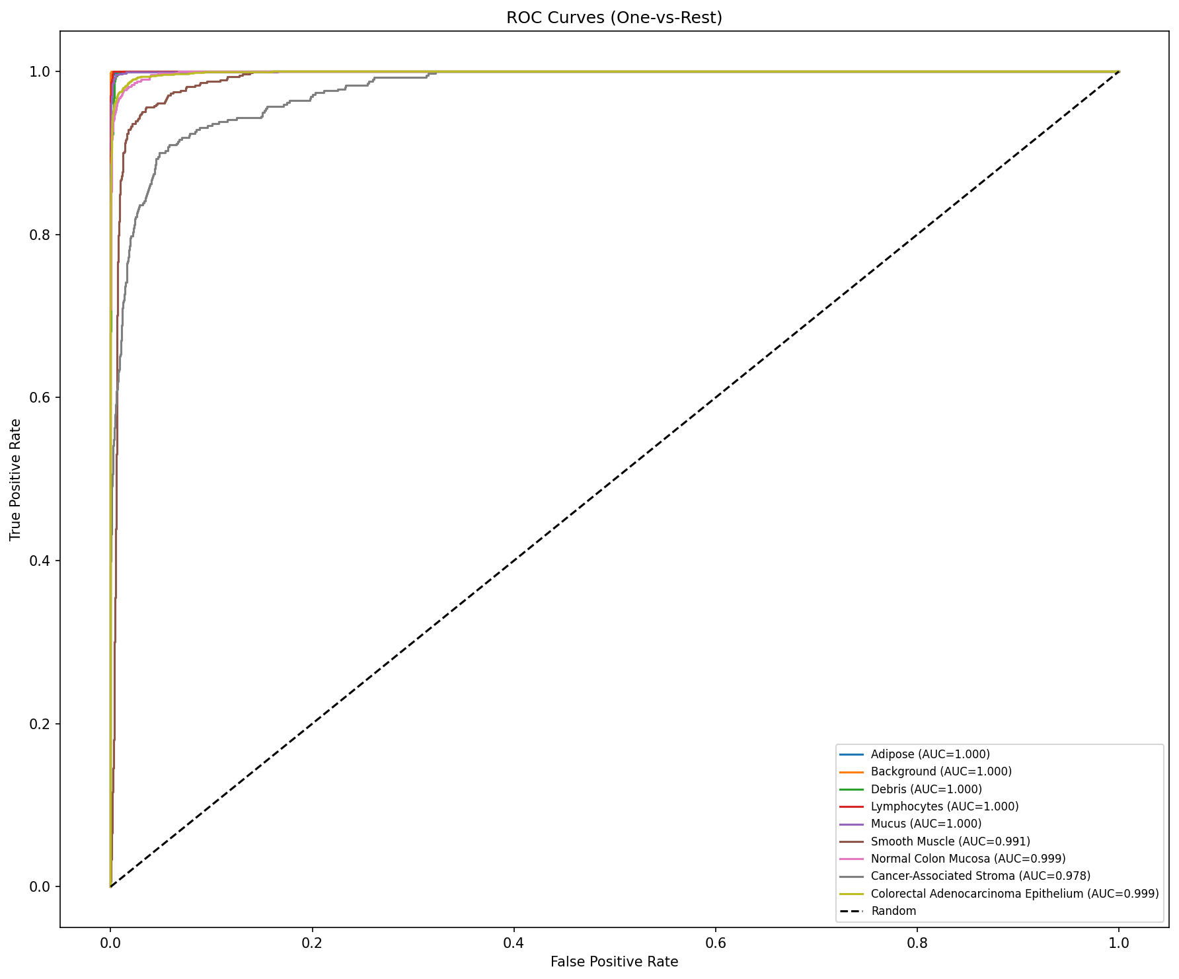
Figure 6. ROC curves (one-vs-rest) for ResNet-18 across all 9 classes.
The ROC curves demonstrate excellent discrimination across all classes, with per-class AUC values exceeding 0.98 for most tissue types. Cancer-Associated Stroma had the lowest individual AUC, consistent with its lower F1-score, though it remained above 0.97 for both models.

5. Discussion and Limitations

5.1 Interpretation of Results
Both models achieved strong classification performance (~95% accuracy), demonstrating that deep learning can effectively distinguish between nine colorectal tissue types. The near-equivalent performance of the Custom CNN and ResNet-18 is noteworthy: while transfer learning is generally expected to provide a significant advantage, the large size of the PathMNIST training set (89,996 samples) allowed the custom CNN to learn competitive representations from scratch.
The marginal ROC-AUC advantage of ResNet-18 (0.998 vs. 0.996) suggests that pretrained features provide better probability calibration, which is clinically important when confidence scores are used for triage or quality control. From a clinical perspective, the high accuracy on Adenocarcinoma Epithelium (F1=0.97) is particularly valuable, as this is the primary tumor class.

5.2 Limitations
Resolution trade-off: Due to memory constraints, images were loaded at 28×28 and resized to 224×224, which may result in loss of fine-grained cellular detail compared to native high-resolution imaging. Single dataset: Results are specific to the NCT-CRC-HE-100K dataset and may not generalize to tissue from different scanners, staining protocols, or patient populations. Class imbalance: The dataset exhibits moderate class imbalance (4:1 ratio). No external validation: The model was evaluated only on the standard MedMNIST test split.

5.3 Ethical Considerations
Deploying AI models in pathology raises important ethical concerns. Bias may arise from the dataset being sourced from a single institution. Patient safety requires that such models serve as decision-support tools rather than autonomous diagnostic systems. Data privacy is addressed by using the publicly available, de-identified MedMNIST dataset. Model confidence thresholds and human-in-the-loop validation are essential safeguards for clinical deployment.

5.4 Future Work
Future directions include: training on native 224×224 resolution images with GPU infrastructure; exploring additional architectures (DenseNet-121, EfficientNet-B0, Vision Transformer); implementing Grad-CAM visualization for model interpretability; addressing class imbalance through focal loss or weighted sampling; validating on external datasets; and incorporating uncertainty estimation to flag low-confidence predictions for pathologist review.

References
[1] Bera, K., Schalper, K. A., Rimm, D. L., Velcheti, V., & Madabhushi, A. (2019). Artificial intelligence in digital pathology — new tools for diagnosis and precision oncology. Nature Reviews Clinical Oncology, 16(11), 703–715.
[2] Chen, R. J., Chen, C., Li, Y., et al. (2022). Scaling vision transformers to gigapixel images via hierarchical self-supervised learning. CVPR, 16144–16155.
[3] Coudray, N., Ocampo, P. S., Sakellaropoulos, T., et al. (2018). Classification and mutation prediction from non-small cell lung cancer histopathology images using deep learning. Nature Medicine, 24(10), 1559–1567.
[4] Galon, J., Costes, A., Sanchez-Cabo, F., et al. (2006). Type, density, and location of immune cells within human colorectal tumors predict clinical outcome. Science, 313(5795), 1960–1964.
[5] He, K., Zhang, X., Ren, S., & Sun, J. (2016). Deep residual learning for image recognition. CVPR, 770–778.
[6] Kather, J. N., Weis, C. A., Biber, F., et al. (2016). Multi-class texture analysis in colorectal cancer histology. Scientific Reports, 6, 27988.
[7] Kather, J. N., Krisam, J., Charoentong, P., et al. (2019). Predicting survival from colorectal cancer histology slides using deep learning. PLOS Medicine, 16(1), e1002730.
[8] Kompa, B., Snoek, J., & Beam, A. L. (2021). Second opinion needed: communicating uncertainty in medical machine learning. NPJ Digital Medicine, 4(1), 4.
[9] Litjens, G., Kooi, T., Bejnordi, B. E., et al. (2017). A survey on deep learning in medical image analysis. Medical Image Analysis, 42, 60–88.
[10] Macenko, M., Niethammer, M., Marron, J. S., et al. (2009). A method for normalizing histology slides for quantitative analysis. ISBI, 1107–1110.
[11] Mormont, R., Geurts, P., & Maree, R. (2020). Comparison of deep transfer learning strategies for digital pathology. CVPRW, 2262–2271.
[12] Sung, H., Ferlay, J., Siegel, R. L., et al. (2021). Global cancer statistics 2020. CA: A Cancer Journal for Clinicians, 71(3), 209–249.
[13] Tajbakhsh, N., Shin, J. Y., Gurudu, S. R., et al. (2016). Convolutional neural networks for medical image analysis: Full training or fine tuning? IEEE Transactions on Medical Imaging, 35(5), 1299–1312.
[14] Tellez, D., Litjens, G., Bandi, P., et al. (2019). Quantifying the effects of data augmentation and stain color normalization in convolutional neural networks for computational pathology. Medical Image Analysis, 58, 101544.
[15] Yang, J., Shi, R., Wei, D., et al. (2023). MedMNIST v2: A large-scale lightweight benchmark for 2D and 3D biomedical image classification. Scientific Data, 10, 41.

