**RSA cryptosystem with large key length**

**1 Introduction**

**1.1 Description of problem**

RSA is a practical public-key cryptosystem which is widely used in cyber security. It is usually involved in such a question that what key length is appropriate, 200 bits, 1000 bits, 6000 bits or more? 200 bits was first considered as a secure length of public-key according to Rivest, Shamir and Adleman [6]. It took more than one billion years to break RSA with 200 bits public-key length in 1978. However, with the development of computer science technique and engineering, by using proper integer factorization algorithm, it only took less than 30 minutes to break 200 bits long RSA for the computer with Intel Dual-Core i7-4500U 1.80GHz. So far, a 768-bit key has been broken by Shor’s algorithm with quantum computers.

Typically, the RSA key with length from 1024 to 4096 bits is considered to be reasonable recently. As we already know, the longer the key length is, the more difficult it would be cracked. What is the reason that stopping us to pick the longest public-key. The reason is that RSA is a relatively slow algorithm, as the length of key increase, although it makes itself difficult to be cracked and improves the security of data, it also takes more time to encrypt and decrypt data.

In this paper, I will implement a RSA cryptosystem with several large length key from 200 bit to 4096 bits or more. The time complexities of best case, worse case and average case for each algorithm I use would be obtained from these experimentations. Combined with the theoretical time complexity of integer factorization algorithm, I will prove that the key length within certain range will be practice feasible.

**1.2 Description of algorithms**

The RSA algorithm is based on Diffie-Hellman algorithm [1] which is a specific method to exchange cryptographic keys through public network channel securely. For instance, first Alice and Bob agree publicly on a prime modulus and a generator like 23 and 5. Then Alice chooses a secret random number 13, calculates 5 to the power 13, mod 23, and sends the result publicly to Bob. Meanwhile, Bob also chooses a secret random number 17, calculates 5 to the power 17, mode 23, and sends the result publicly to Alice. Once Alice got Bob’s result, she raises the result to the power of her secret number 13, mod 23 to obtain the shared secret. The same as Bob. After this exchange is done, both Alice and Bob will have the same shared secret key.

In this RSA cryptosystem, a pair of keys will be generated to encrypt and decrypt data. It involves a public key and a private key. The public key can be known by everyone and is used for encrypting messages. The RSA algorithm involves four steps: key generation, key distribution, encryption and decryption. In this paper, I will focus on key generation, data encryption and decryption.

Several modern cryptographic algorithms will be used to generate large size key pairs, including Euclidean algorithm, Chinese remainder theorem [2], modular exponentiation and primality test like Miller-Rabin primality test [3]. The procedure of key generation is as follows. First of all, it will generate two big random numbers p and q which are differ in the length of several bits to make them more difficult to guess. Then it implemented Rabin-Miller primality test algorithm with certain number of witnesses like 64 to determine whether those two big number are prime or not. The Rabin-Miller algorithm is a prime probability test algorithm, and it would be only 1/(2^128) chance of not being a prime number with 64 witnesses. After that, it randomly generates e and uses Euclidean algorithm to check until the greatest common divisor with (p-1)(q-1) is 1. For the data encryption and decryption, modular exponentiation will be used to calculate a type of exponentiation performed over a modulus.

**1.3 Specific Aims**

**Specific Aim 1** I will implement the RSA cryptosystem by using Euclidean algorithm, Chinese remainder theorem, modular exponentiation and primality test.

**Specific Aim 2** I will add a time complexity monitor for each algorithm to obtain the experimentation results. For the test cases, several different length of public keys will be used to test this RSA cryptosystem, and the stages will cover key pair generation, data encryption and data decryption.

**Specific Aim 3** In order to measure the efficiency of RSA algorithm. I will analysis the statistic data gathered from the experimentation. Estimate the time complexities for each algorithm including best case, worse case and average case. Meanwhile, the time complexity for encryption and decryption will also be covered in this statistic analysis.

**2 Background**

**2.1 RSA cryptosystem**

RSA is a widely used public-key cryptosystem for secure data transmission. It was first described in 1977.

**2.2 Diffie Hellman**

**2.3 Primality test**

**2.4 Euclidean algorithm**

**2.5 Chinese remainder theorem**

**2.6 Modular exponentiation**

**2.7 Factoring algorithm**

**Integer factorization**

**3 Preliminary Results**

|  |  |  |
| --- | --- | --- |
| Key length | Number of attempts | Time cost (sec) |
| 200 | 155 | 0.01 |
| 1000 | 155 | 0.2 |
| 3000 | 155 | 0.45 |
| 6000 | 155 | 0.9 |

**Table 1:** Primality test

**4 Work Plan**

This section describes the work plan for achieving the three specific aims.

**4.1 Aim 1: Implement the RSA cryptosystem**

I will develop the RSA cryptosystem using Euclidean algorithm, Chinese remainder theorem, modular exponentiation and primality test. There are five stages in this period.

4.1.1 I will implement the primality test algorithm. The main task of this stage is generate two large distinct random prime numbers p and q. These integers can be efficiently found by using primality test.

4.1.2 I will implement Euclidean algorithm which will be used to compute the greatest common divisor. Although this algorithm is much simple than primality test algorithm, it is an efficient method for computing the greatest common divisor of two numbers.

4.1.3 The Chinese Remainder Theorem is a common practice during decryption. I will implement this algorithm as an option to replace modular exponentiation.

4.1.4

**4.2 Aim 2: Add a time complexity monitor for each algorithm to obtain the experimentation results**

**4.3 Aim 3: Analysis the RSA cryptosystem time complexity**

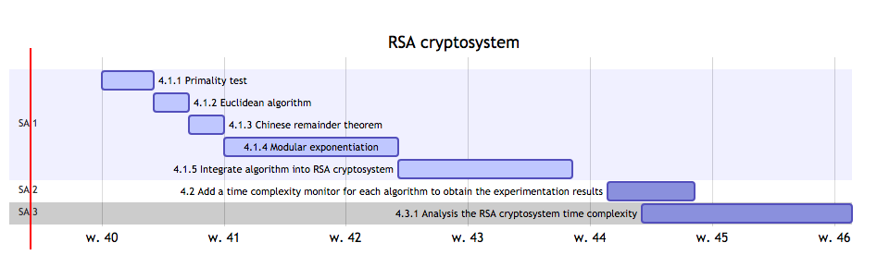

**Figure 1:** Gantt chart showing the schedule of the work plan.

**5 Broader Impacts**

**References:**

[1] Diffie, W., and Hellman, M. “New directions in cryptography”, IEEE Trans. Inform. Theory IT-22, pp. 644-654, 1976

[2] G.N. Shinde, and H.S. Fadewar, “Faster RSA Algorithm for Decryption Using Chinese Remainder Theorem”, ICCES, vol.5, no.4, pp.255-26, 2008

[3] H. W. Lenstra, Jr., “Miller’s primality test”, Inform. Process. Lett. 8:2, pp. 86- 88, 1979.

[4] L. Zhong, “Modular exponentiation algorithm analysis for energy consumption and performance,” tech. rep., Citeseer,2000.

[5] Nentawe Y. Goshwe, “Data Encryption and Decryption Using RSA Algorithm in a Network Environment”, International Journal of Computer Science and Network Security, Vol.13 No.7, pp. 9-13, 2013.

[6] R.L. Rivest, A. Shamir, and L. Adleman, “A Method for Obtaining Digital Signatures and Public-Key Cryptosystems”, Communications of the ACM, Volume21 Issue 2, pp. 120-126, 1978.

[7] Rene Schoof, “Four primality testing algorithms”, Algorithmic Number Theory, Volume 44, 2008.