**Name: Yew Siew Chen (WQD180004)**

**WQD7005 Data Mining**

**Assignment Milestone 4**

For assignment milestone 4, interpretation of data will be carried out. The stock data includes all the listed company in Bursa Malaysia with the stock price for 1/3/2019 until 26/4/2019.

For quantitative analysis, SAS Enterprise Miner (EM) is used to explore and visualise the stock data crawled. First, load the data file into SAS EM, the Metadata is shown in Figure 1 and Figure 2 is the variables. Besides that, Figure 3 shows the descriptive statistics for the numerical variables.

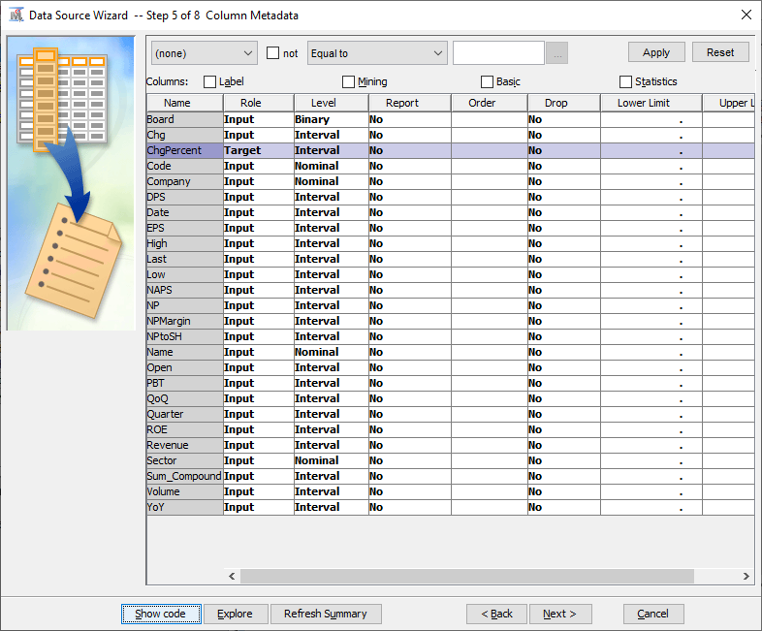

**Figure 1.** Metadata.

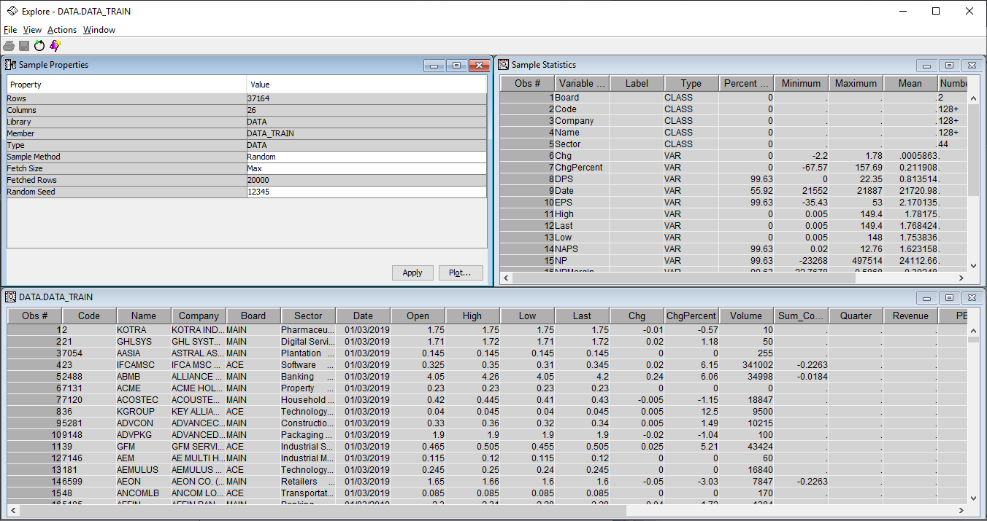

**Figure 2.** Variables and Sample Statistics of the Dataset.

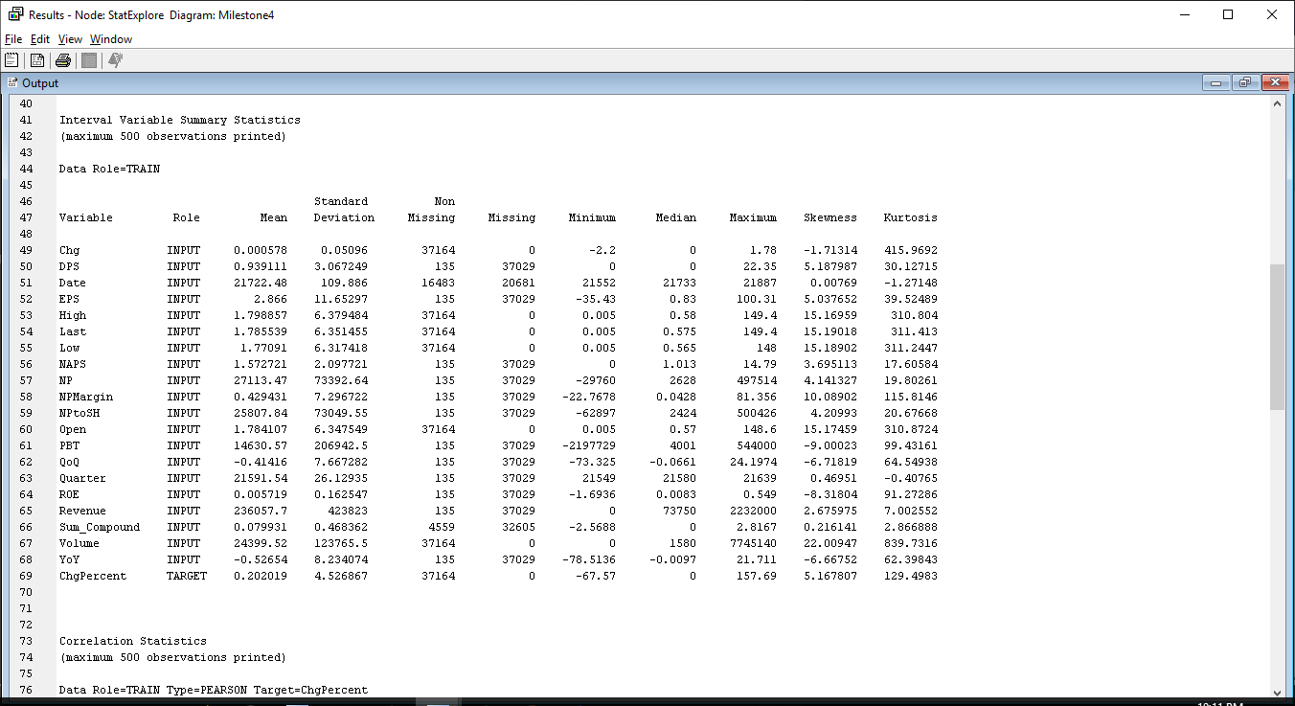

**Figure 3.** Descriptive Statistics of the Dataset.

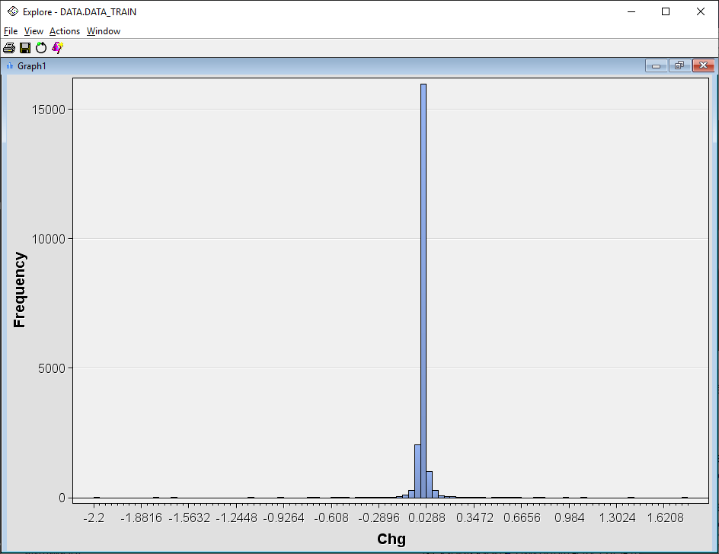

**Figure 4.** Histogram of Change in Stock Price.

As shown in Figure 4, the shape of histogram for price change is symmetric and bell-shaped with one peak between -0.011 and 0.0288. The minimum value is -2.2 and the maximum value is 1.78. Most of the change in stock price are close to zero.

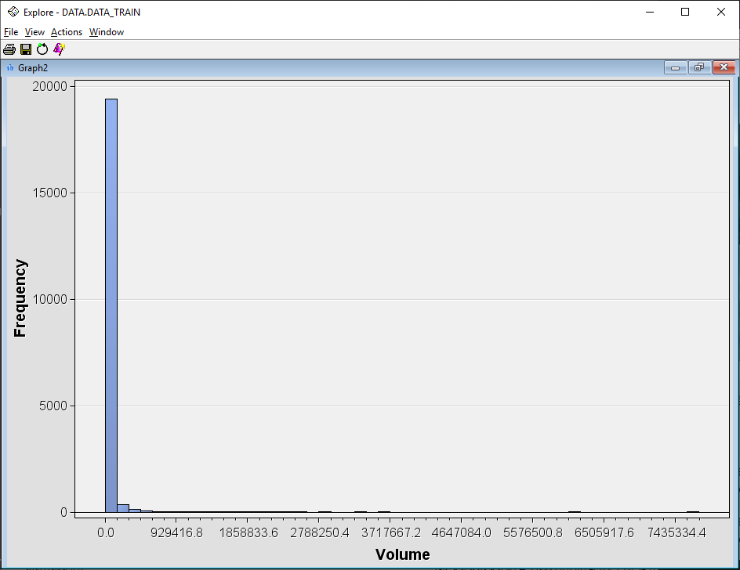

**Figure 5.** Histogram of Trading Volume.

From Figure 5, the shape of histogram for trading volume is highly skewed to the right. Most of the trading volume per day are less than 154902 unit but there are also some extremely high values.

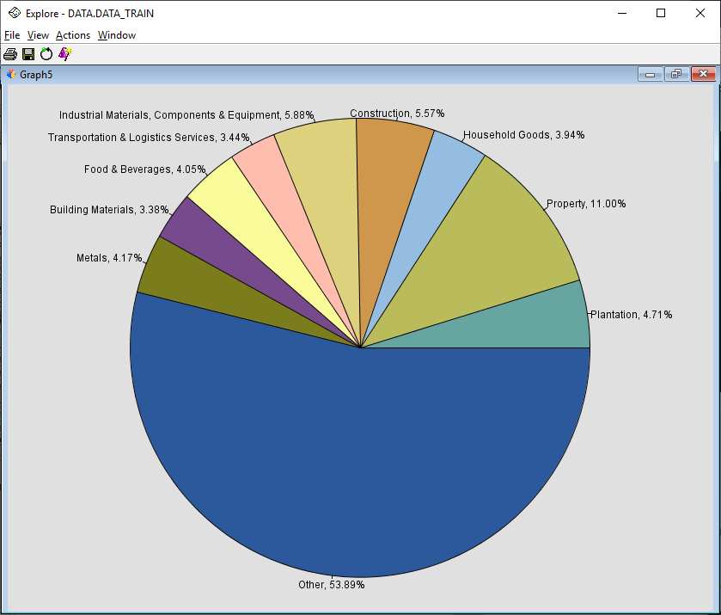

**Figure 6.** Types of Sector of Company Listed.

From Figure 6, the sector with the highest frequency is Property with 11%, followed by Industrial Materials, Components & Equipment, 5.88% and then Construction sector 5.57%.

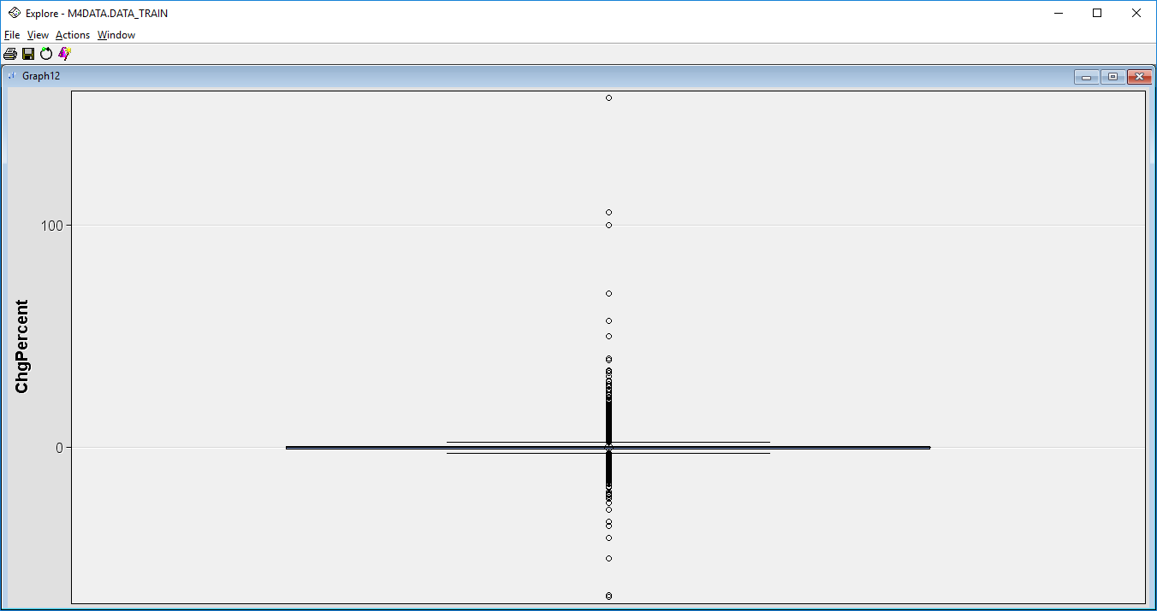

**Figure 7.** Boxplot for Change Percentage in Price.

Most of the changes in stock prices are small but there are also extreme outliers which are more than 100%.

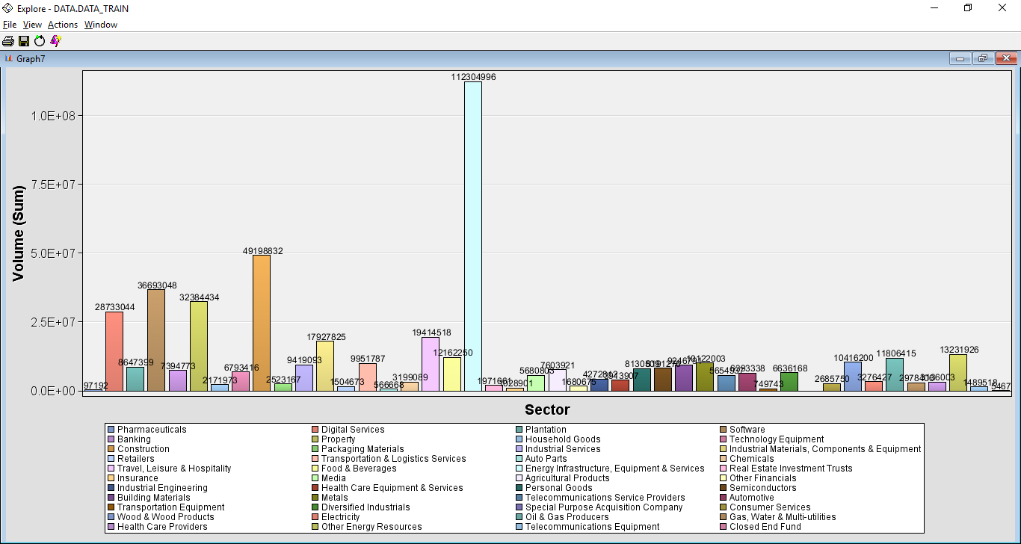

**Figure 8.** Total Trading Volume for Different Sectors.

For the period of observation, the sector that has the highest trading volume is Energy Infrastructure, Equipment & Services. The second highest is Construction.

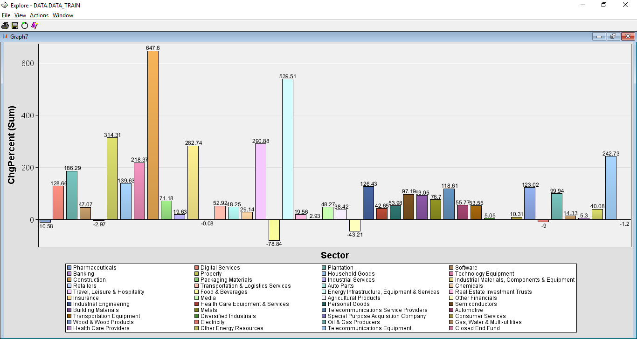

**Figure 9.**  Net Change Percentage in Stock Price for Each Sector.

The sector that has the highest positive change percentage in price is Construction, second highest is Energy Infrastructure, Equipment & Services, and followed by Property. However, Food & Beverages sector has the highest negative change in stock price.

Since it is complicated to visualize the data for all the companies, we filter the data to visualize it for 5 companies. 5 companies in the construction sectors are chosen since the sector has the highest change percentage of stock price in the period. The 5 companies include Ahmad Zaki Resources Berhad (AZRB), Gamuda Berhad (GAMUDA), Hock Seng Lee Berhad (HSL), Muhibbah Engineering (M) Bhd (MUHIBAH), WCT Holdings Berhad (WCT).

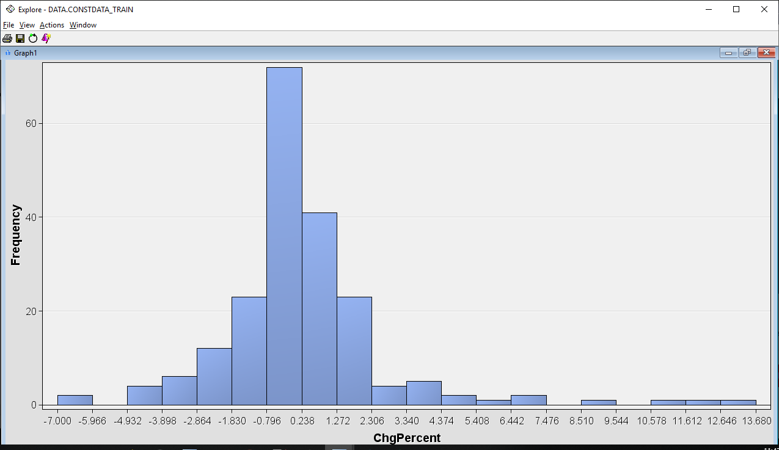

**Figure 10.** Change Percentage Histogram.

Based on Figure 10, the shape of histogram for change percentage is slightly skewed to the right with one peak between -0.796 and 0.238. The minimum value is -7.000 and the maximum value is 13.680.

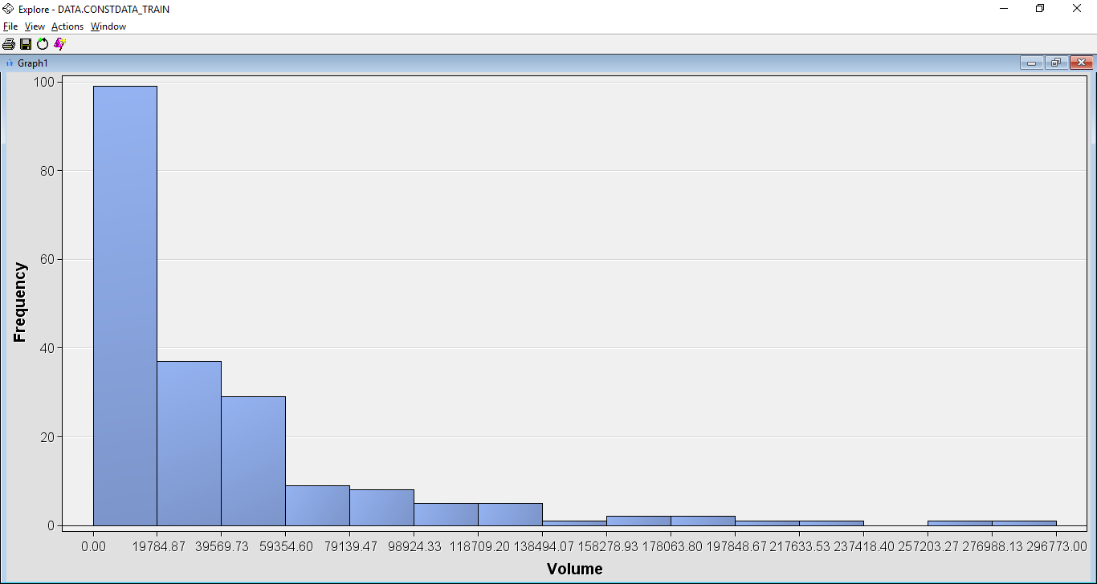

**Figure 11.** Trading Volume Histogram.

Based on Figure 11, the shape of histogram for trading volume is heavily skewed to the right with one peak between 0 and 19784.87. The minimum value is 0 and the maximum value 296773. There are some extreme large values for trading volume.

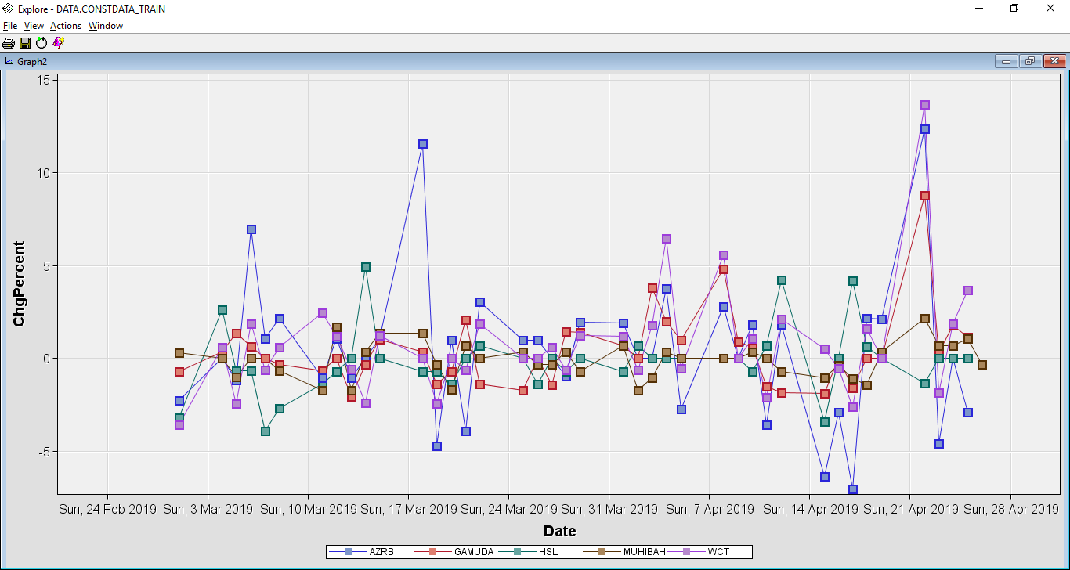

**Figure 12.** Change Percentage of Price for the 5 Companies.

Figure 12 shows that AZRB was the most volatile stock in the period, it had the highest number of highs and lows. MUHIBAH was the most stable stock with small changes. The other stocks are slightly volatile. On 22 April 2019, WCT, AZRB and GAMUDA moved up to significant peaks. WCT had the highest peak in change percentage for that day.

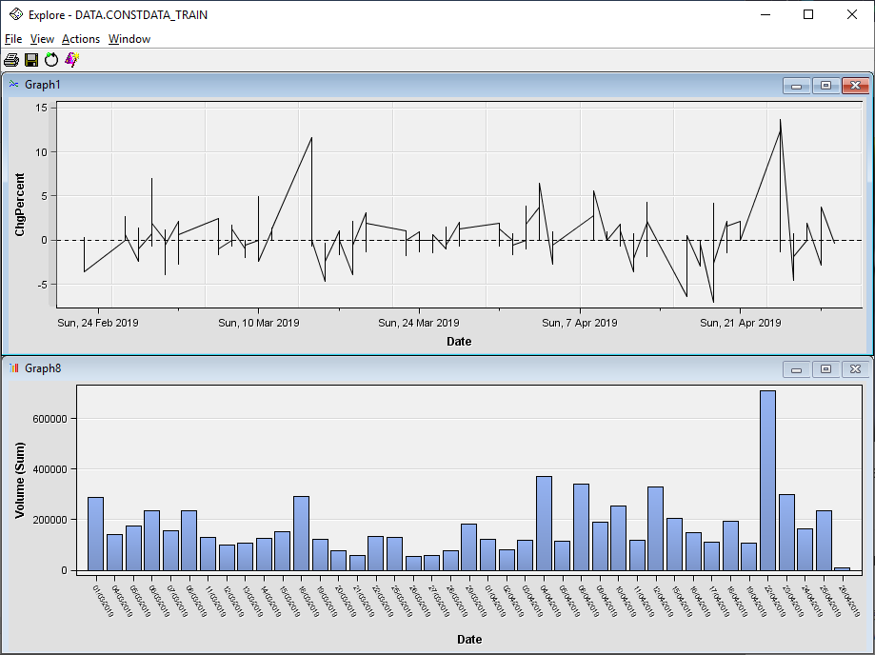

**Figure 13.** Price Volume Analysis.

Figure 13 shows that the stock price is highly related to the trading volume. The stock price increased when the trading volume was high. This shows that when many people are interested in the stock, its price increased. When less people are interested in the stock, the price decreased.

For each of the stocks, analysis is done by visualising the change percentage, sum of compound value and financial report announcement. The compound value is obtained by applying sentiment analysis on the news headlines by using Python. Positive value represents positive news, zero compound value is neutral news and negative value is negative news. Since there are cases that have multiple news per day, so the compound value is analysed using the sum. Net profit margin (NPMargin) is used to represent the results of financial report announcement. The net profit margin is equal to how much net income or profit is generated as a percentage of revenue.

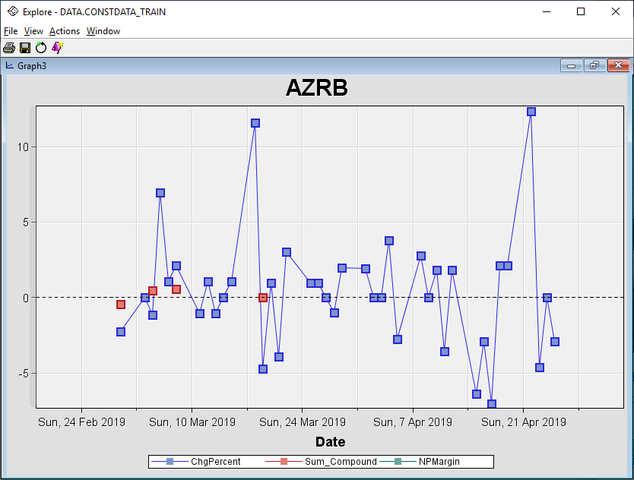

**Figure 14.** Change Percentage of Price and Sum of Compound Value for AZRB.

Figure 14 shows the change percentage and sum of compound value for Ahmad Zaki Resources Berhad. When there was positive news being announced, the stock price increased on that day or the next day. For the stock AZRB, there was no financial report announcement in the period.

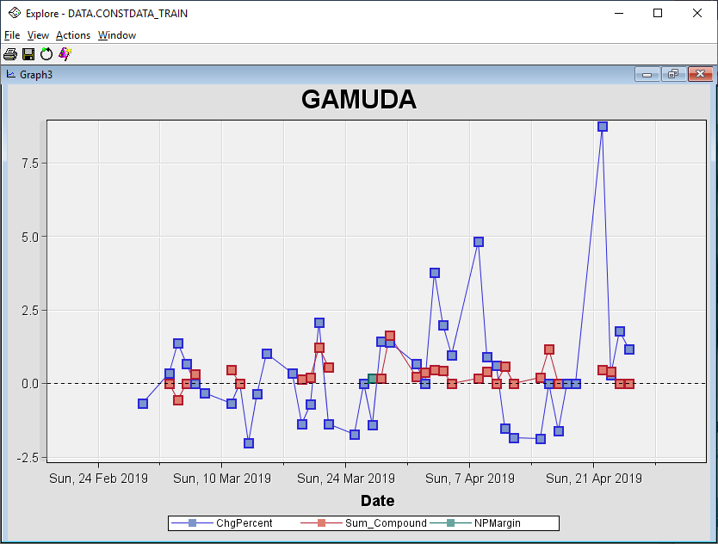

**Figure 15.** Change Percentage of Price, Sum of Compound Value and Net Profit Margin for GAMUDA.

Figure 15 shows the change percentage, sum of compound value and net profit margin for Gamuda Berhad. Continuous announcement of positive news caused the stock price to increase most of the time. On 27 March 2019, there was announcement of financial report and the net profit margin is positive. Thus, the stock showed positive change in the following days. Positive news and positive net profit margin caused the stock to increase continuously and even reached a high peak after a few days.

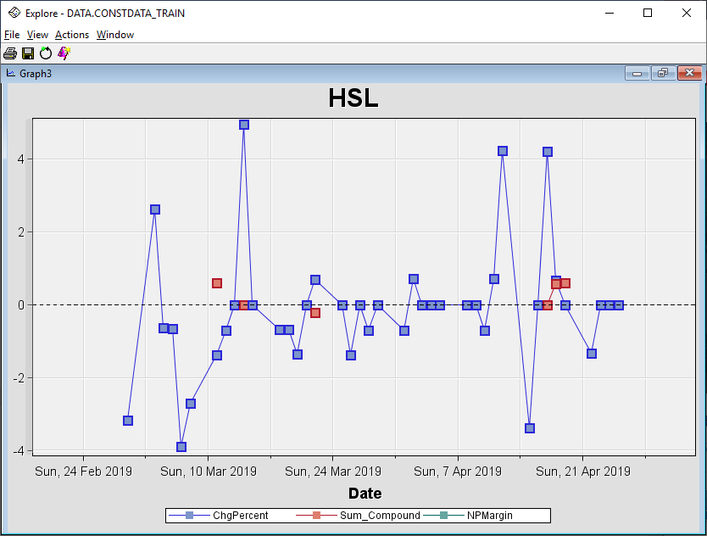

**Figure 16.** Change Percentage of Price and Sum of Compound Value for HSL.

Figure 16 shows the change percentage and sum of compound value for Hock Seng Lee Berhad. When there was positive news being announced, the stock price increased on that day or the next day and vice versa. For this stock, there was no financial report announcement in the period.

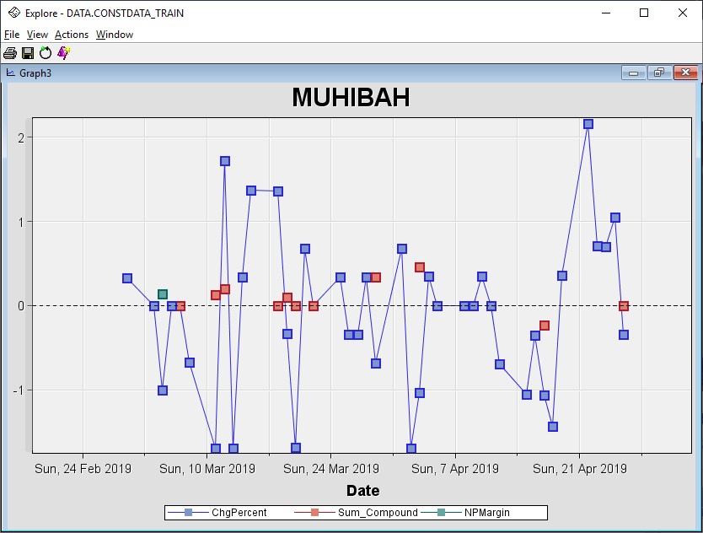

**Figure 17.** Change Percentage of Price, Sum of Compound Value and Net Profit Margin for MUHIBAH.

Figure 17 shows the change percentage, sum of compound value and net profit margin for Muhibbah Engineering (M) Bhd. Despite the announcement of positive news and positive net profit margin, the stock showed significant fluctuations.

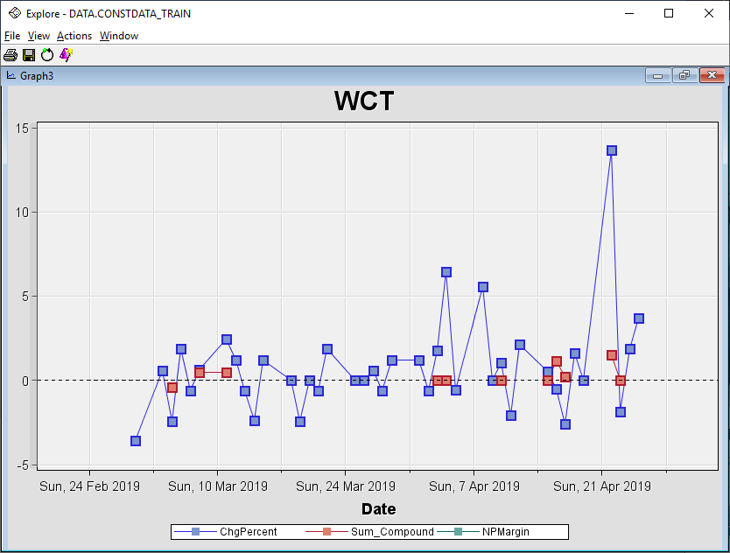

**Figure 18.** Change Percentage of Price and Sum of Compound Value for WCT.

Figure 18 shows the change percentage and sum of compound value for WCT Holdings Berhad. For most of the time, the increment in stock price were related to the announcement of positive news. The same thing happened when there was negative news being announced, the price dropped. For this stock, there was no financial report announcement in the period.

Conclusion, the price volume analysis shows that if more people want to buy a stock, its price increases, and vice versa. The analysis of individual stock also shows that supply and demand is closely tied to news reports. Negative news causes sales of stock and a decrease in stock prices while positive news causes purchases of stock and increase in stock prices. At the same time, the announcement of financial report with positive net profit margin also causes increase in stock price.

Link:

https://drive.google.com/file/d/1NYS88YVWG3wrO47SfGsAKqfoyCXLwecR/view?usp=sharing