Group 5

Bernardo Barcellos de Castro Cunha 9293380
Eduardo Santos Carlos de Souza 9293481
William Quelho Ferreira 9293421

Pre-Trained CNN applied to driving-related object recognition

Main Objective:
Given an image taken facing the direction in which a car is moving, the system shall detect road signs, cars, pedestrians and other relevant objects for a driver or autonomous system using a pre-trained convolutional neural network (CNN). The system would ideally work in real-time and could possibly be able to detect the position of the objects within the image.

Input Images:
The images of the our dataset will be collected by two different ways. We will research for datasets that other people have already built and manually select from them images that can be useful for our project. Also we will use an automated crawler of our own to look for relevant images on Google Images. Some of the datasets that we will use include:
- Graz02
- PascalVOC
- ImageNet
All images used in our datasets will be available at http://bit.ly/2spOvbj.
The images will be rescaled to 64x64, and some variations will be applied for the training images, with transformations such as translation, rotation and/or horizontal mirroring.

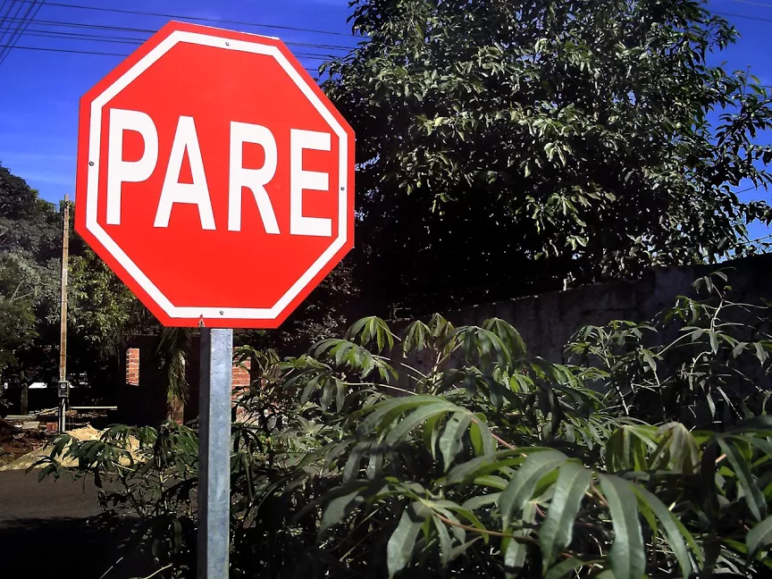
Figure 1: Example of a dataset image collected from Google Images
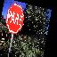
Figure 2: Image after processing

The dataset’s images will belong to one of the following classes:
- Bicycle
- Car
- Motorcycles
- Pedestrian
- Traffic Light
- Dog
- No parking sign
- Stop Sign
- Toll
- Truck

Detailed description:
The idea of our project is to adapt a pre-trained CNN to recognize objects of classes specific for use in a driving scenario, such as in an autonomous vehicle.
We intend to use the VGG16 model trained on the ImageNet dataset as our pre-trained CNN. We will download the trained CNN without the input and top layers, then freeze the parameters for the convolutional layers, and re-generate the top layers and input layers, and retrain them on our specific dataset.
After acquiring the images from the aforementioned datasets or Google Images, we will manually filter out the unwanted ones, and divide them into different directories, one for each class. After that, we randomly select 20% of the images in each class and move them into a different directory, meant to test the CNN after training is complete over the remaining 80%. For the remaining 80% we will apply the size reduction and random transformations mentioned above on 10 to 20 copies of each image. We do this in order to increase the variety of our training data and reduce the training time.
With both the modeled CNN and the dataset in hands, we will train the network on our personal computers using the Keras fit function for 200 epochs. Then we will evaluate our success by taking a testing set, predicting the class for each image, assuming that the identified class for the image is the position of the maximum value of the output of the CNN, and comparing the predicted class with the correct one. We expect mildly successful results.

Source code and images:
The source code for the project can be found at https://github.com/wqferr/PPdI.
The datasets used for training and testing can be found at http://bit.ly/2spOvbj.

First Results:
The CNN was trained with the 10 classes, each one with more or less 90 training images and 10 testing images, manually filtered, for 60 epochs. It took 1 hour and 40 minutes and we got 64% of accuracy.
We later trained the CNN on 5 classes with 160 training images and 40 test images. We got approximately 62% average accuracy.
We have come to realize that our CNN needs bigger and more varied datasets. We have obtained relatively low accuracy when trying to predict the class of our test images (that were not present during training), however when doing the same for the training set we get more than 95% accuracy. So our network is well fitted for the training dataset, however when trying to predict the class of an image that deviates from it, the CNN gets the class wrong much more often. It might be difficult to acquire varied enough images.

