Cocos2dx有五种屏幕适配模式：

EXACT_FIT NO_BORDER SHOW_ALL FIXED_HEIGHT FIX_WIDTH

**EXACT_FIT**

X轴与Y抽均拉伸到与屏幕大小相等

**NO_BORDER**

保持比例，放缩较大的倍数 （screen/designResolution）

**SHOW_ALL**

保持比例，放缩较小的倍数 （screen/designResolution）

**FIX_WIDTH**

保持比例，同时保证宽度不变

**FIXED_HEIGHT**

保持比例，同时保证高度不变

下面的例子中（图片大小为960*640 屏幕窗口大小为500*500 DesignResolutionSize = 960*640）

同时查看各种尺寸的区别：

Size winSize = director->getWinSize();

Size visibleSize = director->getVisibleSize();

Size designResolutionSize = director->getOpenGLView()->getDesignResolutionSize();

Size screenSize = director->getOpenGLView()->getFrameSize();

log("winSize width = %f, height = %f", winSize.width, winSize.height);

log("visibleSize width = %f, height = %f", visibleSize.width, visibleSize.height);

log("designResolutionSize width = %f, height = %f", designResolutionSize.width, designResolutionSize.height);

log("screenSize width = %f, height = %f", screenSize.width, screenSize.height);

**EXACT_FIT**

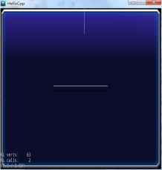



**NO_BORDER**

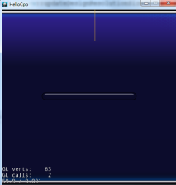



**SHOW_ALL**

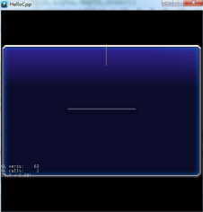



**FIX_WIDTH**

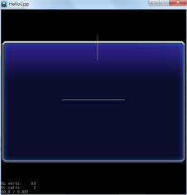



**FIXED_HEIGHT**

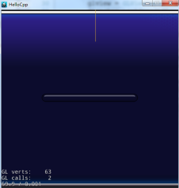



**源码分析：**

在上面的各种尺寸获取过程中：

winSize存于Director中

visibleSize、designResolutionSize与screenSize均存在与GLView中

注意getVisibleSize的获取方法：

Size GLView::getVisibleSize() const

{

if (_resolutionPolicy == ResolutionPolicy::NO_BORDER)

{

return Size(_screenSize.width/_scaleX, _screenSize.height/_scaleY);

}

else

{

return _designResolutionSize;

}

}

**实际上，visibleSize就是ResolutionSize的可以看到的部分**

调用：

glview = GLViewImpl::createWithRect("HelloCpp", Rect(0, 0, 500, 500));

内部会调用：

void GLView::setFrameSize(float width, float height)

{

_designResolutionSize = _screenSize = Size(width, height);

}

也就是初始化状态View中的designResolutionSize与screenSize均为自己的设置，此时均为500*500

调用

director->setOpenGLView(glview);

内部会调用：

_winSizeInPoints = _openGLView->getDesignResolutionSize();

也就是此时winSizeInPoints也设置为当前的designResolutionSize，此时为500*500

调用

director->getOpenGLView()->setDesignResolutionSize(960, 640, ResolutionPolicy::EXACT_FIT);

内部会调用：

_designResolutionSize.setSize(width, height);

也就是此时designResolutionSize变为960*640

内部还会调用：

director->_winSizeInPoints = getDesignResolutionSize();

也就是此时winSizeInPoints变为960*640

总结整个过程：

WinSize ScreenSize DesignResolutionSize

createGL 500*500 500*500

setOpenGLView 500*500（通过designResolutionSize设置）

setDesignResolution 960*640 960*640

void GLView::setDesignResolutionSize(float width, float height, ResolutionPolicy resolutionPolicy)

{

CCASSERT(resolutionPolicy != ResolutionPolicy::UNKNOWN, "should set resolutionPolicy");

if (width == 0.0f || height == 0.0f)

{

return;

}

_designResolutionSize.setSize(width, height);

_resolutionPolicy = resolutionPolicy;

**updateDesignResolutionSize();**

}

**void GLView::updateDesignResolutionSize()**

{

if (_screenSize.width > 0 && _screenSize.height > 0

&& _designResolutionSize.width > 0 && _designResolutionSize.height > 0)

{

_scaleX = (float)_screenSize.width / _designResolutionSize.width;

_scaleY = (float)_screenSize.height / _designResolutionSize.height;

if (_resolutionPolicy == ResolutionPolicy::NO_BORDER)

{

_scaleX = _scaleY = MAX(_scaleX, _scaleY);

}

else if (_resolutionPolicy == ResolutionPolicy::SHOW_ALL)

{

_scaleX = _scaleY = MIN(_scaleX, _scaleY);

}

else if ( _resolutionPolicy == ResolutionPolicy::FIXED_HEIGHT) {

_scaleX = _scaleY;

_designResolutionSize.width = ceilf(_screenSize.width/_scaleX);

}

else if ( _resolutionPolicy == ResolutionPolicy::FIXED_WIDTH) {

_scaleY = _scaleX;

_designResolutionSize.height = ceilf(_screenSize.height/_scaleY);

}

// calculate the rect of viewport

float viewPortW = _designResolutionSize.width * _scaleX;

float viewPortH = _designResolutionSize.height * _scaleY;

_viewPortRect.setRect((_screenSize.width - viewPortW) / 2, (_screenSize.height - viewPortH) / 2, viewPortW, viewPortH);

// reset director's member variables to fit visible rect

auto director = Director::getInstance();

director->_winSizeInPoints = getDesignResolutionSize();

director->_isStatusLabelUpdated = true;

director->setGLDefaultValues();

}

}