设置透明度可以使用setOpacity函数，如果父节点有串联关系，则优先获取父节点的透明度，但是注意，该函数同时也会更新Color值。同时如果设置了_cascadeOpacityEnabled，则同时会更新子节点

对于Layer而言

//setCascadeOpacityEnabled(true);

setOpacity(100);

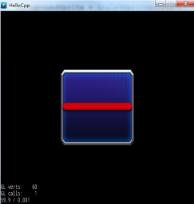

变为：

setCascadeOpacityEnabled(true);

setOpacity(100);

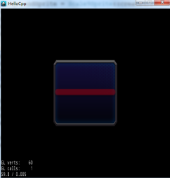

以Sprite为例：

void Node::setOpacity(GLubyte opacity)

{

_displayedOpacity = _realOpacity = opacity;

**updateCascadeOpacity();**

}

**void Node::updateCascadeOpacity()**

{

GLubyte parentOpacity = 255;

**if (_parent != nullptr && _parent->isCascadeOpacityEnabled())**

**{**

**parentOpacity = _parent->getDisplayedOpacity();**

**}**

**updateDisplayedOpacity(parentOpacity);**

}

**void Node::updateDisplayedOpacity(GLubyte parentOpacity)**

{

_displayedOpacity = _realOpacity * parentOpacity/255.0;

**updateColor();**

if (_cascadeOpacityEnabled)

{

for(const auto& child : _children)

{

child->updateDisplayedOpacity(_displayedOpacity);

}

}

}

**void Sprite::updateColor(void)**

{

Color4B color4( _displayedColor.r, _displayedColor.g, _displayedColor.b, _displayedOpacity );

// special opacity for premultiplied textures

if (_opacityModifyRGB)

{

color4.r *= _displayedOpacity/255.0f;

color4.g *= _displayedOpacity/255.0f;

color4.b *= _displayedOpacity/255.0f;

}

for (ssize_t i = 0; i < _polyInfo.triangles.vertCount; i++) {

_polyInfo.triangles.verts[i].colors = color4;

}

// renders using batch node

if (_batchNode)

{

if (_atlasIndex != INDEX_NOT_INITIALIZED)

{

_textureAtlas->updateQuad(&_quad, _atlasIndex);

}

else

{

// no need to set it recursively

// update dirty_, don't update recursiveDirty_

setDirty(true);

}

}

// self render

// do nothing

}