Body paragraph before the figure.
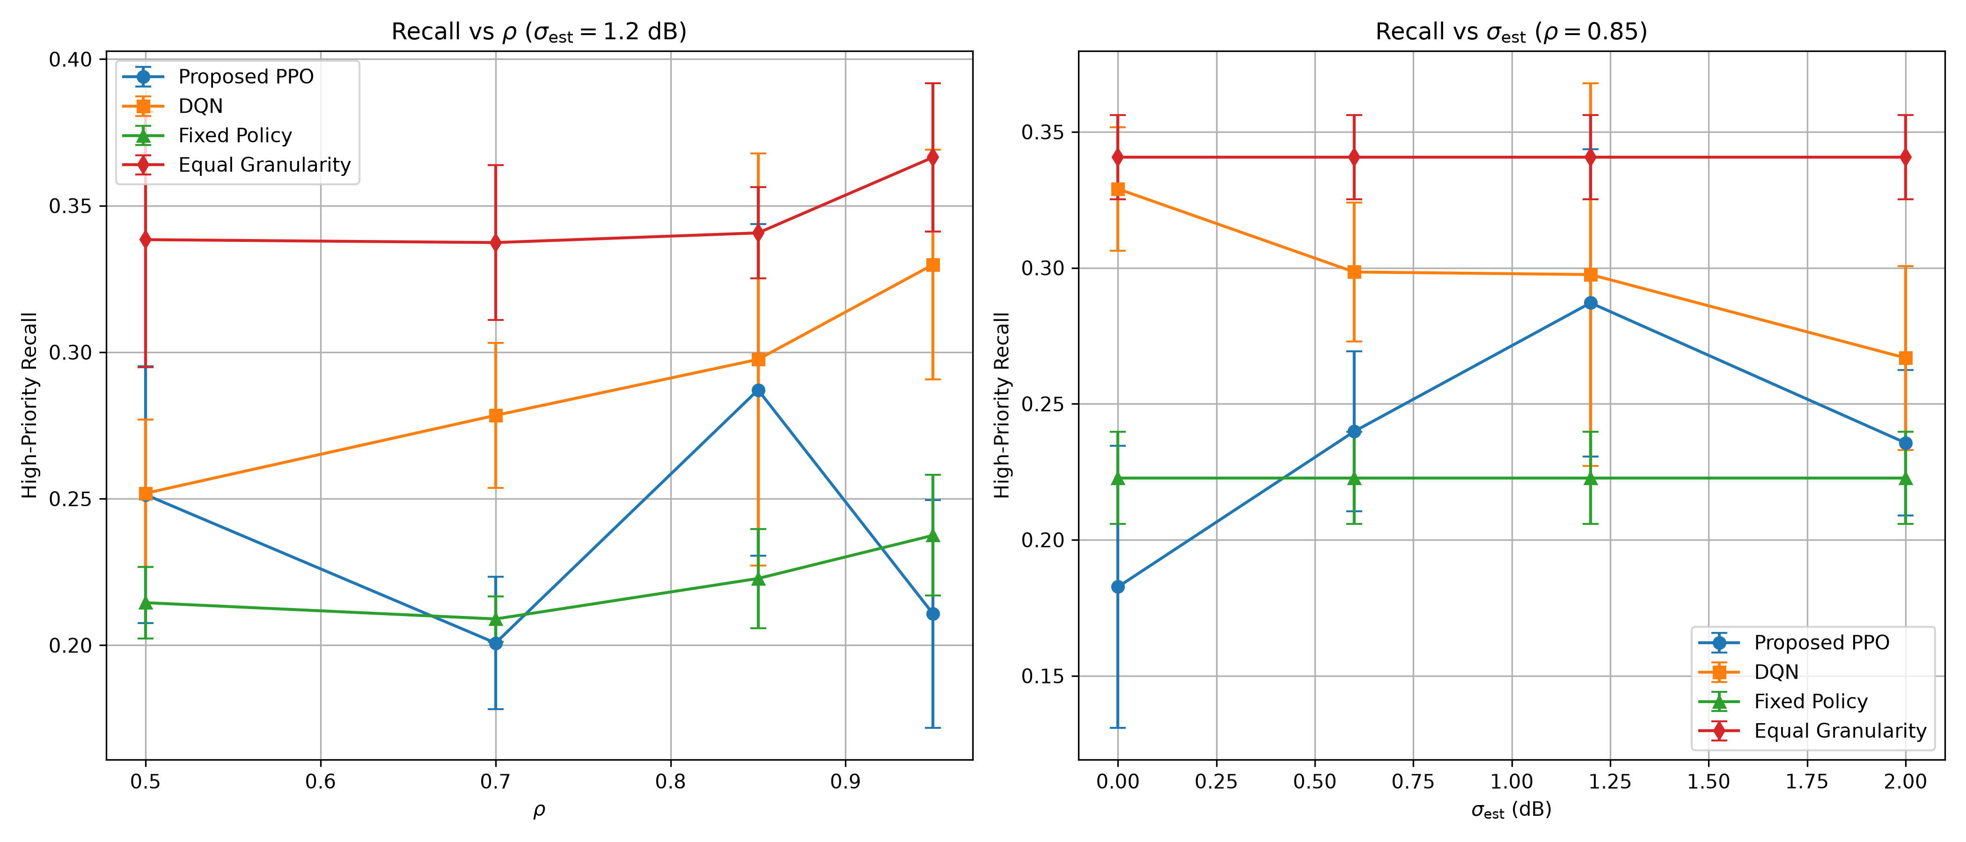
Fig. 2. Test caption below figure.

