solderbench: An open-source synthetic benchmark for PCB solder-joint defect inspection algorithm development
[Author Name]ª
ª [Affiliation], [City], [Country]
Corresponding author. E-mail address: [email]

Abstract
Automated optical inspection (AOI) of solder joints is a critical quality-control step in printed circuit board (PCB) assembly, and three-dimensional (3D) point-cloud inspection is increasingly adopted because solder quality is essentially a volumetric property. However, publicly available 3D solder-joint datasets are essentially nonexistent: industrial scan data are proprietary, so new inspection algorithms are difficult to compare fairly. We present solderbench, an open-source, pure-Python synthetic benchmark for developing and evaluating 3D solder-joint defect inspection algorithms. solderbench provides (i) a parametric point-cloud generator that simulates five joint classes (good, insufficient, excessive, bridging, and collapse) with more than fifteen controllable parameters and seed-level, point-wise reproducibility; (ii) a seven-dimensional geometric feature extractor; (iii) six baseline classifiers, including a re-implementation of the industrial volume-threshold rule S3DA; and (iv) automated comparison and ablation runners that export CSV, LaTeX, and figure artifacts. On a 1250-sample benchmark (seed 42), a random forest reaches 0.9440 accuracy and 0.9439 macro-F1, and feature ablation identifies height variance as the most informative descriptor. solderbench lowers the cost of developing, teaching, and fairly evaluating 3D solder-joint inspection algorithms, and exposes a clean integration point for real 3D-camera data.
Keywords: solder joint inspection; automated optical inspection; 3D point cloud; synthetic benchmark; defect classification; reproducible evaluation

Required metadata
Table 1. Code metadata (mandatory).
Nr. | Code metadata description | Value
C1 | Current code version | v0.1.0
C2 | Permanent link to code/repository used for this code version | [GitHub URL placeholder, e.g. https://github.com/your-org/solderbench]
C3 | Permanent link to reproducible capsule | [placeholder, e.g. Zenodo DOI after archival]
C4 | Legal code license | MIT License
C5 | Code versioning system used | git
C6 | Software code languages, tools, and services used | Python (>= 3.8)
C7 | Compilation requirements, operating environments and dependencies | numpy, scipy, pandas, scikit-learn, matplotlib; OS-independent
C8 | Link to developer documentation/manual | [placeholder, e.g. repository README.md]
C9 | Support email for questions | [email placeholder]

1. Motivation and significance
Surface-mount technology (SMT) dominates modern printed circuit board (PCB) assembly, and the quality of solder joints largely determines the reliability of the final product. Automated optical inspection (AOI) is the standard quality-control workhorse on SMT lines [1,2]. Classical AOI operates on 2D images and has been studied for three decades [3], and deep-learning-based 2D detectors now achieve high accuracy on public image datasets such as DeepPCB [4,5]. Increasingly, however, solder-joint inspection is moving to 3D: whether a joint contains too little solder, too much solder, or has collapsed around an internal void is fundamentally a volumetric question, and 3D AOI cameras that recover joint geometry as point clouds are now common on production lines [6,7].
This shift creates a methodological problem. While general-purpose 3D deep learning has advanced rapidly — with point-cloud architectures such as PointNet and PointNet++ [8,9] and mature tooling such as Open3D [10] — research on 3D solder-joint inspection is severely hampered by the absence of public data. Real 3D scans come from production lines and are commercially sensitive; manufacturers rarely release them, and the few published 3D point-cloud studies rely on private in-house data [6,7]. As a consequence, (i) new algorithms cannot be compared against each other on a common footing, (ii) reported numbers are difficult to reproduce, and (iii) researchers without access to an SMT line — including most academic groups and students — are effectively excluded from the problem. The 2D side of the field solved an analogous problem with public benchmarks [5]; no equivalent exists for 3D solder joints.
solderbench addresses this gap with a synthetic-data route. Instead of collecting and anonymizing real scans, it simulates solder-joint point clouds from a parametric geometric model whose parameters (nominal joint size, noise level, defect strength, bridging distance, collapse depth, and so on) are physically interpretable and user-controllable. Synthetic generation has three practical advantages over the real-data route. First, cost: a labeled dataset of arbitrary size can be generated in seconds on a laptop, with perfect labels by construction and no confidentiality constraints. Second, control: class distributions, difficulty, and sensor noise can be dialed deliberately, which enables controlled stress tests that real data cannot provide. Third, reproducibility: every cloud is a deterministic function of a random seed, so two researchers running the same seed obtain point-wise identical data.
The scientific questions solderbench is built to support are: (a) which geometric descriptors discriminate solder-joint defect classes, and how much each contributes; (b) how classical machine-learning pipelines compare with the rule-based methods used in industry; and (c) how algorithm rankings behave as data difficulty is varied. By fixing data generation, feature extraction, baselines, and evaluation protocol in one small, dependency-light package, solderbench turns anecdotal comparisons into a reproducible benchmark. We emphasize that solderbench does not claim to replace validation on real scans; its role is to make algorithm development and comparison possible before — and while — real data are negotiated (see Section 4 for an honest discussion of limitations).

2. Software description

2.1. Software architecture
solderbench is a pure-Python package (about 1,000 lines of source) organized as a linear pipeline of five modules with a single public API surface exported from solderbench/__init__.py:
- generator.py — SolderJointGenerator: the parametric point-cloud simulator (data layer);
- features.py — extract_features: the seven-dimensional geometric descriptor extractor (representation layer);
- baselines.py — get_baselines: the six baseline classifiers (model layer);
- evaluate.py — run_comparison / run_ablation: experiment runners with automatic CSV, booktabs LaTeX, and figure export (evaluation layer);
- data.py — load_dataset(): a unified data entry point and the designated integration point for real 3D-camera point clouds.
The data flow is strictly feed-forward: generator -> feature matrix -> classifiers -> evaluation tables/figures. Every stage consumes and returns plain NumPy arrays or pandas DataFrames, so any stage can be replaced independently — most importantly, synthetic clouds from the generator can be swapped for segmented real scans at the load_dataset() boundary without touching downstream code. The package ships with a unittest suite (15 tests covering dataset shape and class balance, exact same-seed reproducibility, feature validity, a statistical check that insufficient-solder joints have significantly smaller volume than good joints, and fit/predict smoke tests for all six baselines), a pyproject.toml for pip install -e ., and a codemeta.json metadata file. The only runtime dependencies are numpy, scipy, pandas, scikit-learn, and matplotlib.

2.2. Software functionalities
Parametric point-cloud generation. SolderJointGenerator simulates surface-mount solder joints as 3D point clouds in five classes that mirror the dominant defect taxonomy of SMT production:
- good — a nominal joint modeled as a half-ellipsoid with natural size variation;
- insufficient — too little solder, modeled as a uniformly shrunk ellipsoid (default shrink range 0.55-0.85 of nominal scale);
- excessive — too much solder with an irregular profile, modeled as an inflated ellipsoid (default mean inflation 1.3) plus a random bump of extra points;
- bridging — a solder bridge to the neighbouring joint, modeled by an abnormally small centre-to-centre distance plus a low strip of bridge points;
- collapse — a collapsed/void joint, modeled by a Gaussian dent at a random offset of the joint top.
More than fifteen parameters are exposed, including the number of points per cloud (n_points), sensor noise amplitude (noise), the insufficient-solder shrink range, the excessive-solder inflation mean/standard deviation and bump size range, the bridging distance mean/standard deviation and bridge point-count range, and the collapse depth range. Class distributions deliberately overlap — for example, the upper tail of insufficient overlaps the lower tail of good — so that no classifier can reach a perfect score; this is a deliberate methodological property that keeps the benchmark discriminative.
Geometric feature extraction. extract_features computes seven physically interpretable descriptors per joint: vol (volume by voxel counting, voxel size 0.01), max_h (maximum height), h_var (variance of point heights), area (convex-hull surface area, approximating the joint surface), vol_area_ratio (vol / area), convex_vol_ratio (vol / ConvexHull.volume, a shape-irregularity measure computed with scipy.spatial.ConvexHull), and min_dist (centre-to-centre distance to the nearest neighbouring joint).
Baseline classifiers. get_baselines returns six baselines spanning the methods a practitioner would try first: S3DA, a re-implementation of the industrial volume-threshold rule in which a joint is classified by thresholding its estimated solder volume [6]; logistic regression; a support vector machine with an RBF kernel [12]; k-nearest neighbours; gradient boosting; and a random forest [11]. All trainable baselines are scikit-learn estimators [13] with fixed random states.
Experiment runners. run_comparison(X, y) trains and evaluates all six baselines under a fixed protocol (stratified 7:3 train/test split plus 5-fold cross-validation on the training set) and returns a ranked DataFrame of accuracy, macro precision, macro recall, macro F1, and cross-validated accuracy; run_ablation(X, y) performs leave-one-feature-out and single-feature analysis for the random forest. Both runners export their tables as CSV and booktabs LaTeX, and run_comparison additionally renders the confusion matrix of the best model as a PNG figure. A single command, python examples/run_benchmark.py, reproduces the full benchmark reported in Section 3.

2.3. Implementation details
Two design decisions deserve emphasis because they protect the benchmark's validity.
Prevention of sampling-density leakage. Voxel-counting volume estimates are biased by point density: a denser cloud fills more voxels and looks 'bigger'. If defect classes were generated with different point counts, a classifier could cheat by learning the sampling density instead of the geometry. solderbench therefore resamples every cloud to exactly n_points points, so volumetric features reflect shape, not density.
Seed-level reproducibility. All randomness flows from a single numpy.random generator seeded at construction. The same seed produces point-wise identical clouds, identical feature matrices, and identical experiment tables; this property is asserted by the test suite. Combined with the fixed evaluation protocol and the pinned random_state of every baseline, the complete benchmark is bit-for-bit reproducible, and the tables in Section 3 can be regenerated with one command.
The feature extractor uses scipy.spatial.ConvexHull [15] for surface-area and convex-volume terms; array plumbing is NumPy [14]; tables are pandas DataFrames [16]; figures are rendered with matplotlib [17]. There is no compiled code, no GPU requirement, and no network access at runtime.

3. Illustrative examples

3.1. Quickstart
The following end-to-end example generates a dataset, extracts features, and runs both experiments in eight lines:
from solderbench import (SolderJointGenerator, extract_features,
get_baselines, run_comparison, run_ablation)

gen = SolderJointGenerator(n_points=1500, noise=0.02, seed=42)
clouds, labels = gen.generate(n_per_class=250) # 5 classes x 250 joints
X, y = gen.to_features(clouds, labels) # 7-feature matrix + labels

results = run_comparison(X, y) # 6 methods x Acc/P/R/F1 + 5-fold CV
print(results[["no", "name", "Accuracy", "F1"]])

abl = run_ablation(X, y) # leave-one-out + single-feature dF1
print(abl.head(8))

3.2. Benchmark comparison
examples/run_benchmark.py produces the benchmark snapshot reported in Table 2: 1250 samples (5 classes x 250 joints, 1500 points per cloud, seed 42, stratified 7:3 split; 5-fold cross-validation on the training set).
Table 2. Baseline comparison on the solderbench benchmark (seed = 42, 1250 samples). Best results in bold.
No. | Method | Accuracy | Precision | Recall | F1 | CV Acc. (5-fold)
B1 | S3DA (volume threshold) | 0.8960 | 0.8990 | 0.8960 | 0.8964 | 0.9234 +/- 0.0138
B2 | Logistic Regression | 0.9387 | 0.9416 | 0.9387 | 0.9386 | 0.9657 +/- 0.0198
B3 | SVM (RBF) | 0.9387 | 0.9390 | 0.9387 | 0.9385 | 0.9771 +/- 0.0177
B4 | KNN | 0.8933 | 0.8944 | 0.8933 | 0.8921 | 0.9234 +/- 0.0168
B5 | GradientBoosting | 0.9413 | 0.9417 | 0.9413 | 0.9412 | 0.9577 +/- 0.0138
B6 | RandomForest (Ours) | 0.9440 | 0.9452 | 0.9440 | 0.9439 | 0.9680 +/- 0.0160
Three observations follow. First, the industrial rule S3DA (B1) is a strong baseline at 0.8960 accuracy, confirming that solder volume alone carries most of the class signal — exactly the physics the generator encodes. Second, all learning-based methods improve on the rule, with the random forest best on the held-out test set (accuracy 0.9440, macro F1 0.9439). Third, test-set and cross-validation rankings do not fully coincide (the RBF SVM has the highest CV accuracy, 0.9771), which illustrates why solderbench reports both protocols rather than a single number.
Figure 1 shows the confusion matrix of the random forest on the held-out test set. Bridging is perfectly separated (75/75), because the min_dist feature exposes the abnormally small inter-joint distance by construction. The dominant residual confusion is between collapse and good/insufficient (4 and 6 samples, respectively): a shallow dent changes the height distribution only subtly, which is precisely the hard case reported for real 3D inspection systems.
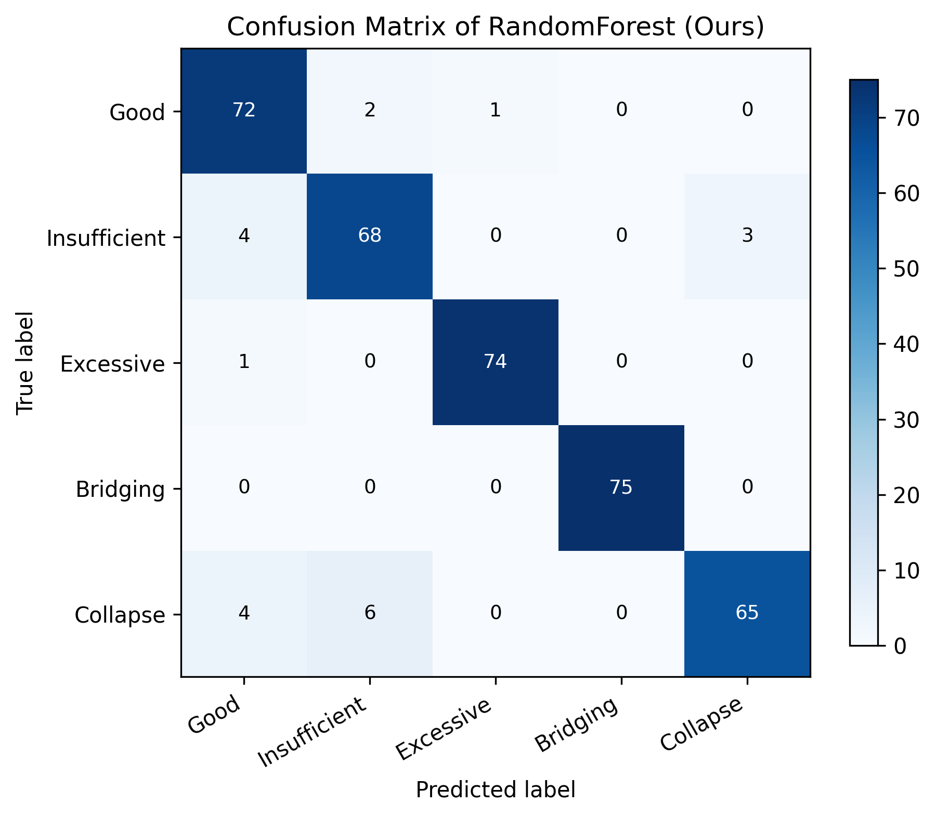
Figure 1. Confusion matrix of the RandomForest baseline (B6) on the held-out test set (375 samples, seed 42). Bridging is perfectly classified via the min_dist feature; the main confusion is collapse vs. good/insufficient.

3.3. Feature ablation
Table 3 reports the leave-one-feature-out (LOO) ablation for the random forest (full-model macro F1 = 0.9439).
Table 3. Leave-one-feature-out ablation of the RandomForest model (macro F1; full model = 0.9439).
Removed feature | dF1 vs. full model | Interpretation
h_var | -0.0459 | Most informative: collapse dents and excessive bumps reshape the height distribution
vol_area_ratio | -0.0105 | Compactness cue separating volumetric defects from nominal joints
min_dist | -0.0054 | Small overall cost because bridging is nearly separable already
area | -0.0052 | Correlated with vol; adds modest independent signal
convex_vol_ratio | -0.0025 | Irregularity cue; partially redundant with h_var
vol | +0.0026 | Slightly redundant once ratios are present
max_h | 0.0000 | Fully redundant given h_var and vol
The ablation has a clean physical reading. Height variance (h_var) is the single most valuable descriptor because the two hardest defects — collapse (a dent) and excessive solder (a bump) — are primarily height-distribution phenomena, whereas volume-only cues saturate. Single-feature runs corroborate this picture: the strongest single feature is convex_vol_ratio (macro F1 = 0.6412), which captures shape irregularity common to several defect types, while the weakest is min_dist (macro F1 = 0.3616), which is highly informative for bridging but carries no signal for the other four classes. The near-zero or positive deltas for vol and max_h indicate information redundancy rather than irrelevance: both are strongly correlated with the ratio features. These results demonstrate the kind of descriptor-level insight that a controlled synthetic benchmark makes cheap to obtain and exact to reproduce.

4. Impact
solderbench contributes to three communities. For inspection-algorithm research, it provides the first public, reproducible 3D benchmark for solder-joint defect classification, replacing per-paper private datasets with a common task, a common protocol, and versioned reference numbers; new methods can be ranked against six baselines with a single command. For teaching, the package is a self-contained case study in geometric machine learning: the complete pipeline from point-cloud simulation to feature engineering to model comparison fits in a short lab session, runs on any laptop, and every design decision (fixed point count, overlapping class tails, dual evaluation protocols) doubles as a lesson in benchmark methodology. For reproducibility practice, the combination of seed-level determinism, a one-command benchmark script, machine-readable exports (CSV/LaTeX/PNG), a codemeta.json descriptor, and an MIT license makes the software trivially citable, archivable, and reusable.
The path from synthetic benchmark to production data is deliberately short. A user with access to a real 3D AOI camera replaces the body of solderbench.data.load_dataset — or simply passes their own X, y — with code that reads the camera scans, segments individual joints, and calls solderbench.extract_features; all downstream experiments run unchanged. The synthetic benchmark can then serve as a pre-training or sanity-check stage, and the feature ablation indicates which descriptors deserve attention when real data are scarce.
We state the limitations honestly. The generator is a geometric model, not a physics simulator: it does not model wetting dynamics, surface tension, oxidation, or realistic sensor artifacts such as occlusion, multi-path reflections, or structured-light failure modes, and its noise model is a simple isotropic perturbation. Class-conditional distributions were chosen to be plausible and overlapping, not fitted to measured production data. Consequently, absolute metric values on solderbench must not be extrapolated to real production performance, and synthetic validation cannot substitute for validation on real scans. What the benchmark does guarantee is that comparisons made on it are fair, controlled, and exactly reproducible — which is the property the field currently lacks.

5. Conclusions
We presented solderbench, an open-source, pure-Python synthetic benchmark for 3D PCB solder-joint defect inspection. It combines a parametric five-class point-cloud generator with seed-level reproducibility, a seven-dimensional geometric feature extractor, six baselines including the industrial S3DA volume-threshold rule, and automated comparison/ablation runners with CSV, LaTeX, and figure export. On the reference benchmark (1250 samples, seed 42), a random forest achieves 0.9440 accuracy and 0.9439 macro F1, and ablation identifies height variance as the dominant descriptor. By removing the data-access barrier that currently fragments 3D solder-joint inspection research, solderbench makes algorithm development, comparison, and teaching in this domain open and reproducible. Future work includes fitting generator parameters to measured scans as they become available, adding sensor-artifact models, and extending the class taxonomy.

Acknowledgements
[Acknowledgements placeholder — funding, colleagues, and infrastructure to be acknowledged here.]

References
[1] Q. Ling, N.A.M. Isa, Printed circuit board defect detection methods based on image processing, machine learning and deep learning: A survey, IEEE Access 11 (2023) 15921-15944. https://doi.org/10.1109/ACCESS.2023.3245093
[2] Y. Zhou, M. Yuan, J. Zhang, G. Ding, S. Qin, Review of vision-based defect detection research and its perspectives for printed circuit board, Journal of Manufacturing Systems 70 (2023) 557-578. https://doi.org/10.1016/j.jmsy.2023.08.019
[3] M. Moganti, F. Ercal, Automatic PCB inspection systems, IEEE Potentials 14(3) (1995) 6-10. https://doi.org/10.1109/45.464686
[4] W. Dai, A. Mujeeb, M. Erdt, A. Sourin, Soldering defect detection in automatic optical inspection, Advanced Engineering Informatics 43 (2020) 101004. https://doi.org/10.1016/j.aei.2019.101004
[5] S. Tang, F. He, X. Huang, J. Yang, Online PCB defect detector on a new PCB defect dataset, arXiv preprint arXiv:1902.06197 (2019).
[6] Y. Xu, Z. Wang, J. Liang, Y. Zhang, J. Feng, W. Miao, J. Wang, G. Pu, S3DA: A 3D point cloud based PCB solder defect detection algorithm, in: S. Liu (Ed.), Software Fault Prevention, Verification, and Validation (SFPVV 2024), Lecture Notes in Computer Science, vol. 15393, Springer, 2025, pp. 115-130. https://doi.org/10.1007/978-981-96-1621-3_8
[7] Q. Hu, K. Hao, B. Wei, H. Li, An efficient solder joint defects method for 3D point clouds with double-flow region attention network, Advanced Engineering Informatics 52 (2022) 101608. https://doi.org/10.1016/j.aei.2022.101608
[8] C.R. Qi, H. Su, K. Mo, L.J. Guibas, PointNet: Deep learning on point sets for 3D classification and segmentation, in: Proceedings of the IEEE Conference on Computer Vision and Pattern Recognition (CVPR), 2017, pp. 652-660. https://doi.org/10.1109/CVPR.2017.16
[9] C.R. Qi, L. Yi, H. Su, L.J. Guibas, PointNet++: Deep hierarchical feature learning on point sets in a metric space, in: Advances in Neural Information Processing Systems 30 (NeurIPS), 2017, pp. 5099-5108.
[10] Q.-Y. Zhou, J. Park, V. Koltun, Open3D: A modern library for 3D data processing, arXiv preprint arXiv:1801.09847 (2018).
[11] L. Breiman, Random forests, Machine Learning 45(1) (2001) 5-32. https://doi.org/10.1023/A:1010933404324
[12] C. Cortes, V. Vapnik, Support-vector networks, Machine Learning 20(3) (1995) 273-297. https://doi.org/10.1007/BF00994018
[13] F. Pedregosa, G. Varoquaux, A. Gramfort, V. Michel, B. Thirion, O. Grisel, M. Blondel, P. Prettenhofer, R. Weiss, V. Dubourg, J. Vanderplas, A. Passos, D. Cournapeau, M. Brucher, M. Perrot, E. Duchesnay, Scikit-learn: Machine learning in Python, Journal of Machine Learning Research 12 (2011) 2825-2830.
[14] C.R. Harris, K.J. Millman, S.J. van der Walt, R. Gommers, P. Virtanen, D. Cournapeau, E. Wieser, J. Taylor, S. Berg, N.J. Smith, et al., Array programming with NumPy, Nature 585 (2020) 357-362. https://doi.org/10.1038/s41586-020-2649-2
[15] P. Virtanen, R. Gommers, T.E. Oliphant, M. Haberland, T. Reddy, D. Cournapeau, E. Burovski, P. Peterson, W. Weckesser, J. Bright, et al., SciPy 1.0: Fundamental algorithms for scientific computing in Python, Nature Methods 17 (2020) 261-272. https://doi.org/10.1038/s41592-019-0686-2
[16] W. McKinney, Data structures for statistical computing in Python, in: Proceedings of the 9th Python in Science Conference, 2010, pp. 51-56. https://doi.org/10.25080/Majora-92bf1922-00a
[17] J.D. Hunter, Matplotlib: A 2D graphics environment, Computing in Science & Engineering 9(3) (2007) 90-95. https://doi.org/10.1109/MCSE.2007.55

