WellViewer
The WellViewer has been developed to support the creation of the necessary input files for the wells in the MikeShe model from a JupiterXL database. The wells in MikeShe are divided in extraction wells and observation wells. This division is reflected in the WellViewer. The WellViewer can import and create new changes in the JupiterPlus-format. This format has been created to make it possible to store necessary change to the Jupiter-data in common format.

The WellViewer has the following functionality:

- Import wells and head observations from:
  - JupiterXL MS-Access database.
  - MikeShe setup.
- Import plants and extractions from JupiterXL MS-Access database
- Select wells located inside a MikeShe model area.
- Select plants based on mean yearly extraction within a period of time
- Select intakes based on number of head observations within a period of time
- Create changes in the JupiterPlus format to the following properties:
  - Well coordinates (XUTM, YUTM, ELEVATION)
  - Screens (TOP, BOTTOM)
  - Add and remove intakes from plants and change the active period
- Write specialized NOVANA point shapes with entries for each intake.
- Write MikeShe input files for detailed time series for selected observations.
- Write MikeShe input files for extraction wells.
- Write input files for LayerStatistics.

User Interface
The user interface contains three main tab pages: Plants (Figur 1), Wells (Figur 2) and Changes (Figur 3). The Plants page lists the plants in the box on the left. In the section above the list it is possible to select that only plants with a given mean extraction within a given time period should be listed. The plants in red have missing data. This can either be because there are no intakes attached or because the wells attached have missing data, typically screen info. Selecting a plant in from the list will display detailed data for that particular plant on the right. From this detailed view it is possible to access a dialogue where pumping intakes can be added or removed.

The Wells page is very similar to the plants page. There is a list of wells where it is possible to select those that have a certain number of observations within a given period of time. Again the wells marked with red have missing data. The graphs show the observations and any extraction from the well. The table in upper right corner shows the lithology. From this page it is possible to enter dialogs where the well properties and screen properties can be edited.

The Changes page contains a table where all the loaded changes shown. From this page changes can be loaded, saved and applied. Above the table there are two lists with Users and the projects. Deselecting a User or a Project will remove the changes from the table. To only use the changes of a specific user, only that user should be selected before the changes are applied.
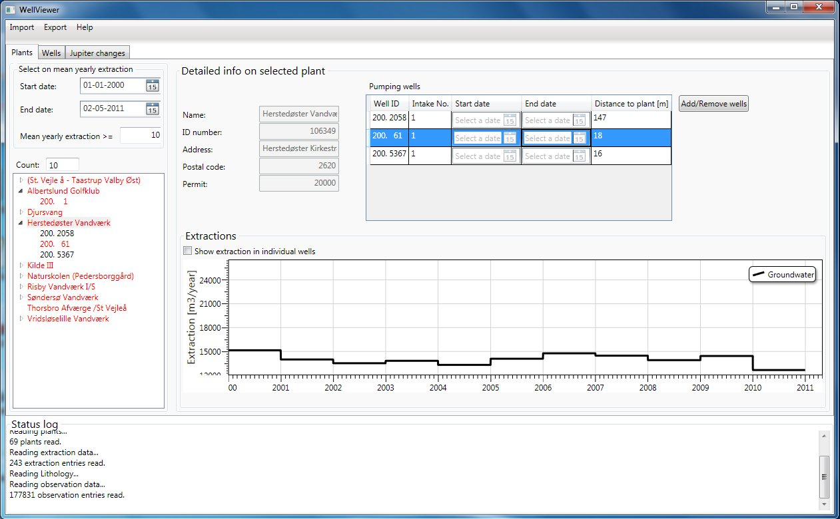
Figur 1 View of plants and detailed info on selected plant.

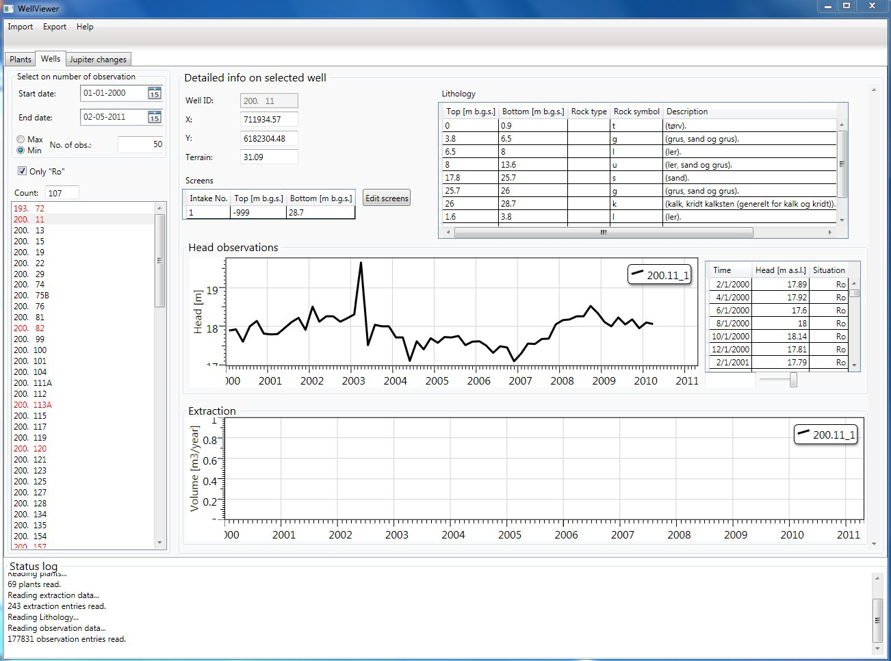
Figur 2 View of wells and detailed info on selected well.

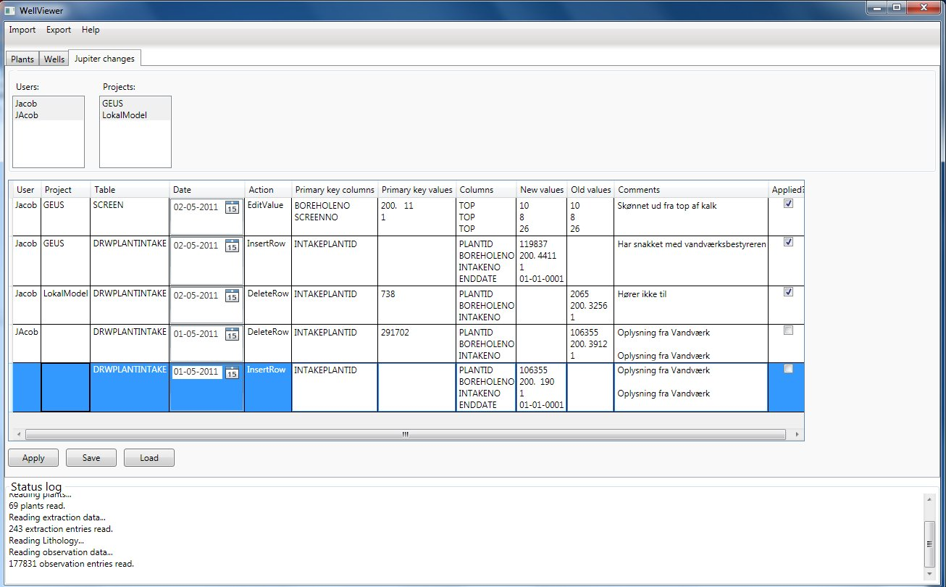
Figur 3. View of changes.

Description of the functionality

Import functionality

Jupiter database
This is used to read in data from a Jupiter XL database. These databases can be downloaded here: jupiter.geus.dk/JupiterWWW/DownloadPCJupiter?xl=1

When a wells is read in it is defined whether it is an extraction well or not. The wells are marked as extraction wells unless the USE field has one of the following values: "A", "G", "I", "J", "L", "R", "U", "M", "P" or the PURPOSE has one of the following values: "A", "G", "I", "J", "L", "R", "U", "M", "P" and the USE is NOT one of the following values: “C", "V", "VA", "VD", "VH", "VI", "VM", "VP", "VV".

When plants and extractions are read in the wells are attached to the plant. A plant can have a subplant and if a well is attached to both plants according to Jupiter it is removed from the upper plant when read in. Otherwise the subsequent distribution of extraction on the intakes would be wrong.

MikeShe setup
If wells have been read in from Jupiter the wells outside the horizontal model area of the MikeShe model will be removed.

Change functionality

Automatic generation of missing data
The program has a built-in algorithm to automatically generate missing data for the screens where it assumes a default screen length and either places the screen at the bottom of the intake or at the bottom of the well.

Export functionality
The type of export is chosen from the different items under the Export menu

ESRI shape (Extractions)
Writes a point shape file with entries for each intake attached to the selected plants that has extraction within the selected period.

Extraction files for MikeShe
This functionality creates the necessary input files for pumping wells in MikeShe. It writes a text-file with an entry for each intake attached to the selected plants and this file can be imported in the well editor. It also writes a .dfs0-file with the yearly extraction rate in items for each intake. It distributes the extraction from the plant evenly on all active intakes each year. If an intake has multiple screens top most level and the bottom most levels are used, so the intake will appear to be screened over the entire depth.
The name of the text-file is “WellEditorImport.txt” and the name of the .dfs0-file is “Extraction.dfs0”. If these files exist in the chosen output directory, they will be overwritten without warning. If a well does not contain the necessary information it will be listed in the file “WellsWithMissingInfo.txt”.

ESRI shape (Head observations)
Writes a point shape file with entries for each of the selected intakes. The point shape contains various data from the JupiterXL-database and statistics on the head observation time series.

LayerStatistics input file
Writes an input file that can be used by the utility layerstatistics. It will include all the selected intakes. It can either produce an entry for each head observation in the time series or it can take the average. This is chosen in the dialog that appears when the button is pressed.

Detailed time series file for MikeShe
Writes a text-file the .dfs0 -files that can be imported as a detailed time series output in MikeShe. An entry is written for all the selected intakes. Writing the .dfs0-files may take a long time. This can be followed by the progress bar that will appear in the lower left corner.

Limitations
The WellViewer does not handle unit conversion. Thus the data to be read in has to be in the same unit as required by the MikeShe-model. If data are read in from a JupiterXL-database the units will be in SI (Extraction in m³ and head observation in m) as required by MikeShe.

