WellViewer
The WellViewer has been developed to support the creation of input files for the wells in the MikeShe model from a JupiterXL database. The wells in MikeShe are divided into extraction wells and observation wells. This division is reflected in the WellViewer.
The data in the Jupiter-database are sometimes erroneous or missing. Some of these missing data can automatically be filled in by the WellViewer. Furthermore, it is possible to change some of the data and save these changes so they can be used with a later version of the database or by other users. The changes are saved in a generic format developed to describe changes to the Jupiter-database. With each change the name of the person creating the change is stored along with a project name, a date and a comment. The following properties can be changed and saved in the JupiterPlus-format:
- Well coordinates (XUTM, YUTM, ELEVATION, DRILLDEPTH)
- Screens (TOP, BOTTOM)
- Add screens to intakes/wells
- Add and remove intakes from plants and change the active period
- Remove head observations

The typical steps in creating the files are:
- Load a Jupiter-database (JupiterXL MS-Access 2000)
- Select the wells/plants to include (based on number of observations/amount of extraction)
- Load a Mike She model (to deselect wells outside model domain)
- Correct errors (Everything in red)
  - Autocorrect
  - Manual correction
  - Load file with corrections and apply changes
- Save any manual corrections to a file.
- Export the Mike She input files.

User Interface
The user interface contains four main tab pages: Plants (Figur 1), Wells (Figur 2) and Jupiter Changes (Figur 3) and Mike She (Figur 4).

Plants
The Plants page lists the plants in the box on the left. In the section above the list it is possible to select that only plants with a given mean extraction within a given time period should be listed. The plants in red have missing data. This can either be because there are no intakes attached or because the wells attached have missing data, typically screen info. Selecting a plant from the list will display detailed data for that particular plant on the right. From this detailed view it is possible to access a dialogue where pumping intakes can be added or removed. If the checkbox above the graph is checked it will show the extraction in the individual wells. The extraction is evenly distributed among the wells, so only one graph will be visible.
Expanding the plant in the list will show the attached extraction wells and selecting one of those will give a detailed view of the well. This is the same view that can be accessed from the Wells-tab.
Plants can be deselected by a right-clicking the list box and importing a shape-file with plant ID-numbers. The IDs will be loaded from the column “PLANTID”.

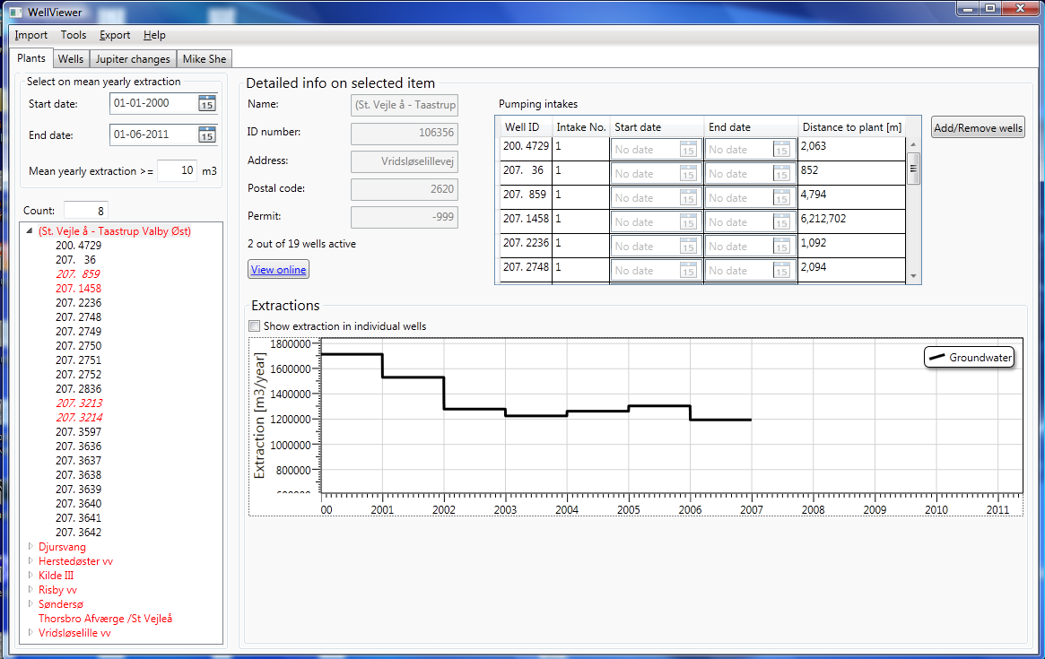
Figur 1. View of plants and detailed info on selected plant.

Wells
The Wells page is very similar to the plants page. There is a list of wells where it is possible to select those that have a certain number of observations within a given period of time. The wells marked with red have missing data. If they are in italic they can be autocorrected.
Wells can be deselected by a right-clicking the list box and importing a shape-file with well-IDs. The IDs will be loaded from the column “BOREHOLENO”.

Selecting a well will give a detailed view at the right. The graphs show the observations and any extraction from the well. If a well is not marked as “used for extraction” there will be no extraction in the well even though it is attached to a plant. If a well has missing data the graph will show extraction in the well. However, if input files are generated without correcting the errors, the well will not be used and the extraction will be redistributed on the remaining wells.

It is possible to change the X and Y-coordinates, the terrain and depths of the screens in the screens table. After making a change a pop-up dialog will appear where meta-data for the change can be entered. Subsequently the change will be added to the list of changes that can be viewed at the Jupiter Changes-tab. In the same way it is possible to delete entries from the list of observations. To add a new screen press the add screen button and a dialog will appear.

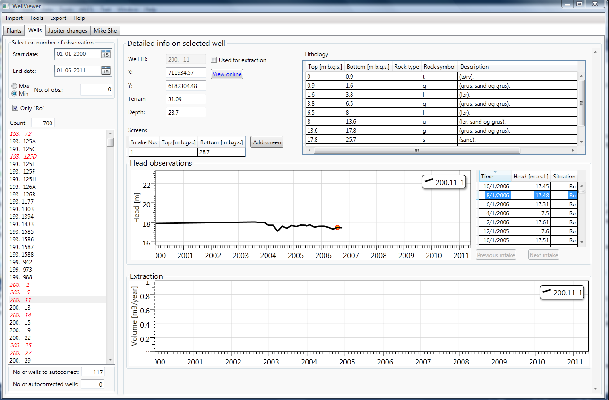
Figur 2. View of wells and detailed info on selected well.

Jupiter Changes
The Changes page contains a table where all the loaded changes are shown. From this page changes can be loaded, saved and applied. Changes that have been made in the current session will also be displayed in this list. Above the table there are two group boxes that each contains two lists. These can be used to select only the changes created by certain users or on certain projects. The lists on the left show all the possible values and the lists on the right show the ones currently in the table. Furthermore it is possible to deselect entries directly from the list by right-clicking.
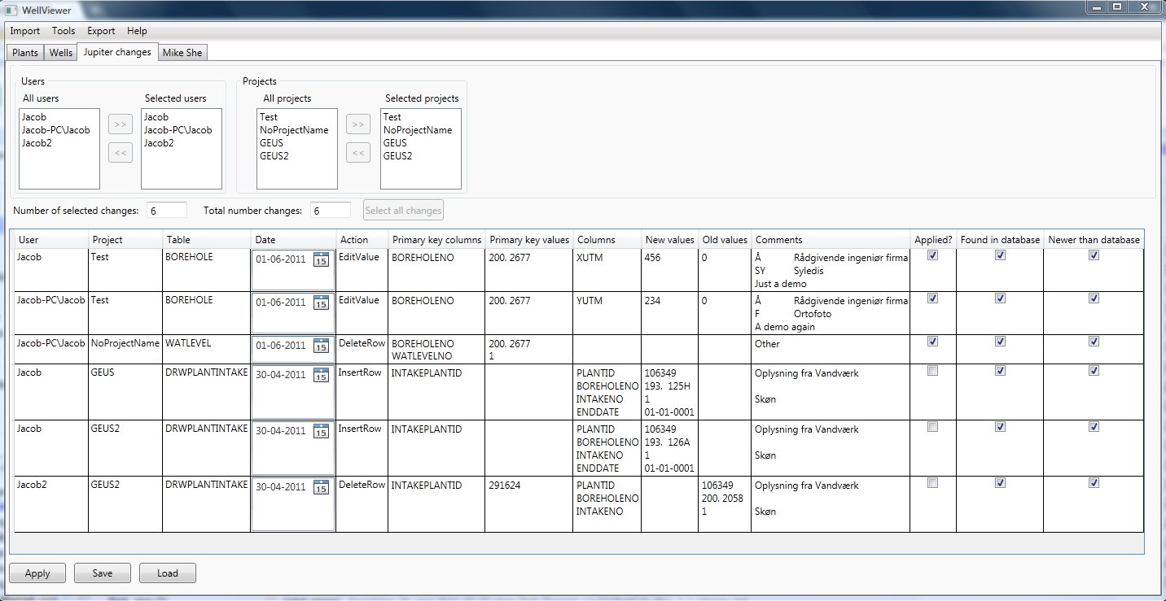
Figur 3. View of changes.

Mike She
On this tab page it is possible to adjust the levels of the screens according to a Mike She model. When a Mike She model is loaded it shows a list of the layers and builds four lists with screens that could be moved (see Figur 4. Only one list shown).
It checks if the screens are above the model terrain and it checks if screens are below model bottom. The screens are listed and subsequently they can be moved to the top or bottom layer by pressing the buttons.
It is also possible to determine that screens can only be present in certain layers (Water bodies). These are selected in the table in the upper right corner. When a selection is changed the table will automatically update.
Furthermore a “chalk” layer can be selected and the WellViewer will then detect screens containing a lithology that can be characterized as chalk that are not in this layer. These wells can be moved to the chalk layer. Only one layer can be chalk layer. The chalk lithologies are defined in the file Lithologies.xml that must be present in the bin-directory.

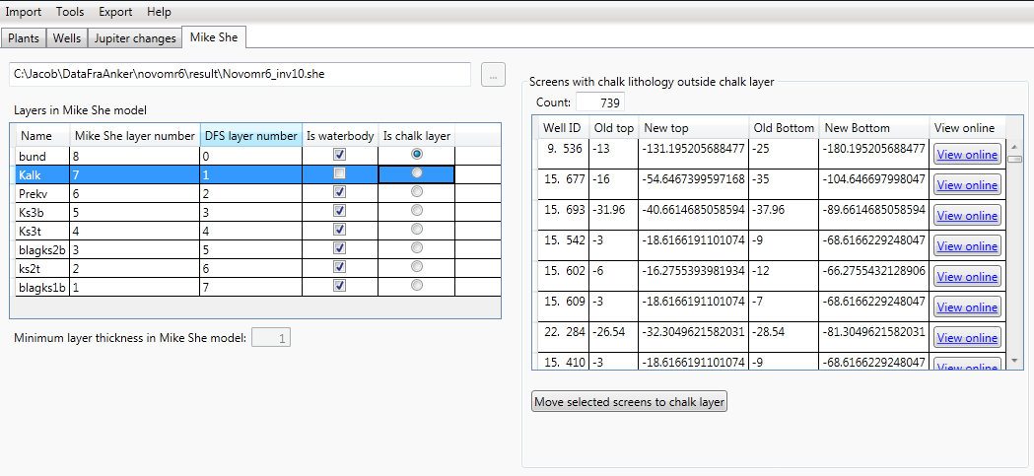
Figur 4. View of the Mike She tab page.

Detailed description of the functionality

Load Jupiter database
This is used to read in data from a Jupiter XL database in Access 2000. These databases can be downloaded here: jupiter.geus.dk/JupiterWWW/DownloadPCJupiter?xl=1.
Only one database can be loaded.

When a wells is read in it is defined whether it is an extraction well or not. The wells are marked as extraction wells unless the USE field has one of the following values: "A", "G", "I", "J", "L", "R", "U", "M", "P" or the PURPOSE has one of the following values: "A", "G", "I", "J", "L", "R", "U", "M", "P" and the USE is NOT one of the following values: “C", "V", "VA", "VD", "VH", "VI", "VM", "VP", "VV".

When plants and extractions are read in the wells are attached to the plant. A plant can have a subplant and if a well is attached to both plants according to Jupiter it is removed from the upper plant when read in. Otherwise the subsequent distribution of extraction on the intakes would be wrong. The extraction is distributed evenly on the active intakes.

Each intake attached to a plant can have a start and an end date showing the active period for this particular intake. These are dates are found first from the dates on the DRWINTAKE-table, then the dates on the screen and then on the dates on the well.

Load MikeShe setup
If wells have been read in from Jupiter the wells and plants outside the horizontal model area of the MikeShe model will be removed. If a plant has just a single well inside the model area all the wells attached to this plant will remain in the list. Otherwise the entire extraction would be assigned to the remaining wells.

Load Changes
An xml-file with changes in the JupiterPlus format will be loaded and they will appear in the list on the Changes tab-page. Multiple files can be loaded

Automatic generation of missing data
The program has a built-in algorithm to automatically generate missing data for the screens. It assumes a default screen length and either places the screen at the bottom of the intake or at the bottom of the well. The default length is 2m. The algorithm ensures that the screen is not above the surface. Applying the algorithm will only affect the selected plants and wells. Thus changing the selection may require that the algorithm be run again.

ESRI shape (Pumping data/head observations)
Writes a point shape file with entries for each intake attached to the selected plants or each intake from the selected wells. See appendix for a description of all columns.

Extraction files for MikeShe
This functionality creates the necessary input files for pumping wells in MikeShe. It writes a text-file with an entry for each intake attached to the selected plants and this file can be imported in the well editor. It also writes a .dfs0-file with the yearly extraction rate in items for each intake. It distributes the extraction from the plant evenly on all active intakes each year. If an intake has multiple screens top most level and the bottom most levels are used, so the intake will appear to be screened over the entire depth.
The name of the text-file is “WellEditorImport.txt” and the name of the .dfs0-file is “Extraction.dfs0”. If these files exist in the chosen output directory, they will be overwritten without warning. If a well does not contain the necessary information it will be listed in the file “WellsWithMissingInfo.txt”. If a plant has no usable wells attached it will be listed in the file “PlantsWithoutWells.txt”

Detailed time series file for MikeShe
Writes a text-file and the .dfs0 -files that can be imported as a detailed time series output in MikeShe. An entry is written for all the selected intakes.

LayerStatistics input file
Writes input files that can be used by the utility layerstatistics. It will include all the selected intakes. It produces a file with entries for every head observation in every well and a file with an entry for every well where the mean of the head observations within the selected period

Appendix A. Description of columns in shape output

Table 1: Columns in both type of shapes.
Column | Description
NOVANAID | Unique ID for Intake. For Headobservations it is WellID_IntakeNumber. For Extractions it is PlantID_WellID_IntakeNumber
XUTM | X-Coordinate
YUTM | Y-Coordinate
JUPKOTE | Elevation
BOREHOLENO | Well ID, DGU-number
INTAKENO | Intake number
LOCATION | Location from Jupiter
BOTROCK | Deepest rock type
DRILENDATE | Drill end date
DRILLDEPTH | Depth of well
CASIBOT | Depth to the bottom of the casing
PURPOSE | Purpose of the well
USE | Use of the well
INTAKETOP | Depth to top of intake
INTAKEBOT | Depth to the bottom of intake
INTAKTOPK | Top of intake in m a.s.l.
INTAKBOTK | Bottom of intake in m a.s.l.
RESROCK | Reservoir rocks at the screens
ANTINT | Number of intakes in the well
SUMSAND | Percent of sand at the screens. Sand is any rock type that contains either (”s”, ”g”, or ”k”)
COMMENT | Empty comment field
AUTOCORRECT | Text telling what autocorrections has been applied to screens
ORG_LAYTOP | Original top layer in Mike She model
ORG_LAYBOT | Original bottom layer in Mike She model
ADJUSTLAY | New layer after movement

Table 2: Columns only present in shape with head observations
Column | Description
REFPOINT | Reference point
AKTAAR | Length of observation time series in years within selected time period
AKTDAGE | Length of observation time series in days within selected time period
PEJPRAAR | Mean number of observations per year with observations in selected time period
ANTPEJ | Number of observations in selected time period
MINDATO | Date of first observation
MAXDATO | Date of last observation
MEANPEJ | Mean head in selected period
MINPEJ | Minimum head in selected period
MAXPEJ | Maximum head in selected period

Table 3: Columns only present in shape with extraction data
Column | Description
PLANTID | ID number of plant
PLANTNAME | Name of plant
NYKOMNR | ”Kommune” number after 2007
KOMNR | ”Kommune” number before 2007
ANLUTMX | X-Coordinate of plant
ANLUTMY | Y-Coordinate of plant
VIRKTYP | Company type of plant
ACTIVE | Integer indicating if plant is marked as active
OVERANL | Plant number of superior plant
ANTUNDERA | Number of subplants
INTSTDATE | Start date of pumping in the intake
INTENDATE | End date of pumping in the intake
MEANINDV | Average plant extraction in selected time period [m3/year]
AKTUELIND | Plant extraction at the end of the selected time period [m3/year]
PERMIT | Plant permit [m3/year]
ANTINT_A | Number of intakes on plant
ANTBOR_A | Number of wells on plant
FRAAAR | First active year intake at plant
TILAAR | Last active year for intake at plant

