Development process record

We intended to use BAN-VQA as our basic model at first, but we failed to use its code. After that, we decided to us another well-performed model, MCAN-VQA, to achieve our original goal.

The development process of BAN-VQA is stated below.

It’s easy to import the github code. We met the first problem when I found the memory in SCC is not enough for installing the libraries and dataset.

After contacting with our professor two times, the library problem is solved. There are pre-installed libraries in SCC so we can use them directly by using the following command:

$ module load python

Besides, we can use the following command to check which version of the library can be loaded:

$ module av python

Use the following command to unload the library

$ module unload python

After solving the library problem, we met another problem that the dataset is much larger than 16GB which means that we cannot use the personal space to run the code. The situation we encountered at that time was: command wget did not report error, but the downloaded file was damaged. I tried several times, finding that the file size was same, but much smaller than the size It should be. Finally, I found that there is a limitation of self-holder.

After contacting with IT help center, we found the solution that we can use the class space. I duplicated the code repository to the class folder, and it can download the dataset successfully.

There was still problems when we tried to run the code. The situation was stated as follows:

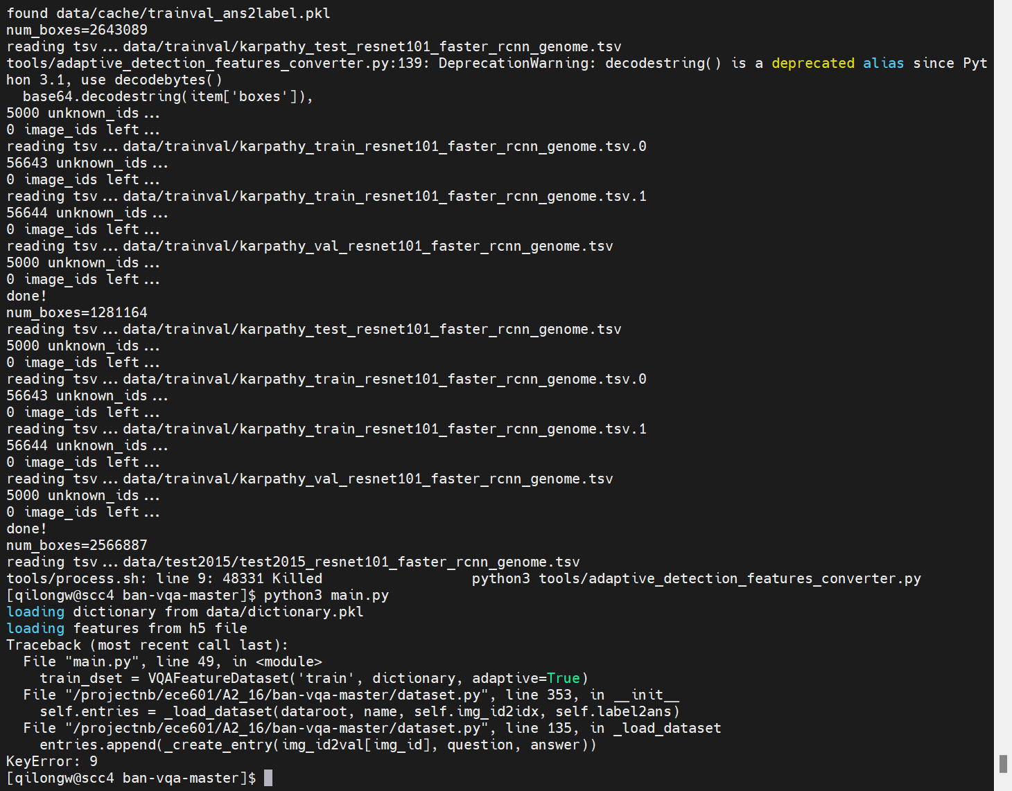

It seems that a dictionary in python was null, causing the error. I think it may be caused by the mistakes during the importing process. I did not find how to solve it, so we had to change the model we used.

Development process of MCAN-VQA:

We found another well-performed model, MCAN-VQA. I downloaded the dataset from a Baidu-Netdisk. This time I run the code on my own computer (Windows System).

I changed some file path in the code into windows path. When running the code, there was an error in run.py that yaml.load(f) reported an error. After searching on the internet, I found that the new version of pyyaml did not support this method. I changed the code into yaml.safe_load(f). It can run successfully.

The final result is stated as follows.

