问题1

1.1描述你使用的环境、操作系统、内核数量、实际内存量。

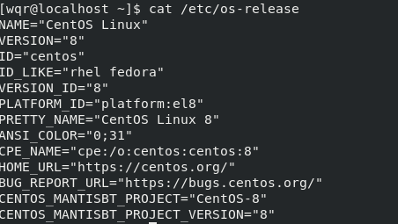

内核数量8

1.2什么参数给出了 > 30 秒的时间？ 19

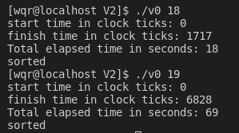

1.3完成时钟滴答和经过时间需要多长时间？

时钟滴答：6828 经过时间：69s

问题5解释你是如何做到的，并将你观察到的时间与步骤 0 中的时间进行比较。  
解释为什么时间不同？

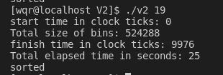

问题7将此程序的时间和内存使用与前面的步骤进行比较。解释结果。  
注意需要统计子进程的时钟滴答和运行时间。(代码要记得实现完整)  
注意：要确保排序正确，在合适位置调用 waitpid。  
你可以使用 gnome-system-monitor 直观地查看CPU和内存使用情况。  
还可以使用命令行 htop 命令（不太好，但可以在终端中使用）

read(fd[i][0],&bins[i].data[j],sizeof(bins[i]));时

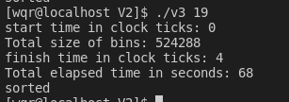read write拖慢的

read(fd[i][0],bins[i].data,sizeof(int)*bins[i].size);时

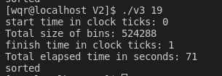 why？？？

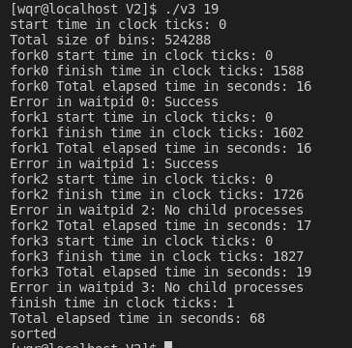

拆开来有什么区别，对read write一样，去看书前面精准的话，P68 和缓冲区大小有关 +5.8节

**else if(pid>0)出加return前**

[wqr@localhost V2]$ gcc -lm -o v3 v3.c

[wqr@localhost V2]$ ./v3

383 886 777 915 793 335 386 492 649 421 362 27 690 59 763 926

start time in clock ticks: 0

Total size of bins: 16

main_pid 12966

child_pid 12970

child_pid 12971

m: 1

m: 0

fork1 start time in clock ticks: 0

fork0 start time in clock ticks: 0

Error in pipe read 4: Bad file descriptor

fork1 finish time in clock ticks: 0

fork1 Total elapsed time in seconds: 0

fork0 finish time in clock ticks: 0

fork0 Total elapsed time in seconds: 0

child_pid 12973

m: 2

child_pid 12975

fork2 start time in clock ticks: 0

m: 3

fork3 start time in clock ticks: 0

fork2 finish time in clock ticks: 0

fork2 Total elapsed time in seconds: 0

fork3 finish time in clock ticks: 0

fork3 Total elapsed time in seconds: 0

finish time in clock ticks: 0

finish time in clock ticks: 0

Total elapsed time in seconds: 0

Total elapsed time in seconds: 0

27 59 383 335 386 492 421 362 649 690 886 777 915 793 763 926

27 59 335 362 383 386 421 492 649 690 886 777 915 793 763 926

not sorted

not sorted

main_pid 12967

main_pid 12968

finish time in clock ticks: 0

Total elapsed time in seconds: 0

27 59 383 335 386 492 421 362 649 690 886 777 915 793 763 926

not sorted

finish time in clock ticks: 0

main_pid 12969

Total elapsed time in seconds: 0

27 59 383 335 386 492 421 362 649 690 763 777 793 886 915 926

not sorted

main_pid 12972

finish time in clock ticks: 0

Total elapsed time in seconds: 0

27 59 383 335 386 492 421 362 649 690 886 777 915 793 763 926

not sorted

main_pid 12974

finish time in clock ticks: 0

Total elapsed time in seconds: 0

27 59 383 335 386 492 421 362 649 690 886 777 915 793 763 926

not sorted

main_pid 12966

**else if(pid>0)出加return后**

[wqr@localhost V2]$ gcc -lm -o v3 v3.c

[wqr@localhost V2]$ ./v3

383 886 777 915 793 335 386 492 649 421 362 27 690 59 763 926

start time in clock ticks: 0

Total size of bins: 16

main_pid 13087

child_pid 13091

m: 0

fork0 start time in clock ticks: 0

fork0 finish time in clock ticks: 0

fork0 Total elapsed time in seconds: 0

child_pid 13093

m: 1

Error in pipe read 4: Bad file descriptor

fork1 start time in clock ticks: 0

fork1 finish time in clock ticks: 0

child_pid 13094

fork1 Total elapsed time in seconds: 0

m: 2

fork2 start time in clock ticks: 0

fork2 finish time in clock ticks: 0

fork2 Total elapsed time in seconds: 0

finish time in clock ticks: 0

Total elapsed time in seconds: 0

27 59 383 335 386 492 421 362 649 690 886 777 915 793 763 926

not sorted

main_pid 13095

child_pid 13096

m: 3

fork3 start time in clock ticks: 0

fork3 finish time in clock ticks: 0

fork3 Total elapsed time in seconds: 0

**子进程不实施m<4，父进程不拦住m=4情况：第4个进程好像跟父进程有关，不能直接退出的**

[wqr@localhost V2]$ gcc -lm -o v3 v3.c

[wqr@localhost V2]$ ./v3

383 886 777 915 793 335 386 492 649 421 362 27 690 59 763 926

start time in clock ticks: 0

Total size of bins: 16

main_pid 15740

parent_pid 0:15741

parent_pid 4:15740

parent_pid 1:15742

parent_pid 2:15743

Error in pipe read 4: Bad file descriptor

child_pid 15745

m: 0

parent_pid 3:15744

child_pid 15746

fork0 start time in clock ticks: 0

m: 1

fork1 start time in clock ticks: 0

27 59 after insert

335 362 383 386 421 492 after insert

fork0 finish time in clock ticks: 0

fork0 Total elapsed time in seconds: 0

child_pid 15748

child_pid 15749

fork1 finish time in clock ticks: 0

m: 3

m: 2

fork1 Total elapsed time in seconds: 0

fork2 start time in clock ticks: 0

fork3 start time in clock ticks: 0

763 777 793 886 915 926 after insert

649 690 after insert

fork2 finish time in clock ticks: 0

fork3 finish time in clock ticks: 0

fork2 Total elapsed time in seconds: 0

fork3 Total elapsed time in seconds: 0

child_pid 15747

m: 4

fork4 start time in clock ticks: 0

27 59 335 362 383 386 421 492 649 690 763 777 793 886 915 926 after insert

Error in pipe write 4: Bad file descriptor

fork4 finish time in clock ticks: 0

fork4 Total elapsed time in seconds: 0

