1. Overview of why it’s value.

1. Title of our food truck is Hummous King
2. A food truck app that would locate where our foodturck is located for an evan. Also an app that would display our menu to our customers.
3. I decided to build a Food Truck app. It’s something that my family wanted to do as a business. It’s great that I get to actually code our own site and not have to pay for it.

2. I got to use bootstrap and Google fonts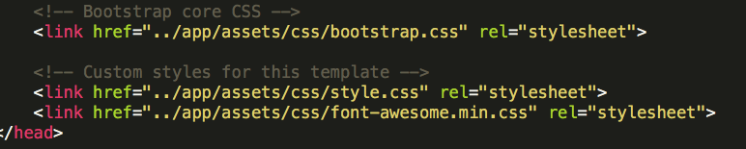

3. I am the only one working on this project. I started on the front end of the site first, then I will work my way to the backend once.

4. I try to work on my project every night for couple of hours.

5. 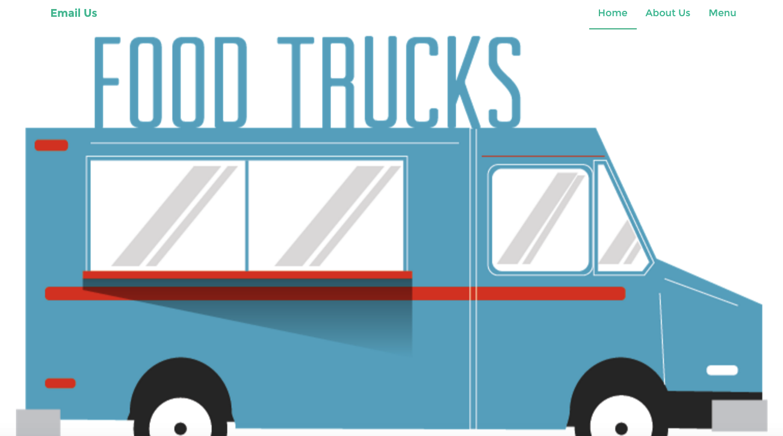

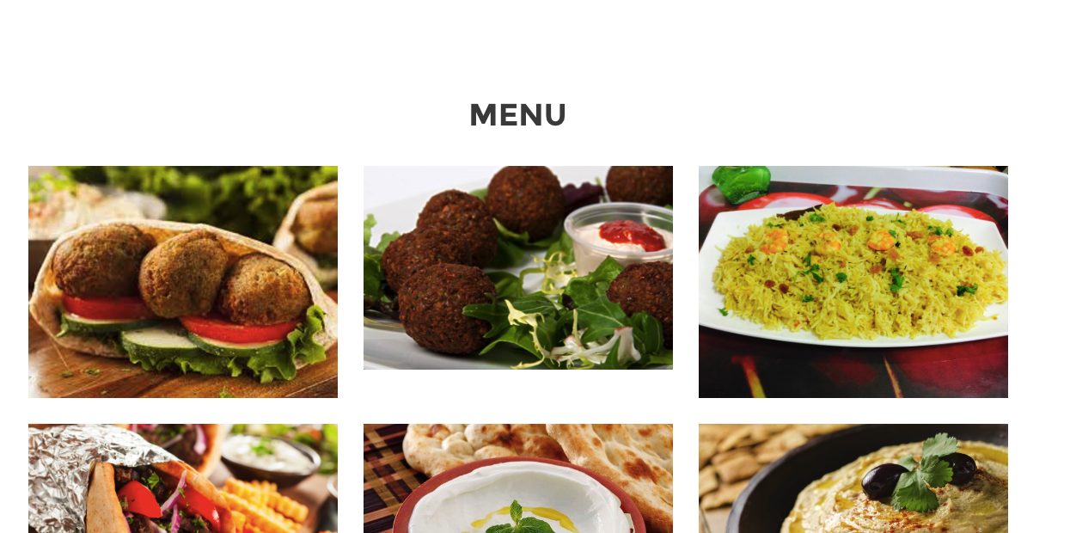

6.

1. <https://github.com/wquttaineh/myfinalproject>
2. http://www.bootcampspot.com/homework/RurMRZxcwpGyGLeW8