Python GUI with Tkinter - lynda.com
Creating and Configuring Widgets
Import all the functions and variables from the base tkinter package
from tkinter import *
Import the themed tk widgets. Once this is done can use the themed widgets by prefacing the constructor methods with ttk
from tkinter import ttk
Instantiate the Tk class to create a top level window that will be the parent for all other widgets. Each instance of the Tk class will have its own tk interpreter.
root = Tk()
Create a themed button that is a child of root with the text property 'click me'
button = ttk.Button(root, text = 'click me'
Make the button visible
button.pack()
To find the current value of a property, use the square brackets and the property name in quotes
button['text']
May also use this indexing method to assign a new value to the property
button['text'] = 'Save'
May also use the config command to change the property of a widget after it has been created
button.config(text = 'New Value')
These properties are stored in a dictionary within the object. To see the dictionary with all the properties available for the object as well as the current value, enter the following at the command line
button.config()
To see the unique identifier for the object. this identifier is appended to the parent object. The root object has the identifier dot ( . )
str(button)
Managing Widget Placement
Three geometry managers available. May use multiple managers within a single application, but must use the same manager to organize widgets within the same master.
Pack Geometry Manager
Places widgets based on the edges of the parent. Example
widget.pack(side = RIGHT)
Useful when you have to place several widgets on top of each other or in a side by side orientation
Grid Geometry Manager
Divides the parent widget area into a 2 dimensional table. Places child widgets into cells using rows and columns
widget.grid(row=0, column=1)
Place Geometry Manager
Allows the program to set the location by defining absolute or relative coordinates in the parent.
widget.place(x=200, y=150)
Event Handlers
Command Callbacks
For interactive widgets that produce events, like buttons. Configure by setting the widget's command property
Event Bindings
Used for events that don't have a command callback. Configure using the widget's bind method.
Example Program
#!/usr/bin/python3

from tkinter import *
from tkinter import ttk

class HelloApp:
def __init__(self, master):
self.label = ttk.Label(master, text="Hello, Tkinter")
self.label.grid(row=0, column=0, columnspan=2)
ttk.Button(master, text="Texas", command=self.texas_hello).grid(row=1, column=0)
ttk.Button(master, text="Hawaii", command=self.hawaii_hello).grid(row=1, column=1)
def texas_hello(self):
self.label.config(text="Howdy Tkinter")
def hawaii_hello(self):
self.label.config(text="Aloha Tkinter")

def main():
root = Tk()
app = HelloApp(root)
root.mainloop()

if __name__ == "__main__": main()
Basic Widgets
Label
label = ttk.Label(root, text=”hello”)
label.pack()
label.config(text=”here is a longer message”)
label.config(wraplength=150)
The number assigned to the wraplength property is in pixels.
label.config(justify=CENTER)
label.config(foreground=”blue”, background=”green”)
label.config(font=('Courier', 18, 'bold))
Using the label to show an image.
create a photo image object. Uses gif, pgm or ppm. External libraries like the Python Image Library can be used for other types.
logo = PhotoImage(file='logo.gif')
label.config(image = logo)
This will replace the text with the image. Use the compound property
label.config(compound = 'text') #change back to the text displey
label.config(compound = 'center') #center the text on the image.
other options for compound are top, bottom, left, and right
When using images, be sure to store the variable reference in a scope where it will not be garbage collected. For example, if the variable is local to a function it will be lost. If the PhotoImage instance is created in a class constructor, it will only last for the life of that instance.
To get around the scope problem, you can create the image object in the widget instance itself.
label.img = logo
label.config(image = label.image)
With the photo image stored in the label, it will stick around for as long as the label exists.
If the image is too large, use the subsample method to make a smaller version. This example takes every 5th pixel
small_img = img.subsample(5,5)
Button
button = ttk.Button(root, text='Click Me')
button.pack()
def buttonCallback():
print('button clicked')
button.config(command=buttonCallback)
Programatically simulate a button click using the invoke method
button.invoke()
The state and instate methods. State sets the state, instate checks the current state
button.state(['disabled']) #also returns the previous state
button.instate(['disabled']) #returns the value true of false
button.state(['!disabled']) #changes state to not disabled, also returns previous state
Other states include active, focus. For complete list, see documentation for themed tk widgets at http://tcl.tk
Check Button
In addition to triggering a callback, they can also store a binary value.
checkbutton = ttk.Checkbutton(root, text="Curly")
checkbutton.pack()
Variables in Tk programs using Tcl
Unlike regular Python variables, Tk programs allow you to watch for when a variable value is changed. The four classes are
BooleanVar
DoubleVar
IntVar
StringVar
Example of assigning a value variable to a check box:
>>> checkbutton = ttk.Checkbutton(root, text='check button')
>>> checkbutton.pack()
>>> val = StringVar()
>>> val.set('original value')
>>> val.get()
'original value'
>>> checkbutton.config(variable=val, onvalue='check is on', offvalue='check is off')
>>> val.get()
'original value'
#Now the user checks the box on
>>> val.get()
'check is on'
#Now the user checks the box off
>>> val.get()
'check is off'
The variable keeps its original value until the user interacts with the box
Radio Button
Radio buttons store the value from one of several mutually exclusive values. In the following example, each radio button is its own object but they are all tied together by the common variable breakfast. The button Muffin has been selected.
>>> breakfast = StringVar()
>>> ttk.Radiobutton(root, text='Pancakes', variable=breakfast, value='Pancakes').pack()
>>> ttk.Radiobutton(root, text='Waffles', variable=breakfast, value='Waffles').pack()
>>> ttk.Radiobutton(root, text='Muffin', variable=breakfast, value='Muffin').pack()
>>> breakfast.get()
''
>>> breakfast.get()
'Muffin'
Note that if multiple buttons have the same value, they will all be selected if one is selected.
Also, for widgets that have a text property, you can assign a variable to that property and it will change with the variable. For instance, adding a label to the radio buttons above will show the current value of the breakfast variable.
label = ttk.Label(root, textvariable=breakfast).pack()
The Entry Widget
For the entry of a single line of text. To create an entry field 30 characters wide:
>>> entry = ttk.Entry(root, width=30)
>>> entry.pack()
>>> entry.get()
'Hello'
Thisn doesn't limit the number of characters that can be entered, just the width of the object. The Entry object doesn't have a command attribute to tie it to a callback, instead must use Binding. For now, we'll just use the get method. There is no set method, instead use the delete and insert methods
>>> entry.delete(0,1)
>>> entry.get()
'ello'
>>> entry.delete(0, END)
>>> entry.get()
'' #returns an empty string
>>> entry.insert(0, 'Enter Your Password') #first arg is the insertion point
>>> entry.config(show='*') #hides characters entered and replaces with stars
>>> entry.state(['disabled'])
('!disabled',)
>>> entry.state(['!disabled'])
('disabled',)
>>> entry.state(['readonly'])
('!readonly',)
Combo Box
>>> month = StringVar()
>>> combobox = ttk.Combobox(root, textvariable=month)
>>> combobox.pack()
>>> combobox.config(values=('Jan', 'Feb', 'March', 'April', 'May', 'June'))
>>> month.set('March') #changes combobox to read March
>>> month.get()
'March'
Some problems with set - you can pass values in that are not a part of the values list. Also, user can type into the combobox and change the values. Check documentation on this.
Spin Box
Not available as a ttk widget. Note the instantiation doesn't include ttk. Not sure why they're not creating this with a reference.
>>> year = StringVar()
>>> sb = Spinbox(root, from_=1990, to=2014, textvariable=year)
>>> sb.pack()
>>> year.set(1995)
>>> year.get()
'1995'
Progress Bar & Scale
Length is the number of pixels in the longest direction. Can use one of 2 modes, determinate if you know how many steps the operation will take, indeterminate to just show that activity is taking place without specifying the time that remains.
>>> pbar = ttk.Progressbar(root, orient=HORIZONTAL, length=200)
>>> pbar.pack()
>>> pbar.config(mode='indeterminate')
>>> pbar.start()
>>> pbar.stop()
>>> pbar.config(mode='determinate', maximum=10.0, value=5.0)
>>> pbar.config(value=7.5) #update progrmatically
>>> pbar.step(value=1.0)
>>> pbar.step() #without argument will increase by 1
>>> pbar.step(2) #increase by 2, if it exceeds max, will wrap
In the following addition, a variable is created and assigned to the progress bar. Then a scale is set up to change the variable and the progressbar is updated.
>>> val = DoubleVar()
>>> pbar.config(variable=val)
>>> scale = ttk.Scale(root, orient=HORIZONTAL, length=400, variable=val, from_=0.0, to=10.0)
>>> scale.pack()
>>> scale.set(7.5) #programatically move the scale slider
>>> scale.get() #programatically retrieve the value
7.5
might be valuable to use a label to show the numeric value of the scale.
Organizational Widgets
Frames
Can act as parent and geometry manager for other widgets. Allows you to divide the interface into manageable subregions.
>>> fr1 = ttk.Frame(root)
>>> fr1.pack()
>>> fr1.config(height=100, width=200)
Six types of frame relief (borders) FLAT (no border), RAISED, SUNKEN, SOLID, RIDGE, GROOVE
>>> fr1.config(relief=RIDGE)
Add a button to the frame. Frame will collapse to the size of the button so add some padding.
ttk.Button(fr1, text='Click Me').grid()
fr1.config(padding=(30,15))
Add a label frame
>>> ttk.LabelFrame(root, height=100, width=200, text='Label Frame').pack()
Can't change the relief property of a label frame
Creating Top Level Windows
The following creates a new window, separate but still a slave of the root window.
>>> from tkinter import *
>>> root = Tk()
>>> window2 = Toplevel(root)
>>> window2.title('New Window')
''
>>> window2.lower() #send new window behind root window
>>> window2.lift(root) #bring window2 to top
Note that Toplevel is not part of the ttk package so it doesn't need to be imported.
>>> window2.state('zoomed') #fullscreen
>>> window2.state('withdrawn') #hidden - not in taskbar
>>> window2.state('normal') #normal default state
>>> window2.state('iconic') # shrink to taskbar
>>> window2.state('normal') # if returning from iconic will return to previous state - like zoomed if it was zoomed
>>> window2.state() #retrieve current state of window
'normal'
>>> window2.iconify() #shortcuts
>>> window2.deiconify()
By default, new window will be 200x200 and right on top of the root window. To change, use the geometry() Method
window.geometry('WIDTHxHEIGHT+X+Y')
Note that the argument is one big string.
>>> window2.geometry('640x480+100+200')
>>> window2.resizable(False, False) #prevent user from resizing
Limit the changes the user may make to the size of the window
>>> window2.maxsize(640, 480)
>>> window2.minsize(200,200)
The Destroy Method
Can be used on all kinds of widgets, not just windows. Will also destroy all child widgets.
window2.destroy()
The Paned Window
Geometry management widget that can hold others by stacking them horizontally or vertically. Displays a divider between widgets that the use can click and drag to adjust
>>> paneWin = ttk.Panedwindow(root, orient=HORIZONTAL)
>>> paneWin.pack(fill=BOTH, expand=True)
>>> frame1 = ttk.Frame(paneWin, width=100, height=300, relief=SUNKEN)
>>> frame2 = ttk.Frame(paneWin, width=400, height=400, relief=SUNKEN)
>>> paneWin.add(frame1, weight=1)
>>> paneWin.add(frame2, weight=4)
>>> frame3 = ttk.Frame(paneWin, width=50, height=400, relief=SUNKEN)
>>> paneWin.insert(1, frame3)
Note that when using the insert method, the first argument is the zero indexed position, so frame3 will be inserted between frame1 and frame2
The weight argument affects the way the frame will scale as the window size changes. Pass in 0 to make a frame that will stay the same size. Default value is 0
paneWin.forget(1)
Forget is not the same as destroy. The object still exists and may be inserted again if needed. The argument is the index of the frame to remove.
Notebook Widget
Create tabbed pages. Frames are the most common, but can add other widgets.
>>> nbook = ttk.Notebook(root)
>>> nbook.pack()
>>> frame1 = ttk.Frame(nbook)
>>> frame2 = ttk.Frame(nbook)
>>> nbook.add(frame1, text='One')
>>> nbook.add(frame2, text='Two')
Then add widgets to the frames
>>> ttk.Button(frame1, text='click me').pack()
>>> nbook.insert(1, frame3, text='Three') #add between 1 and 2
>>> nbook.forget(1) #need to move it to after 2, so remove
>>> nbook.add(frame3, text='Three') #then add again to the right most positiona
To see what tab the user has currently selected
>>> nbook.select() #gives you the actual id
'.4364047136.4367495120'
>>> nbook.index(nbook.select()) #instead returns the index of the selected tab
1
Programatically select a tab
>>> nbook.select(2)
change it's state
>>> nbook.tab(1, state='disabled')
{}
>>> nbook.tab(1, state='hidden')
{}
Note that the tab at index 1 is hidden, but it still exists in the background at index 1, so you can use that index to show it again.
Check the value of a tab property, or all the properties
>>> nbook.tab(1, 'text')
'Two'
>>> nbook.tab(1)
{'text': 'Two', 'image': '', 'padding': [0], 'compound': 'none', 'sticky': 'nsew', 'state': 'normal', 'underline': -1}
The Text Widget
Similar to the Entry widget, but has a much more rich set of features. Not a themed module
Width and height specified in the number of characters, but can contain more.
Wrap has 3 options, char, which wraps exactly at the end, none, and word.
>>> text = Text(root, width=40, height=10)
>>> text.pack()
>>> text.config(wrap='word')
Has get, insert and delete methods similar to the entry widget, but the indexing is more comples. It is in the format
base modifier modifier modifier
base is the starting point, followed by zero or more modifiers.
lines are indexed starting at 1 while characters are zero indexed.
Common Base Formats:
The following descriptions use logical lines - that is, those that end with the newline character. Display lines are different due to word wrapping.
line.char - This would be the starting point. For example, 4.2 would be the position just before character 2 on line 4. The base marking the start of the text box is 1.0
end - when used by itself it refers to the position after the last character in the text box. When used with a line number, it refers to the position after the last character in that line.
Common Modifiers
+/- #chars and +/- # lines
linestart, lineend, wordstart, wordend
Examples:
Get the entire contents. Will also return newline characters.
text.get('1.0', 'end')
Get the first logical line
text.get('1.0', '1.end')
Insert text - this starts at the beginning then counts down 2 logical lines
text.insert('1.0 + 2 lines', 'text to insert')
Then add some more right after what was just inserted
text.insert('1.0 + 2 lines lineend', ' plus a bit more')
Delete text
with the delete method. With only one argument, it will delete the character at that index. With 2 indices, it is non-inclusive so the characters will be deleted up to, but not including, the second index.
text.delete('1.0')
text.delete('1.0', '1.0 lineend') #will delete the line, but not the newline character
text.delete('1.0', 1.0 lineend + 1 chars') #delete line plus the newline character
Replace sections of text
text.replace('1.0', '1.0 lineend', 'This is the new first line.')
Disable text widget
Text widget is not a themed widget, so it doesn't have the same state and instate methods. Instead, it has a state property that can be set to either disabled or normal using the config method. Disabling a text field also prevents other methods from programatically modifying it.
text.config(state='disabled')
Tags
Tags describe a range or collection of characters.Useful for changing properties of parts of the text or to insert and delete.
The tag_add method takes 3 parameters, the name of the tag, the start, and the end
text.tag_add('firstword', '1.0', '1.0 wordend')
Use the configure method to change the background, foreground, justify, overstrike, underline, wrap and other common text operations
text.tag_configure('firstword', background='yellow')
Multiple tags can work on the same section of text. The most recently created will have highest priority, but this can be changed with the raise and lower methods.
Remove tags from text with the tag_remove method. Arguments are tag name, start, and end. This allows you to remove the tag from part or all of the section of text it was applied to.
text.tag_remove('firstword', '1.1', '1.3') #not inclusive, tag not removed from char at 1.3
Find out what sections tag is covering with the tag_ranges method
>>> text.tag_ranges('firstword')
(<textindex object: '1.0'>, <textindex object: '1.1'>, <textindex object: '1.3'>, <textindex object: '1.7'>)
Get a list of all the tags used in a text widget
>>> text.tag_names()
('sel', 'firstword')
The first tag, sel, is built in and represents the text sections that are currently selected. You can use this tag when binding to the virtual selection event covered later.
Provide an index to this method to return the names of tags applied to a specific range of text.
Tags may be used as indices, for example with the replace method:
text.replace('firstword.first', 'firstword.last', 'Newfirstword')
but beware that the act of replacing here also deletes the tag.
Delete a tag altogether
text.tag_delete('firstword')
Marks
Marks specify a location between two characters. Marks will follow this location as text is added or removed
To get a list of the current marks, use mark_names
>>> text.mark_names()
('insert', 'current', 'tk::anchor1')
The first two are automatically tracked
insert: current index of the insertion cursor
current: index of the character under the mouse position
Use the mark name for the base of an index
text.insert('insert', 'meh') #inserts string at location of the insert marker
Create marks using the mark_set method
text.mark_set('my_mark', 'end')
As text is added or removed around a mark, need to decide which side the mark will follow. Do this by setting the gravity to either left or right.
text.mark_gravity('my_mark', 'right')
Remove a mark
text.mark_unset('my_mark')
Pictures and other tk widgets inside a text widget
Makes it somewhat like a geometry manager.
Add an image at the insertion point
floyd = PhotoImage(file='/Users/wrainey/Desktop/floyd.gif')
text.image_create('insert', image=floyd)
Add a button at the insertion point
b1 = Button(text, text='click me')
text.window_create('insert', window=b1)
Treeview Widget
Displays a list of items that the user can interact with and make selections from. Items can be on a single level or in a mutli-tiered hierarchy. Each item represents a node in the tree and can be referenced by a name or an id.
First parameter of the insert method is the parent. Treeview widget automatically creates a root node with the id of the empty string.
treeview.insert(parent, index, itemId, optional property)
>>> tview = ttk.Treeview(root)
>>> tview.pack()
>>> tview.insert('', '0', 'item1', text='First Item')
'item1'
>>> tview.insert('', '1', 'item2', text='Second Item')
'item2'
>>> tview.insert('', 'end', 'item3', text='Third Item')
'item3'
>>> logo = PhotoImage(file='/Users/wrainey/Desktop/floyd.gif').subsample(10,10)
>>> tview.insert('item2', 'end', 'floyd', text='Floyd', image=logo)
'floyd'
Item 2 now has a small image next to the text on the second level
Change the height to the number of entries you want to display
Rearrange items using the move method.
treeview.move('item to move', 'new parent', 'position under new parent')
tview.move('item2', 'item1', 'end')
By default items are created closed, change this using the item method.
tview.item('item1', open=True)
Check the status of the open property
>>> tview.item('item1', 'open')
1
Remove an item from the treeview. It will still exist, so you can reattach it using the move method.
tview.detach('item3')
tview.move('item3', '', 'end')
Remove and destroy an item
tview.delete('item3')
Add Columns to the Treeview
Configure the column property. Can pass it a list or single item.
tview.config(columns = ('version'))
Configure the column properties with the column method. Width in pixels
tview.column('version', width=50, anchor='center')
Configure the main treeview column by referring to it with the special name #0
tview.column('#0', width=150)
Give the column a heading
tview.heading('version', text='Version')
Change the value contained within a slot on the column
tview.set('floyd', 'version', 'Floyd T Barber') #item in the hierarchy, column id, contents
Tags and the Treeview
Add tags to Treeview items to modify their properties as groups. Can be added at the time of creation by including the tags property or later by using the item method.
tview.item('item2', tags=('barbers'))
tview.tag_configure('barbers', background='blue')
Determining Which Item Has Been Selected by the User
Treeview doesn't support a command callback. Instead, listen for virtual events. Three of them to be covered later. For now, just a quick look at the bind method.
First define the callback, then bind it to the event.
def tviewCallback(event):
print(tview.selection())
tview.bind('<<TreeviewSelect>>', tviewCallback)
The selection mode determines whether or not multiple items can be selected. By default, it uses the extended mode which allows multiple items to be selected at once.
tview.config(selectmode='browse') # set to 1 item at a time
>>> tview.config(selectmode='browse')
>>> tview.config(selectmode='none')
>>> tview.selection_add('item1')
('item1', 'item2')
>>> tview.selection_remove('item1')
('item2',)
>>> tview.selection_toggle('item1')
>>> ('item1', 'item2')
Cascading Dropdown Menus
Menus are not part of the themed tk set.
Add this first - tear-able menus are set to true because of legacy apps but not used now.
root.option_add('*tearOff', False)
Create the menu and add it to the root
menubar = Menu(root)
root.config(menu=menubar)
Each menu item is a Menu item.
file = Menu(menubar)
edit = Menu(menubar)
help_ = Menu(menubar)
menubar.add_cascade(menu=file, label="File")
menubar.add_cascade(menu=edit, label="Edit")
menubar.add_cascade(menu=help_, label="Help")
Add commands to a menu
file.add_command(label='New', command=lambda: print('New File'))
lambda function used for the command to be explained later. Add a separator and more items
file.add_separator()
file.add_command(label='Open...', command = lambda: print('Opening file'))
file.add_command(label='Save', command = lambda: print('Saving File'))
If there are keyboard shortcuts, add them by configuring the accelerator property. This doesn't actually bind the shortcut, that will be discussed later.
file.entryconfig('New', accelerator='Ctrl + N')
*doesn't seem to work on Mac
Add an image to a menu item
logo = PhotoImage(file='/Users/wrainey/Desktop/floyd.gif').subsample(10,10)
file.entryconfig('Open...', image=logo, compound='left')
The compound property places the image to the left of the text
Enable or Disable Menu Items
file.entryconfig('Open...', state='disabled')
Delete a menu item
file.entryconfig('Open...', state='disabled')
Add submenus
First create a new menu item and add it as a child of the menu item where you want it to appear. In this example, file is the parent.
save = Menu(file)
file.add_cascade(menu=save, label='Save')
Then add commands to the submenus
save.add_command(label='Save As', command = lambda: print('Saving as...'))
save.add_command(label='Save All', command = lambda: print('Saving all…'))
Add radio and checkbuttons
choice = IntVar()
edit.add_radiobutton(label='One', variable=choice, value=1)
edit.add_radiobutton(label='Two', variable=choice, value=2)
edit.add_radiobutton(label='Three', variable=choice, value=3)
Can do the same with check buttons
Pop-up Menus
Useful for right click menus. Even handler for capturing right click and location to be covered later. For now a quick look at the post method.
file.post(400,300)

Canvas Widget
Provides a space to draw and organize shapes, images, and other widgets. Not a themed tk widget.
canv = Canvas(root)
canv.pack()
canv.config(width=640, height=480)
Create a line beginning at (160,360) and ending at (480,120) The create_line method returns an id which we're capturing in the variable line1
line1 = canv.create_line(160,360, 480,120, fill='blue', width=5)
Can use the id to change properties.
>>> canv.itemconfigure(line1, fill='green')
>>> canv.coords(line1)
[160.0, 360.0, 480.0, 120.0]
>>> canv.coords(line1, 0,0, 320,240, 640,0)
[]
Can use multiple xy pairs to make a line that continues in different directions
canv.itemconfigure(line1, smooth=True) #smooth the line
canv.itemconfigure(line1, splinesteps=5) #smooth the line using a specified number of segments
canv.delete(line1)
canv.delete(all)
Shapes on the canvas
Rectangle. 4 arguments, the x,y coords of the upper left and lower right corners. Oval takes the same 4 arguments that define a bounding box around the oval.
>>> rect = canv.create_rectangle(50,50,200,200)
>>> canv.itemconfigure(rect, fill='yellow')
>>> oval = canv.create_oval(50,50,200,200)
>>> canv.itemconfigure(oval, fill='green')
Arcs are similar in that the 4 arguments are the bounding box. The default arc will be from 0 to 90 degrees.
arc = canv.create_arc(50,50,200,200)
Adjust the arc. extent is the number of degrees from the start
canv.itemconfigure(arc, start=45, extent=135, fill='green')
Polygons. Arguments will be xy points for as many vertices as you like. Ends will close themselves
poly = canv.create_polygon(50, 200, 150, 250, 50, 250)
Add text. First 2 arguments are the center point of the text.
text = canv.create_text(320, 240, text='Hello', font=('Courier', 32, 'bold'))
Add image
logo = PhotoImage(file='/Users/wrainey/Desktop/floyd.gif')
image = canv.create_image(320,240, image=logo)
Use the lift and lower methods to change the stacking order. Remember you can use lower method with an additional parameter to specify which object to place the object behind.
Add widgets to canvas. Can include frames and other geometry management widgets.
>>> button = Button(canv, text='click me')
>>> canv.create_window(320, 60, window=button)
9
Use tags as custom identifiers for items on the canvas. The same tag can be used by multiple canvas items. Any methods that use item id's as parameters can also use tags. Can add tags after creation by using the itemconfigure method.
>>> canv.itemconfigure(poly, tag=('shape')) #can pass in a list of tags
>>> canv.gettags(poly) #returns a list of all tags applied to an object
('shape',)
Scroll Bars
Scroll bars are unique widgets within tk rather than being a part of other widgets. Scrollbar lets the widget being scrolled know its current position, the widget lets the scrollbar know what percentage of the entire area is currently visible.
>>> txt = Text(root, width=40, height=10, wrap='word')
>>> txt.grid(row=0, column=0)
>>> sbar = ttk.Scrollbar(root, orient=VERTICAL, command=txt.yview)
>>> sbar.grid(row=0, column=1, sticky='ns')
>>> txt.config(yscrollcommand=sbar.set)
Possible strange behavior when using event xy coords on a canvas that is scrollable. See the canvasx and canvasy properties for details.
Tk Widget Styles
Used to configure widgets based on state. Can be applied to many so they don't have to be configured manually.
Ten Possible Widget States
active | selected | invalid
disabled | background | hover
focus | readonly
pressed | alternate
Initial setup:
>>> button1 = ttk.Button(root, text='Button 1')
>>> button2 = ttk.Button(root, text='Button 2')
>>> button1.pack()
>>> button2.pack()
Create a Style
>>> style = ttk.Style() #create a style object
>>> style.theme_names() #view styles available on system
('aqua', 'clam', 'alt', 'default', 'classic')
>>> style.theme_use() #to see current theme, call theme_use w/o arguments
'aqua'
>>> style.theme_use('classic') #change the current theme
Widget Style Names
Usuall “T” + widget name
TButton, TFrame, TCombobox
Exceptions:
Treeview (no extra T) | Horizontal.TScrollbar, Vertical.TScrollbar
TPanedwindow (w is only lowercase | Horizontal.TProgressbar, Vertical.TProgressbar
Horizontal.TScale, Vertical.TScale
Find the default style that a widget uses:
>>> button1.winfo_class()
'TButton'
Change the default by using the style object created earlier
>>> style.configure('TButton', foreground='blue')
{}
In addition to modifying existing styles, can create custom styles derived from other existing styles. First argument is Newstylename.Existingstylename. In this example, Alarm will inherit all the other existing properties from TButton.
>>> style.configure('Alarm.TButton', foreground='orange', font=('Arial', 24, 'bold'))
>>> button2.config(style='Alarm.TButton') #apply the new style
Configure settings for different states using the map method
>>> style.map('Alarm.TButton', foreground = [('pressed', 'pink'), ('disabled', 'grey')])
Note the list of tuples with state/value pairs.
>>> button2.state(['disabled']) #disable to check the other state
('!disabled',)
Get a list of all the elements within a style.configure
>>> style.layout('TButton')
[('Button.button', {'children': [('Button.padding', {'children': [('Button.label', {'sticky': 'nswe'})], 'sticky': 'nswe'})], 'sticky': 'nswe'})]
This shows the hierarchy:
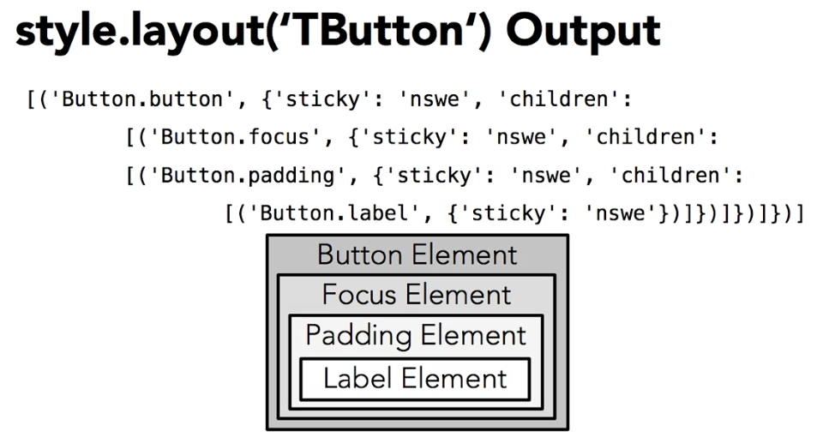
When sticky is set to 'nswe' the element will expand in all 4 directions.
Use the element_options method to see what options are available for each element
>>> style.element_options('Button.label')
('-compound', '-space', '-text', '-font', '-foreground', '-underline', '-width', '-anchor', '-justify', '-wraplength', '-embossed', '-image', '-stipple', '-background')
Use the style.lookup() method to see how an individual option is configured
>>> style.lookup('TButton', 'foreground')
'blue'
Popup Windows for Alerts etc.
Messagebox
Import the messagebox module. Messageboxes don't require the creation of a root element first. However, creating a messagebox will open a new root window
Messageboxes are modal. Program execution will be paused until the user responds to the message.
>>> from tkinter import messagebox
There are a number of different messagebox methods. Here is showinfo
>>> messagebox.showinfo(title='A Friendly Message', message='Hello World')
Informational Messagebox Types
Only give an okay button for user to aknowledge the message. Each plays a different sound and shows a different icon.
showinfo()
showwarning()
showerror()
Question Messagebox Types
Present the user with a choice and will return a Boolean value depending on user choice.
askyesno()
askokcancel()
askretrycancel()
askyesnocancel()
askquestion()
Types with cancel return False if cancel is chosen.
>>> messagebox.askyesno(title='Hungry?', message='Do you want Spam?')
False
File Dialog Boxes
>>> from tkinter import filedialog
>>> filename = filedialog.askopenfile()
>>> filename.name
'/Users/wrainey/Desktop/floyd.gif'
Opens up a standard file open window and returns the path to the file chosen.
Filedialog Types
askdirectory()
asksaveasfile(mode)
asksaveasfilename()
Filedialog Types for Opening One or More Files
askopenfile(mode)
askopenfiles(mode)
askopenfilename()
askopenfilenames()
These don't actually open files, they just return a value for the user selection that can then be used programatically to perform the file operations.
Color Chooser
>>> from tkinter import colorchooser
>>> colorchooser.askcolor(initialcolor = '#FFFFFF')
Returns two lists, the RGB representation and the HEX number. If the user cancels without choosing a color it will return two empty elements, so be sure to check for that in the code calling it.
Not working on Mac from the command interpreter
Geometry Management
Pack Geometry Manager
Places objects against an inner edge of the parent or against the edges of other objects already in the parent. Calculates a bounding box to fit all the children then stretches the parent widget to hold it.
Usen when a widget is expanded to fill its entire parent or to stack multiple widgets vertically or horizontally.
File setup for examples:
#!/usr/bin/python3

from tkinter import *
from tkinter import ttk
root = Tk()

#code here

root.mainloop()
By default, widget will be centered and against the upper edge of the parent. Tk will add space to the left, right and bottom as the window resizes.
ttk.Label(root, text='Hello Floyd', background='gray').pack()
Make the widget fill the parent. Options are X, Y, or BOTH
ttk.Label(root, text='Hello Floyd', background='gray').pack(fill=BOTH)
However, this won't make it taller, must configure the expand property for that
ttk.Label(root, text='Hello Floyd', background='gray').pack(fill=BOTH, expand=True)
Modify the side property to determine which direction multiple objects will packed. Default is TOP, can also use LEFT, RIGHT, BOTTOM
ttk.Label(root, text='Hello Floyd', background='blue').pack(side=LEFT)
ttk.Label(root, text='Hello Andy', background='gray').pack(side=LEFT)
ttk.Label(root, text='Hello Barney', background='green').pack(side=LEFT)
Typically, all widgets are packed against the same side
*background settings not working - not even on example files
By default, widgets are placed in the center of their box, change by modifying the anchor property
Options are the 4 cardinal and 4 intercardinal directions
ttk.Label(root, text='Hello Floyd', background='red').pack(side=LEFT, anchor='nw')
Add external padding
ttk.Label(root, text='Hello Andy', background='red').pack(side=LEFT, padx=10, pady=10)
Add internal padding
ttk.Label(root, text='Hello Barney', background='green').pack(side=LEFT, ipadx=10, ipady=10)
Get a list of all the widgets in the parent with the pack.slaves() method.
print(root.pack_slaves())
[<tkinter.ttk.Label object .4367392496>, <tkinter.ttk.Label object .4367392384>, <tkinter.ttk.Label object .4362832360>]
Returns an iterable list, so you can use in a loop
for widget in root.pack_slaves():
widget.pack_configure(fill=BOTH, expand=True)
print(widget.pack_info()) #get pack info for each widget. Returns a dictionary for each
Note: Since labels usually don't change, these examples are not being assigned to variables. Pack method will not return a reference, so must create the widget and pack it in two steps instead of chaining together like the examples above.
Remove a label with a reference stored in the variable named label01
label01.pack_forget()
also works for other managers grid_forget, place_forget
Grid Geometry Manager
Allows management on an imaginary grid.
ttk.Label(root, text='Yellow', background='yellow').grid(row=1, column=1)
ttk.Label(root, text='Blue', background='blue').grid(row=1, column=0)
ttk.Label(root, text='Green', background='green').grid(row=0, column=0)
ttk.Label(root, text='Orange', background='orange').grid(row=0, column=1)
Grid geometry manager will squeeze all the labels into as small a space as possible.
Complex Layouts
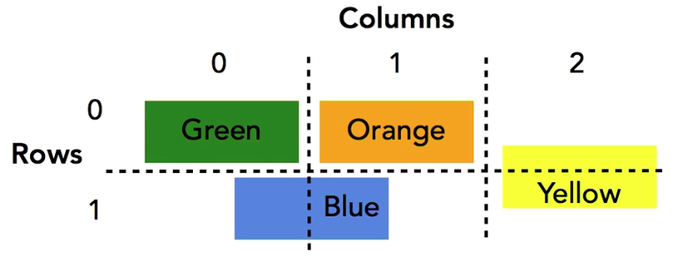

By default, widgets are placed in the center of the gridspace allocated for them. Origin is in the topmost left cell they occupy.
ttk.Label(root, text='Yellow', background='yellow').grid(row=0, column=2, rowspan=2)
ttk.Label(root, text='Blue', background='blue').grid(row=1, column=0, columnspan=2)
ttk.Label(root, text='Green', background='green').grid(row=0, column=0)
ttk.Label(root, text='Orange', background='orange').grid(row=0, column=1)
Sticky Property
Control which side of the allocated area a widget will be anchored to by using the sticky property.
stick = 'e' #can be n, s, e, w
Make widgets expand to fill their cells, but don't change the size of the cells themselves
ttk.Label(root, text='Yellow', background='yellow').grid(row=0, column=2, rowspan=2, stick='nsew')
Weight Property
Controls how much a cell grows/shrinks relative to the other cells when the parent widget is resized. By default, all rows and columns have a weight of 0, which means they won't resize.
Configure weights by calling the rowconfigure and columnconfigure methods on the parent.
Padding
External
ttk.Label(root, text='Green').grid(row=0, column=0, stick='nsew', padx=10, pady=10)
Internal
ttk.Label(root, text='Orange').grid(row=0, column=1, stick='nsew', ipadx=25, ipady=50)
Other Grid Methods
Similar to those of pack:
grid_slaves()
grid_configure()
grid_info()
grid_forget()
Place Geometry Manager
Describe location in absolute or relative terms.
Often used when you need precise control over a small part of the gui, inside a frame that is not resized.
Place the label at a precise position
ttk.Label(root, text='Yellow').place(x=100,y=50)
Place the label at a relative position. The value for rel is from 0.0 to 1.0.
ttk.Label(root, text='Green').place(relx=0.5, rely=0.5)
By default these properties will refer to the upper left corner of the widget. Change using the anchor properties. Use the cardinal or intercardinal directions or the keyword center
ttk.Label(root, text='Green').place(relx=0.5, rely=0.5, anchor='center')
Absolute and relative coordinates may be combined in the place method. When doing this, the relative location is calculated first, then the absolute. The following calculates the center then positions the widget 100 pixels right and 50 pixels down.
ttk.Label(root, text='Green').place(relx=0.5, x=100, rely=0.5, y=50)
Absolute coordinate values can also be negative. The following is used to place the label offset from the top right corner
ttk.Label(root, text='Orange').place(relx=1.0, x=-5, y=5, anchor='ne')
Specify the Absolute Size of a Widget
ttk.Label(root, text='Yellow').place(x=100,y=50, width=100, height=50)
Specify the Relative Size of a Widget
ttk.Label(root, text='Yellow').place(relx=0.5, rely=0.5, anchor='center', relwidth=0.5, relheight=0.5)
This makes the widget half the size of the parent and always centered.

Command Callbacks
Basic syntax:
def callback():
print('This is callback')
ttk.Button(root, text='Click Me', command=callback).pack()

Callback with parameters.
Example, calculator buttons.
ttk.Button(root, text='Click Me 1', command= lambda: callback(1) ).pack()
ttk.Button(root, text='Click Me 2', command= lambda: callback(2) ).pack()
ttk.Button(root, text='Click Me 3', command= lambda: callback(3) ).pack()
The lambda keyword creates an anonymous function
The following can be configured with Command Callbacks
Button | Spinbox
Checkbutton | Scale
Radiobutton | Scrollbar
Binding to Keyboard Events
ButtonPress | Enter | Motion | KeyRelease
ButtonRelease | Leave | KeyPress | FocusIn

The following example will print out some of the data held in the keypress event.
def key_press(event):
print('type: {}'.format(event.type))
print('widget: {}'.format(event.widget))
print('char: {}'.format(event.char))
print('keysym: {}'.format(event.keysym))
print('keycode: {}'.format(event.keycode))

root.bind('<KeyPress>', key_press)
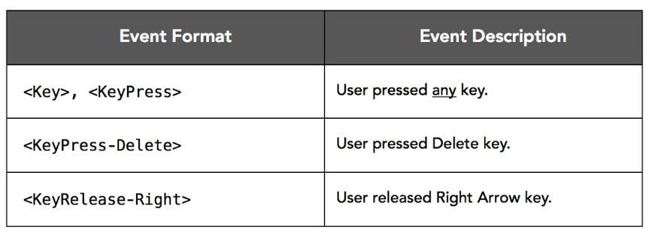

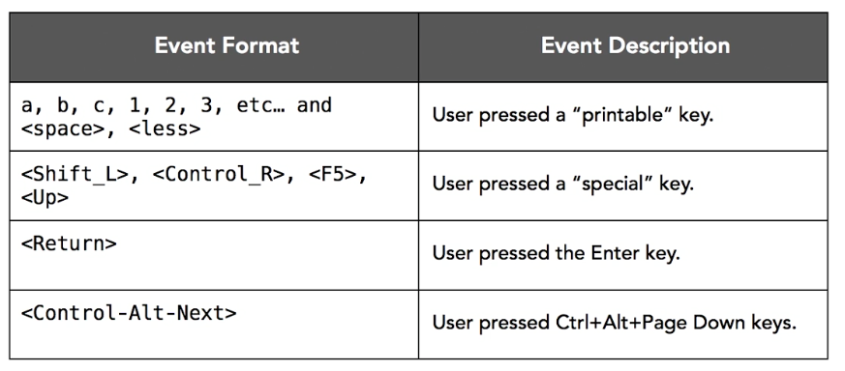

Binding to shortcuts
The use of the lambda function is a little different here. We need to add the e parameter to catch the event.
root.bind('<Control-c>', lambda e: shortcut('Copy'))
root.bind('<Control-v>', lambda e: shortcut('Paste'))
Binding to Mouse Events
May only want to trigger events when user interacts with a specific widgets. So it's more common to bind to widgets rather than the root.
Mouse Buttons: 1: left, 2:click scroll wheel, 3: right
Click Events:
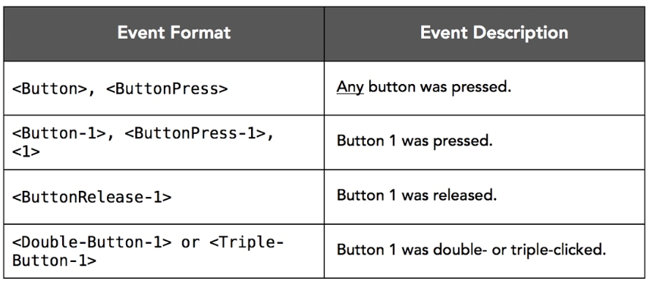

Motion Events
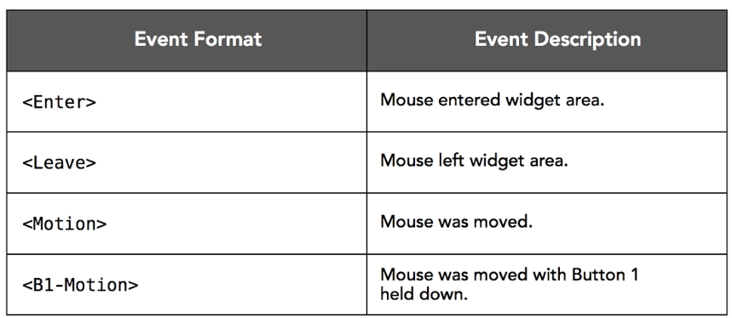

Click event examples
def mouse_press(event):
print('type: {}'.format(event.type))
print('widget: {}'.format(event.widget))
print('num: {}'.format(event.num))
print('x_root: {}'.format(event.x_root))
print('y_root: {}'.format(event.y_root))

canvas = Canvas(root, width=640, height=480, background='white')
canvas.pack()

canvas.bind('<ButtonPress>', mouse_press)
Mouse coordinates are relative to the widget, not the screen. Access the global x and y coordinates relative to the entire screen, use the x_root and y_root properties instead.
def mouse_press(event):
print('type: {}'.format(event.type))
print('widget: {}'.format(event.widget))
print('num: {}'.format(event.num))
print('x_root: {}'.format(event.x_root))
print('y_root: {}'.format(event.y_root))

canvas = Canvas(root, width=640, height=480, background='white')
canvas.pack()

canvas.bind('<ButtonPress>', mouse_press)
Quick Drawing example
#!/usr/bin/python3

from tkinter import *
from tkinter import ttk

def mouse_press(event):
global prev
prev=event

def draw(event):
global prev
canvas.create_line(prev.x, prev.y, event.x, event.y, width=5)
prev = event

root = Tk()

canvas = Canvas(root, width=640, height=480, background='white')
canvas.pack()
canvas.bind('<ButtonPress>', mouse_press)
canvas.bind('<B1-Motion>', draw)

root.mainloop()
Virtual Event Bindings
Often used for widgets that have built in responses to user interaction - for example, the Treeview, Entry, etc
Use double angle brackets << >> to bind with a virtual event.
entry = ttk.Entry(root)
entry.pack()
entry.bind('<<Copy>>', lambda e: print('Copy'))
entry.bind('<<Paste>>', lambda e: print('Paste'))
Custom Virtual Event
entry.event_add('<<OddNumber>>', '1', '3', '5', '7', '9')
entry.bind('<<OddNumber>>', lambda e: print('Odd Number'))
The name OddNumber is arbitrary.
Print out event info for the event
print(entry.event_info('<<OddNumber>>'))
Trigger Virtual and Custom Events Programatically
entry.event_generate('<<OddNumber>>')
entry.event_generate('<<Copy>>')
Delete Virtual Events
entry.event_delete('<<OddNumber>>'>
Binding to Multiple Events
In the following example, the more specific event <1> will trigger if the label is clicked with button 1 and the more general <ButtonPress> will not. However, <ButtonPress> will trigger if buttons 2 or 3 are pressed.
label1.bind('<ButtonPress>', lambda e: print('<ButtonPress> Label1'))
label1.bind('<1>', lambda e:print('<1> Label1'))
If the following is added, both the root and button events will trigger when label1 is clicked with button1
root.bind('<1>', lambda e: print('<1> Root'))
Remove a binding
label1.unbind('<1>')
Bind everything in a widget or root
root.bind_all('<Escape>', lambda e: print('Escape'))
If you have multiple windows in a program, no mater which has focus the function for the escape key will run.

Example Application
Starting with this template.
#!/usr/bin/python3

from tkinter import *
from tkinter import ttk

class Feedback:

def __init__(self, master):
pass

def main():
root = Tk()
feedback = Feedback(root)
root.mainloop()

if __name__ == "__main__":main()
The master parameter in the __init__ method is the top level Tk widget. Slave widgets may be created in the __init__ function.
Python Trick:
If you want to create a string that spans multiple lines in the code, enclose it in parens to that it is treated as a list. Purely for code readability.

#!/usr/bin/python3
# feedback_solution.py by Barron Stone
# This is an exercise file from Python GUI Development with Tkinter on lynda.com

from tkinter import *
from tkinter import ttk
from tkinter import messagebox

class Feedback:

def __init__(self, master):

master.title('Explore California Feedback')
master.resizable(False, False)
master.configure(background = '#e1d8b9')

self.style = ttk.Style()
self.style.configure('TFrame', background = '#e1d8b9')
self.style.configure('TButton', background = '#e1d8b9')
self.style.configure('TLabel', background = '#e1d8b9', font = ('Arial', 11))
self.style.configure('Header.TLabel', font = ('Arial', 18, 'bold'))

self.frame_header = ttk.Frame(master)
self.frame_header.pack()

self.logo = PhotoImage(file = 'tour_logo.gif')
ttk.Label(self.frame_header, image = self.logo).grid(row = 0, column = 0, rowspan = 2)
ttk.Label(self.frame_header, text = 'Thanks for Exploring!', style = 'Header.TLabel').grid(row = 0, column = 1)
ttk.Label(self.frame_header, wraplength = 300,
text = ("We're glad you chose Explore California for your recent adventure. "
"Please tell us what you thought about the 'Desert to Sea' tour.")).grid(row = 1, column = 1)

self.frame_content = ttk.Frame(master)
self.frame_content.pack()

ttk.Label(self.frame_content, text = 'Name:').grid(row = 0, column = 0, padx = 5, sticky = 'sw')
ttk.Label(self.frame_content, text = 'Email:').grid(row = 0, column = 1, padx = 5, sticky = 'sw')
ttk.Label(self.frame_content, text = 'Comments:').grid(row = 2, column = 0, padx = 5, sticky = 'sw')

self.entry_name = ttk.Entry(self.frame_content, width = 24, font = ('Arial', 10))
self.entry_email = ttk.Entry(self.frame_content, width = 24, font = ('Arial', 10))
self.text_comments = Text(self.frame_content, width = 50, height = 10, font = ('Arial', 10))

self.entry_name.grid(row = 1, column = 0, padx = 5)
self.entry_email.grid(row = 1, column = 1, padx = 5)
self.text_comments.grid(row = 3, column = 0, columnspan = 2, padx = 5)

ttk.Button(self.frame_content, text = 'Submit',
command = self.submit).grid(row = 4, column = 0, padx = 5, pady = 5, sticky = 'e')
ttk.Button(self.frame_content, text = 'Clear',
command = self.clear).grid(row = 4, column = 1, padx = 5, pady = 5, sticky = 'w')

def submit(self):
print('Name: {}'.format(self.entry_name.get()))
print('Email: {}'.format(self.entry_email.get()))
print('Comments: {}'.format(self.text_comments.get(1.0, 'end')))
self.clear()
messagebox.showinfo(title = 'Explore California Feedback', message = 'Comments Submitted!')

def clear(self):
self.entry_name.delete(0, 'end')
self.entry_email.delete(0, 'end')
self.text_comments.delete(1.0, 'end')

def main():

root = Tk()
feedback = Feedback(root)
root.mainloop()

if __name__ == "__main__": main()

