BASH SCRIPTING Up and Running - lynda.com
Check Bash Version
echo $BASH_VERSION

Expansions
Tilde expansion:
~ | Home variable
~- | Old Pwd variable - previous directory
Brace Expansion
Repeat command with different terms
Create multiple files with one command
touch {apple,banana,cherry,orange}
Interpolation within a range
Create multiple files with sequenced names. name can be anything, contents of braces determine the number of files and the characters added to the name.
touch name_{1..10}
touch name_{a..f}
touch firstname_{1..5}_lastname
Add zero padding by adding a 0 before the first term
touch name{01..100}
Specify an interval
touch name{01..100..2}
Can be subranges, backwards, etc
Can chain together:
touch {apple,banana}_{01..05}_{a..d}
Redirection
Works with standard input, output and error. Given 2 folders, temp and temp2. The folder temp contains files named file_01 to file_10, but permissions set to 000 on file_05. The following will copy files from temp to temp2 in verbose mode, displaying an error for file_05
cp -v * ../temp2
To send this output to a file instead, use this command
cp -v * ../temp2 1>../temp2/success.txt 2> ../temp2/error.txt
The 1 in this command represents the standard output and 2 is the standard error.
To direct the output to a single file, use the & to represent both the 1 and 2, like this:
cp -v * ../temp2 &> ../temp2/log.txt
To direct the output to nowhere, use /dev/null
cp -v * ../temp2 &> /dev/null
GREP
Enable color for search terms
export GREP_OPTIONS='--color=auto'
Look up awk and sed

Bash Script Syntax
Begins with the path to the bash executable, which is usually
#!/bin/bash
#comments like this
Bash can be picky about whitespace in expressions, but indentations and between lines are okay
Running a bash script
Can do it from the command line like this
bash test.sh
But can also be done taking advantage of the !# line. To do this, make the .sh file executable, then run it from the root
./test.sh
Displaying Text with echo
Three modes: no quotes, single quotes and double quotes
No Quotes
Bash will interpret things as it finds them. This means special characters need to be escaped with a backslash.
echo hello #fine
echo (hello) #error
echo \(hello\) #fine
Single Quotes (Strong Quotes)
Nothing inside the quotes is interpreted, everything comes out literally
greeting=”hello”
echo '$greeting, world'
#output is: $greeting, world
Double Quotes
Variables inside the quotes are evaluated
echo “$greeting, world”
#output is: hello world
Variables
No spaces between assignment operator.
If the variable contains a space, it must be escaped
Use a $ in front of the name to access them
Adding Variable Attributes with declare
declare -i d=123 # d is an integer
declare -r e=456 # e is read only
declare -l f=”LOLCats # lowercase f is lolcats
declare -u f=”LOLCats #uppercase, f is LOLCATS
Built-in Variables
$HOME | User home directory |  | $HOSTNAME | System name
$PWD | Current working directory |  | $BASH_VERSION | The version of Bash
$SECONDS | Number of seconds the Bash session has been running. In script, the time since script started
$0 | The name of the script
See Internal Variables for more
Command Substitution
To get information back from the commands that run in a script. For example, without the $() around it, the value of d would be the string “pwd” Command substitution runs the command and substitutes in the value returned. So with the $() d will hold the working directory.
#!/bin/bash
d=$(pwd)
echo $d
Useful for more complex commands. The following pings google then uses grep to pull out just the response time and store it in the variable named a
#!/bin/bash
a=$(ping -c 1 google.com | grep 'bytes from' | cut -d = -f 4)
echo "the ping was $a"
Arithmetic Expressions
Integer Math
Must be wrapped in double parens. If assigning the result to a variable, must have $ before the parens.
variableName=$((3+2))
Expression can use literal numbers and variables. All the usual operators, ** is for exponents.
Only for integer math. To use floating point, use the
Floating Point Math
Pipe the operation into the bc program. Not available by default on Raspberry PI
variableName=$(echo 1/3 | bc -l)
Comparison Operations
Use double brackets. Must have spaces between the brackets and expression.
[[ expression ]]
Expression returns 0 or 1. 0 is for success (TRUE) 1 is for failure (FALSE)
String Operators: >, <, >=, <=, !=, ==
Numeric Operators: -gt, -lt, -ge, -le, -ne, -eq
Logical Operators: && || !
String Null Value: -z (null) -b (not null) Example
a="" #empty string
b="cat"
[[ -z $a && -n $b ]]
echo $? # outputs the return value
Output is 0 because a is null and b is not null
String Manipulation
Concatenation
a="hello"
b="world"
c=$a$b
echo $c #output: helloworld
Length
echo ${#a} #output: 5
Substrings
colon plus index number. Strings indexed at 0
echo ${c:3} #output: loworld
Specific number of characters after the position
echo ${c:3:4} #output: lowo
Count from the end of the string instead of the beginning. Note the space after c:
echo ${c: -4} #output: orld
First 3 letters of the last 4 letters
echo ${c: -4:3} #output: orl
String Substitution
Starting with the variable
fruit="apple banana banana cherry"
Replace the first substring 'banana' with 'durian'
echo ${fruit/banana/durian} #output: apple durian banana cherry
Replace all substring of banana. Note the double //
echo ${fruit//banana/durian} #output: apple durian durian cherry
Replace a substring only if it's at the beginning. No change if it's not
echo ${fruit/#apple/durian} #output: durian banana banana cherry
echo ${fruit/#banana/durian} #output: apple banana banana cherry
Replace substrings at the end the same way using the % sign.
Use wildcard matching
echo ${fruit/c*/durian} #output: apple banana banana durian
Coloring and Styling Text with tput
Can use other more arcane method, but this is simpler.

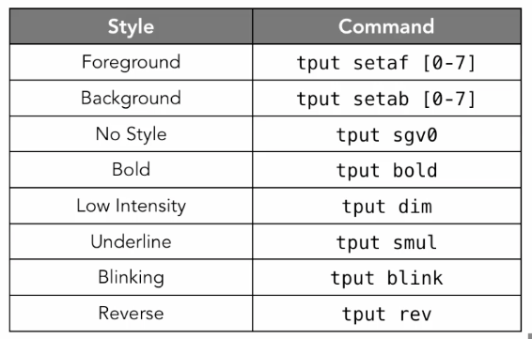

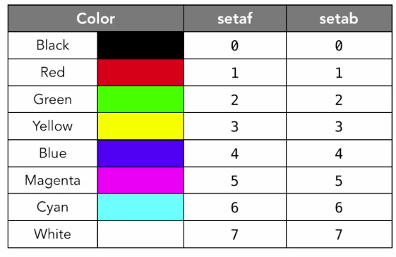

man terminfo #for more tput info
tput is a command, so need to use command substitution
Example:
#!/bin/bash
flashred=$(tput setab 0; tput setaf 1; tput blink)
red=$(tput setab 0; tput setaf 1)
none=$(tput sgr0)
echo -e $flashred"ERROR: "$none$red"Something went wrong"$none

The date command
date #output: Thu Jan 7 18:26:36 EST 2016
Use string formatting option: plus sign followed by quotes containing formatting codes
date +"%d-%m-%Y" #output: 07-01-2016
See manual page for all kinds of format specifiers.
Format output with printf
Prints out data in a particular format. More options than echo
#!/bin/bash
today=$(date +"%d-%m-%Y")
time=$(date +"%H:%M:%S")
printf -v d "Current User:\t%s\nDate:\t\t%s @ %s\n" $USER $today $time
echo "$d"
This outputs:
Current User: pi
Date: 07-01-2016 @ 18:39:58
Arrays
Declare by using the parens. No commas between elements
#!/bin/bash
b=("apple" "banana" "cherry")
echo ${b[2]} #output: cherry
b[5]="kiwi" #populate a non-sequential element
b+=("mango") #push an element onto the end
echo ${b[@]} #output the entire array. Empty elements not shown
echo ${b[6]} #output is mango,
echo ${b[@]: -1} #access the last element, just like strings
Sparse arrays okay. Useful when recording data with a particular position in a list
Associative Arrays
In Bash 4 and Above
#!/bin/bash
declare -A asarray
asarray[color]=blue
asarray["office building"]="HQ West" #Quotes if key/value contains spaces
echo ${asarray["office building"]} is ${asarray[color]}
#output: HQ West is blue
Reading and Writing Text Files
Binary files best left to other programs
Writing
Write the string to a file, creating it if it doesn't already exist, replacing current contents if it does.
echo "Some text" > file.txt
Empty out the file contents
> file.txt
Add more text to the end of a file without replacing current contents
echo "Some more text" >> file.txt
Reading
Read a file line by line and output to screen. Incrementing variable added for clarity. Using the file tile.txt created earlier
Use the file as the input for a loop
#!/bin/bash
i=1
while read f; do
echo "Line $i: $f"
((i++))
done < file.txt
Output:
Line 1: Some text
Line 2: Some more text
Use the file as an input for a command
This example will issue a series of commands to connect to project Gutenberg and retrieve a certain index. Saved in a file named ftp.txt
open mirrors.xmission.com
user anonymous nothinghere #nothingher because password not required
ascii
cd gutenberg
get GUTINDEX.00
Run this with
ftp -n < ftp.txt
The -n option uses the username specified in the file, not the user currently logged in
*The ftp command doesn't exist on Raspberry PI
Here Documents
Use for long documents where it would be tedious to echo out line by line.
A here document looks like this:
#!/bin/bash
cat << EndOfText
This is a
multi
line
text string
EndOfText
This will output everything up to the string 'EndOfText' This string is arbitrary and should be something that will not show up in the regular text.
Control Structures
The if Statement
if expression; then
echo “True”
elif expression2; then
echo “expression is False, expression2 is True
fi
Expression may also be written (expression) [expression] [[expression]] depending on context.
May be used with regular expressions. Example:
#!/bin/bash
a="2This is a string"
if [[ $a =~ [0-9]+ ]]; then
echo "There are numbers in the string: $a"
else
echo "There are no numbers in the string: $a"
fi
the =~ operator is used for regular expressions.
While Loops
Using integer comparison ( the single square brackets )
i=0
while [ $i -le 10 ]; do
echo i:$i
((i+=1))
done
Until Loops
Counterpart to the while loop.
#!/bin/bash
j=0
until [ $j -ge 10 ]; do
echo j:$j
((j+=1))
done
For Loops
Usually for a sequence or range of things. Here used with brace expansion
#!/bin/bash
for i in {1..10}
do
echo $i
done
May also specify an interval
for i in {1..10..2}
Another form:
#!/bin/bash
for (( i=1; i<=10; i++ ))
do
echo $i
done
Use parameter expansion to loop through an array
#!/bin/bash
arr=("apple" "banana" "cherry")
for i in ${arr[@]}
do
echo $i
done
Looping through an associative array
Use !=-xc

