Unix for OSX - lynda.com

Command Structure
command options arguments
Command: always a single word

Manual Pages
man apropos
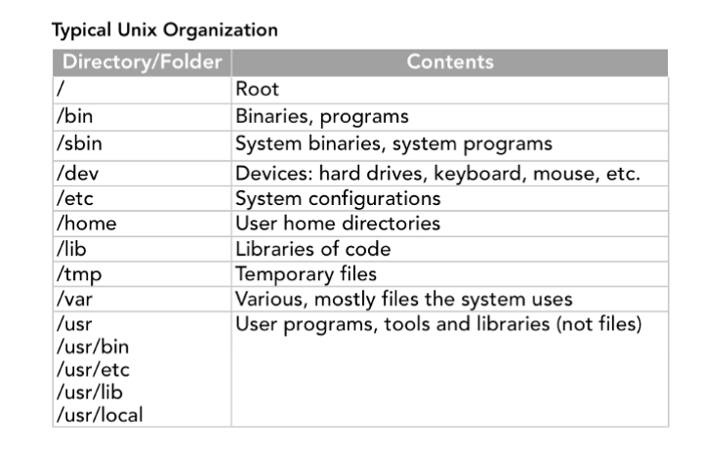
Reading Files
cat: concatenate. Ouputs directly to screen
more: paginated output to screen
less: like more, but gives you the ability to move back through the output. f: forward b:back q:quit g: go to beginning of document G: go to end of document
See man pages for options to use with less

Searches the manual pages for entries matching the string - can be partial | man apropos [string]
Search manual for a keyword | man k [string]

Suppress newline character | -n
Version (ie ruby -v) | -v
Force Quit | Ctrl + c

Moving Around the Filesystem
a / before a path makes it an absolute path, starting from the root. No slash means starting from the present working directory

Shortcut to the home directory | cd ~
Takes you back to your most recent directory | cd -
display file page by pge | less
Display lines from the beginning of a file | head
Display lines from the end of a file | tail | -f follow the file. Allows you to watch for updates. Can watch access log for web server
make a directory | mkdir | -p will create all parent directories as needed. Good if you want to make a nexted directory  -v turns on verbose mode to give you some feedback
mv |  | -n no overwriting
by default, mv overwrites |  | -f force overwriting
 |  | -i interactive
 |  | -v verbose
copy - uses same iptions as mv | cp
copy a directory add R (recursive | cp R source destination
remove a file | rm filename
remove a directory | rmdir directoryname | Will only remove an empty directory
remove a directory and everything in it | rm -R

Cursor to start of line | Ctrl + a
Cursor to end of line | Ctrl + e
Autocomplete | Tab
Autocomplete multiple choice | Tab + Tab

OSX Shortcuts
Open the utilities folder | Cmd + shift + u

Links (aliases)
Hard Links
ln nameoffiletolink hardlinkname
This creates a link to the file in the filesystem - really a pointer to the part of the drive where the data is stored. This doesn't break if the file is moved and doesn't break if the original filename is deleted.
Symbolic Links (sym links)
ln -s nameoffiletolink symlinkname
Symbolic links reference the file to the path, not the actual location in storage. Will break if the file is moved or deleted.

Searching for Files and Directories
find path expression
Wildcard
* | Zero or more characthers (glob)
? | any single character
[..] | any single characters in the brackets
find -name
can use modifiers like -and -not to exclude results. See man page

File and Directory Ownership and Privileges
whoami
lets you know what user you are right now.
Users and groups - enter groups to see what groups user is a member
File and Directory Ownership
2nd and 3rd columns you see when typing ls -la
Change Ownership
chown owner:group filename
Use this for files and directories. Use the -R option if you want to change the ownership of the directory contents as well. Will usually need sudo to change ownerships
File and Directory Permisssions
Use chmod (Change Mode)
chmod u=rwx,g=rw,o=r filename
Shortcuts:
This adds write permission to user and group and leaves the rest of the existing permissions as they were.
chmod ug+w filename
This takes away write permision from others
chmod o-w filename
The letter a may be used in place of ugo when you want to change a permission for all. For example, this gives read and write permission to everyone
chmod a+rw filename
Octal Notation for File Permissions
For conversion of rwx to octal, each of the letters represents a power of two r=4, w=2, x=1.
For example
chmod 777 filename gives all the permissions to everyone
chmod 764 filename gives all to user, read and write to group, and read only to others
chmod 755 - user has all permissions, everyone else has read and execute

No Permissions: | 0 |  | Read | 4
Execute | 1 |  | Read & Execute | 5
Write | 2 |  | Read & Write | 6
Write & Execute | 3 |  | Read, Write & Execute | 7

Users
The Root User
Can do anything, read, write, execute, even create and delete other user accounts.
sudo - substitute user and do. Can be superuser or other user. Understand it as substituting the user before running the command - or run the command as a different user

Chapter 5: Command Basics
A command is actually a program - executable files.
Can chain commands by putting semicolons between them
The $PATH Variable
A colon separated list of filepaths. OS will look in the leftmost path first, then the ones to the right until it finds the command or runs out.
To see the path: echo $PATH
To change the path for the current session in bash: PATH=
Can use which with a command to see what path to what version it is using.
To change the path permanently:

Useful Commands
date, uptime, users, who, uname (operating system name), hostname, domainname
df : disk freespace. Add -h option for human readable
du + path : disk usage. Add -a to see files, otherwise it's just folders
Managing Processes:
ps : Process Status. Shows a snapshot of process currently running. Add -a to see processes run by other users, like root.
ps aux : Note that this doesn't use the hypnen before aux. Shows all processes (a), the user (u) and includes the background processes (x)
top : shows a live view of the top processes running. Use -n to specify the number of processes, -o for sort order (see man ), -U for filter by user
kill + processid : Stop a process. Won't work for all processes, so use the -9 option to kill 'em all
Commands for Text Files
wc : word count
sort : sort lines
uniq : unique removes duplicates. See man - won't remove dupes if they aren't next to each other. Need to use sort with -u option or sort before uniq
cal / ncal : Calendar
expr : Expression evaluator
history : shows previous commands. Use numbers to reissue the commands in the list.
!$ references the arguments of the previous command. Here's a common case
nano textfile.txt
cat !$
This would allow you to go back and look at the file you just edited

!3 | References history command #3
!-2 | References command which is 2 commands back
!cat | References mos recent command beginning with 'cat'
!! | References previous command
!$ | References previous command's arguments

Directing Input and Output
Standard Input: stdin keyboard /dev/stdin
Standart Output: stdout text terminal /dev/stdout
We can change the input and output. For example
sort fruit.txt > sorted_fruit.txt
sends the output from the sort command to the file sorted_fruit.txt. This is destructive - will overwrite the current contents of sorted_friut.txt.
Append the output to a file:
echo “plum” >> fruit.txt
adds plum to the end of fruit.txt without overwriting the current contents
Direct input from a file to a processes
As a review, sort fruit.txt is in the command/argument form. Another way is to provide the file as input
sort < fruit.txt
Can redirect both the input and the output
sort < fruit.txt > sorted_fruit.txt
This runs the sort command with fruit.txt as the end put then sends the output to the file sorted_fruit.txt. The input and output must be files.
Sending the output of a command to another command using the pipe
This allows us to skip using the file as an intermediary. For example
cat fruit.txt | sort
This is sending the output from the cat command to the sort command. These can be chained
cat fruit.txt | sort | uniq
the content of the file is first sorted then sent through the uniq filter which outputs it to screen by default, or you can send the output to a file
cat fruit.txt | sort | uniq >> uniquesortedfruit.txt
commonly used to pipe lengthy output into less so that it can be paginated
The input has to come from a command and the output from it should be the output from a command
Suppressing Output
Redirect the output to a special null file.
ls -la > /dev/null
Remember it's and absolute path so begin with the slash /
Can use it as input as well
echo < /dev/null
Ch 7: Configuring bash for your personal preferences
Master default settings are in /etc/profile -don't mess with them. Instead use ~/.bash_profile This is only used when you first login, not when you type bash at the command line to start a subshell. When starting a subshell, the file ~/.bashrc is used. So, to fix this we put all configurations in ~/.bashrc and put the following in ~/.bash_profile.
if [ -f ~/.bashrc ]; then
source ~/.bashrc
fi
This says if the file ~/.bashrc exists, use it. Raspberry Pi already set up to do this.
Command Alias's
Shortcuts for bash.
alias ll='ls -la'
basic form. Use unalias to get rid of an alias. Created on the command line, they only work for the current login. Place them in configuration files so they'll be available every time. Check man pages to make sure you don't overwrite an alias. Other useful ones
alias home='cd ~'
alias up='cd ..'
alias h='history'
Can use to reconfigure unix commands to default to options, such as
alias mv='mv -i'
Changes the mv command to default to the interactive option
alias mkdir='mkdir -p'
Will add the parent option. Can also use it to correct your frequent typos
Environment (Shell) Variables
Use of the $ tells unix that we want it to return the value of the variable. It's not part of the variable nameoffiletolink
To make a variable available every time, put it in .bashrc.
Export
This command creates a shell variable and makes it available to other processes.
export MYNAME='Will'
Configure existing environment variables to use options. For example, look at the man pages for options for less.
export LESS='-M'
sets the less command to always use the maximum verbose option.
Use export when the variable needs to be available to the processes that bash will run. If not exported, it will only be available to bash.
The PATH Variable
A colon delimited list of file paths that unix uses when looking for the definition of a command that you want to run. Allows you to run processes without entering a full path to them. To see it, type
echo $PATH
Modify the PATH variabl in the .bashrc file. May need to alter the order of the paths, or add new. Consider this:
export PATH=”/usr/local/bin:$PATH”
This adds /usr/local/bin to the beginning of the existing PATH. Must use double quotes in order for the $variable to be evaluated. Can also add to the end
Configuring History with Environment Variables
Clear history with
history -c
Some example settings
export HISTSIZE=1000 #500 is the default
export HISTFILESIZE=10000
export HISTTIMEFORMAT='%b %d %I:%M %p ' #using strftime format
export HISTCONTROL=ignoreboth # ignoredups:ignorespace
export HISTIGNORE=”history:pwd:exit:ls:ls -la:ll”
Probably should not ignore things like cp and mv - might want to go back and look at file names, paths, etc
Customize the Command Prompt with a Shell Variables
Main command prompt is the variable PS1. Example: put the following in .bashrc to show username, current directory (no path) and $ that changes to # if you are logged in as root. For current directory with full path, use lowercase f instead of uppercase.
export PS1=”\u\W\$ ”
Configure the Logout File
Configure in the .bash_logout file. Use to clear out temp files, restart database, etc
grep: Searching for Matching Expressions
Stands for Global Regular Expression Print. Outputs all lines matching a regular expression. In its most simple form:
grep apple fruit.txt
Searches for apple in the file fruit.txt. Will return the entire line, not just the match.
-i | case insensitive
-w | whole word match only
-v | only lines that don't match.
-n | includes line numbers
-c | counts matches

grep: Multiple files and directories
Use the recursive ( -R ) option. When searching a whole folder, -Rn will give you the filenames and line numbers, -Rh will suppress the file names, -Rl will give you just the file names, -RL will return the files that don't have a match,
Allows the use of wildcards. For example,
grep apple *fruit.txt
Will only search files whose names end in 'fruit.txt'
Can use for piped input as well. For example, the following will pipe in the currently running processes and return those that match /usr
ps aux | grep /usr
also useful with history. Can find shortcuts
history | grep nano | less
will return a paginated list of all the times you've used nano.
Use the option --color to color the matches. Also can use color=always, color=never and color=auto. auto will color text if output to the terminal but not if output to a file. Can use the shell variable GREP_OPTIONS to make these changes in .bashrc
Regular Expressions
It's a good idea to put in quotes. The string 'apple' is the simplest regular expression. It must match exactly. change it to 'a..le' the dots are wildcards so those spaces may be occupied by any two characters and still match.
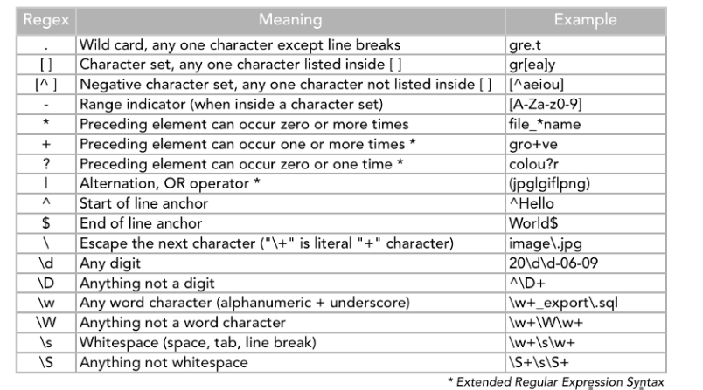

x
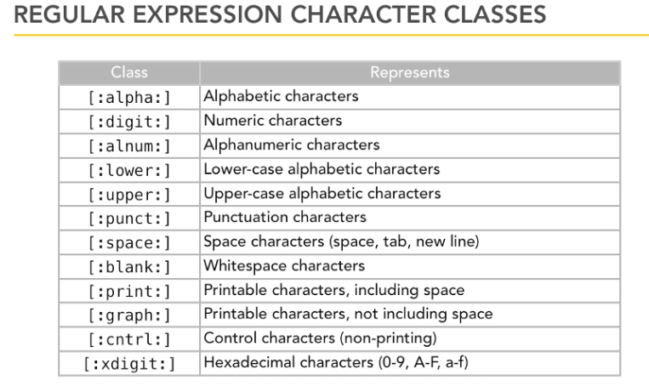
To experiment with regular expressions, pipe them from echo into grep like this:
echo 'AaBbCcDdEe' | grep '[[:upper:]]'
Double brackets are needed to specify that :upper: is a character class reather than a character set. It's saying 'a character set made up of the character class upper.'
Things to watch out for:
grep 'ap*le' *fruit.txt
The * in grep has a different meaning from the wildcard unix *. In grep, it means the previous character is repeated 0 or more times. In unix, it means anything can be there.

The extended set
When using the extended syntax + | or ? you must add the -E option. For example,
grep 'ap+le' fruit.txt
would look for the literal string 'ap+le' To use the + to signify that the preceding element can occur one or more times, add the -E option like this
grep -E 'ap+le' fruit.txt
tr: Translate
Copies from input to output with the substitution of certain characters based on the translation rules that we provide. In its most simple form:
echo 'a,b,c' | tr ',' '-'
This pipes the output from echo into translate with the rule to replace the comma with the dash. A more interesting example:
echo '14252436524' | tr '123456' 'EBGDAE'
returns
EDBABDGEABD
This is mapping the numbers to the letters, in this case the strings on a guitar to their tuning.
If the input has something that isn't in the translation string, it is not changed. So if the number 9 were in the input, it would be left alone. Translation is based on the character position in the search string and the replacement string.
Another example, assume people.txt is filled with names with first character uppercase. The following will change those upper case to lower case
tr 'A-Z' 'a-z' <people.txt
Since the letters are well ordered sets, we could also do it this way
tr '[:upper:]' '[:lower:]' < people.txt
Could use it to replace separating characters in a csv file.
tr options: Deleting and Squeezing Characters
-d | Delete characters in listed set
-s | Squeeze repeats in listed set (remove them)
-c | Use complementary set (use together with d or s)
-dc | Delete characters not in listed set
-sc | Squeeze characters not in listed set

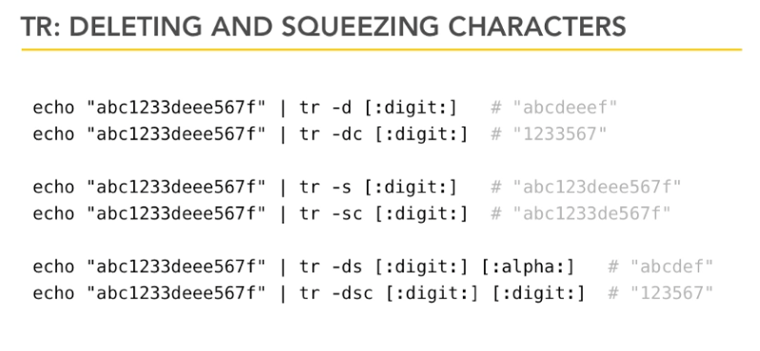
SED: Stream Editor
Common to use for substitution. Basic form
sed 's/a/b/'
Where s is substitution, a is search string and b is replacement string
echo 'upstream' | sed 's/up/down/'
upstream becomes downstream. This is string replacement - different from translation. Doesn't search globally by default - just changes the first occurance of the string.
To make sed search globally, add the g modifier
echo 'upstream' | sed 's/up/down/g'
Delimiter is determined by the first character after the beginning s. So if the search string contains the / character, delimit with colons instead. like this:
echo 'upstream' | sed 's:up:down:g'
Each line is treated as a separate stream. So if g option isn't use, will change the first occurance of search string in every line.
Mutiple searches okay. Use the -e option like this
echo 'daytime sunlight' | sed -e 's/day/night/' -e 's/sun/moon/'
Can save a set of commands in a file to run on different input
Anything you can grep, you can sed
SED: Regular Expressions and Back-references
Simple example using a regular expression
echo “Who needs vowels?” | sed 's/[aeiou]/_/g'
Wh_ n__ds v_w_ls? #output
Just like grep, you need to use the -E option if you want to use extended features like +
In bash, to type the actual tab/enter/esc etc key, type ctrl + v, then the actual character
Backreferences
Actually a part of regular expressions. Simple example
echo 'daytime' | sed -E 's/(...)time/\1light/'
Must use the -E option because of the parens.
Useful example - reverse first and last names and add a comma
echo “Dan Stevens” } sed -E 's/([A-Za-z]+) ([A-Za-z]+)/\2, \1/'
Stevens, Dan #output
The above can be interpreted as: Take a group of characters followed by a space and then another group of characters, reverse them with a comma and space in between. Could do this with an entire file
sed -E 's(apple|pear|plum|peach)/\1 tree/' fruit.txt
This will take any of the 4 matching strings and append a space and the string 'tree'
cut: Cutting Select Text Portions
Allows you to cut out select portions of each line of a file. Can cut characters, bytes, or fields. Example:
cut -c 2-10 dir_content.txt
this will cut and return characters ( -b for bytes, -f for fields ) 2 through 10 from the file dir_content.txt. In the case of this file containing a directory listing, it's cutting out and returning the permissions.
Can cut multiple things. Say we want to cut permissions, file size and file name from the directory listing
cut -c 2-10,30-35,49- dir_content.txt
the dash after 49 means to include everything to the end of the line.
Fields: in tab separated value ( tsv ) files you can cut fields. Allows you to grab selected columns. Returns another tab separated list. so you can save the output as another .tsv file. Example returns columns 2 and 6:
cut -f 2,6 us_presidents.tsv
To change the delimeter, use the -d option like this. Example changing it to commas
cut -f 2,6 -d “,” us_presidents.csv
use the -s option to allow lines without delimiters to pass through
diff: Comparing Files
Syntax:
diff original_file.txt revised_file.txt
returns coded msg. See man
If sending the output to a file, use the .diff extension
Pipe to diffstat to see summary.
xargs: Passing argument lists to commands
Execute as Arguments. Parses an input stream into items, then loops through each item in that list and passes it to a command. Use the -t option to see what it's doing
echo 'lorem_ipsum.txt us_presidents.csv' | xargs -t wc
Passes 2 files to wordcount. If you need to run wordcount separately for 1 file at a time, use the -n option
echo 'lorem_ipsum.txt us_presidents.csv' | xargs -t -n1 wc
The -n1 causes wc to run with 1 argument at a time.
Can use with a placeholder:
cat fruit.txt | xargs -I {} echo “buy more: {}”
Placeholder doesn't have to be {}, but it's the most common
-0 option will separate on null characters rather than spaces and lines. Will mainly use this with filenames where a space in the name might cause problems
xargs : Usage Examples
Use with file manifests (list of file names)
cat file_manifest.txt | xargs cat | less
The above will show each file named in file_manifest.txt through less. Could use this to assemble a number of files -ie- a book where each chapter is in a separate file.
Make a directory for each of the items in the file fruits.txt, first sorting and taking out dupes
cat fruit.txt | sort | uniq | xargs -I {} mkdir -p fruitdirs/{}
This will create a directory called fruitdirs ( -p parent option causes that ) and then directories inside it for each of the items in the sorted and uniq'd file.
Use this to kill multiple bad processes:
ps aux | grep 'badprocesses' | cut -c 11-15 | xargs kill -9
In the cut, 11-15 will be the process id
xargs together with grep:
grep 'apple' *fruit.txt
This searches for the string 'apple' in all the files whose names end in 'fruit.txt' and returns filename:searchstring. Use the -l option with grep to get just the filenames. These filenames can then be passed into something like wc. Example:
grep -l 'apple' *fruit.txt | xargs wc
Also works well with find

PING
To ping a set number of times, use the -c command
ping -c 3 google.com

