Real-Time Multilingual Speech Translation System
ESP32-S3 Edge Device + Cloud AI Backend
Final-Year Capstone Project — Complete Technical Documentation
Covers Steps 1–11: Architecture, ASR, Language ID, Translation, TTS,
Orchestration, Database, Deployment, Testing, and Frontend Demo

Table of Contents

0. Project Overview
This project is a real-time, end-to-end speech translation system. An ESP32-S3 edge device captures a speaker's voice, streams it to a cloud backend, and the backend transcribes, detects the language, translates the text, synthesizes speech in the target language, and streams the translated audio back — all within a latency budget of roughly 2.5 to 3 seconds. A Streamlit web app provides an alternative browser-based demo interface. The system runs entirely on a single free-tier Oracle Cloud VM, using only open-source, CPU-friendly AI models.

High-Level Architecture
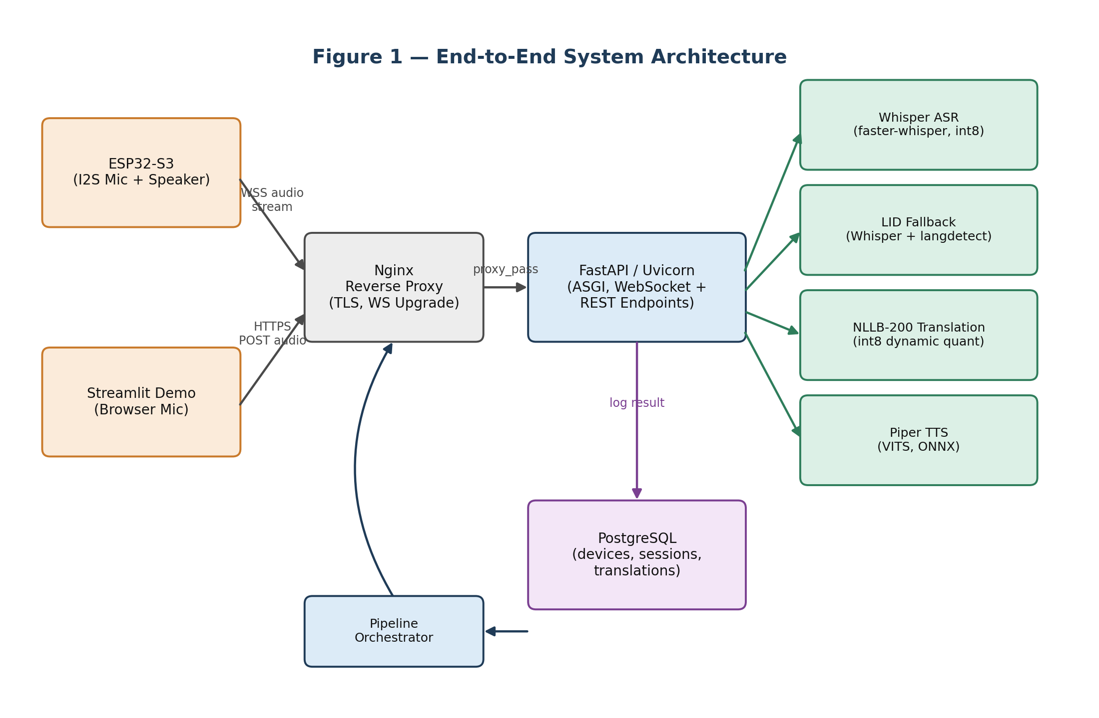
Figure 1: ESP32 and Streamlit clients connect through Nginx to a FastAPI backend, which runs the ASR → LID → Translation → TTS pipeline and logs results to PostgreSQL.
The project was built incrementally over 11 steps, each adding one architectural layer. This document consolidates every step into a single, interview-ready reference.

The 11 Steps at a Glance
Step | Focus Area | Key Technology
1 | Backend Scaffolding | FastAPI, ASGI (Uvicorn), Poetry, Docker, CORS
2 | Audio Ingestion | WebSockets, PCM, RMS-based Voice Activity Detection (VAD)
3 | Speech-to-Text (ASR) | faster-whisper (Whisper + CTranslate2, int8 quantization)
4 | Language Identification | Whisper acoustic LID + langdetect text fallback
5 | Machine Translation | Meta NLLB-200-distilled-600M, dynamic int8 quantization
6 | Text-to-Speech | Piper (VITS architecture, ONNX runtime)
7 | Pipeline Orchestration | PipelineOrchestrator, async execution, two-frame WebSocket replies
8 | Database Persistence | PostgreSQL, async SQLAlchemy (asyncpg), Alembic migrations
9 | Cloud Deployment | Docker Compose, Nginx reverse proxy, Let's Encrypt TLS, Oracle Cloud A1 VM
10 | Testing & Evaluation | Unit/Integration/E2E tests, WER, BLEU, p95 latency
11 | Frontend Demo | Streamlit browser UI, REST-based audio upload

1. Backend Scaffolding — FastAPI, ASGI, and Project Setup
The backend is built on FastAPI because the project needs high concurrency (for streaming audio), automatic request validation, and automatic API documentation — all with minimal boilerplate.

1.1 FastAPI vs. Flask vs. Django
Feature | FastAPI | Flask | Django
Philosophy | API-first, modern, minimal | Micro-framework | Batteries-included, monolithic
Performance | Very high (Go/Node-level) | Moderate | Moderate
Concurrency | Asynchronous (ASGI) | Synchronous (WSGI) | Synchronous (WSGI)
Validation | Built-in via Pydantic | Third-party (Marshmallow) | Forms / DRF Serializers
Docs | Automatic Swagger & ReDoc | Third-party | Third-party (drf-yasg)
FastAPI is built on Starlette (the web/ASGI layer) and Pydantic (the data-validation layer). It parses Python type hints to automatically validate incoming requests and serialize outgoing responses.

1.2 ASGI vs. WSGI — Why It Matters for Streaming
- WSGI (Web Server Gateway Interface): the traditional synchronous standard. One worker thread handles one request at a time; if that request is waiting on I/O (a database call, a model inference), the thread is blocked. WSGI cannot support long-lived connections such as WebSockets.
- ASGI (Asynchronous Server Gateway Interface): the async successor. It uses Python's asyncio event loop to juggle thousands of concurrent, non-blocking connections on a single thread, and natively supports WebSockets, HTTP/2, and background tasks.
This matters directly for the capstone: the ESP32-S3 streams audio continuously over a WebSocket. Only an ASGI server (Uvicorn, running FastAPI) can hold that connection open while still serving other HTTP requests at the same time.

1.3 Dependency Management — Poetry
A virtual environment isolates a project's Python packages so they cannot conflict with the system Python or with other projects. On top of that, this project uses Poetry instead of plain pip because:
- Deterministic locking: poetry.lock records exact hashes of every package so the environment is identical across a laptop, Docker, staging, and production.
- Smart dependency resolution: heavy ML libraries like torch and transformers have many transitive dependencies; Poetry resolves conflicts before writing the lock file, where plain pip might silently install a broken combination.
- Separation of concerns: main vs. dev dependency groups live in one readable pyproject.toml.

1.4 Docker & Docker Compose
Docker packages the application and all its dependencies (exact Python version, system libraries, model runtimes) into a portable container image, so the same image runs identically on a laptop, in CI, and on the cloud VM. Docker Compose then defines multi-container stacks (the FastAPI app, PostgreSQL, Nginx) in one YAML file, launched with a single command.
- Environment consistency — eliminates "works on my machine."
- Isolation — a crashing Python process cannot take down the host OS.
- Easy scaling — trivial to run multiple instances behind a load balancer.
- Platform independence — same container on Windows, macOS, or Linux.

1.5 CORS (Cross-Origin Resource Sharing)
CORS is a browser security mechanism that blocks a web page on one origin from calling an API on a different origin unless that API explicitly allows it. It only affects browsers — the ESP32 firmware is not subject to CORS. It matters here because a local React/Vite frontend on localhost:3000 needs explicit CORS middleware to call the FastAPI backend on localhost:8000 during development.

1.6 Interview Q&A
Q: How does FastAPI handle validation and serialization?
A: FastAPI uses Pydantic models built from type hints. Incoming JSON, headers, and path variables are automatically parsed and validated; a failure returns a 422 Unprocessable Entity with details. On the way out, Pydantic models filter and serialize the response to JSON.
Q: What is the purpose of FastAPI's lifespan parameter?
A: lifespan takes an asynccontextmanager function: code before yield runs once at startup (e.g., loading Whisper/NLLB/Piper model weights); code after yield runs at shutdown (cleaning up connections). It replaces the deprecated @app.on_event handlers with structured, single-location startup/shutdown logic and state sharing.
Q: Why is FastAPI considered one of the fastest Python web frameworks?
A: It is built on Starlette (a lightweight ASGI framework) and Pydantic v2 (validation compiled in Rust). Because it runs natively on async/await over an ASGI server like Uvicorn, it handles concurrent I/O using an event loop rather than spawning heavy OS threads, giving throughput comparable to Node.js and Go.
Q: How would Docker Compose help this system scale to production?
A: The same docker-compose.yml can add a PostgreSQL container for translation logs and a Redis container for a Celery task queue. Because services address each other via Docker's internal DNS (e.g., postgresql://db:5432), no hardcoded hostnames need to change between local development and production.

2. Real-Time Audio Ingestion & Streaming
This layer gets raw audio from the ESP32's microphone into the backend, continuously and with minimal delay, and decides where one spoken utterance ends.

2.1 WebSockets vs. HTTP for Streaming
Dimension | WebSockets | HTTP (REST/POST)
Connection | Persistent, full-duplex (one handshake) | Stateless, one request-response cycle each time
Data flow | Bidirectional, either side can push | Client-initiated only
Overhead | Low (2-14 byte frame header) | High (full HTTP headers per request)
ESP32 memory fit | Excellent — tiny continuous buffers | Poor — needs to buffer whole files
Rule of thumb used throughout the project: WebSockets for low-latency, continuous, bidirectional streams (the ESP32 device); HTTP POST for infrequent, stateless, batch transactions (the Streamlit demo, which uploads one complete recording at a time).

2.2 Digital Audio Fundamentals (PCM)
- Sample rate — 16 kHz: by the Nyquist-Shannon theorem, capturing a frequency f requires sampling at ≥ 2f. Human speech tops out around 4-8 kHz, so 16 kHz is enough for accurate speech recognition while keeping bandwidth low (CD audio is 44.1 kHz, unnecessarily high for speech).
- Bit depth — 16-bit: gives 65,536 discrete amplitude levels (−32768 to 32767), i.e. 96 dB of dynamic range — plenty of clarity for speech models.
- Channels — Mono: speech models extract linguistic features from one source; stereo only doubles data size without adding information, so audio is always downmixed to mono.

2.3 Buffering & Voice Activity Detection (VAD)
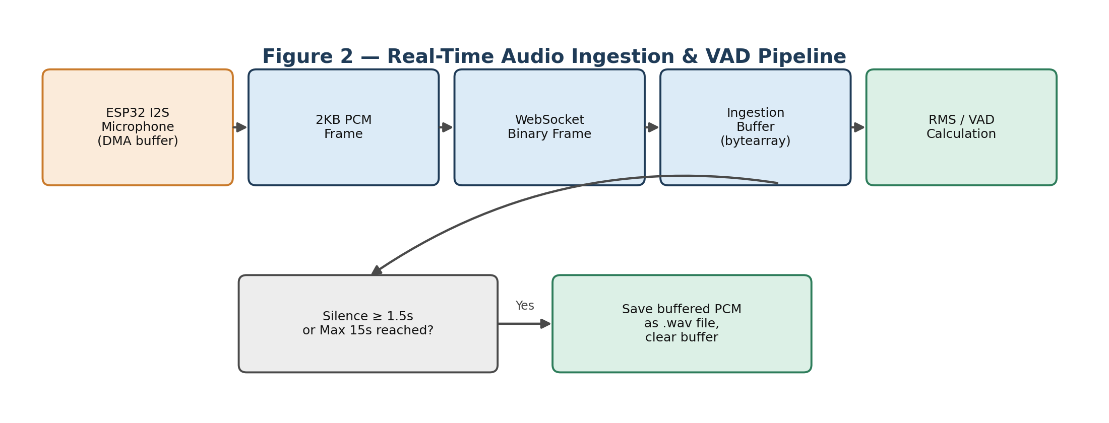
Figure 2: The ESP32 streams small PCM frames continuously; the server buffers them and uses RMS energy to detect when the speaker has stopped talking.
Processing steps:
- 1. Chunking — the ESP32's I2S microphone DMA buffer flushes small frames (1024-2048 bytes of 16-bit PCM) over the WebSocket.
- 2. Buffering — the server appends incoming chunks to an in-memory bytearray.
- 3. Silence detection — the server computes Root Mean Square (RMS) energy of the recent audio: RMS = sqrt( (1/N) Σ xᵢ² ). If RMS stays below a threshold (e.g., 500) for 1.5 continuous seconds, silence is declared.
- 4. Boundary save — once silence is detected, the buffered PCM is written to a .wav file and the buffer is cleared for the next utterance.
Two guardrails prevent false triggers: silence checks only start after speech has actually begun (has_speech_started flag), and a hard 15-second maximum prevents unbounded memory growth from background noise.

2.4 Streaming Over Unreliable Networks
- Latency: round-trip time; the target end-to-end budget is under 1 second for this stage.
- Jitter: variation in packet arrival time; mitigated with a jitter buffer that smooths out arrival timing before processing.
- Packet loss: over TCP (which WebSockets use), a lost packet triggers retransmission and blocks all packets behind it — Head-of-Line (HoL) blocking. For very lossy links, UDP/WebRTC is the standard mitigation because it drops the lost frame instead of stalling everything behind it.

2.5 Interview Q&A
Q: Why stream raw PCM instead of a compressed format like MP3/AAC from the ESP32?
A: Three reasons: the ESP32's CPU is too weak to encode MP3/AAC in real time without burning power; compression introduces algorithmic framing latency that raw PCM has none of; and ASR models require uncompressed PCM/float input anyway, so compressing and then decompressing would waste CPU on both ends for no benefit.
Q: How does silence detection avoid false triggers?
A: It requires a minimum silence duration (1.5 seconds of RMS below threshold, using sample-count arithmetic rather than wall-clock time), only activates after speech has genuinely started, and enforces a 15-second hard cap so continuous background noise cannot grow the buffer indefinitely.
Q: Why downmix to mono and resample to 16kHz before running Whisper?
A: Whisper's feature extractor is hardcoded to expect 16,000 samples per second of mono audio; feeding a different sample rate shifts the frequency spectrum and makes the audio sound pitch-shifted to the model, destroying accuracy. Stereo also doubles convolutional compute with no extra phonetic information.
Q: What is Head-of-Line blocking and how does it affect audio ingestion?
A: TCP (which WebSockets run over) guarantees ordered delivery, so a single dropped packet halts delivery of every packet behind it until it is retransmitted and acknowledged. For audio this produces bursty arrivals followed by silence, increasing perceived latency and jitter — the reason WebRTC/UDP is preferred on very poor networks.

3. Speech-to-Text (ASR) — Whisper & faster-whisper
Automatic Speech Recognition (ASR) converts the saved WAV utterance into text. The project uses OpenAI's Whisper model, run through the faster-whisper / CTranslate2 engine for CPU speed.

3.1 How Whisper Works
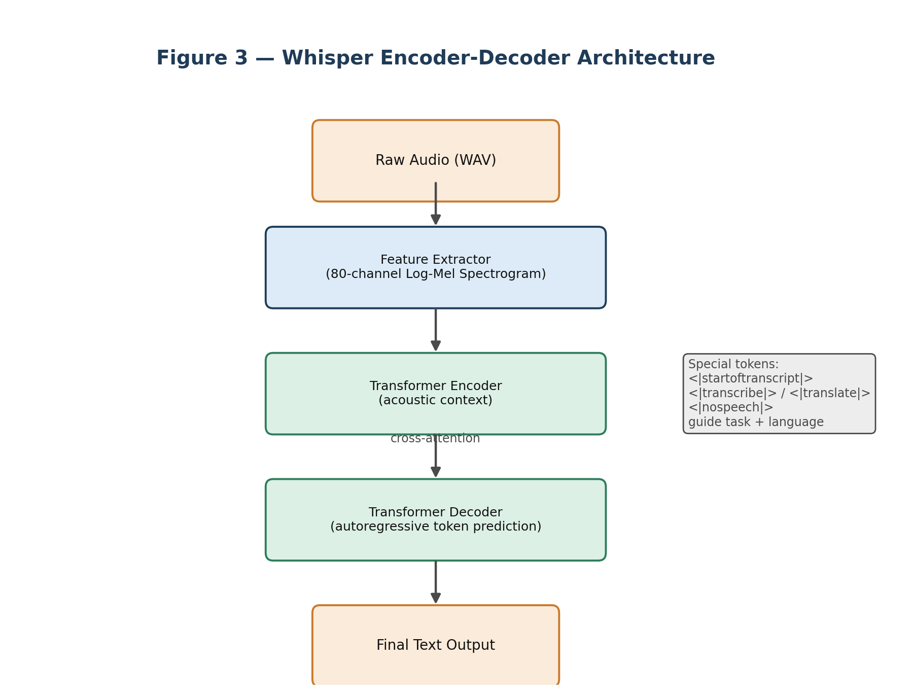
Figure 3: Whisper is an encoder–decoder Transformer trained on 680,000 hours of multilingual audio.
- 1. Feature extraction — raw audio becomes an 80-channel Log-Mel Spectrogram.
- 2. Transformer Encoder — captures acoustic context from the spectrogram.
- 3. Transformer Decoder — autoregressively predicts text tokens, attending back to the encoder output via cross-attention.
- 4. Special tokens (<|startoftranscript|>, <|translate|>, <|transcribe|>, <|nospeech|>) let one model handle language ID, transcription, and translation.

3.2 Whisper vs. faster-whisper
Aspect | OpenAI Whisper (PyTorch) | faster-whisper (CTranslate2)
Engine | PyTorch | Custom C++ inference engine
CPU speed | Baseline | Up to 4x faster
Memory | Large (full PyTorch stack) | Minimal, optimized layout
Quantization | Limited/clunky | Out-of-the-box int8 / int8_float16 / int16
CTranslate2 achieves this through custom memory management, kernel fusion, and GEMM routines tuned for the underlying hardware (Intel MKL / OpenBLAS).

3.3 Model Quantization
Quantization converts weights from 32-bit floats (FP32) to 8-bit integers (INT8), shrinking the model 4x. This matters because CPU inference is usually bottlenecked by memory bandwidth — smaller weights load into cache faster — and modern CPUs have dedicated low-precision instructions (AVX-512 VNNI, ARM NEON) that execute several INT8 multiplications per cycle. A per-layer dynamic scaling factor keeps accuracy loss under 1-2% relative word-error-rate increase.

3.4 CPU vs. GPU Inference
Metric | CPU (VNNI/AVX) | GPU (CUDA/Tensor Cores)
Throughput | Moderate | Extremely high
Latency (batch=1) | Low-moderate | Extremely low once loaded
Cost | Low | High
Best for | Edge servers, budget cloud | Enterprise, batch offline

3.5 Interview Q&A
Q: Batch vs. streaming transcription — how do they differ in latency?
A: Batch transcription waits for a complete audio segment and processes it in one shot; latency is at least the utterance length plus 1.5-2x model inference time on slow CPUs. Streaming transcription feeds small rolling chunks continuously and returns partial results, giving ultra-low latency at the cost of heavier, repeated computation and needing an architecture built for prefix updates.
Q: Why is the Whisper model loaded during FastAPI startup rather than per-request?
A: Loading a model means reading hundreds of megabytes of weights and allocating memory — 2 to 10 seconds. Doing that inside the endpoint would add a multi-second penalty to every single request. Loading it once in the lifespan handler pays that cost exactly once, so real requests only pay sub-second inference time.
Q: What is the INT8 scaling factor and how is dynamic range managed?
A: Quantization maps floats in [min, max] to integers in [-128, 127] using a scale factor S, where x_int8 = round(x_float / S). Dynamic quantization computes S at runtime from the current batch's activation range; static quantization pre-computes S from a calibration dataset. faster-whisper uses dynamic INT8, scaling weights and activations layer-by-layer to preserve precision for critical voice features.
Q: How would you configure faster-whisper on a 2-core, no-GPU cloud VM?
A: Use a small model (tiny/base) to fit CPU cache and parameter count, set compute_type="int8" for INT8 matrix math, and set cpu_threads=2 to match the physical cores — the default of using all logical cores can cause context-switch thrashing on small VMs.

4. Language Identification (LID) & Fallback Logic
Before translating, the system must know what language was spoken. Two complementary techniques are combined: Whisper's built-in acoustic language detection, and a text-based fallback for when Whisper is unsure.

4.1 Two Approaches to LID
- Statistical N-Gram (text-based, e.g. langdetect): splits text into character n-grams (bigrams/trigrams), compares their frequency profile against pre-computed language profiles using distance metrics or Naive Bayes. Extremely fast and lightweight, but unreliable on very short text ("Hi", "No") and sensitive to spelling errors.
- Neural acoustic (audio-based, e.g. Whisper, ECAPA-TDNN): converts audio into embeddings and classifies them with a softmax layer over supported languages using phonetics, accent, and prosody. Handles spoken language directly but is computationally heavier and sensitive to noise and thick accents.

4.2 Reliability Comparison
Dimension | Audio-based (Whisper) | Text-based (langdetect)
Short utterances | More reliable (distinct phonetics) | Less reliable (ambiguous spelling)
Noisy audio | Less reliable | More reliable (works off clean text)
Foreign accents | Less reliable | More reliable (spelling stays consistent)
Resource cost | High (deep learning pass) | Low (microsecond lookup)

4.3 Confidence Scores & the Hybrid Fallback Pipeline
A confidence score comes from the softmax output over language classes: P(y=c|x) = e^zc / Σⱼ e^zj. A score of 0.95 is high certainty; 0.40 signals ambiguity typical of noisy or mixed-language speech.
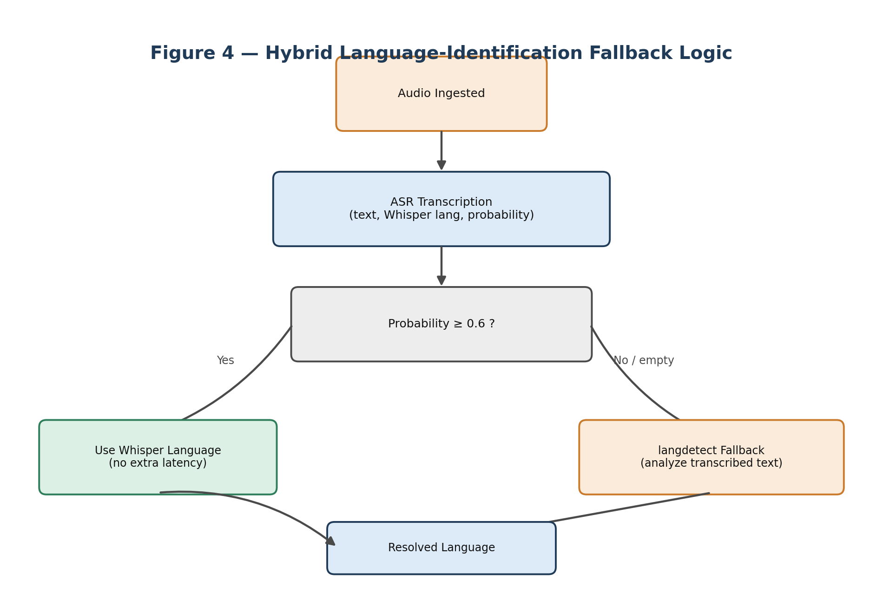
Figure 4: If Whisper's confidence is at least 0.6, its language guess is used directly; otherwise langdetect checks the transcribed text as a semantic cross-check.
Why 0.6? Below 60% probability, Whisper's acoustic classifier is statistically prone to misidentification from noise or accents, so the pipeline pays the extra langdetect cost only when needed — keeping the common case (confident audio) fast.

4.4 Common Edge Cases
- Code-switching: a speaker mixes languages mid-sentence; mitigated by segmenting audio and allowing multiple dominant languages.
- Proper nouns: foreign names can confuse text classifiers due to out-of-vocabulary words.
- Homoglyphs: words spelled identically across languages but with different meanings.
- Silence/noise triggers: VAD false positives producing garbled text; mitigated by falling back to a default language (e.g. English) rather than erroring out.

4.5 Interview Q&A
Q: Why not run text-based LID on every segment instead of relying on Whisper's built-in detection?
A: Whisper already performs language ID in its first forward pass to pick the correct decoder tokens, so that signal is free. Running langdetect on every segment would add redundant work; the threshold-based fallback only pays that extra cost when the audio-based prediction is ambiguous (probability below 0.6).
Q: Character n-gram model vs. neural embedding model for language detection — what's the difference?
A: An n-gram model (langdetect) splits text into overlapping substrings, compares their frequency to pre-trained profiles, and is fast but ignores acoustics and context. A neural embedding model (Whisper) converts audio spectrogram frames into vectors capturing accent and intonation, then classifies via softmax — far more accurate for spoken audio but computationally heavier.
Q: For a very short word like "No", which modality wins — audio or text?
A: Audio. The written word "No" is identical across English, Spanish, German, and Italian, making text-based guessing essentially 50/50. The spoken pronunciation, though, differs noticeably in vowel rounding and intonation between languages, so the acoustic classifier can identify it correctly.
Q: How does the system support manual language override, and why does that matter for IoT devices?
A: Clients can pass a source_language parameter (via REST form field or WebSocket command), which bypasses auto-detection entirely. This matters for hardware devices with physical settings menus, saves the computation of running classification, and improves Whisper's own transcription accuracy by constraining the decoder to one language's token space.

5. Machine Translation — NLLB-200 on CPU
Once text and its source language are known, Meta's NLLB-200 ("No Language Left Behind") model translates it into the requested target language.

5.1 Why NLLB-200?
Model | Languages | Size (FP32) | CPU Speed | Verdict
NLLB-200-distilled-600M | 200+ | ~2.4 GB | Medium | Chosen — best fit for constraints
MarianMT | ~150 pairs | ~300 MB/pair | Fast | Impractical — one model per pair
mBART-50 | 50 | ~2.4 GB | Slow | Fewer languages, not seq2seq-ready
A single 600M-parameter model covers 200 languages with zero routing logic, is fully supported by the transformers library (tokenizer, model, and language-code mapping all standardized), and sits in the sweet spot between quality and the larger 1.3B/3.3B variants that would not fit the CPU-only budget.

5.2 Dynamic Quantization (int8)
Loading NLLB in float32 costs ~2.4 GB RAM, tight on the project's CPU VM. Applying PyTorch dynamic quantization to Linear layers immediately after loading (torch.quantization.quantize_dynamic) drops RAM to ~1.2 GB and speeds up CPU inference 2-3x, with negligible (<0.5 BLEU) quality loss. It is dynamic quantization — weights are quantized offline, activations are computed at full precision at runtime — so no calibration dataset is required.

5.3 Language Codes
NLLB does not use ISO 639-1 codes directly; it uses its own BCP-47-style codes, e.g. en → eng_Latn, es → spa_Latn, fr → fra_Latn, zh → zho_Hans, ja → jpn_Jpan. This mapping lives in a single NLLB_LANG_MAP dictionary that both the REST and WebSocket paths validate against.

5.4 How Translation Is Triggered
- REST: POST /api/v1/audio/transcribe accepts an optional target_language form field; if omitted, the response simply has no translation key.
- WebSocket: target_language can be set at connect time via a query parameter, or mid-session via JSON commands (set_target_language / clear_target_language) with no reconnect required.

5.5 Model Lifecycle & Error Handling
The TranslationService is a singleton, loaded once at FastAPI startup alongside the TranscriptionService (Whisper), and stored in a shared ml_models dictionary so no request pays a reload cost.
Situation | Behaviour
Unknown target_language | HTTP 400 / WebSocket error JSON
Model not loaded (startup race) | HTTP 503 / silent skip
Empty text (ValueError) | HTTP 400 / WebSocket error message
Source == target language | Instant no-op; latency_sec: 0.0

5.6 Performance
Utterance Length | Approx. Latency
Short (< 10 words) | 0.8 - 1.5 s
Medium (10-30 words) | 1.5 - 3.5 s
Long (30-80 words) | 3.5 - 8 s
Beam search (num_beams=4) is used for translation quality; reducing to greedy decoding (num_beams=1) trades some quality for lower latency.

5.7 A Real Deployment Gotcha: Hugging Face Xet Storage
Downloading facebook/nllb-200-distilled-600M initially stalled at 0 bytes, caused by two separate bugs: (1) newer transformers defaults to requesting model.safetensors first, but this repo only ships pytorch_model.bin, causing a silent 404 — fixed by passing use_safetensors=False; and (2) Hugging Face's new "Xet Storage" CDN requires an authenticated read-token even for public models, so unauthenticated requests hang indefinitely with no error. The fix is setting the environment variable HF_HUB_DISABLE_XET=1, which forces the classic CloudFront CDN. On the Oracle Cloud VM this must be set before first startup or the initial model download will hang silently.

6. Text-to-Speech (TTS) — Piper & VITS
The final AI stage converts translated text back into spoken audio, using Piper, a fast neural TTS engine suitable for CPU-only hardware.

6.1 How Neural TTS Works
A standard neural TTS pipeline has a Front-End and a Back-End:
- Front-End (text processing): text normalization ("$5" → "five dollars"), homograph disambiguation ("I live here" vs. "live music"), and grapheme-to-phoneme (G2P) conversion into phonetic tokens.
- Acoustic Model: predicts a Mel-Spectrogram from the phoneme sequence (e.g. Tacotron 2, FastSpeech 2).
- Vocoder: converts the Mel-Spectrogram back into a raw waveform (e.g. WaveNet, HiFi-GAN, WaveGlow).

6.2 Piper's VITS Architecture
Piper uses VITS (Variational Inference with adversarial learning), an end-to-end model that merges the acoustic model and vocoder into a single joint network trained with a Variational Autoencoder and a GAN. Key benefits:
- End-to-end joint training produces highly natural voices without error propagation between separate stages.
- Non-autoregressive — predicts all audio frames in parallel, giving a real-time factor often below 0.2 on a single CPU core.
- Exported to ONNX, so it runs fast across platforms without a heavy Python deep-learning stack.

6.3 Formant vs. Concatenative vs. Neural TTS
Class | How It Works | Trade-off | Example
Formant (rule-based) | Mathematical acoustic-resonance formulas | Tiny, offline, but robotic | eSpeak NG
Concatenative | Chains recorded speech segments | Clear phonemes, but disjointed and huge database | Festival, early Siri
Neural (E2E) | Deep net generates waveform directly | Very natural, but compute-heavy | Piper, Coqui XTTS

6.4 Audio Playback on I2S Hardware
For the ESP32 + MAX98357A I2S amplifier, Piper's 22.05kHz or 16kHz output is standardized to 16kHz, 16-bit, mono PCM: downsampling saves ~27% bandwidth without hurting intelligibility on small speakers, 16-bit gives the industry-standard 96dB dynamic range, and mono halves bandwidth since the device only has one speaker.

6.5 Interview Q&A
Q: Autoregressive vs. non-autoregressive TTS — which is better for edge devices?
A: Autoregressive models (Tacotron 2, WaveNet) generate each audio sample dependent on all previous samples — O(N) time and prone to stalling. Non-autoregressive models (VITS/Piper, FastSpeech 2) predict all frames in parallel — O(1) time, orders of magnitude faster — which is required to hit low latency on CPU-only edge devices.
Q: Why does Piper use ONNX Runtime?
A: ONNX provides a standardized model representation executed by a highly optimized C++ backend. This bypasses Python's GIL and PyTorch's heavy runtime, giving 3-5x faster CPU inference and a much smaller memory footprint.
Q: Why downsample 22050Hz audio to 16000Hz for the ESP32?
A: It cuts network transfer size by about 27%, keeps the I2S DMA clock configuration consistent across all audio (avoiding jitter/pops), and is harmless anyway since the small MAX98357A speaker cannot reproduce frequencies above 8kHz — the Nyquist limit of 16kHz sampling.
Q: How does a vocoder fit into the pipeline, and how does VITS simplify it?
A: Traditionally the acoustic model outputs a Mel-Spectrogram (a visual frequency representation humans can't hear directly), and the vocoder reconstructs the actual waveform from it. VITS merges the acoustic predictor and the vocoder into one end-to-end network, skipping the intermediate spectrogram hand-off and reducing error propagation between stages.

7. Pipeline Orchestration & End-to-End Streaming
Step 7 ties ASR, LID, Translation, and TTS together into one coordinated workflow, and defines exactly how results stream back to the ESP32.

7.1 The Orchestrator Pattern
A centralized PipelineOrchestrator governs data flow instead of embedding translation or TTS logic inside route handlers. This gives separation of concerns and reusability — the same orchestrator can be called from a REST endpoint, a WebSocket handler, or a background test worker — and it isolates logging and latency tracking in one place.
Error isolation: each stage is wrapped so that a translation or TTS failure is logged with error metadata and the pipeline still returns whatever upstream output succeeded (e.g., the transcription), instead of raising a 500 error.

7.2 Sync vs. Async Execution
FastAPI route handlers run on a single-threaded asyncio event loop. async/await only yields control back to that loop on non-blocking I/O — a CPU-bound PyTorch inference call does not yield, so it blocks every other client's WebSocket/HTTP traffic until it finishes. The correct fix is to offload CPU-bound inference to a thread pool via loop.run_in_executor(), or to separate worker processes/microservices in production. In the current single-request pipeline, inference runs synchronously inside async wrappers, which is acceptable for a demo but would bottleneck under real concurrent load.

7.3 Two-Frame WebSocket Response
Rather than a multipart HTTP response (which requires boundary-parsing logic the ESP32's limited RAM struggles with), the WebSocket protocol natively distinguishes Text frames from Binary frames. The server sends a JSON Text frame first (transcription/translation, for an OLED display) immediately followed by a binary WAV frame (the synthesized audio), which the ESP32 can stream straight into its I2S buffer with zero parsing overhead.

7.4 Latency Budget
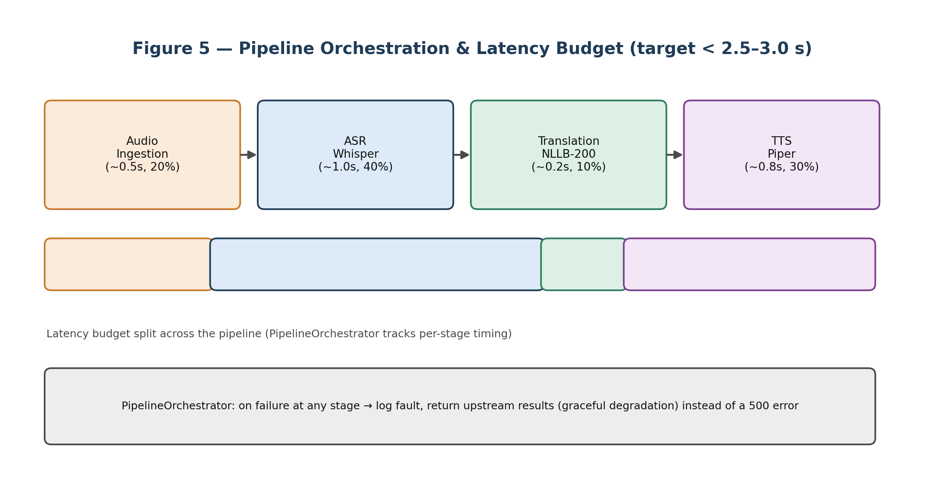
Figure 5: Target end-to-end latency is under 2.5-3.0 seconds, split roughly 40% ASR, 30% TTS, 20% networking/ingestion, 10% translation.

7.5 Graceful Degradation
If TTS or translation fails, the system falls back to returning the intermediate transcription so the user gets useful feedback instead of silence. If ASR itself fails entirely (unrecoverable), the server sends a structured JSON error frame, which the ESP32 can detect and respond to with a short pre-recorded error tone rather than hanging.

7.6 Interview Q&A
Q: Why separate route logic from pipeline orchestration logic?
A: It gives separation of concerns and reusability: the same PipelineOrchestrator can be invoked from a REST endpoint, a WebSocket handler, a gRPC service, or a background test worker. It also makes the pipeline independently unit-testable without mocking FastAPI's request/response cycle, and centralizes logging and latency metrics.
Q: If PyTorch inference is CPU-bound, why doesn't async/await alone prevent blocking?
A: async/await relies on cooperative multitasking on a single OS thread — a coroutine only yields control at an await on non-blocking I/O. CPU-bound numerical work never hits such an await point, so it runs to completion on the event loop's thread, blocking every other concurrent request. The fix is to offload it via loop.run_in_executor() to a separate thread or process.
Q: Why is a two-frame (JSON + binary WAV) WebSocket reply better than multipart HTTP for the ESP32?
A: Parsing multipart boundaries requires buffer scanning and string search that consumes scarce flash/RAM on the ESP32. WebSockets natively frame Text vs. Binary data, so the device can immediately parse and display the JSON text (for an OLED screen) and then stream the following binary frame straight into its I2S audio buffer with no boundary-stripping logic.
Q: How would you push this pipeline toward sub-second latency?
A: Three directions: streaming ASR that emits partial transcripts frame-by-frame instead of waiting for full-silence VAD; pipeline parallelism, translating and synthesizing the first stabilized words while ASR is still processing the tail of the sentence; and streaming TTS that returns audio chunks as the vocoder produces them rather than waiting for the whole utterance to finish.

8. Database Persistence — PostgreSQL, SQLAlchemy, Alembic
Every translation performed by the pipeline is optionally logged for history, analytics, and demo purposes, using an async PostgreSQL layer that never blocks the real-time audio path.

8.1 Why PostgreSQL?
Criterion | SQLite | PostgreSQL | MongoDB
Concurrent writes | Single writer only | MVCC — many concurrent | Supported
Relational schema | Yes | Yes | No (document model)
Async driver | aiosqlite | asyncpg (fastest) | motor
Production readiness | Small apps only | Industry standard | Yes
The data is naturally relational (devices → sessions → translations) and needs concurrent access from simultaneous WebSocket and REST calls, making PostgreSQL with the asyncpg driver the standard choice for async Python backends.

8.2 Schema
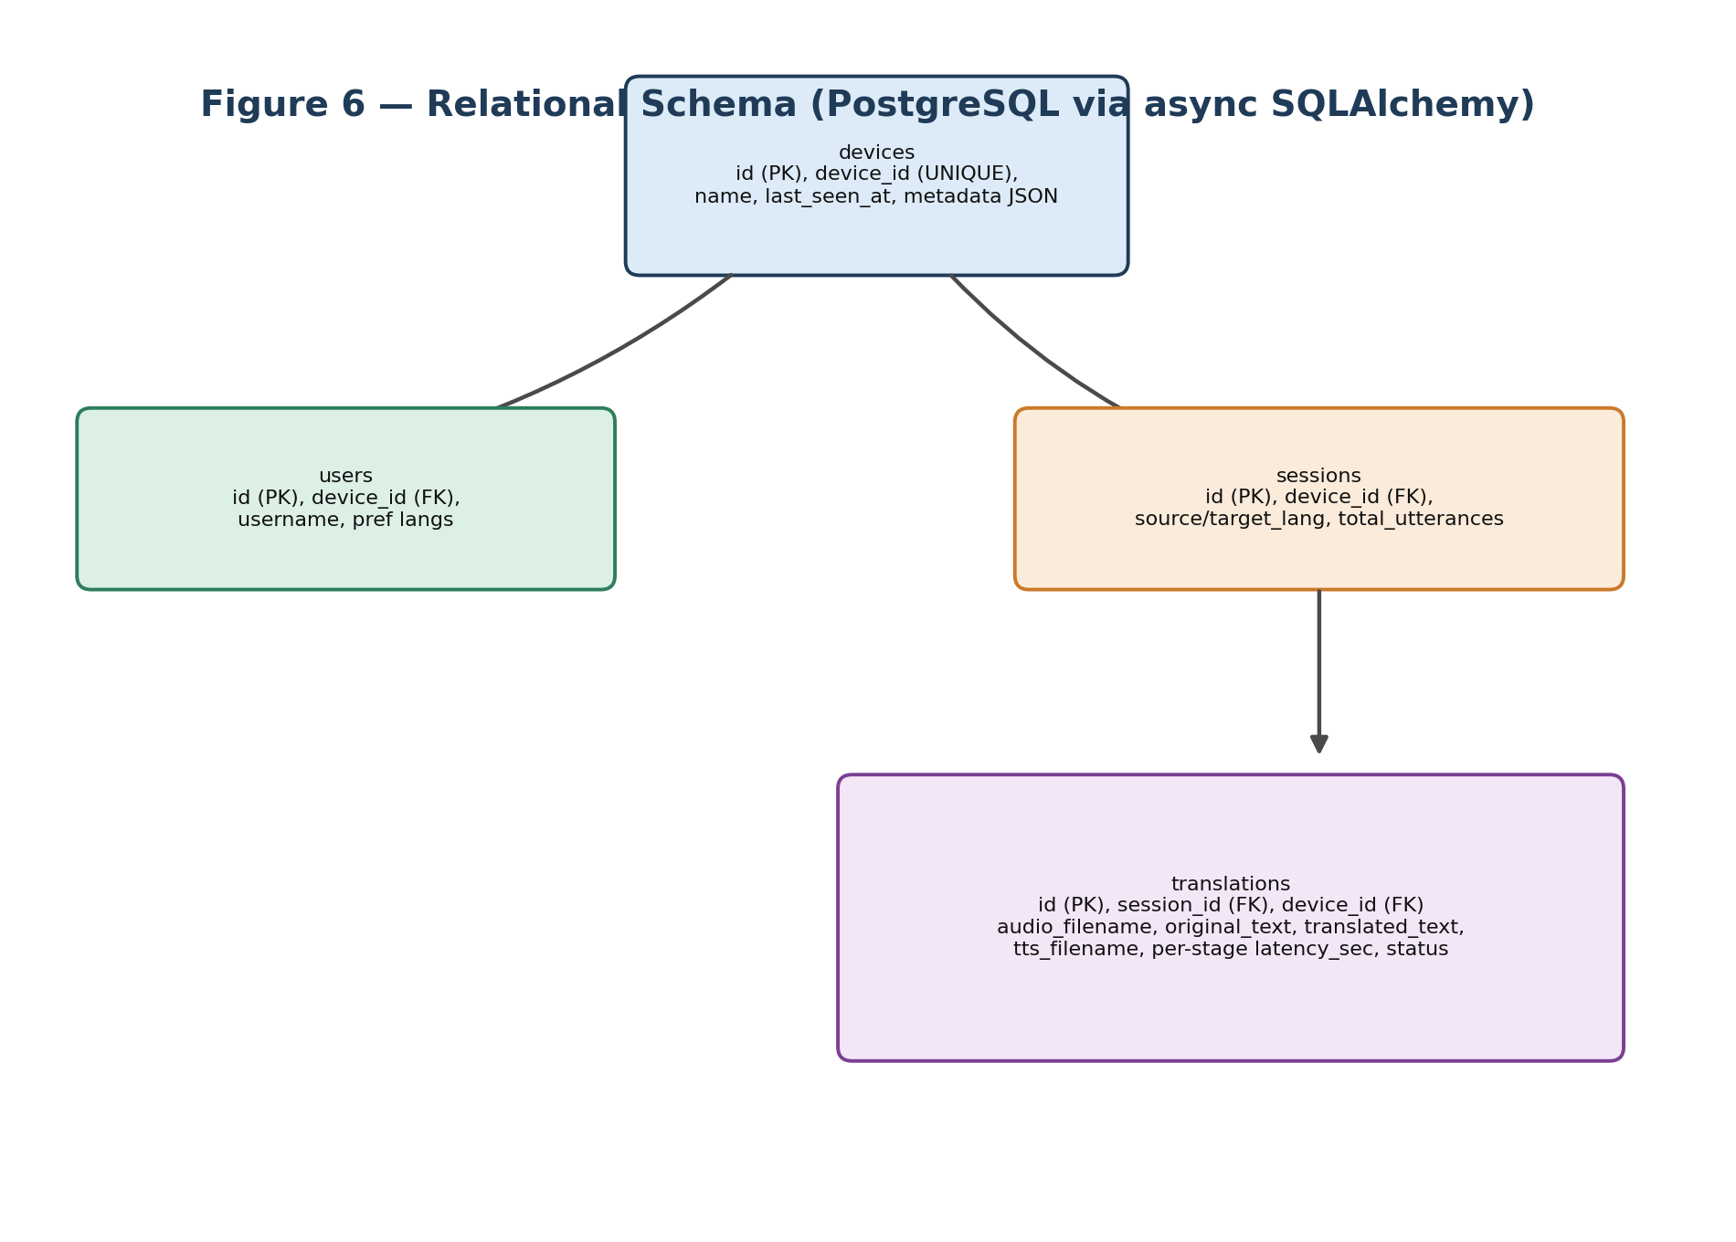
Figure 6: devices are the root entity; each has users and sessions; each session accumulates translation records with per-stage latency.
Decision | Rationale
UUID (string) primary keys | No sequence contention; safe for distributed inserts; portable across DBs
device_id denormalized into translations | Avoids a JOIN through sessions for per-device history queries
total_utterances counter on sessions | Cheaper than COUNT(*) at query time; updated atomically
metadata as JSON column | Firmware version, MAC address, etc. are schema-free — avoids an extra table
DateTime(timezone=True) everywhere | Always store UTC; avoids subtle bugs from server timezone changes

8.3 Async SQLAlchemy Essentials
- asyncpg over psycopg2: psycopg2 blocks the event loop, which is catastrophic in an async FastAPI app; asyncpg is a pure-async, pure-Python driver and the fastest one available for Postgres.
- expire_on_commit=False: by default SQLAlchemy expires all attributes after commit, forcing a fresh DB round-trip on next access — which can raise a MissingGreenlet/DetachedInstanceError in async code if the session has already closed. Disabling expiry keeps last-committed values safely in memory.
- pool_pre_ping=True: sends a cheap SELECT 1 before handing out a pooled connection, so a stale connection (e.g. after a DB restart) is recycled instead of raising a "connection closed" error.
- Dependency injection: a get_db() generator yields an AsyncSession per request via FastAPI's Depends(), and closes it automatically even on exceptions.

8.4 Alembic Migrations
A migration is a versioned script that evolves the schema incrementally instead of dropping and recreating tables. Each revision stores its own ID and a down_revision pointer, forming a chain Alembic walks to apply or roll back changes. alembic revision --autogenerate compares the ORM models against the live schema and drafts a diff — always reviewed manually, since autogenerate misses things like partial indexes. Async projects need a bridged env.py that wraps the synchronous Alembic context in conn.run_sync(...).

8.5 Interview Q&A
Q: What is the N+1 query problem and how do you avoid it?
A: Accessing a relationship (e.g. device.sessions) inside a loop triggers one query per iteration. It's avoided with eager loading, e.g. select(Device).options(selectinload(Device.sessions)), which fetches everything in a bounded number of queries.
Q: Session.commit() vs. Session.flush() — what's the difference?
A: flush() writes pending changes to the database within the current transaction without committing — useful to obtain a DB-generated ID before finalizing. commit() ends the transaction, making the changes permanent.
Q: Why use expire_on_commit=False?
A: After commit(), SQLAlchemy normally expires all attributes, forcing a new query on next access — but if the session is already closed, that raises a DetachedInstanceError in async code. Disabling expiry keeps the last-committed values in memory, safe to read after the session closes.
Q: What does pool_pre_ping=True do?
A: Before handing a pooled connection to a caller, SQLAlchemy sends a cheap SELECT 1. If the database has silently closed that connection (e.g. after a restart), it's recycled and replaced with a fresh one, preventing 'connection closed' errors in long-running servers.

9. Cloud Deployment — Docker, Nginx, HTTPS, Oracle Cloud
The full stack runs on a single Oracle Cloud Always-Free VM, chosen because it is the only free tier large enough to hold three loaded AI models at once.

9.1 Why Oracle Cloud's Free Tier?
Provider | Free CPU | Free RAM | AI Workload Viability
Oracle Ampere A1 | 4 OCPU (ARM) | 24 GB | Runs Whisper + NLLB + Piper
Render Free | 0.1 vCPU | 512 MB | Out of memory on model load
AWS EC2 t2.micro | 1 vCPU (x86) | 1 GB | Out of memory on model load
GCP e2-micro | 0.25 vCPU | 1 GB | Too small

9.2 Deployment Architecture
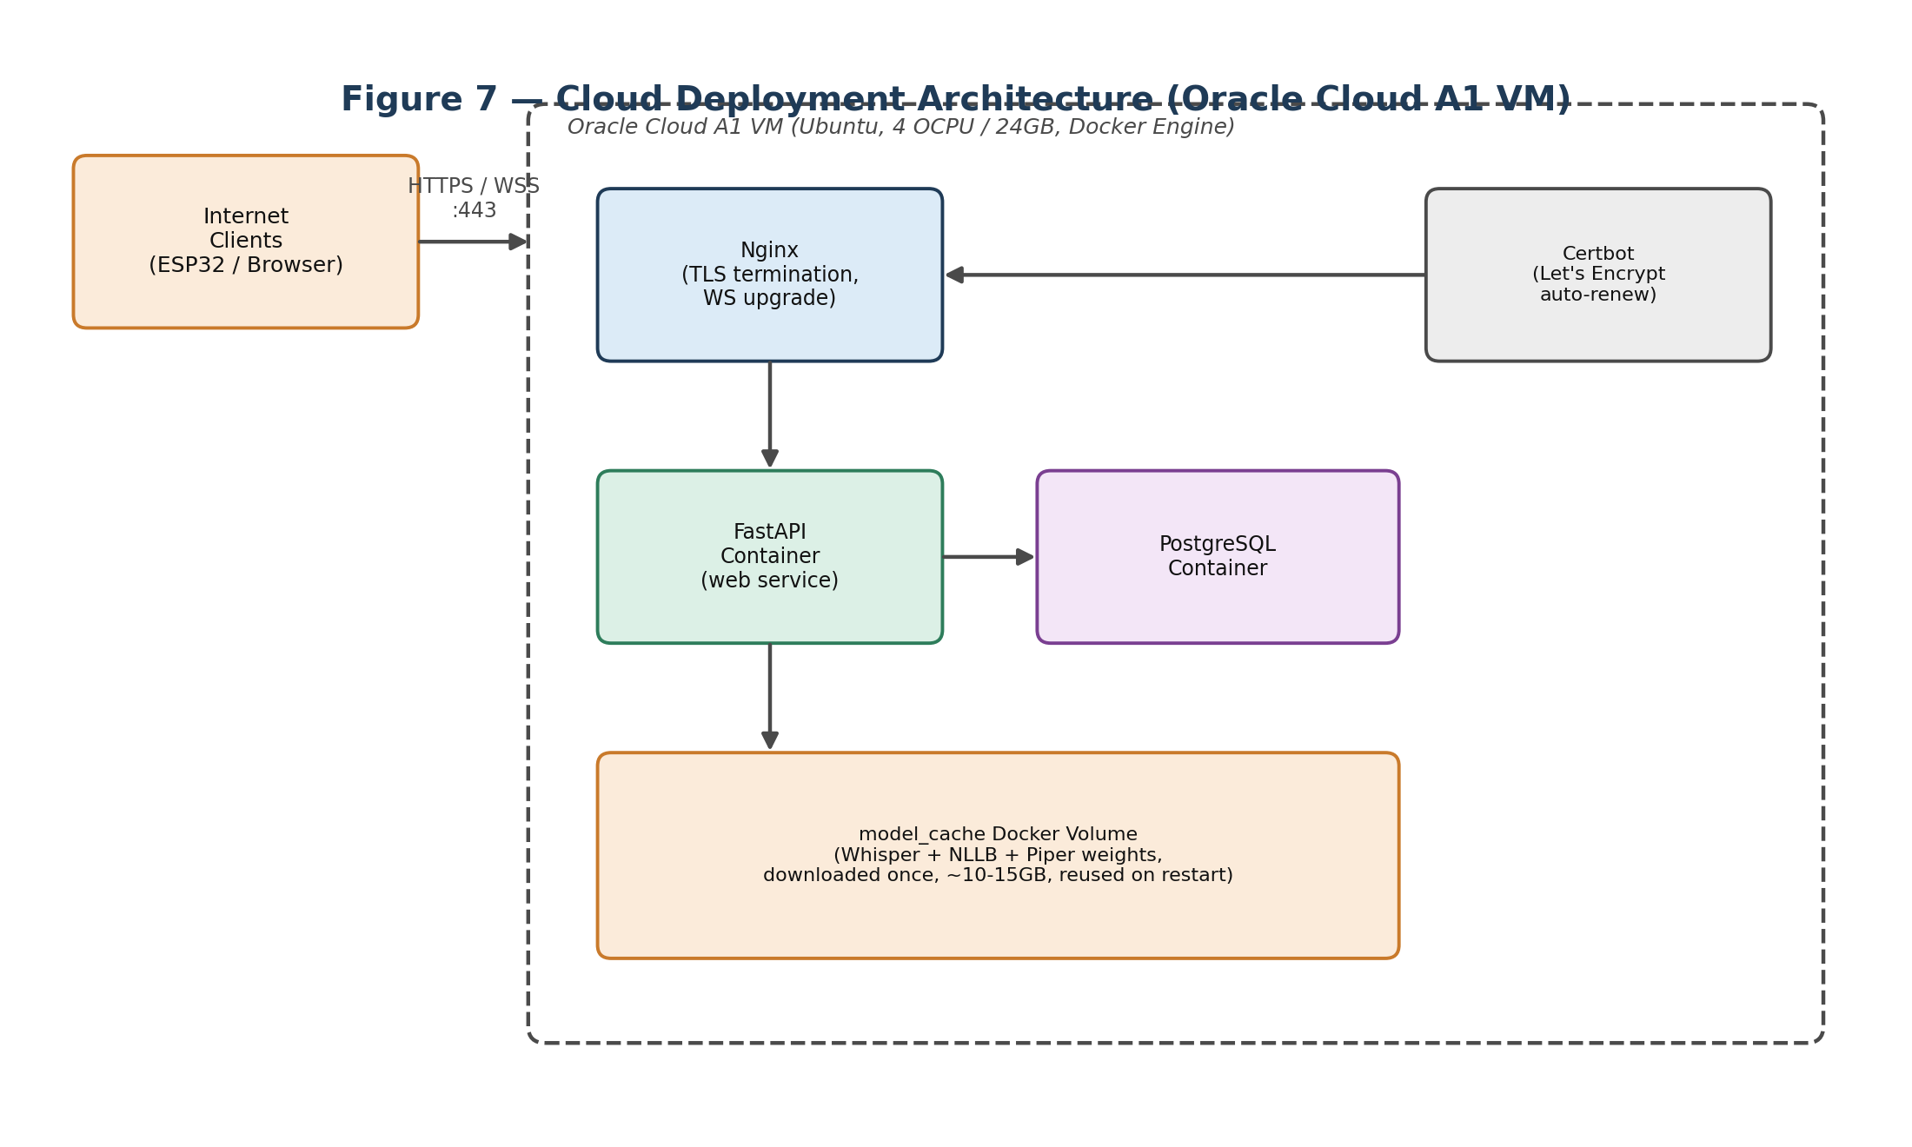
Figure 7: Nginx terminates TLS and forwards to the FastAPI container; a named Docker volume caches downloaded model weights so restarts are fast.

9.3 Docker Fundamentals Used Here
- Image / Container / Layer: an image is a read-only blueprint; a container is a running instance of it; each RUN/COPY instruction adds a cached filesystem layer.
- Multi-stage builds: a builder stage has gcc/Poetry/build tools; the final runtime stage copies over only installed packages plus ffmpeg/libgomp, shrinking the image from ~2GB to ~700MB and reducing attack surface.
- Where models live: baking models into the image balloons it to 10-15GB and forces a full rebuild on every model update; downloading fresh at every boot costs 5-20 minutes each time. This project uses a named Docker volume (model_cache): the first docker compose up downloads once (~20 minutes), and every subsequent restart reuses the cached volume (~30-90 seconds).

9.4 Reverse Proxy — Why Nginx in Front of FastAPI
Nginx is the only service the public internet talks to directly. Uvicorn/FastAPI are not built to safely handle raw internet traffic (SSL, thousands of simultaneous sockets), so Nginx handles TLS termination, connection multiplexing, rate limiting, and security headers, forwarding plain HTTP internally to the FastAPI container.
WebSocket upgrades need special handling because Nginx, by default, strips the Connection header on the way through. Without the following directives, the WebSocket handshake fails silently:
- proxy_http_version 1.1;
- proxy_set_header Upgrade $http_upgrade;
- proxy_set_header Connection "upgrade";
- proxy_read_timeout 3600s; — a 60-second default would kill a live translation session mid-stream.
- proxy_buffering off; — streams binary audio frames immediately instead of buffering them.

9.5 HTTPS / TLS
TLS uses asymmetric cryptography once, during the handshake, for the server to prove its identity (certificate) and for both sides to agree on a symmetric session key; all actual data afterward is encrypted with fast symmetric AES. Let's Encrypt is a free, automated Certificate Authority: certbot writes a challenge file, Let's Encrypt's servers fetch it over HTTP to prove domain ownership, and issues a certificate valid for 90 days, renewed automatically via a cron job every 60 days.

9.6 Secrets Management
.env files hold database passwords and must never be committed to git (they persist forever in history). This project keeps .env.example (fake values, committed) separate from .env.production (real values, git-ignored, chmod 600 on the VM). The ESP32 firmware itself hardcodes the WebSocket URL in a config.h header, recompiled and reflashed if the domain changes — a BLE/WiFi provisioning UI would be the production-grade alternative.

9.7 CI/CD — Capstone-Appropriate vs. Production-Grade
This project uses a manually-triggered deploy.sh: git pull, verify .env.production exists, docker compose build, run Alembic migrations, docker compose up -d, then a health check and log tail. A "proper" production pipeline would run this automatically via GitHub Actions on every push to main, running the test suite first and deploying over SSH using repository secrets.

9.8 Memory Management for Three AI Models on One VM
Component | RAM Footprint
Whisper base (int8) | ~300 MB
NLLB-200 600M (int8) | ~1.2 GB
Piper voice (ONNX, per language) | ~60-120 MB
Python + FastAPI overhead | ~200 MB
PostgreSQL | ~100 MB
Grand total (active) | ~2.1 GB, comfortable on 12-24 GB
Mitigations against RAM spikes: lazy-loading Piper voices per language on first use (Whisper/NLLB load eagerly at startup); loading in RAM-ascending order so if the largest model (NLLB) OOMs, ASR still works; a 4GB swapfile as a safety net; and an explicit Docker memory limit in docker-compose.yml.

9.9 Interview Q&A
Q: What is Docker and what problem does it solve?
A: Docker packages an application and all its dependencies into a portable container image so it runs identically everywhere, eliminating 'works on my machine' issues. Images are immutable blueprints, containers are running instances, layers are cached incremental changes, and volumes provide persistent storage. Isolation comes from Linux namespaces (process/network/filesystem) and cgroups (CPU/RAM limits).
Q: Why put Nginx in front of the app instead of exposing FastAPI directly?
A: Nginx is the single public entry point, handling SSL termination (only Nginx needs a certificate), efficient multiplexing of thousands of connections, security headers, rate limiting, and static file serving. Exposing Uvicorn directly means every client opens a raw TCP connection straight to the Python process, with no TLS and no protective buffering.
Q: Why do WebSockets need special Nginx configuration?
A: WebSocket connections start as HTTP/1.1 requests carrying Upgrade: websocket and Connection: Upgrade headers, but Nginx rewrites the Connection header by default, causing the handshake to fail. The fix is explicitly forwarding those two headers, plus extending proxy_read_timeout for the long-lived session and disabling proxy_buffering so audio frames stream immediately.
Q: What is a VCN / Security List in Oracle Cloud?
A: A VCN (Virtual Cloud Network) is a software-defined private network, analogous to an AWS VPC, containing subnets that VMs live in. A Security List is OCI's stateful firewall controlling inbound/outbound traffic per subnet via protocol+port+source-CIDR rules — unlike AWS Security Groups, which apply per-instance. Accepting HTTPS requires an explicit ingress rule for TCP port 443 from 0.0.0.0/0.

10. Testing, Accuracy Evaluation & Performance Benchmarking
This step verifies the system actually works and quantifies how well, using standard software-testing layers plus ASR/translation-specific accuracy metrics.

10.1 The Three Testing Layers
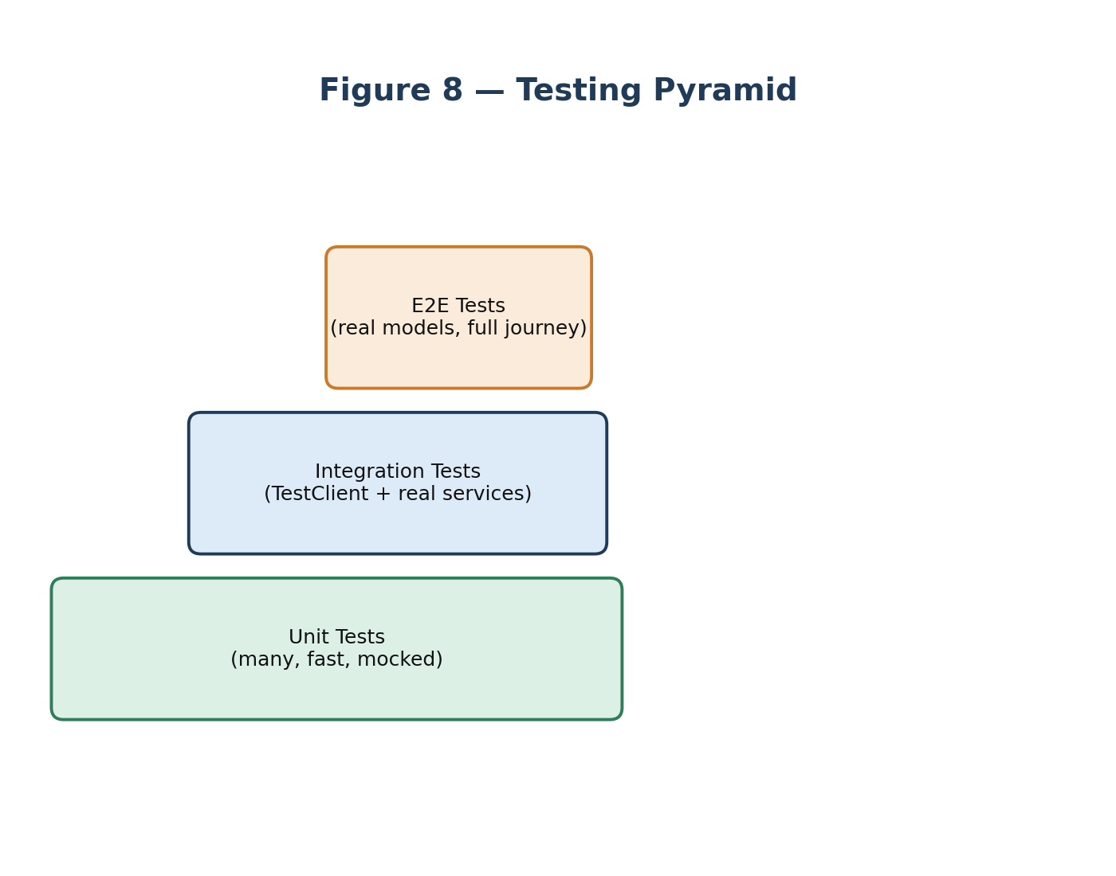
Figure 8: Aim for many fast unit tests, fewer integration tests, and very few slow end-to-end tests.
Type | Tests | Speed | Real Models? | Example
Unit | One function/class, dependencies mocked | < 1 s | No | test_ingestion.py — add_chunk() with synthetic PCM
Integration | Two or more real components together | Medium | Sometimes | test_api_endpoints.py — TestClient hitting /health
E2E | Full user journey, input to output | Slow | Yes | test_pipeline.py — real WAV through the whole pipeline
Mocking replaces slow or non-deterministic dependencies (e.g. a 30-second NLLB load) with instant, controllable fakes. Rule of thumb: the unit test suite should run in under 10 seconds total — if it takes minutes, tests are being written at the wrong layer.

10.2 Word Error Rate (WER) — ASR Accuracy
WER = (Substitutions + Deletions + Insertions) / total reference words, computed with the Wagner-Fischer dynamic-programming edit-distance algorithm. Example: reference "hello how are you today" (5 words) vs. hypothesis "hello how our you" gives 1 substitution + 1 deletion = WER 40%.
WER | Quality
< 5% | Excellent — commercial ASR level
5-15% | Good — research/capstone demo level
15-30% | Acceptable for noisy environments
> 30% | Needs improvement
Whisper base on clean English speech typically achieves 5-10% WER.

10.3 BLEU Score — Translation Quality
BLEU = BP × exp(Σ wₙ log pₙ), comparing n-gram precision between the machine translation and a human reference, with a Brevity Penalty (BP) discouraging overly short outputs.
BLEU | Quality
> 40 | High quality — near human
25-40 | Good quality
15-25 | Understandable
< 15 | Poor quality
NLLB-200 achieves BLEU 30-50 on standard benchmarks depending on language pair. BLEU is imperfect — it penalizes valid paraphrases — which is why neural metrics like COMET are gaining favor for correlating better with human judgment.

10.4 p95 Latency — Why Not Just the Average
A single slow outlier (a model cache miss, a GC pause) skews an average badly: ten runs of [1.2, 1.1, 1.3, 1.2, 1.1, 1.2, 1.3, 1.2, 1.1, 12.0] give an average of 2.37s that looks alarming even though only one run was actually slow. p95 says "95% of requests completed within X seconds" — it captures the worst realistic experience for most users, and p99 is the even stricter production-SLA standard. This project's target is p95 under 6 seconds for the full pipeline on the Oracle A1 VM.

10.5 Concurrency & the CPU Bottleneck
The system is single-threaded for inference (Python's GIL, no GPU). With three concurrent users, each user's total wall time roughly triples because ASR/translation/TTS calls queue up behind each other on one CPU thread. Mitigations: run_in_executor to offload sync ML calls to a thread pool, a queue-based worker pool, or GPU inference (a 10-50x speedup).

10.6 Documentation Practices Used
FastAPI auto-generates Swagger UI (/docs) and ReDoc (/redoc) from route docstrings, Pydantic field annotations, and explicit tags/summary/description parameters. A good README covers: a one-line description, an architecture diagram, prerequisites, an environment-variable table, local run steps, an API reference, testing instructions, and an honest list of known limitations.

10.7 Interview Q&A
Q: What's the difference between unit, integration, and E2E tests?
A: Unit tests isolate one function with all dependencies mocked, running in milliseconds and catching logic bugs. Integration tests wire two or more real components together (e.g. FastAPI routes plus real service classes) to catch contract mismatches. E2E tests simulate the full user journey — real audio in, translated WAV out — slow but giving the highest confidence. The testing pyramid recommends many unit, fewer integration, very few E2E.
Q: How is WER calculated?
A: WER = (Substitutions + Deletions + Insertions) / total reference words, computed via the Wagner-Fischer edit-distance algorithm after lowercasing and stripping punctuation. A WER of 10% means roughly 1 in 10 words was wrong; commercial ASR achieves 3-5% on clean speech.
Q: What does p95 latency mean and why prefer it over the average?
A: p95 means 95% of requests completed within that time. Averages hide tail behavior — a single cold-start or GC-pause outlier can double the reported average — whereas p95/p99 are the standard production SLA metrics because they reflect the worst experience most real users actually see.
Q: How would this system scale to 10 concurrent users?
A: The current bottleneck is Python's GIL plus synchronous CPU inference — model calls are effectively sequential. Options: offload inference to a ThreadPoolExecutor so the event loop stays responsive; run multiple Uvicorn workers, each with its own model copy (linear RAM cost); or move to GPU inference, which could cut per-call latency from ~4s to ~0.3s and comfortably handle 10+ concurrent users.

11. Frontend Prototyping — Streamlit Demo UI
Alongside the ESP32 hardware path, a Streamlit web app provides a fast, code-only way to demo the pipeline from any browser with a microphone.

11.1 Streamlit's Execution Model
Streamlit re-runs the entire Python script top-to-bottom every time the user interacts with a widget. Because local variables reset on every rerun, Streamlit provides st.session_state, a persistent key-value dictionary, to carry values (like conversation history) across reruns. Expensive operations (loading a model, querying a database) can be decorated with st.cache_data / st.cache_resource to skip recomputation when inputs haven't changed.

11.2 Streamlit vs. React/Vue
Feature | Streamlit | React / Vue
Language | Pure Python | JavaScript/TypeScript/JSX
State location | Server-side Python process | Client-side browser runtime
Execution | Whole file reruns on change | Component-level reconciliation
Dev speed | Extremely fast (minutes-hours) | Moderate (routing, build steps)
Customizability | Layout grids and markdown/CSS | Unlimited layout and animation
Deployment | Runs as a Python app server | Static assets on a CDN
Streamlit is ideal for internal tools, ML proofs-of-concept, and demo portals; a React/Vue frontend talking to a REST/GraphQL API is the standard for large, consumer-facing products needing rich client-side interaction.

11.3 Browser-Based Audio Recording
Recording relies on the browser's MediaDevices and MediaRecorder APIs: getUserMedia({audio:true}) requests microphone permission, the resulting MediaStream is encoded into chunks (typically WebM/OGG), and stopping the recorder compiles those chunks into a binary Blob. Streamlit's built-in st.audio_input component wraps all of this and hands the raw bytes straight to the Python script, which POSTs them to the FastAPI backend.

11.4 REST vs. WebSocket — Why REST for the Demo
The ESP32 needs continuous, sub-second streaming, so it uses a persistent WebSocket. The Streamlit demo, in contrast, captures one complete audio file per interaction — a natural fit for a stateless HTTP POST, which is simpler, has clean error handling, and avoids building stateful connection-management code inside a script that reruns on every widget click.

11.5 Known Limitations
- Double re-encoding: the browser encodes to WebM, the backend converts to 16kHz WAV, and Piper outputs WAV again — extra compute overhead.
- No streamed audio feed: unlike the ESP32's continuous chunking, the demo is fully batch-oriented and doesn't showcase low-latency VAD splitting.
- CORS / mixed-content: connecting a Streamlit app over HTTP to an HTTPS backend needs careful CORS and mixed-content handling.

11.6 Interview Q&A
Q: How does Streamlit persist state across reruns if the whole script executes on every click?
A: It resets all local variables each rerun, but exposes st.session_state, a server-side key-value store that survives reruns — used here to hold history lists or connection state that shouldn't reset when a widget changes.
Q: Why REST for the Streamlit UI but WebSocket for the ESP32?
A: The ESP32 must stream audio chunks continuously with sub-second latency, which only a WebSocket's persistent connection supports efficiently. The Streamlit demo instead captures one complete audio file in the browser first, so a stateless HTTP POST matches that batch workflow, handles errors cleanly, and avoids adding connection-state logic to a script that reruns on every interaction.
Q: How does audio get from the browser microphone into the Python script?
A: The browser's MediaDevices/MediaRecorder JavaScript APIs capture microphone input as a Blob; Streamlit's built-in st.audio_input component manages this recording and exposes the resulting bytes directly to Python, with no custom iframe component needed.
Q: How does a reverse proxy like Nginx serve both HTTP and WebSocket traffic on one port?
A: Nginx inspects incoming request headers: ordinary requests are routed as standard HTTP, but a request carrying Upgrade: websocket and Connection: Upgrade triggers a WebSocket handshake, after which Nginx forwards raw data frames bidirectionally between client and backend without closing the connection.

12. Consolidated Summary — The Full Project in One Table
This table is the elevator-pitch answer to "Tell me about your capstone project":
Step | One-Line Summary
1. Scaffolding | FastAPI's lifespan context manager handles startup/shutdown; Pydantic settings validate config from env files with zero boilerplate.
2. Audio Ingestion | Raw PCM from I2S microphones is buffered into a bytearray; RMS-based VAD detects speech boundaries without needing a separate model.
3. Speech-to-Text | faster-whisper runs Whisper via CTranslate2 with int8 quantization for 4x faster CPU inference; returns text plus a detected language code.
4. Language ID | Fusion approach: Whisper's audio-based LID is trusted above a 0.6 confidence threshold; langdetect (text-based) is the fallback — avoiding a single point of failure.
5. Translation | NLLB-200 (600M params) supports 200 languages via FLORES-200 codes; dynamic quantization cuts RAM from 2.4GB to ~1.2GB at minimal quality cost.
6. Text-to-Speech | Piper uses VITS, combining the acoustic model and vocoder into one end-to-end network; ONNX runtime gives fast CPU inference.
7. Pipeline | PipelineOrchestrator chains ASR → LID → MT → TTS with per-stage timing; WebSocket replies send JSON metadata then binary WAV in two frames.
8. Database | Async SQLAlchemy with the asyncpg driver; Alembic handles schema migrations; expire_on_commit=False avoids DetachedInstanceError in async code.
9. Deployment | Multi-stage Docker build keeps images lean; models live in a Docker volume, not baked into the image; Nginx proxies WebSockets with the mandatory Upgrade/Connection headers and a long timeout.
10. Testing | Testing pyramid: many mocked unit tests, few integration tests, one E2E test; WER measures ASR quality, BLEU measures translation quality, p95 latency is the SLA metric.
11. Frontend | A Streamlit browser demo records via st.audio_input and POSTs to the same REST API, giving a fast, code-only alternative to the ESP32 hardware path.

In one sentence: the system takes speech in one language and plays back translated speech in another, running entirely on a single free-tier cloud VM, using open-source, CPU-quantized AI models end to end.

