Project Architecture, Technology & Pipeline Overview
Real-Time Multilingual Speech Translation System
ESP32-S3 Edge Device + Cloud AI Backend
A concise reference covering system architecture, the technology stack,
the end-to-end processing pipeline, and the engineering approach behind it

Table of Contents

1. Introduction
This document explains how the Real-Time Multilingual Speech Translation System is designed and built. It focuses on three things: the architecture (how components fit together), the technology stack (what each component is built with, and why), and the pipeline (the exact sequence of steps that turns a spoken sentence in one language into spoken audio in another). It closes with a summary of the overall engineering approach that guided every design decision — favouring open-source, CPU-friendly, and cost-free tools throughout, since the entire system runs on a single free-tier cloud VM.
In one sentence: a small edge device (or a browser) captures speech, streams it to a cloud backend, and the backend transcribes, identifies the language, translates the text, synthesizes speech in the target language, and streams the result back — in under about three seconds.

2. System Architecture
The system has four architectural layers: a client layer (the ESP32 hardware device and a Streamlit browser demo), a gateway layer (Nginx), an application layer (FastAPI running the AI pipeline), and a persistence layer (PostgreSQL).
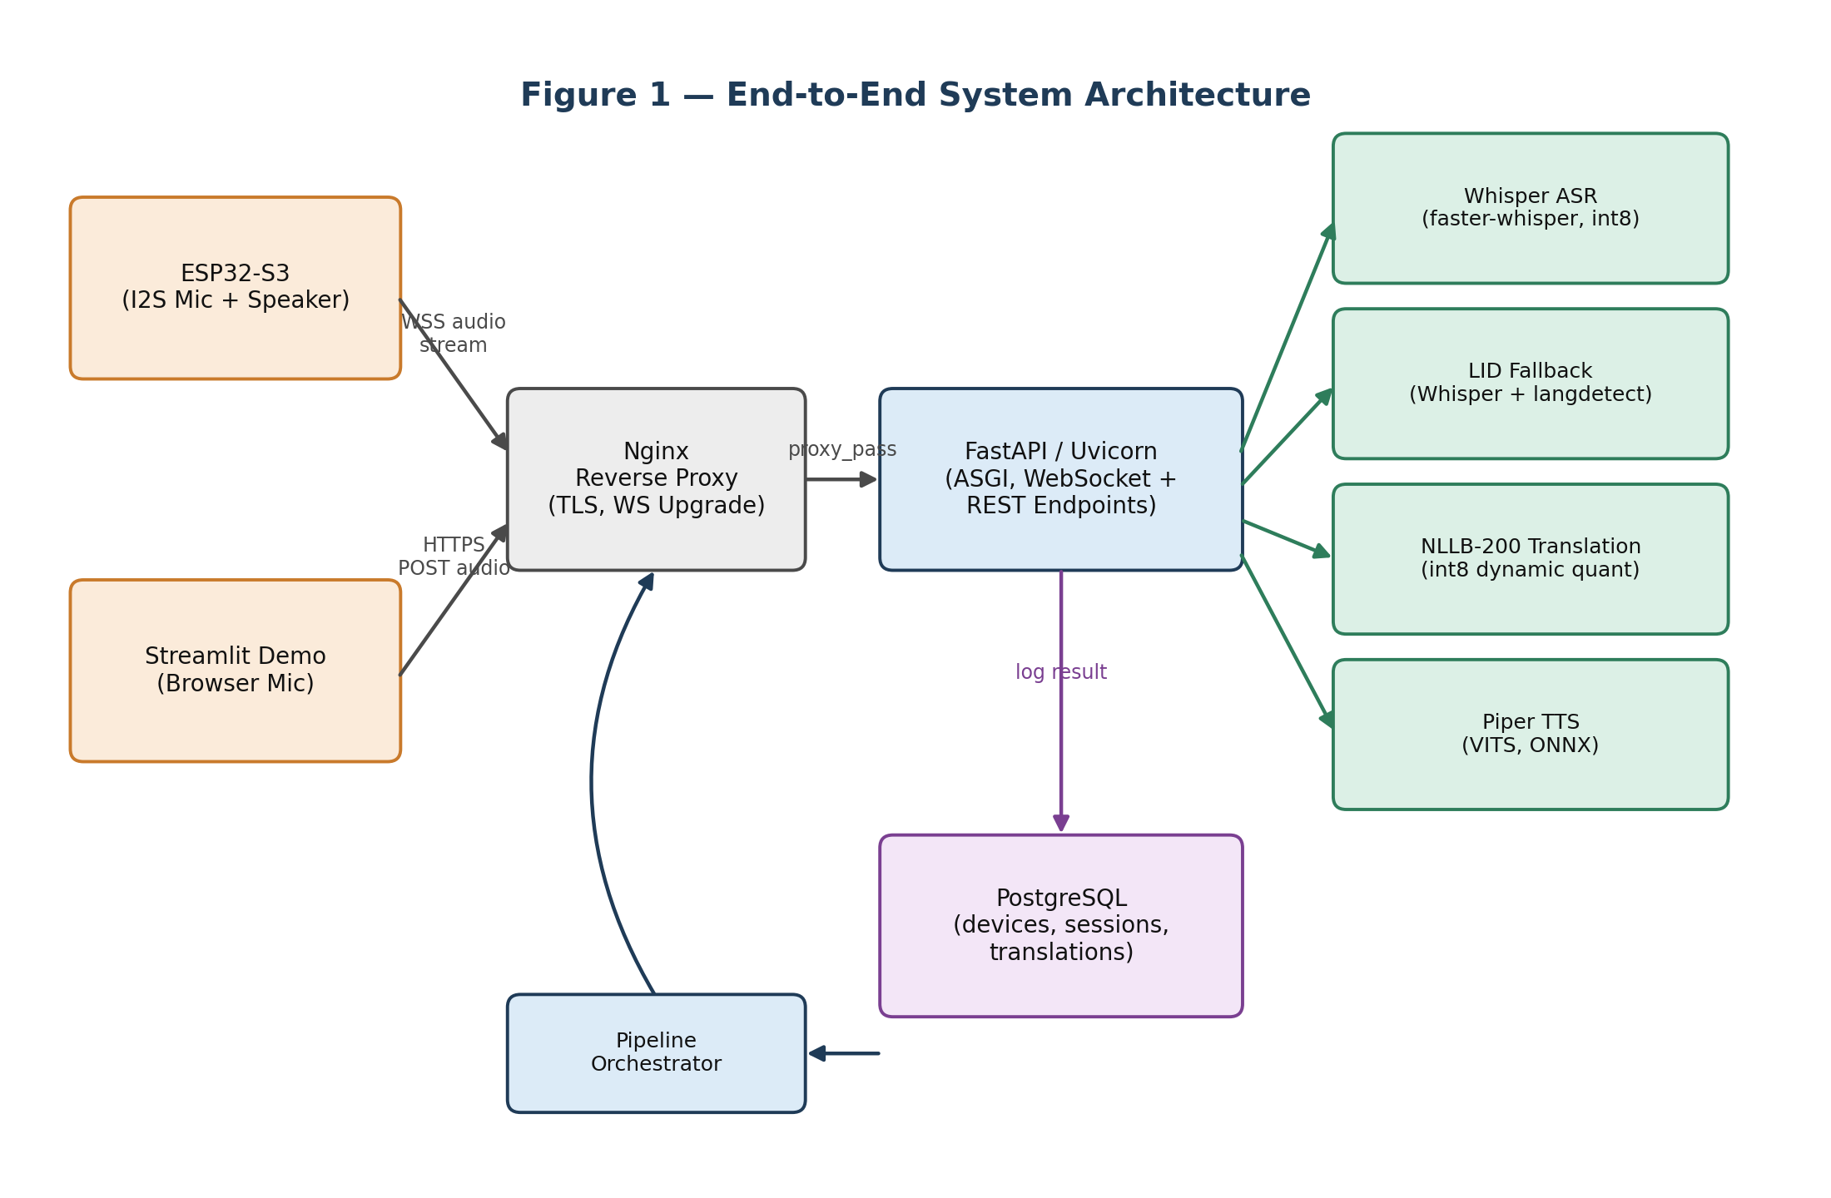
Figure 1: Clients connect through Nginx to FastAPI, which drives the AI pipeline and logs results to PostgreSQL.

2.1 Client Layer
- ESP32-S3 (production path): an I2S microphone captures audio and streams it continuously over a WebSocket; an I2S speaker (via a MAX98357A amplifier) plays back the translated audio. This is the intended IoT deployment target — small, cheap, always-on hardware.
- Streamlit demo (development/demo path): a browser records a complete utterance and POSTs it as a file over HTTPS. This exists purely to make the system demoable from a laptop without needing physical hardware.

2.2 Gateway Layer — Nginx
Nginx is the only service exposed directly to the internet. It terminates TLS (so the backend never has to manage certificates), forwards traffic to FastAPI over plain HTTP inside the Docker network, and is specifically configured to support long-lived WebSocket upgrades — forwarding the Upgrade and Connection headers and disabling response buffering so audio frames are not delayed.

2.3 Application Layer — FastAPI
FastAPI, running on the Uvicorn ASGI server, exposes both a REST endpoint (for the Streamlit/batch path) and a WebSocket endpoint (for the ESP32/streaming path). Both endpoints feed the same underlying pipeline logic through a single orchestrator, so the two client types share one code path for the actual AI processing.

2.4 Persistence Layer — PostgreSQL
Every translation is optionally logged — the original text, the translation, per-stage timing, and status — against the device and session that produced it. Persistence is deliberately non-blocking: if the database is briefly unavailable, the pipeline still returns the translation to the user, and only the logging step is skipped.

3. Technology Stack
Every technology choice in this project was made under the same constraint: it has to run well on a CPU-only, free-tier cloud VM. That constraint rules out GPU-only models and anything with a heavy licensing cost, and explains most of the choices below.

3.1 Backend & API
Layer | Technology | Why
Web framework | FastAPI | Native async (ASGI), automatic validation via Pydantic, automatic Swagger/ReDoc docs
Application server | Uvicorn | ASGI server needed for WebSocket support and async concurrency
Dependency management | Poetry | Deterministic, hashed lock file; clean separation of main/dev dependencies
Reverse proxy | Nginx | TLS termination, WebSocket upgrade handling, single public entry point
Containerization | Docker + Docker Compose | Reproducible environment across dev, CI, and the production VM

3.2 AI / ML Models
Stage | Model | Runtime / Optimization
Speech-to-Text (ASR) | OpenAI Whisper | faster-whisper on CTranslate2, int8 quantized — ~4x faster on CPU
Language Identification | Whisper (acoustic) + langdetect (text) | Threshold-based fallback (≥0.6 confidence keeps Whisper's guess)
Machine Translation | Meta NLLB-200-distilled-600M | PyTorch dynamic int8 quantization — RAM cut from 2.4GB to ~1.2GB
Text-to-Speech | Piper (VITS architecture) | Exported to ONNX Runtime for fast, lightweight CPU inference

3.3 Data & Infrastructure
Layer | Technology | Why
Database | PostgreSQL | Relational schema fits devices → sessions → translations; MVCC handles concurrent access
ORM / DB driver | SQLAlchemy (async) + asyncpg | Non-blocking DB calls inside an async FastAPI app; asyncpg is the fastest Postgres driver available
Migrations | Alembic | Versioned, reviewable schema changes instead of destructive recreate-table workflows
Hosting | Oracle Cloud Always-Free (A1, ARM) | The only free tier with enough RAM (24GB) and CPU (4 OCPU) to hold three loaded AI models
TLS certificates | Let's Encrypt + Certbot | Free, automated, auto-renewing HTTPS certificates

3.4 Frontend / Demo
Component | Technology | Why
Demo UI | Streamlit | Pure-Python, extremely fast to build, ideal for an ML demo/proof-of-concept
Browser audio capture | HTML5 MediaDevices / MediaRecorder (via st.audio_input) | No custom JavaScript needed; records mic audio directly to Python
Edge firmware | ESP32-S3 (I2S mic + MAX98357A amp) | Low-cost, low-power hardware target for the production IoT use case

4. End-to-End Processing Pipeline
Regardless of which client sends the audio, every request passes through the same five-stage pipeline, coordinated by a single PipelineOrchestrator. This section walks through it stage by stage.

4.1 Stage 0 — Audio Ingestion & Voice Activity Detection
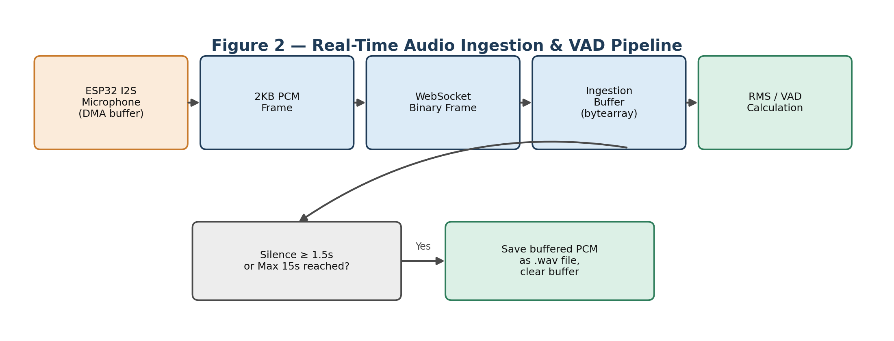
Figure 2: Small PCM frames are buffered continuously; RMS energy detects when the speaker has stopped talking.
- The ESP32 streams 16kHz, 16-bit, mono PCM in small frames (1-2KB) over a WebSocket.
- The server appends frames to an in-memory buffer and computes the RMS (Root Mean Square) energy of recent audio.
- When energy stays below a threshold for 1.5 continuous seconds (after speech has started), the utterance boundary is declared, the buffer is written to a .wav file, and a fresh buffer starts for the next utterance. A 15-second hard cap prevents unbounded memory growth.

4.2 Stage 1 — Speech-to-Text (ASR)
The saved WAV is passed to faster-whisper. The model returns the transcribed text, a detected language code, and a confidence probability for that language guess — all from a single inference pass.

4.3 Stage 2 — Language Identification & Fallback
If Whisper's language confidence is at least 0.6, that language is used directly at zero extra cost. If it is lower (or empty, e.g. from noise), the transcribed text is passed to langdetect as a text-based cross-check, which is far more reliable once clean text exists — correcting cases where an accent or background noise confused the acoustic classifier.

4.4 Stage 3 — Machine Translation
The resolved source language, the target language (chosen by the client), and the transcribed text are passed to NLLB-200. The service maps both languages from ISO codes (e.g. en, es) to NLLB's own codes (eng_Latn, spa_Latn) before calling the model. If source and target are identical, translation is skipped entirely as a zero-cost no-op.

4.5 Stage 4 — Text-to-Speech
The translated text is passed to Piper, which synthesizes it directly into a 16kHz, 16-bit, mono WAV file — the same format the ESP32's I2S amplifier expects, so no further conversion is needed before playback.

4.6 Orchestration, Timing, and Delivery
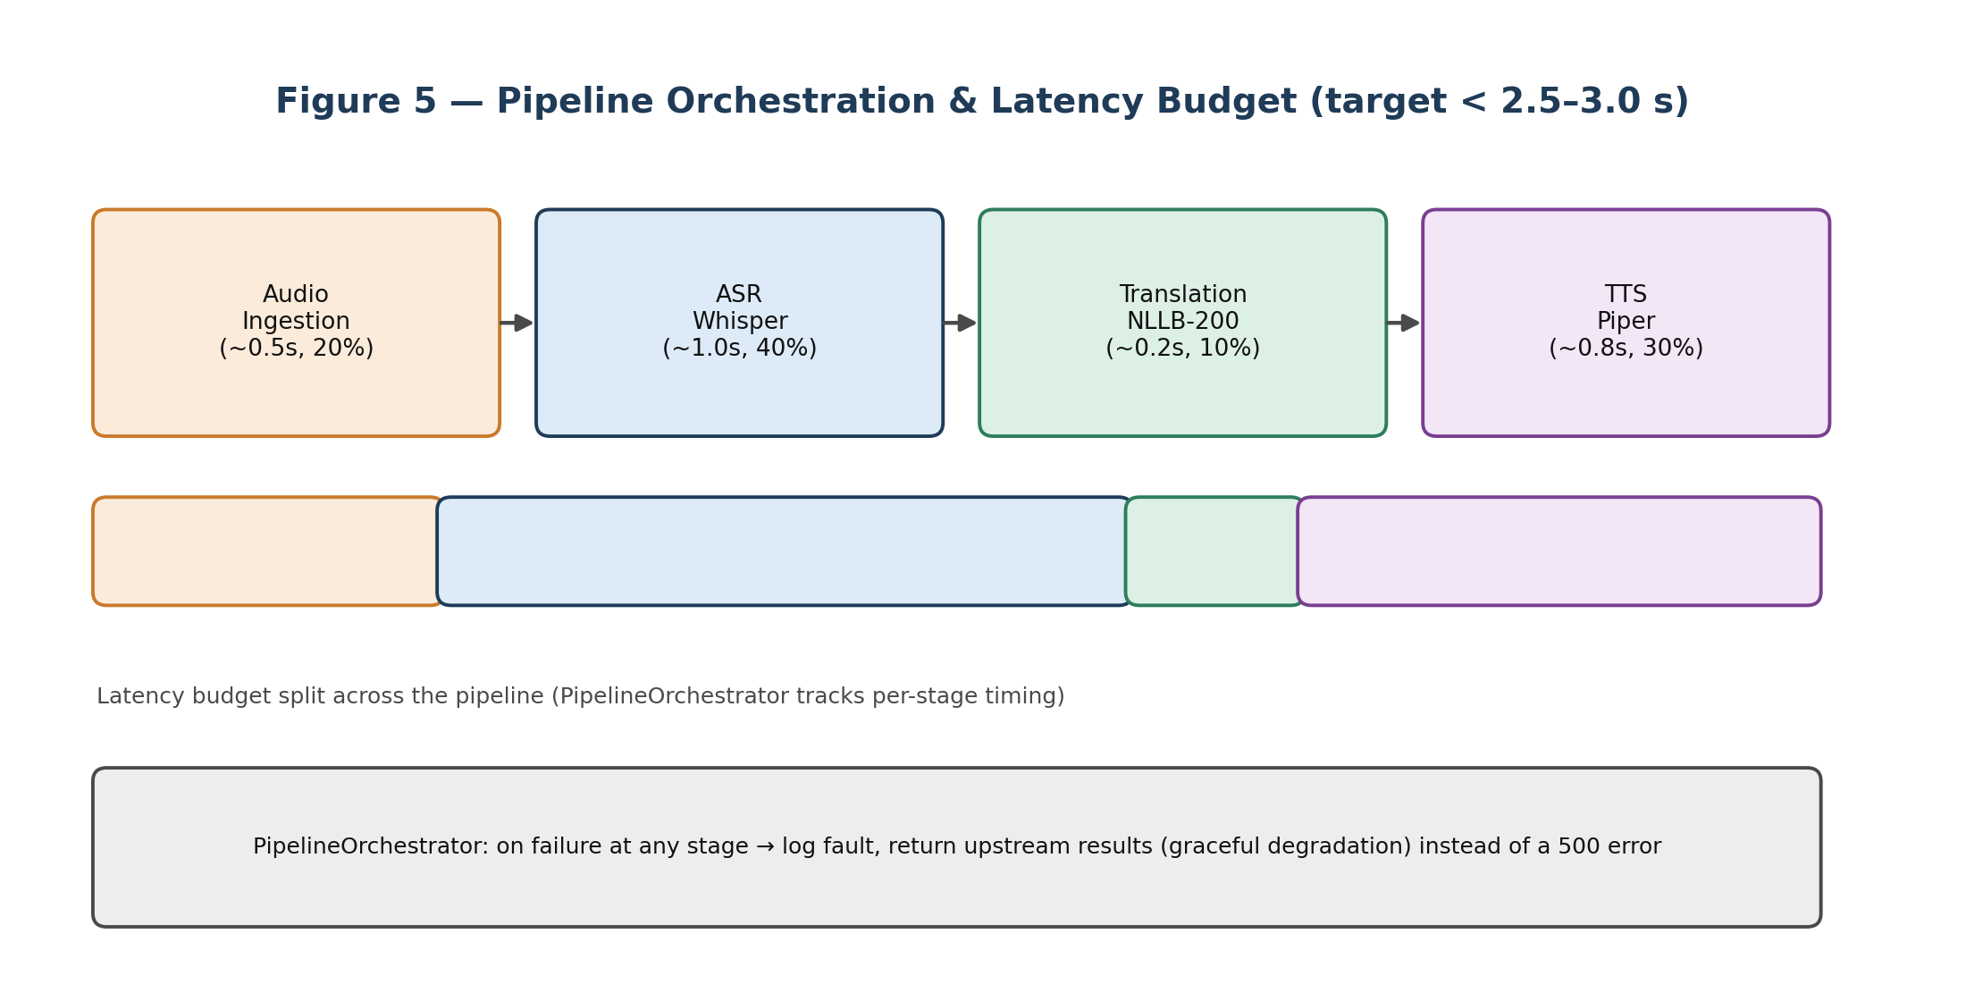
Figure 5: The orchestrator times every stage against a roughly 2.5-3.0 second end-to-end budget and degrades gracefully on partial failure.
- Graceful degradation: if translation or TTS fails, the pipeline still returns whatever succeeded upstream (e.g. the transcription) instead of raising an error — the user always gets some useful output.
- Two-frame delivery over WebSocket: results are sent as a JSON text frame (transcription + translation, for an on-device display) immediately followed by a binary frame (the synthesized WAV), so the ESP32 can display text and stream audio without any multipart parsing.
- REST delivery: for the Streamlit path, the same result is returned as one JSON response, with the translation and any generated audio referenced by filename.
- Non-blocking logging: after responding to the client, the orchestrator asynchronously logs the device, session, and translation record to PostgreSQL, wrapped in its own try/except so a database hiccup never affects the real-time response.

5. Deployment Architecture
The entire stack — Nginx, FastAPI, PostgreSQL, and all three AI models — runs on one Oracle Cloud Always-Free VM (4 OCPU ARM, 24GB RAM), managed with Docker Compose.
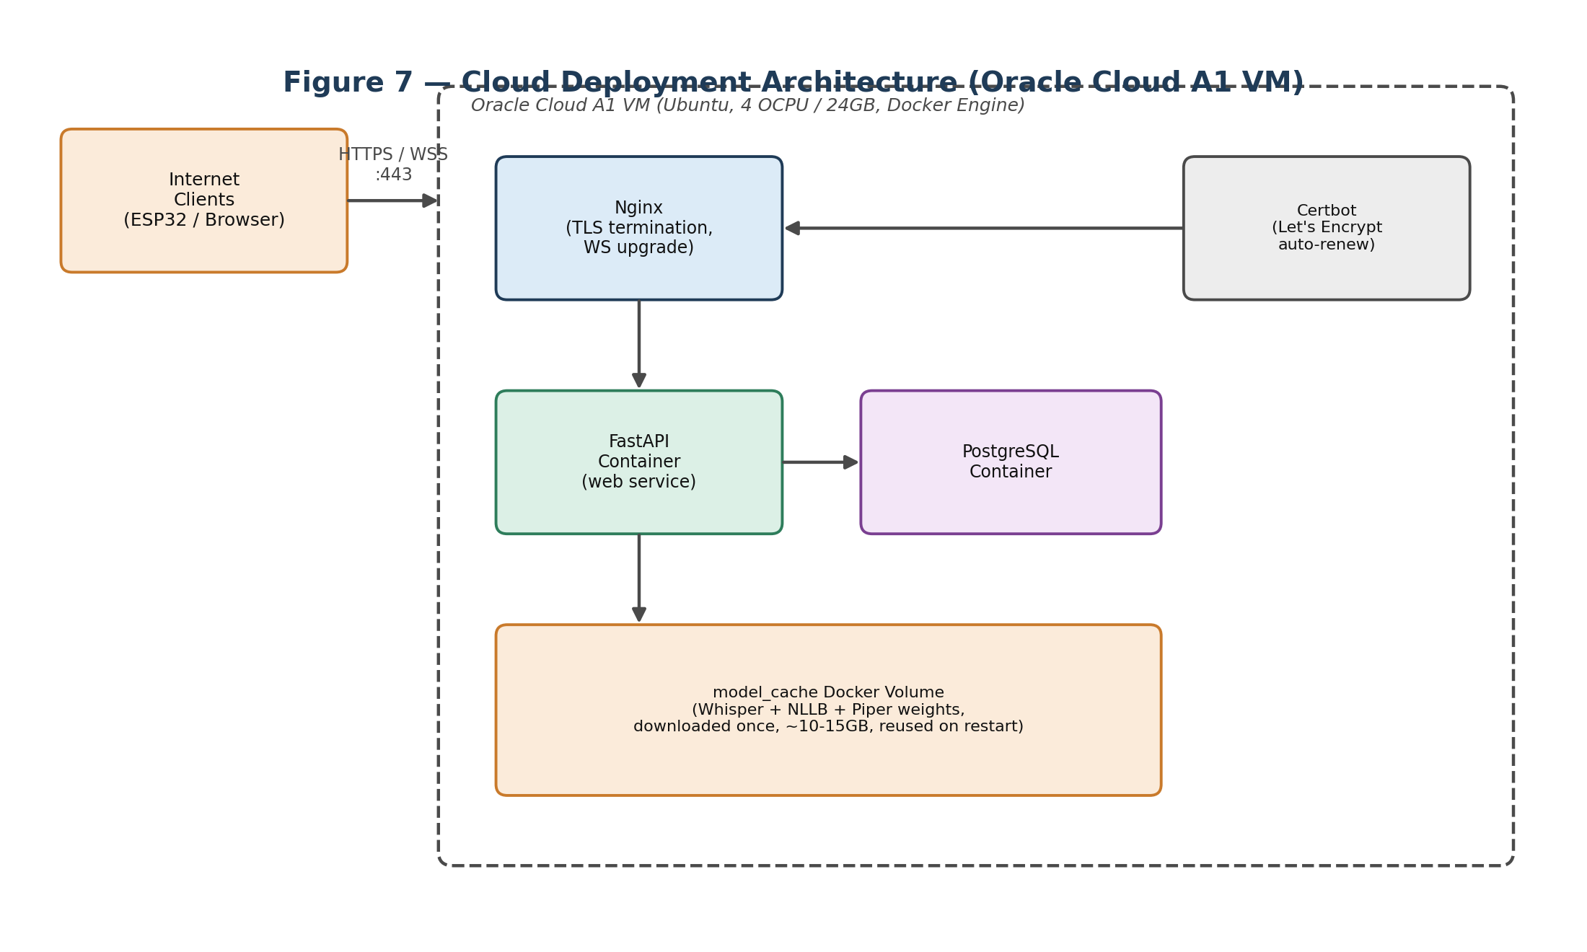
Figure 7: Nginx terminates TLS and proxies to the FastAPI container; AI model weights are cached in a Docker volume rather than baked into the image.
- Multi-stage Docker builds: a build stage with compilers and Poetry produces the installed dependencies, and only those (plus runtime libraries like ffmpeg) are copied into the final, much smaller runtime image.
- Models live in a Docker volume, not the image: baking model weights into the image would make it 10-15GB and force a full rebuild on every model update. Instead, models download once into a named volume on first boot (~15-20 minutes) and are reused on every restart (~30-90 seconds).
- TLS via Let's Encrypt: Certbot automatically proves domain ownership and issues a certificate, renewed on a nightly cron job with zero manual intervention.
- Deploy flow: a simple deploy script pulls the latest code, rebuilds changed Docker layers, runs Alembic migrations, and restarts the stack — sufficient for a single-VM capstone deployment without a full CI/CD platform.

6. Engineering Approach & Key Design Decisions
A handful of guiding principles were applied consistently across every layer of the system:

6.1 CPU-First, Not GPU-First
No GPU is available on the free-tier VM, so every AI model was deliberately chosen for its CPU-optimized runtime and quantized to int8: faster-whisper (CTranslate2), NLLB-200 (PyTorch dynamic quantization), and Piper (ONNX Runtime). This trades some raw model size and a little accuracy for a system that runs, in practice, entirely for free.

6.2 Match the Protocol to the Client
WebSockets are used only where their strengths matter — the ESP32's continuous, low-latency, bidirectional audio stream — while the Streamlit demo intentionally uses plain HTTP REST, because it only ever sends one complete file at a time and a stateless request-response cycle is simpler and easier to debug. The same backend pipeline serves both, so this is a protocol choice, not a duplicated implementation.

6.3 Fail Softly, Never Silently
Every optional stage (translation, TTS, database logging) is isolated so its failure cannot break the stages before it. The system always tries to hand the user the most useful output it can — even if that is only a transcription — rather than surfacing a generic error.

6.4 Decouple Orchestration from Transport
All pipeline logic (ASR → LID → Translation → TTS, with timing) lives in one PipelineOrchestrator class, independent of whether the caller was a REST endpoint or a WebSocket handler. This keeps the AI logic testable in isolation and means the two transport layers stay thin.

6.5 Cache Expensive Things Exactly Once
Model weights are loaded once at FastAPI startup (not per-request) and cached in a Docker volume (not re-downloaded per deployment). Both decisions exist purely to keep the recurring, per-request cost of the system as close to zero as possible.

6.6 Build for a Single Free-Tier VM
Every infrastructure choice — Oracle's Always-Free A1 shape, Docker Compose instead of Kubernetes, a manual deploy script instead of a full CI/CD pipeline, Let's Encrypt instead of a paid certificate — reflects the same real constraint: the whole system, AI models included, needed to run reliably at zero infrastructure cost.

Taken together, these decisions describe a system that is small enough to run for free, but architecturally complete: a clean client/gateway/application/persistence separation, a well-defined multi-stage AI pipeline with graceful degradation, and a deployment process that is reproducible from a clean VM.

