Campbell's Biology, 9e (Reece et al.)
Chapter 5 The Structure and Function of Large Biological Molecules

In Chapter 5, the principles of chemistry covered in earlier chapters are applied to the understanding of biological polymers and lipid membranes. The emphasis is on properly linking monomers and their polymers, and on the structural and functional diversity of the different polymer types. Particular attention is given to protein structure, because this is central to understanding subsequent chapters on metabolism, molecular biology, and molecular medicine.

Multiple-Choice Questions

1) Humans and mice differ because
A) their cells have different small organic molecules.
B) their cells make different types of large biological molecules.
C) their cells make different types of lipids.
D) their cells have some differences in the sequence of nucleotides in their nucleic acids.
E) their cells make different types of proteins.
Answer: D
Topic: Concept 5.1
Skill: Knowledge/Comprehension

2) Molecules with which functional groups may form polymers via dehydration reactions?
A) hydroxyl groups
B) carbonyl groups
C) carboxyl groups
D) either carbonyl or carboxyl groups
E) either hydroxyl or carboxyl groups
Answer: E
Topic: Concepts 5.1, 4.3
Skill: Application/Analysis

3) Which of these molecules is not formed by dehydration reactions?
A) fatty acids
B) disaccharides
C) DNA
D) protein
E) amylose
Answer: A
Topic: Concept 5.1
Skill: Knowledge/Comprehension
4) In animal metabolism, most of the monomers released by digestion of food macromolecules are metabolized to provide energy. Only a small portion of these monomers are used for synthesis of new macromolecules. The net result is that
A) water is generated by animal metabolism.
B) water is consumed by animal metabolism.
C) the water consumed is exactly balanced by the water generated, to maintain homeostasis.
D) water is consumed during homeostasis, but water is generated during periods of growth.
E) water is generated during homeostasis, but water is consumed during periods of growth.
Answer: B
Topic: Concept 5.1
Skill: Application/Analysis

5) Which of these classes of biological molecules consist of both small molecules and macromolecular polymers?
A) lipids
B) carbohydrates
C) proteins
D) nucleic acids
E) lipids, carbohydrates, proteins, and nucleic acids all consist of only macromolecular polymers
Answer: B
Topic: Concept 5.1
Skill: Knowledge/Comprehension

6) Which of the following is not a polymer?
A) glucose
B) starch
C) cellulose
D) chitin
E) DNA
Answer: A
Topic: Concept 5.1
Skill: Knowledge/Comprehension

7) What is the chemical reaction mechanism by which cells make polymers from monomers?
A) phosphodiester linkages
B) hydrolysis
C) dehydration reactions
D) ionic bonding of monomers
E) the formation of disulfide bridges between monomers
Answer: C
Topic: Concept 5.1
Skill: Knowledge/Comprehension
8) How many molecules of water are needed to completely hydrolyze a polymer that is 11 monomers long?
A) 12
B) 11
C) 10
D) 9
E) 8
Answer: C
Topic: Concept 5.1
Skill: Knowledge/Comprehension

9) Which of the following best summarizes the relationship between dehydration reactions and hydrolysis?
A) Dehydration reactions assemble polymers, and hydrolysis reactions break down polymers.
B) Dehydration reactions eliminate water from lipid membranes, and hydrolysis makes lipid membranes water permeable.
C) Dehydration reactions can occur only after hydrolysis.
D) Hydrolysis creates monomers, and dehydration reactions break down polymers.
E) Dehydration reactions ionize water molecules and add hydroxyl groups to polymers; hydrolysis reactions release hydroxyl groups from polymers.
Answer: A
Topic: Concept 5.1
Skill: Knowledge/Comprehension

10) Which of the following polymers contain nitrogen?
A) starch
B) glycogen
C) cellulose
D) chitin
E) amylopectin
Answer: D
Topic: Concept 5.2
Skill: Knowledge/Comprehension

11) The molecular formula for glucose is C6H12O6. What would be the molecular formula for a molecule made by linking three glucose molecules together by dehydration reactions?
A) C18H36O18
B) C18H32O16
C) C6H10O5
D) C18H10O15
E) C3H6O3
Answer: B
Topic: Concept 5.2
Skill: Application/Analysis
12) The enzyme amylase can break glycosidic linkages between glucose monomers only if the monomers are the α form. Which of the following could amylase break down?
A) glycogen
B) cellulose
C) chitin
D) glycogen and chitin only
E) glycogen, cellulose, and chitin
Answer: A
Topic: Concept 5.2
Skill: Knowledge/Comprehension

13) On food packages, to what does the term insoluble fiber refer?
A) cellulose
B) polypeptides
C) starch
D) amylopectin
E) chitin
Answer: A
Topic: Concept 5.2
Skill: Knowledge/Comprehension

14) A molecule with the chemical formula C6H12O6 is probably a
A) carbohydrate.
B) lipid.
C) monosaccharide
D) carbohydrate and lipid only.
E) carbohydrate and monosaccharide only.
Answer: E
Topic: Concept 5.2
Skill: Knowledge/Comprehension

15) Lactose, a sugar in milk, is composed of one glucose molecule joined by a glycosidic linkage to one galactose molecule. How is lactose classified?
A) as a pentose
B) as a hexose
C) as a monosaccharide
D) as a disaccharide
E) as a polysaccharide
Answer: D
Topic: Concept 5.2
Skill: Knowledge/Comprehension
16) All of the following are polysaccharides except
A) lactose.
B) glycogen.
C) chitin.
D) cellulose.
E) amylopectin.
Answer: A
Topic: Concept 5.2
Skill: Knowledge/Comprehension

17) Which of the following is true of both starch and cellulose?
A) They are both polymers of glucose.
B) They are cis-trans isomers of each other.
C) They can both be digested by humans.
D) They are both used for energy storage in plants.
E) They are both structural components of the plant cell wall.
Answer: A
Topic: Concept 5.2
Skill: Knowledge/Comprehension

18) Which of the following is true of cellulose?
A) It is a polymer composed of enantiomers of glucose.
B) It is a storage polysaccharide for energy in plant cells.
C) It is digestible by bacteria in the human gut.
D) It is a major structural component of plant cell walls.
E) It is a polymer composed of enantiomers of glucose, it is a storage polysaccharide for energy in plant cells, it is digestible by bacteria in the human gut, and it is a major structural component of plant cell walls.
Answer: D
Topic: Concept 5.2
Skill: Knowledge/Comprehension

19) Humans can digest starch but not cellulose because
A) the monomer of starch is glucose, while the monomer of cellulose is galactose.
B) humans have enzymes that can hydrolyze the β glycosidic linkages of starch but not the α glycosidic linkages of cellulose.
C) humans have enzymes that can hydrolyze the α glycosidic linkages of starch but not the β glycosidic linkages of cellulose.
D) humans harbor starch-digesting bacteria in the digestive tract.
E) the monomer of starch is glucose, while the monomer of cellulose is glucose with a nitrogen-containing group.
Answer: C
Topic: Concept 5.2
Skill: Knowledge/Comprehension
20) Which of the following statements concerning saturated fats is not true?
A) They are more common in animals than in plants.
B) They have multiple double bonds in the carbon chains of their fatty acids.
C) They generally solidify at room temperature.
D) They contain more hydrogen than unsaturated fats having the same number of carbon atoms.
E) They are one of several factors that contribute to atherosclerosis.
Answer: B
Topic: Concept 5.3
Skill: Knowledge/Comprehension

21) A molecule with the formula C18H36O2 is probably a
A) carbohydrate.
B) fatty acid.
C) protein.
D) nucleic acid.
E) hydrocarbon.
Answer: B
Topic: Concept 5.3
Skill: Knowledge/Comprehension

22) Which of the following statements is true for the class of biological molecules known as lipids?
A) They are insoluble in water.
B) They are made from glycerol, fatty acids, and phosphate.
C) They contain less energy than proteins and carbohydrates.
D) They are made by dehydration reactions.
E) They contain nitrogen.
Answer: A
Topic: Concept 5.3
Skill: Knowledge/Comprehension

23) The label on a container of margarine lists "hydrogenated vegetable oil" as the major ingredient. What is the result of adding hydrogens to vegetable oil?
A) The hydrogenated vegetable oil has a lower melting point.
B) The hydrogenated vegetable oil stays solid at room temperature.
C) The hydrogenated vegetable oil has more "kinks" in the fatty acid chains.
D) The hydrogenated vegetable oil has fewer trans fatty acids.
E) The hydrogenated vegetable oil is less likely to clog arteries.
Answer: B
Topic: Concept 5.3
Skill: Knowledge/Comprehension
24) Which of the following is true regarding saturated fatty acids?
A) They are the predominant fatty acid in corn oil.
B) They have double bonds between carbon atoms of the fatty acids.
C) They are the principal molecules in lard and butter.
D) They are usually liquid at room temperature.
E) They are usually produced by plants.
Answer: C
Topic: Concept 5.3
Skill: Knowledge/Comprehension

25) Large organic molecules are usually assembled by polymerization of a few kinds of simple subunits. Which of the following is an exception to this statement?
A) a steroid
B) cellulose
C) DNA
D) an enzyme
E) a contractile protein
Answer: A
Topic: Concepts 5.1-5.3
Skill: Knowledge/Comprehension

26) Which modifications of fatty acids will best keep triglycerides solid at warmer temperatures?
A) creating cis double bonds to the fatty acids
B) adding hydrogens to the fatty acids
C) creating trans double bonds to the fatty acids
D) adding hydrogens and trans double bonds to the fatty acids
E) adding cis double bonds and trans double bonds to the fatty acids
Answer: D
Topic: Concept 5.3
Skill: Application/Analysis

27) Why are human sex hormones considered to be lipids?
A) They are essential components of cell membranes.
B) They are not soluble in water.
C) They are made of fatty acids.
D) They are hydrophilic compounds.
E) They contribute to atherosclerosis.
Answer: B
Topic: Concept 5.3
Skill: Knowledge/Comprehension
28) All of the following contain amino acids except
A) hemoglobin.
B) cholesterol.
C) antibodies.
D) enzymes.
E) insulin.
Answer: B
Topic: Concepts 5.3, 5.4
Skill: Knowledge/Comprehension

29) The bonding of two amino acid molecules to form a larger molecule requires
A) the release of a water molecule.
B) the release of a carbon dioxide molecule.
C) the addition of a nitrogen atom.
D) the addition of a water molecule.
E) the release of a nitrous oxide molecule.
Answer: A
Topic: Concept 5.4
Skill: Knowledge/Comprehension

30) There are 20 different amino acids. What makes one amino acid different from another?
A) different side chains (R groups) attached to a carboxyl carbon
B) different side chains (R groups) attached to the amino groups
C) different side chains (R groups) attached to an α carbon
D) different structural and optical isomers
E) different asymmetric carbons
Answer: C
Topic: Concept 5.4
Skill: Knowledge/Comprehension

31) The bonding of two amino acid molecules to form a larger molecule requires which of the following?
A) removal of a water molecule
B) addition of a water molecule
C) formation of a glycosidic bond
D) formation of a hydrogen bond
E) both removal of a water molecule and formation of a hydrogen bond
Answer: A
Topic: Concept 5.4
Skill: Knowledge/Comprehension
32) Polysaccharides, triacylglycerides, and proteins are similar in that they
A) are synthesized from monomers by the process of hydrolysis.
B) are synthesized from subunits by dehydration reactions.
C) are synthesized as a result of peptide bond formation between monomers.
D) are decomposed into their subunits by dehydration reactions.
E) all contain nitrogen in their monomer building blocks.
Answer: B
Topic: Concepts 5.1-5.4
Skill: Application/Analysis

33) Dehydration reactions are used in forming which of the following compounds?
A) triacylglycerides
B) polysaccharides
C) proteins
D) triacylglycerides and proteins only
E) triacylglycerides, polysaccharides, and proteins
Answer: E
Topic: Concepts 5.1-5.4
Skill: Knowledge/Comprehension

34) Upon chemical analysis, a particular polypeptide was found to contain 100 amino acids. How many peptide bonds are present in this protein?
A) 101
B) 100
C) 99
D) 98
E) 97
Answer: C
Topic: Concept 5.4
Skill: Knowledge/Comprehension

35) What aspects of protein structure are stabilized or assisted by hydrogen bonds?
A) primary structure
B) secondary structure
C) tertiary structure
D) quaternary structure
E) secondary, tertiary, and quaternary structures, but not primary structure
Answer: E
Topic: Concept 5.4
Skill: Knowledge/Comprehension
36) How many different kinds of polypeptides, each composed of 12 amino acids, could be synthesized using the 20 common amino acids?
A) 412
B) 1220
C) 240
D) 20
E) 2012
Answer: E
Topic: Concept 5.4
Skill: Application/Analysis

37) Which bonds are created during the formation of the primary structure of a protein?
A) peptide bonds
B) hydrogen bonds
C) disulfide bonds
D) phosphodiester bonds
E) peptide bonds, hydrogen bonds, and disulfide bonds
Answer: A
Topic: Concept 5.4
Skill: Knowledge/Comprehension

38) What maintains the secondary structure of a protein?
A) peptide bonds
B) hydrogen bonds between the amino group of one peptide bond and the carboxyl group of another peptide bond
C) disulfide bonds
D) hydrophobic interactions
E) hydrogen bonds between the R groups
Answer: B
Topic: Concept 5.4
Skill: Knowledge/Comprehension

39) Which type of interaction stabilizes the α helix and the β pleated sheet structures of proteins?
A) hydrophobic interactions
B) disulfide bonds
C) ionic bonds
D) hydrogen bonds
E) peptide bonds
Answer: D
Topic: Concept 5.4
Skill: Knowledge/Comprehension
40) Which level of protein structure do the α helix and the β pleated sheet represent?
A) primary
B) secondary
C) tertiary
D) quaternary
E) primary, secondary, tertiary, and quaternary
Answer: B
Topic: Concept 5.4
Skill: Knowledge/Comprehension

41) The amino acids of the protein keratin are arranged predominantly in an α helix. This secondary structure is stabilized by
A) covalent bonds.
B) peptide bonds.
C) ionic bonds.
D) polar bonds.
E) hydrogen bonds.
Answer: E
Topic: Concept 5.4
Skill: Knowledge/Comprehension

42) The tertiary structure of a protein is the
A) bonding together of several polypeptide chains by weak bonds.
B) order in which amino acids are joined in a polypeptide chain.
C) unique three-dimensional shape of the fully folded polypeptide.
D) organization of a polypeptide chain into an α helix or β pleated sheet.
E) overall protein structure resulting from the aggregation of two or more polypeptide subunits.
Answer: C
Topic: Concept 5.4
Skill: Knowledge/Comprehension

43) What type of covalent bond between amino acid side chains (R groups) functions in maintaining a polypeptide's specific three-dimensional shape?
A) ionic bond
B) hydrophobic interaction
C) van der Waals interaction
D) disulfide bond
E) hydrogen bond
Answer: D
Topic: Concept 5.4
Skill: Knowledge/Comprehension
44) At which level of protein structure are interactions between the side chains (R groups) most important?
A) primary
B) secondary
C) tertiary
D) quaternary
E) all of the above
Answer: C
Topic: Concept 5.4
Skill: Knowledge/Comprehension

45) The R group or side chain of the amino acid serine is –CH2–OH. The R group or side chain of the amino acid leucine is –CH2–CH–(CH3)2. Where would you expect to find these amino acids in a globular protein in aqueous solution?
A) Serine would be in the interior, and leucine would be on the exterior of the globular protein.
B) Leucine would be in the interior, and serine would be on the exterior of the globular protein.
C) Both serine and leucine would be in the interior of the globular protein.
D) Both serine and leucine would be on the exterior of the globular protein.
E) Both serine and leucine would be in the interior and on the exterior of the globular protein.
Answer: B
Topic: Concept 5.4
Skill: Application/Analysis

46) Misfolding of polypeptides is a serious problem in cells. Which of the following diseases are associated with an accumulation of misfolded polypeptides?
A) Alzheimer's only
B) Parkinson's only
C) diabetes mellitus only
D) Alzheimer's and Parkinson's only
E) Alzheimer's, Parkinson's, and diabetes mellitus
Answer: D
Topic: Concept 5.4
Skill: Knowledge/Comprehension
47) Changing a single amino acid in a protein consisting of 325 amino acids would
A) alter the primary structure of the protein, but not its tertiary structure or function.
B) cause the tertiary structure of the protein to unfold.
C) always alter the biological activity or function of the protein.
D) always alter the primary structure of the protein and disrupt its biological activity.
E) always alter the primary structure of the protein, sometimes alter the tertiary structure of the protein, and affect its biological activity.
Answer: E
Topic: Concept 5.4
Skill: Application/Analysis

48) Normal hemoglobin is a tetramer, consisting of two molecules of β hemoglobin and two molecules of α hemoglobin. In sickle-cell disease, as a result of a single amino acid change, the mutant hemoglobin tetramers associate with each other and assemble into large fibers. Based on this information alone, we can conclude that sickle-cell hemoglobin exhibits
A) altered primary structure.
B) altered secondary structure.
C) altered tertiary structure.
D) altered quaternary structure.
E) altered primary structure and altered quaternary structure; the secondary and tertiary structures may or may not be altered.
Answer: E
Topic: Concept 5.4
Skill: Application/Analysis

49) What methods may be used to elucidate the structures of purified proteins?
A) X-ray crystallography
B) bioinformatics
C) analysis of amino acid sequence of small fragments
D) NMR spectroscopy
E) both X-ray crystallography and NMR spectroscopy
Answer: E
Topic: Concept 5.4
Skill: Knowledge/Comprehension

50) In a normal cellular protein, where would you expect to find a hydrophobic amino acid like valine?
A) in the interior of the folded protein, away from water
B) on the exterior surface of the protein, interacting with water
C) in the transmembrane portion interacting with lipid fatty acid chains
D) in the interior of the folded protein, away from water, or in a transmembrane portion interacting with lipid fatty acid chains
E) anywhere in the protein, with equal probability
Answer: D
Topic: Concept 5.4
Skill: Application/Analysis
51) Which of the following techniques uses the amino acid sequences of polypeptides to predict a protein's three-dimensional structure?
A) X-ray crystallography
B) bioinformatics
C) analysis of amino acid sequence of small fragments
D) NMR spectroscopy
E) high-speed centrifugation
Answer: B
Topic: Concept 5.4
Skill: Knowledge/Comprehension

52) If cells are grown in a medium containing radioactive 35S, which of these molecules will be labeled?
A) phospholipids
B) nucleic acids
C) proteins
D) amylose
E) both proteins and nucleic acids
Answer: C
Topic: Concept 5.4
Skill: Application/Analysis

53) What is the term used for a protein molecule that assists in the proper folding of other proteins?
A) tertiary protein
B) chaperonin
C) enzyme protein
D) renaturing protein
E) denaturing protein
Answer: B
Topic: Concept 5.4
Skill: Knowledge/Comprehension

54) DNAase is an enzyme that catalyzes the hydrolysis of the covalent bonds that join nucleotides together. What would first happen to DNA molecules treated with DNAase?
A) The two strands of the double helix would separate.
B) The phosphodiester bonds between deoxyribose sugars would be broken.
C) The purines would be separated from the deoxyribose sugars.
D) The pyrimidines would be separated from the deoxyribose sugars.
E) All bases would be separated from the deoxyribose sugars.
Answer: B
Topic: Concepts 5.1, 5.5
Skill: Knowledge/Comprehension
55) Which of the following statements about the 5' end of a polynucleotide strand of DNA is correct?
A) The 5' end has a hydroxyl group attached to the number 5 carbon of ribose.
B) The 5' end has a phosphate group attached to the number 5 carbon of ribose.
C) The 5' end has phosphate attached to the number 5 carbon of the nitrogenous base.
D) The 5' end has a carboxyl group attached to the number 5 carbon of ribose.
E) The 5' end is the fifth position on one of the nitrogenous bases.
Answer: B
Topic: Concept 5.5
Skill: Knowledge/Comprehension

56) One of the primary functions of RNA molecules is to
A) transmit genetic information to offspring.
B) function in the synthesis of proteins.
C) make a copy of itself, thus ensuring genetic continuity.
D) act as a pattern or blueprint to form DNA.
E) form the genes of higher organisms.
Answer: B
Topic: Concept 5.5
Skill: Knowledge/Comprehension

57) If 14C-labeled uridine triphosphate is added to the growth medium of cells, what macromolecules will be labeled?
A) phospholipids
B) DNA
C) RNA
D) both DNA and RNA
E) proteins
Answer: C
Topic: Concept 5.5
Skill: Application/Analysis

58) Which of the following descriptions best fits the class of molecules known as nucleotides?
A) a nitrogenous base and a phosphate group
B) a nitrogenous base and a pentose sugar
C) a nitrogenous base, a phosphate group, and a pentose sugar
D) a phosphate group and an adenine or uracil
E) a pentose sugar and a purine or pyrimidine
Answer: C
Topic: Concept 5.5
Skill: Knowledge/Comprehension
59) Which of the following are nitrogenous bases of the pyrimidine type?
A) guanine and adenine
B) cytosine and uracil
C) thymine and guanine
D) ribose and deoxyribose
E) adenine and thymine
Answer: B
Topic: Concept 5.5
Skill: Knowledge/Comprehension

60) Which of the following are nitrogenous bases of the purine type?
A) cytosine and guanine
B) guanine and adenine
C) adenine and thymine
D) thymine and uracil
E) uracil and cytosine
Answer: B
Topic: Concept 5.5
Skill: Knowledge/Comprehension

61) If a DNA sample were composed of 10% thymine, what would be the percentage of guanine?
A) 10
B) 20
C) 40
D) 80
E) impossible to tell from the information given
Answer: C
Topic: Concept 5.5
Skill: Application/Analysis

62) A double-stranded DNA molecule contains a total of 120 purines and 120 pyrimidines. This DNA molecule could be composed of
A) 120 adenine and 120 uracil molecules.
B) 120 thymine and 120 adenine molecules.
C) 120 cytosine and 120 thymine molecules.
D) 120 adenine and 120 cytosine molecules.
E) 120 guanine and 120 thymine molecules.
Answer: B
Topic: Concept 5.5
Skill: Application/Analysis
63) The difference between the sugar in DNA and the sugar in RNA is that the sugar in DNA
A) is a six-carbon sugar and the sugar in RNA is a five-carbon sugar.
B) can form a double-stranded molecule.
C) is an aldehyde sugar and the sugar in RNA is a keto sugar.
D) is in the α configuration and the sugar in RNA is in the β configuration.
E) contains one less oxygen atom.
Answer: E
Topic: Concepts 5.2, 5.5
Skill: Knowledge/Comprehension

64) Which of the following statements best summarizes the differences between DNA and RNA?
A) DNA encodes hereditary information, whereas RNA does not.
B) The bases in DNA form base-paired duplexes, whereas the bases in RNA do not.
C) DNA nucleotides contain a different sugar than RNA nucleotides.
D) DNA contains the base uracil, whereas RNA contains the base thymine.
E) DNA encodes hereditary information, whereas RNA does not; the bases in DNA form base-paired duplexes, whereas the bases in RNA do not; and DNA nucleotides contain a different sugar than RNA nucleotides.
Answer: C
Topic: Concept 5.5
Skill: Knowledge/Comprehension

65) If one strand of a DNA molecule has the sequence of bases 5'ATTGCA3', the other complementary strand would have the sequence
A) 5'TAACGT3'.
B) 5'TGCAAT3'.
C) 5'UAACGU3'.
D) 3'UAACGU5'.
E) 5'UGCAAU3'.
Answer: B
Topic: Concept 5.5
Skill: Application/Analysis

66) What is the structural feature that allows DNA to replicate?
A) sugar-phosphate backbone
B) complementary pairing of the nitrogenous bases
C) disulfide bonding (bridging) of the two helixes
D) twisting of the molecule to form an α helix
E) three-component structure of the nucleotides
Answer: B
Topic: Concept 5.5
Skill: Knowledge/Comprehension
67) A new organism is discovered in the forests of Costa Rica. Scientists there determine that the polypeptide sequence of hemoglobin from the new organism has 72 amino acid differences from humans, 65 differences from a gibbon, 49 differences from a rat, and 5 differences from a frog. These data suggest that the new organism
A) is more closely related to humans than to frogs.
B) is more closely related to frogs than to humans.
C) evolved at about the same time as frogs, which is much earlier than primates and mammals.
D) is more closely related to humans than to rats.
E) is more closely related to frogs than to humans and also evolved at about the same time as frogs, which is much earlier than primates and mammals.
Answer: B
Topic: Concept 5.5
Skill: Application/Analysis

68) Which of the following is an example of hydrolysis?
A) the reaction of two monosaccharides, forming a disaccharide with the release of water
B) the synthesis of two amino acids, forming a peptide with the release of water
C) the reaction of a fat, forming glycerol and fatty acids with the release of water
D) the reaction of a fat, forming glycerol and fatty acids with the consumption of water
E) the synthesis of a nucleotide from a phosphate, a pentose sugar, and a nitrogenous base with the production of a molecule of water
Answer: D
Topic: Concepts 5.1-5.4
Skill: Knowledge/Comprehension

69) If cells are grown in a medium containing radioactive 32P-labeled phosphate, which of these molecules will be labeled?
A) phospholipids
B) nucleic acids
C) proteins
D) amylose
E) both phospholipids and nucleic acids
Answer: E
Topic: Concepts 5.2-5.5
Skill: Application/Analysis
70) If cells are grown in a medium containing radioactive 15N, which of these molecules will be labeled?
A) fatty acids only
B) nucleic acids only
C) proteins only
D) amylase only
E) both proteins and nucleic acids
Answer: E
Topic: Concepts 5.2-5.5
Skill: Application/Analysis

71) How will brief heating (to 95°C) affect macromolecular structures in aqueous solution?
A) DNA duplexes will unwind and separate.
B) Proteins will unfold (denature).
C) Starch will hydrolyze into monomeric sugars.
D) Proteins will hydrolyze into amino acids.
E) DNA duplexes will unwind and separate, and proteins will unfold (denature).
Answer: E
Topic: Concepts 5.2, 5.4, 5.5
Skill: Application/Analysis

72) Which of the following is not a monomer/polymer pairing?
A) monosaccharide/polysaccharide
B) amino acid/protein
C) triglyceride/phospholipid bilayer
D) deoxyribonucleotide/DNA
E) ribonucleotide/RNA
Answer: C
Topic: Concepts 5.2-5.5
Skill: Knowledge/Comprehension
Art Questions

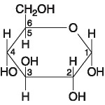

Figure 5.1

73) If two molecules of the general type shown in Figure 5.1 were linked together, carbon-1 of one molecule to carbon-4 of the other, the single molecule that would result would be
A) maltose.
B) fructose.
C) glucose.
D) galactose.
E) sucrose.
Answer: A
Topic: Concept 5.2
Skill: Knowledge/Comprehension

74) Which of the following descriptors is true of the molecule shown in Figure 5.1?
A) hexose
B) fructose
C) glucose
D) hexose and fructose only
E) hexose and glucose only
Answer: E
Topic: Concept 5.2
Skill: Knowledge/Comprehension

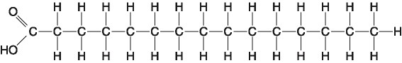

Figure 5.2

75) Which of the following statements is true regarding the molecule illustrated in Figure 5.2?
A) It is a saturated fatty acid.
B) A diet rich in this molecule may contribute to atherosclerosis.
C) Molecules of this type are usually liquid at room temperature.
D) It is a saturated fatty acid and a diet rich in this molecule may contribute to atherosclerosis.
E) It is a saturated fatty acid, a diet rich in this molecule may contribute to atherosclerosis, and molecules of this type are usually liquid at room temperature.
Answer: D
Topic: Concept 5.3
Skill: Knowledge/Comprehension

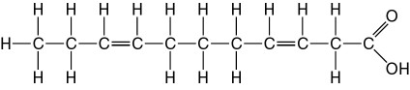

Figure 5.3

76) Which of the following statements is true regarding the molecule illustrated in Figure 5.3?
A) It is a saturated fatty acid.
B) A diet rich in this molecule may contribute to atherosclerosis.
C) Molecules of this type are usually liquid at room temperature.
D) It is a saturated fatty acid and a diet rich in this molecule may contribute to atherosclerosis.
E) It is a saturated fatty acid, a diet rich in this molecule may contribute to atherosclerosis, and molecules of this type are usually liquid at room temperature.
Answer: C
Topic: Concept 5.3
Skill: Knowledge/Comprehension

77) The molecule shown in Figure 5.3 is a
A) polysaccharide.
B) polypeptide.
C) saturated fatty acid.
D) triacylglycerol.
E) unsaturated fatty acid.
Answer: E
Topic: Concept 5.3
Skill: Knowledge/Comprehension

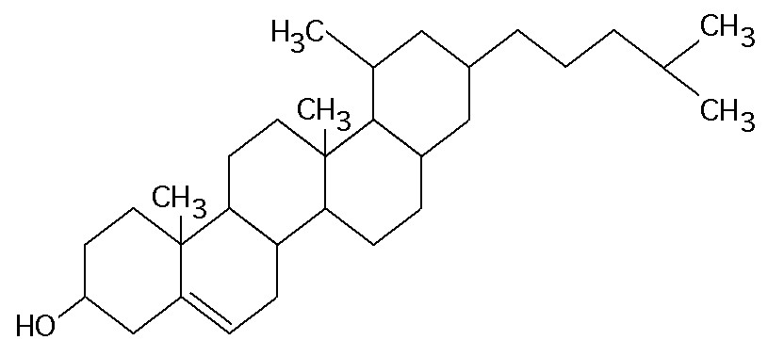

Figure 5.4

78) What is the structure shown in Figure 5.4?
A) pentose molecule
B) fatty acid molecule
C) steroid molecule
D) oligosaccharide molecule
E) phospholipid molecule
Answer: C
Topic: Concept 5.3
Skill: Knowledge/Comprehension
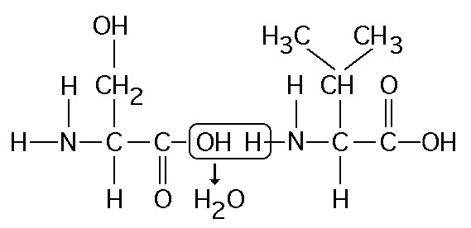

Figure 5.5

79) Which of the following statements is/are true regarding the chemical reaction illustrated in Figure 5.5?
A) It is a hydrolysis reaction.
B) It results in a peptide bond.
C) It joins two fatty acids together.
D) It is a hydrolysis reaction and it results in a peptide bond.
E) It is a hydrolysis reaction, it results in a peptide bond, and it joins two fatty acids together.
Answer: B
Topic: Concept 5.4
Skill: Application/Analysis

Refer to Figure 5.6 to answer the following questions.

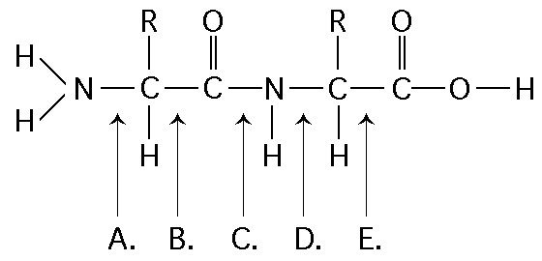

Figure 5.6

80) At which bond would water need to be added to achieve hydrolysis of the peptide, back to its component amino acid?
A) A
B) B
C) C
D) D
E) E
Answer: C
Topic: Concept 5.4
Skill: Knowledge/Comprehension
81) Which bond is a peptide bond?
A) A
B) B
C) C
D) D
E) E
Answer: C
Topic: Concept 5.4
Skill: Knowledge/Comprehension

82) Which bond is closest to the amino terminus of the molecule?
A) A
B) B
C) C
D) D
E) E
Answer: A
Topic: Concept 5.4
Skill: Knowledge/Comprehension

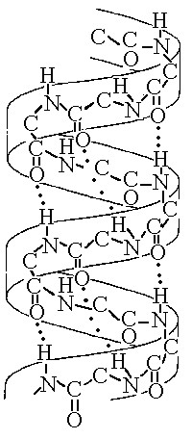
Figure 5.7

83) The structure depicted in Figure 5.7 shows the
A) 1-4 linkage of the α glucose monomers of starch.
B) 1-4 linkage of the β glucose monomers of cellulose.
C) double-helical structure of a DNA molecule.
D) α helix secondary structure of a polypeptide.
E) β pleated sheet secondary structure of a polypeptide.
Answer: D
Topic: Concept 5.4
Skill: Knowledge/Comprehension
The following questions are based on the 15 molecules illustrated in Figure 5.8. Each molecule may be used once, more than once, or not at all.

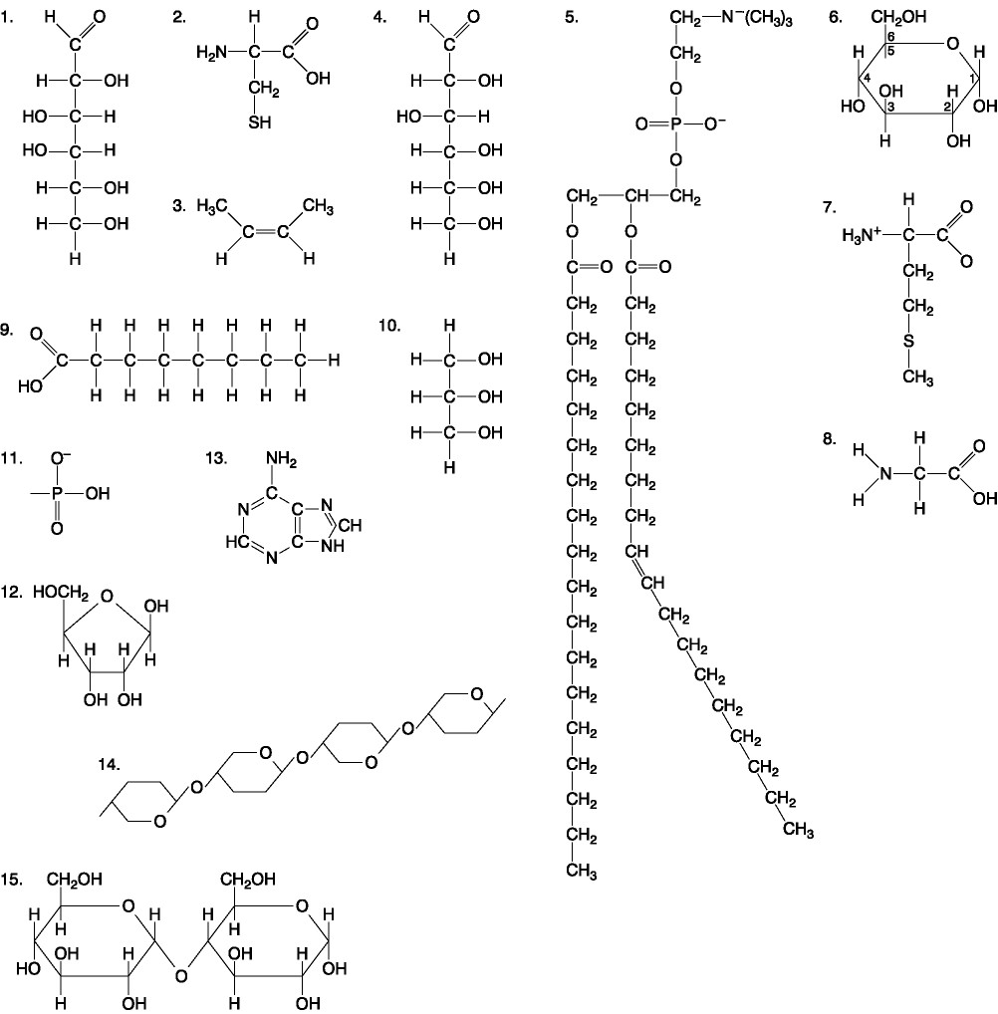

Figure 5.8

84) Which molecule has both hydrophilic and hydrophobic properties and would be found in plasma membranes?
A) 1
B) 5
C) 6
D) 12
E) 14
Answer: B
Topic: Concept 5.2
Skill: Knowledge/Comprehension
85) Which of the following combinations could be linked together to form a nucleotide?
A) 1, 2, and 11
B) 3, 7, and 8
C) 5, 9, and 10
D) 11, 12, and 13
E) 12, 14, and 15
Answer: D
Topic: Concept 5.5
Skill: Knowledge/Comprehension

86) Which of the following molecules contain(s) an aldehyde type of carbonyl functional group?
A) 1
B) 4
C) 8
D) 10
E) 1 and 4
Answer: E
Topic: Concept 5.2
Skill: Knowledge/Comprehension

87) Which molecule is glycerol?
A) 1
B) 6
C) 10
D) 14
E) 15
Answer: C
Topic: Concept 5.2
Skill: Knowledge/Comprehension

88) Which molecule is a saturated fatty acid?
A) 1
B) 5
C) 6
D) 8
E) 9
Answer: E
Topic: Concept 5.3
Skill: Knowledge/Comprehension
89) Which of the following molecules is a purine type of nitrogenous base?
A) 2
B) 3
C) 5
D) 12
E) 13
Answer: E
Topic: Concept 5.5
Skill: Knowledge/Comprehension

90) Which of the following molecules act as building blocks (monomers) of polypeptides?
A) 1, 4, and 6
B) 2, 7, and 8
C) 7, 8, and 13
D) 11, 12, and 13
E) 12, 13, and 15
Answer: B
Topic: Concept 5.4
Skill: Knowledge/Comprehension

91) Which of the following molecules is an amino acid with a hydrophobic R group or side chain?
A) 3
B) 7
C) 8
D) 12
E) 13
Answer: B
Topic: Concept 5.4
Skill: Knowledge/Comprehension

92) Which of the following molecules could be joined together by a peptide bond as a result of a dehydration reaction?
A) 2 and 3
B) 3 and 7
C) 7 and 8
D) 8 and 9
E) 12 and 13
Answer: C
Topic: Concept 5.4
Skill: Knowledge/Comprehension
93) A fat (or triacylglycerol) would be formed as a result of a dehydration reaction between
A) one molecule of 9 and three molecules of 10.
B) three molecules of 9 and one molecule of 10.
C) one molecule of 5 and three molecules of 9.
D) three molecules of 5 and one molecule of 9.
E) one molecule of 5 and three molecules of 10.
Answer: B
Topic: Concept 5.3
Skill: Knowledge/Comprehension

94) Which of the following molecules could be joined together by a phosphodiester type of covalent bond?
A) 3 and 4
B) 3 and 8
C) 6 and 15
D) 11 and 12
E) 11 and 13
Answer: D
Topic: Concept 5.3
Skill: Knowledge/Comprehension

95) Which of the following molecules is the pentose sugar found in RNA?
A) 1
B) 4
C) 6
D) 12
E) 13
Answer: D
Topic: Concept 5.5
Skill: Knowledge/Comprehension

96) Which of the following molecules contains a glycosidic linkage type of covalent bond?
A) 4
B) 6
C) 12
D) 13
E) 15
Answer: E
Topic: Concept 5.2
Skill: Knowledge/Comprehension
97) Which of the following molecules has a functional group that frequently forms covalent bonds that maintain the tertiary structure of a protein?
A) 2
B) 3
C) 7
D) 8
E) 9
Answer: A
Topic: Concept 5.4
Skill: Knowledge/Comprehension

98) Which of the following molecules consists of a hydrophilic "head" region and a hydrophobic "tail" region?
A) 2
B) 5
C) 7
D) 9
E) 11
Answer: B
Topic: Concept 5.3
Skill: Knowledge/Comprehension

99) Which of the following statements is false?
A) Molecules 1 and 4 could be joined together by a glycosidic linkage to form a disaccharide.
B) Molecules 9 and 10 could be joined together by ester bonds to form a triacylglycerol.
C) Molecules 2 and 7 could be joined together to form a short peptide.
D) Molecules 2, 7, and 8 could be joined together to form a short peptide.
E) Molecules 14 and 15 could be joined together to form a polypeptide.
Answer: E
Topic: Concepts 5.2-5.4
Skill: Knowledge/Comprehension

Scenario Questions

Use the following information to answer the questions below.

Approximately 32 different monomeric carbohydrate subunits are found in various natural polysaccharides. Proteins are composed of 20 different amino acids. DNA and RNA are each synthesized from four nucleotides.

100) Among these biological polymers, which has the least structural variety?
A) polysaccharides
B) proteins
C) DNA
D) RNA
Answer: C
Topic: Concepts 5.2-5.5
Skill: Synthesis/Evaluation
101) Which class of biological polymer has the greatest functional variety?
A) polysaccharides
B) proteins
C) DNA
D) RNA
Answer: B
Topic: Concepts 5.2-5.5
Skill: Synthesis/Evaluation

102) Professor Jamey Marth at the University of California, Santa Barbara, identified 70 molecules that are used to build cellular macromolecules and structures. These include at least 34 saccharides, 8 nucleosides, and 20 amino acids. In theory, then, which class of biological polymer has the greatest information-coding capacity?
A) polysaccharides
B) proteins
C) DNA
D) RNA
Answer: A
Topic: Concepts 5.2-5.5
Skill: Synthesis/Evaluation

End-of-Chapter Questions

The following questions are from the end-of-chapter “Test Your Understanding” section in Chapter 5 of the textbook.

103) Which of the following categories includes all others in the list?
A) monosaccharide
B) disaccharide
C) starch
D) carbohydrate
E) polysaccharide
Answer: D
Topic: End-of-Chapter Questions
Skill: Knowledge/Comprehension

104) The enzyme amylase can break glycosidic linkages between glucose monomers only if the monomers are in the α form. Which of the following could amylase break down?
A) glycogen, starch, and amylopectin
B) glycogen and cellulose
C) cellulose and chitin
D) starch and chitin
E) starch, amylopectin, and cellulose
Answer: A
Topic: End-of-Chapter Questions
Skill: Knowledge/Comprehension
105) Which of the following statements concerning unsaturated fats is true?
A) They are more common in animals than in plants.
B) They have double bonds in the carbon chains of their fatty acids.
C) They generally solidify at room temperature.
D) They contain more hydrogen than do saturated fats having the same number of carbon atoms.
E) They have fewer fatty acid molecules per fat molecule.
Answer: B
Topic: End-of-Chapter Questions
Skill: Knowledge/Comprehension

106) The structural level of a protein least affected by a disruption in hydrogen bonding is the
A) primary level.
B) secondary level.
C) tertiary level.
D) quaternary level.
E) All structural levels are equally affected.
Answer: A
Topic: End-of-Chapter Questions
Skill: Knowledge/Comprehension

107) Enzymes that break down DNA catalyze the hydrolysis of the covalent bonds that join nucleotides together. What would happen to DNA molecules treated with these enzymes?
A) The two strands of the double helix would separate.
B) The phosphodiester linkages of the polynucleotide backbone would be broken.
C) The purines would be separated from the deoxyribose sugars.
D) The pyrimidines would be separated from the deoxyribose sugars.
E) All bases would be separated from the deoxyribose sugars.
Answer: B
Topic: End-of-Chapter Questions
Skill: Knowledge/Comprehension

108) The molecular formula for glucose is C6H12O6. What would be the molecular formula for a polymer made by linking ten glucose molecules together by dehydration reactions?
A) C60H120O60
B) C6H12O6
C) C60H102O51
D) C60H100O50
E) C60H111O51
Answer: C
Topic: End-of-Chapter Questions
Skill: Application/Analysis
109) Which of the following pairs of base sequences could form a short stretch of a normal double helix of DNA?
A) 5'-purine-pyrimidine-purine-pyrimidine-3' with 3'-purine-pyrimidine-purine-pyrimidine-5'
B) 5'-AGCT-3' with 5'-TCGA-3'
C) 5'-GCGC-3' with 5'-TATA-3'
D) 5'-ATGC-3' with 5'-GCAT-3'
E) All of these pairs are correct.
Answer: D
Topic: End-of-Chapter Questions
Skill: Application/Analysis

