## Name:

## Mr. Tudor

## Biology

1. The jaguar is a top predator that helps to regulate other populations in the rainforest. It produces wastes that are broken down to nutrients by decomposers. Microorganisms live in its fur and it may also be home to some parasites. This description describes the jaguar’s...
2. Habitat
3. Niche
4. Trophic Level
5. Biome
6. A group of organisms of the same species that inhabit a specific area and interbreed is called a(n)...
7. Organism
8. Community
9. Population
10. Ecosystem
11. Aspects of the nonliving environment that affect the species in the environment and determine which species can live there are called .....
12. Ecosystems
13. Abiotic Factors
14. Biotic Factors
15. Commensalism
16. The oxpecker is a bird that feeds on ticks and other parasitic insects. This bird can commonly be found living near (or on) hippopotami eating ticks off of it. The relationship between the oxpecker and hippo is an example of ....
17. Parasitism
18. Ecosystem
19. Commensalism
20. Mutualism
21. Predators, prey, parasites, photosynthetic producers and other living organisms are called .......
22. Ecosystems
23. Abiotic Factors
24. Commensalism
25. Biotic Factors
26. A tick sucks blood from a dog and a tapeworm steals nutrition from the host it lives in. This type of symbiosis, where one species benefits and the other is harmed, is called ...
27. Mutualism
28. Parasitism
29. Commensalism
30. Predator-Prey
31. The entire portion of the earth that supports life is referred to as the ...
32. Ecosystem
33. Population
34. Community
35. Biosphere
36. The study of interactions among organisms and between organisms and their environment is called...
37. Biology
38. Symbiosis
39. Physiology
40. Ecology
41. Orchid epiphytes (a tropical flower) grow on trees in the rain forest but have no significant effect on the trees. This type of symbiosis, where one species benefits and the other is neither helped nor harmed, is called ....
42. Parasitism
43. Mutualism
44. Commensalism
45. Predator-Prey
46. Which term describes the interactions among the populations in a community and the community’s physical/abiotic surroundings?
47. Organism
48. Population
49. Community
50. Ecosystem
51. What approximate percentage of the energy found in primary consumers is passed on to secondary consumers?
52. 50%
53. 100%
54. 90%
55. 10%
56. A mouse eats grass, a snake eats the mouse, and an eagle eats the snake. What is the eagle?
57. Tertiary Consumer
58. Primary Consumer
59. Secondary Consumer
60. Primary Producer
61. In a food chain or energy pyramid, there are different feeding levels (such as primary producer, primary consumer, etc...). What do we call these feeding steps?
62. Zones of Consumerism
63. Communities
64. Levels of Energy
65. Trophic Levels
66. Which trophic level in the following food chain has the most available energy?
67. Tertiary Consumers
68. Secondary Consumers
69. Primary Consumers
70. Primary Producers
71. The recycling of matter in ecosystems requires the breakdown of dead organic matter. This is accomplished by ...
72. Decomposers
73. Primary Consumers
74. Secondary Consumers
75. Primary Producers
76. Which of the following best describes a predator-prey relationship between organisms?
77. Both species eat each other
78. A prey species eats the predator species
79. A predator species eats the prey species
80. The predator has a mutualistic symbiotic relationship with the prey
81. A carnivore that eats herbivores (such as a cheetah that eats a thompson gazelle) is called a(n)...
82. Primary Producer
83. Primary Consumer
84. Secondary Consumer
85. Tertiary Consumer
86. If a food chain goes from Algae -->Anchovy (fish) --> Sailfin (fish) --> Shark and the level of primary producer has 100,000 Kcal of energy, how much energy will make it to the trophic level of the sharks?
87. 100 Kcal
88. 100,000 Kcal
89. 1000 Kcal
90. 10,000 Kcal
91. The types of organisms that make up a community will depend on ....
92. The biotic factors in the community
93. The abiotic factors in the community
94. Both a and b
95. none of the above
96. Some levels of ecological organization are shown in the sequence below.

Organism --> Population --> A --> Ecosystem --> B.

Which terms represented by the letters A and B would complete the sequence? A represents the next level that comes after populations, and B represents the next level that comes after ecosystem.

1. A - Organism, B - Community
2. A - Community, B - Biome
3. A - Cell, B - Molecule
4. A- Biome, B - Community
5. Hummingbirds need large amounts of energy to flap their wings between 60 and 200 times per second. Their wings beat so rapidly that it is difficult to see them move. They often appear suspended in air for extended periods of time without changing their location. Hummingbirds have long bills and grooved tongues to reach into flowers to feed on flower nectar. They also feed on insects.   
   Which term BEST describes the ecological relationship between hummingbirds and insects?
6. Commensalism
7. Mutualism
8. Parasite - Host
9. Predator - Prey
10. Which of the following are also called autotrophs because they make their own food?
11. Primary Consumers
12. Primary Producers
13. Secondary Consumers
14. Tertiary Consumers
15. The roots of many clover plants produce structures that are filled with bacteria. The clover plants provide food and shelter for the bacteria, while the bacteria produce a nutrient that is used by the plants. As a result, the clover plants that have these structures on their roots grow at a faster rate and are healthier than clover plants that do not have the structures.
16. Mutualism
17. Parasitism
18. Predator - Prey
19. Commensalism

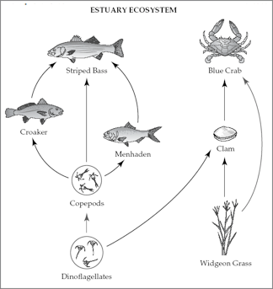

1. This diagram shows the relationship among organisms living in an Atlantic coast estuary. Which term below BEST describes the role of the blue crab in the estuary (somewhat salty water) ecosystem?
2. Carnivore
3. Herbivore
4. Producer
5. Omnivore
6. What trophic level would the Menhaden occupy?
7. Primary Producer
8. Primary Consumer
9. Secondary Consumer
10. Tertiary Consumer
11. A partial food web is shown below.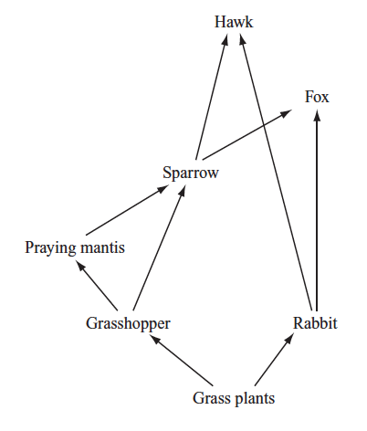

Which of the following changes is most likely to occur if the sparrow population decreases?

1. The fox population decreases.
2. The hawk population increases.
3. The grasshopper population competes less with the praying mantis population.
4. The hawk population and the fox population prey more heavily on grasshoppers
5. Which of the following energy pyramids shows the correct placement of trophic levels?
6. 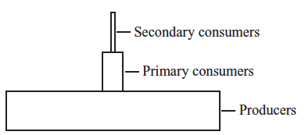
7. 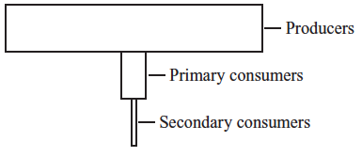
8. 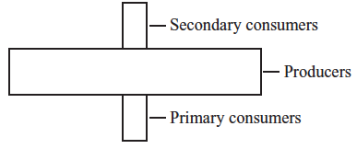
9. 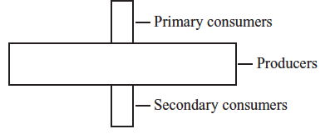
10. Fatty acids are one of the products that result from the action of lipase in the digestive system. What is one way that fatty acids are used in the body?
11. for storing energy.
12. for encoding genetic information.
13. as the building blocks of antibodies.
14. as the building blocks of hemoglobin
15. Scientists have found geysers on one of Saturn’s moons. The geysers release water vapor containing complex organic compounds, which may indicate the presence of life. Which of the following elements is most likely abundant in the organic compounds in the water vapor?
16. carbon
17. iron
18. chlorine
19. zinc
20. Ovalbumin is a protein found in eggs. Which of the following best describes the molecular structure of ovalbumin?
21. a group of six carbon atoms joined in a ring
22. a chain of amino acids folded and twisted into a molecule
23. a set of three fatty acids attached to a molecule of glycerol
24. a sequence of nitrogenous bases attached to a sugar-phosphate backbone

Short Answer Questions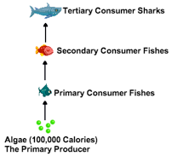

31. In this food chain, how much energy will make it to the trophic level of the sharks? Explain how you arrived at your answer.

answer the following three questions based upon the food web above

32. A team of scientists studying a kelp forest ecosystem noticed a sudden decrease in the kelp population. They discovered that a foreign species with no natural predators in the ecosystems was eating the kelp. The scientists hypothesized that ships from other parts of the world had transported the foreign species to this ecosystem. The food web you see here shows the relationship between organisms in the kelp forest ecosystem.

33. Describe, in detail, the roles of the kelp crab, sea otter, and sea urchin in the food web. You should include vocabulary like producer, primary consumer, secondary consumer, predator, prey, herbivore, carnivore.

34. Descri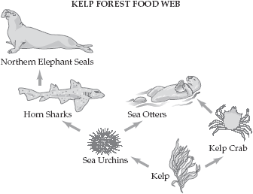be, in detail, the impact that a prey population will have on the predatory population. What would occur in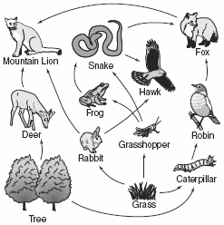 the the food web above if sea urchins died out?

answer the following questions based upon the food web to the right

35. What is the longest food chain that contains grass as a producer?

What are the primary producers?

Are there any omnivores? Explain your answer.

Which species would be MOST affected if a disease killed off most of the trees in the ecosystem shown? What other species might be affected? Explain your answers.

Would the snake obtain a greater percentage of energy from the grass after eating an equal mass of frogs or grasshoppers? Explain your answer.