SELFIE WASH LAUNDRY
ONLINE APPOINTMENT AND MANAGEMENT SYSTEM
Proponents
CABAL, IVAN JAMES V.
CANON, DANIELO
CASTILLO, JC
DACARA, JOHN LLOYD
ROLDAN, SIRE ALBERT
TORREON, VARLEY

Table of Contents

- Introduction of the study ……………………………………………………… 3
- Objectives of the study ……………………………………………………… 4
- Conceptual Framework ……………………………………………………… 5
- Scope and Limitation ……………………………………………………… 8
- UML ……………………………………………………… 10
- ERD ……………………………………………………… 11

- INTRODUCTION
The rapid growth of digital technology has significantly transformed how service-based businesses operate. In recent years, many industries have shifted from traditional walk-in models to online platforms that offer greater convenience, efficiency, and accessibility for both business owners and customers. The laundry service industry is no exception, as increasing customer demand for on-demand and contactless transactions has pushed laundry businesses to modernize their operations.
Selfie Wash Laundry is a multi-branch laundry service business that currently relies on manual and walk-in processes for managing appointments and operations. This approach presents challenges in scheduling, payment processing, and cross-branch oversight, particularly as the business continues to grow. To address these challenges, the proponents developed the Selfie Wash Laundry Online Appointment and Management System — a web-based application that modernizes the operations of the business by providing a unified platform connecting clients, branch staff, and administrators within a single digital environment.
The system enables clients to book laundry appointments online, select from a range of available services, specify garment weights and clothing types, apply promotional discounts, and complete payments through an integrated online payment gateway or cash on delivery. Administrators manage branches, users, pricing configurations, and sales reports through a role-based dashboard designed for clarity and operational efficiency.
The system is organized into four major modules: File Maintenance, Branch and User Maintenance, Online Appointment and Management, and Reports. These modules collectively support the full operational lifecycle of the business — from configuring services and managing user access, to processing client appointments and generating sales analytics exportable in PDF, CSV, and Excel formats.

The system is built on the MERN stack MongoDB, Express, React, Node and developed in Visual Studio Code. It recognizes three distinct user roles: the Super Administrator, who holds full system-wide access; the Branch Administrator, who is scoped to their assigned branch; and the Client, who interacts with the public-facing portal to book appointments, make payments, and track laundry status in real time.

- OBJECTIVES OF THE STUDY
General Objectives
To design, develop, and implement the Selfie Wash Laundry Online Appointment and Management System for Selfie Wash Laundry to modernize its appointment and business operations.
Specific Objectives
• To design, develop, and implement a module that will manage the system's file maintenance including services, clothing types, kilogram rates, and promotional codes.
• To design, develop, and implement a module that will manage the branches and user accounts.
• To design, develop, and implement a module that will manage online appointments and payments.
• To design, develop, and implement a module that will manage sales reports and data exportation.

- CONCEPTUAL FRAMEWORK
OUTPUT

Selfie Wash Laundry Online Appointment and Management System

PROCESS
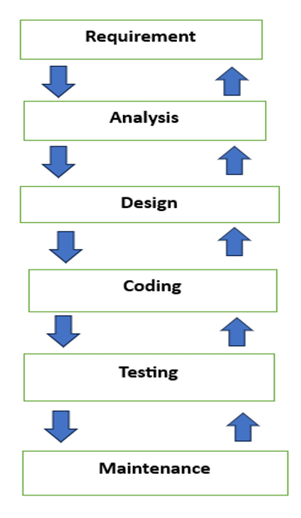
Reference: Sommerville, I. (2016). Software Engineering (10th ed.). Pearson Education Limited
INPUT

Software:
- VS Code
- MongoDb Atlas
- Node.js
- React
- At least windows 10 or higher
Hardware:
- Dual Core Processor
- At least 8GB of RAM
- At least 256GB of Storage
Peopleware:
- Super Admin
- Branch Staff Admin
- Client

Modified Waterfall Model
- Requirement — The proponents gathered information from the client, Selfie Wash Laundry, to understand their operational challenges and define what the system must accomplish.
- Analysis — The gathered requirements were evaluated and system constraints were identified, particularly in defining the three user roles and their respective access levels.
- Design — The proponents produced the ERD, UML Use Case Diagram, and UI/UX mockups, and planned the four key modules of the system.
- Coding — The system was implemented using the MERN stack with Visual Studio Code as the primary IDE.
- Testing — Unit Testing, System Testing, Integration Testing, and UAT were conducted to ensure the system met all requirements.
- Maintenance — The proponents will monitor and update the system to address any issues and support the growing needs of Selfie Wash Laundry.

Input
For the inputs, the system requires software, hardware, and peopleware resources. In terms of software, the proponents used Visual Studio Code (2021) as the Integrated Development Environment (IDE) and MongoDB Atlas as the cloud-based NoSQL database. The front-end user interface was built using React, while Node.js was used as the server-side runtime environment. The system requires a machine running at least Windows 10 as the operating system. For hardware, the system requires a minimum of a Dual Core Processor, 8GB of RAM, and 256GB of storage. In terms of peopleware, the system involves three types of users: the Super Administrator, the Branch Staff Administrator, and the Client.

Process
For the process, the proponents used the Modified Waterfall Model as the Software Development Life Cycle (SDLC). The first phase is Requirement, where the proponents gathered all system requirements needed to define the scope of the study. The second phase is Analysis, where the requirements were evaluated and system constraints were identified. The third phase is Design, where the proponents produced the ERD, UML Use Case Diagram, and UI/UX mockups. The fourth phase is Coding, where the actual implementation of the system was carried out. The fifth phase is Testing, where the system underwent Unit Testing, System Testing, Integration Testing, and UAT. The final phase is Maintenance, which covers post-deployment bug fixes, updates, and monitoring

Output
Once all the inputs are gathered and undergo the entire development process, the proponents came up with the output named the Selfie Wash Laundry Online Appointment and Management System. The system is composed of four major modules: the File Maintenance module for managing system-level reference data, the Branch and User Maintenance module for managing branches and user accounts, the Online Appointment and Management module for booking, payment processing, and appointment tracking, and the Reports module for generating and exporting sales reports in PDF, CSV, and Excel formats.

- SCOPE AND LIMITATIONS
Scope
- The system covers four major modules that address the operational and administrative needs of Selfie Wash Laundry.
- The first is the File Maintenance module, which covers the configuration and management of all system-level reference data including services, clothing types, kilogram pricing rates, and promotional codes. Login history tracking is also included under this module as part of system security utilities.
- The second is the Branch and User Maintenance module, which enables the Super Administrator to add new branches, edit branch profiles, and manage Branch Administrator accounts including role assignment and access credentials. Branch Administrators may also update their own branch profile within permitted fields such as phone number, address, and availability.
- The third is the Online Appointment and Management module, which serves as the core operational component of the system. Clients may book appointments, select services, specify garment details, apply promo codes, and pay online through PayMongo or Cash on Delivery. Both the Super Administrator and Branch Administrator may confirm, manage, and cancel appointments.
- The fourth is the Reports module, which provides sales analytics for both the Super Administrator and Branch Administrator. The Super Administrator accesses system-wide reports with per-branch breakdowns, while the Branch Administrator accesses reports scoped to their assigned branch only. Both roles may export reports in PDF, CSV, and Excel formats.

Limitations
- The system processes payments exclusively through the PayMongo payment gateway and supports Cash on Delivery as an alternative payment option, with transaction recording handled within the platform. No other payment gateways or methods are supported.
- Only the Super Administrator may add new branches and manage user accounts. Branch Administrators are limited to updating their own branch profile within permitted fields only, such as phone number, address, and availability.
- Sales reports are view and export only. Branch Administrators cannot access reports outside their assigned branch, and no report editing or annotation is supported within the system.
- The VAT rate cannot be modified through the system interface. Any adjustment to the VAT rate requires direct database access by the developer, as it is intentionally restricted from the UI to preserve data integrity

- UNIFIED MODELING LANGUAGE (UML)
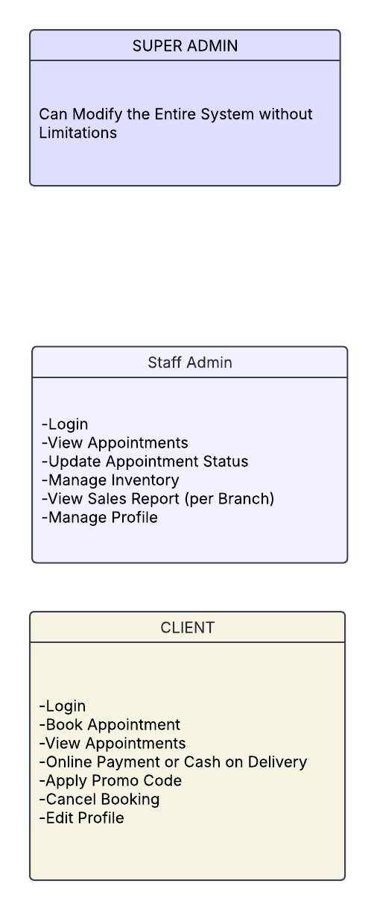




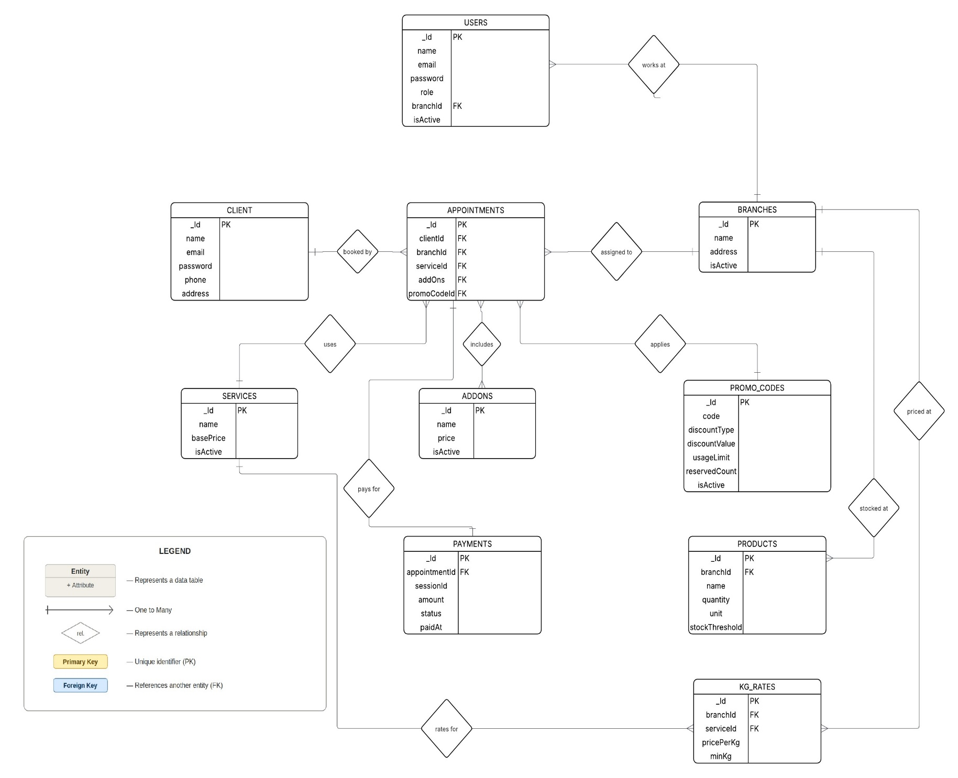
- ENTITY RELATIONSHIP DIAGRAM (ERD)

