Федеральное государственное автономное образовательное учреждение высшего образования **«Национальный исследовательский университет ИТМО»**

Факультет Программной Инженерии и Компьютерной Техники

**Лабораторная работа №3**

по дисциплине **«Основы программной инженерии»**

Вариант: **8289**

**Преподаватель**:   
Вадим Миху

**Выполнил**: Алферов Г.А.

**Группа**: Р3207

Санкт-Петербург, 2025

# Задание

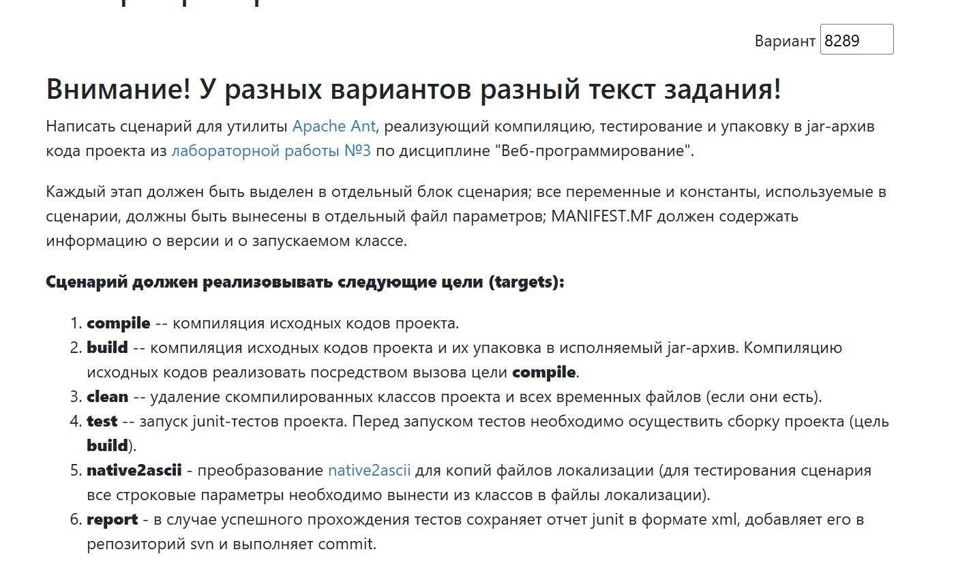

# Реализация build.properties

lib.dir=lib  
junit=${lib.dir}/junit-4.13.2.jar  
hamcrest=${lib.dir}/hamcrest-core-1.3.jar  
contrib=${lib.dir}/ant-contrib-1.0b3.jar  
jakarta=$${lib.dir}/jakarta.persistence-api-3.1.0.jar"  
  
src.dir=src/main  
main.dir=${src.dir}/java/org/GleBlassUSA  
web.dir=${src.dir}/webapp  
resources.dir=${src.dir}/resources  
native2ascii.resources=${resources.dir}/native2ascii  
  
ant.dir=ant  
build.dir=${ant.dir}/build  
build.dir.lib=${build.dir}/WEB-INF/lib  
build.web.xml=${build.dir}/WEB-INF/web.xml  
classes.dir=${build.dir}/WEB-INF/classes  
  
test.classes.dir=${build.dir}/test/classes  
test.dir=src/test/java  
junit.report.dir=reports  
  
compile.version=1  
  
report.dir=./report  
svn.dir=./wc  
build=./build  
classes=${build}/classes  
report.name=test.xml

# Реализация build.xml

<?xml version="1.0" encoding="UTF-8"?>  
  
<project name="web3" default="build">  
  
 <property file="build.properties"/>  
  
 <path id="classpath">  
 <fileset dir="${lib.dir}" includes="*.jar"/>  
 </path>  
  
 <path id="classpath.test">  
 <pathelement location="${junit}"/>  
 <pathelement location="${hamcrest}"/>  
 <pathelement location="${classes.dir}"/>  
 <pathelement location="${jakarta}"/>  
 </path>  
  
 <taskdef resource="net/sf/antcontrib/antcontrib.properties">  
 <classpath>  
 <pathelement location="${contrib}"/>  
 </classpath>  
 </taskdef>  
  
 <target name="clean">  
 <echo message="------CLEANING------"/>  
 <delete dir="${build.dir}"/>  
 <delete dir="${junit.report.dir}"/>  
 <echo message="------CLEANING COMPLETED------"/>  
 </target>  
  
 <target name="compile" depends="clean">  
 <echo message="------COMPILING------"/>  
 <mkdir dir="${classes.dir}"/>  
 <mkdir dir="${test.classes.dir}"/>  
 <javac srcdir="${src.dir}" destdir="${classes.dir}" classpathref="classpath" includeantruntime="false"/>  
 <javac destdir="${test.classes.dir}" srcdir="${test.dir}" includeantruntime="false" encoding="utf-8">  
 <classpath refid="classpath.test"/>  
 </javac>  
 <echo message="------COMPILING COMPLETED------"/>  
 </target>  
  
 <target name="build" depends="compile">  
 <echo message="------BUILDING------"/>  
 <copy todir="${build.dir.lib}">  
 <fileset dir="${lib.dir}"/>  
 </copy>  
 <copy todir="${build.dir}">  
 <fileset dir="${web.dir}"/>  
 </copy>  
 <copy todir="${classes.dir}">  
 <fileset dir="${resources.dir}"/>  
 </copy>  
 <jar destfile="${build.dir}/${ant.project.name}.jar">  
 <fileset dir="${classes.dir}"/>  
 <manifest>  
 <attribute name="Created-By" value="wrakelft"/>  
 <attribute name="Manifest-Version" value="1.0"/>  
 <attribute name="Main-Class" value="NoClass"/>  
 </manifest>  
 </jar>  
 <war destfile="${build.dir}/${ant.project.name}.war" webxml="${build.web.xml}">  
 <fileset dir="${build.dir}"/>  
 <manifest>  
 <attribute name="Created-By" value="wrakelft"/>  
 <attribute name="Manifest-Version" value="1.0"/>  
 <attribute name="Main-Class" value="NoClass"/>  
 </manifest>  
 </war>  
 <echo message="------BUILDING COMPLETED------"/>  
 </target>  
  
 <target name="test" depends="build">  
 <echo message="------TESTING------"/>  
 <mkdir dir="${junit.report.dir}"/>  
 <trycatch>  
 <try>  
 <junit printsummary="yes" fork="yes" haltonfailure="true" showoutput="true">  
 <classpath>  
 <path refid="classpath.test"/>  
 <pathelement location="${test.classes.dir}"/>  
 </classpath>  
 <formatter type="xml"/>  
 <batchtest todir="${junit.report.dir}">  
 <fileset dir="${test.dir}" includes="**/*Test.java"/>  
 </batchtest>  
 </junit>  
 <property name="test.successful" value="true"/>  
 </try>  
 <catch>  
 <property name="test.failed" value="true"/>  
 </catch>  
 </trycatch>  
 <echo message="------TESTING COMPLETED------"/>  
 </target>  
  
 <target name="report" depends="test">  
 <echo message="------REPORTING------"/>  
 <condition property="tests.successful">  
 <not>  
 <isset property="tests.failed"/>  
 </not>  
 </condition>  
 <if>  
 <isset property="test.successful"/>  
 <then>  
 <move todir="${svn.dir}">  
 <fileset dir="${junit.report.dir}" includes="TEST-*.xml"/>  
 </move>  
 <exec executable="svn">  
 <arg value="add"/>  
 <arg value="--force"/>  
 <arg value="${svn.dir}/*"/>  
 </exec>  
 <exec executable="svn">  
 <arg value="update"/>  
 <arg value="${svn.dir}/*"/>  
 </exec>  
 <exec executable="svn">  
 <arg value="commit"/>  
 <arg value="${svn.dir}/*"/>  
 <arg value="-m"/>  
 <arg value="Report update"/>  
 </exec>  
 </then>  
 <else>  
 <echo message="Test not successful. Report hasn't been added"/>  
 </else>  
 </if>  
 <echo message="------REPORTING COMPLETED------"/>  
 </target>  
  
 <target name="native2ascii">  
 <echo message="------NATIVE2ASCII------"/>  
 <delete dir="${native2ascii.resources}"/>  
 <native2ascii encoding="utf-8" src="${resources.dir}" dest="${native2ascii.resources}" includes="**/*.properties"/>  
 <echo message="------NATIVE2ASCII COMPLETED------"/>  
 </target>  
  
</project>

# Вывод

В ходе выполнения лабораторной работы я познакомился с утилитой Apache Ant для автоматизации процесса сборки. Написал сценарии для своего проекта. Попробовал протестировать код с помощью JUnit.