|  |
| --- |
| Townsville Table Tennis Association  **Spinville** |
| Friday Junior – Level’s Program |
| Progress Development and Achievements |
|  |
| **Olav Dahl** |
| **2017** |

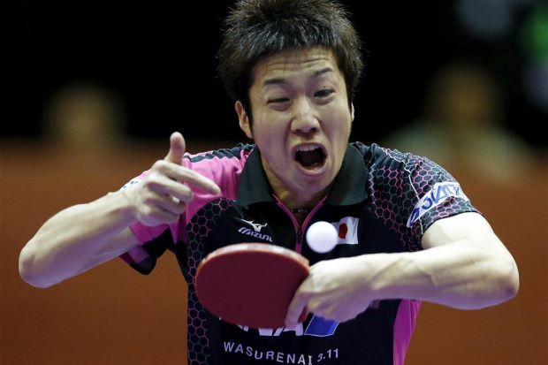

|  |
| --- |
| This will be the document that contains all of the exercises needed to be completed by the player in order to “Rank up” or “Level up”. The exercises will become progressively harder as they achieve more. This program will enable the player to actively view their improvements and will entice their peers to start a rivalry or friendly competition between them by reaching a higher level. This will allow our players to coherently improve as a group rather than individuals. |

# Introductory Level 1 – The humble beginnings

This level of exercises is the key fundamentals of beginner table tennis. They should know basic rules of table tennis, what a serve is, bat grip, ready position and the difference between forehand/backhand and pushing/counter hitting.

* How do you hold your bat correctly?
  + Check finger positioning
  + Discuss the 2 different main grips (Shake hand – preferred teaching, Pen grip – not preferred since we don’t know what we are teaching lol)
  + Firmness, not too loose and not too firm
* Ready position – what is it?
  + Playing foot slightly behind their other foot
  + Bent knees, balance forward
  + Bat up ready for the ball
* Simple strokes – What is the difference between forehand and a backhand?(very simplified) Counter hit vs pushing difference?
  + Spot for each stroke on table (forehand side and backhand side of the table)
  + Counter hit is flat hitting or slight topspin
  + Backspin on pushes and you go under the ball
* What is a serve? *They have to demonstrate after explanation*
  + It is the start of a rally (must be tossed, make contact with ball, bounce on your side once before entering the opponents court)
  + Check for
    - Flat palm
    - Behind table
    - Above table height
    - Ball always visible
    - Ball tossed at least 15cm straight into the air
* What are the basic rules of a match? Rules of table tennis
  + Service rules again (Make sure they know that you don’t have to serve cross-court as that is explicitly for doubles)
  + First to 11 points unless at 10-10 (Winner decided when leading with 2 points)
  + 2 serves each until 10-10 (service change each point)
  + Matches can vary in length (Best of 3, Best of 5, Best of 7)
  + Let service if the ball clips the net during serve. Get another serve
  + A Let is also called if a ball rolls into your court or another external force interferes with the match

# Introductory Level 2 – Learning the ropes

This level will further develop the fundamentals of table tennis through shadow play, technique correcting, reiteration of the previous level themes (ready position, grip) and introduce footwork technique (Side-jumps vs Sidesteps).

* What are the two main types of footwork?
  + Side jumps – Bouncy motion moving side to side (Least preferred of the two)
  + Side steps – small sideways steps which allow for agile movements and allow for quicker and more accurate reactions (the preferred method)
* Forehand counter-hit technique – They demonstrate and explain (shadow play)
  + They must vaguely explain the following:
    - Make sure they maintain grip throughout entire stroke
    - Foot position, weight transfer, shoulder and upper body rotation
    - Knees bent to generate power from weight transfer
    - Rotate so bat goes behind body in preparation for shot
    - Accelerate forwards with open bat, rotating forwards and bat accelerating at an ascending angle to generate slight topspin and lift ball over the net
    - Follow through and finish stroke in front of face or just below
    - Recover to ready position
* Forehand push technique– They demonstrate and explain (shadow play)
  + They must vaguely explain the following:
    - Maintain grip throughout the stroke
    - Step-in with playing foot
    - Extend forearm in a forward manner
    - Hit underneath the ball with a gentle touch
    - Recover to ready position

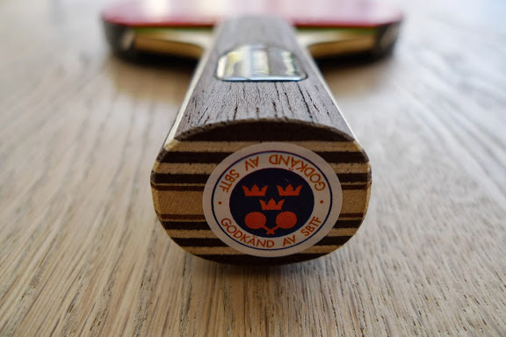

# Introductory level 3 – Transition into the world of TT

This will be the final level of skill development before the player embarks onto their grand journey through table tennis. A summary of all basic shots will be discussed in this level;