a. *Find all students who study ‘Advanced Databases’ this year.*

concat(/students[@year='2019-2020']/student/firstname/text()[../../course/submodule="Advanced Databases"]," ",/students[@year='2019-2020']/student/lastname/text()[../../course/submodule="Advanced Databases"])

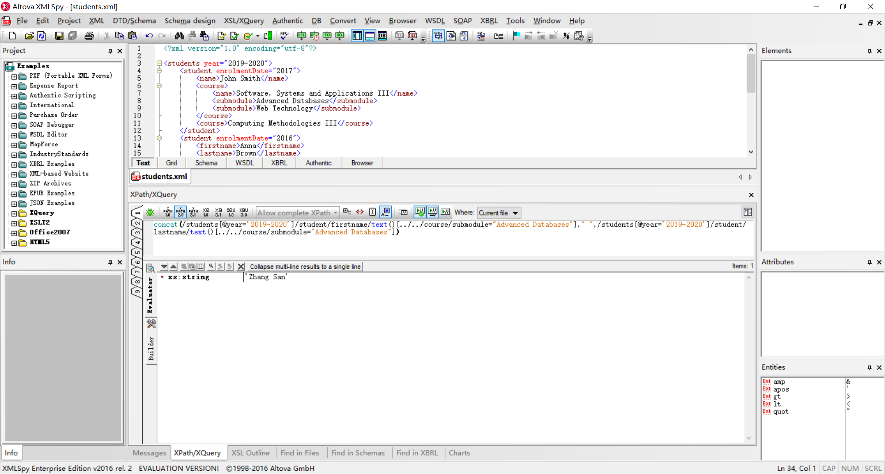

找到所有是firstname和lastname的同学

/students[@year='2019-2020']/student/name/text()[../../course/submodule="Advanced Databases"]

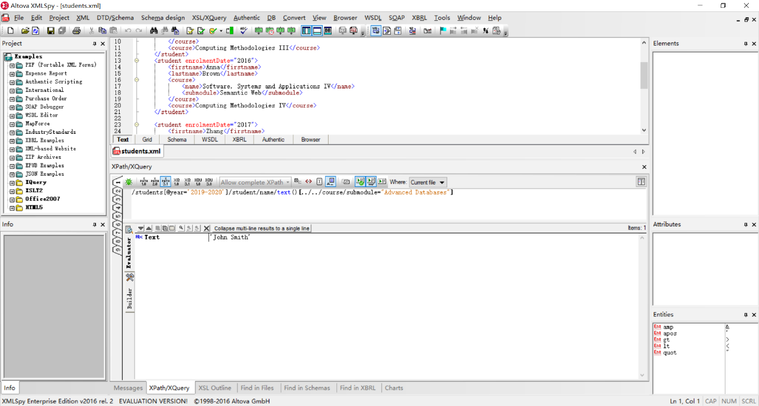

找到所有是name的同学

我不知道怎么把这两条xpath的结果合并，union |这个无法对字符串生效

b. *Find all teachers who teach ‘Advanced Databases’ this year.*

/teachers/teacher/name/text()[../../course/submodule/name="Advanced Databases"]

今年怎么表达？？？？，如果有的老师今年没有这门课也会被查出来，头大！

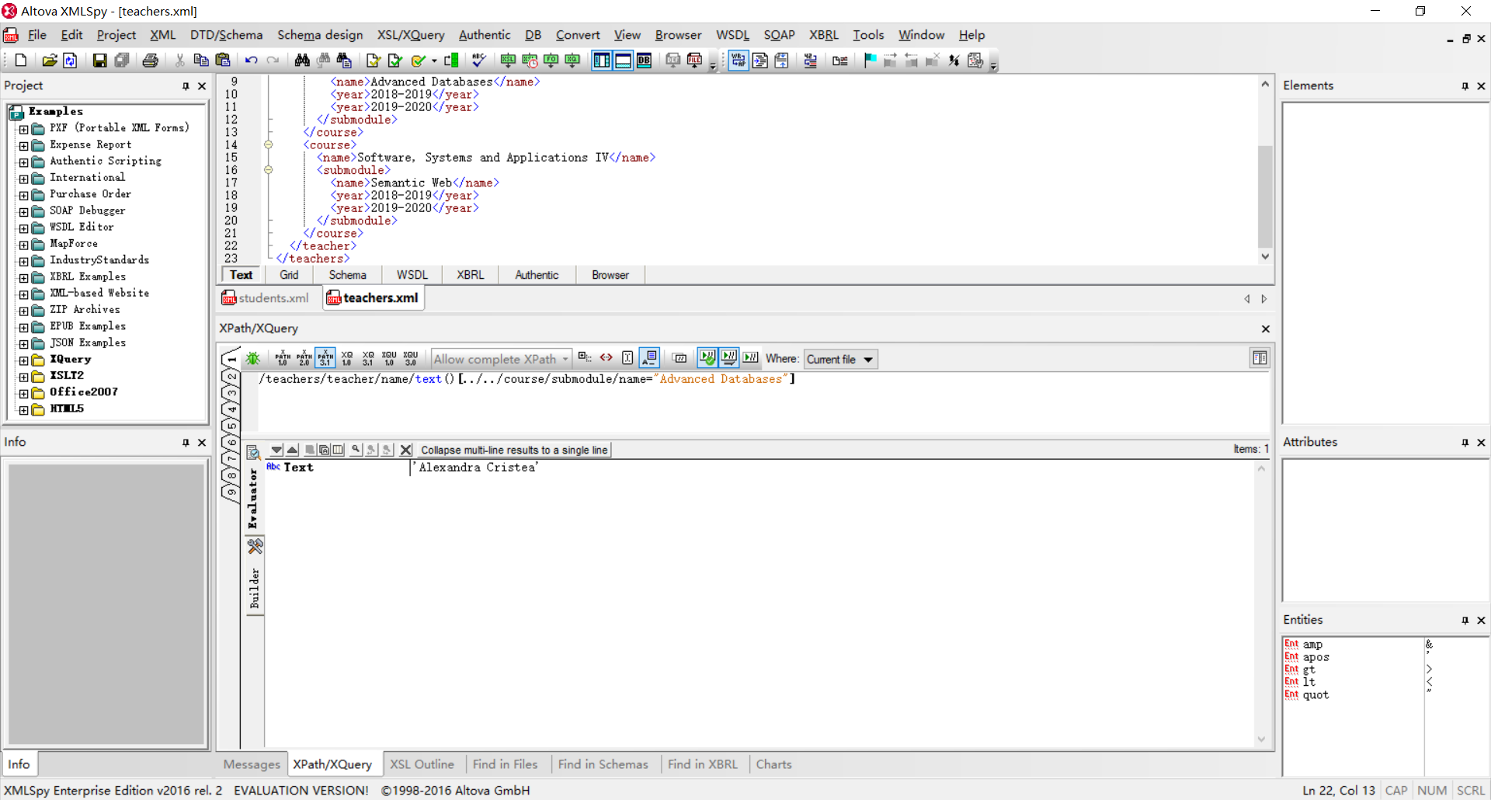

c. How many years has Professor Cristea been teaching ‘Advanced Databases’ (atDurham)?

for $x in /teachers/teacher[name="Alexandra Cristea"]/course/submodule[name="Advanced Databases"]/year[1]

return 2020-number(substring(string($x),1,4))

2020-number(substring(string(/teachers/teacher[name="Alexandra Cristea"]/course/submodule[name="Advanced Databases"]/year[1]),1,4))

这个老师在达勒姆大学干了几年

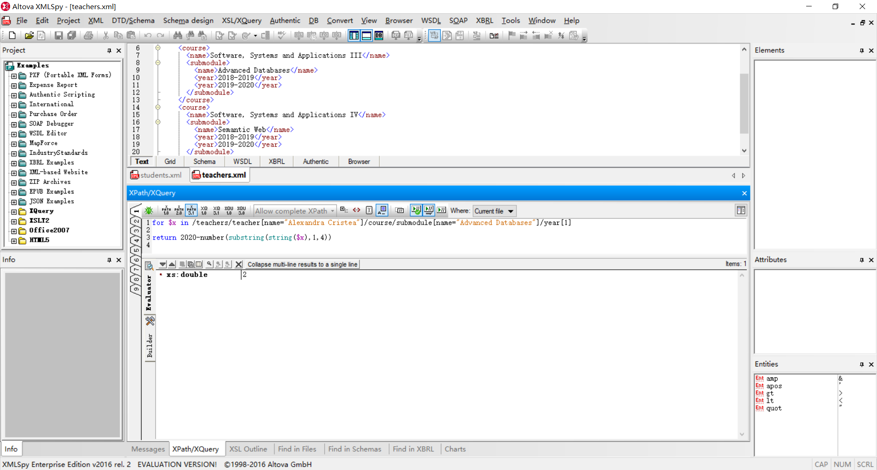

d. Find all students in year 3 currently taught by Alexandra.

for $x in /students/student[@enrolmentDate='2017']/course[name="Software, Systems and Applications III"]|/students/student[@enrolmentDate='2017']/course[name="Software, Systems and Applications IV"]

return $x/../name

我只能找到满足条件同学的name，有的同学风骚起的firsname和lastname也应该要查到才行，妈的我不会

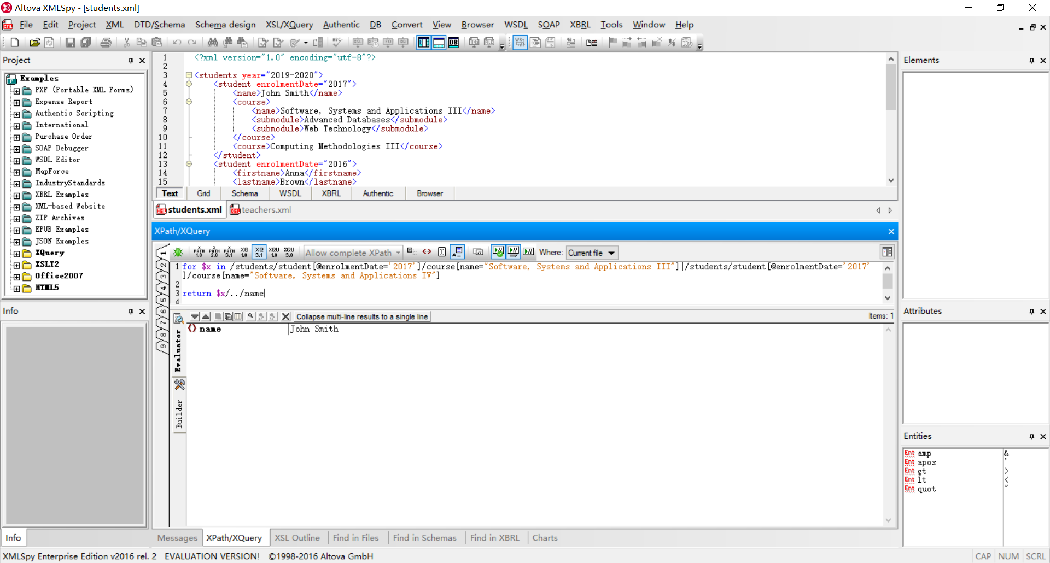

e. How many teachers and how many students are kept in the databases where the last nameis not known?

let $x:= count(/students/student[lastname=""]

return $x

let $x:= count(/teachers/teacher[lastname=""]

return $x