Seasonal Globe Report

Design

Class and Sequence Diagrams
This section provides class diagrams for the main and utility classes, and sequence diagrams denoting flow through the Draw and Load functions.
Main Classes
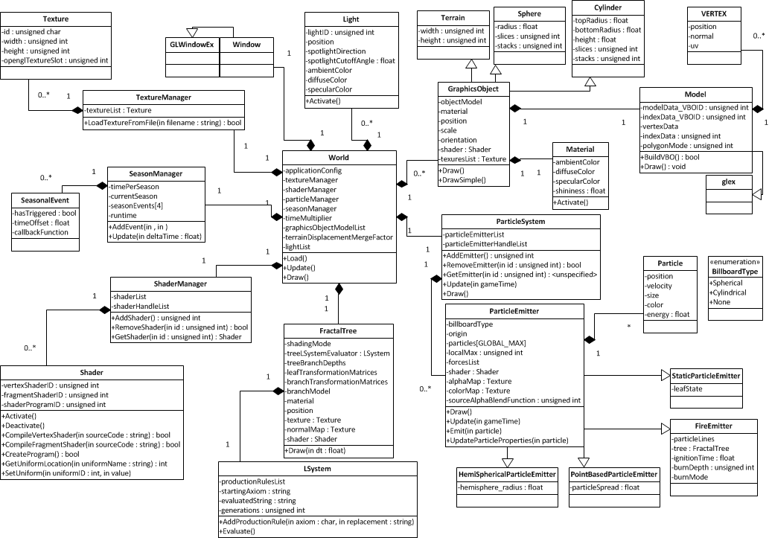
Utilities Classes
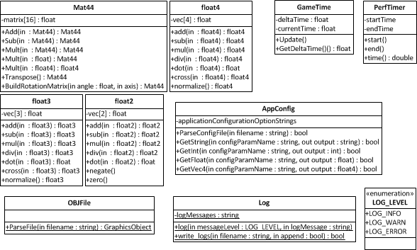

Load Function Sequence Diagram
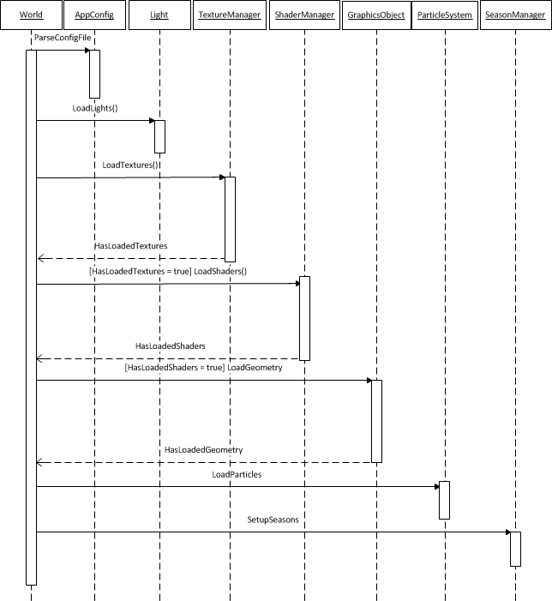
Draw Function Sequence Diagram
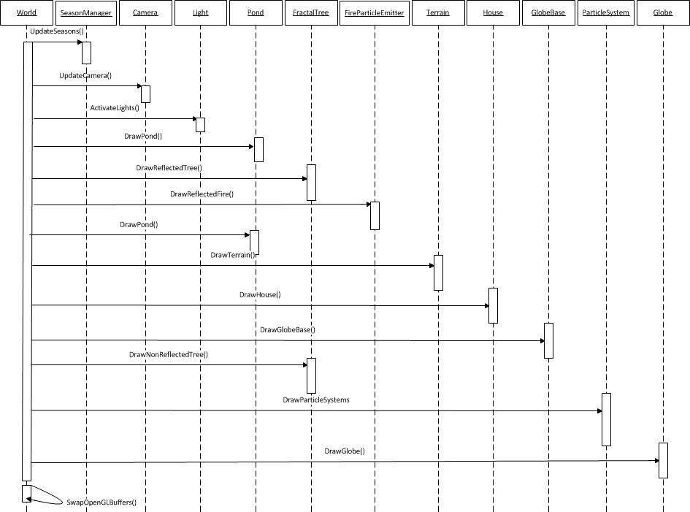

The System Classes
This section outlines the roles and responsibilities of each non-trivial class within the system.

Geometry Classes
The Model class [exclusively] manages geometric data, and the creation, usage and deletion of associated Vertex Buffer Objects.
The GraphicsObject class collects and renders common object elements, including the geometry, transformations (translation, scale, orientation) and shading parameters (material, textures, shader).
The Cylinder and Sphere classes extend GraphicsObject with properties including radius and height, creating geometry mathematically.

The TerrainLoader class (extending GraphicsObject) loads terrain from a height-map and creates indices in a disk shape.

The OBJFile class is responsible for loading geometry from an OBJ file, returning a list of GraphicsObjects.

Fractal Tree Classes
The generic LSystem class is responsible for generating a string based on a set of production rules, starting string and generation count.

The FractalTree class is responsible for the animated growth and death, and L-System interpretation to build the tree.

Mathematics Classes
float2, float3, and float4 provide system-wide 2D, 3D and 4D vector operations respectively, including: dot and cross product, addition, subtraction, multiplication, and normalisation.

The Mat44 class, entirely written with SSE instructions, provides 4x4 matrix functionality, including matrix multiplication. The matrix size was chosen to match that of OpenGL and for the allowance of any required transformation.

Shading Classes
The Shader class is responsible for compilations, activations, deactivations and uniform submission, of vertex and fragment shaders, and producing a program applied to a model.

The ShaderManager maintains all shaders and serves as a single point of access. It is responsible for the addition and removal of shaders.

The Texture class, storing the OpenGL texture ID, manages operations including setting minification and magnification filters, and texture activation and deactivation.

The TextureManager maintains all textures loaded (from files), serving as a single point of access to add/ remove textures.

The Light class, used to activate lights, contains all light properties (regardless of light type) including position, spotlight direction and cut-off angle, and ambient, diffuse and specular colour.

The Material class manages object properties, including ambient, diffuse and specular colours.
Both Material and Light activate properties through OpenGL, accessed through built-in shader variables.

Particle Classes
The ParticleEmitter class, which cannot be directly instantiated, is the base emitter, responsible for the update and drawing of emitters, providing pure virtual “hooks” used by emitters extending the base class. It contains common data, including a particle array, emitter origin, a list of forces, and textures.

Classes extending ParticleEmitter include: HemiSphericalParticleEmitter, PointBasedParticleEmitter (emit particles from point in spread), StaticParticleEmitter, and FireParticleEmitter (defining particles along a line).

With a handle based implementation, the ParticleSystem manages the update and drawing of all active particle emitters.

World Classes
The SeasonManager manages events and transitions between seasons, normalizing time per season into 0 to 1 range, and maintaining a list of events, each with a normalized range offset.

The World scene manager stores world state, including GraphicsObjects, lights, shader and texture managers. It contains the global update and draw functions.

Miscellaneous Classes
The GameTime class, used to control animation speed, tracks time in the application, providing delta time since the previous frame.

The AppConfig class loads the configuration file, allowing users to query it for values associated with variable names.

System Design Critique
This section provides critical analysis of the software design, outlining potential improvements.

Merits of the Design
The software design clearly distributes responsibilities among well defined singular purpose classes, allowing easier initialisation, usage, and clean-up, and improving stability and portability of code (due to reduced coupling). Reducing bug potential, few global variables exist, creating a more stable, secure product.
The software design promotes data hiding, encapsulation and maintenance, with access interfaces for all data.
Due to the applications deterministic nature, all memory required is allocated at load time, making memory related issues easier to locate.

Weaknesses of the Design
Notable design weaknesses are also apparent. While “manager” classes are reasonable for maintaining a collection of related data, the resource management classes should be amalgamated, with a single well- defined management interface, reducing code size, development time and bug potential, while improving maintainability and extensibility.

The shader system design was flawed, with under-developed relationships between the vertex and fragment shaders. The two should be separated to improve code clarity and promote object reuse.

The application configuration class also had design flaws. Rather than using text parsing and direct string operations, the code could be more maintainable and extensible by employing classes stream operators.

Design Changes
The renderer design for the fractal tree changed significantly. Originally, the L-System was evaluated at load time and interpreted per-frame (drawing tree). While simple, it proved too expensive, resulting in the more restrictive format of caching matrices at load time.

Due to implementation difficulties, the terrain loading design was also altered. Previously, only vertices and indices required to make a disk were stored from the height-map. It was altered to store all vertices, calculating a disk of indices, creating a more flexible loader.

The design of shader uniform submission was simplified. Rather than entirely manual control, texture, material and light uniforms were set through OpenGL variables (automatically passed to shaders).

What I would do differently
The geometry loading mechanic would be restructured, serializing geometry data (to binary format) then streaming directly into memory, reducing load times and increasing maintainability.

Once OpenGL initialised, memory allocations slowed significantly. To remedy this, I would develop a custom allocator, allocating a large block of memory then manually partitioning it for various purposes. Though wasteful it would improve load times and force greater programmer discipline.

To improve performance, the design of the particle system would be changed to use point sprites (or custom geometry shader based implementation).

Finally, I would adopt entirely manual control of shader variables, supporting vertex attributes and removing limitations OpenGL imposes (e.g. 8 lights).

Graphics

Fractal Tree

The fractal tree proved an excellent opportunity to demonstrate problem solving abilities, and an appreciation for algorithmic complexity and performance oriented techniques.

In order to achieve my vision, I wished to be able to easily modify the tree structure, and allow fire to be animated in a semi-realistic fashion, along its branches.

The fractal tree is based on a deterministic Lindenmayer parallel rewriting system, recursively replacing a string using a set of production rules (mapping an “axiom” to a replacement string). Given “AB” and production rules A → AB and B → BA, in the first generation the string would become “ABBA”.
With user defined production rules, generation count, and starting string, we begin by evaluating the L-System, then interpreting it using the rules:

Axiom | Action
F | Move forward
[ | Push matrix stack
] | Pop matrix stack
- | Rotate left on X axis
+ | Rotate right on X axis
^ | Rotate up on Y axis
V | Rotate down on Y axis
< | Rotate left on Z axis
> | Rotate right on Z axis
L | Draw leaf
The X, Y and Z axis' are defined as (1,0,0), (0,1,0) and (0,0,1) respectively.
In the original implementation, the L-System was evaluated at load time and interpreted each frame. This was prohibitively expensive and lead to its rejection in favour of caching matrices at load time.

Once the L-System has been evaluated we calculate the tree depth and matrices count for each depth. The depth is incremented and decremented when “[“ and “]” were found respectively. The matrix count is incremented when “F” or “L” is found.
Interpreting each character in the evaluated string, we build transformation matrices and store them in depth-order. Requiring no modifications, these could be used to draw a static tree.

The algorithm required extra complexity to allow animation of the tree/ fire.

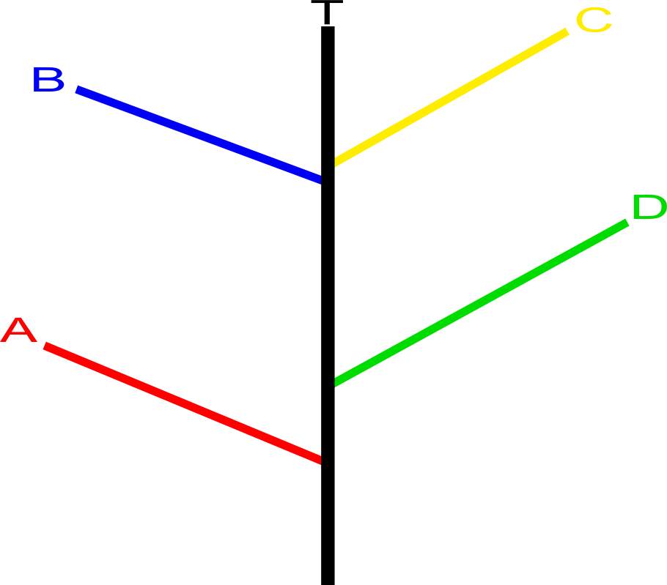

Using the original matrix data only, when growing the tree it was found the entirety of A would grow, before B started growing (then C and D). In order to achieve the desired effect (where they would start and finish at the same time), we required information denoting the first and last matrix index per branch segment, for a given depth.

It is then possible to animate growth of the tree over a growth time K. We first calculate which depth of the tree must be animated (scaled). Given the runtime R (growth time so far), and tree depth D, we can find the current animation level:

L = lerp(0, D, (1.0/K) * R)

For every depth under L, we draw the branches normally. We must convert the runtime into the range 0 to N, where N is the time per depth (K/D):

M = R – (L * N)

For each set of branch segments at the current depth, we must find find which [of the multiple] matrix to apply a scaling operation to. Given a segment length S (segment matrix count), the interpolation factor is:
F = (1.0 / N) * M
The index of the matrix to scale is:
I = lerp(0, S, F)
We draw each branch under “I” normally, then scale matrix I (along Y axis) using the fractional part of “I”. All branches above “L” are ignored.

Death of the tree is much simpler – when the fire has engulfed it, we change the alpha value of the appropriate depth. The branches fade out with the fire over time.

Whilst fast and flexible at load time, the implementation of the tree meant it could not be changed once built (without rebuilding the entire tree).

Particle System
The particle system was designed to be flexible in its implementation, while retaining some important performance related characteristics (imposing some limitations upon the user).
The system contains two components: a particle emitter manager and emitters.

The emitter manager is used to manage the storage, update and draw of all emitters in the system. Using a template function (so one may add any of the multiple emitter types), the user may add an emitter. A new emitter is created (on heap), and is added to a list of emitters (a vector of pointers). An emitter handle is also created (in a separate vector), containing the same pointer. When the function completes, the user receives an integer ID (an index into the vector of handles). This ID is then used to retrieve the emitter from the manager. This design was employed, so that an emitter may be removed (with memory deleted), whilst the ID will still remain valid – on removal, the emitter handle pointer is simply nullified. Emitter handles are never removed as this would invalidate emitters passed to the user, if the ID was greater than that of the one removed (illustrated below).

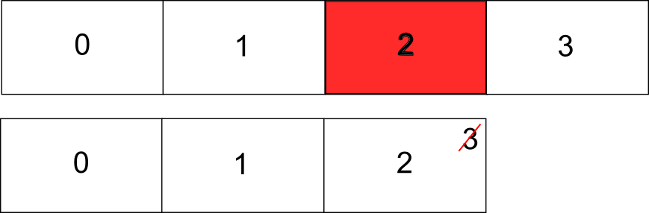

Clearly, if element 2 was removed, the index “3” would become invalid.
The particle emitters themselves inherit from a base Particle Emitter to add specific functionality. The base emitter contains shared data, including: the particle array (static size), billboard type (spherical, cylindrical or none), local particle maximum, origin, rate of emission, forces list, the shader, alpha and colour map. Further, the statically linked functions Draw() and Update() are used to display and update particles. From within the Update function, multiple virtual functions may be called, including an Emit() function (to initialise the properties and emit a particle) and UpdateParticleProperties() function (to update properties that may not be updated in the primary Update() function).
Multiple custom emitters have been defined, including a hemispherical emitter (emitting particles over a hemisphere of a given radius), a point based emitter (emitting from a point in a spread), static emitter (used for leaves), and the fire emitter. The fire emitter uses a list of Particle Lines, where each line has a start and end position, and is associated with a depth in the tree. With this data, it is possible to animate the fire particles on the tree (in a similar fashion to the tree growth function described above).

Project Management
The Seasonal Globe project was managed successfully and productively, and by learning the use of new tools and employing existing skills, the final application met both global and personal requirements.

In order to manage time a schedule was created (see Time Plan). This helped motivate and measure progress at any time (comparing current results to expected results). Compared to the archaic methodologies however, I do not believe requirements can be perfectly defined in a single project stage. Instead, I followed agile development methodologies, assessing progress and selecting tasks to complete and review in a short time period. By assignment conclusion, it was clear the schedule had proved useful, and allowed me to improve my scheduling skills and become more disciplined. However, as may be expected, predicted time management is not perfect. Despite best intentions, I found that in the pursuit of a personal vision (and the difficulty of certain implementations), some aspects took longer than expected (primarily animated fire and terrain).

For many years, I have used (and advocated use of) version control systems (VCS). I have appreciated their usage scenarios, and the aid they provide in rapid development and the maintenance of project history and data integrity. At many times I have prototyped ideas – rather than modifying the base code (which may lead to instabilities), VCS' have allowed for cheap “branches” to be created to allow for faster development. Since moving from Subversion (centralised) to Git (distributed), I have also found my work flow to be faster (entire repository copy stored on the client).

I also employed the project management tool Redmine, which allowed for features such as repository viewing, bug tracking and a “wiki”, entirely accessed through a web browser. As a single centralised source of important information, this lead to productivity gains.

I have also improved my requirements analysis and design skills. Historically, when I have immediately started implementing an application, the lack of design foresight has lead to problems. Considering this, I chose to split the specification into its component parts. Each area in turn, I designed the relevant algorithms at a high level, rewriting specifications to add further details. Selecting an appropriate algorithm, these were designed on paper, obvious problems being identified quickly and resolved (without the expense of finding issues during implementation stage). Once adequately completed, algorithms could be implemented without many of the concerns that may have arisen without such designs. By following a disciplined approach, my project management and professional skills have improved.

Finally, during the project I discovered the usefulness of static code analysis tools, which I will continue into the future. Using “Parasoft”, I was able to view and resolve design issues my coding style had inflicted. Though some issues seemed of little relevance (in context of use), I believe the static analysis tools overall improved my coding style and the quality of the product.

Time Plan
