Dumpsite siting check against the SWM Rules 2026
Method, results and a step-by-step guide to reproduce every number
Gujarat dumpsite RS-GIS study (14 sites, 10 cities) · Integrated Waste Management and Circular Economy, mid-semester project
Folder: Project 1\siting_compliance_26Sep · Run date: 26 September 2026 (about 4 am IST) · Scripts: 01, 02, 03, 04 in scripts\
Master outlines: Locations of landfills in gujurat Completed.kml (14 sites × 6 epochs, same polygons and parsing as the area and volume analyses)
Use of this document. This is a working and reproducibility record prepared with Claude for your own use: methods, commands, checks and numbers. Under the course rule on AI-generated content, do not copy its sentences into the slides or report; write those yourself. Figures, tables and numbers are analysis outputs you can use.
Contents
1. What was done and what came out
2. The rules checked
3. Folder layout
4. Data used
5. Software setup (once)
6. Step 01 - download the layers
7. Step 02 - the siting check
8. Step 03 - figures, workbook and Google Earth layers
9. Step 04 - independent check of the numbers
10. Manual check of one site in Google Earth Pro (Mehsana, MEH-01)
11. Checks carried out
12. Full results
13. Limitations
14. Troubleshooting
15. References and links
Appendix A. Map of every site
Appendix B. Columns of siting_long.csv
Appendix C. Parameters (scripts\config.py)
Reading order to reproduce the results: Sections 5 → 6 → 7 → 8 → 9 (or scripts\run_all.bat), then the manual check in Section 10.

1. What was done and what came out
Each of the 14 traced dumpsites was tested against the landfill siting criteria of the Solid Waste Management Rules, 2026 (MoEFCC notification S.O. 388(E), 27 January 2026, Schedule II, Part A, clauses (vii) and (viii)); these are the same criteria listed on the "Landfill siting rules (SWM 2026 rules)" slide of Lecture 8. The test uses the 2026 traced outline of each site (its current extent). The same test on the 2016 outline is reported for comparison, using today's surroundings.
Of the 12 criteria, 10 can be checked with open data (distances to rivers, ponds, highways, habitation, parks and airports; overlap with the 100-year flood plain, coastal regulation zone, wetlands and protected areas). Two cannot: water-supply wells (no public map) and inclusion in the town-planning land-use plan (needs the Development Plan maps). Each site is therefore scored out of 10.
Everything runs from four Python scripts. Following Sections 5 to 9 in order reproduces every table and figure in the folder. Section 10 shows how to check one site by hand in Google Earth Pro.

1.1 Headline numbers (2026 outline)
ID | Site | Outline 2026 (ha) | Rules breached (of 10) | Conditional / to check | Rules breached | Conditional / to check (which)
VAD-01 | Vadodara LF-1 | 12.9 | 5 | 1 | River, Pond, Highway (NH / SH), Habitation, Flood plain (100-year) | Airport / airbase
AHM-01 | Ahmedabad LF-1 (Pirana) | 29.9 | 3 | 1 | Highway (NH / SH), Habitation, Flood plain (100-year) | Airport / airbase
GNR-01 | Gandhinagar LF-1 | 12.6 | 3 | 1 | River, Habitation, Flood plain (100-year) | Airport / airbase
JAM-01 | Jamnagar LF-1 | 2.8 | 3 | 1 | Highway (NH / SH), Habitation, Airport / airbase | Critical habitat / eco-fragile area
SUR-02 | Surat LF-2 (Khajod) | 31.2 | 3 | 1 | Pond, Airport / airbase, Flood plain (100-year) | Habitation
VAP-01 | Vapi LF-1 | 1.4 | 3 | 1 | River, Airport / airbase, Flood plain (100-year) | Habitation
BHJ-01 | Bhuj LF-1 | 6.7 | 3 | 0 | Highway (NH / SH), Habitation, Airport / airbase | -
MEH-01 | Mehsana LF-1 | 2.8 | 3 | 0 | Highway (NH / SH), Habitation, Airport / airbase | -
SUR-01 | Surat LF-1 (Bhatar) | 0.4 | 3 | 0 | Habitation, Airport / airbase, Flood plain (100-year) | -
VAD-02 | Vadodara LF-2 (Atladara) | 0.7 | 3 | 0 | Habitation, Airport / airbase, Flood plain (100-year) | -
BHV-01 | Bhavnagar LF-1 | 14.8 | 1 | 1 | Flood plain (100-year) | Airport / airbase
AHM-02 | Ahmedabad LF-2 | 8.2 | 0 | 2 | - | Habitation, Airport / airbase
AHM-03 | Ahmedabad LF-3 | 8.5 | 0 | 2 | - | Habitation, Airport / airbase
RAJ-01 | Rajkot LF-1 | 28.0 | 0 | 1 | - | Airport / airbase
Breach = the measured distance is below the legal minimum, or the outline overlaps a zone where landfills are not permitted. Conditional = an airport or airbase at 10-20 km (allowed only with a no-objection certificate from civil aviation / Air Force, which we cannot see). Check = habitation or eco-sensitive-zone result that needs confirmation (Sections 7.4 and 7.11).

1.2 Key analysis points (for your own wording)
- Across the 14 sites there are 33 definite breaches (of 140 site-rule checks) plus 12 conditional / to-check results. Every site breaches or is conditional on at least one rule; 10 of the 14 breach three or more.
- Worst: Vadodara LF-1 (VAD-01), 5 breaches - on the Jambuva river (0 m), a pond at 148 m, NH48 at 53 m, houses within 200 m and 99% of the outline inside the modelled 100-year flood extent; the Vadodara airport is at 11.4 km (conditional).
- Airports are the most general problem: all 14 dumpsites are within 20 km of an aerodrome. 7 are within 10 km, where the rules do not allow a landfill at all: BHJ-01 (3.6 km), JAM-01 (9.7 km), MEH-01 (2.5 km), SUR-01 (8.8 km), SUR-02 (6.2 km), VAD-02 (8.7 km), VAP-01 (8.5 km). The other 7 are at 10-20 km and would need an NOC. Mehsana's dump is 2.5 km from the Mehsana airstrip and Bhuj's 3.6 km from the Bhuj airport / Air Force station.
- Flood plain: 8 of 14 outlines overlap the modelled 100-year flood extent (JRC/Copernicus, 90 m): AHM-01 84%, BHV-01 100%, GNR-01 12%, SUR-01 100%, SUR-02 100%, VAD-01 99%, VAD-02 82%, VAP-01 51%.
- River within 100 m at 3 sites: Gandhinagar on the Sabarmati bank (2 m), Vapi on the Daman Ganga bank (2 m), Vadodara LF-1 touching the Jambuva (0 m).
- NH / SH within 200 m at 5 sites: Pirana (SH142, 28 m), Bhuj (SH, 30 m), Mehsana (SH219, 37 m), Vadodara LF-1 (NH48, 53 m), Jamnagar (SH6, 191 m).
- Habitation within 200 m: 8 breaches confirmed on imagery (AHM-01, BHJ-01, GNR-01, JAM-01, MEH-01, SUR-01, VAD-01, VAD-02) and 4 to confirm (AHM-02, AHM-03, SUR-02, VAP-01). Bhavnagar and Rajkot have no dwellings inside the ring.
- No site breaches the park, wetland or CRZ criteria with the data used, and none lies inside a protected area. Jamnagar is 5.4 km from Khijadiya Wildlife Sanctuary, inside the 10 km default eco-sensitive zone, so its ESZ notification should be checked.
- Five most populous cities (9 sites): mean 2.0 breaches per site; other cities (5 sites): mean 3.0. The three sites with no definite breach (AHM-02, AHM-03, RAJ-01) are all in the large cities, and all three still have an airport within 20 km.
- 2016 vs 2026 outlines: 30 → 33 breaches. Growth pushed five sites into a new breach (GNR-01 into the flood extent; JAM-01 to within 200 m of SH6; MEH-01 to within 200 m of houses; SUR-02 and VAD-01 to within 200 m of a pond), while shrinking outlines removed the river breach at SUR-01 and VAD-02.
- Legal note: these dumpsites are legacy dumps, not engineered landfills sited under the 2026 rules. The siting criteria formally apply to new sanitary landfills; for existing dumps the rules require mapping by 31 October 2026 and time-bound biomining / bioremediation (Rule 15), and Schedule II(A)(v) requires sites in use for more than five years to be upgraded. The result is therefore how far each site is from a location the rules would accept.

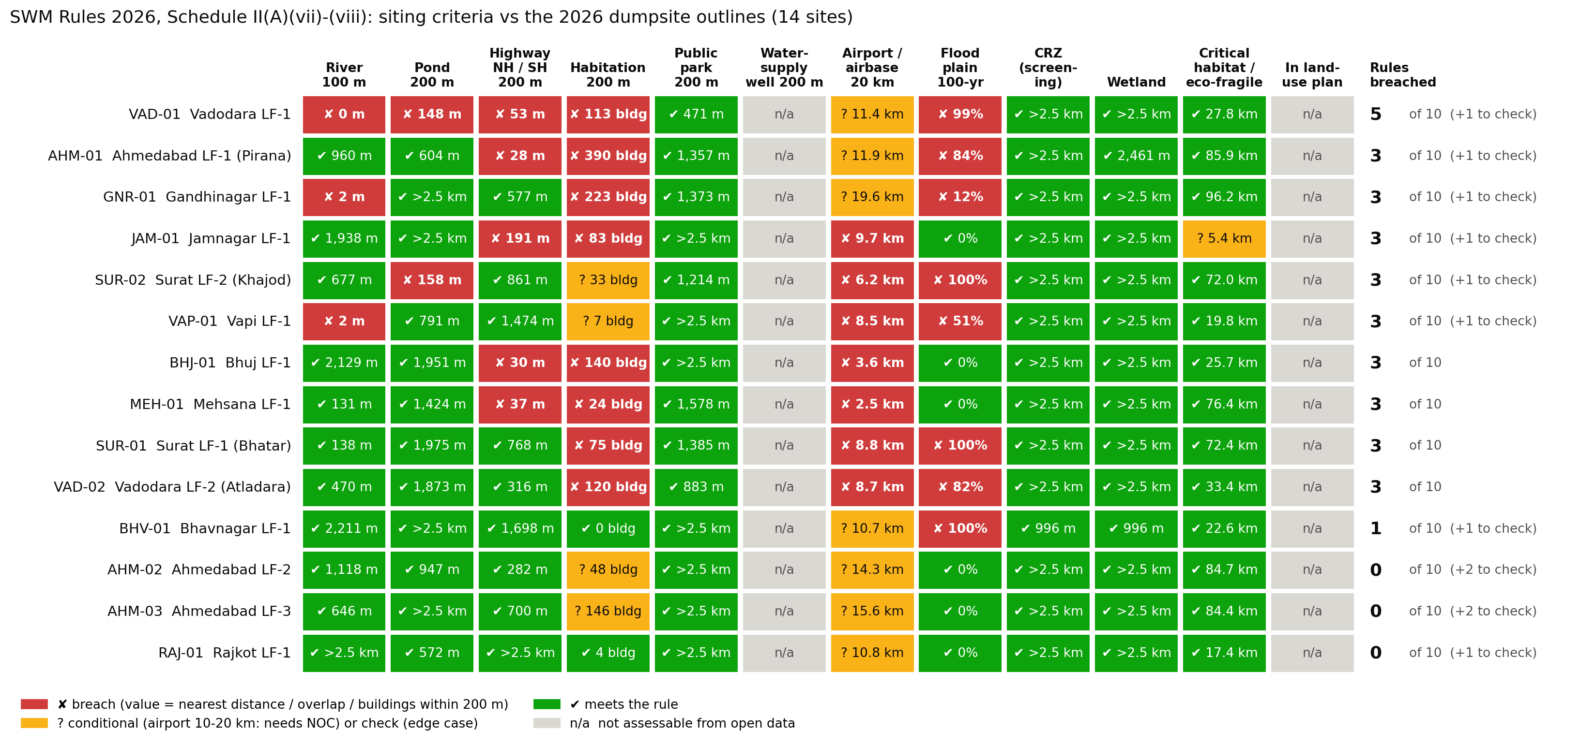
Figure S1 - rule-by-rule result for every site (2026 outline); value = nearest distance, % of outline in flood extent, or residential buildings within 200 m.

2. The rules checked
Source text (Gazette of India, S.O. 388(E), 27 January 2026, Schedule II 'Specifications for Sanitary Landfills', (A) Criteria for site selection):
(vii) The landfill site shall be 100 meter away from river, 200 meter from a pond, 200 meter from Highways, Habitations, Public Parks and water supply wells and 20 km away from Airports or Airbase. However in a special case, landfill site may be set up within a distance of 10 and 20 km away from the Airport or Airbase after obtaining no objection certificate from the civil aviation authority or Air force as the case may be. The Landfill site shall not be permitted within the flood plains as recorded for the last hundred years, zone of coastal regulation, wetland, Critical habitat areas, sensitive eco-fragile areas. (viii) The sites for landfill and processing and disposal of solid waste shall be incorporated in the Town Planning Department's land-use plans.
ID | Rule | Limit | How it is tested here | Confidence
R1 | River | 100 m | Nearest OSM river (centre-line or river water area) to the outline edge | medium-high
R2 | Pond | 200 m | Nearest OSM pond / lake / reservoir ≥ 100 m² (water lying mostly inside the dump is ignored) | medium
R3 | Highway | 200 m | Nearest OSM motorway / trunk / primary road, or any road with an NH / SH reference (OSM India: trunk = NH, primary = SH) | medium-high
R4 | Habitation | 200 m | ≥ 5 residential buildings within 200 m: Overture footprints outside the dump, not tanks, not on industrial / plant land, on a GHSL-2018 residential cell; then an imagery review | medium
R5 | Public park | 200 m | Nearest OSM leisure = park / recreation_ground | medium
R6 | Water-supply well | 200 m | Not assessable - no public map of water-supply wells | -
R7 | Airport / airbase | 20 km (10-20 km with NOC) | Distance to the aerodrome reference point of every airport, airbase and airstrip; < 10 km = breach, 10-20 km = conditional | high
R8 | Flood plain | not permitted | Overlap with the JRC / Copernicus 100-year river flood map (90 m); ≥ 10% of the outline = breach | low-medium
R9 | Coastal Regulation Zone | not permitted | Screening: within 500 m of the OSM coastline or 50 m of OSM tidal features (CRZ Notification 2019) | low
R10 | Wetland | not permitted | Outline overlaps an OSM wetland polygon (marsh, mangrove, tidal flat, salt marsh) | low-medium
R11 | Critical habitat / eco-fragile | not permitted | Inside or < 1 km from a wildlife protected area = breach (minimum ESZ, SC order 3 June 2022); 1-10 km = check the notified ESZ | medium
R12 | Land-use plan | required | Not assessable - needs the Development Plan / TP scheme maps | -
Distances are always measured from the edge of the 2026 traced outline (the waste footprint) to the nearest point of the feature, as the shortest ground distance. The rules do not say from which point to measure; the edge-to-edge distance is the strictest reading. For airports the reference point is used instead (Section 7.7), because Indian aviation rules measure garbage restrictions from the aerodrome reference point.

3. Folder layout
Everything for this analysis sits in one new folder inside the project folder. Nothing outside it is changed; the only input read from outside is the master KML.
Path (inside siting_compliance_26Sep) | Contents
scripts\config.py | Every path, data source, rule threshold and search radius; the habitation imagery review
scripts\outlines.py | Reads the master KML with the same name rules as final_analysis.py (copied from volume_final_26Sep)
scripts\geo_utils.py | OSM JSON → geometries, per-site distance projection, feature classes
scripts\01_download_layers.py | Step 01: downloads OSM, aerodromes, protected areas, Overture buildings, GHSL, JRC flood map
scripts\02_siting_check.py | Step 02: the rule-by-rule check for the 2026 and 2016 outlines
scripts\03_figures_tables.py | Step 03: figures S1-S6, per-site maps, Excel workbook, Google Earth KML
scripts\04_verify.py | Step 04: recomputes the key numbers by an independent route
scripts\run_all.bat / run_all.sh | Runs 01 → 04 in order (Windows / Linux-macOS)
data\site_outlines.geojson | 2016 and 2026 outlines and the 2016-26 union of every site (WGS84)
data\sources.json | What was downloaded, from where, when, and the data versions
data\raw\osm\ | Overpass answers: <SITE>_local.json, <SITE>_nonres.json, gujarat_protected.json, gujarat_aerodromes.json
data\raw\buildings\ | Overture building footprints within 600 m of each site (GeoParquet)
data\raw\ghsl\ | GHSL residential / non-residential built-up map (2018, 10 m) clipped per site
data\raw\jrc_flood\ | JRC 100-year flood depth and permanent water: the two tiles cut to Gujarat on their native grid + README / licence
data\raw\ourairports_IN.csv | OurAirports list for India (airport reference points)
outputs\tables\siting_results.xlsx | MAIN workbook: summary, matrices, distances, detail, habitation, airports, rules, sources, parameters
outputs\tables\*.csv | The same tables as CSV (siting_long.csv is the full record: one row per site × epoch × rule)
outputs\sites\<SITE>\ | <SITE>_layers.geojson (every feature used, with its distance) and <SITE>_siting_map.png
outputs\siting_check_layers.kml | Outlines, 100 / 200 m rings and flagged features for all 14 sites - open in Google Earth Pro
figures\ | figS1-figS6 (200 dpi PNG)
docs\ | This guide (Word + PDF)
logs\ | Console output of every step and environment.txt (package versions)

4. Data used
Layer | Used for | Source and version | Resolution / date | Licence
OpenStreetMap (Overpass API) | Rivers, ponds, roads, parks, residential / industrial land, wetlands, coast, tidal features | Overpass mirror maps.mail.ru; OSM data as of 2026-09-25T21:10:33Z (per site in sources.json) | Vector; mapping completeness varies | ODbL
OSM protected areas | R11 | Overpass, all of Gujarat + margin (28 wildlife PAs incl. Khijadiya, Marine NP, Velavadar, Vadhvana) | as of 2026-09-25T21:20:47Z | ODbL
OSM aerodromes + OurAirports | R7 | 35 OSM aerodromes in Gujarat + margin; reference points from OurAirports (davidmegginson.github.io/ourairports-data) | Points / polygons, Sep 2026 | ODbL / public domain
Overture Maps buildings | R4 | Release 2026-09-23.1 (Google Open Buildings + Microsoft ML Buildings + OSM), public S3 bucket | Footprints, ~2020-2025 imagery | ODbL / CDLA
GHSL GHS-BUILT-C FUN R2023A | R4 | JRC Global Human Settlement Layer: residential vs non-residential built-up, read over HTTP | 10 m, epoch 2018 | CC BY 4.0
JRC global river flood hazard map | R8 | Copernicus EMS / GloFAS, v2.1.2 (README 12 Jan 2026), RP100 depth, tiles N30_E60 and N30_E70 | 3 arc-s (~90 m); MERIT-DEM base | CC BY 4.0
Esri World Imagery | Maps and imagery review only | Esri, Maxar, Earthstar Geographics (tile service) | ~0.5 m | Esri terms (display)
Master KML | Outlines | Locations of landfills in gujurat Completed.kml | Manual tracing, Google Earth Pro | -
Not used (not available as open GIS data): official CZMP High Tide Line maps (R9), National Wetland Atlas polygons (R10), notified ESZ boundaries (R11), city Development Plan maps (R12), water-supply well locations (R6).

5. Software setup (once)
Python 3.10 or newer (the run here used 3.11; the volume analysis used 3.10 - both work). In a command prompt:
cd "D:\COursework\Waste and circular economy\Project 1\siting_compliance_26Sep\scripts"
python -m pip install -r requirements.txt
requirements.txt lists numpy, pandas, shapely, pyproj, rasterio, geopandas, pyarrow, duckdb, requests, matplotlib, contextily, openpyxl. Exact versions of the run are in logs\environment.txt. Step 01 needs internet; steps 02-04 work offline except the satellite basemap in the maps (step 03).

6. Step 01 - download the layers
python 01_download_layers.py
What it does, in order (files that already exist are skipped, so a re-run only fetches what is missing):
- Reads the master KML with outlines.py and writes data\site_outlines.geojson (2016 outline, 2026 outline and the 2016-26 union per site).
- For each site, asks the Overpass API for all OSM features within 2.5 km of the union: rivers and streams, water bodies, reservoirs, roads (motorway to tertiary), parks, residential / industrial / landfill land, places, wetlands, coastline, tidal features and wells (<SITE>_local.json); and non-residential land within 800 m - industrial / commercial land, treatment plants, power plants, landfill facilities (<SITE>_nonres.json). Four sites are fetched at a time.
- One Overpass query each for all protected areas and all aerodromes in Gujarat plus a margin (bounding box 19.8-24.9 °N, 68.0-74.6 °E).
- Downloads the OurAirports list and keeps the rows for India.
- Downloads the two JRC 100-year flood depth tiles that cover the 14 sites and the matching permanent-water tiles, and cuts each to Gujarat on its native 90 m grid (a window read, no resampling); only the cuts are kept (15 MB instead of 80 MB).
- Reads the GHSL residential / non-residential raster (a 44 GB global GeoTIFF) window by window over HTTP and saves a small clip per site.
- Queries the newest Overture Maps release on the public S3 bucket with DuckDB for building footprints within 600 m of each site (the first query takes ~5 minutes while DuckDB reads the file index; the rest ~5 s each).
- Writes data\sources.json with endpoints, OSM timestamps, release names and download times.
Run time here: about 15 minutes, mostly Overpass. Re-running on another day gives slightly different OSM / Overture data (the maps are edited continuously); to reproduce the exact numbers, keep the data\raw folder and skip step 01.

7. Step 02 - the siting check
python 02_siting_check.py
Runs in about 10 seconds and writes every table in outputs\tables plus the per-site layer files. The logic, rule by rule:

7.1 Outlines and distances
Outlines are parsed exactly as in the area analysis (parts of a site merged; a 2025 image is the 2024 epoch). Each site gets its own azimuthal equidistant projection centred on the site, in which distances from the site are true ground distances; this avoids the scale error of UTM 43N for the western sites (Bhuj, Jamnagar and Rajkot lie in UTM zone 42). All distances are the shortest distance between the outline polygon and the feature geometry.

7.2 R1 River (100 m)
Features: OSM waterway = river (centre-lines) and river water areas (natural = water + water = river, waterway = riverbank). Streams, canals and drains are not rivers and are only drawn on the maps. Unnamed river polygons borrow the name of the nearest named river line within 500 m.

7.3 R2 Pond (200 m)
Features: OSM natural = water with water = pond / lake / reservoir / basin / lagoon / oxbow or no water tag, and landuse = reservoir / basin; rivers, canals, wastewater and similar are excluded. Water bodies smaller than 100 m² are ignored, and so are water bodies lying mostly (≥ 50%) inside the dump's 2016-26 union (leachate or pit water, e.g. the AHM-03 cell).

7.4 R3 Highway (200 m)
Features: OSM motorway, trunk and primary roads (in OSM India, trunk = National Highway, primary = State Highway) and any road whose ref or name carries NH / SH / NE. A stricter variant (only motorway / trunk or roads with an NH / SH ref) is stored as alt_value; it gives the same verdict at all 14 sites.

7.5 R4 Habitation (200 m)
A building counts as habitation only if all of the following hold: it is an Overture footprint lying outside the dump's 2016-26 union plus 20 m (site sheds and trommels drop out); it is not a near-circular structure ≥ 100 m² (tanks, clarifiers, silos; compactness 4πA/P² ≥ 0.88); its centre is not on OSM industrial / commercial / treatment-plant / power / landfill land; and it stands on a GHSL-2018 'residential' cell. Automatic breach = at least 5 such buildings within 200 m of the outline.
Because building footprints near dumps include plant units, godowns and huts, every site's 200 m ring was then reviewed on Esri World Imagery at zoom 17. Where the buildings could not be confirmed as dwellings, the automatic breach is reported as 'check'. The review is written in config.py (HABITATION_REVIEW) so it can be changed and re-run after you confirm it in Google Earth Pro:
Site | Residential bldgs ≤ 200 m | All bldgs ≤ 200 m | Imagery review | Note | Verdict
AHM-01 | 390 | 437 | confirmed | dense housing on the east / south-east edge; industrial units elsewhere (excluded) | breach
AHM-02 | 48 | 63 | uncertain | Pirana STP to the west (excluded); small structures to the north and south-east may be sheds or huts | check
AHM-03 | 146 | 150 | uncertain | many small structures in the walled yard just north; may be a waste-handling / scrap yard, not homes | check
BHJ-01 | 140 | 161 | confirmed | houses of the residential area to the south | breach
BHV-01 | 0 | 1 | none | no buildings inside the 200 m ring | ok
GNR-01 | 223 | 235 | confirmed | dense cluster of small dwellings along the west edge | breach
JAM-01 | 83 | 96 | confirmed | residential plots and houses to the south and west | breach
MEH-01 | 24 | 46 | confirmed | houses to the north-west | breach
RAJ-01 | 4 | 38 | none | structures in the ring are the processing-plant buildings on the east side | ok
SUR-01 | 75 | 79 | confirmed | most mapped structures are Bhatar STP units, but dense housing lies inside the ring to the south-west | breach
SUR-02 | 33 | 52 | uncertain | small cluster south of the southern cell; north side is industrial (excluded) | check
VAD-01 | 113 | 140 | likely | scattered houses / farm buildings to the north and west | breach
VAD-02 | 120 | 122 | confirmed | apartments and houses to the west and south | breach
VAP-01 | 7 | 13 | uncertain | a few small structures to the south-east; industrial buildings excluded | check
Sensitivity (habitation_detail.csv): with 1 or 20 residential buildings as the threshold instead of 5, the automatic result changes only at RAJ-01 (4 buildings: breach at 1) and VAP-01 (7: ok at 20).

7.6 R5 Public park (200 m)
Features: OSM leisure = park and leisure = recreation_ground. Private gardens are not public parks and are ignored.

7.7 R7 Airport / airbase (20 km; 10-20 km only with NOC)
All OSM aerodromes in Gujarat that are not abandoned (airports, airbases and airstrips such as Mehsana) are used; their reference points come from OurAirports (matched by ICAO code or within 4 km). Main distance = outline edge to the aerodrome reference point, the reference used by the Aircraft Rules 1937 (rule 91: no garbage deposit within 10 km of the aerodrome reference point). < 10 km = breach; 10-20 km = conditional (an NOC may exist, but we cannot see it); ≥ 20 km = ok. Sensitivity: distance to the aerodrome boundary (alt_value), which turns AHM-01 (9.6 km) and RAJ-01 (9.6 km, old Rajkot airport) into breaches.
Status notes: the old Rajkot airport (VARK) lost its scheduled flights when Rajkot International (Hirasar, VAHS) opened in 2023 - RAJ-01 is 18.2 km from Hirasar, so it is conditional either way. 'Military use' in the airport column is taken from OSM tags.

7.8 R8 Flood plain (100-year)
The JRC / Copernicus global river flood hazard map (100-year return period, 90 m, v2.1.2) is vectorised around each site (cells with depth > 0) and intersected with the outline. ≥ 10% of the outline inside the flood extent = breach; 0-10% = edge overlap (check). The overlap area, nearest flooded cell and maximum depth under the outline are stored in siting_long.csv.
How to read it: the model runs on MERIT-DEM (bare-earth, around the year 2000) at 90 m, so it describes the land the dump stands on, not the top of today's mound - e.g. all 31 flood cells over Pirana have 0.4-2.0 m depth, including cells under the mound. That is the question the rule asks (is the site on a 100-year flood plain?). It is a global model: use it as screening, and cross-check the large overlaps (BHV-01, SUR-01, SUR-02, VAD-01, AHM-01, VAD-02) with local flood records if you cite them.

7.9 R9 Coastal Regulation Zone (screening)
CRZ Notification 2019: 500 m landward of the High Tide Line on the sea front and 50 m (or the creek width) along tidal-influenced water bodies. Official HTL maps are not public in GIS form, so the check is a screening: breach if the outline is within 500 m of the OSM coastline or within 50 m of OSM tidal features (tidal = yes, mangrove, tidal flat, salt marsh, mud, tidal channel). No site is flagged; the closest is BHV-01 (996 m from a salt marsh). The tidal reach of the Tapi at Surat and of creeks at Bhavnagar is not tagged in OSM - treat R9 as not proven either way for SUR-01, SUR-02 and BHV-01.

7.10 R10 Wetland
Breach if the outline overlaps an OSM natural = wetland polygon (any wetland type). No overlaps. The National Wetland Atlas (ISRO SAC) would be the authoritative layer but is only available as a web map.

7.11 R11 Critical habitat / eco-fragile area
Wildlife protected areas (national parks, sanctuaries, conservation / community reserves, Marine NP, Ramsar wetlands) from OSM. Inside or < 1 km = breach (the Supreme Court's 3 June 2022 order in T.N. Godavarman made 1 km the minimum eco-sensitive zone); 1-10 km = check (MoEFCC 2011 guidelines apply 10 km where no ESZ is notified); > 10 km = ok. Only JAM-01 is within 10 km (Khijadiya WLS, 5.4 km). Reserved forests and city nature parks are listed separately and not scored.

7.12 Counting
For each site: breaches = number of the 10 assessable rules with verdict 'breach'; conditional_or_check = number with 'conditional' or 'check'; R6 and R12 are always 'not assessable' and never counted.

8. Step 03 - figures, workbook and Google Earth layers
python 03_figures_tables.py (about 8 minutes: the maps download satellite tiles)
python 03_figures_tables.py --maps-only (maps only)
Output | What it shows
figures\figS1_compliance_matrix_2026.png | Site × rule grid with verdict and measured value (Figure S1)
figures\figS2_breaches_per_site.png | Rules breached per site, with the rule names
figures\figS3_sites_per_rule.png | How many sites breach each rule
figures\figS4_distance_vs_limit.png | Measured distance (or building count) against the legal limit, six rules
figures\figS5_site_maps.png | All 14 sites on satellite imagery with the 100 / 200 m rings and the features
figures\figS6_2016_vs_2026.png | Breaches with the 2016 vs the 2026 outline
outputs\sites\<SITE>\<SITE>_siting_map.png | One larger map per site with the rule list
outputs\tables\siting_results.xlsx | Summary, Matrix_2026, Distances_2026, Detail_2026, Matrix_2016, Detail_2016, Habitation, Airports, Protected_areas, Rules, Data_sources, Parameters (verdict cells coloured)
outputs\siting_check_layers.kml | Per-site folders: 2026 outline, 100 / 200 m rings, rivers, ponds, highways, parks, residential buildings ≤ 200 m, flood extent, protected areas, airports
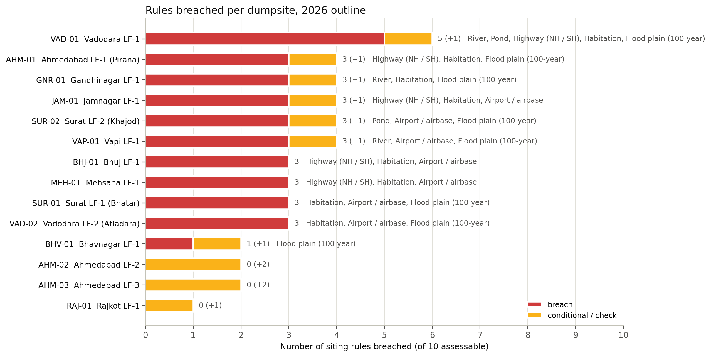
Figure S2 - rules breached per site (red) and conditional / to-check results (amber).
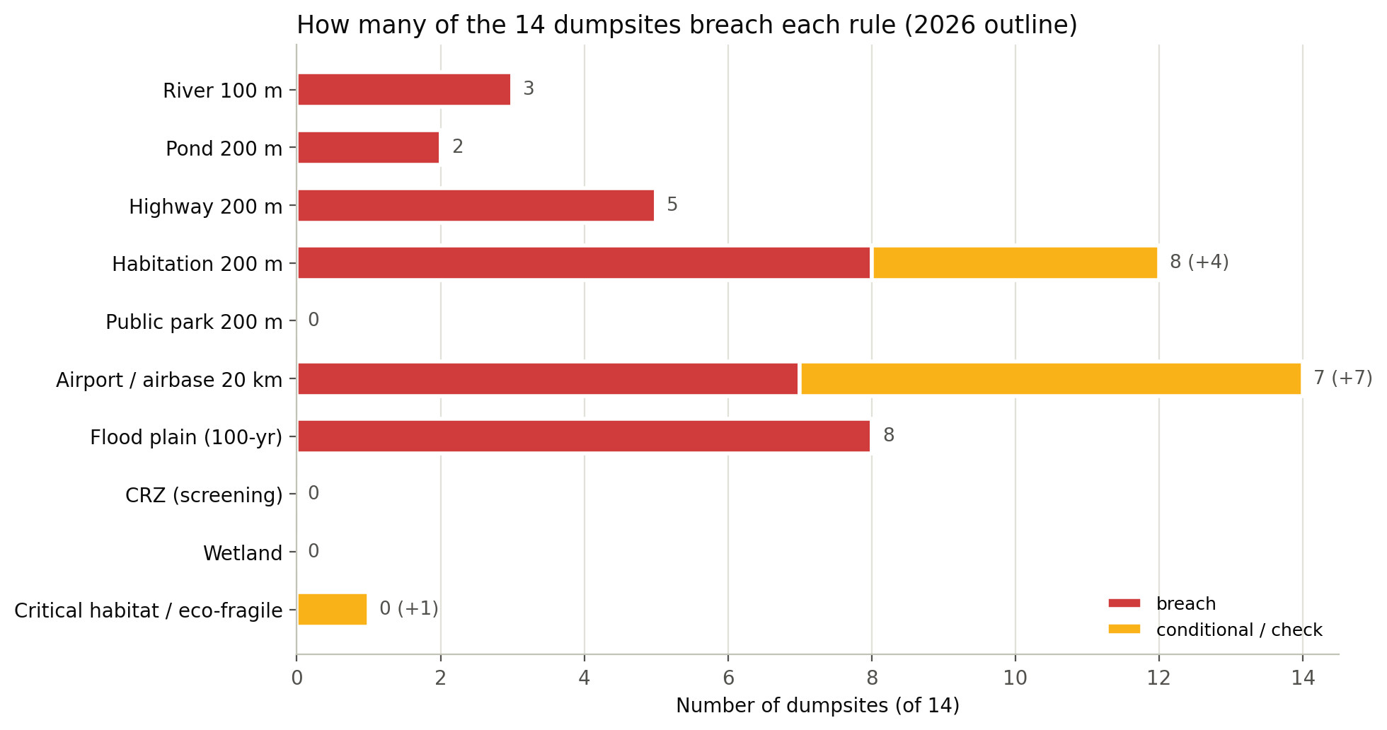
Figure S3 - number of sites breaching each rule.
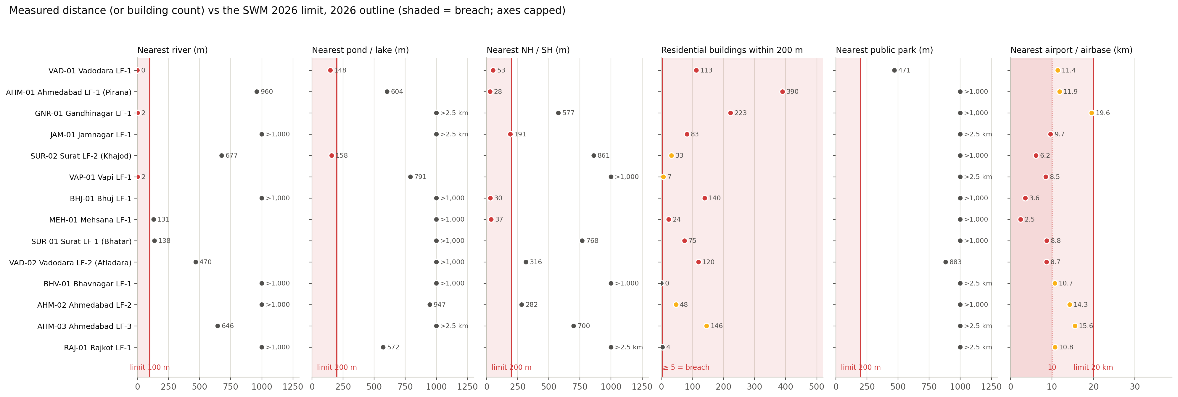
Figure S4 - measured value vs the legal limit (shaded = breach; axes capped, so > 1,000 m values sit at the cap).
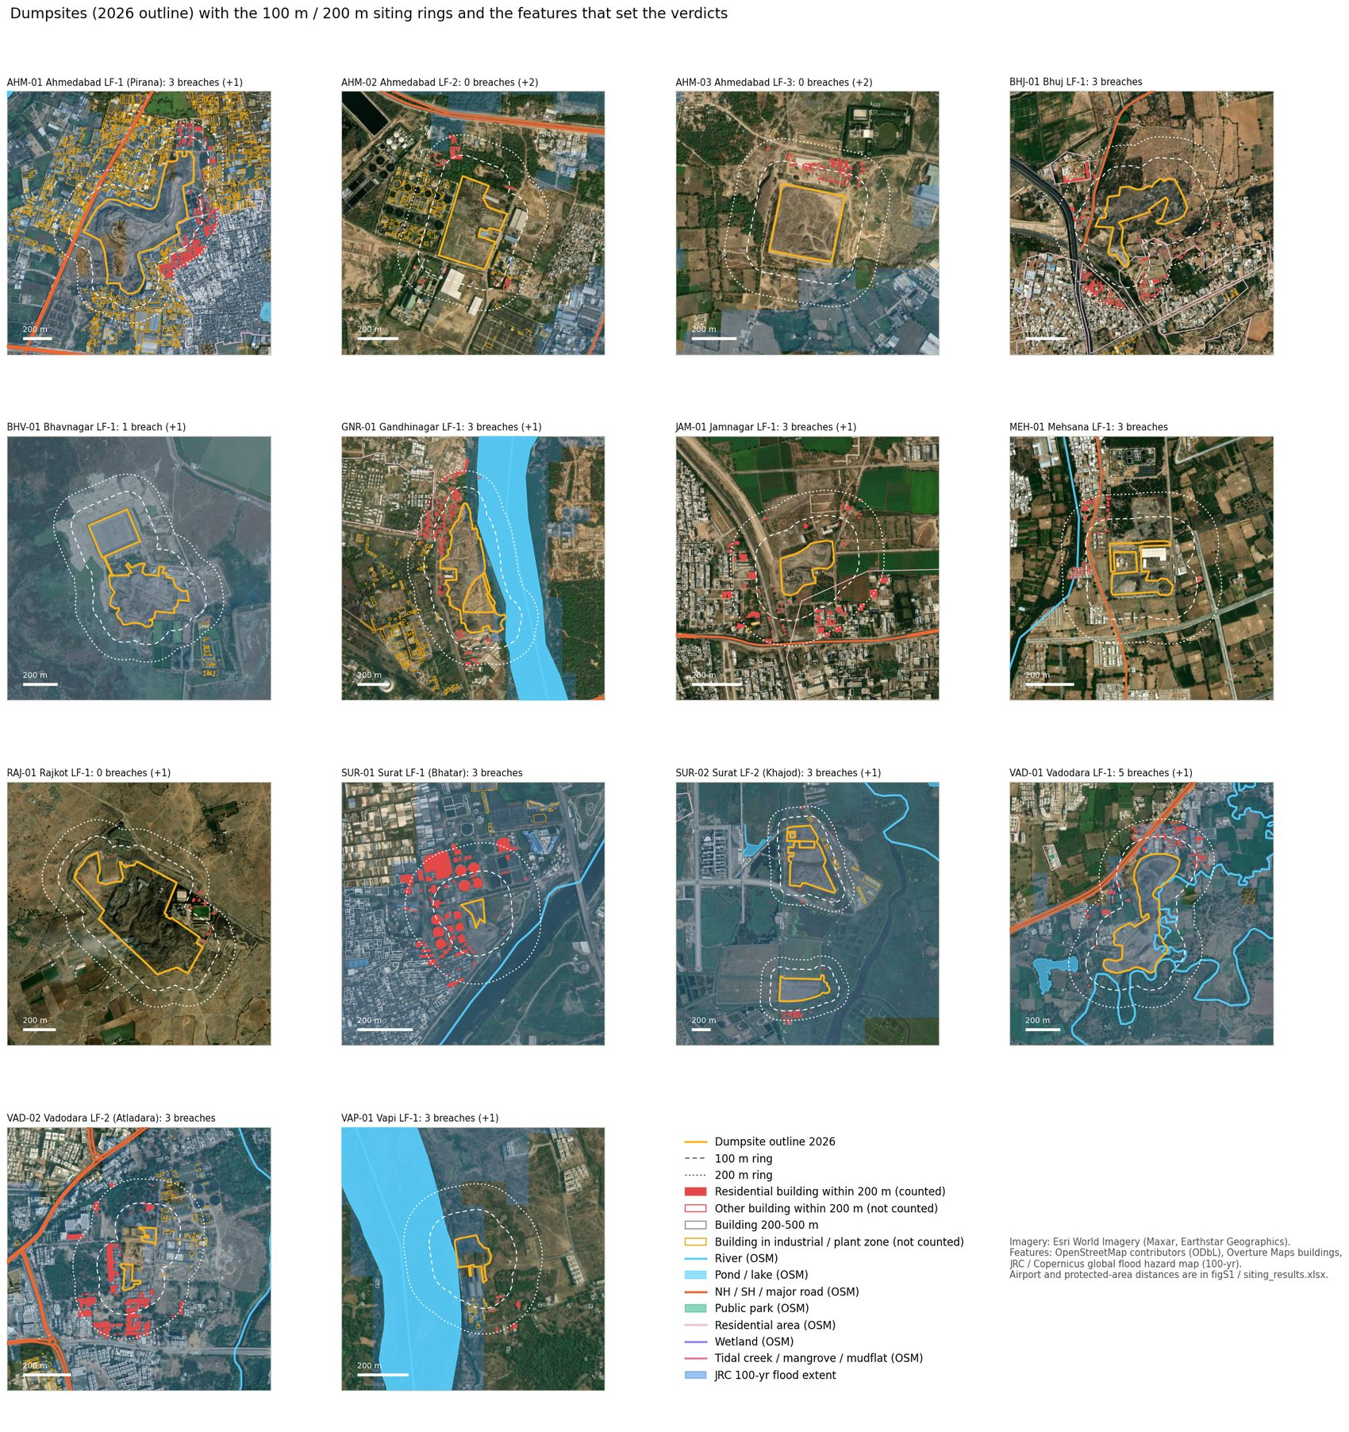
Figure S5 - all 14 sites on satellite imagery with the 100 / 200 m rings and the features that set the verdicts.
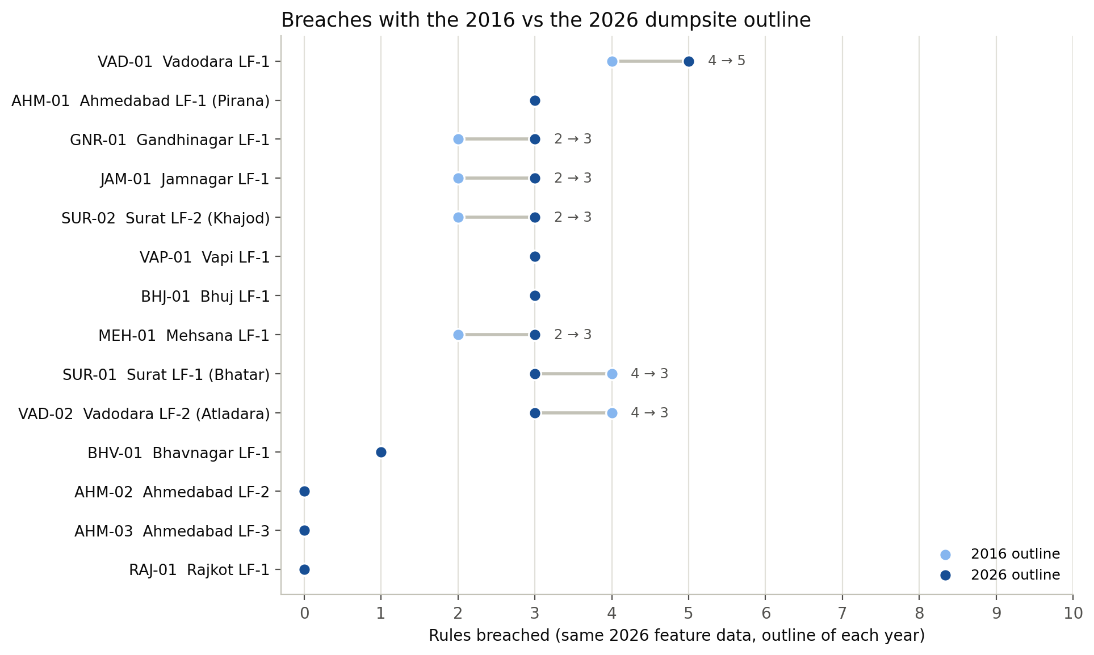
Figure S6 - breaches with the 2016 and the 2026 outline (same 2026 feature data).

9. Step 04 - independent check of the numbers
python 04_verify.py
Recomputes the step-02 distances by a different route: features re-projected to UTM 43N (the CRS of the area analysis), nearest points found there, and the distance between them measured on the WGS84 ellipsoid (pyproj Geod); airport distances as ellipsoidal distances from every outline vertex to the reference point; residential-building counts recomputed in UTM 43N. Result (outputs\tables\verification.csv):
Check | Sites compared | Largest difference
river distance (m) | 13 | 0.0
pond distance (m) | 10 | 0.0
highway distance (m) | 13 | 0.0
park distance (m) | 7 | 0.0
airport reference point (km) | 14 | 0.00
residential buildings within 200 m | 14 | 2.0
All distances agree to 0.1 m (0.01 km for airports). The residential-building counts differ by 1-2 at BHJ-01 and JAM-01 only: both lie in UTM zone 42, where UTM 43N stretches distances by ~0.3% and moves one or two buildings across the 200 m line. No verdict changes, which is why step 02 uses the per-site projection.

10. Manual check of one site in Google Earth Pro (Mehsana, MEH-01)
This reproduces three of MEH-01's results by hand, with no scripts. Expected values from the tables: SH219 at 37 m, Mehsana airstrip reference point at 2.45 km, 24 residential buildings within 200 m.
- Open Google Earth Pro. File → Open → outputs\siting_check_layers.kml. In Places, expand 'MEH-01 Mehsana LF-1', tick outline_2026, buffer_100m, buffer_200m, highway and building.
- Also open the master KML (Locations of landfills in gujurat Completed.kml) and tick the Mehsana 2026 polygon - it must coincide with outline_2026.
- Highway: Tools → Ruler → Line. Click on the outline edge closest to the Himatnagar link road (SH219, drawn orange) and then on the road centre-line. The length should read about 35-40 m (the road line is the centre-line; your click on the edge can differ by a few metres).
- Airport: search 'Mehsana Airport'. With the Ruler, measure from the nearest outline edge to the middle of the runway. Expect about 2.2-2.5 km (the reference point is at the runway centre; the aerodrome boundary is 2.23 km).
- Habitation: turn on historical imagery (clock icon) and pick the newest date. Count houses inside the dotted 200 m ring (the red building outlines in the KML help). The table's 24 are the footprints on GHSL residential cells; you should see houses on the north-west side.
- Flood / river: an unnamed OSM river line passes 131 m from the outline (≥ 100 m → ok), and the JRC map has no 100-year flooding within 3 km of this site.
The same can be done in QGIS: load outputs\sites\MEH-01\MEH-01_layers.geojson (filter by the 'layer' field), set the project CRS to a local projected system (e.g. EPSG:32643) and use the Measure Line tool; the distance_m attribute of each feature is the value computed in step 02.

11. Checks carried out
- Outlines: the 2016 / 2026 areas read by outlines.py match the final area table (e.g. Pirana 38.5 → 29.9 ha, Khajod 68.7 → 31.2 ha).
- Legal text: the thresholds were checked against the Gazette text of S.O. 388(E) (Schedule II(A)(vii)-(viii)), not only against the lecture slide; they are identical.
- Independent distances (Section 9): all agree; no verdict depends on the projection.
- Visual review of every site on satellite imagery (Figure S5 and the zoom-17 review in Section 7.5). This found that raw building footprints overcount habitation - they include the Pirana and Bhatar sewage-treatment units, Rajkot's processing-plant buildings and industrial sheds - which is why the non-residential filters and the review were added. The first automatic run had 13 habitation breaches; after filtering and review, 8 breaches and 4 to check.
- Map drawing bug found and fixed: OSM river centre-lines were first drawn with a fill colour, which filled the area enclosed by the line (a false blue wedge at Mehsana). Lines are now drawn as lines. This affected only the maps, not the numbers.
- Airport list: OSM aerodromes were cross-checked against OurAirports; Mehsana (airstrip, no ICAO code) would have been missed by a code-only filter, so all non-abandoned aerodromes are kept.
- Flood cells were inspected per site (depths 0.4-8 m; SUR-02 7-8 m on low-lying estuary land; GNR-01's overlap is its river-side edge).
- Road classes: with the strict highway definition (motorway / trunk or an NH / SH ref only) all 14 verdicts are unchanged.
- Flood-map cutting: a first version mosaicked and resampled the two JRC tiles; that shifted the 90 m grid by a fraction of a cell and changed flood overlaps by up to 21 percentage points (GNR-01). The tiles are now cut on their native grid, and the cuts reproduce the full-tile results exactly (all 336 site × epoch × rule rows identical).

12. Full results

12.1 Measured values, 2026 outline
ID | River (m) | Pond (m) | NH / SH (m) | Res. bldgs ≤ 200 m | Park (m) | Airport ref. pt (km) | Flood (% outline) | Protected area (km)
AHM-01 | 960 | 604 | 28 | 390 | 1,357 | 11.9 | 84 | 85.9
AHM-02 | 1,118 | 947 | 282 | 48 | 2,534 | 14.3 | 0 | 84.7
AHM-03 | 646 | > 2.5 km | 700 | 146 | > 2.5 km | 15.6 | 0 | 84.4
BHJ-01 | 2,129 | 1,951 | 30 | 140 | 3,180 | 3.6 | 0 | 25.7
BHV-01 | 2,211 | 2,561 | 1,698 | 0 | > 2.5 km | 10.7 | 100 | 22.6
GNR-01 | 2 | > 2.5 km | 577 | 223 | 1,373 | 19.6 | 12 | 96.3
JAM-01 | 1,938 | > 2.5 km | 191 | 83 | > 2.5 km | 9.7 | 0 | 5.4
MEH-01 | 131 | 1,424 | 37 | 24 | 1,578 | 2.5 | 0 | 76.4
RAJ-01 | 3,318 | 572 | > 2.5 km | 4 | > 2.5 km | 10.8 | 0 | 17.4
SUR-01 | 138 | 1,975 | 768 | 75 | 1,385 | 8.8 | 100 | 72.4
SUR-02 | 677 | 158 | 861 | 33 | 1,214 | 6.2 | 100 | 72.0
VAD-01 | 0 | 148 | 53 | 113 | 471 | 11.4 | 99 | 27.8
VAD-02 | 470 | 1,873 | 316 | 120 | 883 | 8.7 | 82 | 33.4
VAP-01 | 2 | 791 | 1,474 | 7 | > 2.5 km | 8.5 | 51 | 19.8
> 2.5 km = no such feature within the 2.5 km search radius.

12.2 Verdict matrix, 2026 outline
ID | River | Pond | Highway | Habitation | Public park | Airport | Flood plain | CRZ | Wetland | Eco-fragile | Breaches
VAD-01 | breach | breach | breach | breach | ok | conditional | breach | ok | ok | ok | 5
AHM-01 | ok | ok | breach | breach | ok | conditional | breach | ok | ok | ok | 3
GNR-01 | breach | ok | ok | breach | ok | conditional | breach | ok | ok | ok | 3
JAM-01 | ok | ok | breach | breach | ok | breach | ok | ok | ok | check | 3
SUR-02 | ok | breach | ok | check | ok | breach | breach | ok | ok | ok | 3
VAP-01 | breach | ok | ok | check | ok | breach | breach | ok | ok | ok | 3
BHJ-01 | ok | ok | breach | breach | ok | breach | ok | ok | ok | ok | 3
MEH-01 | ok | ok | breach | breach | ok | breach | ok | ok | ok | ok | 3
SUR-01 | ok | ok | ok | breach | ok | breach | breach | ok | ok | ok | 3
VAD-02 | ok | ok | ok | breach | ok | breach | breach | ok | ok | ok | 3
BHV-01 | ok | ok | ok | ok | ok | conditional | breach | ok | ok | ok | 1
AHM-02 | ok | ok | ok | check | ok | conditional | ok | ok | ok | ok | 0
AHM-03 | ok | ok | ok | check | ok | conditional | ok | ok | ok | ok | 0
RAJ-01 | ok | ok | ok | ok | ok | conditional | ok | ok | ok | ok | 0

12.3 Nearest aerodrome
ID | Nearest aerodrome | Ref. point (km) | Boundary (km) | Verdict | Verdict (boundary)
AHM-01 | Sardar Vallabhbhai Patel International Airport (VAAH; airport, scheduled flights) | 11.86 | 9.64 | conditional | breach
AHM-02 | Sardar Vallabhbhai Patel International Airport (VAAH; airport, scheduled flights) | 14.29 | 12.07 | conditional | conditional
AHM-03 | Sardar Vallabhbhai Patel International Airport (VAAH; airport, scheduled flights) | 15.57 | 13.35 | conditional | conditional
BHJ-01 | Bhuj Rudra Mata Air Force Base (VABJ; airport, scheduled flights; military use) | 3.59 | 3.31 | breach | breach
BHV-01 | Bhavnagar Airport (VABV; airport, scheduled flights) | 10.72 | 10.01 | conditional | conditional
GNR-01 | Sardar Vallabhbhai Patel International Airport (VAAH; airport, scheduled flights) | 19.59 | 17.69 | conditional | conditional
JAM-01 | Jamnagar Airport (VAJM; airport, scheduled flights; military use) | 9.67 | 8.14 | breach | breach
MEH-01 | Mehsana Airport (no code; airstrip) | 2.45 | 2.23 | breach | breach
RAJ-01 | Rajkot Airport (VARK; airport, no scheduled flights) | 10.75 | 9.61 | conditional | breach
SUR-01 | Surat Airport (VASU; airport, scheduled flights) | 8.75 | 6.24 | breach | breach
SUR-02 | Surat Airport (VASU; airport, scheduled flights) | 6.17 | 4.63 | breach | breach
VAD-01 | Vadodara Green Airport Harni (VABO; airport, scheduled flights; military use) | 11.40 | 10.02 | conditional | conditional
VAD-02 | Vadodara Green Airport Harni (VABO; airport, scheduled flights; military use) | 8.72 | 7.17 | breach | breach
VAP-01 | Daman Airport (VADN; airport, no scheduled flights; military use) | 8.52 | 7.73 | breach | breach

12.4 2016 outline vs 2026 outline
ID | Breaches 2016 | Breaches 2026 | What changed
AHM-01 | 3 | 3 | -
AHM-02 | 0 | 0 | Flood plain: check → ok
AHM-03 | 0 | 0 | -
BHJ-01 | 3 | 3 | -
BHV-01 | 1 | 1 | -
GNR-01 | 2 | 3 | Flood plain: ok → breach
JAM-01 | 2 | 3 | Highway: ok → breach
MEH-01 | 2 | 3 | Habitation: ok → breach
RAJ-01 | 0 | 0 | -
SUR-01 | 4 | 3 | River: breach → ok
SUR-02 | 2 | 3 | Pond: ok → breach
VAD-01 | 4 | 5 | Pond: ok → breach
VAD-02 | 4 | 3 | River: breach → ok
VAP-01 | 3 | 3 | Habitation: ok → check
The 2016 run uses the same (2026) feature data, so it isolates the effect of the dump's own growth or shrinkage; it does not show how the surroundings (houses, roads) have changed since 2016.

13. Limitations
- Legal scope: the siting criteria are written for new sanitary landfills; the 14 sites are legacy dumpsites (many opened decades before these rules). 'Breach' means the location does not meet the criteria, not a finding of an offence.
- Two criteria not assessed (water-supply wells, land-use plan) - scores are out of 10, not 12.
- OSM completeness: small ponds, park boundaries, tidal creeks and wetlands are unevenly mapped; missing features can only hide breaches, not create them. Positional accuracy is typically within about 10 m.
- Habitation depends on ML building footprints (Google / Microsoft, imagery ~2020-25), GHSL 2018 and an imagery review by eye; four sites are left as 'check'. Confirm them in Google Earth Pro and edit HABITATION_REVIEW if needed.
- Flood plain is a 90 m global model on a ~2000 bare-earth DEM, not a recorded 100-year flood line; small sites (SUR-01, VAP-01, VAD-02) touch only 1-2 model cells.
- CRZ is a screening with OSM features; official CZMP / HTL maps may place SUR-01, SUR-02 or BHV-01 in CRZ along tidal water.
- Protected areas come from OSM, not WDPA / ENVIS; notified ESZ boundaries were not available.
- Airports: NOCs for sites at 10-20 km cannot be seen, so these are 'conditional'. The reference point vs boundary choice changes AHM-01 and RAJ-01 (Section 7.7).
- Outlines: ±2 m edge uncertainty from the tracing; results within ~5 m of a limit (none except JAM-01's highway at 191 m) should be treated as borderline.
- Surroundings are 2025-26: the 2016 comparison changes only the outline.

14. Troubleshooting
Problem | Fix
Overpass error / timeout in step 01 | Re-run step 01: finished files are kept. Mirrors are tried in the order of OVERPASS_URLS in config.py; overpass-api.de can be slow or blocked.
DuckDB 403 / 'InvalidAccessKeyId' for Overture | The bucket is public. The script removes AWS credentials from the environment; if an AWS profile is configured on your PC, run from a fresh prompt or set AWS_PROFILE to nothing.
Overture query is slow | Normal for the first site (~5 min, reading the file index). Keep data\raw\buildings to avoid repeating it.
'pyarrow is required for parquet' | python -m pip install pyarrow
GHSL read fails | Check that jeodpp.jrc.ec.europa.eu is reachable in a browser; the global file is read over HTTP (no download).
Maps have no satellite background | The Esri tile service was unreachable; the maps are still drawn. Re-run with --maps-only later.
Numbers differ from this guide after re-running step 01 | OSM / Overture changed. Use the data\raw folder of this run to reproduce the exact numbers.

15. References and links
- MoEFCC (2026). Solid Waste Management Rules, 2026. Gazette of India, S.O. 388(E), 27 January 2026. Schedule II(A)(v), (vii), (viii); Rule 15. https://static.pib.gov.in/WriteReadData/specificdocs/documents/2026/jan/doc2026129773501.pdf
- PIB (2026). New Solid Waste Management Rules notified; to come into force from 1 April 2026. https://www.pib.gov.in/PressReleasePage.aspx?PRID=2219676
- Lecture 8 - SWM in Different Countries, slides 39-40 (Landfill siting rules, SWM 2026 rules).
- Aircraft Rules, 1937, rule 91 (slaughtering / garbage within 10 km of the aerodrome reference point).
- MoEFCC (2019). Coastal Regulation Zone Notification, G.S.R. 37(E), 18 January 2019.
- Supreme Court of India (2022). In re: T.N. Godavarman Thirumulpad v. Union of India, I.A. 1000/2003, order of 3 June 2022 (1 km eco-sensitive zone).
- MoEFCC (2011). Guidelines for declaration of Eco-Sensitive Zones around National Parks and Wildlife Sanctuaries.
- Baugh, C., Colonese, J., D'Angelo, C., Dottori, F., Neal, J., Prudhomme, C., Salamon, P. (2024). Modelled flood inundation for different return period scenarios at the global scale. European Commission, JRC. https://jeodpp.jrc.ec.europa.eu/ftp/jrc-opendata/CEMS-GLOFAS/flood_hazard/
- Pesaresi, M. et al. (2023). GHSL Data Package 2023 (GHS-BUILT-C R2023A). European Commission, JRC. https://ghsl.jrc.ec.europa.eu/
- Overture Maps Foundation. Buildings theme, release 2026-09-23.1. https://overturemaps.org/
- OpenStreetMap contributors (2026). Data via the Overpass API. https://www.openstreetmap.org/copyright
- OurAirports (2026). airports.csv. https://ourairports.com/data/

Appendix A. Map of every site
Orange outline = 2026 dumpsite; dashed / dotted white = 100 m / 200 m rings; red fill = residential buildings within 200 m (counted for R4); red outline = other buildings within 200 m (not counted); amber outline = buildings on industrial / plant land (not counted); orange line = NH / SH / major road; light blue = rivers and ponds; blue tint = JRC 100-year flood extent. The rule list on the right repeats the site's row of Figure S1.
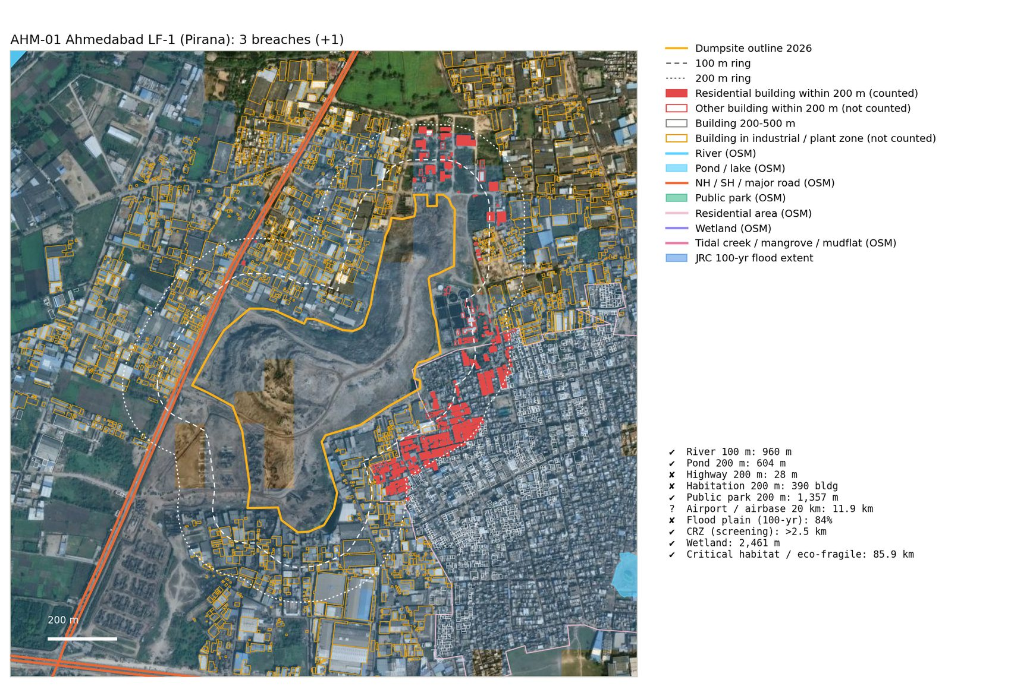
AHM-01 Ahmedabad LF-1 (Pirana)
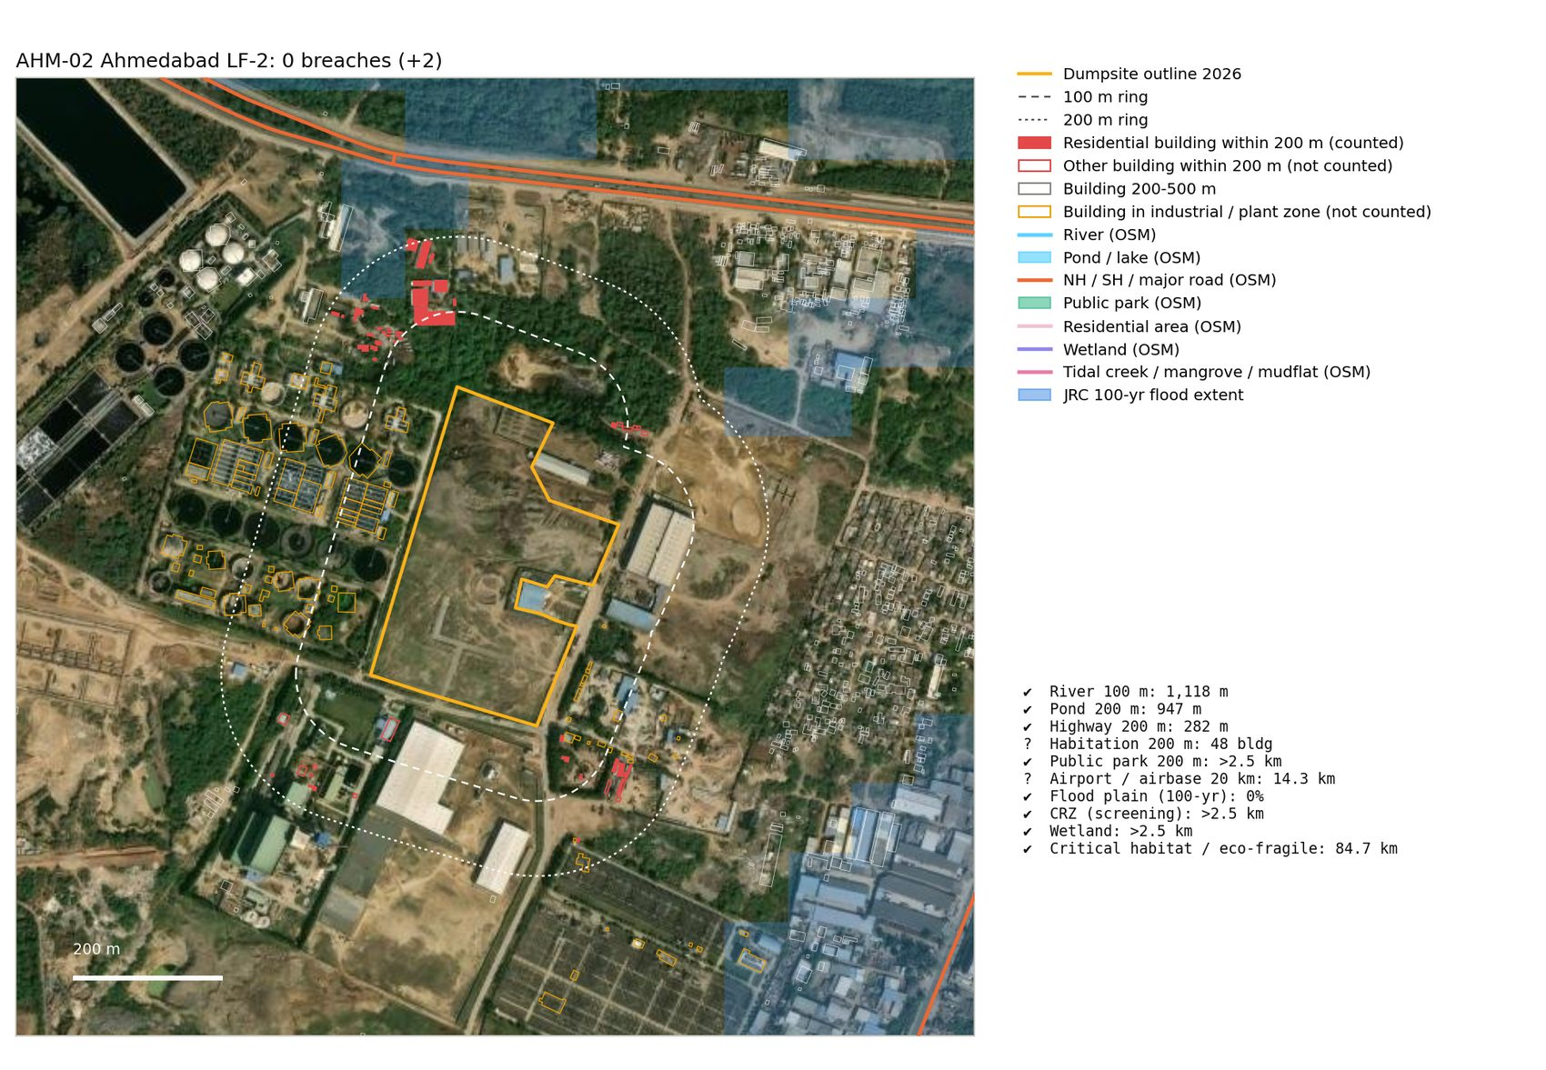
AHM-02 Ahmedabad LF-2
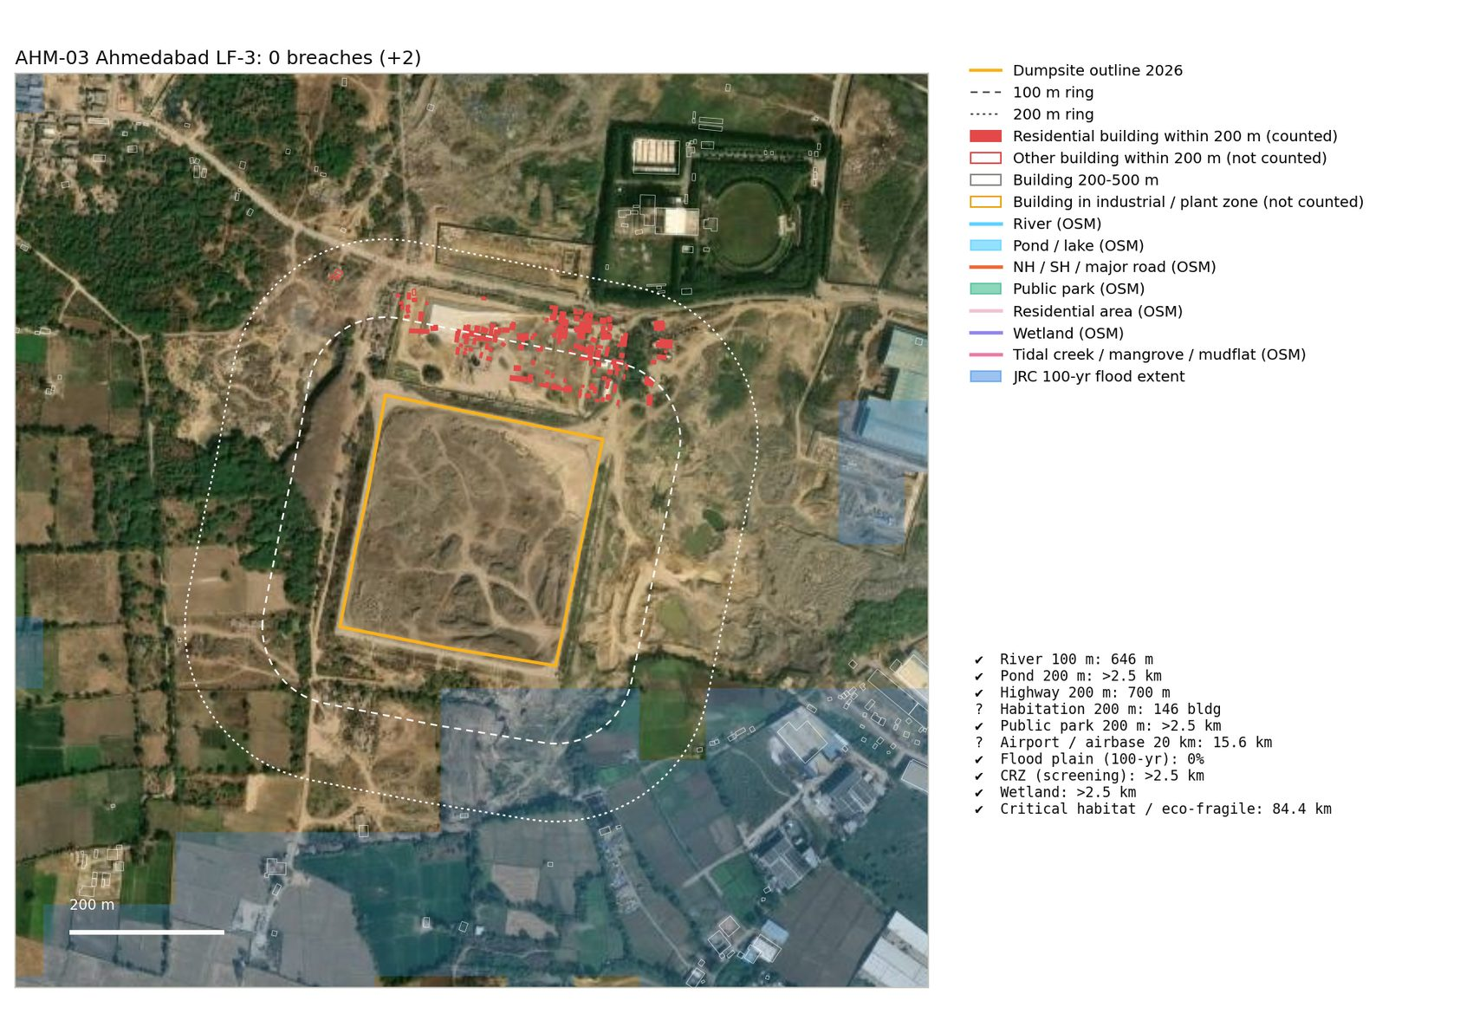
AHM-03 Ahmedabad LF-3
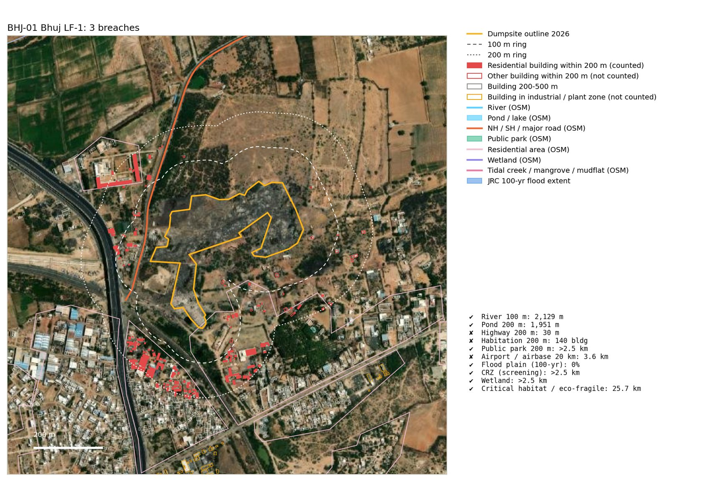
BHJ-01 Bhuj LF-1
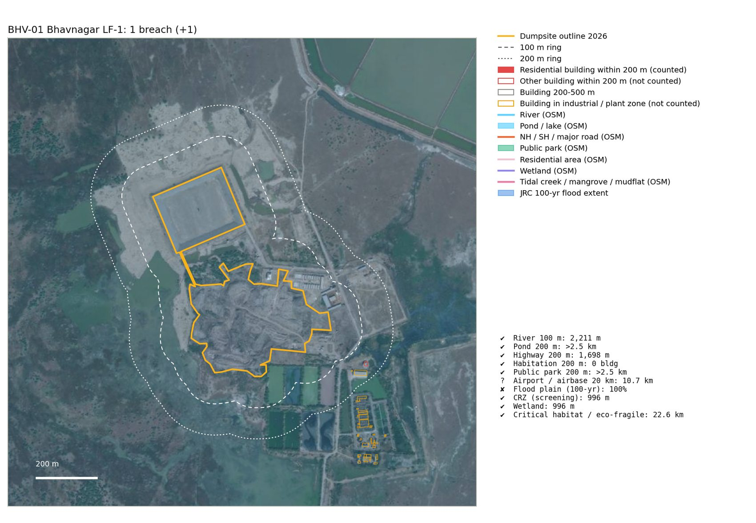
BHV-01 Bhavnagar LF-1
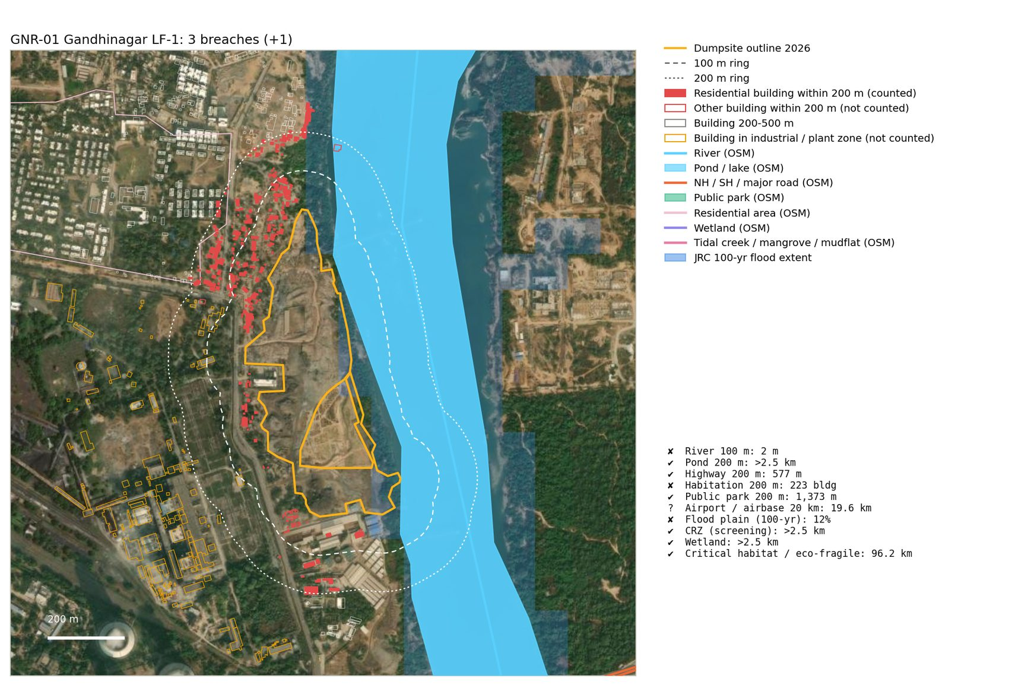
GNR-01 Gandhinagar LF-1
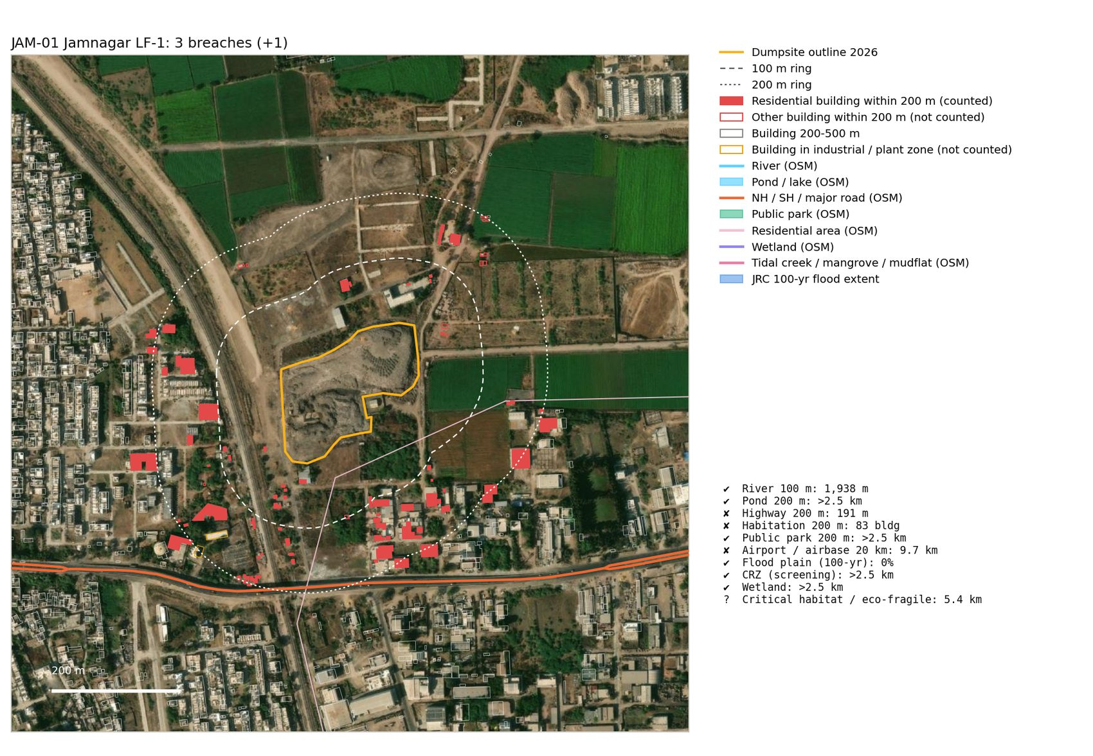
JAM-01 Jamnagar LF-1
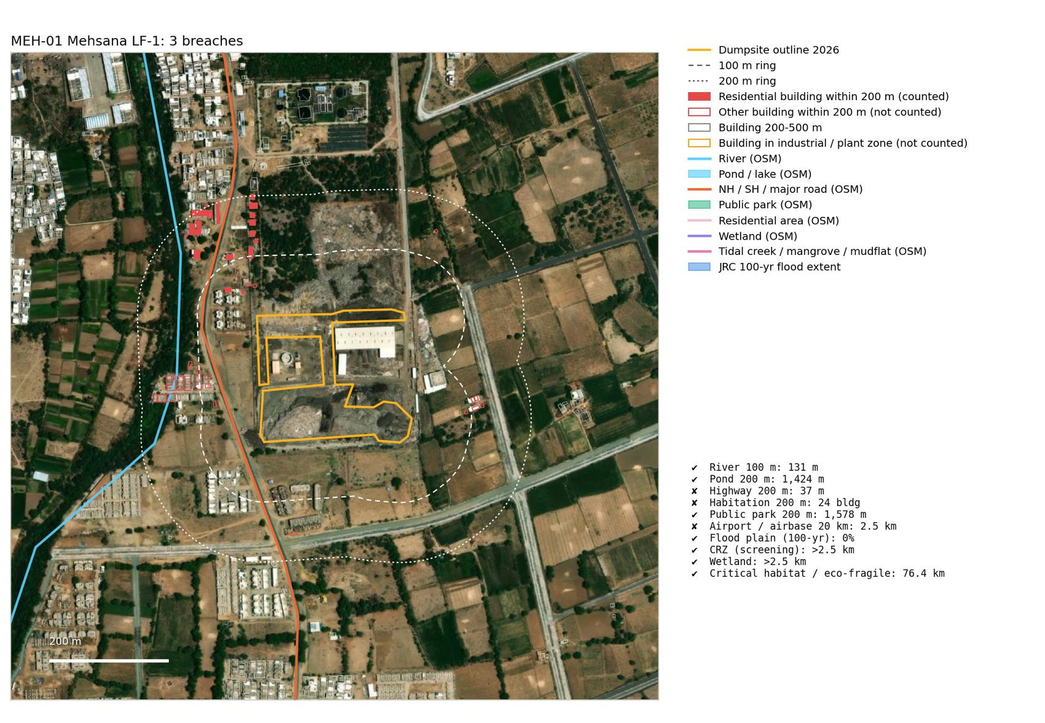
MEH-01 Mehsana LF-1
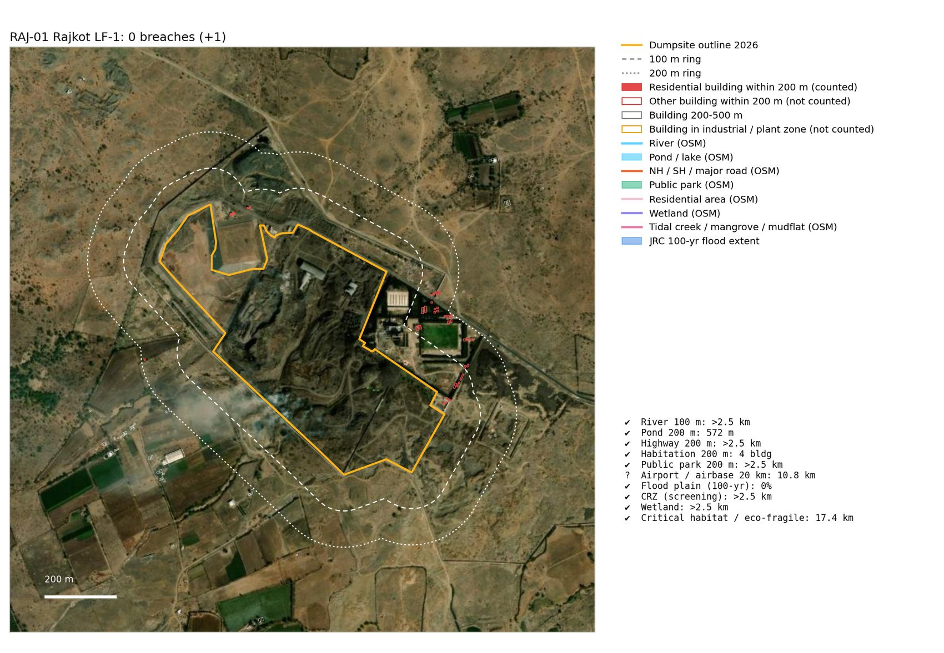
RAJ-01 Rajkot LF-1
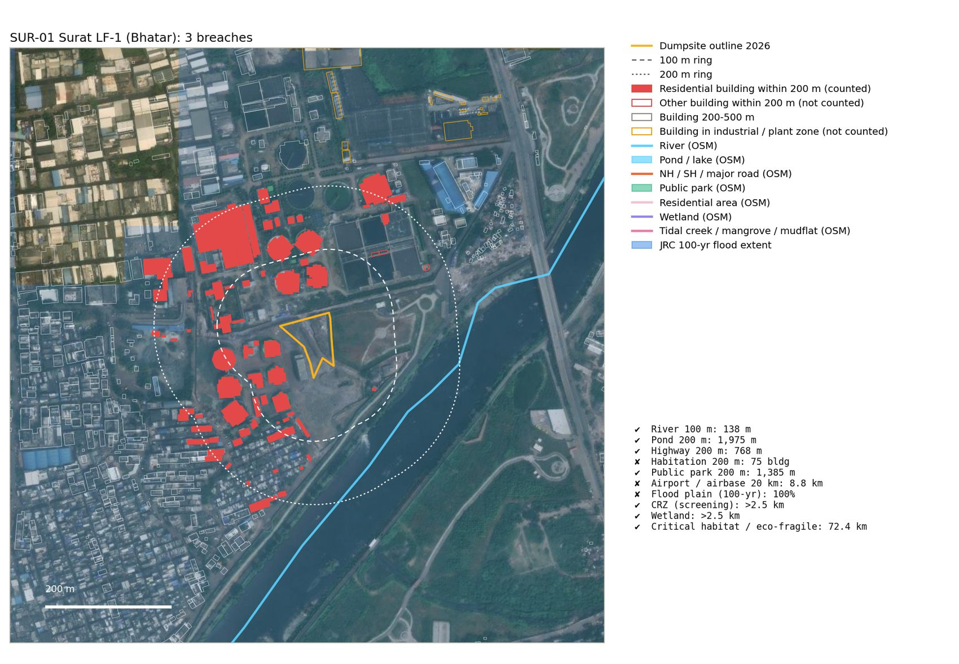
SUR-01 Surat LF-1 (Bhatar)
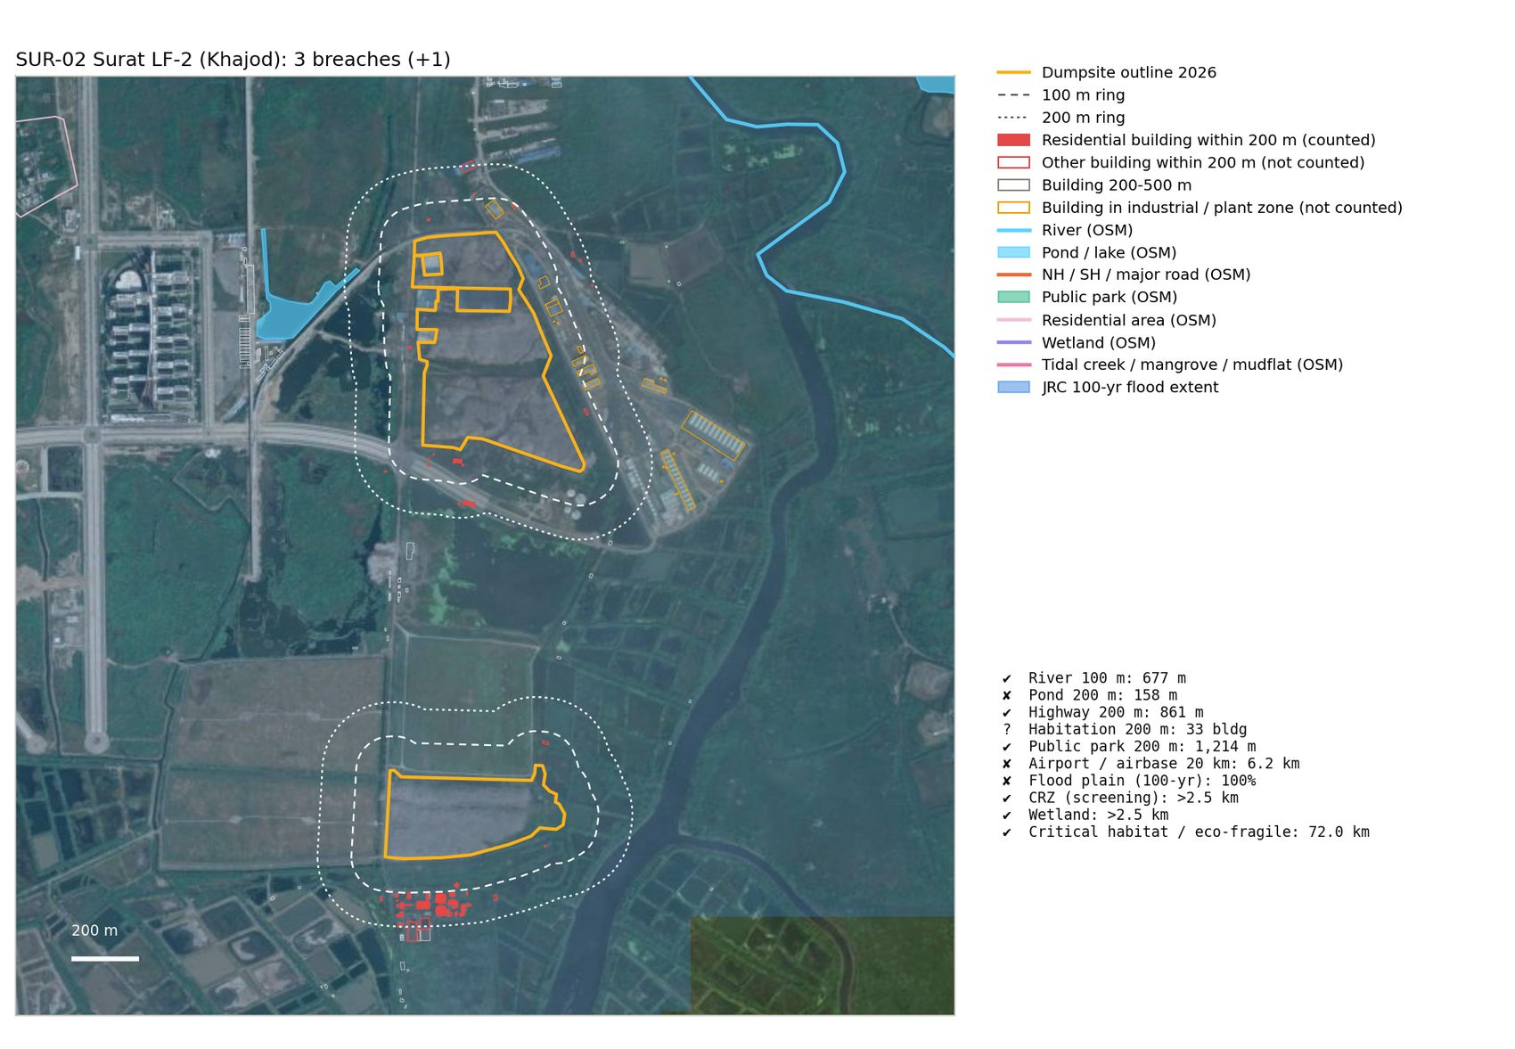
SUR-02 Surat LF-2 (Khajod)
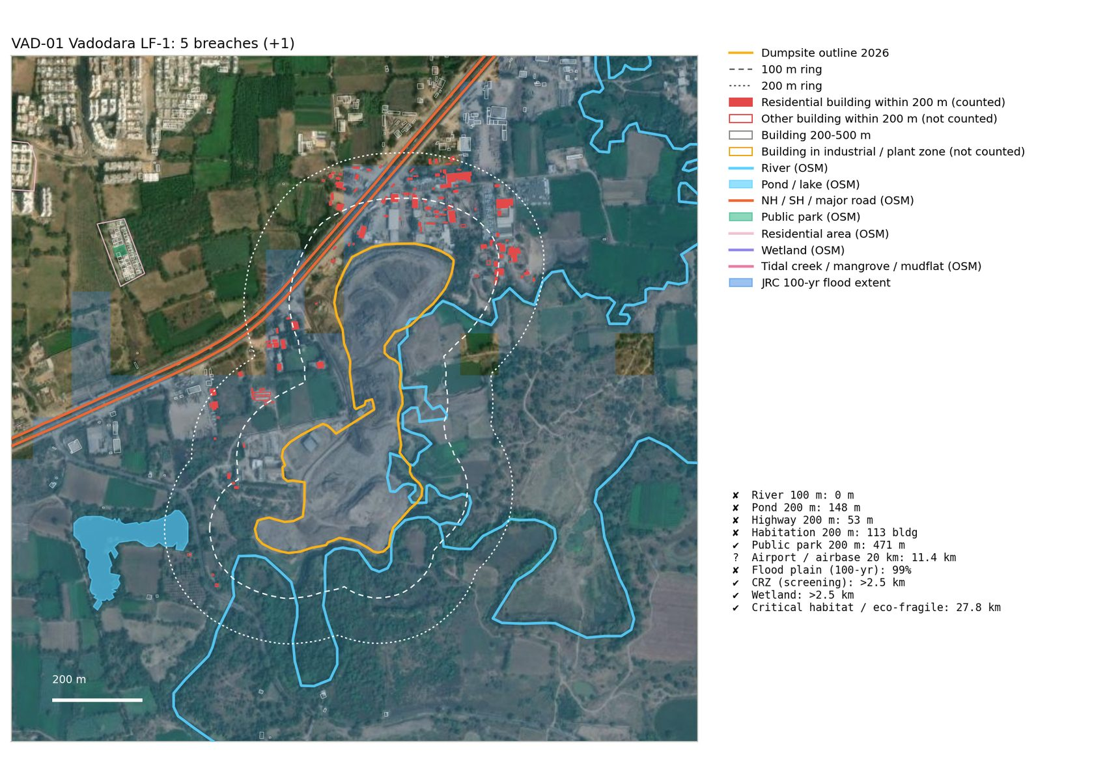
VAD-01 Vadodara LF-1
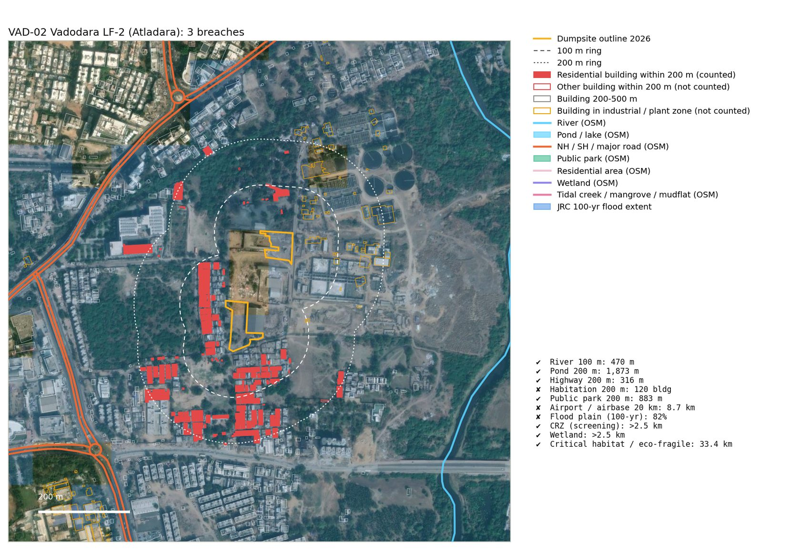
VAD-02 Vadodara LF-2 (Atladara)
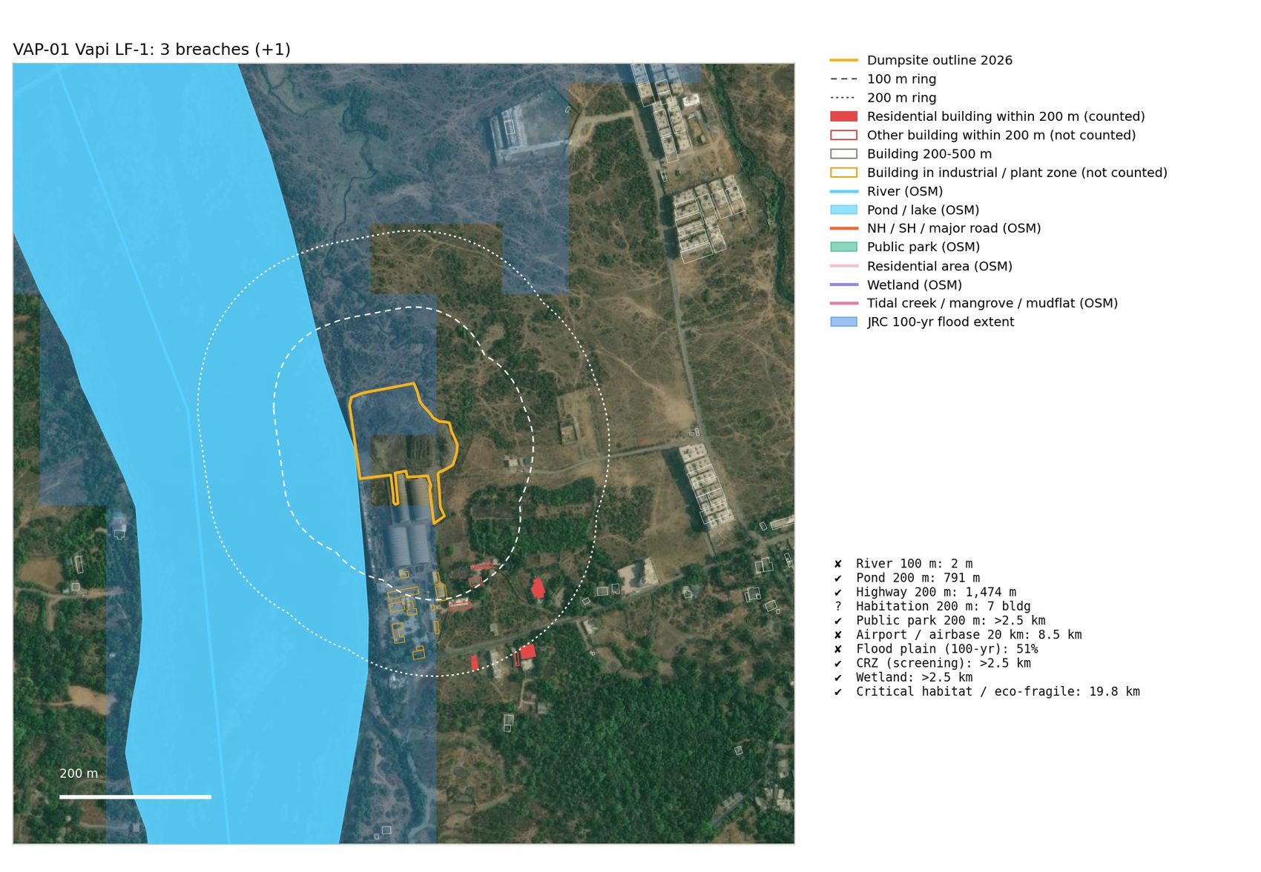
VAP-01 Vapi LF-1

Appendix B. Columns of siting_long.csv
Column | Meaning
site | Site ID
name | Site name
epoch | Outline year tested (2026 main, 2016 comparison)
outline_ha | Outline area (ha)
rule_id | R1-R12
rule | Rule name
limit | Legal limit
value | Measured value (nearest distance, km for R7 / R11, % for R8)
unit | Unit of value
nearest_feature | Nearest feature / explanation
n_within_limit | Number of features inside the limit (R4: residential buildings within 200 m)
verdict | breach / conditional / check / ok / not assessable
basis | Data and decision rule used
alt_value | Sensitivity value (R3 strict roads; R7 aerodrome boundary)
alt_verdict | Verdict with alt_value
alt_basis | What the sensitivity is
alt_feature | Nearest feature under the sensitivity
auto_verdict | R4 verdict before the imagery review
imagery_review | R4 imagery review (confirmed / likely / uncertain / none)
imagery_note | R4 review note
osm_residential_m | Distance to the nearest OSM residential area (m)
airport_kind | Airport type (scheduled / no scheduled flights / airstrip; military use)
flood_overlap_ha | Outline area inside the 100-yr flood extent (ha)
flood_nearest_m | Distance to the nearest flooded 90 m cell (m)
flood_max_depth_m | Maximum modelled depth under the outline (m)
other_protected_land | Nearest non-wildlife protected land (e.g. reserved forest), not scored

Appendix C. Parameters (scripts\config.py)
Parameter | Value
MAIN_EPOCH | 2026
COMPARE_EPOCH | 2016
FACILITY_BUFFER | 20.0
LOCAL_RADIUS | 2500.0
BUILDING_RADIUS | 600.0
GUJARAT_BBOX | (19.8, 68.0, 24.9, 74.6)
HIGHWAY_CLASSES | {'trunk', 'primary', 'motorway_link', 'primary_link', 'motorway', 'trunk_link'}
HIGHWAY_REF_REGEX | (?<![A-Za-z])(NH|SH|NE)(?![A-Za-z])
POND_WATER_TYPES | {'', 'lake', 'oxbow', 'reservoir', 'basin', 'lagoon', 'pond'}
MIN_POND_M2 | 100.0
PARK_LEISURE | {'park', 'recreation_ground'}
HAB_MIN_BUILDINGS | 5
HAB_SENS | (1, 5, 20)
TANK_MIN_M2 | 100.0
TANK_COMPACTNESS | 0.88
AIRPORT_NOC_MIN_M | 10000
AIRPORT_TYPES | {'medium_airport', 'small_airport', 'large_airport'}
CRZ_SEA_M | 500.0
CRZ_TIDAL_M | 50.0
ESZ_MIN_M | 1000.0
ESZ_DEFAULT_M | 10000.0
FLOOD_MIN_DEPTH | 0.0
FLOOD_MIN_FRAC | 0.1
OVERTURE_RELEASE | None
EPOCH_MAP | {2025: 2024}

