Predicting NFL Wide Receiver Performance to Identify
Contract Value

Capstone Report

Team Delta
William Reed and Jason Kuzmission
* Each author contributed equally to the design, coding & development, analysis, and writing of this project

Stakeholder: NFL General Manager

August 2026

GitHub Repository:
https://github.com/wreed25/Capstone-Project

Executive Summary
A wide receiver contract is a forward decision made with backward looking evidence. For a General Manager, the practical question is not simply what a receiver produced last season, but what level of receiving production is reasonable to expect next and whether the financial commitment is aligned with that expectation. This project built a decision support workflow around that question. Historical player performance was used to forecast next season receiving yards, and contract information was introduced only after the football prediction was complete.
The final modeling dataset contained 2,129 player season observations and 134 predictors. On the held out player grouped test set, tuned Random Forest produced the strongest overall result with a mean absolute error of 219.94 yards, root mean squared error of 295.65 yards, and R squared of 0.517. A second rolling future season evaluation added an important qualification. Multiple linear regression produced the lowest average mean absolute error at 185.19 yards, while Random Forest produced the lowest average root mean squared error at 246.47 yards and the highest average R squared at 0.608. In practical terms, Random Forest remained useful when larger misses mattered most, while linear regression remained a credible benchmark for typical error.
The final forecasts were then matched to historical wide receiver contracts. This produced 919 player season contract observations. Of those, 10 were classified as High Cost / Lower Production Review cases. These are not declarations that a contract was bad. They are a focused review queue that tells a front office where financial commitment and model expected receiving production appear unusually far apart. The recommended use is to combine these flags with scouting, medical information, roster role, guarantees, team need, and other football context before making a personnel decision.
1. The Decision Facing the General Manager
Wide receiver contracts force a front office to make a decision before the next season is played. Recent production is easy to see, but it does not travel cleanly from one season to the next. Opportunity can change. Quarterback play can change. Coaching, injuries, depth chart movement, and offensive role can change. A useful decision tool therefore has to look beyond last season receiving yards while still staying grounded in information that would have been available at the time of the decision.
This project asks whether historical wide receiver performance, usage, efficiency, and player information can predict next season receiving yards well enough to support later contract risk analysis for an NFL General Manager. The working hypothesis is that opportunity, efficiency, production, and experience contain useful predictive information, and that a multivariable model will outperform a simple forecast based only on previous season receiving yards.
A key design choice was to separate football forecasting from contract evaluation. Compensation was not allowed to influence the receiving yard prediction. Contract information entered the workflow only after the model produced its forward estimate. That separation matters because it keeps the performance forecast independent of the price that will later be judged against it.
2. Building a Reliable View of Future Production
The analysis began with player performance data from the nflverse ecosystem and organized the information at the player season level. The modeling target was next_season_receiving_yards, defined as the same player's receiving yards in the immediately following season. A season was included for supervised modeling only when the same player had a valid immediately following season, so the model learned from genuine season to season transitions rather than unrelated observations.
The dataset was expanded with receiving efficiency measures such as catch rate, yards per reception, yards per target, touchdowns per reception, and first downs per reception. Administrative identifiers, fantasy scoring fields, and future aware metadata were removed when they could duplicate information or reveal facts that would not have been available at prediction time. The resulting modeling dataset contained 2,129 player season observations and 134 predictors.

Table 1. Final Analytical Dataset and Validation Design
Measure | Final specification
Player season observations | 2,129
Model predictors | 134
Target | Next season receiving yards
Grouping variable | player_id
Held out validation | Player grouped
Player overlap across held out groups | 0
Additional validation | Season aware and rolling future season

3. What the Player Data Revealed
Before choosing a model, the player data were examined for the patterns a front office would expect to matter. The initial exploration used the broader integrated dataset to understand distributions, missingness, overlap among variables, and unusual observations. The main relationships were then checked again on the final 2,129 observation modeling dataset so the conclusions reflected the data actually used for prediction.

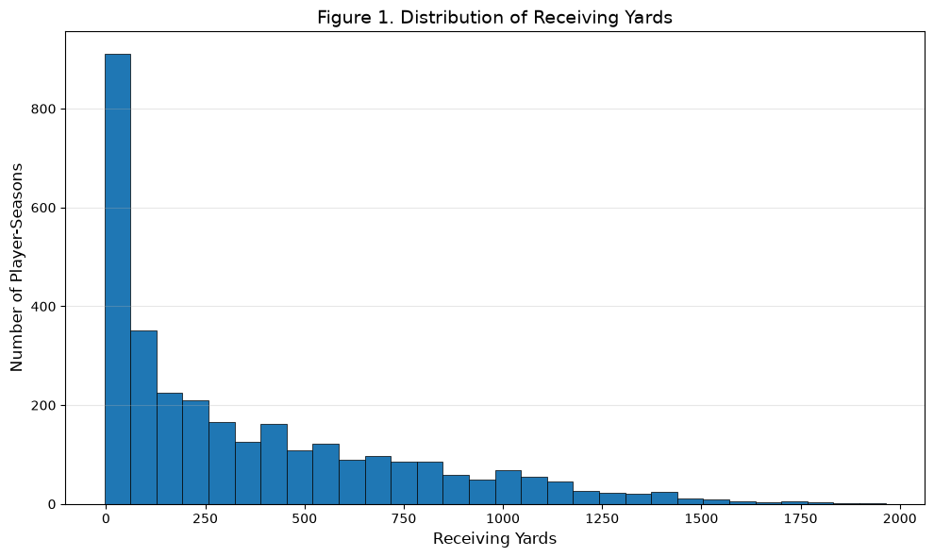
Figure 1. Distribution of receiving yards in the exploratory player season dataset.

Receiving production was concentrated among a relatively small group of players. Most player seasons fell in the lower and middle ranges, while a smaller number of high volume receivers created a long upper tail. For decision making, this means average model performance alone is not enough. Large misses on high production players can matter materially when the forecast is later compared with contract cost.
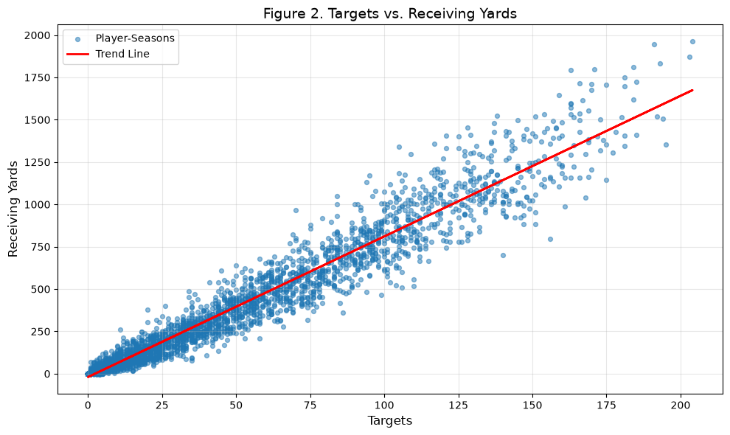
Figure 2. Targets versus receiving yards.

Opportunity emerged as one of the clearest signals. Players with more targets generally produced more receiving yards, but the relationship was not one for one. Receivers with similar target volume could finish with very different yardage totals. That spread is where efficiency, player context, and nonlinear relationships become useful.
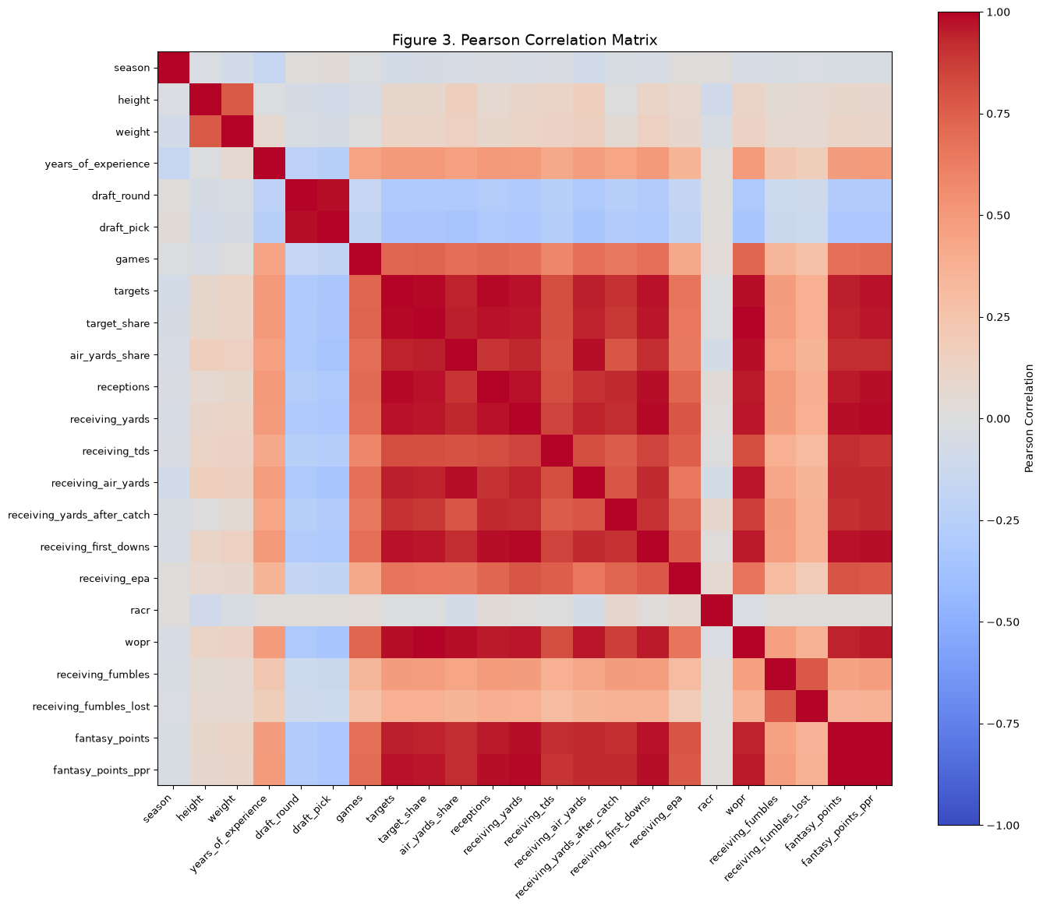
Figure 3. Pearson correlation matrix of candidate numerical variables.

The data also showed that many opportunity and production measures tell overlapping stories. Targets, receptions, target share, and current production were strongly related. That redundancy supported the use of dimensionality reduction, regularization, and tree based models rather than assuming every variable contributed unique information.

Table 2. Important Relationships Identified in the Player Data
Relationship or variable | Interpretation
Targets and receiving yards | Strong positive opportunity and production relationship
Targets and target share | Substantial redundancy among opportunity measures
Targets and receptions | Highly overlapping volume measures
Fantasy scoring variables | Composite measures overlapping underlying production
Draft round and draft pick | Closely related player metadata
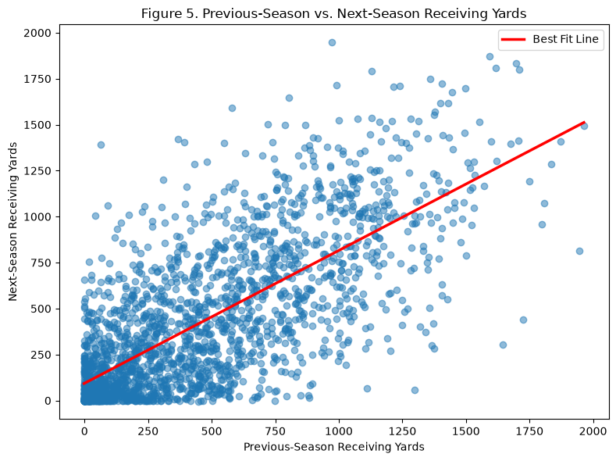
Figure 4. Current season versus next season receiving yards.

Last season production was informative, but not sufficient by itself. Current receiving yards correlated 0.726 with next season receiving yards, while targets correlated 0.705 with next season receiving yards. The relationship was strong enough to justify a persistence baseline, but the remaining spread showed why a broader model could add value.

Table 3. Key Relationships in the Final Modeling Dataset
Relationship | Pearson r
Current receiving yards vs. next season receiving yards | 0.726
Targets vs. next season receiving yards | 0.705
Current receiving yards vs. targets | 0.968

Taken together, the exploratory results told a consistent story. Historical production and opportunity provide a meaningful starting point, but they are noisy and highly related. The forecasting problem therefore requires a model that can use multiple signals without mistaking repeated versions of the same information for independent evidence.
4. Protecting the Forecast From False Confidence
The validation design was built around one practical risk: making the model look better than it really is. Because the same receiver can appear in several seasons, the primary held out test grouped observations by player. No player appeared in both the training and held out groups. Missing value imputation and scaling were learned from training data only and then applied to evaluation data. This kept information from the evaluation set from leaking into model preparation.
Two reduction approaches were also tested because the predictor set contained substantial overlap. Principal component analysis reduced 134 predictors to 46 components while retaining 95 percent of training variance. Lasso retained 64 predictors and reduced 70 coefficients to zero. These tests confirmed that much of the original predictor set was redundant, although the final nonlinear models were evaluated with the broader leakage controlled predictor set.

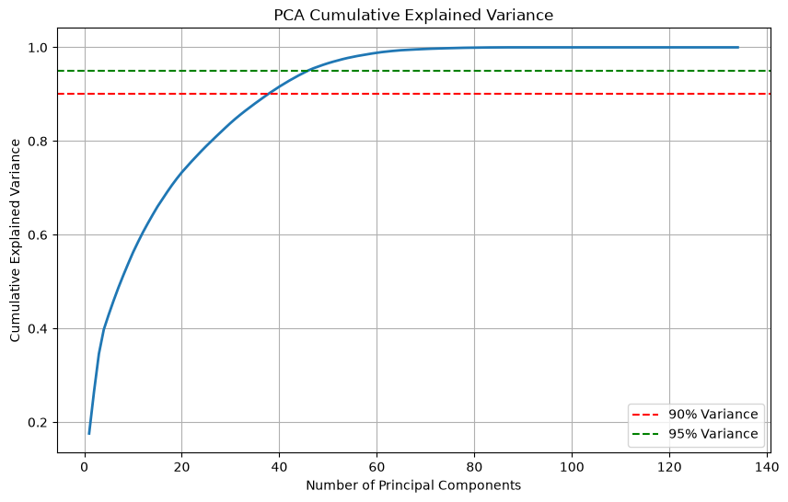
Figure 5. PCA cumulative explained variance on standardized training data.

5. Choosing a Forecast That Holds Up Under Pressure
The model comparison started with the simplest reasonable football forecast: assume next season receiving yards will equal the current season total. That historical persistence baseline established the minimum standard. Multiple linear regression then tested whether the broader predictor set added value. Random Forest and Gradient Boosting were added to capture interactions and nonlinear relationships that a straight line model may miss.
Model tuning preserved the player grouped structure. Five fold grouped cross validation kept observations from the same player together within validation folds. Random Forest tuning focused on mean absolute error, and the held out test set remained untouched until final comparison.
The model was judged with three complementary measures. Mean absolute error was the primary measure because it translates directly into typical receiving yard error. Root mean squared error was used to expose the cost of larger misses, which matter when a forecast feeds a contract review. R squared was treated as supporting evidence describing how much variation in next season production the model explained.

6. What the Forecast Can and Cannot Tell the Front Office
Table 4. Held Out Model Performance Comparison
Model | MAE | RMSE | R squared
Tuned Random Forest | 219.94 | 295.65 | 0.517
Untuned Random Forest | 221.98 | 297.67 | 0.510
Tuned Gradient Boosting | 224.42 | 299.33 | 0.505
Multiple Linear Regression | 224.57 | 304.43 | 0.488
Untuned Gradient Boosting | 227.90 | 306.91 | 0.480
Historical Persistence | 232.32 | 323.76 | 0.421

Tuned Random Forest was selected as the primary performance model because it achieved the lowest held out MAE, lowest held out RMSE, and highest held out R squared among the evaluated models. Its advantage over the alternatives is modest rather than overwhelming, so the result is best interpreted as an incremental improvement in generalization rather than evidence that future receiving production is highly predictable.
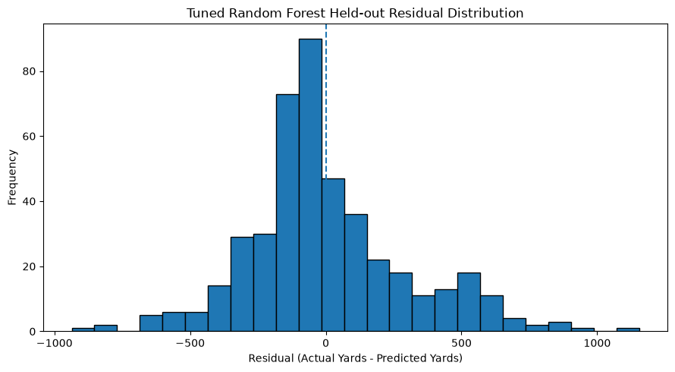
Figure 6. Tuned Random Forest held out residual distribution.

The tuned Random Forest showed almost no average directional bias, with a mean residual of 1.76 yards. The median residual was negative 56.58 yards, and the residual standard deviation was 295.64 yards. The largest underprediction was 1,154.22 yards and the largest overprediction was negative 936.19 yards. The practical message is straightforward: the model is reasonably centered overall, but individual player forecasts can still miss by a large amount.
Prediction uncertainty also changed across the forecast range. Errors were more tightly clustered at lower predicted receiving yard values and became more dispersed as predicted production increased. For a General Manager, that means a high forecast should not be read as a precise yardage promise. It is better understood as an estimate with greater uncertainty around some higher production players.
A season aware test provided another check on realism by training on predictor seasons through 2023 and evaluating the 2024 predictor season, corresponding to 2025 receiving outcomes. The tuned Random Forest produced a mean absolute error of 181.30 yards, root mean squared error of 247.59 yards, and R squared of 0.567. This supported the view that the model retained useful signal when the evaluation more closely resembled a real forward forecasting setting.

Table 5. Rolling Future Season Validation
Model | Mean MAE | Mean RMSE | Mean R squared
Tuned Random Forest | 190.17 | 246.47 | 0.608
Multiple Linear Regression | 185.19 | 247.93 | 0.605
Historical Persistence | 193.68 | 268.04 | 0.532

Rolling evaluation provides a more nuanced comparison than the single held out split. Linear regression produced the lowest average MAE across the four future season tests, while Random Forest produced the lowest average RMSE and highest average R squared. Both fitted models improved on historical persistence in RMSE and R squared. This result prevents an overly broad claim that Random Forest dominates every metric in every setting. Instead, Random Forest remains the selected held out model while linear regression remains a credible benchmark, especially when typical absolute error is the only criterion.

7. Turning the Forecast Into a Contract Review Queue
Once the football forecasts were complete, contract data were added for the business decision. The contract history contained 7,122 events across 1,626 wide receivers. The forecasting pipeline generated 1,976 forward predictions covering outcome seasons 2014 through 2025. Of those predictions, 919 matched at least one contract signed for the corresponding outcome season.
Some player seasons matched more than one contract event. To create one reproducible record for review, contract types were prioritized in this order: Extension, Franchise, UFA, RFA, ERFA, Drafted, Other, SFA, and Practice. APY was used to break ties within the same priority. Later contract status was not used to choose the historical contract because doing so could introduce hindsight into a decision that should be evaluated using information available at the time.
The final screening framework compares each contract with its own season rather than using one dollar threshold across the entire NFL history. Contract cost and predicted production were first compared with season specific median benchmarks. Raw value ratios were useful descriptively, but they could become extreme for very inexpensive contracts. For the final categories, cost and predicted production were therefore converted to season specific percentile ranks. The value gap equals production percentile minus cost percentile. A strongly negative gap means the contract ranks much higher in cost than the player ranks in expected receiving production. A positive gap means expected production ranks more favorably than cost.

Table 6. Contract Review Category Distribution
GM category | Observations
Market Aligned / Other | 719
High Cost / High Production | 177
Lower Cost / High Production Value | 13
High Cost / Lower Production Review | 10
Total | 919

Table 7. Primary High Cost / Lower Production Review Cases
Player | Team | Outcome | Type | Pred. yards | Cost pct. | Prod. pct. | Value gap
Matt Slater | Patriots | 2020 | UFA | 47.95 | 0.773 | 0.015 | -0.758
Allen Robinson | Bears | 2018 | UFA | 208.11 | 0.917 | 0.250 | -0.667
Markus Wheaton | Bears | 2017 | UFA | 172.63 | 0.813 | 0.156 | -0.656
Deonte Harty | Bills | 2023 | UFA | 107.25 | 0.821 | 0.179 | -0.641
Andre Roberts | Texans | 2021 | UFA | 108.30 | 0.752 | 0.114 | -0.638
Jamal Agnew | Jaguars | 2021 | UFA | 146.90 | 0.805 | 0.238 | -0.567
Tavon Austin | Cowboys | 2018 | Other | 242.38 | 0.813 | 0.333 | -0.479
Cedrick Wilson Jr. | Dolphins | 2023 | Other | 221.61 | 0.840 | 0.449 | -0.391
Marquise Brown | Chiefs | 2025 | UFA | 208.80 | 0.789 | 0.442 | -0.347
JuJu Smith-Schuster | Chiefs | 2022 | UFA | 239.00 | 0.752 | 0.427 | -0.325

The screen identified 10 High Cost / Lower Production Review cases. These cases are where the tool earns its place in a front office workflow, but also where judgment matters most. A flag does not mean the contract was a mistake. Receiving yards do not capture special teams value, blocking, leadership, availability, defensive attention, or a role that may be strategically important even with limited receiving volume. The flag means the financial commitment and expected receiving production are far enough apart to justify a deeper review.

8. The Business Meaning of the Results
The analysis supports the core idea behind the project: a front office can learn more from the broader historical profile of a receiver than from simply carrying last season yardage forward. Every fitted model in the held out comparison improved on historical persistence, and tuned Random Forest produced the strongest held out combination of mean absolute error, root mean squared error, and R squared.
The future season tests also prevent the model from being oversold. Linear regression was slightly better on average mean absolute error, while Random Forest was better on average root mean squared error and R squared. That distinction matters. If the front office cares most about the typical miss, linear regression deserves attention. If larger errors create greater financial concern, Random Forest has a stronger case because root mean squared error penalizes those misses more heavily.
The value of the project is not a promise of precise receiving yard forecasts. It is a disciplined way to turn historical performance into a forward estimate and then use that estimate to focus contract review. Instead of asking a General Manager to inspect every contract equally, the workflow narrows attention to cases where expected receiving production and financial commitment appear unusually misaligned.

9. Where Football Context Still Matters
Several important football factors remain outside the model. Injuries, quarterback changes, coaching changes, offensive scheme, depth chart movement, trades, player development, age related decline, route participation, and playing time can all change a receiver future opportunity in ways that prior season statistics may not capture.
Receiving yards are also only one part of wide receiver value. Blocking, special teams work, leadership, route gravity, situational performance, and tactical role can matter to a team even when receiving volume is modest. The contract analysis also emphasizes APY and same year contract matching. It does not fully model guarantees, incentives, option structures, cap charges, dead money, or every transaction detail that shapes the true economic cost of a deal.
The NFL environment will continue to change. Offensive trends, rules, data definitions, roster construction, and the labor market can shift over time. The model should therefore be refreshed and revalidated as new seasons become available rather than treated as a permanent scoring system.

10. Recommended Front Office Use
Use the model as a review queue, not as a contract verdict. High Cost / Lower Production cases should trigger a structured second look at medical information, scouting grades, role, guarantees, roster alternatives, and team need. Lower Cost / High Production cases can be used in the opposite direction to surface players whose expected receiving production may justify closer acquisition, extension, or retention review.
The next version should add injury history, quarterback quality, offensive environment, route and snap participation, age curves, and richer contract structure. Prediction intervals or another measure of forecast uncertainty would also improve the decision process by showing when two similar point forecasts carry very different levels of confidence.

11. Technical Reproducibility
The complete analytical workflow is maintained in the project GitHub repository. The notebooks are organized in execution order so that data validation, integration, exploration, feature engineering, modeling, evaluation, and contract decision support can be reproduced from the beginning.

Order | Notebook
01 | Data Source Validation
02 | Data Collection and Integration
03 | Exploratory Data Analysis
04 | Feature Engineering and Preprocessing
05 | Modeling
06 | Baseline Models
07 | Model Tuning and Evaluation
08 | Contract Value and GM Decision Support

The analysis is implemented in Python using the project environment and dependencies documented in the repository. Random states are fixed where supported, including random state 42 for the principal training, testing, and tuning procedures. This allows the technical team to reproduce the reported results and update the workflow as new NFL seasons become available.

References
nflverse. nflverse documentation. https://nflverse.nflverse.com/
scikit-learn developers. scikit-learn documentation. https://scikit-learn.org/
Polars developers. Polars documentation. https://docs.pola.rs/
statsmodels developers. statsmodels documentation. https://www.statsmodels.org/

Appendix A. Data Dictionary
The complete project codebook is maintained with the GitHub repository and is the authoritative reference for the finalized modeling fields. It identifies each field, data type, analytical role, and plain language definition. The full predictor list is kept outside the main stakeholder narrative because it is technical reference material rather than a decision making requirement.

Appendix B. Additional Model Results
Principal component linear regression achieved a mean absolute error of 221.97 yards, root mean squared error of 296.64 yards, and R squared of 0.514. Lasso regression achieved a mean absolute error of 221.00 yards, root mean squared error of 297.40 yards, and R squared of 0.511. These results showed that substantial dimensionality reduction was possible without destroying predictive performance, but tuned Random Forest retained the strongest held out overall result.

Appendix C. GM Decision Support Output
The final GM decision support dataset contains 919 observations and 18 fields covering outcome seasons 2014 through 2025. The saved file was reloaded and audited with zero duplicate player season outcome keys and zero missing GM categories. The final distribution was 719 Market Aligned / Other, 177 High Cost / High Production, 13 Lower Cost / High Production Value, and 10 High Cost / Lower Production Review observations.

