**Linux Mastery: Master the Linux Command Line in 11.5 Hours**

**Section 8**

**Setting up Linux virtual machine**

1.Installing virtual Box

* download oracle virtualBox for windows.
* install virtualbox on your pc.
* download ubuntu a linux distro from ubuntu site.
* file will be save in downloads as disk image file eg: ubuntu.img.
* open virtualbox and select new option and configure the virtual machine.
* create a virtual hard disk in vdi(virtualbox disk image).
* now open the settings and select ubuntu.img for controller:IDE field.
* then click on start to launch ubuntu.

2.Setting up linux virtual machine

* after the successfull booting of ubuntu select install ubuntu.
* then select "Erase disk and install Ubuntu";
* select location ,keyboard and then move on with username and password.
* now click on "continue" will start installing it will take 10-20 minutes.
* after installation is completed click on restart , now ubuntu is ready to use.

**Assignment**

**Assignment 1 : "Pipeline Master" Project**

**Task 1 :**

Command 1 : **ls /etc | tee file1.txt|ls /run |tee file2.txt**

Explanation : This command will list the items present in the /etc directory and will append in file1.txt using tee command and list the items present in /run directory and will append in file2.txt.

**Task 2 :**

Command 2 : **cat file1.txt file2.txt | tee unsorted.txt | sort -r >reversed.txt**

Explanation : This command will print the content of file present in file1.txt and file2.txt and append in unsorted.txt. The unsorted.txt file will be sorted in reverse order and append the data in reversed .txt.

**Output:**

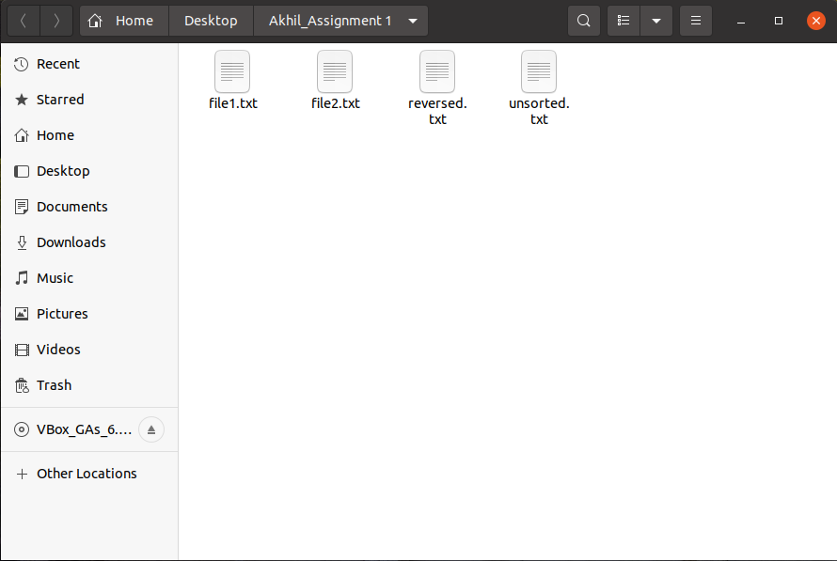

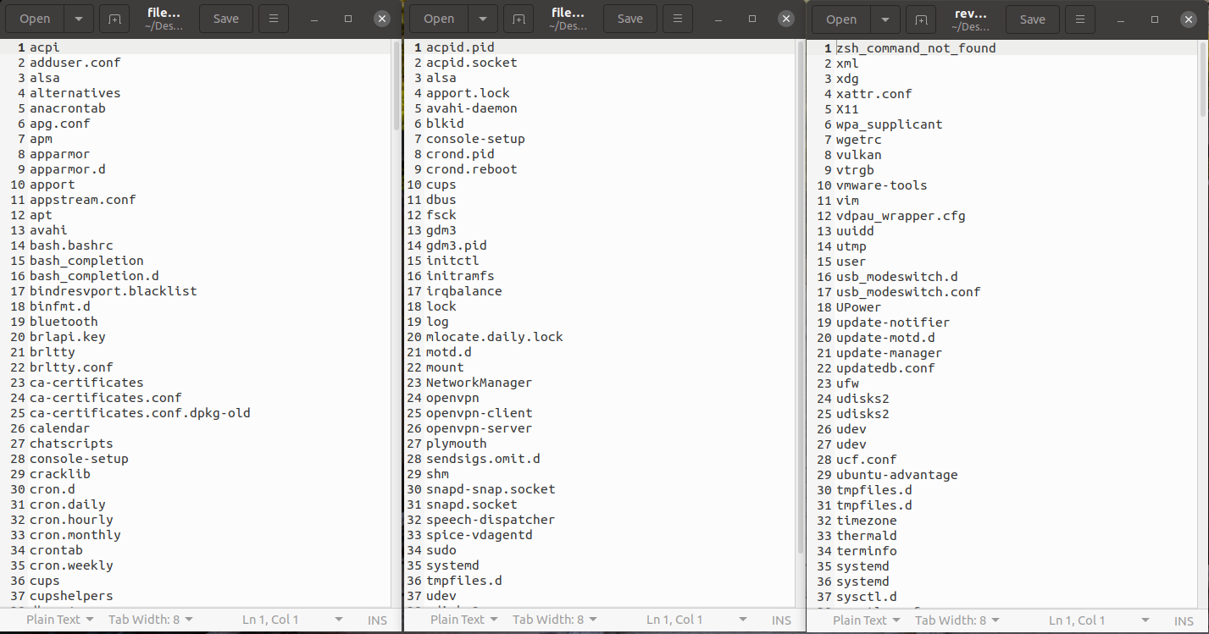

**Assignment 2 : "Super Secret" Project**

**Task 1 :**

Command 1 : mkdir Desktop/super_secret_stuff

Explanation : This command will create a directory named super_secret_stuff in Desktop.

Command 2 : touch Desktop/super_secret_stuff/top_secret.txt

Explanation : This command will create a text file named top_secret.txt inside Desktop/super_secret_stuff directry.

Command 3 : sudo updatedb

Explanation : This command will update database.

Command 4 : locate top_secret > ~/secret_place.txt

Explanation : This command will locate the top_secret file and append the path of the file in secret_place.txt file.

**Output:**

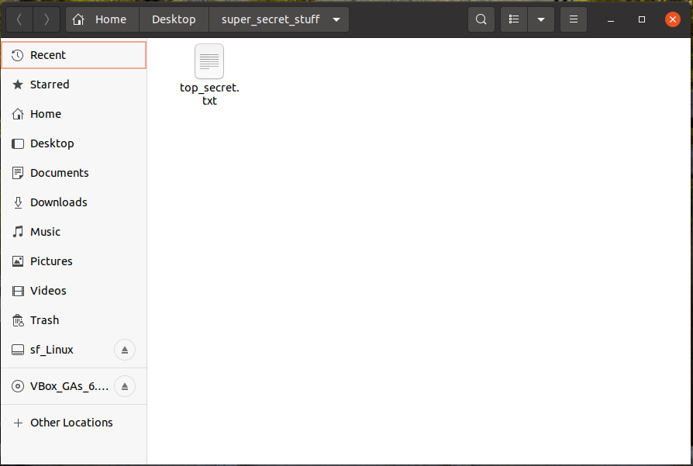

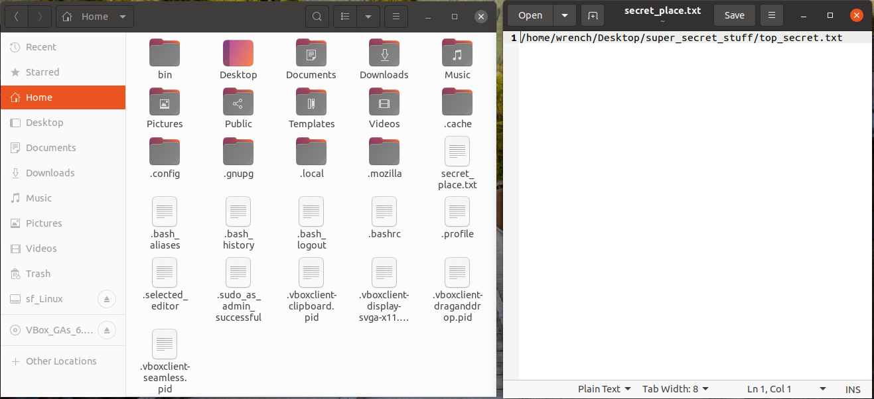

**Task 2 :**

Command 5 : sudo find / -maxdepth 4 -type f -size +1M -exec ls -lh {} \; | sort -k 5hr > filesizes.txt

Explanation : This command will find all the files from root directory to a maximum depth of 4 levels with files having size more than 1MB and executes the "ls -lh" command and sort the list in reverse order of the 5th column of the list and appends the data in filesizes.txt.

**Output:**

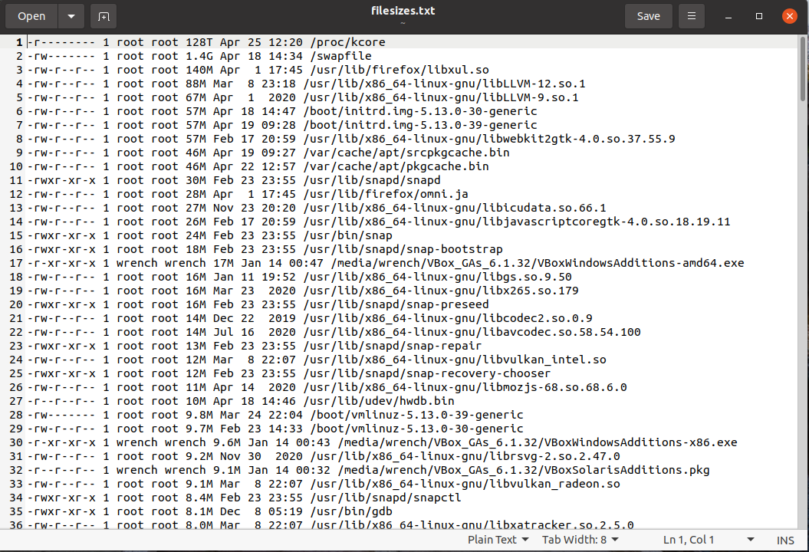

**Assignment 3 : "Hungry for Data" Project**

**Task 1 :**

File content : filename : hungery.sh

#!/bin/bash

echo "I am hungry. Feed me data." >> ~/demands.txt

date >> ~/demands.log

Explanation : bash file is created in the name of hungery.sh.

Text and date are appended in demands.txt and demands.log files.

**Output:**

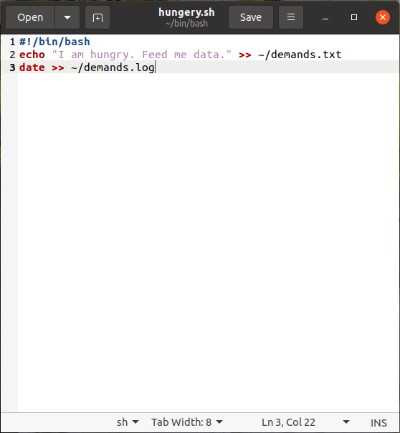

**Task 2 :**

Command 1 : crontab -e

Explanation : Opened crontab -e for scheduled operation of bash file

File content : Inside Crontab

* * * * * bash ~/bin/bash/hungery.sh

Explanation : This command inside crontab will run the bash file hungery.sh automatically in 1 minute time interval.

**Output:**

