CWB110 Midterm Project
(50 points)
Getting started
- Extract mterm.zip to the location of choice on your workstation– it contains:
  - mterm.html – the base web page for the project
  - images folder – contains images to use in the project (3 images).
  - html5doctype.txt – W3C compliant HTML5 doctype template for page.
- add title,”CWB110 Midterm Project”, to mterm.html.
- add student name in a remark tag.
- Add the html5 doctype declaration structure to mterm.html using the appropriate text from html5doctype.txt. Save the file as mterm_solution.html
- note the page is organized, for the most part, into html5 structural elements. The exception being the <div> assigned an id of “container”, which encapsulates the entire page.
- create and format the page exactly as indicated in the instructions and screen shots below.
- create an external style sheet, mterm.css, and use it exclusively to format the project.
- I will use Firefox browser to grade the projects so be sure your project displays correctly in this browser.
page
- sans-serif font family.
- window background color is #666666.
- use ems for all measurements throughout project.
- add all appropriate element tags (see Figure 4 and 5).
- default link color #3CF with no underline.
- default link :hover underlines link but does not change the color.
container
- set width to 48.12em (770px – normal browser base is 16px thus 770/16 = 48.12em).
- center container using CSS margins.
- container background is #FFF.
heading
- water.jpg is the background image.
- image used is 770px by 155px – this defines page width and height of the header.
- position and size the header text appropriately using the appropriate element tag and padding to position it as shown. Color is #39F.
navigation (nav)
- position links as indicated(horizontally)
- apply sufficient space between each link and “ | “ as shown in the example (hint: padding ).
- text is #FFF.
- links are bolded with no underline.
- links are small caps (hint: font-variant).
- :hover changes link color to #CCC.
- nav background is #000.
section
- apply appropriate heading tags to sub headings (“The old man and the sea kayak”, “Surfing with Sponge Bob and Squidward”, and “ Anchovy herding”) Note headings are serif font-family, color is #39F.
- float section left and apply an appropriate width to it.
- create two classes and use them to float the two images, boat_sm.jpg and rope_post_sm.jpg, appropriately. Format both images for breathing room from text.
- format the <ul> in the 2nd paragraph appropriately. The <li>s are hyperlinks so add the appropriate element tags. use href=”#” as the source for the links.
aside
- apply appropriate heading tags to the sub heading elements (use screen shots as pattern).
- smaller headings are #39F.
- larger headings and default text are #9CF.
- set width to 13em.
- float aside right.
- background color is #414C46.
- format “more…” in each section as a hyperlink use href=”#” as the source for the links.
- format the <ul> under Archive. The <li>s are hyperlinks so add the appropriate element tags. Use href=”#” as the source for the links.
footer
- clear the floats.
- use a top border as a divider.
- insert the © character.
- apply an appropriate height.
- hyperlink color is #39F and bolded.
- :hover is #3CF.
- text-decoration follows default for page.

Figure 1.
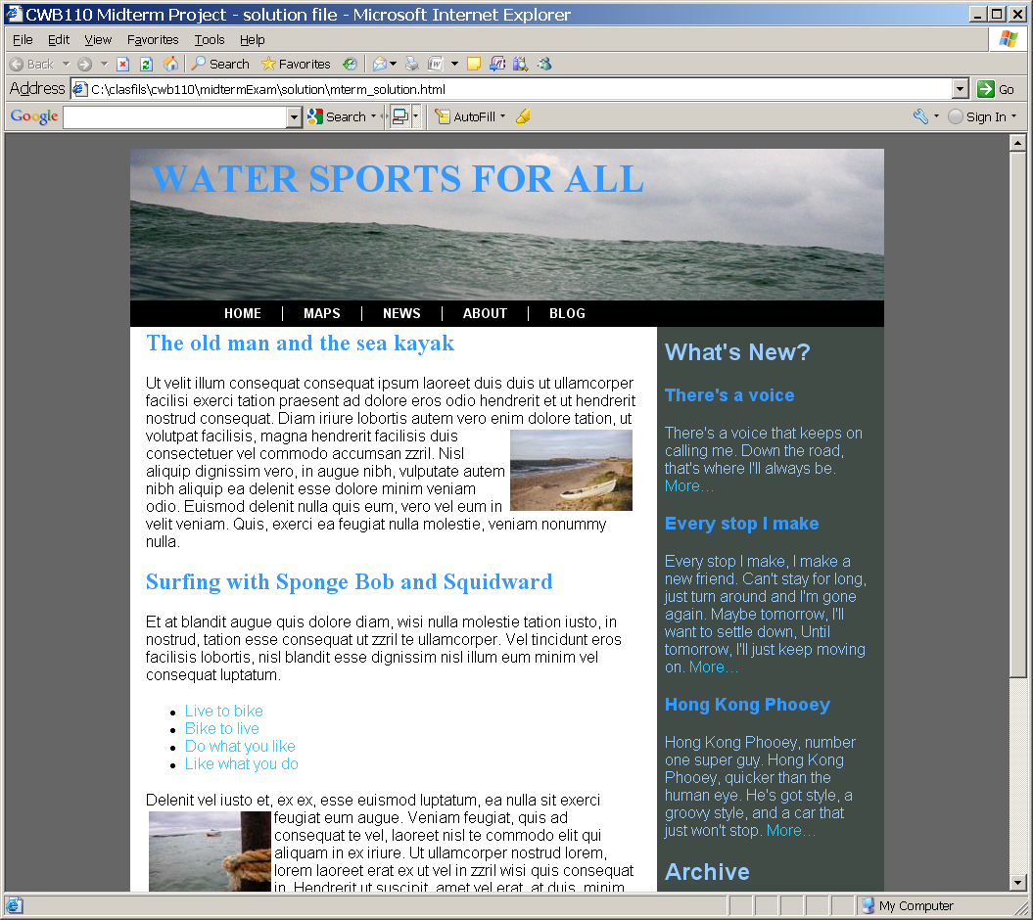
- page centered, width applied
- page main font - sans serif
- note breathing room between content and border in all areas of the page.
- heading text positioned appropriately
- window background color applied #666666
- nav hyperlinks small caps, white – note positioning and :hover must be added.
- add appropriate element tags for headings – note serif font-family
- create 2 classes to control floating the two images.
- add tags to format as an unordered list. Each list item is a hyperlink. Note :hover must be added.
- section is floated left.

Figure 2.
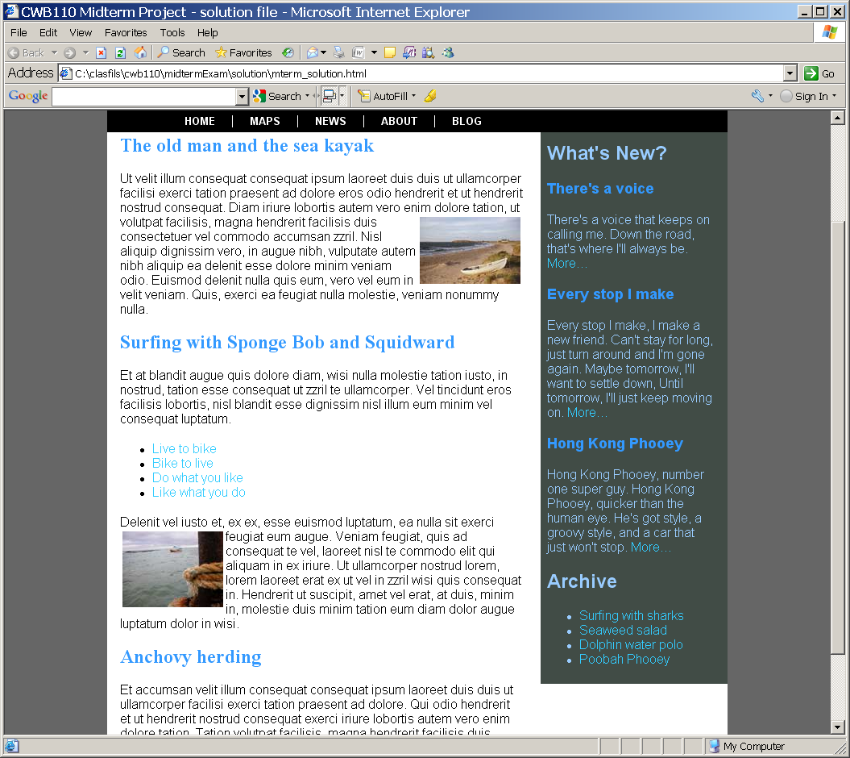
- apply appropriate element tags to aside content headings
- hyperlinks
- format list. Each item is a hyperlink.
- aside is floated right

Figure 3.
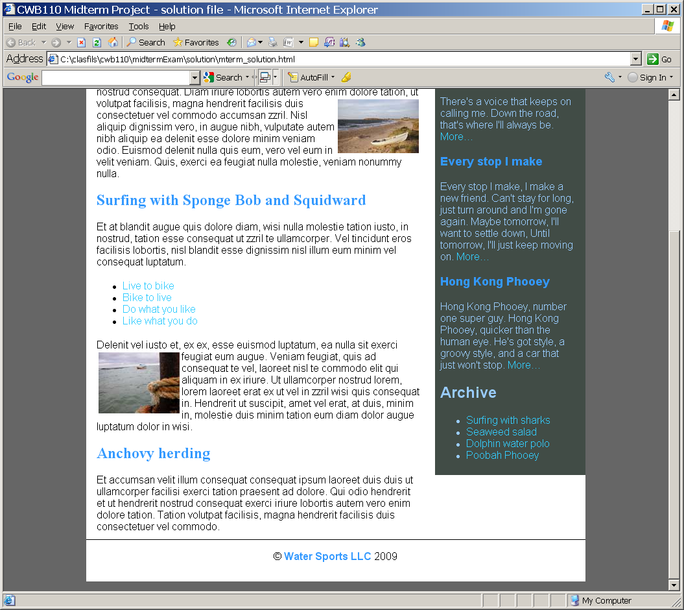
- separate footer from content with top border.
- add © character
- apply breathing room

Figure 4.
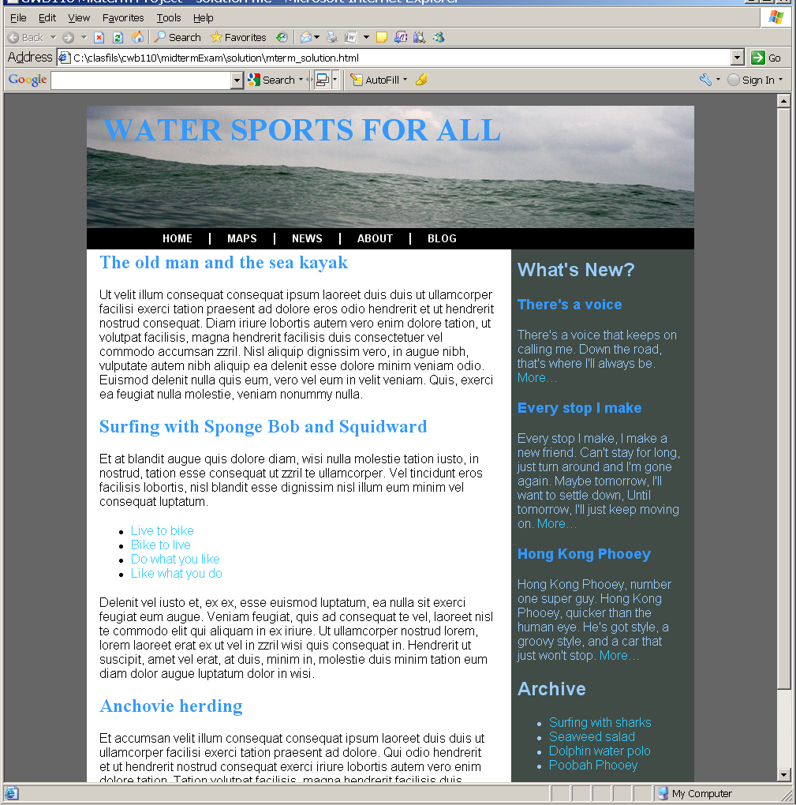

Figure 5.
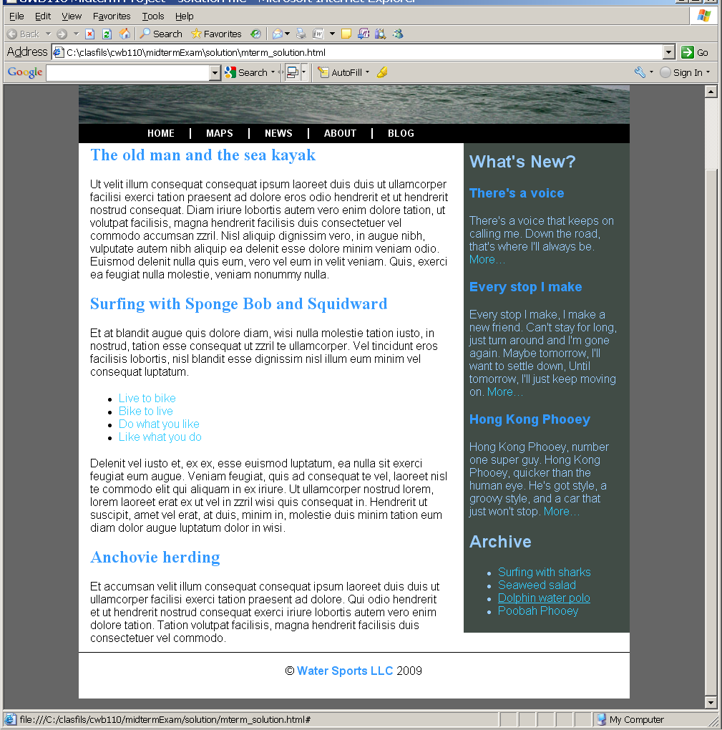

Submission
Submit your project to the cislinux server in your web server directory. Be sure to double check your submitted project in Firefox browser(on the web server) and correct any problems you may encounter.
Submit the “itsup.txt” file to the Aims Online Dropbox area for this assignment.

