

Engagement Services

Management System (ESMS)

Users Guide

Friday, April 27, 2012

**Table of Contents**

Introduction 3

What is ESMS? 3

Technical Information 3

Logging in to ESMS 4

Requesting an ESMS Account 4

I Forgot My ESMS Account Information 4

How Do I Login to ESMS? 4

Using ESMS 5

My Engagements 5

Manage Servers 6

Manage Servers: Basic Functions 6

Manage Servers: Administrative Functions 8

Manage IP Addresses 13

Manage IP Addresses: Basic Functions 13

Manage IP Addresses: Administrative Functions 15

Manage Switches & Ports 17

Manage Switches & Ports: Basic Functions 17

Manage Switches & Ports: Administrative Functions 19

Administrative Only Sections 21

Users & Contacts Section 21

Cabinets & Racks Section 23

Hardware Section 24

Software Section 27

Change Log Section 27

System Console Section 28

SQL Console Section 29

Additional ESMS Information 30

# Introduction

## What is ESMS?

The Engagement Services Management System is a web-based database intended to help the Data Center team manage all aspects of the deployment of servers for intake clients. Currently it can be used to manage rackspace for servers (both physical and virtual), portspace for network switches, IP address requests, and OS installations.

## Technical Information

From a technical perspective ESMS is a 32-bit client/server ASP.NET 4.0 application that is written in XML and C#. Its database backend is a simple MS-JET MDB that is accessed through ADO.NET. ESMS requires a Windows x86 Microsoft IIS server with the full .NET Framework 4.0 SDK installed. The system is completely open-source at this time. The footprint of ESMS at this time is approximately 20MB, but as it is a system in active development this footprint is likely to change frequently. ESMS is designed to be completely self-contained and will function well on a shared MS-IIS server hosting other applications.

# Logging in to ESMS

## Requesting an ESMS Account

ESMS is Active Directory integrated so you’ll need to request to have your AD account added to the FS_ESMS_Users AD Group, and this will be facilitated by the AD team ([ad_support@fs.fed.us](mailto:ad_support@fs.fed.us)). You’ll need to provide your supervisor’s name when requesting access.

## I Forgot My ESMS Account Information

ESMS uses your Active Directory credentials. If you’re seeing a message like “AD Auth was successful, but your username has not been granted access to this system!” it means that your AD user and password worked, but your account isn’t in the group allowed access to ESMS. Contact AD Support ([ad_support@fs.fed.us](mailto:ad_support@fs.fed.us)) or your Supervisor to correct that issue.

## How Do I Login to ESMS?

The USDA-Forest Service employs two running instances of ESMS - one for Inventory and management of the Albuquerque Data Center (aka BigByte), and one for the Kansas City Data Center (aka NITC or MCI).

ABQDC: <http://apps.phe.fs.fed.us/esms/> (“phe.ad” AD Accounts)

KCDC: <http://apps.fs.fed.us/esms/> (standard AD Accounts)

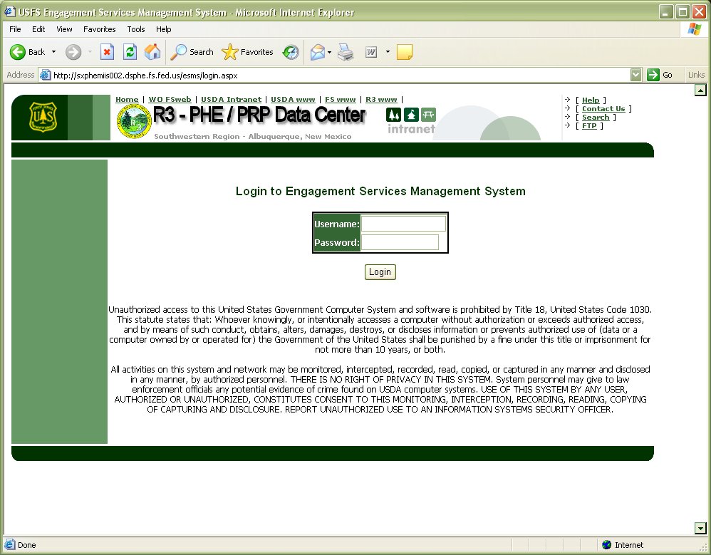

# Using ESMS

## My Engagements

Upon a successful login you will be taken to the **My Engagements** home screen. Currently, the My Engagements portion will be largely whitespace, at a later date this should include a array of items significant to the user’s role, duties, and level of access.

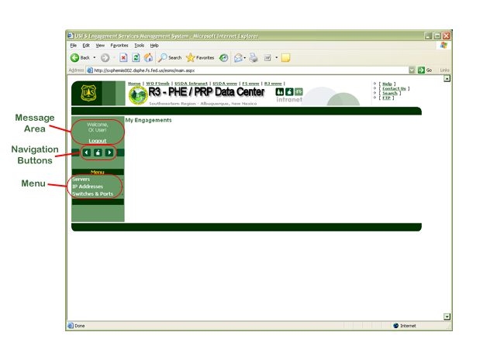

All users will see the **Message Area**. This usually will just show a message that welcomes the user by name and present an option to logout of ESMS. Occasionally the message area may also show messages about planned outages or upgrades to ESMS. The **Navigation Buttons** will always be present as well, allowing a user to effectively navigate backward and forward or return to the My Engagements area. Depending on your account’s permission level you will be presented with a variety of options in the **Menu** on the left side of the page. The standard user menu contains links to manage **Servers**, **IP Addresses**, **Switches & Ports**, **Reports***,* the currentESMS**Users Guide** (this document hopefully), and an at-a-glance**Firmware Status**page.

## Manage Servers

The Manage Servers area can be used to add, delete, and view the servers provisioned in the Data Center. Admin and Network role accounts will have an additional subset of functions available to them, but those will be discussed in later sections.

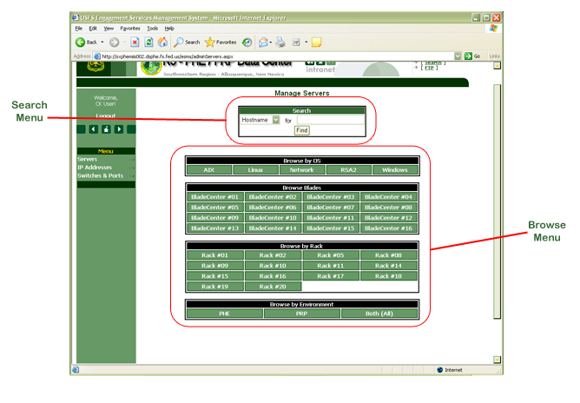

### Manage Servers: Basic Functions

The **Search Menu** allows a user to search for servers by hostname, public IP address, and description. The search is a “LIKE” search by default so the user can enter partial information and the system will automatically find records that match. The ***hostname search*** is straightforward – it will search only on the hostname. The ***public IP address search*** is also pretty straightforward. The ***purpose search*** is particularly powerful – since all servers should have their assigned SR number in their description, a user can search for all servers assigned to particular SR’s. The purpose search can also be leveraged to search for role, purpose, or owner keywords. The **Browse Menu** presents a number of buttons with the common ways that servers are sorted in the Data Center. Searches by OS (AIX, Linux, Windows, Network, etc.), BladeCenter number, Cabinet, and Environment (QA, PHE, PRP, etc.) are available.

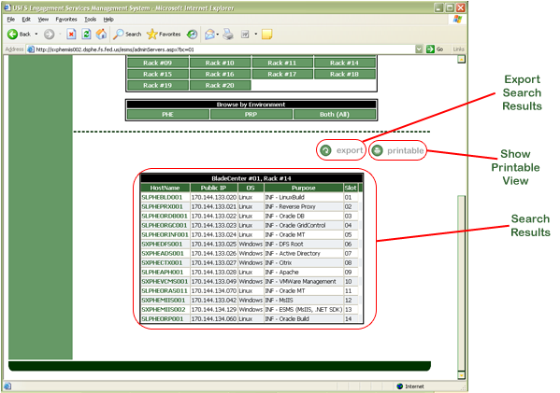When the user clicks ***Find*** with their search or clicks a browse button the detail for all servers that match will appear directly below the browse menu.

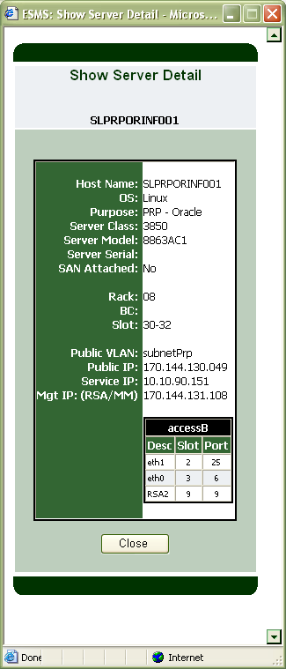

Two new buttons will also appear – Export and Printable. The **Export** button will cause a comma-separated values text file to be created from the search results and it will be downloaded to the user via a “*Save As...*” dialog box. The **Printable** button will show the search results in a more-printer friendly view. The **Search Results** will show the Hostname, Public IP address, OS, Purpose, and Location (Rack, BladeCenter, and Slot) for all matching servers. The search results allow the user to get more information about each server by clicking on the hostname. The **Server Detail** window will provide the user with all the critical information about the selected server. Basic information like the hostname, OS, and purpose are shown as are more advanced information like public VLAN, service IP, management IP, and a table showing the switch ports that the server occupies. This information can be particularly useful to users in troubleshooting outages and odd behavior.

### Manage Servers: Administrative Functions

Within the Manage Servers section users with admin rights have an array of additional options and abilities.

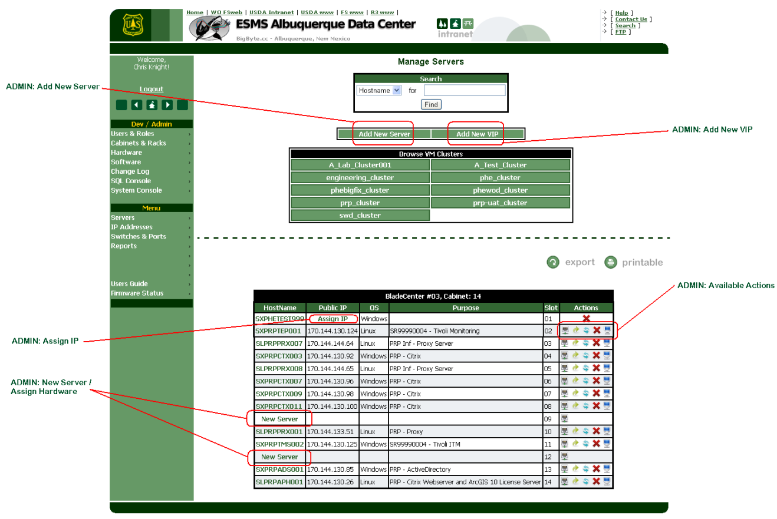

*Add New Server Button –* Click this button to utilize a simplified method for provisioning new servers. This will open the **Provision New Server** window and the user will be prompted to choose from one of a basic set of types of servers to provision – All **Available Rackspace** (ESMS will present all available Rackspace regardless of architecture) **Available Blades**, **Available xSeries**, or **Available pSeries** (AIX incl. LPAR/MPAR) servers. Once the user selects from one of the basic hardware types they will be presented with a list of matching hardware candidates to choose from. To build a new server on a listed piece of hardware, simply click ‘New Server’, and the ‘Add New Server’ window will appear.

***NOTE*** *– Servers listed in Row/Cabinet ’0000’ are essentially in storage and are not available for immediate provisioning.*

Defining a new server is fairly straightforward; you need a valid **Host Name** (See USFS Document ‘server_naming_convention_v1.7.docx’), **OS** (Windows, Linux, ESX, AIX), **Purpose** information for the server (SR#, CR#, Project name, Role, or JIRA task number are all candidates for inclusion here), and the **Public** **VLAN** (subnet) where this server’s public NIC will reside (This ultimately determines what IP address the DNS team will assign). If it is known whether the server will use SAN storage it can be documented at this time. If network cabling isn’t documented and the user knows how the server is cabled (either from JIRA comments or emails) this information can be added by clicking **Edit/ Change Networking** at this time. The final bit of optional information is **Service IP** and it can be documented here. Upon saving the new server ESMS may also prompt for additional server configuration information as well including specific OS builds, RAID configurations, and any other custom instructions for building the server.

*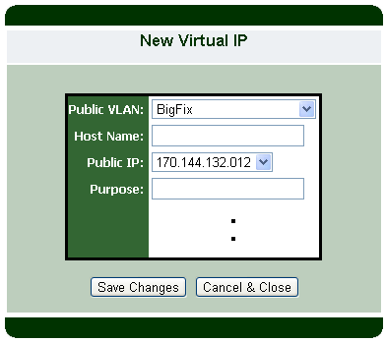Add New VIP Button –* Many applications require servers to use virtual IP addresses for services or for load balancing. Microsoft Clustering Services (MSSQL Server, Sharepoint, WebMethods Broker) and Oracle RAC Databases are some examples that utilize virtual IPs (VIPs) regularly. Click this button to document a new VIP assignment. The ‘**New Virtual IP**’ window will appear. Generally speaking a VIP is simply a **Host Name** (usually derived from the physical server’s actual hostname) and an **IP Address**. The user should first select the appropriate **Public VLAN** (In general it’s a best-practice to put the VIP in the same VLAN as the static IPs for a given device, but that is by no means a law) and Host Name. ESMS will automatically refresh the list of available Public IP addresses once the Public VLAN is chosen. Finally if there is any **Purpose** information to be recorded against this VIP (Again the SR#, CR#, Project name, Role, or JIRA task number are all candidates for inclusion here) key it here. Once the information is entered click **Save Changes**. ESMS has recorded the new VIP. If DNS resolution is necessary, now is the time to make changes to DNS.

*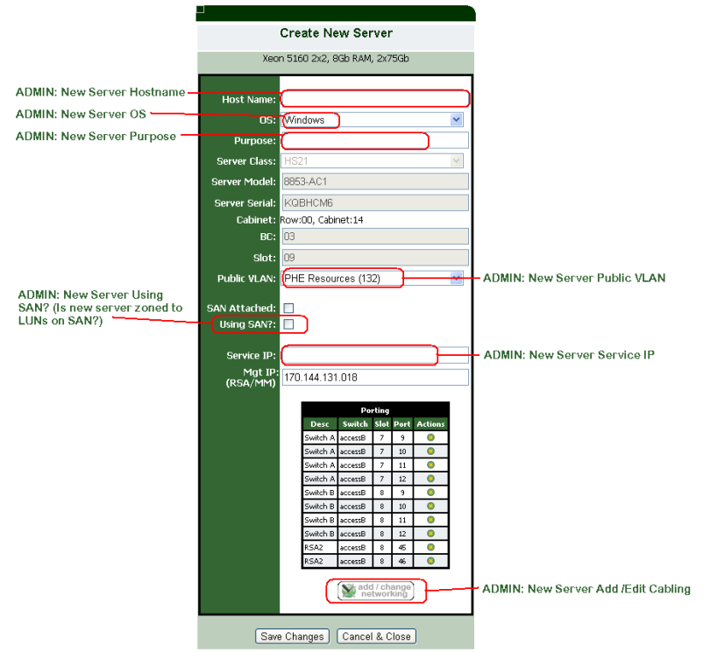New Server* – If you are seeing this, it means there is no server configuration (valid host name, OS, IP, etc.) currently residing on that server. To build a new server on that piece of hardware, simply click ‘**New Server**’, and the ‘Add New Server’ window will appear. Defining a new server is fairly straightforward; you need a valid **Host Name** (See USFS Document ‘server_naming_convention_v1.7.docx’), **OS** (Windows, Linux, ESX, AIX), **Purpose** information for the server (SR#, CR#, Project name, Role, or JIRA task number are all candidates for inclusion here), and the **Public** **VLAN** (subnet) where this server’s public NIC will reside (This ultimately determines what IP address the DNS team will assign). If it is known whether the server will use SAN storage it can be documented at this time. If network cabling isn’t documented and the user knows how the server is cabled (either from JIRA comments or emails) this information can be added by clicking **Edit/ Change Networking** at this time. The final bit of optional information is **Service IP** and it can be documented here. Upon saving the new server ESMS may also prompt for additional server configuration information as well including specific OS builds, RAID configurations, and any other custom instructions for building the server.

*Assign IP* – If you are seeing this, it means that a base server configuration has been defined, but that an IP address needs to be assigned, typically by the DNS team. To assign an IP, simply click Assign IP and the Assign IP window will appear.

***NOTE:*** *The IP’s available for assignment will depend entirely on the VLAN / subnet assigned to the server during the initial configuration. If you don’t see the IP address you want to assign, it may be necessary to have the existing configuration deleted and recreated with special care being taken to assign the correct subnet/VLAN.*

CableServer.png*Cable Server Action* – Clicking this button will open the Add Cabling window and allow the user to document Ethernet and Fiber Cabling as well as switch porting for the server.

move.png*Move Server Action* – Clicking this button will bring up a window that allows the user to “move” the server hostname and underlying hardware to another location. This is most often used when a “blade swap” is being conducted in the datacenter where one blade is swapped with another blade either from a different slot within a chassis or to a different chassis.

***NOTE:*** *If you have moved a blade into an empty slot in an existing bladechassis, there is a good chance you won’t find the correct “to location” in the system using this method. Notify the system administrator if this type of move is required.*

recycle.png*Recycle Server Action* – This action will open a special “new server” window that allows an admin to repurpose the hardware and IP as a new servername, with a new purpose, and perhaps even a different OS.

***NOTE:*** *The hardware and IP address will be re-used with the new hostname. It is appropriate to contact the DNS team to ensure all DNS records are updated appropriately.*

*Delete Server Action* – This action is straightforward, the server configuration will be deleted from ESMS. The hardware will remain in the system available for re-use.



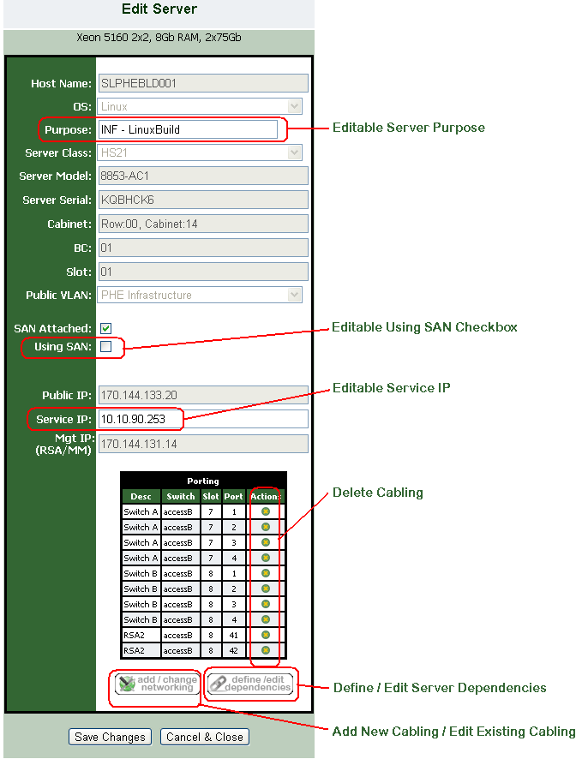Additionally, Admin users have additional abilities within Server Detail windows as well. Most obviously is that admin users get an editable form of the Server Detail window. On this page the user can edit a server’s documented **Purpose, Service IP** address and the **Using SAN** checkbox.

***NOTE*** *– SAN Attached is not the same as “Using SAN”. SAN Attached should only be checked if the server hardware has an HBA and that HBA is cabled to the SAN Fabric. Using SAN should be checked if a piece of software running on that server is actually making use of storage out on the SAN. (Logically a server can be SAN Attached, but never be zoned to LUNs out on the SAN.)*

Appropriately permissioned admin users can also **Delete Cabling**, **Add Cabling** or **Edit Existing Cabling** for a given server as well as **Define and Edit Server Dependencies** directly from the Server Detail window as well.

Deleting cabling from Server Detail is pretty straightforward, click the  action icon in the Porting table and confirm.

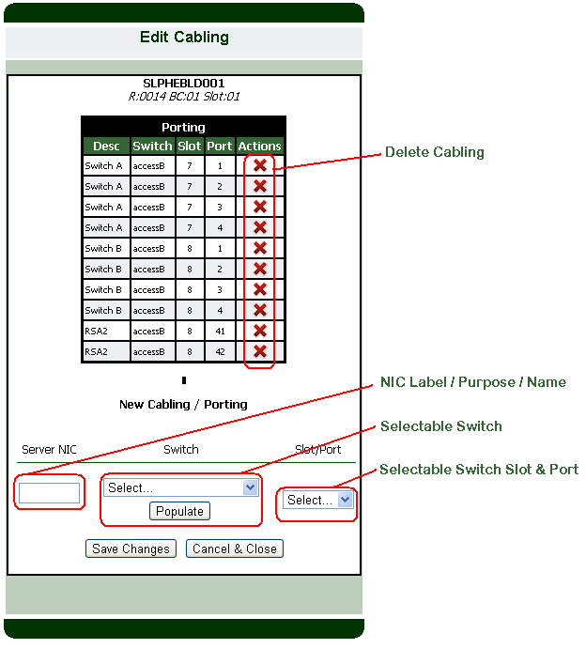Clicking the Add /Change Networking button opens a window that allows the user to define cabling (one-at-a-time) for the server.

**NOTE** – There isn’t a true “edit” cabling function. The way to facilitate a cabling ‘edit’ is to delete an existing cable and add a new one.

To add a new cable, begin by entering the label or name of the device network interface ( **Server NIC**) that will be cabled. This will most often be something like ‘eth0’, ‘eth1’, ‘eth2’, etc. or ‘RSA2’ / ‘AMM’). A good rule of thumb for NIC labeling is “However it is labeled on the hardware, it should be labeled in ESMS.” Next, select the appropriate **Switch** from the drop-down that the device is cabled to and click **Populate**. The **Slot/Port** drop-down will then be updated with the available (open / free / uncabled) ports in the selected switch. Select the port that the device is cabled into and click **Save Changes**.

**NOTE** - If a given port doesn’t appear in the drop-down list, it likely means the system already has something cabled to that port. In that case, more investigation should be done to confirm if the cabling trace is in error, or if the current documentation is in error.

To Delete an existing cable simply click the  icon, and confirm.

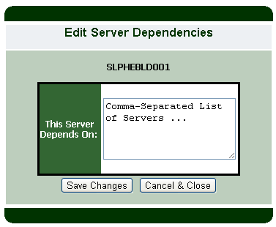As mentioned earlier, admin users can also define server dependencies from Server Detail. First, its important to note that in a typical client-server relationship, the client device depends upon the server device. In practice nearly all Application servers (Apache, IIS, Oracle Application Server) depend on some kind of Database Server (Oracle Database, MS-SQL). Likewise, many Database servers depend upon services like EFS (GFPS, DFS). This kind of relationship is what ESMS intends to capture. Documenting and tracking these dependencies can be helpful or even critical in planning outages and disaster recovery. To document a dependency the user should click ‘**Define/ Edit Dependencies**’ and then either create or add hostnames to the comma separated list that appears.

***IMPORTANT*** *– No other information should be added – only a comma separated list of server hostnames.*

Once all dependencies are documented, click **Save Changes**. The window will automatically close.

## Manage IP Addresses

The Manage IP Addresses area allows user to lookup servers and IP addresses and also browse the various VLANs in use in the Data Center. As with the Manage Servers area users with admin accounts will have additional functions available to them.

To those unacquainted, a VLAN or Virtual LAN is a group of hosts with a common set of requirements that communicate as if they were attached to the same wire, regardless of their physical location. Basically, servers in the Data Center are grouped together in VLANs based on their environment (PHE or PRP) or their role (Database servers, Management devices, and Network devices) in order to optimize network performance. In ESMS the term subnet and VLAN are generally interchangeable for most users, so they will be considered interchangeable for the purposes of ESMS.

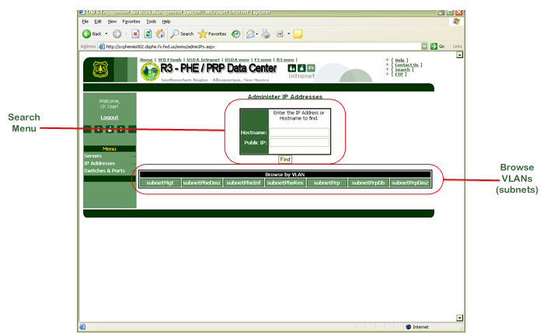

### Manage IP Addresses: Basic Functions

The **Search Menu** allows users to lookup IP addresses by the hostname that occupies the IP address or simply by the IP address directly. As with the search function in the manage servers area, this is a “LIKE” search. Users can also browse all the IP addresses in each VLAN by clicking on the appropriate buttons in the **Browse VLANs** menu.

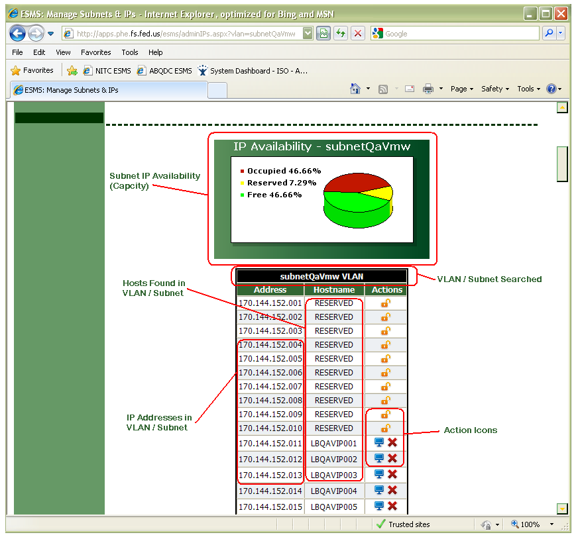

The results will show the **VLAN/ Subnet Searched**, a list of **the IP Addresses in the VLAN/ Subnet**, a list of the **Hosts found in the VLAN/ Subnet** referenced against the IP address assigned to them, and depending on the permission level of the user an array of **Action Icons** column representing functions available to the user. Normal users will only see the  icon next to servers which if clicked will show the details of the server occupying that IP address. If an IP address is reserved, you’ll simply see the word RESERVED instead of a hostname.

### Manage IP Addresses: Administrative Functions

As with the Manage Servers area, users with elevated Admin rights in ESMS will see additional abilities and actions in Manage IP Addresses.

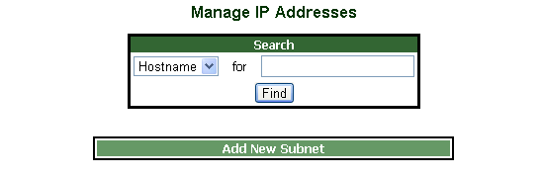

Most significantly admin users can **Add New Subnets** and **Add New Virtual IP’s** from the Manage IP Addresses page.

*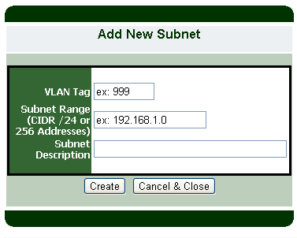Add New Subnet Button* – From time to time it may be necessary to add new IP address space to the Data Center. Add New Subnet lets the user add an additional Class-C network to the data center IP address space. All the user needs to know is the **VLAN Tag** (Generally a number that the network team and network switches use to identify the VLAN that the devices that will receive this IPs will reside within) a **Subnet Range**, and a **Description** of the subnet. This description should be short, but evocative since it will be used by the average user when assigning servers, looking up IP addresses and other daily duties.

***NOTE*** *– At this time ESMS only supports adding full class-C (256 Addresses) through this method. If a smaller subnet is to be added, contact the ESMS Administrator to make the addition manually.*

*Add New VIP Button –* Many applications require servers to use virtual IP addresses for services or for load balancing. Microsoft Clustering Services (MSSQL Server, Sharepoint, WebMethods Broker) and Oracle RAC Databases are some examples that utilize virtual IPs (VIPs) regularly. Click this button to document a new VIP assignment. The ‘**New Virtual IP**’ window will appear. Generally speaking a VIP is simply a **Host Name** (usually derived from the physical server’s actual hostname) and an **IP Address**. The user should first select the appropriate **Public VLAN** (In general it’s a best-practice to put the VIP in the same VLAN as the static IPs for a given device, but that is by no means a law) and Host Name. ESMS will automatically refresh the list of available Public IP addresses once the Public VLAN is chosen. Finally if there is any **Purpose** information to be recorded against this VIP (Again the SR#, CR#, Project name, Role, or JIRA task number are all candidates for inclusion here) key it here. Once the information is entered. Click **Save Changes**. ESMS has recorded the new VIP. If DNS resolution is necessary, now is the time to make changes to DNS.

Once a list of IP addresses for a given subnet is displayed, administrative users will see additional icons in the actions column.

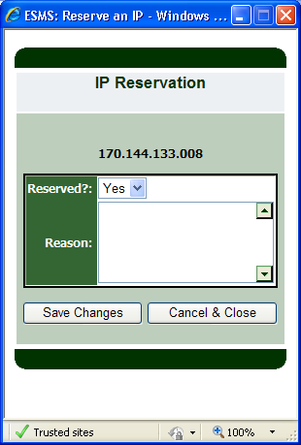 *Reserve IP Action* – This icon will only appear next to free (that is, no server or virtual IP assignment is currently documented in ESMS) IP addresses. Clicking this icon will open a window that will allow the user to mark it as reserved and leave a comment. Generally the comment should indicate the reason for the reservation and if available the RN, JIRA Task or CR number that the reservation is required by. The comment will automatically have the username of the user making the reservation and the time and date of the reservation added by the system.



*Clear IP Reservation Action* – This “unlock” icon will only appear next to IP addresses that are currently documented as reserved within ESMS. Clicking this icon will open a window that will allow the user to clear the existing IP reservation and remove all comments pertaining to the reservation. You can also get more information about a reserved IP address by hovering the mouse pointer over this icon without clicking.



## Manage Switches & Ports

The **Manage Switches & Ports** area allows users to view a representation of the switches in use in the Data Center to see which ports currently are cabled, which ports are free, and for cabled ports which servers are cabled to that port. Before a user can see switch detail, they must first select a switch.

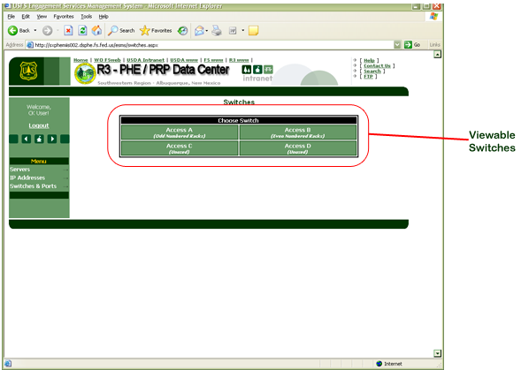

### Manage Switches & Ports: Basic Functions

The **Viewable Switches** menu allows the user to select a switch and see a representation of the desired switch. Once the user selects a switch, ESMS will render a visual approximation of the switch desired showing all populated slots and ports.

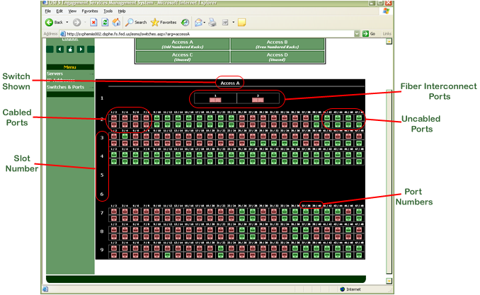

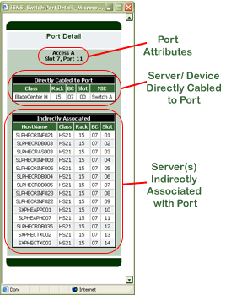A given switch should appear in ESMS very similar to its real-life appearance. The **Switch Shown** is labeled at the top, and the **Slot Number** is shown on the left side of the rendered switch – just as one would see on the real switch. Likewise, **Port Numbers** are present within each slot. The format for these numbers is “top/bottom”, so odd-numbered ports are in the top of each slot while even-numbered ports are in the bottom. Users can use ESMS to communicate with the network team by describing ports by their switch, slot number, and port number attributes (*example: Access A, Slot 4, Port 35*) since ESMS represents each switch as it appears in the data center. **Cabled Ports** appear in red (), while **Uncabled** (free) **Ports** appear in green (). By clicking on a cabled port ESMS will show **Port Detail** information about where cabling goes and which server(s) uses that cable. The port detail window will show the **Port Attributes** including switch and slot information. All cabled ports will show which **Server/ Device is Directly Cabled to the Port.** Typically this information is presented with a focus on the hardware class (i.e. 3850, 3650, BladeCenter) and location information (Rack, BC, Slot) and a descriptor of the Network Interface Card (NIC) on the device that is cabled to the port. Many of the servers in the Data Center are either based on High-Density Computing (BladeCenters) or are virtualized (P-Series and ESX). For this reason you may also see a table of **Server(s) Indirectly Associated with Port**. This table lists all of the servers and their locations that could be affected by changes in cabling to the port selected.

### Manage Switches & Ports: Administrative Functions

In addition to viewing porting status, users with admin rights and responsibilities are able to **Add Switches** and **Bulk Add Cabling** directly from Manage Switches. Additionally, if a user is viewing an existing switch and clicks on an unoccupied (green) port a window appears that allows them to document what device is cabled to that port..

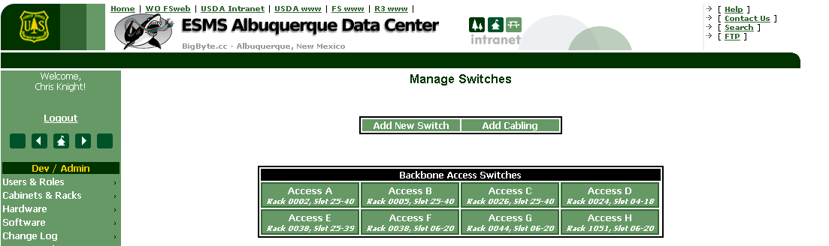

**Add New Switch** - Clicking this opens an Add Hardware window. Since that function is discussed in depth later in this document, it won’t be explained in length here.

**Add Cabling** – Clicking this opens the Bulk-Add Cabling window. This window allows the user to add one or more (there is no upper limit) cables to the ESMS system. Along the way, ESMS attempts to help the user by maintaining proper referential integrity.

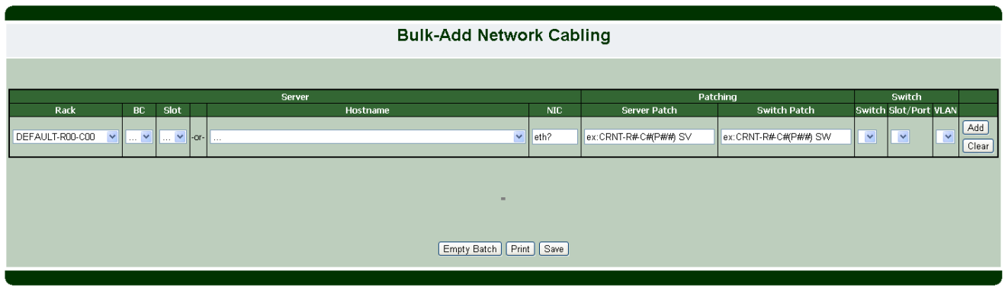

When the user wishes to document a cable using this form, they should select the device’s Rack, BC# (In the case of a Blade server) and Slot OR Hostname. The form will automatically validate this information for the user and update the form.

If the user chooses to document cabling by Rack, the system will update the BC drop-down only with valid data (or disable it if there are no BladeChassis in that rack), and selecting the BC will update the Slot drop-down with valid data. Once a slot is selected the documented server hostname will automatically appear in the hostname drop-down. Likewise, if the user chooses to document by hostname, the Rack, BC and Slot columns will be automatically updated with appropriate information. In this way, the user is ‘kept honest’ and the integrity of the data in ESMS is assured.

Once a device is selected, the next key point is to document the correct Ethernet adapter. Most servers have at least two NICs, sometimes many more. It is best to keep to standard naming here (eth0, eth1, eth2, RSA2, AMM, etc.). This field documents PHYSICAL ports only – a good rule of thumb is “However it is labeled on the hardware, it should be labeled in ESMS.”

In addition fields exist to allow the user to document Patch cable tracing and porting. This data can be helpful in troubleshooting network issues.

***NOTE*** *– Patching data is meta-data. It is not unique-enforced, it is not validated, and any typos or mistakes made entering this information will not be caught and presented to the user for revision.*

Next, the user should select the appropriate switch, slot and port where the cable is connected. Like the device side of the form, the contents of the Switch Slot drop-down depends on the selection in the Switch drop-down, and the contents of the Switch Port drop-down depends on the selection in the Switch Slot drop-down. In addition, only OPEN ports will be shown. If a given port doesn’t appear in the list, it likely means the system already has something cabled to that port. In that case, more investigation should be done to confirm if the cabling trace is in error, or if the current documentation is in error.

***NOTE*** *– Since the batch-in-progress is not committed until the user clicks* ***Save****, it is possible that the form drop-downs will allow the user to errantly document multiple cables for a single port. Exercise care when building your batch!*

Finally, since this form is intended to be used to document entire batches of cabling, the user should click **Add** to add the cable to the batch. If necessary the user can also click **Clear** to reset all selections and start over with a given cable. Once the batch is ready to commit the user should click **Save**.

***NOTE*** *– No matter how big or small the batch, no changes are made to the system until the user clicks “Save”. Care should be taken to avoid closing the window prematurely and losing the batch in progress.*

The user can also click **Print** to print a copy of the batch for reporting purposes or click **Empty Batch** to dump all cabling and start the batch over.

***NOTE*** *- At this time there is no way to remove or edit incorrect cable traces from a batch in progress. Exercise care when building your batch!*

## Administrative Only Sections

In addition to the special abilities granted to admin users in the Servers, IP Addresses, and Switches & Ports sections of ESMS, Administrative users also have exclusive access to advanced sections listed in the **Administration Menu**.

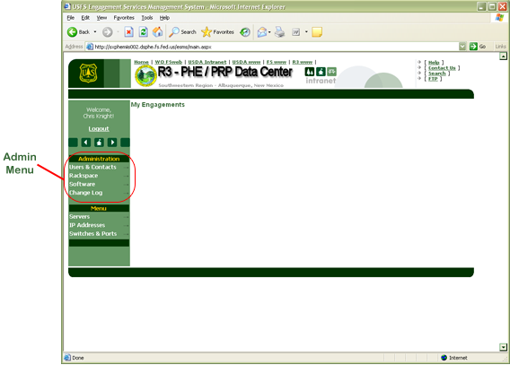

### Users & Contacts Section

This section allows the admin user to view the list of accounts added to the AD groups governing ESMS access. This is a read-only section, if users need to be added to these groups it is necessary to contact the AD team via [ad_support@fs.fed.us](mailto:ad_support@fs.fed.us).

To navigate this section, click the Users, Admins, or Super links at the top of the page to get a listing of the users currently in those AD groups.

***NOTE*** *- Near the bottom of the page you’ll see links pertinent to the Workspace-On-Demand Module. At this time ESMS is not using the Workspace-On-Demand module as it is still in the very early stages of development.*

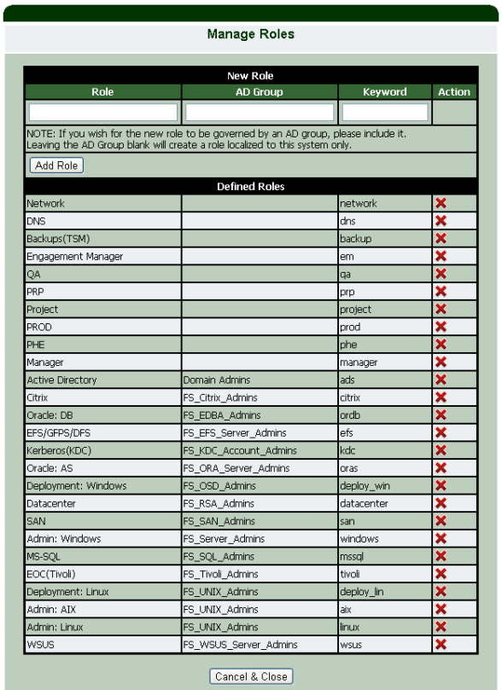In addition to ESMS AD groups, ESMS also assigns roles and responsibilities based on membership in other AD groups. ESMS also allows for local-only roles (not supported by membership in an AD group). To view and manage ESMS currently defined roles, click the **Manage Roles** button.

***NOTE*** *– Generally speaking it is preferable to make roles in ESMS dependent upon membership in other AD groups as it fits seamlessly into the enterprise security model already in place.*

*Manage Roles Button* – When clicked this button will open the **Manage Roles** window. Here the admin user can see the list of defined roles and add new roles. If a role is to be tied to AD group membership, then that role should have an AD group defined, otherwise the role becomes a local-only role. The table below lists the “default” roles in ESMS:

|  |  |  |
| --- | --- | --- |
| **Role** | **AD Group** | **Role Keyword** |
| Network |  | network |
| DNS |  | dns |
| Backups(TSM) |  | backup |
| Engagement Manager |  | em |
| QA |  | qa |
| PRP |  | prp |
| Project |  | project |
| PROD |  | prod |
| PHE |  | phe |
| Manager |  | manager |
| Active Directory | Domain Admins | ads |
| Citrix | FS_Citrix_Admins | citrix |
| Oracle: DB | FS_EDBA_Admins | ordb |
| EFS/GFPS/DFS | FS_EFS_Server_Admins | efs |
| Kerberos(KDC) | FS_KDC_Account_Admins | kdc |
| Oracle: AS | FS_ORA_Server_Admins | oras |
| Deployment: Windows | FS_OSD_Admins | deploy_win |
| Datacenter | FS_RSA_Admins | datacenter |
| SAN | FS_SAN_Admins | san |
| Admin: Windows | FS_Server_Admins | windows |
| MS-SQL | FS_SQL_Admins | mssql |
| EOC(Tivoli) | FS_Tivoli_Admins | tivoli |
| Deployment: Linux | FS_UNIX_Admins | deploy_lin |
| Admin: AIX | FS_UNIX_Admins | aix |
| Admin: Linux | FS_UNIX_Admins | linux |
| WSUS | FS_WSUS_Server_Admins | wsus |

### Cabinets & Racks Section

This section allows the admin user to add and modify the properties of cabinets and racks installed in the datacenter. The terms “Cabinet” and “Rack” are used interchangeably in ESMS though convention usually dictates that a cabinet is hung from a wall and a rack is a free standing unit.

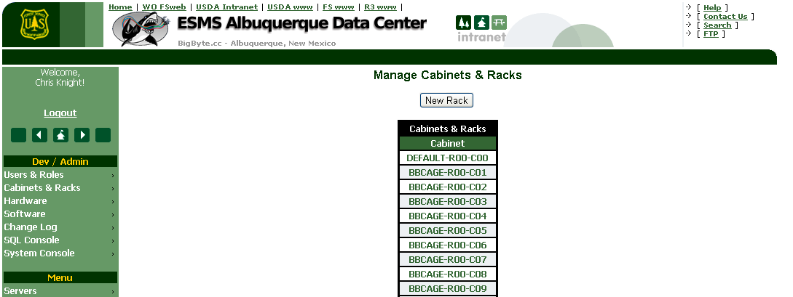

Within Cabinets & Racks the admin user can add and edit the racks available for installing hardware. To add a new rack, click **New Rack**. The New Rack window will appear. Enter the **Row #**, **Cabinet #**, **Room / Area** identifier for the rack, **Bottom “U”** Number (Lowest available less any IDF or Patch Panels), and **Top “U”** Number (Highest available less any IDF or Patch Panels). Once the key information is entered click Save Changes to add the rack to the system.

***NOTE*** *– ESMS uses the format “<room/area>-R<row#>-C<cabinet#>” to identify cabinets and racks in all areas of the system.*

To edit a rack, simply click the rack name from the list of racks shown in **Manage Cabinets & Racks**. The **Edit Rack** window will appear with the rack’s current properties shown. The user can make any necessary changes, then **Save Changes**.

***NOTE*** *– At this time there is no way to delete a rack/cabinet from ESMS via the web interface. This action would need to be done from the SQL Console and changes to multiple tables in the database are necessary.*

### Hardware Section

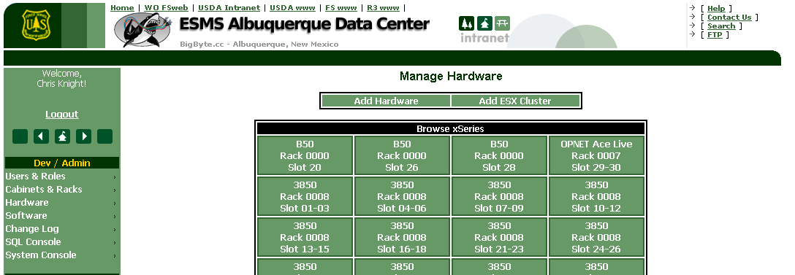This section allows the admin user to browse the hardware installed in the data center, add new hardware types, and document additional pieces of hardware (switches, servers, blade chassis, storage arrays, tape drives, etc.) installed in the cabinets the data center.

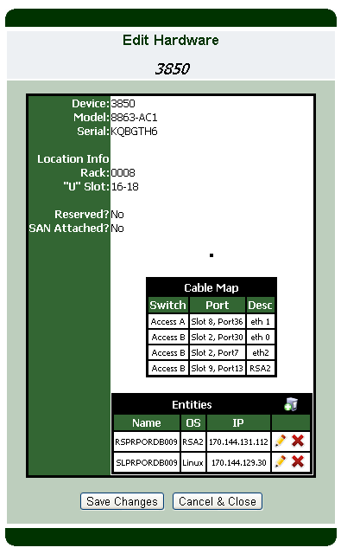To examine an existing piece of hardware scroll through the listed hardware and click on a device. The **Edit Hardware** window will appear, populated with the specific model, serial and other properties of the hardware. In addition a table showing the cabling for the device is present as is a table showing that device’s various documented **Entities**.

This undoubtedly begs the question, “What in the world is an entity in ESMS?”. Logically, a hardware device installed in the data center can be associated with any number of hostnames and IP addresses. Those hostnames and IP addresses may come from the base OS installed on the device (a “server entity” in this case), a virtual IP for services running on top of the OS on the device (a “VIP entity”), a DNS Alias or CNAME record (a “DNS entity”), or even a management device like an RSA2, iDRAC, or AMM (a “management entity”). This table in Edit Hardware allows the user to view, add and delete new VIP, DNS or management entities for a given device

***NOTE*** *- Server entities should be managed via the Manage Servers section.*

To add an Entity, click the  icon in the title bar of the Entities table. A **New Entity** window will open that allows the user to provide the **Hostname**, **Type** of entity, **Purpose** of the entity (Project, Application or SR# for example), **Public VLAN**, and **IP Address** of the entity.

***NOTE*** *– Once a Public VLAN is chosen from the drop down it is necessary to click the Show IPs button to populate the list of available IP addresses in the selected subnet/VLAN.*

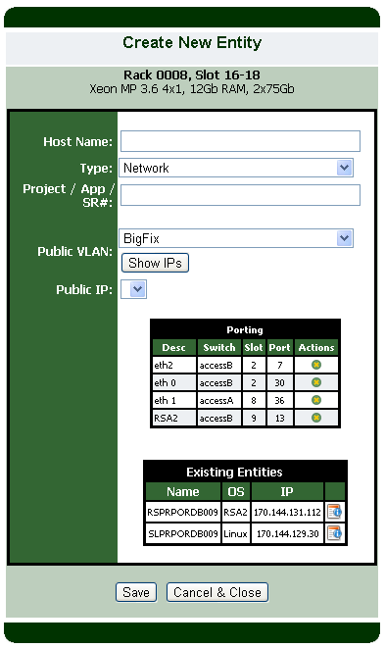Once the information is entered completely, click **Save** to store the new entity. The Entity Table in the Edit Hardware window should now show the additional entity.

To edit an existing entity, click the icon next to the desired entity. An **Edit Server** window will appear that will allow the user to really only modify the Purpose descriptor on the entity.

***NOTE*** *– If any material changes to the entity need to be made (Changes to the hostname, IP address, subnet, etc.) the proper way to make these changes is to delete the old entity and create a new entity with the correct information. In this way all referential integrity is maintained and no entity can have the same IP address or hostname as another.*

When the changes are complete, click Save Changes to modify the entity.

Deleting an entity is very straightforward – click the  icon and confirm. The entity hostname will be deleted from the system and the IP address will be freed for use by any other server or entity.

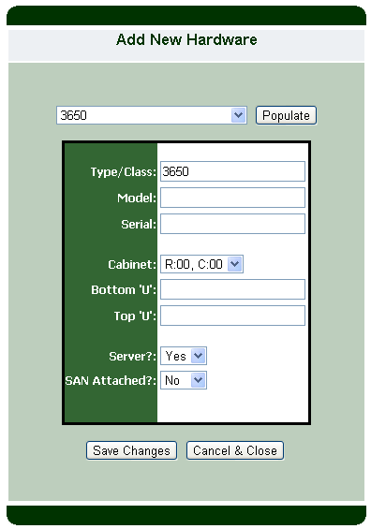Adding hardware to ESMS is also fairly straightforward; click **Add Hardware** from the Manage Hardware Section. By default ESMS is pre-populated with a number of common hardware types. When the **Add Hardware** window opens, those basic types are available to be selected from a drop-down as the “archetype” for the new hardware device. If the device to be added doesn’t fit one of the existing types, a new type can be added – but for now lets assume we are adding a new device of an existing hardware type. Scroll thru the type dropdown to select the appropriate type and click Populate. The basic known properties of the device will be pre-loaded by ESMS and the form fields to add the **Type/Class**, **Model**, **Serial**, **Cabinet**, **U-Locations**, and **SAN Attachment** status will be enabled. The user should enter all the pertinent data and click Save Changes.

**NOTE** – The device archetype automatically fetches the U-size for the device and the user entered bottom and top U locations will be checked against this U-size. If the entered locations are not what ESMS expects based on the hardware type selected, the system will not allow you to save the device until the locations are accurate or the correct type is chosen. In addition, if a device has a management interface but is not a traditional server with an operating system, the Server dropdown should be set to “No”. If the device has a Host Bus Adapter for attachment to SAN fiber and it is possible to attach to the SAN fabric from the cabinet where the device is installed, the SAN Attached dropdown should be set to “Yes”.

In the case of adding BladeCenters and pSeries hardware the Add Hardware window will change dramatically when Populate is clicked. This is because these types of devices are unique in their complexity, so more key data must be captured to document the device accurately.

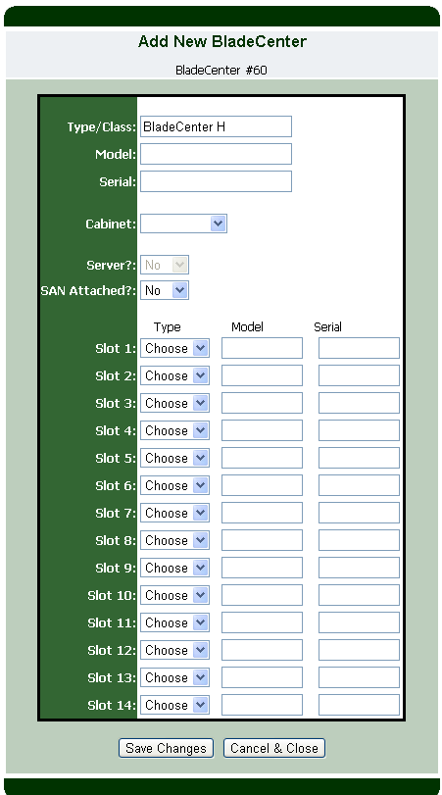

In addition to the basic blade chassis device information, adding a BladeChassis requires the user to document all of the blades and the blade model and serial numbers installed in the chassis. Additionally ESMS will automatically assign the next highest number to the chassis, so if the new chassis has been assigned a number during physical installation, then they should be entered into the ESMS system in numerical order.

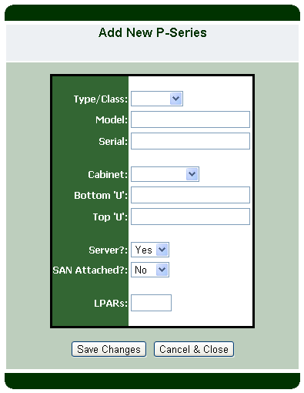Likewise, pSeries gear is unique in that its method of virtualization allows the user to define logical and micro-partitions (LPARs and MPARs respectively) of the device that are for all intents and purposes virtual machines. When adding the hardware to ESMS, it is necessary to define the total number of MPARs and LPARs for the device. This will create a physical machine “slot” and the entered number of virtual machine “slots” for adding new server entities from the Manage Servers section.

From time to time totally new hardware devices or one-off appliances are bound to find their way into the data center. When that happens, it will be necessary to add a New Hardware Type to ESMS. To do so, select **Add New Type** from the Add Hardware window and click Populate. An **Add New Hardware Type** window will appear. A Hardware type is generally just a **Name** of the device (description and model usually), a selected basic **Type** (server, storage, appliance, switch, etc.) and a **U-height**. This U-Height will be applied as an integrity check to every instance of this type of hardware. Once the information is entered correctly, click **Save Changes**. Once you are back on the Add Hardware window the type drop-down list should include the new type.

### Software Section

This section allows the admin to add new standard software and applications used on servers within the data center

***NOTE*** *– This section is incomplete and mostly unused at this time.*

### Change Log Section

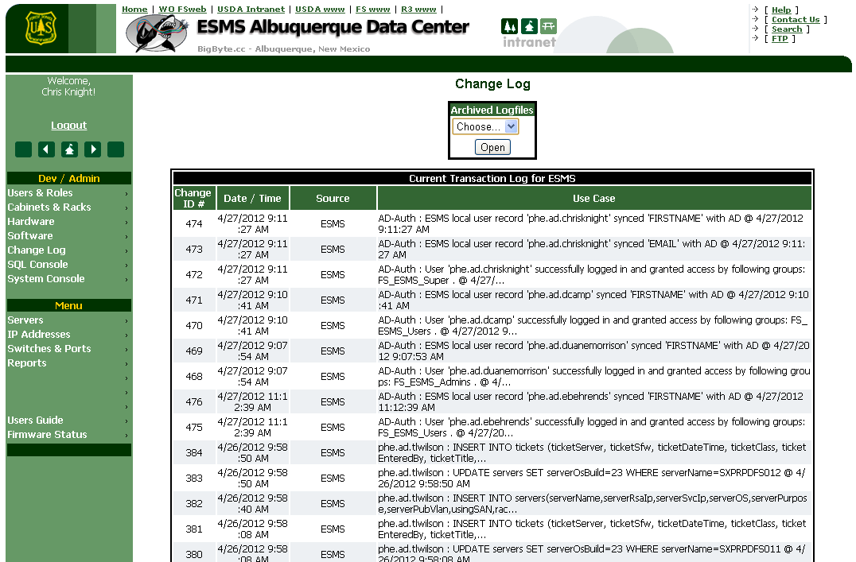

This section allows the admin user to view ESMS’ log of changes (ESMS logs any action that forces a SQL UPDATE, INSERT, DELETE and all user login events.). In addition, since the windows event logs will from time to time “fill up”, there is a dropdown to select archival logs.

***NOTE*** *– This section is an approximate reflection of the Windows Event Log used by ESMS, so anyone with Windows administrative access can also view the ‘ESMS’ Event Log directly on the server hosting ESMS.*

### System Console Section

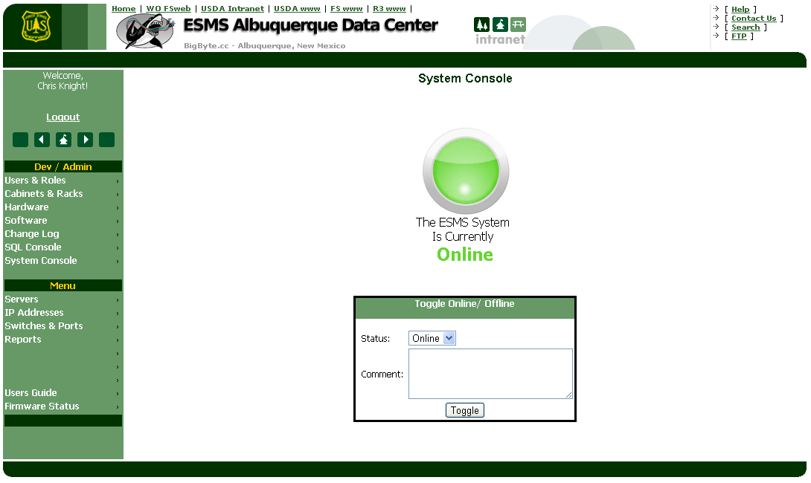

This section can be used to put the ESMS system into (or take out of) an administrative “down” mode where users cannot access application pages and cannot make changes to the database. This is essentially a mode where users that attempt to access the system simply get an “ESMS is DOWN!” page with the username of the person that put the system offline.

### SQL Console Section

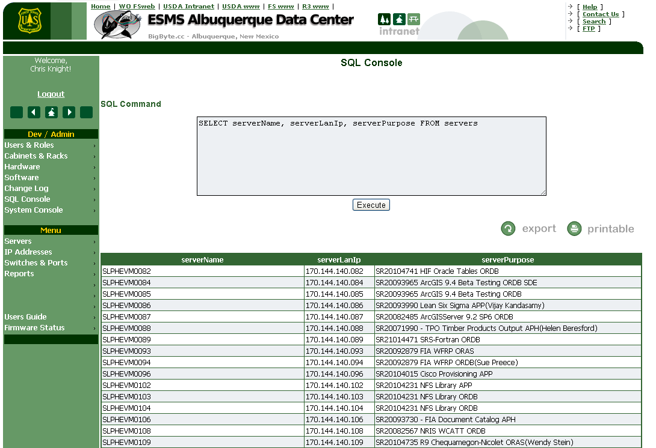

This section is an additional section accessible only to ESMS “Super” administrative users. Using the SQL Console, an administrative user can execute interactive (SELECT, UPDATE, INSERT, ALTER, and DELETE) SQL queries directly against the ESMS database.

***NOTE*** *– Because it is very easy to delete large amounts of data with a single click thru the SQL console, access to this section and membership in the FS_ESMS_Super AD group should be very tightly controlled, preferably confined to users with intimate knowledge of SQL queries and the table design of ESMS.*

## Additional ESMS Information

In addition to this basic usage guide, there is an Administrators Guide to ESMS that contains much more “nuts and bolts” information about the ESMS software and how it operates “under the hood”. Anyone responsible for maintaining an instance of ESMS should read the ESMS Administrator’s Guide and have a basic administrator’s understanding of Microsoft IIS Server 6+. Anyone developing for the ESMS system should have an understanding of HTML, CSS, XML, and ASP.NET 2.0-4.0 for the Web (including AJAX). Additionally, since ESMS can interface with VMware ESX and VMware infrastructure an understanding of the vSphere PowerCLI (PowerShell Module) and the VMware viSDK would be extremely helpful.