IMAGERY QUALITY ASSESSMENT SUMMARY

Project: Buncombe County, North Carolina

Producer: The Sanborn Map Company, Inc.

Date: March-April, 2010

DELIVERY INFORMATION

Date: 10-19-11

State Liaison: Steve Strader

POC Information: Raleigh, NC (919) 571-4092 sstrader@usgs.gov

Type of Review: Full QA

PROJECT INFORMATION

Project size: 230 GB

Image Size: 10000 x 10000

Number of image files: 824

File Naming Convention: OC6i0_37_000_10063301_20100518R0.tif etc.

File Format Information: GeoTIFF’s with World Files

Metadata: Project Level as HTML and XML Documents

Applicable NGA Urban Area: N/A

Quadrangle Information: 22 Total, 5 Complete, 17 Partial

Radiometry: RGB Color

Coordinate System: StatePlane, NAD83, North Carolina, FIPS 3200, Feet

Pixel Resolution: .5 Foot

Relative Horizontal Accuracy and Edge Alignment: No Problems

Horizontal Accuracy: RMSE of 2.5 Feet using 8 points, ASPRS Class 2, 4 feet is expected

Bounding Coordinates:

WEST LONGITUDE = 82.890833333
NORTH LATITUDE = 35.833055556
EAST LONGITUDE = 82.160000000
SOUTH LATITUDE = 35.409166667

REVIEW INFORMATION

General Observations: Overall image characteristics such as brightness, contrast, tonal balance, and visible detail were fine.

Some small mismatch and shadows. See examples below.

*14 image fixes with suspicious datum location information.
869604,869702,965401,965601,969801,969904,979401,979402,979503,979504,10070401,10070402,10070503, &10070504, see holes in project. (This has been corrected by adding the correct projection info to the geotiff header._{brf})

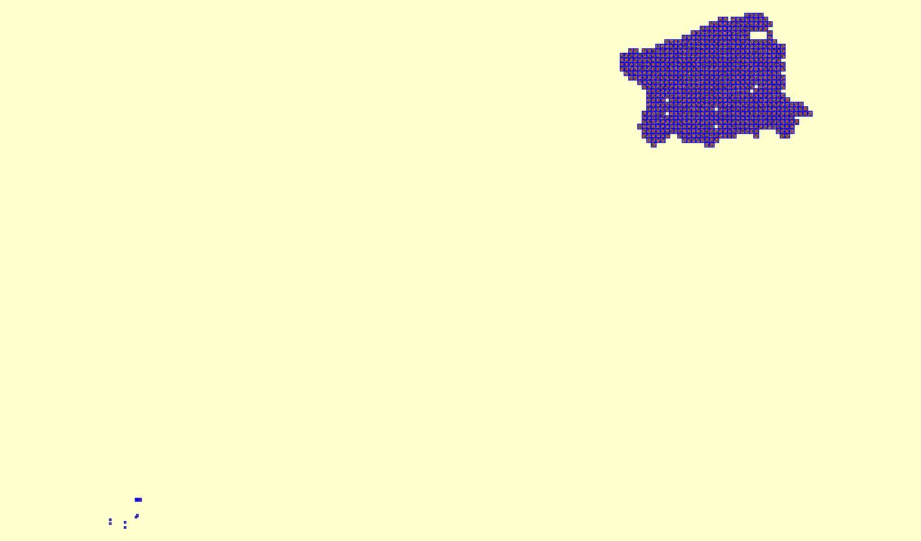
14 Quads ^

Error File: An error shape file was not necessary

Location:

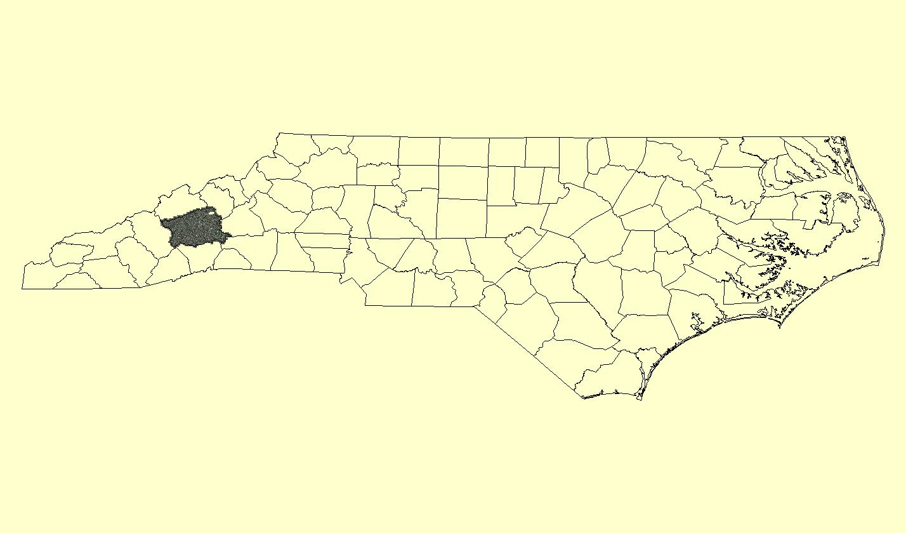

Project Outline:

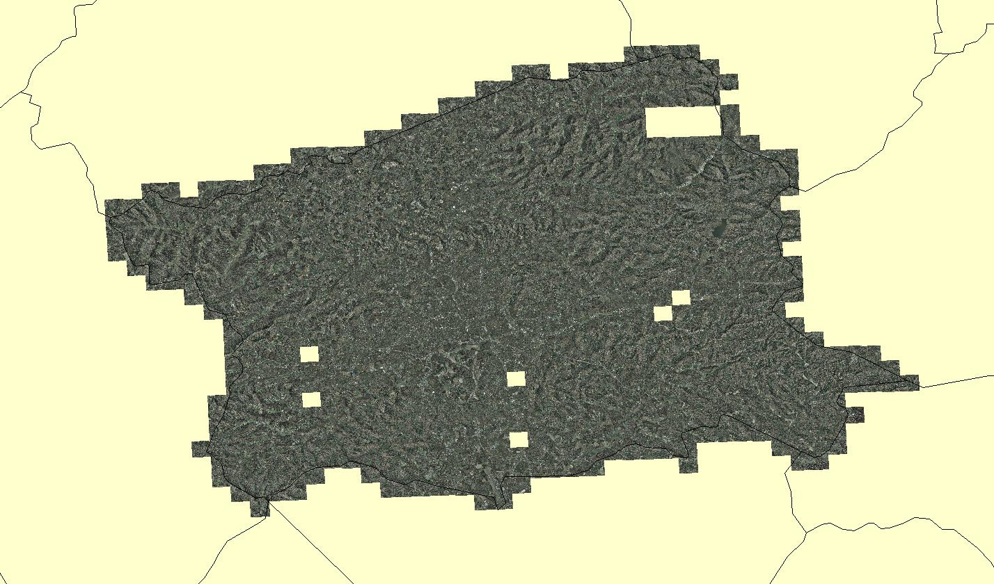

Project / Quadrangle Area:

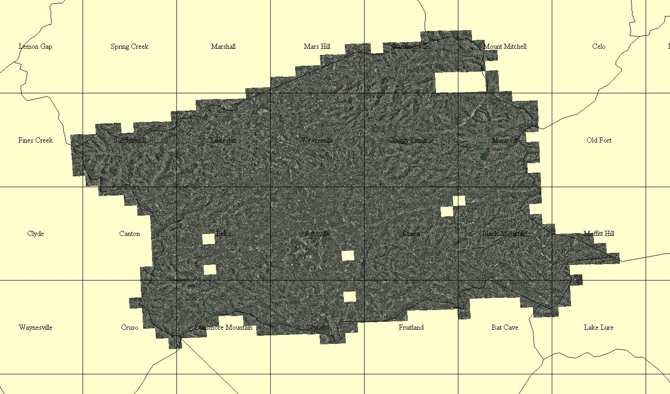

Examples:

Mismatch 875203-875204
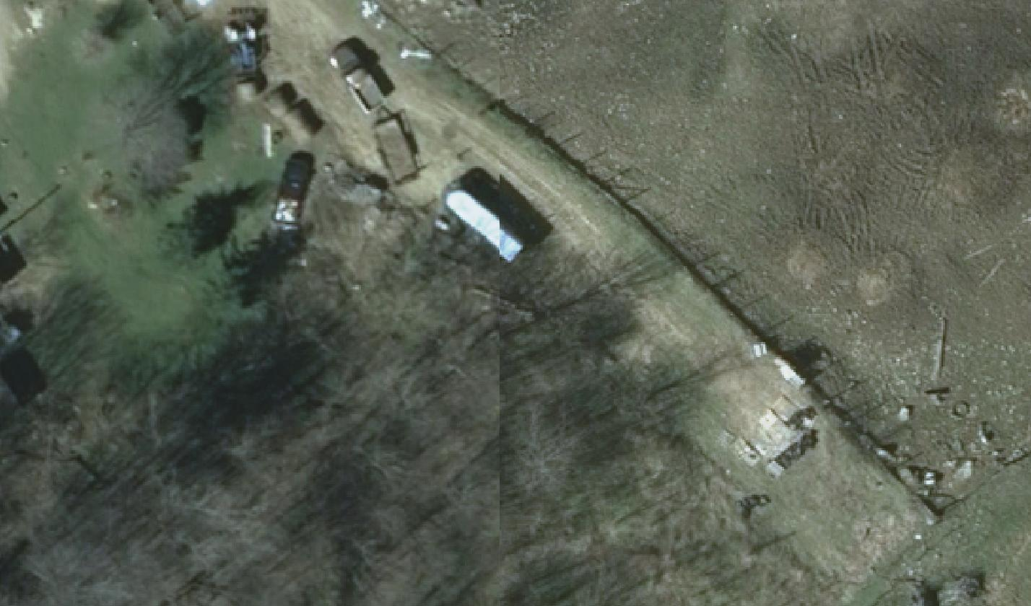

Shadows 868802
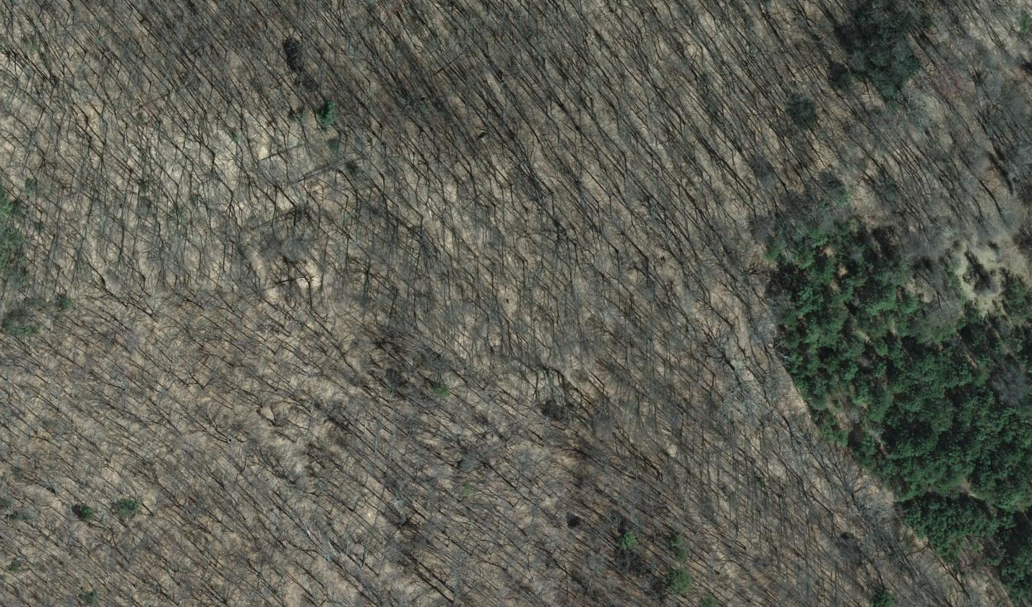

Shadow 869903-869904
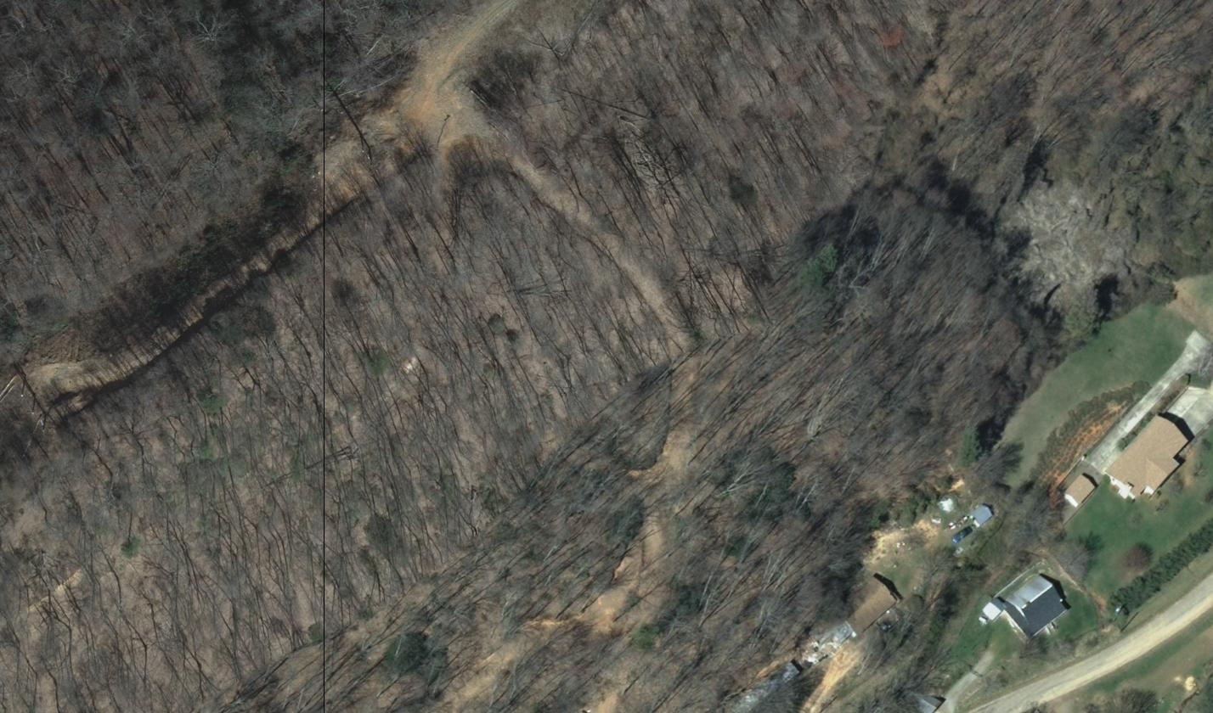

REVIEWER

Summary Prepared By: M. Marzuco

Date: 12-16-2011

Square Miles: County 661, Images approx. 746

Review Time: 26 ¾ Hrs

Camera: Large Format Z/I Digital Mapping Camera

Viewing Scale: 1:3000 with additional zooms

Viewing Software: Global Mapper v11.00 (64-bit)

