CHRIST (Deemed to be University)
Department of Statistics and Data Science
MSc Computational Statistics & Applied AI

CIA 3 - INDIVIDUAL PROJECT
MCAI513B-3: Multivariate Techniques

Multivariate Customer Segmentation and Churn Prediction for E-Commerce

Student | Details
Name | Wriddhijit Roy
Roll No. | 2548613
Specialization | Machine Learning / AI - Marketing Analytics
Maximum Marks | 50
Project Type | Individual Project

Dataset used: supplied online_retail.csv (UCI Online Retail, 2010-2011)
Prepared according to the CIA 3 rubric (A1-A4, B1-B5, C1-C3)

Executive Summary
This project develops an end-to-end multivariate marketing-analytics workflow for e-commerce customer segmentation and churn-risk prediction. The supplied dataset contains 541,909 transaction lines. After excluding rows without CustomerID, cancellations, invalid non-positive values and duplicates, 392,692 valid sales lines remain, representing 4,338 customers and 18,532 invoices. Each customer is represented by the RFM random vector X=(Recency, Frequency, Monetary)^T, allowing dependence among purchasing dimensions to be modelled through the mean vector and covariance matrix rather than through isolated threshold scores.
PCA on log-transformed, winsorized and standardized RFM variables showed that the first two principal components explain 94.03% of total variation. K-Means model selection over k=2,...,8 selected k=2 with silhouette=0.469. The Loyal / High-Value segment contains 1,678 customers (38.7%) but accounts for 85.5% of customer-level monetary value. MANOVA indicates a strong multivariate segment effect (Wilks' lambda=0.3167, F=3117.28, p<0.001).
For churn prediction, a prospective 91-day holdout window is used to avoid defining churn directly from current Recency. Among 3,370 customers available before the cutoff, 43.0% had no purchase in the following outcome period. Hotelling's T-squared=677.84 (F=225.81, p<0.001) shows a strong multivariate difference between retained and churned RFM profiles. LDA achieves ROC-AUC=0.725, balanced accuracy=0.665, and churn-class F1=0.627 on a stratified 30% test set. Assumption diagnostics are reported transparently: normality and equal-covariance assumptions are not fully satisfied, so the classical tests are interpreted with caution and QDA is identified as an alternative.

1. A1 - Domain Knowledge and Problem Context

1.1 Business domain
The domain is e-commerce marketing analytics and customer relationship management. A retailer needs to distinguish customers who are recent and active from those who buy infrequently or have become inactive, while also considering spending intensity. These dimensions are operationally connected: frequent buyers often spend more, while long recency is generally associated with lower engagement. Treating R, F and M independently ignores their covariance and can create inconsistent customer labels when thresholds are applied separately.

1.2 Why the problem is genuinely multivariate
For customer i, define the random vector
X_i = [R_i, F_i, M_i]^T in R^3
where R_i is days since the most recent purchase at the analysis date, F_i is the number of distinct purchase invoices, and M_i is cumulative purchase value. The population is summarized by the mean vector mu = E[X] and covariance matrix Sigma = Cov(X). In the supplied data, the sample correlations are R-F=-0.261, R-M=-0.122 and F-M=0.553. The positive F-M association and negative Recency associations demonstrate that the coordinates are not independent, which motivates a joint multivariate treatment.

1.3 Distributional framing
Classical Hotelling T-squared, MANOVA and LDA are connected to multivariate-normal theory. Raw RFM is highly right-skewed, especially Frequency and Monetary. The analysis therefore uses log1p transforms and 1st-99th percentile winsorization before multivariate inference/model fitting, followed by standardization for PCA and clustering. Normality is tested rather than assumed; the remaining departures are retained as a documented limitation instead of being hidden.

2. Dataset and Data Preparation
The uploaded file has 541,909 rows and covers 1 December 2010 to 9 December 2011. This matches the UCI Online Retail dataset. It is not the two-year Online Retail II file originally mentioned in the proposal; the analysis intentionally uses the dataset actually supplied for this assignment. UCI describes it as transaction data for a UK-based non-store online retailer and identifies clustering/classification as appropriate tasks [1].
Data-quality step | Rows / count
Raw transaction rows | 541,909
Missing CustomerID | 135,080
Rows after CustomerID/date filter | 406,829
Cancellation rows removed | 8,905
Non-positive UnitPrice removed | 40
Duplicate transaction lines removed | 5,192
Final valid sales rows | 392,692
Unique customers | 4,338
Unique invoices | 18,532
Countries represented | 37
Table 1. Transaction cleaning summary derived from the supplied CSV.
Cancellations are identified from InvoiceNo values beginning with C. Rows lacking CustomerID cannot support customer-level RFM analysis and are removed. The original index column is administrative and is excluded from analysis. Revenue is calculated as Quantity x UnitPrice.

3. A2 - Problem Identification and Proposed Solution

3.1 Applied questions
- Segmentation question: What customer groups emerge when Recency, Frequency and Monetary behavior are analysed jointly rather than scored independently?
- Inference question: Do the mean RFM vectors differ significantly across the discovered customer segments?
- Churn inference question: Do customers who subsequently churn have a different mean historical RFM vector from customers who return?
- Prediction question: Can historical multivariate RFM behavior classify the probability that a customer will make no purchase during the next 91 days?

3.2 Proposed multivariate solution
The solution uses PCA to summarize correlated RFM information, K-Means on the retained PCA scores for segmentation, MANOVA to test joint RFM differences across segments, Hotelling T-squared to test retained-versus-churned mean vectors, and LDA to construct an interpretable linear churn boundary. A Streamlit application operationalizes the workflow by accepting a transaction CSV and returning segment labels plus churn probabilities.

3.3 Why this solution over simple RFM scoring
Traditional RFM quintiles impose separate cut-points and do not account for covariance. PCA explicitly uses eigendecomposition of the standardized covariance/correlation structure; K-Means finds groups in the resulting multivariate geometry; Hotelling T-squared and MANOVA test mean-vector differences rather than three unrelated tests; and LDA yields a single linear discriminant function that combines the joint predictors.

4. A3 - Multivariate Techniques and Mathematical Formulation

4.1 Sample mean vector and covariance matrix
x_bar = (1/n) Sum_i X_i
S = (1/(n-1)) Sum_i (X_i - x_bar)(X_i - x_bar)^T
For n=4,338 customers, the raw sample mean vector is approximately x_bar=(92.06, 4.27, 2048.69)^T. Monetary is measured in pounds sterling because the source retailer is UK-based.

4.2 Principal Component Analysis (Unit 5)
After transformation and standardization, let S_z be the 3x3 sample covariance matrix. PCA solves the eigenproblem S_z v_j = lambda_j v_j. The jth principal component score is z_i^T v_j, and the proportion of variance explained is lambda_j / Sum lambda.
Component | Eigenvalue | Explained variance | Cumulative
PC1 | 2.2611 | 75.35% | 75.35%
PC2 | 0.5606 | 18.68% | 94.03%
PC3 | 0.1790 | 5.97% | 100.00%
The first two PCs retain 94.03% of standardized RFM variation, so two dimensions exceed the 90% retention rule used in the pseudo-algorithm.

4.3 K-Means clustering (Unit 5)
Minimize J = Sum_{k=1}^K Sum_{i in C_k} || z_i - c_k ||^2
K-Means is fitted to the retained PCA score space for k=2,...,8. The selected k maximizes the silhouette coefficient, which balances within-cluster cohesion and between-cluster separation. Multiple random initializations (n_init=50) reduce sensitivity to poor starting centroids.

4.4 MANOVA (Unit 3)
The dependent vector is Y=(log R, log F, log M)^T and the factor is the K-Means cluster label. The null hypothesis H0 states that all cluster mean vectors are equal. The analysis reports Wilks lambda and Pillai trace from the multivariate linear model. Pillai trace is emphasized in discussion because covariance homogeneity is imperfect.

4.5 Two-sample Hotelling's T-squared (Unit 2)
T^2 = (n0*n1/(n0+n1)) (x_bar0-x_bar1)^T S_p^{-1} (x_bar0-x_bar1)
F = ((n0+n1-p-1)/(p(n0+n1-2))) T^2
Here p=3 and the groups are retained (0) and churned (1). The test asks whether the historical transformed RFM mean vectors are equal before the prospective outcome window.

4.6 Linear Discriminant Analysis (Unit 4)
For class k, LDA assumes X|Y=k is multivariate normal with class mean mu_k and a shared covariance matrix Sigma. The discriminant score is
delta_k(x) = x^T Sigma^{-1} mu_k - 0.5 mu_k^T Sigma^{-1} mu_k + log(pi_k)
A customer is assigned to the class with the larger discriminant score. Predictors are standardized log-RFM features. A stratified 70/30 train-test split is used for evaluation. Because Box M rejects shared covariance, the report treats LDA as an interpretable baseline and identifies QDA as a natural alternative.

5. Assumption Verification and Diagnostics

5.1 Normality and outlier handling
Variable | Normality statistic | p-value | Skewness | Excess kurtosis
R_log | 256.88 | <0.001 | -0.416 | -0.602
F_log | 545.16 | <0.001 | 1.004 | 0.465
M_log | 73.08 | <0.001 | 0.294 | -0.238
All three transformed variables still reject univariate normality at conventional levels, although skewness is substantially moderated. With thousands of observations, formal normality tests are highly sensitive to small departures. The analysis therefore combines transformation/winsorization with explicit caution in the interpretation of MVN-based p-values.

5.2 Positive-definite covariance
The standardized covariance matrix eigenvalues are 0.1790, 0.5606, 2.2611. All are positive, so the matrix is positive definite and no singular-covariance fallback is required in the observed analysis. The code still uses a pseudo-inverse in Hotelling T-squared as a safe edge-case strategy.

5.3 Equality of covariance matrices
For churn groups, Box M chi-square=514.66, df=6, p<0.001, so equal covariance is rejected. For clusters, Box M chi-square=946.35, df=6, p<0.001. These diagnostics mean the homoscedasticity assumptions behind pooled-covariance Hotelling inference and standard LDA are not perfectly satisfied.
Levene tests on churn-group transformed features also reject equal variance for R_log (p<0.001), F_log (p<0.001) and M_log (p<0.001). Consequently, model accuracy and domain interpretation are reported alongside inferential p-values instead of claiming that the assumptions are exact.

6. A4 - Pseudo Algorithm
- Input data matrix / transaction table containing InvoiceNo, StockCode, Description, Quantity, InvoiceDate, UnitPrice, CustomerID and Country.
- Validate the required schema; parse InvoiceDate. If required columns are absent, stop and return an informative error.
- Remove rows with missing CustomerID or invalid dates because a customer-level random vector cannot be constructed.
- Identify cancellations from InvoiceNo beginning with C and remove them; remove Quantity<=0 or UnitPrice<=0; remove exact duplicate transaction lines.
- Create Revenue=Quantity x UnitPrice.
- Aggregate by customer to X_i=(R_i,F_i,M_i)^T, where R is days since last purchase at reference date, F is distinct invoice count, and M is total Revenue.
- Apply log1p to R, F and M. Winsorize each transformed coordinate at its 1st and 99th percentiles. Compute x_bar and S.
- Check normality diagnostics, outliers and eigenvalues of S. If S is singular/non-positive-definite, use regularization or Moore-Penrose pseudo-inverse and flag the limitation.
- Standardize transformed RFM. Perform PCA eigendecomposition. Retain the minimum number of PCs whose cumulative variance is at least 90%.
- For k=2,...,8, fit K-Means in retained PC space and calculate silhouette score. Select k with maximum silhouette. Output customer cluster labels and profiles.
- Fit MANOVA with transformed RFM vector as outcomes and cluster as factor. Report Wilks lambda, Pillai trace, F and p-values with covariance-assumption caveat.
- For churn modelling, set cutoff = maximum transaction date minus 91 days. Compute RFM using only transactions on/before cutoff.
- Label Y_i=0 (retained) if customer i makes a purchase after cutoff during the 91-day outcome window; otherwise label Y_i=1 (churned).
- Use Hotelling T-squared to test H0: mu_retained = mu_churned. Verify pooled covariance properties and Box M.
- Split historical customers 70/30 with stratification. Fit standardized LDA on log-RFM. Compute confusion matrix, accuracy, balanced accuracy, precision, recall, F1 and ROC-AUC.
- Apply the fitted LDA model to the current full-history RFM snapshot to estimate churn probability. Output CustomerID, RFM values, segment and churn probability.
- If missing/invalid user uploads occur in the app, return a validation message rather than silently producing results.
Outputs: customer-level segment table, churn probabilities, statistical test summaries, figures, and a downloadable CSV. Edge cases explicitly handled: missing customer IDs, invalid dates, cancellation lines, non-positive amounts, duplicate rows, singular covariance, and failed schema validation.

7. B1 - End-to-End Workflow Flowchart
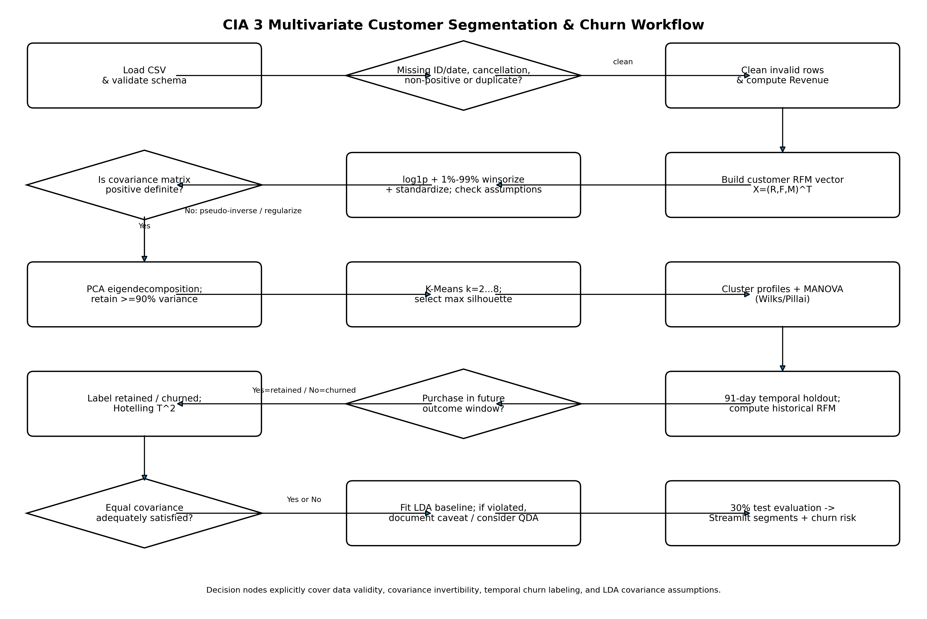
Figure 1. Complete workflow including data-quality and statistical decision nodes.

8. B3/B4 - Technical Implementation and Reproducibility
The project is implemented in Python with modular functions for loading/cleaning, RFM construction, transformation, PCA/K-Means segmentation, prospective churn target construction and LDA fitting. A Jupyter notebook is provided for reproducibility, and a Streamlit application accepts a user CSV and returns segment labels plus churn probabilities.

8.1 Repository structure
The GitHub-ready package contains data/raw, data/processed, src, notebooks, outputs, flowchart, app, report and evidence_templates folders, plus README.md, requirements.txt, .gitignore, AI_DISCLOSURE.md and a submission checklist. The raw CSV is intentionally excluded from Git via .gitignore and is linked to the official source, avoiding unnecessary large-file duplication.

8.2 GitHub Student Developer Pack / Codespaces
The README documents GitHub Codespaces as the Student Developer Pack integration. The student must activate/verify the pack in the real GitHub account, execute the project in Codespaces, expose Streamlit port 8501 publicly for demonstration, and capture screenshots. These external-account actions cannot be truthfully fabricated inside the report package, so evidence placeholders and exact steps are supplied.

8.3 Deployment command
pip install -r requirements.txt
streamlit run streamlit_app.py --server.address 0.0.0.0 --server.port 8501

9. B5 - Results, Interpretation and Visualisation

9.1 Mean vector and covariance relationships
Statistic | Recency | Frequency | Monetary
Mean | 92.06 | 4.27 | 2048.69
Variance | 10002.45 | 59.26 | 80734362.11
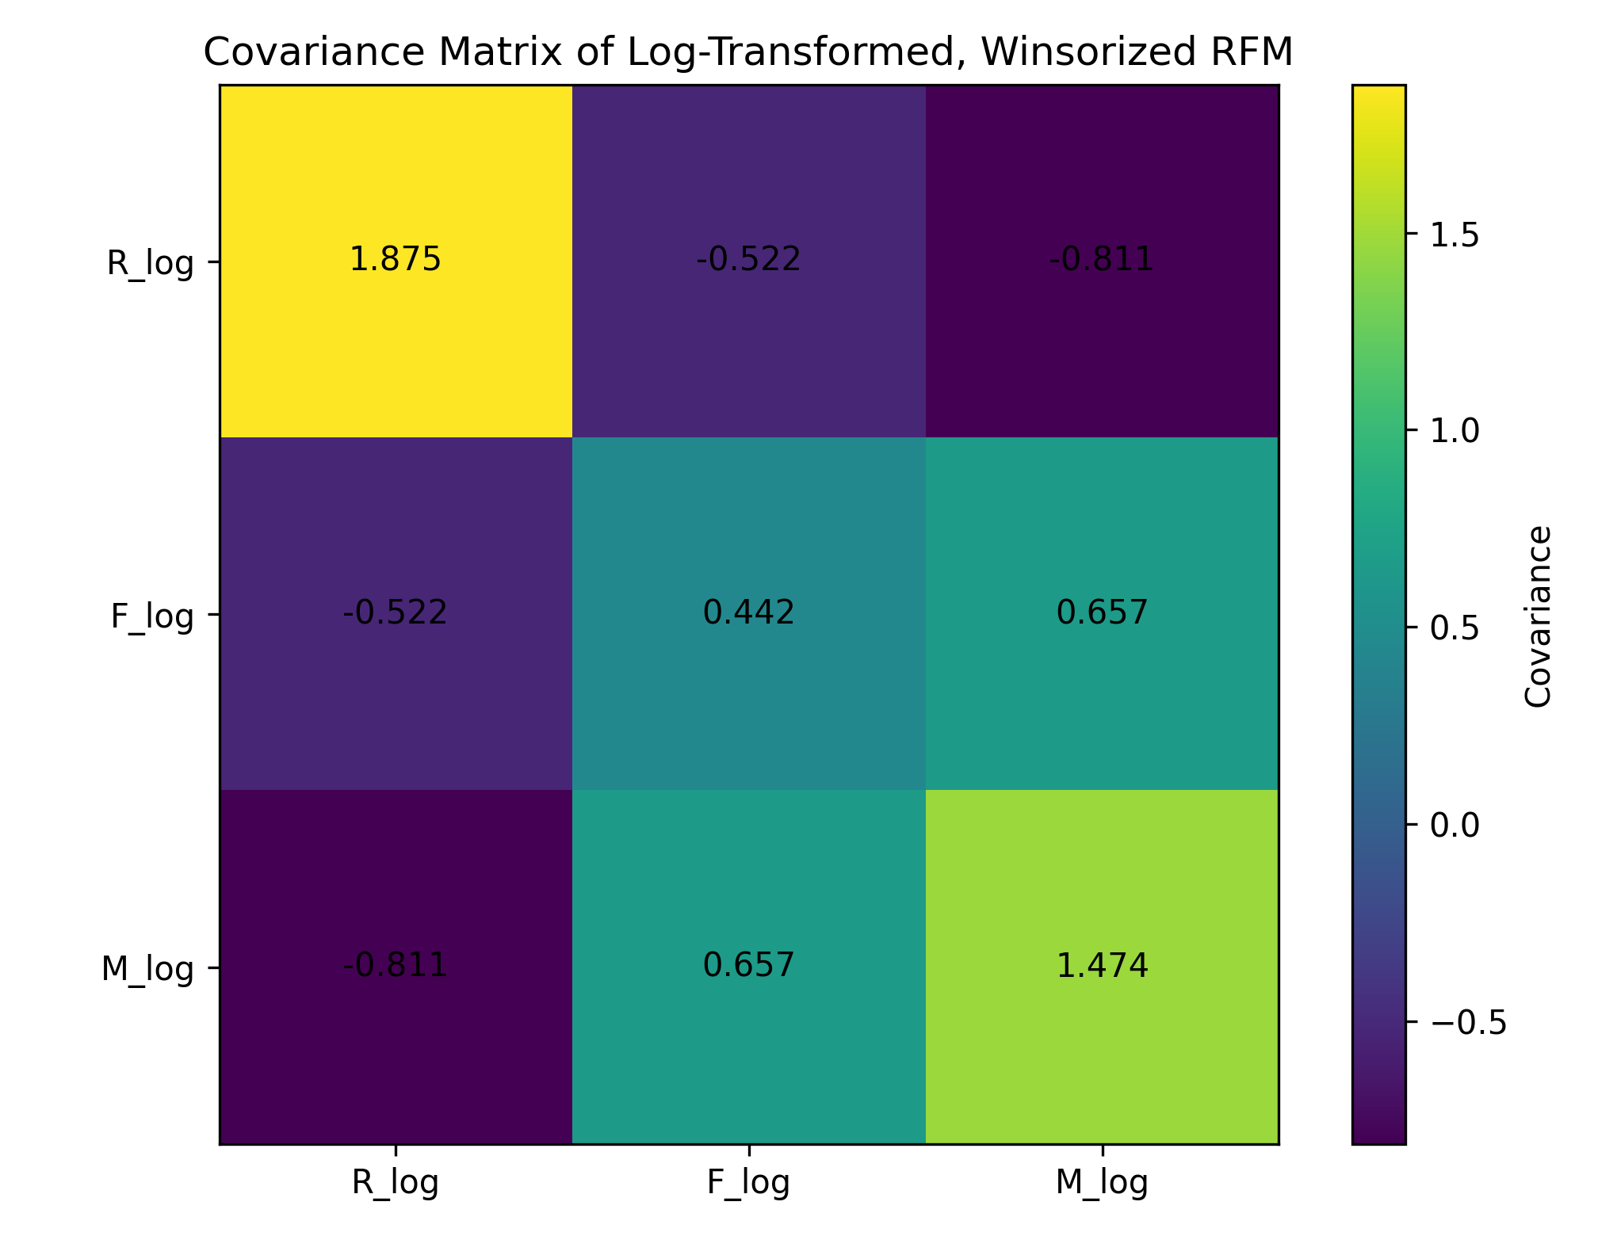
Figure 2. Covariance matrix after log transformation and winsorization.
Frequency and Monetary move together positively, while Recency tends to move inversely with both engagement measures. This covariance is the central reason that a multivariate procedure is preferable to independent R, F and M thresholds.

9.2 PCA and cluster selection
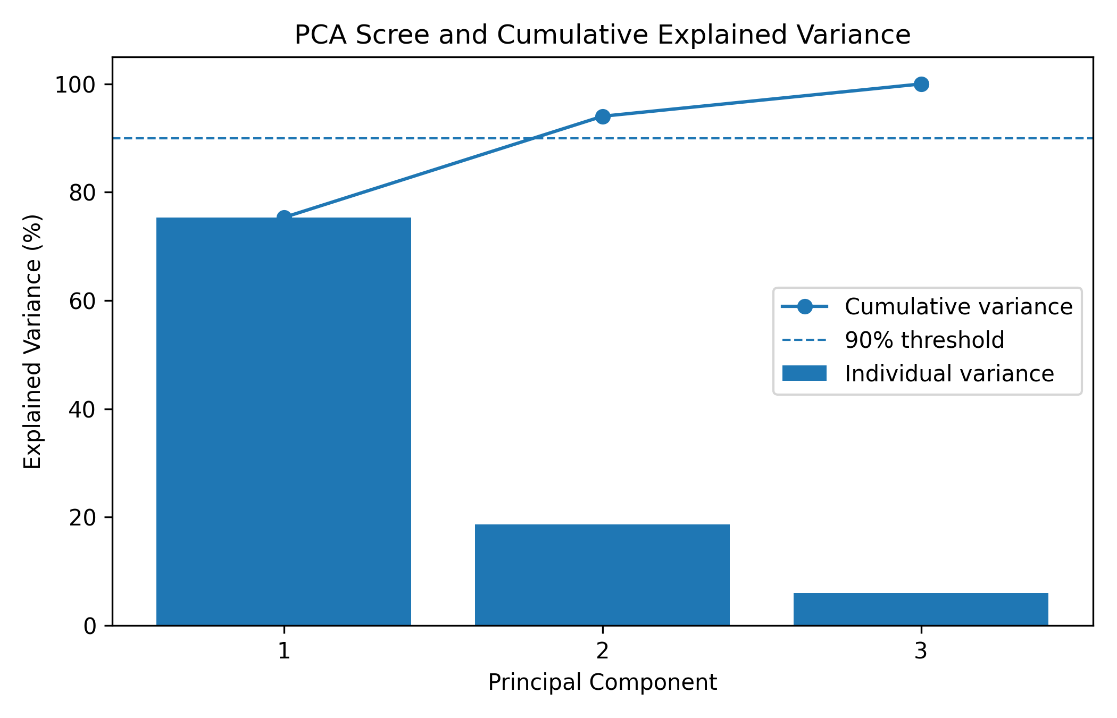
Figure 3. PCA variance decomposition; two PCs exceed the 90% cumulative-variance rule.
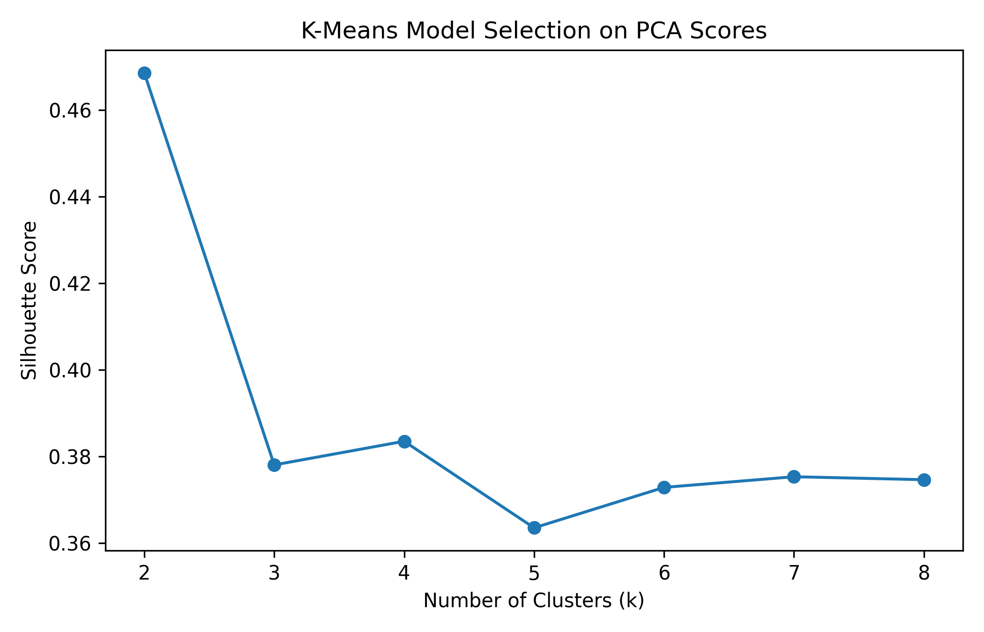
Figure 4. Silhouette criterion for k=2 to 8.
The maximum silhouette score is 0.469 at k=2; therefore the segmentation is not selected by arbitrary business thresholds. PC1 alone explains 75.35% of standardized variation, and PC1+PC2 explain 94.03%.

9.3 Customer segment profiles
Segment | Customers | Share | Mean R | Mean F | Mean M | Revenue share
At-Risk / Low-Engagement | 2,660 | 61.3% | 133.5 | 1.66 | 485.96 | 14.5%
Loyal / High-Value | 1,678 | 38.7% | 26.3 | 8.41 | 4525.96 | 85.5%
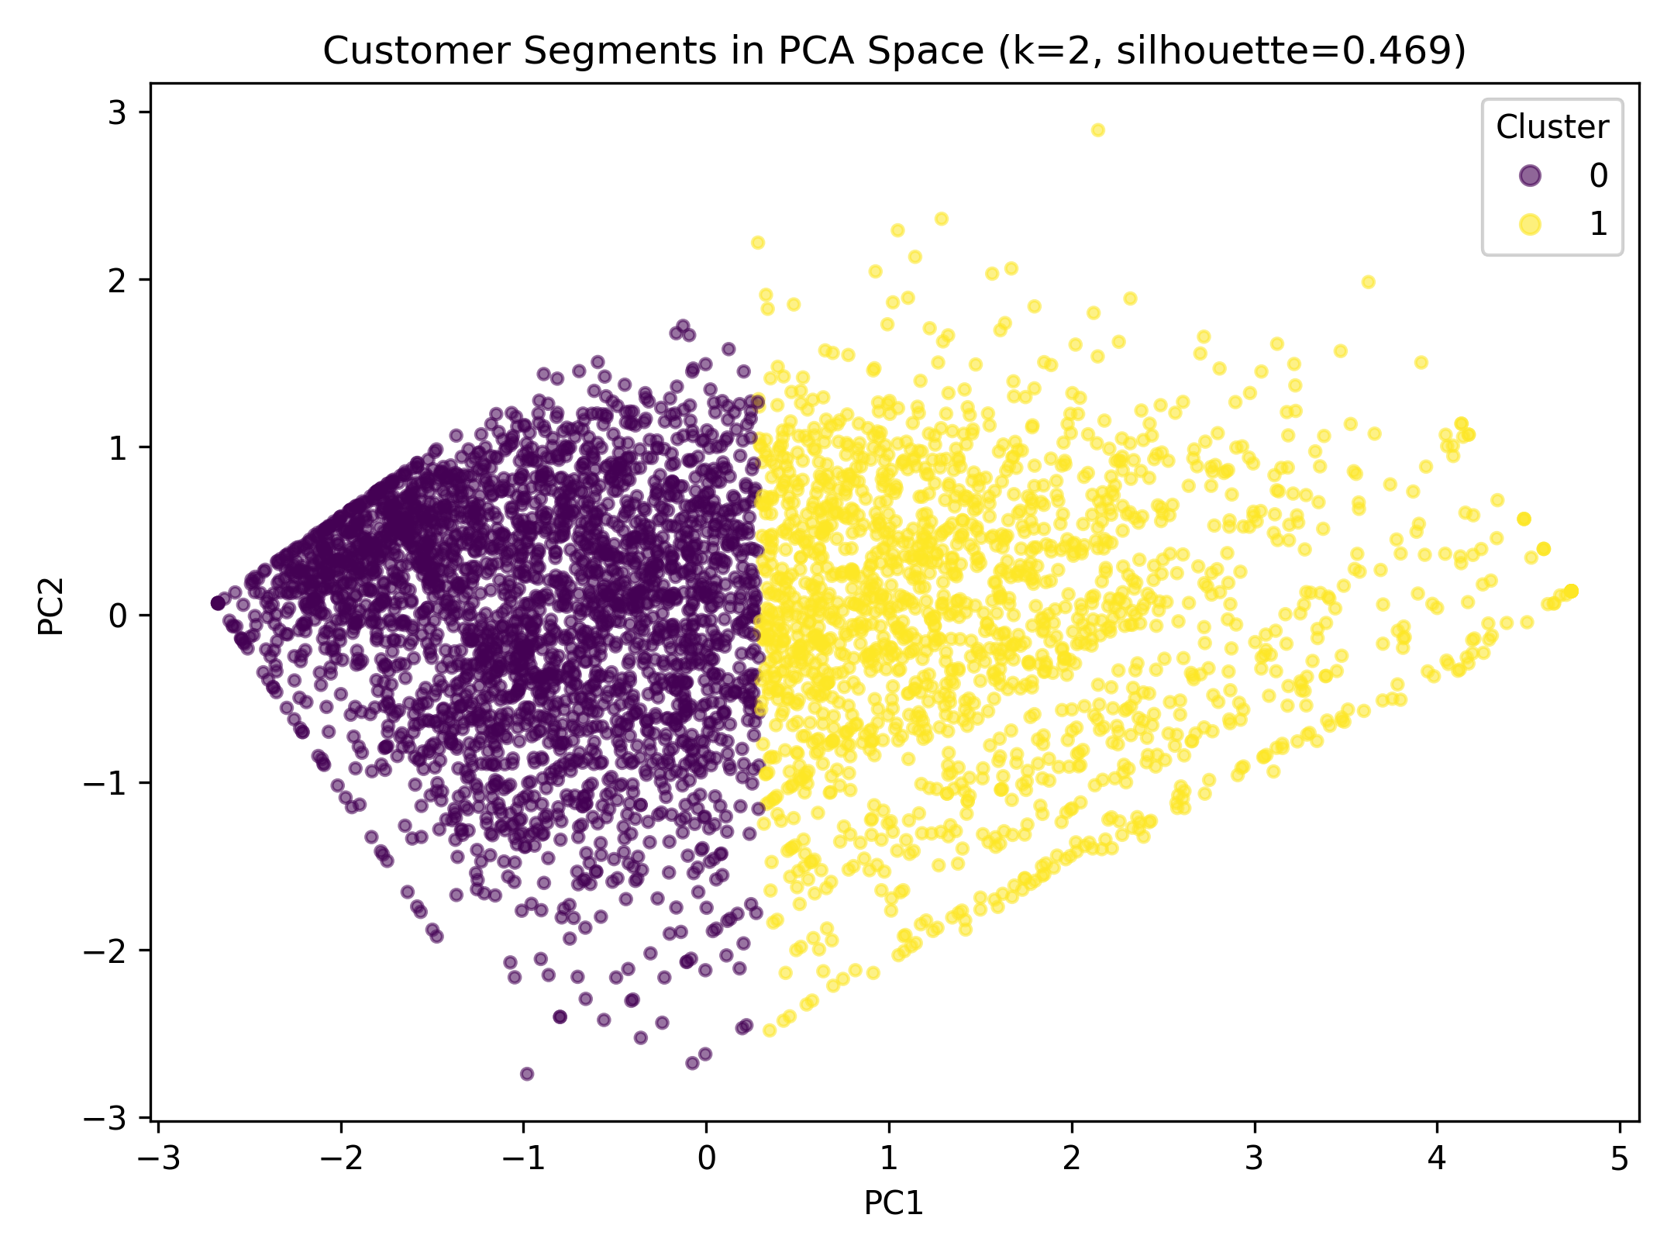
Figure 5. K-Means customer segments in the two-dimensional PCA space.
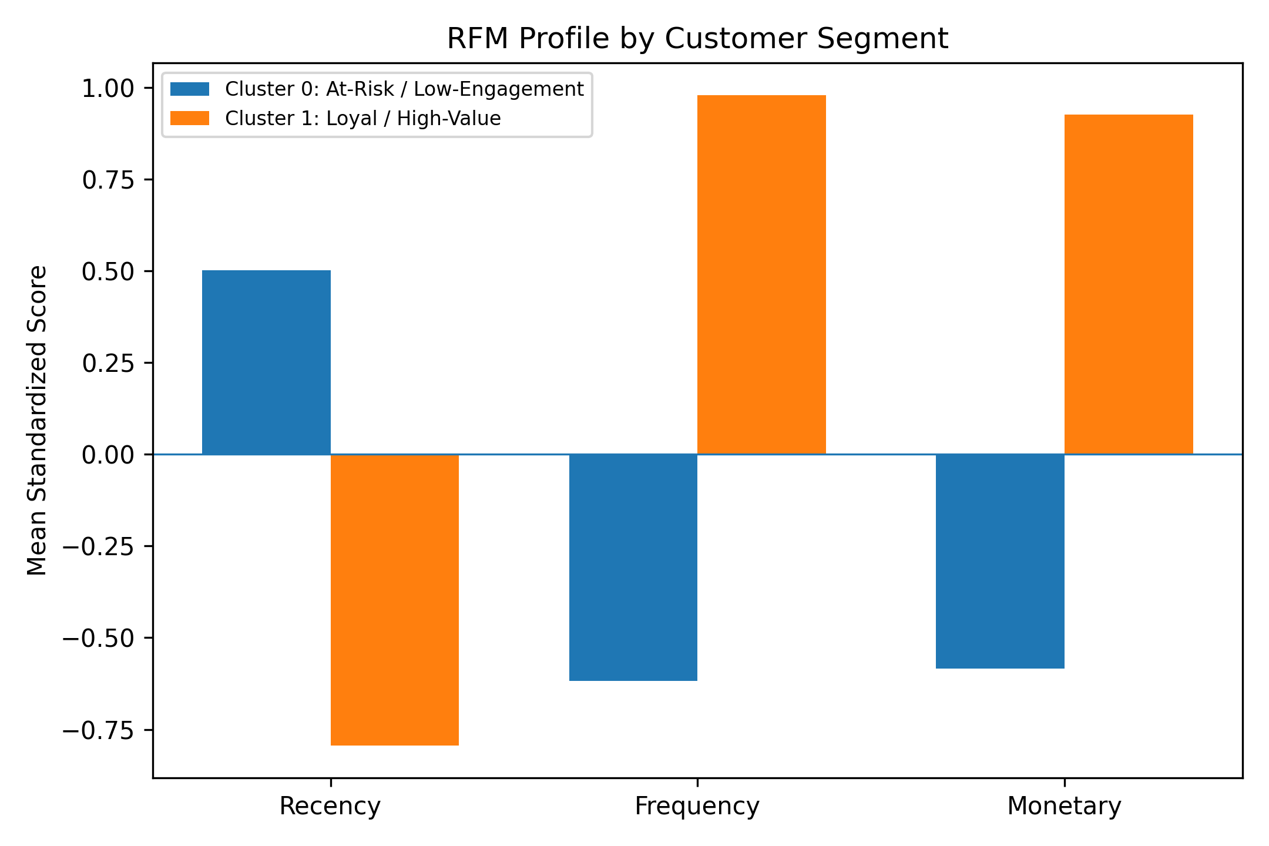
Figure 6. Standardized RFM profile by segment.
The Loyal / High-Value segment has mean Recency 26.3 days, Frequency 8.41 invoices, and Monetary 4525.96. It contains only 38.7% of customers but contributes 85.5% of monetary value. The At-Risk / Low-Engagement segment has mean Recency 133.5 days and much lower Frequency (1.66) and Monetary (485.96). A practical retention strategy is therefore to protect the smaller high-value group while using lower-cost reactivation campaigns for the larger low-engagement group.

9.4 MANOVA across customer segments
Statistic | Value | Num df | Den df | F | p-value
Wilks' lambda | 0.3167 | 3 | 4334 | 3117.28 | <0.001
Pillai's trace | 0.6833 | 3 | 4334 | 3117.28 | <0.001
Hotelling-Lawley trace | 2.1578 | 3 | 4334 | 3117.28 | <0.001
Roy's greatest root | 2.1578 | 3 | 4334 | 3117.28 | <0.001
Wilks lambda is small and Pillai trace is large, so the joint transformed RFM means differ strongly across the two discovered segments. Because the clusters were constructed from the same RFM variables, this MANOVA is best interpreted as descriptive validation of multivariate separation, not an independent causal discovery test.

9.5 Prospective churn construction and Hotelling T-squared
The maximum transaction date is 2011-12-09. A 91-day outcome period is reserved after cutoff 2011-09-09. RFM predictors are computed only from history available by the cutoff. Customers with any purchase in the outcome window are retained; those without a purchase are labelled churned. This produces 3,370 historical customers: 1,921 retained and 1,449 churned (churn proxy rate 43.0%).
Group | Mean Recency | Mean Frequency | Mean Monetary
Retained | 72.8 | 4.80 | 2295.91
Churned | 122.1 | 1.86 | 712.59
Hotelling T-squared=677.84, converted F=225.81 with df=(3,3366), p<0.001. Churned customers had a substantially larger historical Recency and smaller Frequency/Monetary averages. However, Box M rejects equal covariance, so the exact pooled-covariance p-value should be treated as approximate evidence rather than as assumption-perfect inference.

9.6 LDA churn prediction
Metric | Test result
Accuracy | 0.667
Balanced accuracy | 0.665
Precision - churn | 0.605
Recall - churn | 0.651
F1 - churn | 0.627
ROC-AUC | 0.725
Train size | 2,359
Test size | 1,011
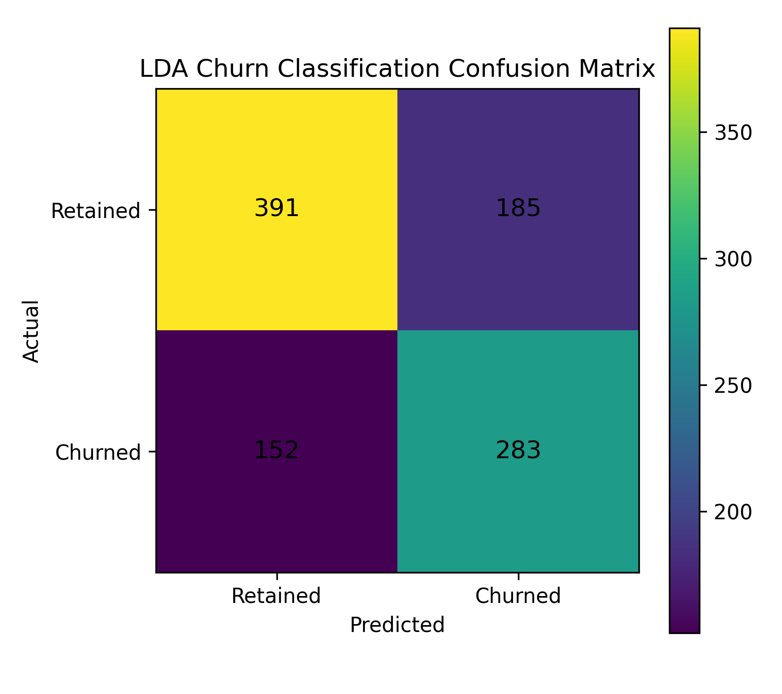
Figure 7. Confusion matrix for held-out churn classification.
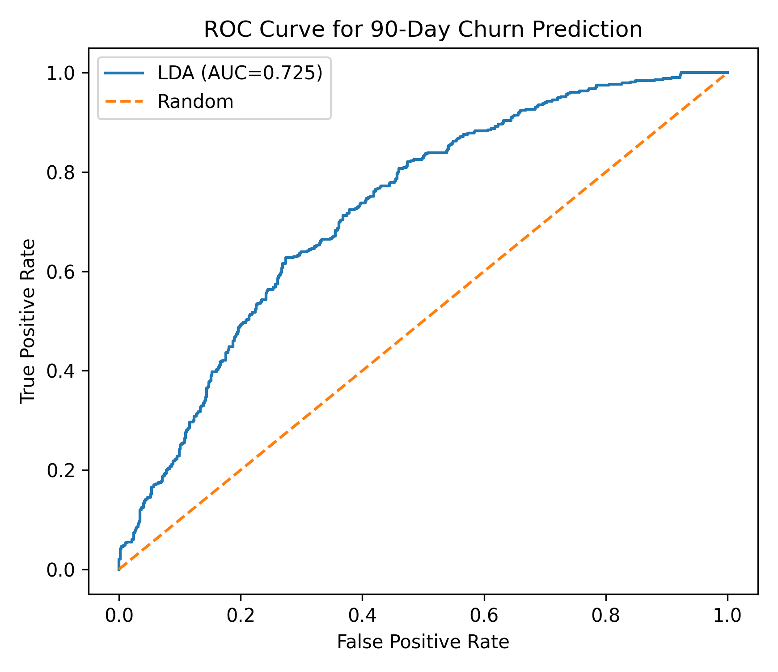
Figure 8. ROC curve for the LDA churn classifier.
On the held-out test set, the model correctly identifies 283 churned customers and 391 retained customers, while producing 185 false churn alerts and missing 152 churn cases. ROC-AUC=0.725 indicates moderate ranking ability. This is useful for prioritizing retention outreach, but it is not strong enough to be treated as a fully automated decision rule without additional behavioral features and model comparison.

10. Deployed App Deliverable
The Streamlit app in app/streamlit_app.py implements the core pipeline for an uploaded transaction CSV. It displays cleaned transaction count, customer count, selected number of clusters, historical churn rate, segment summary, customer-level RFM values, churn probabilities, and a downloadable CSV. The public deployment URL must be created from the student account and inserted into README/LinkedIn/LMS evidence before submission.

11. C1/C1b/C2 - Professional Development Deliverables
Two complete LinkedIn post drafts are included in evidence_templates/LinkedIn_Posts.md. They document ideation/implementation/results, contain the required course context and hashtags, and specify which static visualization to attach. A 100-120 second original promotional-video narration is provided in Promotional_Video_Script.md. Peer endorsement instructions are also included. Public posting, actual engagement, account screenshots, instructor tagging, and real peer endorsements must be performed by the student because those are verifiable external actions.

12. C3 - Peer Review and Critical Reflection Draft
The strongest aspect of my project is the way the customer problem is treated as genuinely multivariate rather than as three separate RFM scorecards. I first model Recency, Frequency and Monetary value as a joint customer vector, examine its covariance structure, transform the highly skewed variables, and then use PCA before clustering. The workflow also links exploratory segmentation to formal inference through MANOVA and Hotelling's T-squared, and finally to prediction using Linear Discriminant Analysis. A second strength is the prospective churn definition. I compute predictors only from the historical period and classify churn according to whether the customer purchases in the following 91-day window. This reduces the direct target leakage that would occur if churn were simply defined as high current Recency.
A limitation is that LDA assumes approximately multivariate normal class distributions and a common covariance matrix. In this dataset, normality tests remain significant even after log transformation and winsorization, and Box's M test rejects covariance equality. Therefore, LDA is useful as an interpretable course-aligned baseline, but its assumptions are not perfectly satisfied. An alternative I considered is Quadratic Discriminant Analysis, which permits class-specific covariance matrices. Logistic regression or tree-based classifiers could also improve predictive flexibility, but QDA is the most direct multivariate alternative to LDA within this problem.
From reviewing [PEER NAME]'s project, [PROJECT TITLE], I learned [SPECIFIC INSIGHT - for example, how the peer verified assumptions before choosing a technique, improved a visualization, or linked a statistical result to a domain decision]. Their LinkedIn post is available at [PEER LINKEDIN POST URL]. This peer review reminded me that a technically correct statistic becomes more useful when the assumptions, limitations and decision implications are communicated clearly. It also encouraged me to compare statistical performance with interpretability rather than selecting a method only because it produces a stronger numerical score. For this project, that means keeping LDA as a transparent course-aligned baseline while documenting where its assumptions fail and where a more flexible classifier may be justified.
Submission note: replace [PEER NAME], [PROJECT TITLE], [SPECIFIC INSIGHT] and [PEER LINKEDIN POST URL] only after reviewing a real classmate. The rubric requires the peer to be named and the LinkedIn post cited; fabricated evidence should not be used.

13. Limitations and Future Improvements
- Churn is a behavioral proxy (no purchase within 91 days), not a contractual account-closure event. Some customers may simply have long natural purchase cycles.
- The supplied file covers about one year and is the UCI Online Retail dataset, not the two-year Online Retail II dataset named in the original proposal.
- RFM alone omits product-category preference, returns behavior, geography, seasonality and acquisition channel, all of which could improve churn prediction.
- Formal normality and common-covariance assumptions are violated. QDA, regularized discriminant analysis, logistic regression and tree ensembles are sensible predictive comparisons, but the present project retains LDA to map directly to the course syllabus.
- MANOVA is performed after clustering on the same RFM variables; it confirms separation descriptively but should not be treated as an independent confirmatory experiment.
- Future work should use rolling temporal validation and test whether campaign interventions actually change retention, which would require causal inference rather than predictive classification alone.

14. Conclusion
The project demonstrates why e-commerce customer behavior is better represented as a multivariate random vector than as isolated univariate scores. PCA reduces correlated RFM information while retaining 94.03% of variation in two dimensions; K-Means yields two clearly differentiated customer groups; MANOVA and Hotelling T-squared show strong joint mean-vector differences; and prospective LDA provides a moderate but interpretable churn-risk classifier. The Streamlit interface converts these statistical results into a practical customer table for targeting. Equally important, assumption violations are explicitly documented, so the conclusions remain statistically responsible rather than overstated.

AI-Assisted Development Disclosure
OpenAI ChatGPT was used as an AI-assisted development tool to help structure the Python codebase, debug statistical workflows, draft explanations and prepare documentation. The numerical analysis was executed on the supplied dataset. The student must review, understand, test and adapt all code and should be prepared to explain each technique during the viva. This disclosure is included because the assignment rubric requires AI-assisted code to be disclosed.

References
[1] UCI Machine Learning Repository. Online Retail. https://archive.ics.uci.edu/dataset/352/online+retail (accessed 22 September 2026).
[2] Chen, D., Sain, S. L., & Guo, K. (2012). Data mining for the online retail industry: A case study of RFM model-based customer segmentation using data mining. Journal of Database Marketing & Customer Strategy Management, 19(3), 197-208. https://doi.org/10.1057/dbm.2012.17
[3] scikit-learn developers. Linear and Quadratic Discriminant Analysis; PCA; KMeans documentation. https://scikit-learn.org/
[4] Johnson, R. A., & Wichern, D. W. Applied Multivariate Statistical Analysis. Pearson. (General reference for Hotelling T-squared, MANOVA and multivariate-normal methods.)

Appendix A - Rubric Submission Checklist
Ref | Deliverable | Status
A1-A4 | Report PDF with domain, problem, mathematics, assumptions and pseudo-algorithm | Prepared
B1 | Flowchart PNG/PDF | Prepared
B2 | GitHub Student Developer Pack activation screenshot | STUDENT ACTION
B3 | Public GitHub URL + deployed app URL | STUDENT ACTION
B4 | README, folder structure, >=5 meaningful commits, .gitignore | Files prepared; commits required
B5 | Results + >=2 labelled visualisations | Prepared
C1 | 2 public LinkedIn post URLs + visualisation | Drafts prepared; publish required
C1b | 60-180 second captioned promotional video URL | Script prepared; record/post required
C2 | Screenshots of 3 real peer endorsements | STUDENT ACTION
C3 | 300-400 word reflection including named peer and post citation | Draft prepared; peer details required
External URLs/screenshots are intentionally not fabricated. Insert them only after completing the relevant actions in your own GitHub/LinkedIn accounts.

