Parking Garage Counter System

José Leiva, Julio Mayedo Fernández, and William Riera
Group 7
Miami-Dade College
COP1047C-2265-6452: Introduction to Python Programming
Group Assignment 3 (Phase 2): GitHub Collaboration and Function Stubs
Professor Jhon Romero
July 5, 2026

Parking Garage Counter System
Introduction
This report documents Phase 2 of the team’s software project. Building on the planning, design, and repository setup completed in Phase 1, this phase establishes the standards and structural foundation required before the program is implemented. The scope of Phase 2 covers four deliverables: a team standards document that defines how the team works together; a complete set of function stubs that declare every required feature without implementing them; evidence of active GitHub collaboration from every team member; and this report.
The goal of this phase is to ensure that, before any program logic is written in Phase 3, the team shares a common set of coding conventions, a disciplined version-control workflow, and a clear division of responsibilities. Establishing these elements early reduces the risk of integration problems, keeps the source code consistent across contributors, and gives each member a well-defined area of ownership. No functional code is written during this phase; the function stubs serve only to define the program’s structure and document the intended behavior of each operation.
Team Standards Document
The team standards document is stored as standards.md in the Documentation folder of the repository. It records the team’s roles, the coding conventions every member follows, the Git workflow that governs how work is merged, and the procedures the team uses to communicate and resolve conflicts. The full content is summarized in the four subsections below.
Team Information
- José Leiva — Software Developer.
- Julio Mayedo Fernández — Software Developer.
- William Riera — Project and Documentation Manager, GitHub Coordinator, and Lead Software Developer.
Coding Standards
- Naming conventions: functions and variables use snake_case (for example, add_record and parking_spaces); constants use UPPER_CASE; status values are stored as the strings Occupied, Available, and Reserved.
- Indentation: four spaces per level; tabs are not used, in keeping with PEP 8 (official style guide for Python code).
- Comments and docstrings: every function includes a docstring stating its purpose, parameters, return value, author, and status, and inline comments explain any non-obvious logic. A # TODO marker identifies work deferred to Phase 3.
- Line length: lines are limited to 79 characters, following PEP 8.
Git Workflow
- Branch strategy: the main branch holds stable, reviewed code, and each member works on a feature branch named <developer>-stubs
- Commit messages: written in the present tense and describing one logical change (for example, Add add_record() function stub).
- Pull requests: changes are merged into main through a pull request that each member self-reviews before it is merged; the GitHub Coordinator resolves any merge conflicts.
Team Procedures
- Communication: the team uses the official Canvas email platform as the primary communication tool, and members have been advised to respond within 24 hours.
- Task assignment: tasks are divided so that each member owns at least one function stub, and the assignments are recorded in the Team Responsibilities section of this report.
- Conflict resolution: technical disagreements are settled by team discussion and majority agreement; if no agreement is reached, the Project Manager makes the final decision.
Function Stubs
The function stubs are stored as parking_garage_counter_stubs.py in the SourceCode folder of the repository. Each stub declares one of the seven required operations using the project’s own terminology — parking space records, spot numbers, license plates, vehicle types, and the statuses Occupied, Available, and Reserved — and documents its parameters, return value, author, and status. No logic is implemented; each body contains only a docstring and a TODO marker reserved for Phase 3. The complete file is reproduced below.
"""
Parking Garage Counter System - Function Stubs
Team Members: José Leiva, Julio Mayedo Fernández, and William Riera
Course: COP1047C Introduction to Python Programming
Date: June 29, 2026
"""
# ‘pass’ is a placeholder that lets each function stay empty without a syntax error.

def add_record(parking_spaces):
"""
Add a new parking space record to the system.

Parameters:
parking_spaces (list): The current list of parking space records.

Returns:
list: Updated list of records with the new record added.

Author: José Leiva
Status: Stub - Implementation pending Phase 3
"""
# TODO: Implementation in Phase 3
pass

def search_record(parking_spaces, spot_number):
"""
Search for a parking space record by its spot number.

Parameters:
parking_spaces (list): The current list of parking space records.
spot_number (str): The parking spot number to search for.

Returns:
list: Matching parking space record(s) found.

Author: José Leiva
Status: Stub - Implementation pending Phase 3
"""
# TODO: Implementation in Phase 3
pass

def display_records(parking_spaces):
"""
Display all parking space records in a formatted table.

Parameters:
parking_spaces (list): The current list of parking space records.

Returns:
None: Prints the parking space records to the console.

Author: Julio Mayedo Fernández
Status: Stub - Implementation pending Phase 3
"""
# TODO: Implementation in Phase 3
pass

def update_status(parking_spaces, spot_number, new_status):
"""
Update the parking status of a specific parking space.

Parameters:
parking_spaces (list): The current list of parking space records.
spot_number (str): Spot number of the parking space to update.
new_status (str): New status (Occupied, Available, or Reserved).

Returns:
list: Updated list of parking space records.

Author: Julio Mayedo Fernández
Status: Stub - Implementation pending Phase 3
"""
# TODO: Implementation in Phase 3
pass

def generate_report(parking_spaces):
"""
Generate a summary report of the parking garage.

Parameters:
parking_spaces (list): The current list of parking space records.

Returns:
dict: Summary statistics (Total, Occupied, Available, Reserved)

Author: William Riera
Status: Stub - Implementation pending Phase 3
"""
# TODO: Implementation in Phase 3
pass

def exit_program():
"""
Exit the program gracefully.

Parameters:
None

Returns:
None: Terminates the program.

Author: William Riera
Status: Stub - Implementation pending Phase 3
"""
print("Exiting the Parking Garage Counter System. Goodbye!")

# TODO: Implementation in Phase 3
pass

def main_menu():
"""
Display the main menu and handle attendant input.

Parameters:
None

Returns:
None: Loops until the user chooses to exit.

Author: William Riera
Status: Stub - Implementation pending Phase 3
"""

# TODO: Implementation in Phase 3
pass

if __name__ == "__main__":
# TODO: Implementation in Phase 3
pass

Commit History
The commit history below shows that every member of Group 7 contributed to the repository during Phase 2. Each member created their personal branch, at least one commit, and pushed it to the shared repository, consistent with the team’s Git workflow. José Leiva committed the add_record and search_record stubs, Julio Mayedo Fernández committed the display_records and update_status stubs, and William Riera committed the standards document, the remaining stubs, and this report.
Commit History Showing Contributions From All Team Members
Figure 1.1
William Riera’s Project Contribution
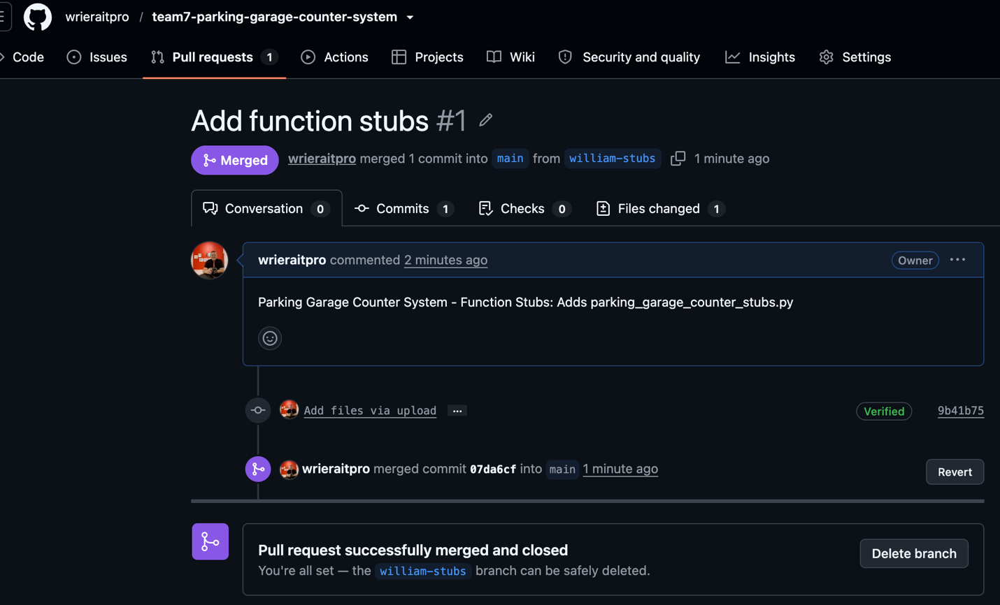
Figure 1.2
José Leiva’s Project Contribution

Figure 1.3
Julio Mayedo Fernández’s Project Contribution
Repository Screenshots
The following screenshots document the current state of the shared repository, including the home page and the folder structure that organizes the documentation, flowchart, source code, and screenshots.
Figure 2
Repository Home Page
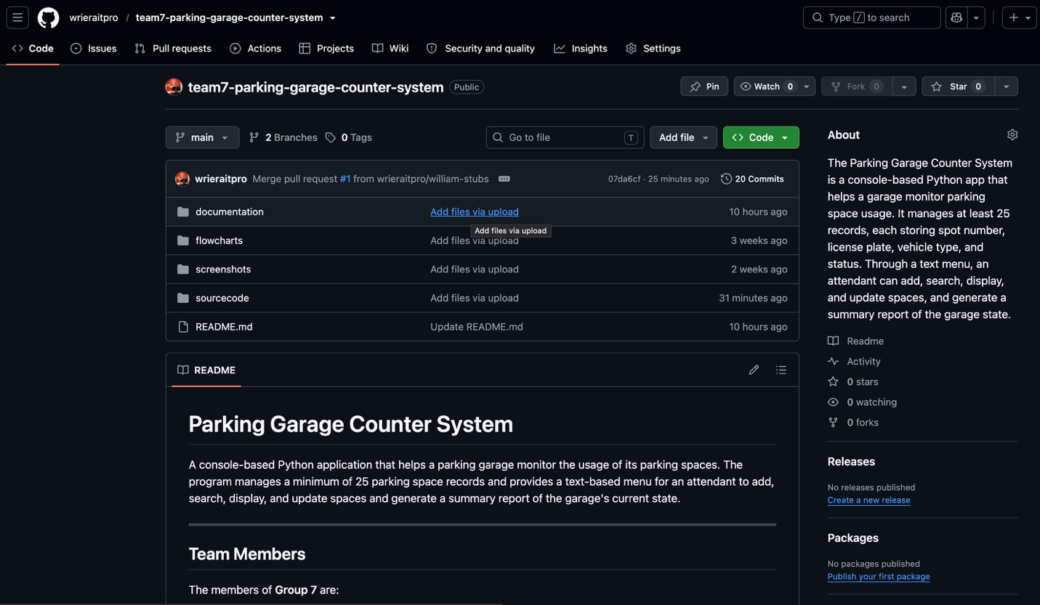

Figure 3
Repository Folder Structure
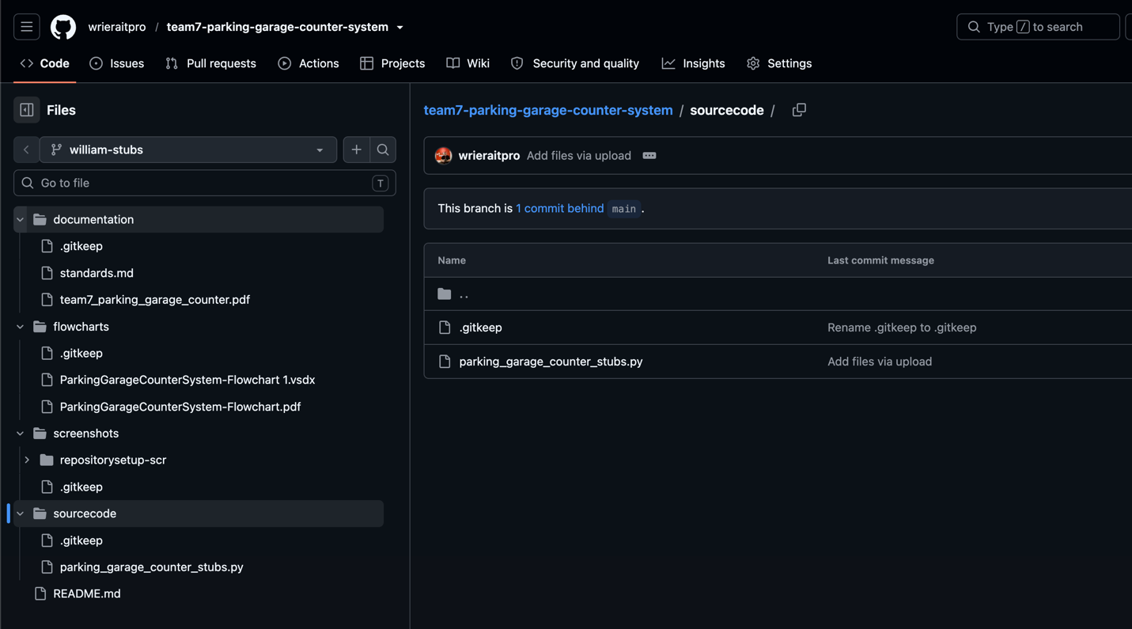
Figure 4
Repository Collaborators
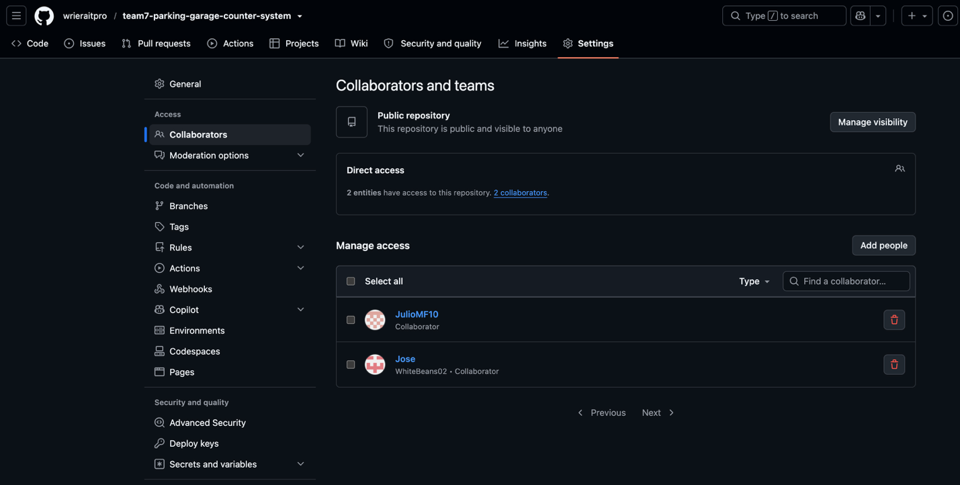
GitHub Repository URL
The shared repository that hosts the team’s standards document, function stubs, and supporting documentation is available at the address below.
https://github.com/wrieraitpro/team7-parking-garage-counter-system

Team Responsibilities
The responsibilities for Phase 2 were divided so that every member authored at least one function stub and committed work to the repository, as required. Table 1 summarizes each member’s contributions.

Table 1
Phase 2 Responsibilities by Team Member
Team Member | Phase 2 Responsibilities
José Leiva | Authored the add_record() and search_record() function stubs with full docstrings; committed and pushed the contributions to the repository.
Julio Mayedo Fernández | Authored the display_records() and update_status() function stubs with full docstrings; committed and pushed the contributions to the repository.
William Riera | Authored the standards.md document and the generate_report(), exit_program(), and main_menu() stubs; coordinated the GitHub repository, reviewed pull requests, and prepared the Phase 2 report.

Conclusion
Phase 2 completes the preparatory foundation for the Parking Garage Counter System. The team has agreed on a shared standards document, created fully documented function stubs for all seven required operations, and divided responsibilities so that every member contributed work to the repository. These steps give the team a consistent set of coding conventions, a disciplined Git workflow, and clearly assigned ownership before any program logic is written.
The next phase, Phase 3, will replace each stub’s TODO marker with working code, implement the menu-driven main loop, and validate the program against the requirement to manage at least 25 parking space records across the statuses Occupied, Available, and Reserved. With the conventions and structure now established, the team is well positioned to implement, test, and integrate the completed system efficiently and collaboratively.

References
GitHub. (n.d.-a). About commits. GitHub Docs. Retrieved June 29, 2026, from https://docs.github.com/en/pull-requests/committing-changes-to-your-project/creating-and-editing-commits/about-commits
GitHub. (n.d.-b). About pull requests. GitHub Docs. Retrieved June 29, 2026, from https://docs.github.com/en/pull-requests/collaborating-with-pull-requests/proposing-changes-to-your-work-with-pull-requests/about-pull-requests
Python Software Foundation. (n.d.-a). PEP 8 – Style guide for Python code. Retrieved June 29, 2026, from https://peps.python.org/pep-0008/
Python Software Foundation. (n.d.-b). PEP 257 – Docstring conventions. Retrieved June 29, 2026, from https://peps.python.org/pep-0257/

